September 2019

2019 2020 Guided pathways priorities

Priorities
- Guided Pathways statewide launch/scaling
- Technology aligment and support
- Allocation model development

Timeline

Fall 2019
- Scale of Adoption Assessment (SOAA) completed
- Math Landscape analysis data collection and site visits
- Hope Survey (28 colleges) financial insecurity data collection
- Guided Pathways Allocation Plan released and reviewed
- Faculty engagement
- Capacity building – technical assistance and coaching

Winter 2020
- Math Landscape data analysis
- Scale of Adoption Assessment (SOAA) analysis
- Guided Pathways work plans completed (March 1, 2020)
- Guided Pathways Strategic Plan completed

Spring 2020
- Statewide Scale of Adoption Assessment results released
- College work plans review and analysis
- 2-year Learning Agenda alignment

Math Acceleration Landscape Analysis
- Fall 2019 Site visits
- Winter 2020 Analysis and report
- Spring 2020 Integration planning

Readiness Indicators Review
- Scale of Adoption Assessment (2018/2019)
- Math Landscape analysis
- Leadership transition status
- Hope survey engagement
- Early Key Performance Indicator data
- Learning Agenda engagement
- Council/Commission engagement
- Guided Pathways work plan
- Community College Research Initiatives eflection briefs
- Meta Major inventory

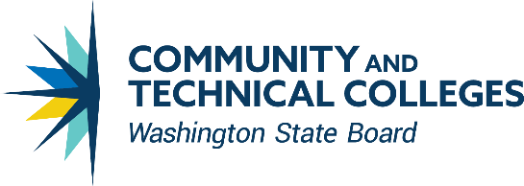
CONTACT INFORMATION
Kristi Wellington Baker
Student Success Center Director
Student Success Center
CC BY 4.0 360-704-1022
Except where otherwise noted kwellingtonbaker@sbctc.edu

