Register Now!
Implementing Co-requisite Mathematics
November 5th, 2019
Highline College (Student Union Bldg)

Hosted by: Facilitated by:
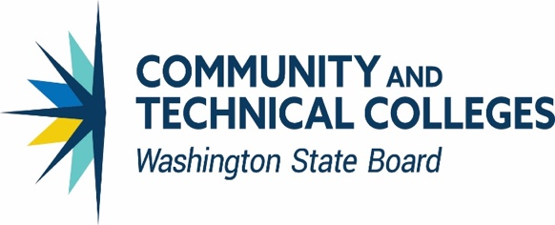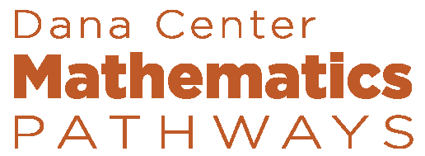

As a follow-up to the initial fall 2018 workshop, this 1-day gathering supports college and university teams who are currently offering math co-requisite courses designed to help students get to-and-through college-level mathematics more successfully.

Each institution should bring a team of 3-5 people including:
- Mathematics faculty members who teach developmental mathematics, statistics, college algebra, and/or quantitative reasoning courses
- Academic and students services administrators, advisors and institutional researchers

Through this interactive workshop, teams will share successes and challenges from their co-requisite implementation, consider key steps in scaling up their offerings, explore strategies for continuous improvement, create short-term action plans, and learn about free tools and resources available for ongoing support of their work.

NOTE: For institutions that did not attend the November 2018 Co-Requisite Workshop, we encourage you to register for the Co-Requisite Part II workshop. To prepare you to attend the Part II workshop, you are required to engage in a 2-hour webinar on October 22, 2019 at 3:00-5:00 pm PT. Post-registration details will provide more information.

The meeting site costs and meals are covered; your only costs are travel to and from the event and lodging the night before if you need to arrive early. Individuals need to register through the link available on our new Dana Center Washington math pathways dashboard; please contact Bill Moore for if you have any questions. The deadline is October 1st but the workshop will likely fill so if your college is interested get your team registered as soon as you can!

