REGISTRATION FORM

2019 Assessment, Teaching & Learning Fall Retreat
November 14-15, 2019
Rainbow Lodge, North Bend

EMAIL YOUR REGISTRATION FORM BY October 15th, 2019
TO jeclark@sbctc.edu

Name:
College:
E-Mail Address:

Registration fee & what is included
The registration fee for this one & one-half day retreat is $125 per person. Registration includes meeting materials, one night’s lodging, and four meals - lunch & dinner on November 14, breakfast & lunch on November 15. Dependent on the number of registrations, participants may be housed in double occupancy rooms.

___ I will attend the entire retreat, will be staying overnight, and eating all meals
___ I will be attending the entire retreat, but will not stay overnight

Payment Information
We are not able to accept payment by credit card or payment at the retreat. Please mail a college-issued check or personal check to SBCTC, attn Jackie, PO Box 42495, Olympia WA 98504-2495.

Dietary Accommodations
Indicate below if you have any special dietary needs. Reasonable accommodations for persons with disabilities will be provided if requests are made at least 10 days prior to the event. Efforts will be made to accommodate late requests.
[enter your special need here]

Cancellation Policy
If you register for the retreat and fail to notify Jackie via email of your cancellation by November 1, 2019, your institution will be billed the full cost of $125 to cover our expense.

Start/End Time
To aid in making your travel plans, the retreat will start at 10:00am on November 14 and end with lunch on November 15. A confirmation will be emailed prior to the event.

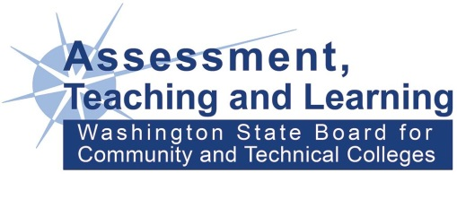
Link to Draft Agenda: http://bit.ly/2YdzqJS

