REGISTRATION FORM

Assessment, Teaching & Learning Summer 2019 Retreat
June 26, 27, 28, 2019
Spokane Community College, Spokane WA

EMAIL YOUR REGISTRATION FORM BY MAY 31
TO jeclark@sbctc.edu

Name:
College:
E-Mail Address:

Registration Fee & What Is Included
The registration fee for this two & one-half day retreat is $135 per person. Registration includes meeting materials, and five meals - lunch on June 26, breakfast & lunch on June 27 & 28.

Participants are responsible for making their own travel & lodging arrangements.

Payment Information
Payment must be by college-issued check or personal check made payable to SBCTC & mailed to SBCTC, attn Jackie, PO Box 42495, Olympia WA 98504-2495. We are not able to accept payment by credit card or payment at the retreat.

Dietary Accommodations
Indicate below if you have any special dietary needs. Reasonable accommodations for persons with disabilities will be provided if requests are made at least 10 days prior to the event. Efforts will be made to accommodate late requests.
[enter your special need here]

Cancellation Policy
If you register for the retreat and fail to notify Jackie via email of your cancellation by June 12, 2019, your institution will be billed the full cost of $135 to cover our expense.

Start/End Time
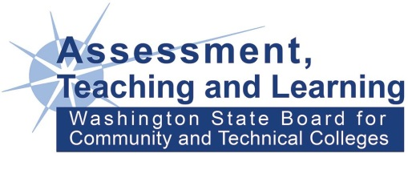
To aid in making your travel plans, the retreat will start at 10:30am on June 26 and end by 3:00pm on June 28. A confirmation will be emailed prior to the event.

