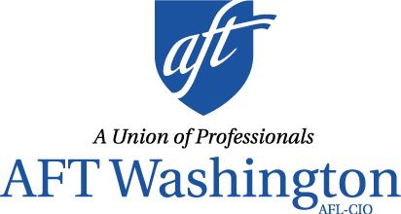

SUPPORT HB 1355
(Effective CTC Counseling)

AFT Washington is seeking to establish counseling standards and ratios at the Community and Technical Colleges (CTCs) to better serve our students.

What We’re Asking
We are seeking minimum standards that define what faculty counselors in the CTCs do and what constitutes a qualified counselor by:

- Requiring all campuses have counselors to help every student succeed;

- Ensuring counselors are qualified with the right credentials, experience, and education; and

- Establishing a supportive environment that helps students meet their goals by requiring a maximum ratio of one counselor to 900 students.

Why We’re Asking
- Students aren’t receiving the help they need
- The current statewide ratio is nearly one counselor to 1,900 students, according to a recent survey.

- Years of defunding mean that there are too few counselors to meet students’ needs
  - This keeps students from getting consistent counseling, no matter where they go to school.

- Student needs are multifaceted
  - Students’ lives are complex with competing responsibilities – qualified counselors help students navigate their career preparation, personal challenges, and life stressors, increasing student success.

For more information, please contact Sandra Toussaint, AFT Washington Political Organizer by e-mail stoussaint@aftwa.org or by phone 206-427-8107.

625 Andover Park West, Suite 111, Tukwila, WA 98188 ♦ 206-242-4777 ♦ TF: 866-992-3892 ♦ http://wa.aft.org ♦ Facebook at aftwa ♦ Twitter @AFTWA opeiu8/afl-cio

