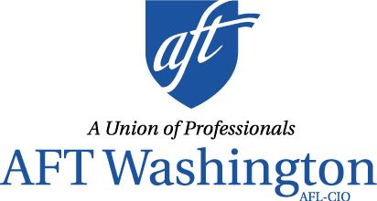

SUPPORT HB 1300
[Re]Invest in Our Colleges (ROC)

AFT Washington, the Washington Education Association, the Washington State Labor Council, the unions, students, and community members who benefit from Community and Technical Colleges (CTCs), seek $500 million in permanent funding for the CTC system.

What We’re Asking
We are seeking $500 million to improve our colleges for the students and the professionals that make education possible. Here’s how:
- Improving counseling for students by providing funding for additional counselors;
- Improving student success by investing in strategies and programming that achieve diversity, equity and inclusion for students, employees, and the community;
- Increasing student retention, completion, and supporting the college community by increasing the number of full-time, tenure track positions, and providing adjunct faculty with pay equity;
- Enhancing professional development funding for faculty and staff, to better serve our students;
- Making compensation fairer by raising pay for all college employees to a livable wage, providing economic security; and
- Premium pay for faculty teaching our incarcerated students, due to their unique working conditions.

Why We’re Asking
Washingtonians benefit from CTCs, with nearly 60% of post-high-school students enrolling at one in their educational path. With 34 CTCs in the state, they’re very often the only higher education option in our students’ communities. And the education provided by CTCs fills the gaps in Washington’s workforce: our CTCs provide economic stability for our communities and give our employers qualified, local applicants.

However, the system is underfunded. We have done more for less for far too long and the inadequate funding level has led to salaries below market rate, insufficient support services, and a precarious workforce over-reliant on part-time faculty.

We have a gap coming in Washington’s workforce. The state predicts we’ll have 44,000 job openings per year, but only 33,000 workers graduating with the education needed per year. We’re asking for this funding to close the gap and improve Washington’s CTC system to strengthen our communities and keep Washington’s economy healthy.

For more information, please contact Sandra Toussaint, AFT Washington Political Organizer by e-mail stoussaint@aftwa.org or by phone 206-427-8107.

625 Andover Park West, Suite 111, Tukwila, WA 98188 ♦ 206-242-4777 ♦ TF: 866-992-3892 ♦ http://wa.aft.org ♦ Facebook at aftwa ♦ Twitter @AFTWA
opeiu8/afl-cio 011819

