2018 LEGISLATIVE SUMMARY
AFT Washington
Dr. Bernal C. Baca, Lobbyist
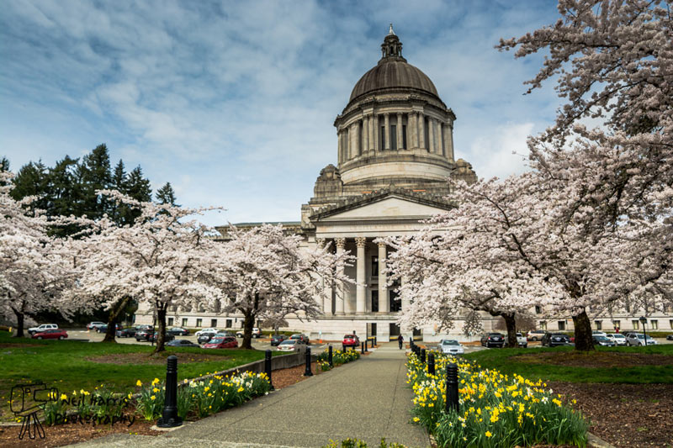

INTRODUCTION
The 2018 legislative session was incredibly successful for many of AFT Washington’s top legislative priorities. With the election of Manka Dhingra (D-45), the Democrats enjoyed their first session with unified control of government in many years. Suddenly, Democrats had the ability to move bills out of committee in the Senate when in previous years progressive legislation languished in committees. This session’s significant accomplishments range from enacting EHB 1237, the local bargaining bill for CTC faculty, to the Washington State Voting Rights Act, ensuring communities of color and marginalized peoples across our state have more equitable elected representation. In addition, SB 6388, the Paraeducator “fix” bill to extend the deadline for Paraeducators certification, to HB 1488, the “Washington DREAM Act” which will allow DACA recipients to receive additional financial aid resources for college regardless of the future of the federal DACA program.
Though AFT Washington and our allies enjoyed great success this year, there was also significant legislation that did not make it to the Governor’s desk. Both this session’s successes and our ongoing legislative struggles will be discussed in this report.

SUCCESSES

AFT Washington’s top priority bills:
EHB 1237 Modifying collective bargaining law to authorize providing additional compensation to academic employees at community and technical colleges
After many years of fighting to provide community and technical college faculty the ability to receive salary increases through success at their local bargaining tables, AFT Washington succeeded this year in passing the bill necessary to achieve this goal—EHB 1237. All full- and part-time faculty, counselors, and librarians at our colleges are covered under this bill.

SB 6388 Concerning Paraeducators
Paraeducators working for a district before or during the 2017-18 school year must meet minimum employment requirements by the date of hire for the 2019-20 school year. Persons that have not previously worked as a paraeducator for a district must meet these requirements by the date of hire for the 2018-19 school year or any subsequent school year.
For paraeducators hired for the 2018-19 school year, school districts must provide the fundamental course of study for paraeducators by September 1, 2020. For those hired for the 2019-20 school year, districts must provide the course by September 1, 2021.
In addition, school districts must implement fundamental course of study requirements, in school years for which state funding is specifically appropriated for this purpose.

Labor Bills supported by AFT Washington:
SHB 2703 An act relating to clarifying hours and wages for education employee compensation claims
Changes the eligibility for unemployment benefits for educational employees who have multiple employers. Modifies the analysis of whether an educational employee has a contract or reasonable assurance of continued employment for purposes of unemployment benefits.

HB 2751 Concerning the deduction of union dues and fees
Provides that if a collective bargaining agreement has a union security provision, written authorization from the employee is not required for the employer to enforce the union security agreement by deducting required dues or fees from the employee's pay. Provides that if a collective bargaining agreement includes requirements for deductions of payments other than union dues or equivalent fees under a union security provision, the employer must make those deductions upon written authorization of the employee. Removes the requirement that an employee's written authorization to deduct dues be filed with the employer.

ESB 6229 Requiring employers to provide exclusive bargaining representatives reasonable access to new employees for the purposes of presenting information about their exclusive bargaining representative
Under state collective bargaining law, an employer must provide the exclusive bargaining representative reasonable access to new employees of the bargaining unit for the purpose of presenting information about the exclusive bargaining representative to the new employees. The presentation may occur at a new employee orientation or at another time mutually agreed to by the employer and the bargaining representative. No employee may be mandated to attend the meetings or presentations by the exclusive bargaining representative. Reasonable access means that the access occurs within 90 days of the employee's start date and the access is for no less than 30 minutes. However, an employer may agree to longer and more frequent new employee access. The access must occur during the employee's regular work hours at the employee's regular worksite, unless another time and place is mutually agreed to by the employer and bargaining representative.

SB 6231 Concerning the statute of limitations for unfair labor practice complaints filed in superior court
Under state collective bargaining statutes, the statute of limitations for unfair labor practice complaints filed in superior court is six months.

Social Justice Issues supported by AFT Washington:
SB 6002 Washington Voting Rights Act (VRA)
The Washington VRA passed the House 52-46, passed the Senate 29-19, and Governor Inslee signed it into law on March 19. The Washington VRA will help ensure every Washingtonian has equitable elected representation in their community. Marginalized communities have historically been under-represented or entirely shut out of our democratic process due to majority-rule electoral systems that reinforce existing power structures. With the passage of the Washington VRA, jurisdictions will have an easier time moving from at-large to district systems which will increase community representation, small towns will save money otherwise spent on expensive court challenges, and communities of color and other marginalized folks in Washington State will enjoy fuller enfranchisement in our democracy.

HB 1488 “Washington DREAM Act”
HB 1488 was a critical success for the undocumented community in Washington State. Nicknamed the “Washington DREAM Act” it makes several changes to state law to protect financial aid eligibility for undocumented students, including protecting DACA students from losing College Bound state financial aid if the DACA program is eliminated at the federal level. Due to this new law, more undocumented students will be able to attend and afford college regardless of DACA’s tenuous future.

HB 1783 Legal Financial Obligations (LFO) Reform
Legal Financial Obligations, or LFOs, are the fines, fees, costs, and restitution imposed by the court on top of a criminal sentence. Often times wealthier people can afford to pay off LFOs in one payment, but LFOs can be prohibitively expensive for people of lower incomes who then remain tied to the criminal justice system for years solely because of these debts. HB 1783 reforms this major barrier to societal re-entry and decreases the disproportionate assessment of LFOs that is a major asset drain on communities of color and low-income communities across Washington.

HB 1508 Breakfast After the Bell
No student can learn on an empty stomach. Beginning in the 2019-2020 school year, Breakfast After the Bell will allow schools where 70% or more of its students are eligible for free- or reduced-price meals to offer breakfast to students if they arrive after the first bell. It also creates a grant program for schools that already provide breakfast to expand their programs. Food insecurity impacts families of all racial and ethnic identities in Washington State, but it disproportionately impacts families of color. This law will ensure more of our students of color who suffer from food insecurity can fulfill their highest educational potentials.
HB 2578 Source of Income Discrimination Ban
Before HB 2578, landlords in Washington State could legally discriminate against their prospective tenants on the basis of the source of their income. This unfair and inequitable practice included denying tenancy to people who use Section 8 housing vouchers, social security, and child support. Many lower income Washingtonians depend on these sources of income to house themselves and their families. It is unacceptable that they automatically be considered undesirable renters simply due to their source of income, and thanks to the passage of HB 2578 it is no longer the case. Now discrimination based on race, disability, sex, familial status, and source of income is state law and will allow marginalized and low-income Washington residents to have homes.

SB 6529 Protecting Agricultural Workers
SB 6529 ultimately passed as an interim workgroup. The purpose of the bill is to determine ways agricultural workers and nearby communities can be protected from and notified of pesticide application in a timely and efficient manner. Pesticide pollution and all its deleterious effects disproportionately impact communities of color who are most often the farm workers themselves and their families. Advance notification of pesticides is a solid, feasible first-step in protecting our rural and agricultural communities from pesticide exposure.

HB 1570 “The Washington Housing Opportunity Act”
Washington State is in the midst of a crushing housing crisis that is impacting communities of color disproportionately by their experiences of homelessness, housing insecurity, and displacement. HB 1570 will increase document recording fees by $50. These fees are Washington’s most important financial resource for combating homelessness through direct funding for domestic violence shelters, youth and young adult services, outreach services, rental assistance, permanent supportive housing services, and much more. Without this increase, services would have been slashed and more than 37,000 Washingtonians would have experienced homelessness in the first two-years.

HB 1939 César Chávez Day
Starting in 2019, the birthday of the renowned labor and civil rights leader, César Chávez will be a non-legal state holiday. March 31st will be a day of remembrance and celebration in Washington as we reflect on the struggles, successes, and intersectional goals of the labor rights movement.

Janitorial Workload Study Proviso
Janitors have some of the highest workplace injury claims across all industries. This budget proviso allocates $500,000 over two years to fund a study that will quantify the physical demands of common janitorial work tasks and assess the safety and health needs of janitorial workers.

HB 1298 “Ban the Box”
HB 1298 prohibits employers from asking about job applicants' criminal history until after an initial screening or interview. It also prohibits employers from asking a job applicant about their criminal record before determining whether the applicant meets the basic criteria for the job. This is a critical victory for Washingtonians with criminal records to re-enter the workforce.

SB 6029 Student Loan Bill of Rights
By request of the Attorney General, Washington’s new Student Loan Bill of Rights establishes baseline standards for student loan servicers, in addition to creating a student loan ombuds to help resolve student complaints and to educate borrowers about student loans. Several new studies have recently shown that students of color are disproportionately targeted by predatory for-profit colleges and hold, on average, more student loan debt than their white peers. The Student Loan Bill of Rights will task the Office of the Attorney General with enforcement so students know what their rights are and hopefully avoid being taken advantage of in the marketplace of higher education.

Access to Democracy Bill Package: HB 1513 “Automatic Youth Voter Registration,” HB 2595 “Automatic Voter Registration,” and SB 6021 “Same Day Voter Registration”
All communities of color face barriers to voting that are societally and governmentally systematic. Some of these barriers are leftovers from the times when people of color were prohibited from voting, however this package of bills aims to tackle some of the remaining barriers. Automatic Voter Registration, Same Day Voter Registration, and Automatic Youth Registration make the process of voting easier and more accessible.

CONCLUSION
It was a momentous year for many of AFT Washington’s priorities. Due to the efforts of our dedicated member activists, staff, labor community allies, and the lobbyist, Washington State had one of the most accomplished legislative sessions in recent memory. Progressive, equitable legislation that previously languished for years in committees were finally brought forward for public hearings and floor votes where many bills enjoyed huge bipartisan support – showing that good policy often knows no party affiliation.
Though we are very proud of our collective success in the 2018 legislative session, there is still plenty of work to be done in the coming years. When the legislature resumes in January 2019 for a 105-day budgetary session, AFT Washington will resume our work of advancing legislation on behalf of our proud and strong Union members.

opeiu8/afl-cio

