  - Washington State Board for Community and Technical Colleges Diversity, Equity Officers Commission Dues
  - March 22, 2023

Invoice # 115 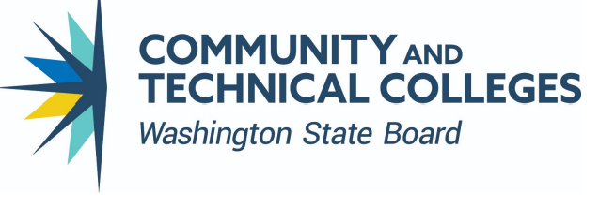
Bill to | Ship to
DECO Member: Erin Tofte  Institution: Wenatchee Valley College | Recipient LWTech Foundation  Mailing Address 11605 132nd Ave NE, Kirkland WA 98034  Attn: LWTech Foundation/ Attn: Alysen Laakso/
Payment Due May 1, 2023  Treasure D’Andre Fisher  Payment Terms Pay via check: - Issue their check to LWTech Foundation - Note Line – DEO Commission Dues | Pay Online:  Go to our online donation form page  Click the “donate to the Foundation today” button.  For designation, select “other”  Type is “CEO Commission Annual Membership”

Qty. | Item# | Description | 2023 Dues | Discount | Line total
1 | 123 | Washington State Board for Community and Technical Colleges Diversity, Equity Officers Commission Dues | 500.00 |  | 500.00
 |  |  |  | Total Discount | 0
 |  |  |  | Subtotal | 500.00
 |  |  |  | Sales Tax
 |  |  |  | Total | 500.00
Thank you for your support!
Diversity, Equity Officers Commission Executive Leadership Team:
Robert Britten, Chair, Lake Washington Institute of Technology
Iesha Valencia, Work Plan Coordinator, Clover Park Technical College
Yadira Rosales, Secretary, Skagit Valley College
Sophia Agtarap, SBCTC I, Washington State Board for Community and Technical Colleges
D'Andre Fisher, Treasurer, Seattle Colleges

