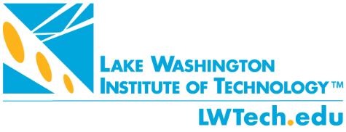

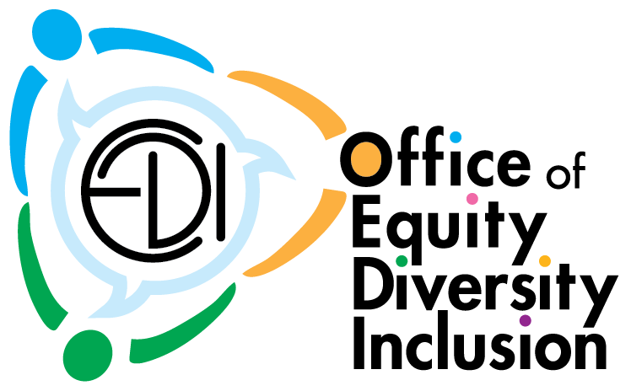

2022-2023 EDICommunications Plan

Prepared by and for the Office of EDI with Leslie Shattuck, Executive Director of Communications and Marketing
July 2022

Background

The Equity Diversity and Inclusion department currently intends to communicate through a variety of communications channels, focusing on different EDI topics and situations, related to LWTech and our CTC system. Communications vehicles will include emails, print publications, presentations, roundtable discussions, and forums.

Objective

With several communications vehicles for internal and external constituents, the communications plan will streamline themes and topics into designated channels, while tying our EDI goals and the goals of the Mission Fulfillment Plan into a sycronized platform for inclusionary conversations and work. As with any communications plan we will remain nimble and ready to pivot should we need to do so.

The main objective of the EDI communications plan is to streamline and focus messaging, by themes, identifying gaps while leveraging current and newly identified opportunities for equity centered engagement campus wide.

Target Audiences

External
- Community Members
- Legislators and Public Officials
- Potential Students and their Families
- Industry Representatives
- SBCTC
- Media
- NWCCU
- Retirees and Former Staff
- Alumni
- Redmond and Kirkland Leaders
- President’s Advisory Council
- Advisory Committees
- Media

Internal
- Faculty
- Staff
- Students
- Board of Trustees
- Foundation Board
- Union Partners

Strategic Communications Areas of Focus:

The following strategic communications areas of focus are in alignment with EDI annual goals for 2022-2023 and will be shared widely in internal and external communications, as noted below.

- Dismantling Systemic Racism on Campus
- Continue to provide EDI Focused support and leadership to the college
- Develop and implement 2022-2023 EDI Strategic Plan
- Continue personal and professional EDI development for students, staff and faculty

Fulfill the Action Plan to Dismantle Systemic Racism on Campus
The college has evolved over the past seven years in its EDI work from building EDI infrastructure, to creating a Community of Belonging, to striving to be an antiracist organization. The latter requires and compels us to look at our systems from employee recruitment and retention to student access and completion, as well as policies and procedures. This message is also in alignment with our SBCTC focused objective to do the same. Key messages will be communicated internally and (when appropriate) externally.

Continue to provide EDI focused support ad leadership to the college
The pandemic has brought an unprecedented amount of change during a very short timeframe. The effects of the pandemic have tested our relationships and norms. While we have done a lot of work to create a Community of Belonging on our “Island of Sanity,” we are unfortunately not immune from national divisions or external uncertainty. This year ahead, effective change management and a very healthy dose of humility and empathy will be needed to guide the college through this uncertain time. Key messages will be communicated internally.

Develop and Implement 2022-2023 (EDI Strategic Plan)
Pre-pandemic, the college had substantive plans to take a fresh look at our equity centered work and the strategic way we implement those goals with our sights set on an aspirational plan. Now, we will need work diligently to put a shorter-term mission fulfillment/strategic plan together to move the college through the remainder of the COVID pandemic and through to our collective recovery with a clear focus on anti-racism efforts as well as the implementation of our Guided Pathways plan. Key messages will be communicated internally and externally.

Continue Personal and Professional EDI Development
It is very important that LWTech continue to grow, develop, and lead with equity, diversity, and inclusion work at our college, as well as engage with our external community. Executive Director Britten will continue to strive to position LWTech as an inclusive, collaborative, and respectful organization that works diligently to create a community of belonging both within and outside of our college community. Key messages will be communicated internally and externally.

Internal Communications Channels and Delivery Mechanisms

Internal Communication | Target Audience | Type of Communication | Frequency | Theme
Robert’s EDI Update | Faculty and Staff | Email | Monthly | Varies month-to-month
Board Bulletin | Board of Trustees | Email | Monthly | Varies month-to-month
Organized Conversations with Classified and Faculty Unions | Classified Staff and Union Faculty | In-Person | Monthly | Varies
Student Forums | Students | In-Person/Zoom Roundtable and Q&A | Quarterly | Varies – Follows Student Needs/Requests
Student Emails | Students | Email | Quarterly | Varies
Ask EDI | Staff/Faculty | On-line Discussion Board | As Needed | Varries
Special Communications | Students, Faculty and Staff | Email | As Needed | Determined by Situation
All-Staff Meetings/Roundtables | Faculty and Staff | In-Person/Zoom | Quarterly | Varies
Department Meetings | Faculty and Staff | In-Person/Zoom | As Needed | Varies
Leadership Team Meetings | Administrative Staff | In-Person/Zoom | Quarterly | Varies
Meetings | Foundation Board | Emails and Meetings | As Needed | Varies
Meetings | College Council, EDIC, Accreditation Committee | Emails and Meetings | As Needed | Varies

External Communications Channels and Delivery Mechanisms

External Communication | Target Audience | Type of Communication | Frequency | Theme
Transformations Magazine/EDI Statement | Donors, Advisory Committee Members, Community Members, Industry, and Neighbors (45,000 mailed) | Printed Magazine | Annual | Varies
Social Media (LinkedIn, Twitter) | All | Tweets | Often | Varies
Webpage | All | Varies | As Needed | Varies
Meetings | DEO Commission, DEHPD | In-Person, Email, Presentations | Monthly | Varies
Meetings | FSOCC | In-Person, Email, Presentations | Monthly | Varies
Varies | CTC System | Varies | Monthly or More Frequently | Varies

Final Thoughts

As mentioned at the beginning of the plan, communications from Executive Director Britten, and the college as a whole, will remain nimble and ready to pivot at any time. This is more important now than ever before as so many unknowns are in front of us as we weather the pandemic, racism and anti-Blackness in our country, dismantling racism at the college, the state budget and preparing to retrain our state’s workforce who have been displaced by the pandemic. LWTech will play a key role in our state’s economic recovery. Lastly, this is a living document that will be updated and adjusted as our ever changing times require.

