Washington State Office of Equity
Pro-Equity Anti-Racism (PEAR) Teams
Frequently Asked Questions (FAQs)
Updated 4/25/2022

- Does contact information need to be provided for the PEAR Team lead only or all PEAR Team members?
Submit contact information (name and email address) for each of your PEAR Team members to the Office of Equity at PEAR@equity.wa.gov by April 30, 2022.
We need contact information for each PEAR Team member to communicate information directly to each PEAR Team member.
Agency/board/commission heads are the leaders of their PEAR Teams. Include your contact information (name and email address) in the contact information that you submit to the Office of Equity.
Agencies are responsible for ensuring the Office of Equity has the most current PEAR Team contact information.
- Can my agency have more than one PEAR Team (e.g., one PEAR Team at each administration/division or key business line level)?
Yes. One PEAR Team is compliance with Executive Order 22-04; PEAR Teams at each administration/division or key business line level are transformative.
Multiple PEAR Teams can help agencies, particularly large agencies or those who have diverse scopes and missions, build more relational partnerships with community in all key business lines.
If you plan to create division/administration/business line-level PEAR Teams, we only need the contact information for each member of your agency PEAR Team. Agencies should only submit one agency PEAR Strategic Action to the Office of Equity.
- Who should comprise PEAR Teams?
Per Executive Order 22-04, PEAR Teams must be comprised of agency executive leaders, the agency equity officer, employees, and external customers, partners, and experts for key business lines.
PEAR Teams should include representation from impacted employees at all organizational levels and impacted communities who have lived experience being marginalized or excluded in your key business lines. PEAR Teams should also include a tribal liaison.
Do not select PEAR Team members simply because they have time to participate or they are in a leadership role. They should also have a demonstrated commitment to achieving PEAR outcomes.
Agencies should consider including individuals outside of their agency with expertise about key business lines, such as research and private sector partners, to encourage more diverse perspectives.
- What is the expected time commitment for PEAR Team members?
PEAR Teams should meet and collaborate regularly to accomplish tasks and submit their PEAR Strategic Action Plan by September 1, 2022.
Suggestion: PEAR Teams can meet twice a month and collaborate outside of scheduled meetings (e.g., telephone/Zoom/Microsoft Teams calls) approximately 5 hours per week until September 1, 2022.
- How could Executive Branch boards and commissions build PEAR Teams?
An Executive Branch board or commission could collaborate with other boards and/or commissions within similar issue areas to build and implement PEAR Teams. A board or commission could also join the PEAR Team of an agency working in a similar issue area if applicable.
- Can already established agency groups become PEAR Teams?
Yes, if the group fulfills Executive Order 22-04 membership representation requirements and they have dedicated members (i.e., regular attendance is expected not optional). Your PEAR Team must be a dedicated group comprised of specific individuals: agency executive leaders, the agency equity officer, employees, and external customers, partners, and experts for key business lines.
- Can we invite groups to our PEAR Team who have the option to participate?
No, see Question 6. PEAR Team members are expected to meet and collaborate consistently to assist agency leaders in implementing Executive Order 22-04 and embed the PEAR framework in all agency decision-making and actions. Agencies should remove any and all barriers to dedicated participation.
Agencies might consider establishing a PEAR Team Advisory Group. Members of the PEAR Team Advisory Group could have the option to participate in advising the agency PEAR Team. This could look like:
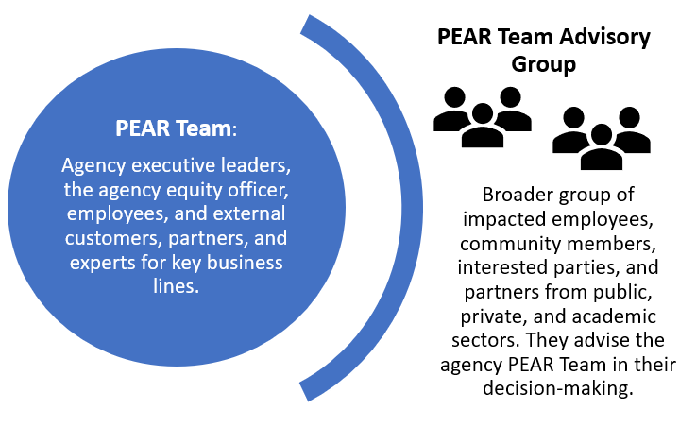
- What support is available to Small Cabinet agencies?
The Office of Equity will provide technical assistance to support the success of each agency. Agency heads lead PEAR Teams and are encouraged to collaborate and find other innovative solutions to maximize resources and ensure success.

