About this Template
The Office of Equity, Diversity, and Inclusion at the Washington State Board for Community and Technical Colleges (SBCTC) has provided this template to support colleges in submitting their diversity, equity, and inclusion (DEI) strategic plans to SBCTC. The use of this template is optional.
Entering information in the format provided below will capture colleges’ alignment of missions and values to their DEI strategic plans; the planning process; and goals, objectives, and success metrics.

1 | DEI STRATEGIC PLAN: overview

A. Overview
SB 5194 requires community and technical colleges (CTCs) to create diversity, equity, and inclusion (DEI) strategic plans. Beginning July 30, 2022 and every two years thereafter, CTCs must submit DEI strategic plans to the State Board for Community and Technical Colleges (SBCTC). SBCTC is available to review draft DEI strategic plans prior to submission.
As noted in the legislation, the inclusive process of developing a DEI strategic plan must include students, faculty, and staff, and colleges are encouraged to utilize findings from their campus climate assessments to inform their DEI strategic plans.
Community and technical colleges received an initial allocation of $125,000 for FY21-22 to support the creation of the DEI strategic plans and other initiatives in SB 5194. Funds must be used in the year received (one-time rollover allowed through FY22-23). Subsequent allocations will be disbursed every year in the amount of $62,500 without rollovers.

2 | DEI STRATEGIC PLAN Template:

A. Equity, Mission, Vision, and Values Statements: Include your college’s mission, vision, and values statements that align with the equity initiatives at your college.

B. Planning Process: Describe the inclusive process for developing the DEI strategic plans to include students, faculty, and staff.

C. DEI Definitions: Include definitions for key terms used within the strategic plan, relevant programs, and related reports.

GOALS, OBJECTIVES, AND SUCCESS METRICs

A. Goal A: Culturally Appropriate Student Outreach Program

B. Goal B: Peer Mentoring Strategies

C. Goal C: Faculty Diversity Program

D. Goal D: DEI Definitions

A. Goal A: Culturally Appropriate Student Outreach Program

Goal A: Objectives

Objective A.1

Objective A.2

Objective A.3

Goal A: Success Metrics

Success Metric A.1

Success Metric A.2

Success Metric A.3

B. Goal B: Peer Mentoring Strategies

Goal B: Objectives

Objective B.1

Objective B.2

Objective B.3

Goal B: Success Metrics

Success Metric B.1

Success Metric B.2

Success Metric B.3

C. Goal C: Faculty Diversity Program

Goal C: Objectives

Objective C.1

Objective C.2

Objective C.3

Goal C: Success Metrics

Success Metric C.1

Success Metric C.2

Success Metric C.3

Additional Initiatives

Goal: Objectives

Objective C.1

Objective C.2

Objective C.3

Goal: Success Metrics

Success Metric C.1

Success Metric C.2

3 | conclusion/next steps

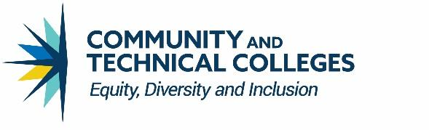
CONTACT INFORMATION
Ha Nguyen, hnguyen@sbctc.edu
Melissa Williams, mwilliams@sbctc.edu

Christina Pleasants, cpleasants@sbctc.edu
Equity, Diversity, and Inclusion Office: edi@sbctc.edu | EDI webpage

