

FA ERP Support

Washington State Board for Community and Technical College

ISIR Jobset Setup

Financial Aid Business Processing Guide

Updated 06/06/2024

**Objective**

A jobset is a set of unique Run Control IDs tied to different processes in PeopleSoft (PS). The jobset tells PS to run the processes in sequential order as the previous process finishes running.

ISIR Jobsets run between 5PM – 5AM for all colleges, and each college will be designated a time slot by FA ERP Support. The ISIR Jobset is a hefty jobset that can significantly slow down the system. The ISIR Jobset includes the following processes:

* Processing loaded ISIRs
* Generation of the Suspense ISIR report
* Population update processes
* Building/updating FA Terms
* Building updating budgets
* Calculating Washington College Grant (WCG) eligibility
* Assigning and waiving Financial Aid checklists
* Assigning and sending Communications

**\*\*PLEASE NOTE\*\***

The first layer of creating a jobset is to create all the Run Control IDs for the different processes that will be included in your ISIR Jobset. As you create your Run Control IDs, **do NOT click Run** but click Save instead.

We recommend you keep a spreadsheet of all the Run Control IDs you create as we move through the guide so when we reach the final layer of setting up your ISIR Jobset, you can copy and paste your Run Control IDs. The Run Control IDs in the jobset cannot have typos or extra spaces so it is important to copy them perfectly.

 

CONTENTS

Run Control ID Naming Convention 3

**Note from Oracle** 3

NEW FTI Record Security Required on Users 3

Create Run Control IDs tied to Processes in ISIR Jobset 4

**FA_INBOUND** – ISIR Inbound 4

**FAPSAR00 – Process ISIRs** 5

**PSQUERY** – ISIR Suspense Query 6

**SFA_FAUNTUPD** (1) – Update FA Progress Units for ABE/AESL 8

**SFA_FAUNTUPD** (2) - Updating FA Progress Units 9

**FAPTRMU1** (2) - Build FA Term in Batch 11

**FAPINCLC** - INAS Batch Calculation (Create a *dummy* Run Control ID) 12

**SCC_POP_UPD** – Update Week of Instructions 13

**CTCFABUD** - Process FA Budgets in Batch 14

SCC_POP_UPD (1) - Set Budget Required Flag to “Y” = “Assign Budget” 14

SCC_POP_UPD (2) - Set Budget Required Flag to “Y” = “Assign Budget” for ALL Terms 15

FAPBDGTD, FAPBDGTS, FAPBDGTF, FAPBDGTM, FAPBDGTD - Budget Equation 16

**CTC_SNG_PRCS**  **-** WCG Pop Update 18

**CTC_SNG_ELG - Populate WCG Eligibility Fields** 19

**SFA_ATB** - Updating Ability to Benefit data in Batch 20

**SFA_SSACCESS** – FA Self-Service Access 21

**SFA_NSLDSUPD** - Update Aggregate Push 22

**CTCHICOM** - BankMobile Checklist and Communication 23

3CENGINE (1) - Assign BankMobile Checklist 23

3CENGINE (2) - Assign BankMobile Communication 25

SCC_COMMGEN - Send BankMobile Communication 28

**CTCFACKL** - FA Checklist Assignments 32

3CENGINE (lots of Run Control IDs needed) – Assign/Waive FA Checklists 32

List of Queries for Mass Assigning 35

List of Queries for Mass Waiving 40

**CTINTLTR** – Initial To-Do Communication & 2nd Request Communication 43

3CENGINE (1) - Assigning Initial Request Communication 43

SCC_COMMGEN (1) - Sending Initial Request Communication 45

3CENGINE (2) - Assigning Second Request Communication – New Checklist Items 49

SCC_COMMGEN (2) - Sending Second Request Communication – New Checklist Items 51

3CENGINE (optional) - Assigning Second Request Communication – Reminder 53

SCC_COMMGEN (optional) - Sending Second Request Communication – Reminder 54

Schedule Jobset Definitions 55

Important Notes Before Proceeding to Setting Up Your Jobset 55

Create an ISIR Jobset 56

Processes and Jobs in ISIR Jobset Type 1 60

Processes and Jobs in ISIR Jobset Type 2 64

Run Control ID for Mass EFC Calculation (only for 2023-2024) 68

ISIR Jobset Timeslots 70

# 

# Run Control ID Naming Convention

It is important that no user in ctcLink have the same Run Control ID so we have made the following Run Control ID naming convention.

|  |  |  |  |
| --- | --- | --- | --- |
| **Institution** | **Even/Odd Year** | **Description** | **User Initials** |
| WA### | EY or OY | ISIR_LOAD | AB |
| WA### | EY or OY | ASSIGN_ESF010 | AB |
| WA### | EY or OY | WAIVE_ESF010 | AB |
| WA### | EY or OY | SEND_LC9 | AB |

Example: WA172_EY_ISIR_LOAD_DE

Note: Run Control IDs cannot be deleted so be careful not to make any typos!

**Note from Oracle**

**Important!**It is recommended to use alphanumeric characters when possible since some special characters may cause conflicts with some products. Do not use the forward slash (*/*) for running COBOL processes.

# NEW FTI Record Security Required on Users

2024-2025 ISIRs come with [Federal Tax Information (FTI) data that is protected by the confidentiality provisions of Internal Revenue Code section 6103](https://fsapartners.ed.gov/knowledge-center/library/electronic-announcements/2023-05-12/access-and-use-federal-tax-information-fti-federal-student-aid-programs-beginning-2024-25-fafsa-processing-cycle-updated-april-18-2024). FA records containing FTI data in PS have been secured and only those with **ZD_DS_QRY_FA_FTI_HIGH_SENS** query permission role can access queries that have FTI data in them.

Users who are running an ISIR Jobset or will be setting one up will need **ZD_DS_QRY_FA_FTI_HIGH_SENS** added to their EMPLID since the following two waive checklist queries look at IRS Response code values which is considered FTI data.

[CTC_FA_SB_WV_025](javascript:__doPostBack('ctl00$MainContent$lvQuerySearchResults$ctrl9$lnkQueryName','')) *Waive Parent Tax Transcript Needed*

Parent IRS Response Code and/or Other Parent IRS Response Code field is 200 (Successful Request)

[CTC_FA_SB_WV_027](javascript:__doPostBack('ctl00$MainContent$lvQuerySearchResults$ctrl10$lnkQueryName','')) *Waive Student Tax Transcript Needed*

Student IRS Response Code and/or Spouse IRS Response Code field is 200 (Successful Request)

# Create Run Control IDs tied to Processes in ISIR Jobset

**FA_INBOUND** – ISIR Inbound

|  |  |
| --- | --- |
| **Navigation** | **Description** |
| Financial Aid > File Management > Import Federal Data Files | The process looks at the text file that was uploaded onto the PS server and loads the ISIR files onto the ISIR staging tables. |

The [FA Business Flow Guide](https://ctclinkreferencecenter.ctclink.us/m/92436/l/794730-9-2-fa-business-flow)’s *‘Importing and Processing ISIR Files’ explains in detail the process of loading files onto the server.*

1. Load individual ISIR files onto the server
2. List each ISIR file path on the text file (i.e. *ISIR_Upload_2025.txt*) in the order you want the system to process the files
3. Load the text file onto the server
4. Enter New or use existing Run Control ID
5. Choose ‘**File List**’ radio button
6. Insert **Inbound File** name

/CSTRANSFER/WA###/ISIR20XX/(text file name)

* + 1. ### your college destination like 172, 010, etc.
    2. XX is aid year

Example: /CSTRANSFER/WA123/ISIR2025/ISIR_Upload_2025.txt

*The file name is case sensitive so if your text file is called **ISIR_Upload_2025.txt**, you can’t put **ISIR_UPLOAD_2025.txt** and expect PS to find and process it.

1. Insert **ISIR TG Number**

1. Click **Save** and copy your Run Control ID on the spreadsheet noting it is tied to the FA_INBOUND process.

**FAPSAR00 – Process ISIRs**

|  |  |
| --- | --- |
| **Navigation** | **Description** |
| Financial Aid > File Management > ISIR Import > Process ISIRs | Load the ISIR records from the ISIR staging tables into the database using the rules that you set up in the ISIR Data Load Parms page. |

1. Enter New or use existing Run Control ID
2. Select **Aid Year**
3. Select **Institution**
4. Enter **TG Number**
5. Check ‘**Active**’ ‘**Load ISIRs**’ ‘**Load System Generated ISIRs**’ ‘**Load ISIR Corrections**’ boxes

1. Click **Save** and copy your Run Control ID on the spreadsheet noting it is tied to the FAPSAR00 process.

**PSQUERY** – ISIR Suspense Query

|  |  |
| --- | --- |
| **Navigation** | **Description** |
| Reporting Tools > Query > Schedule Query | This query is designed to show suspended ISIRs from the most recent load processes.  Due to the large amount of data that could potentially be returned, you will need to use Schedule Query. |

1. Enter New or use existing Run Control ID
2. Enter the following query name then click **Search**:

**CTC_FA_SUSPEND_ISIR_DETAIL**

1. Select the blue link for the desired query

1. Fill in the following Edit Prompts then select **OK**:

* **Institution**
* **Aid Year**

1. Click **Save** and copy your Run Control ID on the spreadsheet noting it is tied to the PSQUERY process.

**SFA_FAUNTUPD** (1) – Update FA Progress Units for ABE/AESL

|  |  |
| --- | --- |
| **Navigation** | **Description** |
| Financial Aid > Financial Aid Term > Update FA Progress Units | This process is used to update FA Progress Units to zero on the student enrollment page. This process captures ABE/AESL classes (indicated by CIP code starting with ‘32’) for the prompted term. |

1. Enter New or Existing Run Control ID
2. Under *Population Selection*, select the following:

**Selection Tool**: PS Query

**Query Name**: CTC_FA_ZEROFAUNITS

1. Enter the following Edit Prompts:

* **Institution**
* **Term** (This value will need to be updated by the start of each term)

1. Select **Preview Selection Results** to ensure students are being selected
2. Under *Parameters*,enter ‘**0.00**’ for **FA Progress Units**

1. Click **Save** and copy your Run Control ID on the spreadsheet noting it is tied to the first SFA_FAUNTUPD process.

**SFA_FAUNTUPD** (2) - Updating FA Progress Units

|  |  |
| --- | --- |
| **Navigation** | **Description** |
| Financial Aid > Financial Aid Term > Update FA Progress Units | This process is used to update FA Progress Units on the student enrollment page to zero. This process captures students who have dropped and have received a “W” grade or received a grade that indicates non completion of a course (i.e: F, 0.0, Z) for the prompted term. |

1. Enter New or Existing Run Control ID
2. Under *Population Selection*, select the following:

**Selection Tool**: PS Query

**Query Name**: CTC_FA_REMOVE_PRGRSS_UNITS

1. Enter the following Edit Prompts:

* **Institution**
* **Term** (This value will need to be updated by the start of each term)

1. Select **Preview Selection Results** to ensure students are being selected
2. Under *Parameters*,enter ‘**0.00**’ for **FA Progress Units**

1. Click **Save** and copy your Run Control ID on the spreadsheet noting it is tied to the second SFA_FAUNTUPD process.

**FAPTRMU1** (1)- Create FA Term Driver Records

|  |  |
| --- | --- |
| **Navigation** | **Description** |
| Financial Aid > Financial Aid Term > Create FA Term Driver Records | Creates FA Term driver records for the batch Financial Aid Term build process |

1. Enter New or use existing Run Control ID
2. Populate **Academic Institution** and **Aid Year** fields
3. For the *Driver Creation Option* field, select ‘**Both Updates and Projections’**
4. Under *Select Careers to Process*, verify that the **Select Career** and **Rebuild Projections** check boxes are selected for the ‘**UGRD**’ career

1. Click **Save** and copy your Run Control ID on the spreadsheet noting it is tied to the first FAPTRUMU1 process.

**FAPTRMU1** (2) - Build FA Term in Batch

|  |  |
| --- | --- |
| **Navigation** | **Description** |
| Financial Aid > Financial Aid Term > Build FA Term in Batch | Creates Financial Aid Terms in batch. |

1. Enter New or use existing Run Control ID
2. Populate **Academic Institution** and **Aid Year** fields
3. **Commit Level** will be ‘**500**’ and **Driver Creation** option will be ‘**Both Update and Projections’**
4. Leave Print Detailed Messages **un**checked

1. Click **Save** and copy your Run Control ID on the spreadsheet noting it is tied to the second FAPTRUMU1 process.

**FAPINCLC** - INAS Batch Calculation (Create a *dummy* Run Control ID)

|  |  |
| --- | --- |
| **Navigation** | **Description** |
| Financial Aid > File Management > INAS Batch Calculation | Calculates INAS in batch. |

As of the 2023-2024 Aid Year, the *INAS Batch Calculation* process was eliminated. However, deleting the process from ISIR Jobset shells can lead to errors and the field cannot be left blank. Therefore, leave the existing Run Control ID as is with 2023 parameters and keep it in your ISIR Jobset.

1. Enter New or use existing Run Control ID
2. Populate **Institution** and **2023**
3. Select ‘**F**’ (Federal) for **Application Type**
4. Select ‘**Y**’ (Yes) for **Clear Calc Requests?**

1. Click **Save** and copy your Run Control ID on the spreadsheet noting it is tied to the second FAPINCLC process.

**SCC_POP_UPD** – Update Week of Instructions

|  |  |
| --- | --- |
| **Navigation** | **Description** |
| Set up SACR > System Administration > Utilities > Population Update > Population Update Process | Updates the Weeks of Instruction on FA Term. |

1. Enter New or use existing Run Control ID
2. Select **STDNT_FA_TERM** **– Student FA Term from the Record** for **Record (Table) Name** from the dropdown menu
3. Select the **Report Error Messages** radio button
4. Select **PS Query** from the **Selection Tool** dropdown menu
5. For **Query Name**, enter or look up and select **CTC_FA_SB_FIX_TERM_WEEKS_INSTR**
6. Select **Edit Prompts** and populate **Institution** and **Aid Year**
7. For **Field Name**, select ‘**Weeks of Instruction**’ from the dropdown menu
8. For **Field Value**, enter ‘**12**’

1. Click **Save** and copy your Run Control ID on the spreadsheet noting it is tied to the SCC_POP_UPD process.

**CTCFABUD** - Process FA Budgets in Batch

### SCC_POP_UPD (1) - Set Budget Required Flag to “Y” = “Assign Budget”

|  |  |
| --- | --- |
| **Navigation** | **Description** |
| Set up SACR > System Administration > Utilities > Population Update > Population Update Process | On students who have a new ISIR loaded and their processing status is not *Ready for Packaging*, *Repackage or Packaging Completed,* flags FA Term for a budget update. |

1. Enter New or use existing Run Control ID
2. Select **STDNT_FA_TERM** **– Student FA Term from the Record** for **Record (Table) Name** from the dropdown menu
3. Select the **Report Error Messages** radio button
4. Select **PS Query** from the **Selection Tool** dropdown menu
5. For **Query Name**, enter or look up and select **CTC_FA_SETBUDFLAG_Y**
6. Select **Edit Prompts** and populate **Institution** and **Aid Year**
7. For **Field Name**, select ‘**Budget Required**’ from the dropdown menu
8. For **Field Value**, select ‘**Yes-Budget Assign Required**’ from the dropdown menu

1. Click **Save** and copy your Run Control ID on the spreadsheet noting it is tied to the first SCC_POP_UPD process for CTCFABUD job.

### SCC_POP_UPD (2) - Set Budget Required Flag to “Y” = “Assign Budget” for ALL Terms

|  |  |
| --- | --- |
| **Navigation** | **Description** |
| Set up SACR > System Administration > Utilities > Population Update > Population Update Process | Selects students who have been flagged for a budget update and sets the budget update flag on all active terms for the prompted aid year. |

1. Enter New or use existing Run Control ID
2. Select **STDNT_FA_TERM** **– Student FA Term from the Record** for **Record (Table) Name** from the dropdown menu
3. Select the **Report Error Messages** radio button
4. Select **PS Query** from the **Selection Tool** dropdown menu
5. For **Query Name**, enter or look up and select **CTC_FA_BUDFLAG_Y_ALLTERMS**
6. Select **Edit Prompts** and populate **Institution** and **Aid Year**
7. For **Field Name**, select ‘**Budget Required**’ from the dropdown menu
8. For **Field Value**, select ‘**Yes-Budget Assign Required**’ from the dropdown menu

1. Click **Save** and copy your Run Control ID on the spreadsheet noting it is tied to the second SCC_POP_UPD process for CTCFABUD job.

### FAPBDGTD, FAPBDGTS, FAPBDGTF, FAPBDGTM, FAPBDGTD - Budget Equation

|  |  |
| --- | --- |
| **Navigation** | **Description** |
| Set up SACR > Common Definitions > Equation Engine > Run Equation | Processes the rules and equations built to construct student budgets. |

1. Enter New or use existing Run Control ID
2. For **Equation**, copy and paste **CTCFABUDYEAR** (Assign Budget Process Aid Year)

1. Under Input Parameters populate fields with the following information:

* **Global** field: **AID_YEAR** (Be careful of typos)
* **Type** field: **String** (*Note – The Operand field will not appear until the Type field is populated)
* **Operand** field: **(aid year i.e. 2025)**

1. Insert a new row by selecting (+)
2. Enter the following data:

* **Global** field: **INSTITUTION** (be careful of typos)
* **Type** field: String (*Note – The Operand field will not appear until the Type field is populated)
* **Operand** field: **(institution ID i.e. WA123)**

1. Click **Save** and copy your Run Control ID on the spreadsheet noting it is tied to the FAPBDGTS, FAPBDGTF, FAPBDGTM, FAPBDGTD processes for CTCFABUD job. This one Run Control ID will be used for multiple processes.

**Please note –** The Run Equations process will auto-populate the budget pages with the necessary data required for processing. Users will need to use the same Run Control ID created from Run Equations page for each budget process.

**CTC_SNG_PRCS**  **-** WCG Pop Update

|  |  |
| --- | --- |
| **Navigation** | **Description** |
| Financial Aid > CTC Custom > CTC Interfaces > WA College Grant > WCG Population/Update | Selects students who have a valid ISIR for the Aid Year, active FA Term(s), and budgets assigned. The process loads all applicable data into the WCG Eligibility table |

1. Enter a New or Existing Run Control ID
2. For **Selection Tool**, select **PS Query**
3. For **Query Name**, enter **CTC_FA_SNG_POPULATE** or find and select it with the lookup tool
4. Select **Edit Prompts** and populate the following:

* **Institution**
* **Aid Year**

1. Under the *Parameters* section, populate **Academic Institution** and **Aid Year**
2. Select **Preview Selection Results** to see the student list populate

**\*Disclaimer\***

Students are REQUIRED to have FA Term and Budgets built in order for them to be picked up in this process.

1. Click **Save** and copy your Run Control ID on the spreadsheet noting it is tied to the CTC_SNG_PRCS process.

**CTC_SNG_ELG - Populate WCG Eligibility Fields**

|  |  |
| --- | --- |
| **Navigation** | **Description** |
| Financial Aid > CTC Custom > CTC Interfaces > WA College Grant > Calculate WCG Eligibility | Calculates and populates eligibility fields for students who were loaded into the WCG Eligibility table during the population/update process. |

1. Enter a New or Existing Run Control ID
2. For **Selection Tool**, select **PS Query**
3. For **Query Name**, enter **CTC_FA_SNG_ELIGIBILITY** or find and select it with the lookup tool
4. Select **Edit Prompts** and populate the following:

* **Institution**
* **Aid Year**

1. Under the *Parameters* section, populate **Academic Institution** and **Aid Year**
2. Select **Preview Selection Results** to see the student list populate
3. Select **Save** and copy your Run Control ID on the spreadsheet noting it is tied to the CTC_SNG_ELG process.

**SFA_ATB** - Updating Ability to Benefit data in Batch

|  |  |
| --- | --- |
| **Navigation** | **Description** |
| Financial Aid > Ability to Benefit > Create Ability to Benefit | Creates Ability to Benefit data in batch. |

1. Enter New or use existing Run Control ID
2. For **Selection Tool**, select **PS Query**
3. For **Query Name**, enter **CTC_FA_SB_PS_ATB** or find and select it with the lookup tool
4. Select **Edit Prompts** and populate the following:

* **Institution**
* **Aid Year**

1. Select Preview Selection and to see the student list populate
2. Under *Default Values*, populate the **Institution** field

**\*Explanation of Default Values section\***

There are several fields that can be completed under the *Default Values* section, but **Institution** is the only field we recommend completing.

If you were to complete the *Aid Year* field, the ATB page will only apply to that one aid year.

By leaving fields like *Student Eligibility* Code blank, it allows the batch process to populate info from the student’s ISIR.

1. Select **Save** and copy your Run Control ID on the spreadsheet noting it is tied to the SFA_ATB process.

**SFA_SSACCESS** – FA Self-Service Access

|  |  |
| --- | --- |
| **Navigation** | **Description** |
| Main Menu > Financial Aid > Awards > Self Service Awarding > Assign Self Service Access | Assigns FA Self Service Access in batch. |

1. Enter New or use existing Run Control ID
2. For **Award Access**, select one of the following options:
   1. **Allow Access** – to allow the student access to award acknowledgement for the selected aid year regardless of filtering option criteria established in self-service awarding options setup
   2. **Deny Access** - to deny the student access to award acknowledgment for the selected aid year regardless of filtering option criteria established in self-service awarding options setup
   3. **Use Filter Options** - to require the student to meet the self-service awarding options access criteria to gain access to an award acknowledgment in self-service awarding

**Note:** Your Filter Options can be found on the Self Service Options page.

Set Up SACR > Common Definitions > Self Service > Financial Aid > Self Service Options

1. Populate **Institution** and **Aid Year**
2. Select **All IDs** **or** **ID Range** radio button
3. For **Inquiry Access,** select **Yes** (allow students to view their financial aid awards)
4. For **EA Access**, select **No** (don’t allow students to self-report aid through Self Service since the feature does not notify staff when a student submits information and stages data into the External Awards table)

1. Select **Save** and copy your Run Control ID on the spreadsheet noting it is tied to the SFA_SSACCESS process.

**SFA_NSLDSUPD** - Update Aggregate Push

|  |  |
| --- | --- |
| **Navigation** | **Description** |
| Financial Aid > File Management > NSLDS > Update Aggregates with NSLDS | Updates NSLDS Aggregate tables with incoming data. |

1. Enter New or use existing Run Control ID
2. Populate **Institution** and **Aid Year**
3. For Report Parameters, select the “Update NSLDS Data” radio button and click the Preserve Override checkbox if applicable **\*\*SEE NOTE**

**Preserve Override Check box:**

Update does not take place if the NSLDS Total amount has been overridden at the student level.

1. For Population Selection select the following:

* **Selection Tool**: **PS Query**
* **Query Name**: **CTC_FA_SB_PS_NSLDS_WEEKLY_PUSH**

1. Select **Edit Prompts** and populate **Institution** and **Aid Year**
2. Select **Preview Selection** to review students

1. Select **Save** and copy your Run Control ID on the spreadsheet noting it is tied to the SFA_NSLDSUP process.

**CTCHICOM** - BankMobile Checklist and Communication

### 3CENGINE (1) - Assign BankMobile Checklist

|  |  |
| --- | --- |
| **Navigation** | **Description** |
| Campus Community > 3C Engine > Run 3C Engine | Assigns BankMobile checklist to students for Student Financials’ BankMobile BioDemo Process. |

1. Enter New or use existing Run Control ID
2. Select the **Population Selection** check box
3. Under *Event Selection* populate the following fields:

* **Academic Institution**
* **Administrative Function**: **GEN**
* **Event ID** (*Note: this is institution specific) – Select the Event ID value that ends with an “I” (Student Financials will be completing the checklist during their process)

1. Under **Population Selection**, choose **PS Query** from the dropdown menu
2. Choose one of the three Higher One query options for the **Query Name** field and enter **Edit Prompts**:
   1. **CTC_FA_HIGHER_ONE_SELECT_1** (Selects students that have their Institutional Review Status Completed) – *If selected, run before Packaging*
   2. **CTC_FA_HIGHER_ONE_SELECT_2** (Selects students that have a specific checklist item marked completed. Example: Institutional Form) – *If selected, run after Budget Assignment*
   3. **CTC_FA_HIGHER_ONE_SELECT_3** (Selects students that have at least one FA Item Type in an offered or accepted status) – *If selected, run after Awarding*

1. Click on *Manage Duplicate Assignment* tab and make sure **Checklist Duplicate Checklist** box is checked

1. Select **Save** and copy your Run Control ID on the spreadsheet noting it is tied to the first 3CENGINE process for CTCHICOM job.

### 3CENGINE (2) - Assign BankMobile Communication

|  |  |
| --- | --- |
| **Navigation** | **Description** |
| Campus Community > 3C Engine > Run 3C Engine | Assigns BankMobile Communication to students with a BankMobile checklist in Initiated status. |

1. Enter New or use existing Run Control ID
2. Select the **Population Selection** check box
3. Under *Event Selection* populate the following fields:

* **Academic Institution**
* **Administrative Function**: **GEN**
* **Event ID**: **BankMobile Intro Letter** (*Note: this is institution specific)

1. Under **Population Selection**, choose **PS Query** from the dropdown menu
2. For **Query Name**, enter **CTC_FA_HIGHERONE_COMM_ASSIGN** or use the lookup tool
3. Enter the following **Edit Prompts**:

* **Institution**
* **Checklist**: **Exx042** (Bank Mobile Biographic Extract) – i.e. ECC042, ESF042

1. Select **Preview Selection Results** to see list of students
2. Click on *Manage Duplicate Assignment* tab and make sure **Check Duplicate Communication** box is checked

1. Select **Save** and copy your Run Control ID on the spreadsheet noting it is tied to the second 3CENGINE process for CTCHICOM job.

### SCC_COMMGEN - Send BankMobile Communication

|  |  |
| --- | --- |
| **Navigation** | **Description** |
| Campus Community > Communications > Communication Generation | Sends out BankMobile Communication. |

To select your BankMobile *Letter Code*, at least one student must be assigned that Letter Code and be in the queue to send out.Run **CTC_FA_INCOMP_COMM_STDNT_LIST** to confirm there is at least one student in the queue.

If there is no one in the queue, assign the Letter Code on yourself or a test ID

1. Navigate to Campus Community > Communications > Communication Management
2. Enter the desired EMPLID then add the communication on the EMPLID
   1. **Function:** GEN
   2. **Institution:** your institution
   3. **Category:** FAGEN
   4. **Context:** FAGEN
   5. **Method:** E
   6. **Direction:** Outgoing Communication
   7. **Letter Code**: your BankMobile Letter Code
3. Select Save
4. Enter New or use existing Run Control ID

Selection Parameters

1. For **ID Selection,** select **All Person IDs**
2. For **Letter Code,** select your institution’s **Bank Mobile** letter
3. Under *Communication Method Usage,* select **Email** for **Method**

Process Parameters

1. Under *Person Communication Usage,* select the following:

* **Address**: **FA Email and Postal Address**
* **Address** **Name**: **FA Student Name**
* **Salutation**: **FA Student Name**
* **Extra Name**: **FA Student Name**
* If applicable, click the **Use Preferred Email Address** checkbox

1. Under *Communication Date Range Selection*, complete the following:

* **From Date**: (Keep the date that auto populated or select a different date)
* **To Date**: (Select a future date several years out)

1. Under Output Settings, select ‘**All Alphabetically by ID Type**’ for **Sort Option**

Email Parameters

1. Under *Email Parameters*, complete the following fields:

* **From**: (Enter the desired email address used by the institution)
* **Subject**: (Enter subject of email)
* **Reply to**: (Enter the desired email address used by the institution)
* **Sender**: (Enter the desired email address used by the institution)
* **Bounce to**: (Enter the desired email address used by the institution)

1. Select **Save** and copy your Run Control ID on the spreadsheet noting it is tied to the second SCC_COMMGEN process for CTCHICOM job.

**CTCFACKL** - FA Checklist Assignments

### 3CENGINE (lots of Run Control IDs needed) – Assign/Waive FA Checklists

|  |  |
| --- | --- |
| **Navigation** | **Description** |
| Campus Community > 3C Engine > Run 3C Engine | Mass assigns and waives FA checklists |

1. Enter New or use existing Run Control ID
2. Select the **Population Selection** check box
3. Under *Event Selection* populate the following fields:

* **Academic Institution**
* **Administrative Function**: **FINA**
* **Event ID:** **Look up by entering “%” and “last 3 digits” of checklist code that is being assigned** (*Note: this is institution specific)
  + Event IDs that end with **‘I’** is for adding checklist in Initiated status
  + Event IDs that end with ‘**W’** is for updating checklists to Waived status

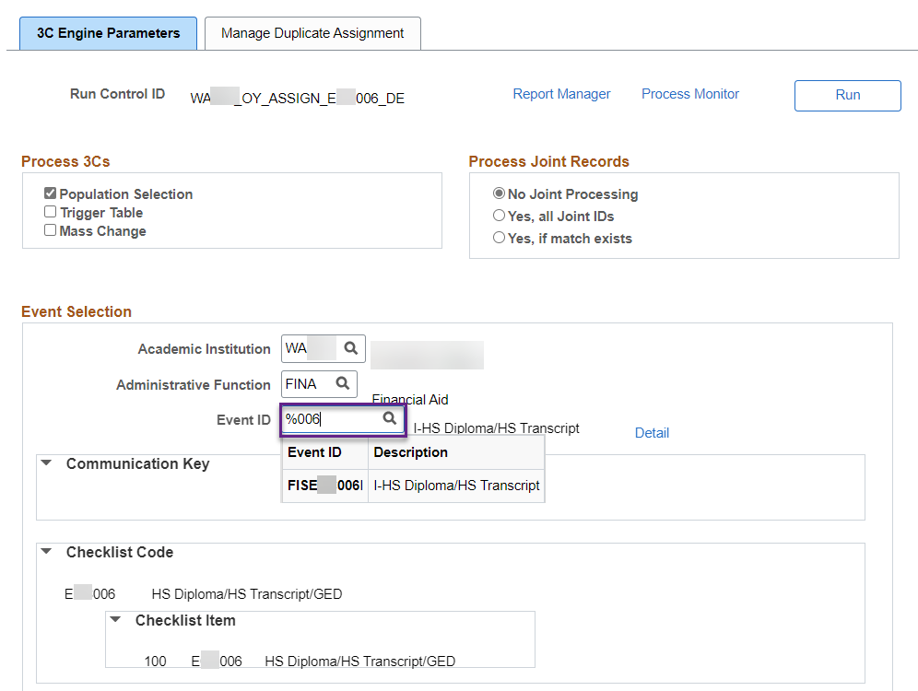

1. Under **Population Selection**, choose **PS Query** from the dropdown menu
2. For **Query Name**, enter **the query name associated with assign/waive of the checklist** or use the lookup tool to find and select it. **The following lists are in this guide after this section: **List of *Queries for Mass Assigning*** and ***List of Queries for Mass Waiving***
3. Enter the following **Edit Prompts**:

* **Institution**
* **Aid Year**
* **Checklist**: **Exx006** (HS Diploma/HS Transcript/GED) – i.e. ECC000, ESF000

1. Select **Preview Selection Results** to see list of students

1. Click on *Manage Duplicate Assignment* tab and make sure **Check Duplicate Checklist** box is
2. Under *Additional Conditions to Prevent Duplicate Checklist*, change the **Variable Data** to ‘Match’ if applicable

**Variable Data of ‘Match’** looks to see if the student already has the checklist assigned for the aid year (for FINA checklist) or term (for FINT checklists) and determines assignment

**Leaving the Variable Data blank** looks to see if the student already has the checklist assigned ever in their student records and determines assignment

1. Select **Save** and copy your Run Control ID on the spreadsheet noting it is tied to the CTCFACKL job.

**Repeat the steps for all the checklist you want to mass assign/waive.**

### List of Queries for Mass Assigning

|  |  |  |  |
| --- | --- | --- | --- |
| **Query Name** | **2024 Criteria** | **2025 Criteria** | **Notes** |
| [CTC_FA_SB_AD_000](javascript:__doPostBack('ctl00$MainContent$lvQuerySearchResults$ctrl0$lnkQueryName','')) No DOB Match | SAR C Code: 063 | No longer a C-flag. Changed to Reject. | Remove from 2025 ISIR Jobset. |
| [CTC_FA_SB_AD_006](javascript:__doPostBack('ctl00$MainContent$lvQuerySearchResults$ctrl1$lnkQueryName','')) No HS Diploma or GED | HS Diploma or Equivalent field on ISIR is not 1 (HS Diploma) or 2 GED) | Same as 2024 | N/A |
| [CTC_FA_SB_AD_006_NO_HOMESCHOOL](javascript:__doPostBack('ctl00$MainContent$lvQuerySearchResults$ctrl2$lnkQueryName','')) No HS Diploma, GED or Home Schooled | HS Diploma or Equivalent field on ISIR is not 1 (HS Diploma), 2 GED) or 3 (Home Schooled) | Same as 2024 | N/A |
| QCS_FA_SB_AD_006_MISMATCH  No HS Diploma, GED or Home Schooled or Mismatch w/ Ext Ed | HS Diploma or Equivalent field on ISIR is either not 1 (HS Diploma), 2 GED), 3 (Home Schooled) OR they indicated 1,2,3 but there is a mismatch on External Education record | Same as 2024 | N/A |
| [CTC_FA_SB_AD_007](javascript:__doPostBack('ctl00$MainContent$lvQuerySearchResults$ctrl3$lnkQueryName','')) ISIR is Official | ISIR is official | Same as 2024 | N/A |
| [CTC_FA_SB_AD_008](javascript:__doPostBack('ctl00$MainContent$lvQuerySearchResults$ctrl4$lnkQueryName','')) Defaulted Loan | SAR C Codes: 124, 132, 134, 135, 136 | SAR C Codes: 163, 165, 216, 217, 327 | Query has been modified and can be used for 2025 and on. |
| [CTC_FA_SB_AD_009](javascript:__doPostBack('ctl00$MainContent$lvQuerySearchResults$ctrl5$lnkQueryName','')) Emancipated Minor | Emancipated Minor field answer is Yes | Same as 2024 | N/A |
| [CTC_FA_SB_AD_010](javascript:__doPostBack('ctl00$MainContent$lvQuerySearchResults$ctrl6$lnkQueryName','')) Rejected ISIR | ISIR status is Rejected | Same as 2024 | N/A |
| [CTC_FA_SB_AD_011](javascript:__doPostBack('ctl00$MainContent$lvQuerySearchResults$ctrl7$lnkQueryName','')) Federal Overpayment | SAR C Code: 133 | SAR C Code: 164 | Query has been modified and can be used for 2025 and on. |
| [CTC_FA_SB_AD_015](javascript:__doPostBack('ctl00$MainContent$lvQuerySearchResults$ctrl8$lnkQueryName','')) Orphan or Ward of the Court/Foster Care | Orphan or Ward of the Court/Foster Care field answer is 1 (Yes) | Parent Deceased or Ward of Court or In Foster Care equal to 1 (Yes) | N/A |
| [CTC_FA_SB_AD_016](javascript:__doPostBack('ctl00$MainContent$lvQuerySearchResults$ctrl9$lnkQueryName','')) Homeless Youth | Answered yes on one of the following fields: Youth determd by SDL Youth determd by HUD At Risk of Homelessness | SAR C Code: 325 is an additional indicator | Query has been modified and can be used for 2025 and on. |
| [CTC_FA_SB_AD_018](javascript:__doPostBack('ctl00$MainContent$lvQuerySearchResults$ctrl10$lnkQueryName','')) Legal Guardianship | Legal Guardianship field answer is Yes | Same as 2024 | N/A |
| [~~CTC_FA_SB_AD_019~~](javascript:__doPostBack('ctl00$MainContent$lvQuerySearchResults$ctrl11$lnkQueryName','')) ~~Selective Service~~ | ~~No longer used~~ | ~~Same as 2024~~ | ~~N/A~~ |
| [CTC_FA_SB_AD_020](javascript:__doPostBack('ctl00$MainContent$lvQuerySearchResults$ctrl12$lnkQueryName','')) Prove US Citizenship | SAR C Code: 146 | SAR C Code: 018 | Query has been modified and can be used for 2025 and on. |
| [CTC_FA_SB_AD_021](javascript:__doPostBack('ctl00$MainContent$lvQuerySearchResults$ctrl13$lnkQueryName','')) Prove VA Status | SAR C Codes: 162, 173, 180 | SAR C Codes: 158, 159, 160 | Query has been modified and can be used for 2025 and on. |
| [CTC_FA_SB_AD_024](javascript:__doPostBack('ctl00$MainContent$lvQuerySearchResults$ctrl14$lnkQueryName','')) SSN Name Mismatch | SAR C Code: 064 | No longer a C-flag. Changed to Reject. | Remove from 2025 ISIR Jobset. |
| [CTC_FA_SB_AD_025](javascript:__doPostBack('ctl00$MainContent$lvQuerySearchResults$ctrl15$lnkQueryName','')) Parent Tax Transcript Needed | Parent Tax Return Filed status field is 1 (Filed/Completed) or 2 (Will File), student is dependent, and selected for V1 or V5 | Parent Filed 1040/1040NR or Parent Filed Joint Return or Other Filed 1040/1040NR is 1 (Yes), student is dependent, and selected for V1 or V5 | Query has been modified and can be used for 2025 and on. |
| [CTC_FA_SB_AD_027](javascript:__doPostBack('ctl00$MainContent$lvQuerySearchResults$ctrl17$lnkQueryName','')) Student Tax Transcript Needed | Tax Return Filed status field is 1 (Filed/Completed) or 2 (Will File), student is dependent, independent or PJ Ind, and selected for V1 or V5 | Filed 1040/1040NR or Filed Joint Return or Spouse Filed 1040/1040NR is 1 (Yes), student is independent, and selected for V1 or V5 | Query has been modified and can be used for 2025 and on. |
| [CTC_FA_SB_AD_034](javascript:__doPostBack('ctl00$MainContent$lvQuerySearchResults$ctrl18$lnkQueryName','')) Proof of Non-Filing Tax (Ind Student) | Tax Return Filed status field is 3 (Will Not File), student is independent or PJ Ind, and selected for V1 or V5 | Filed 1040/1040NR or Filed Joint Return or Spouse Filed 1040/1040NR is equal to 2 (No), student is independent or PJ Ind, and selected for V1 or V5 | Query has been modified and can be used for 2025 and on. |
| [CTC_FA_SB_AD_036](javascript:__doPostBack('ctl00$MainContent$lvQuerySearchResults$ctrl19$lnkQueryName','')) Apply/Update Admissions | Official ISIR and UGRD Acad Program Status is not AC (Active), AD (Admitted), AP (Applicant) or PM (Prematirculant) | Same as 2024 | N/A |
| [CTC_FA_SB_AD_038](javascript:__doPostBack('ctl00$MainContent$lvQuerySearchResults$ctrl20$lnkQueryName','')) ISIR vs Bio Demo Mismatch | Active UGRD applicants with mismatches between ISIR and Student Records for:  Citizenship status, first four of last name, first two of first name or DOB | Same as 2024 | N/A |
| [CTC_FA_SB_AD_047](javascript:__doPostBack('ctl00$MainContent$lvQuerySearchResults$ctrl22$lnkQueryName','')) Discharged Loan | SAR C Codes: 115, 137, 247, 282 | SAR C Codes: 218, 219, 251, 259 | Query has been modified and can be used for 2025 and on. |
| [CTC_FA_SB_AD_048](javascript:__doPostBack('ctl00$MainContent$lvQuerySearchResults$ctrl23$lnkQueryName','')) Loan Bankruptcy | SAR C Code: 116 | SAR C Code: 252 | Query has been modified and can be used for 2025 and on. |
| [CTC_FA_SB_AD_049](javascript:__doPostBack('ctl00$MainContent$lvQuerySearchResults$ctrl24$lnkQueryName','')) NSLDS No Match | SAR C Code: 138 | SAR C Code: 162 | Query has been modified and can be used for 2025 and on. |
| [CTC_FA_SB_AD_050](javascript:__doPostBack('ctl00$MainContent$lvQuerySearchResults$ctrl25$lnkQueryName','')) Exceed Loan Limits | SAR C Codes: 254, 255, 256, 260, 392, 393 | SAR C Codes: 253, 255, 256, 258, 260, 261 | Query has been modified and can be used for 2025 and on. |
| [CTC_FA_SB_AD_051](javascript:__doPostBack('ctl00$MainContent$lvQuerySearchResults$ctrl26$lnkQueryName','')) Reaching Pell LEU | SAR C Codes: 346, 347 | SAR C Codes: 263, 264, 265 | Query has been modified and can be used for 2025 and on. |
| [CTC_FA_SB_AD_052](javascript:__doPostBack('ctl00$MainContent$lvQuerySearchResults$ctrl27$lnkQueryName','')) Unusual Enrollment History | SAR C Codes: 359, 360 | SAR C Codes: 276, 277 | Query has been modified and can be used for 2025 and on. |
| [CTC_FA_SB_AD_053](javascript:__doPostBack('ctl00$MainContent$lvQuerySearchResults$ctrl28$lnkQueryName','')) FSEOG Overpayment | SAR C Codes: 010, 065, 066, 067, 077, 079 | SAR C Codes: 227, 228, 229, 230, 231, 232 | Query has been modified and can be used for 2025 and on. |
| [CTC_FA_SB_AD_054](javascript:__doPostBack('ctl00$MainContent$lvQuerySearchResults$ctrl29$lnkQueryName','')) Pell Overpayment | SAR C Codes: 020, 038, 039, 041, 042, 043 | SAR C Codes: 221, 222, 223, 224, 225, 226 | Query has been modified and can be used for 2025 and on. |
| [CTC_FA_SB_AD_055](javascript:__doPostBack('ctl00$MainContent$lvQuerySearchResults$ctrl30$lnkQueryName','')) Perkins Overpayment | SAR C Codes: 088, 090, 100, 101, 102, 107 | SAR C Codes: 233, 234, 235, 236, 237, 238 | Query has been modified and can be used for 2025 and on. |
| [~~CTC_FA_SB_AD_056~~](javascript:__doPostBack('ctl00$MainContent$lvQuerySearchResults$ctrl31$lnkQueryName','')) ~~ACG Overpayment~~ | ~~No longer used~~ | ~~Same as 2024~~ | ~~N/A~~ |
| [CTC_FA_SB_AD_057](javascript:__doPostBack('ctl00$MainContent$lvQuerySearchResults$ctrl32$lnkQueryName','')) ~~SMART Overpayment~~ | ~~No longer used~~ | ~~Same as 2024~~ | ~~N/A~~ |
| [CTC_FA_SB_AD_058](javascript:__doPostBack('ctl00$MainContent$lvQuerySearchResults$ctrl33$lnkQueryName','')) TEACH Overpayment | SAR C Codes: 289, 290, 291, 292, 293, 294 | SAR C Codes: 239, 240, 241, 242, 243, 244 | Query has been modified and can be used for 2025 and on. |
| [CTC_FA_SB_AD_059](javascript:__doPostBack('ctl00$MainContent$lvQuerySearchResults$ctrl34$lnkQueryName','')) IASG Overpayment | SAR C Codes: 309, 310, 311, 312, 313, 314 | SAR C Codes: 245, 246, 247, 248, 249, 250 | Query has been modified and can be used for 2025 and on. |
| [CTC_FA_SB_AD_060](javascript:__doPostBack('ctl00$MainContent$lvQuerySearchResults$ctrl35$lnkQueryName','')) Citizenship Status | SAR C Codes: 046, 105, 109, 141, 142, 144, 408 | SAR C Codes: 019, 020, 155, 289, 293, 294, 326 | Query has been modified and can be used for 2025 and on. |
| [~~CTC_FA_SB_AD_061~~](javascript:__doPostBack('ctl00$MainContent$lvQuerySearchResults$ctrl36$lnkQueryName','')) ~~Drug Conviction~~ | ~~No longer used~~ | ~~Same as 2024~~ | ~~N/A~~ |
| [CTC_FA_SB_AD_063](javascript:__doPostBack('ctl00$MainContent$lvQuerySearchResults$ctrl37$lnkQueryName','')) Has Bachelor’s Degree | SAR C Codes: 070, 158, 159, 301 | SAR C Codes: 048, 149, 150 | Query has been modified and can be used for 2025 and on. |
| [CTC_FA_SB_AD_077](javascript:__doPostBack('ctl00$MainContent$lvQuerySearchResults$ctrl38$lnkQueryName',''))  Will File Taxes | Tax Return Filed status field is 2 (Will File) for student or parent of dependent student | No longer exists | Remove from 2025 ISIR Jobset. |
| [CTC_FA_SB_AD_100](javascript:__doPostBack('ctl00$MainContent$lvQuerySearchResults$ctrl39$lnkQueryName','')) Residency Mismatch | Official ISIR and Residency mismatch between the ISIR and Student Records | Same as 2024 | N/A |
| QCS_FA_SB_AD_100_EXCL_UND_RES Residency Mismatch excludes Undetermined | See query definition. Use in conjunction with query to assign Exx325 | Same as 2024 | N/A |
| [~~CTC_FA_SB_AD_110~~](javascript:__doPostBack('ctl00$MainContent$lvQuerySearchResults$ctrl40$lnkQueryName','')) ~~PPY FAFSA Income Discrepancy~~ | ~~No longer used~~ | ~~Same as 2024~~ | ~~N/A~~ |
| [CTC_FA_SB_AD_111](javascript:__doPostBack('ctl00$MainContent$lvQuerySearchResults$ctrl41$lnkQueryName','')) Proof of Non-filing Tax (Parents) | Tax Return Filed status field is 3 (Will Not File) for parent of dependent student who is selected for V1 or V5 | Parent Filed 1040/1040NR or Parent Filed Joint Return or Other Filed 1040/1040NR is 2 (No), student is dependent, and selected for V1 or V5 | Query has been modified and can be used for 2025 and on. |
| [CTC_FA_SB_AD_120](javascript:__doPostBack('ctl00$MainContent$lvQuerySearchResults$ctrl42$lnkQueryName','')) Amended Tax Return (Student) | Student IRS Request field is 07 (Amended) | No longer used | Remove from 2025 ISIR Jobset. |
| [CTC_FA_SB_AD_121](javascript:__doPostBack('ctl00$MainContent$lvQuerySearchResults$ctrl43$lnkQueryName','')) Eligible to Not Eligible (Student) | Student IRS Request field is 06 (Elig Change) | No longer used | Remove from 2025 ISIR Jobset. |
| [CTC_FA_SB_AD_125](javascript:__doPostBack('ctl00$MainContent$lvQuerySearchResults$ctrl44$lnkQueryName','')) Amended Tax Return (Parent) | Parent IRS Request field is 07 (Amended) | No longer used | Remove from 2025 ISIR Jobset. |
| [CTC_FA_SB_AD_126](javascript:__doPostBack('ctl00$MainContent$lvQuerySearchResults$ctrl45$lnkQueryName','')) Eligible to Not Eligible (Parent) | Parent IRS Request field is 06 (Elig Change) | No longer used | Remove from 2025 ISIR Jobset. |
| [CTC_FA_SB_AD_130](javascript:__doPostBack('ctl00$MainContent$lvQuerySearchResults$ctrl46$lnkQueryName','')) Parent Data Issue | ISIR Comment Code: 400 | No longer used | Remove from 2025 ISIR Jobset. |
| [CTC_FA_SB_AD_131](javascript:__doPostBack('ctl00$MainContent$lvQuerySearchResults$ctrl47$lnkQueryName','')) Student Data Issue | ISIR Comment Code: 401 | No longer used | Remove from 2025 ISIR Jobset. |
| [QCS_FA_SB_AD_142](javascript:__doPostBack('ctl00$MainContent$lvQuerySearchResults$ctrl6$lnkQueryName','')) Children of Fallen Heroes | ISIR Comment Code: 402 | Parent Killed in Line of Duty equal to 1 (Yes) | Query has been modified and can be used for 2025 and on. |
| QCS_FA_SB_AD_161 Incarcerated Applicant | Incarcerated Applicant Flag field is 1 (Corr File), 2 (Recvd PO) or 3 (Incar Set) | Same as 2024 | N/A |
| QCS_FA_SB_AD_162  Unusual Circumstance Rej FAFSA | Special Circumstances Flag field is 1 (Dep w/o Parent Data), 3 (Unaccompanied Homeless) or 4 (Dep Unsub Loan Only) | Unusual Circumstances or Unsub Only or Youth determined by SDL equal to 1 (Yes) | N/A |
| QCS_FA_SB_AD_190  No Federal Agency Match | ISIR Comment Code: 390 | ISIR Comment Code: 278 | Query has been modified and can be used for 2025 and on. |
| QCS_FA_SB_AD_194 Parent SSN Conflict | ISIR Comment Code: 394 | Same as 2024 | N/A |
| [CTC_FA_SB_AD_V1_D](javascript:__doPostBack('ctl00$MainContent$lvQuerySearchResults$ctrl48$lnkQueryName','')) Selected for V1 (Dependent) | Dependent student selected for V1 | Same as 2024 | N/A |
| [CTC_FA_SB_AD_V1_I](javascript:__doPostBack('ctl00$MainContent$lvQuerySearchResults$ctrl49$lnkQueryName','')) Selected for V1 (Independent) | Independent student selected for V1 | Same as 2024 | N/A |
| [~~CTC_FA_SB_AD_V3~~](javascript:__doPostBack('ctl00$MainContent$lvQuerySearchResults$ctrl0$lnkQueryName',''))  ~~Selected for V3~~ | ~~No longer used~~ | ~~Same as 2024~~ | ~~N/A~~ |
| [CTC_FA_SB_AD_V4](javascript:__doPostBack('ctl00$MainContent$lvQuerySearchResults$ctrl1$lnkQueryName','')) Selected for V4 | Student selected for V4 | Same as 2024 | N/A |
| QCS_FA_SB_AD_V4_D Selected for V4 (Dependent) | Dependent student selected for V4 | Same as 2024 | N/A |
| QCS_FA_SB_AD_V4_I  Selected for V4 (Independent) | Independent student selected for V4 | Same as 2024 | N/A |
| [CTC_FA_SB_AD_V5_D](javascript:__doPostBack('ctl00$MainContent$lvQuerySearchResults$ctrl2$lnkQueryName','')) Selected for V5 (Dependent) | Dependent student selected for V5 | Same as 2024 | N/A |
| [CTC_FA_SB_AD_V5_I](javascript:__doPostBack('ctl00$MainContent$lvQuerySearchResults$ctrl3$lnkQueryName','')) Selected for V5 (Independent) | Independent student selected for V5 | Same as 2024 | N/A |
| [~~CTC_FA_SB_AD_V6_D~~](javascript:__doPostBack('ctl00$MainContent$lvQuerySearchResults$ctrl4$lnkQueryName','')) ~~Selected for V6 (Dependent)~~ | ~~No longer used~~ | ~~Same as 2024~~ | ~~N/A~~ |
| [~~CTC_FA_SB_AD_V6_I~~](javascript:__doPostBack('ctl00$MainContent$lvQuerySearchResults$ctrl5$lnkQueryName','')) ~~Selected for V6 (Independent)~~ | ~~No longer used~~ | ~~Same as 2024~~ | ~~N/A~~ |
| QCS_FA_ISIR_ACTIVE_DUTY  Active Duty | Active Duty field is Y | Same as 2024 | N/A |
| QCS_FA_DEP_WILL_NOT_FILE Proof of Non-Filing Tax (Dep Student) | Tax Return Filed status field is 3 (Will Not File), student is dependent and selected for V1 or V5 | No longer exists | Remove from 2025 ISIR Jobset. |
| QCS_FA_SB_AD_SPC_FLAG  Special Circumstance Flag select | Looks for students that have user selected Special Circumstance Flag on ISIR | Same as 2024 | N/A |
| QCS_FA_ISIR_PACIFIC_ISLAND_RES  Pacific Island Student | State of Residence on ISIR is one of the following:  MH, PW or FM | Same as 2024 | N/A |
| QCS_FA_STATE_AID_LEU Approaching WCG LEU | Remaining WCG quarters is less than three | Same as 2024 | N/A |
| QCS_FA_SB_AD_191  Confirm Name on FAFSA | N/A | ISIR Commend Code: 005 | NEW!! |
| QCS_FA_SB_AD_193  SSN Discrepancy | N/A | ISIR Commend Code: 141 | NEW!! |
| QCS_FA_SB_AD_195  Correct Contributor SSN | N/A | ISIR Commend Code: 013 | NEW!! |
| QCS_FA_SB_AD_197  Foreign Income Non-Filer | N/A | ISIR Commend Code: 303 | NEW!! |
| QCS_FA_SB_AD_198  Foreign Earned Income Excl Review | N/A | ISIR Commend Code: 040, 076, 096, 127 | NEW!! |

### List of Queries for Mass Waiving

|  |  |  |  |
| --- | --- | --- | --- |
| **Query Name** | **2024 Criteria** | **2025 Criteria** | **Notes** |
| [CTC_FA_SB_WV_000](javascript:__doPostBack('ctl00$MainContent$lvQuerySearchResults$ctrl0$lnkQueryName','')) Waive No DOB Match | No longer has SAR C Code: 063 | No longer a C-flag. Changed to Reject. | Remove from 2025 ISIR Jobset. |
| [CTC_FA_SB_WV_008](javascript:__doPostBack('ctl00$MainContent$lvQuerySearchResults$ctrl1$lnkQueryName','')) Waive Defaulted Loan | No longer has SAR C Codes: 124, 132, 134, 135, 136 | No longer has SAR C Codes: 163, 165, 216, 217, 327 | Query has been modified and can be used for 2025 and on. |
| [CTC_FA_SB_WV_010](javascript:__doPostBack('ctl00$MainContent$lvQuerySearchResults$ctrl2$lnkQueryName','')) Waive Rejected ISIR | Valid ISIR now on file for student | Same as 2024 | N/A |
| [CTC_FA_SB_WV_011](javascript:__doPostBack('ctl00$MainContent$lvQuerySearchResults$ctrl3$lnkQueryName','')) Waive Federal Overpayment | No longer has SAR C Code: 133 | No longer has SAR Code: 164 | Query has been modified and can be used for 2025 and on. |
| [CTC_FA_SB_WV_016](javascript:__doPostBack('ctl00$MainContent$lvQuerySearchResults$ctrl4$lnkQueryName','')) Waive Homeless Youth | Had answered yes on one of the following fields:  Youth determd by SDL  Youth determd by HUD  At Risk of Homelessness | No longer has yes on the three fields and also doesn’t have SAR C Code: 325 | Query has been modified and can be used for 2025 and on. |
| [~~CTC_FA_SB_WV_019~~](javascript:__doPostBack('ctl00$MainContent$lvQuerySearchResults$ctrl5$lnkQueryName','')) ~~Waive Selective Service~~ | ~~No longer used~~ | ~~Same as 2024~~ | ~~N/A~~ |
| [CTC_FA_SB_WV_020](javascript:__doPostBack('ctl00$MainContent$lvQuerySearchResults$ctrl6$lnkQueryName','')) Waive Prove Us Citizenship | No longer has SAR C Code: 146 | No longer has SAR C Code: 018 | Query has been modified and can be used for 2025 and on. |
| [CTC_FA_SB_WV_021](javascript:__doPostBack('ctl00$MainContent$lvQuerySearchResults$ctrl7$lnkQueryName',''))  Waive Prove VA Status | No longer has SAR C Codes: 162, 173, 180 | No longer has SAR C Codes: 158, 159, 160 | Query has been modified and can be used for 2025 and on. |
| [CTC_FA_SB_WV_024](javascript:__doPostBack('ctl00$MainContent$lvQuerySearchResults$ctrl8$lnkQueryName','')) Waive SSN Name Mismatch | No longer has SAR C Code: 064 | No longer a C-flag. Changed to Reject. | Remove from 2025 ISIR Jobset. |
| [CTC_FA_SB_WV_025](javascript:__doPostBack('ctl00$MainContent$lvQuerySearchResults$ctrl9$lnkQueryName','')) Waive Parent Tax Transcript Needed | Parent IRS Request field is 02 (Transferred and Not Changed) | Parent IRS Response Code and/or Other Parent IRS Response Code field is 200 (Successful Request) | Query has been modified and can be used for 2025 and on. |
| [CTC_FA_SB_WV_027](javascript:__doPostBack('ctl00$MainContent$lvQuerySearchResults$ctrl10$lnkQueryName','')) Waive Student Tax Transcript Needed | Student IRS Request field is 02 (Transferred and Not Changed) | Student IRS Response Code and/or Spouse IRS Response Code field is 200 (Successful Request) | Query has been modified and can be used for 2025 and on. |
| [CTC_FA_SB_WV_036](javascript:__doPostBack('ctl00$MainContent$lvQuerySearchResults$ctrl11$lnkQueryName','')) Waive Apply/Update Admissions | Acad Program Action Codes is APPL (Application), ADMT (Admit) or MATR (Matriculation) | Same as 2024 | N/A |
| [CTC_FA_SB_WV_038](javascript:__doPostBack('ctl00$MainContent$lvQuerySearchResults$ctrl12$lnkQueryName','')) Waive ISIR vs Bio Demo Mismatch | No more mismatch with Citizenship status, first four of last name, first two of first name or DOB | Same as 2024 | N/A |
| [CTC_FA_SB_WV_053](javascript:__doPostBack('ctl00$MainContent$lvQuerySearchResults$ctrl13$lnkQueryName','')) Waive FSEOG Overpayment | No longer has SAR C Codes: 010, 065, 066, 067, 077, 079 | No longer has SAR C Codes: 227, 228, 229, 230, 231, 232 | Query has been modified and can be used for 2025 and on. |
| [CTC_FA_SB_WV_054](javascript:__doPostBack('ctl00$MainContent$lvQuerySearchResults$ctrl14$lnkQueryName','')) Waive Pell Overpayment | No longer has SAR C Codes: 020, 038, 039, 041, 042, 043 | No longer has SAR C Codes: 221, 222, 223, 224, 225, 226 | Query has been modified and can be used for 2025 and on. |
| [CTC_FA_SB_WV_055](javascript:__doPostBack('ctl00$MainContent$lvQuerySearchResults$ctrl15$lnkQueryName','')) Waive Perkins Overpayment | No longer has SAR C Codes: 088, 090, 100, 101, 102, 107 | No longer has SAR C Codes: 233, 234, 235, 236, 237, 238 | Query has been modified and can be used for 2025 and on. |
| [~~CTC_FA_SB_WV_056~~](javascript:__doPostBack('ctl00$MainContent$lvQuerySearchResults$ctrl16$lnkQueryName','')) ~~Waive ACG Overpayment~~ | ~~No longer used~~ | ~~Same as 2024~~ | ~~N/A~~ |
| [~~CTC_FA_SB_WV_057~~](javascript:__doPostBack('ctl00$MainContent$lvQuerySearchResults$ctrl17$lnkQueryName','')) ~~Waive SMART Overpayment~~ | ~~No longer used~~ | ~~Same as 2024~~ | ~~N/A~~ |
| [CTC_FA_SB_WV_058](javascript:__doPostBack('ctl00$MainContent$lvQuerySearchResults$ctrl18$lnkQueryName','')) Waive TEACH Overpayment | No longer has SAR C Codes: 289, 290, 291, 292, 293, 294 | No longer has SAR C Codes: 239, 240, 241, 242, 243, 244 | Query has been modified and can be used for 2025 and on. |
| [CTC_FA_SB_WV_059](javascript:__doPostBack('ctl00$MainContent$lvQuerySearchResults$ctrl19$lnkQueryName','')) Waive IASG Overpayment | No longer has SAR C Codes: 309, 310, 311, 312, 313, 314 | No longer has SAR C Codes: 245, 246, 247, 248, 249, 250 | Query has been modified and can be used for 2025 and on. |
| [CTC_FA_SB_WV_060](javascript:__doPostBack('ctl00$MainContent$lvQuerySearchResults$ctrl20$lnkQueryName','')) Waive Citizenship Status | No longer has SAR C Codes: 046, 105, 109, 141, 142, 144, 408 | No longer has SAR C Codes: 019, 020, 155, 289, 293, 294, 326 | Query has been modified and can be used for 2025 and on. |
| [~~CTC_FA_SB_WV_061~~](javascript:__doPostBack('ctl00$MainContent$lvQuerySearchResults$ctrl21$lnkQueryName','')) ~~Waive Drug Conviction~~ | ~~No longer used~~ | ~~Same as 2024~~ | ~~N/A~~ |
| [CTC_FA_SB_WV_077](javascript:__doPostBack('ctl00$MainContent$lvQuerySearchResults$ctrl22$lnkQueryName','')) Waive Will File Taxes | Tax Return Filed status field is no longer 2 (Will File) for student or parent of dependent student | No longer exists | Remove from 2025 ISIR Jobset. |
| [CTC_FA_SB_WV_100](javascript:__doPostBack('ctl00$MainContent$lvQuerySearchResults$ctrl23$lnkQueryName','')) Waive Resident Mismatch | No more mismatch between ISIR and Student Records. | Same as 2024 | N/A |
| [~~CTC_FA_SB_WV_110~~](javascript:__doPostBack('ctl00$MainContent$lvQuerySearchResults$ctrl24$lnkQueryName','')) ~~Waive PPY FAFSA Income Discrepancy~~ | ~~No longer used~~ | ~~Same as 2024~~ | ~~N/A~~ |
| [CTC_FA_SB_WV_130](javascript:__doPostBack('ctl00$MainContent$lvQuerySearchResults$ctrl25$lnkQueryName','')) Waive Parent Data Issue | No longer has ISIR Comment Code: 400 | No longer used | Remove from 2025 ISIR Jobset. |
| [CTC_FA_SB_WV_131](javascript:__doPostBack('ctl00$MainContent$lvQuerySearchResults$ctrl26$lnkQueryName','')) Waive Student Data Issue | No longer has ISIR Comment Code: 401 | No longer used | Remove from 2025 ISIR Jobset. |
| QCS_FA_SB_WV_190 Waive No Federal Agency Match | No longer has ISIR Comment Code: 390 and has Reprocessing Code: 50 with ISIR Comment Code: 172 | No longer has ISIR Comment Code: 390 and has Reprocessing Code: 50 with ISIR Comment Code: 139 | Query has been modified and can be used for 2025 and on. |
| QCS_FA_WV_APP_ADM  Waive Apply/Update Admissions | Acad Program Status Code is now AC (Active), AD (Admitted), AP (Applicant) or PM (Prematirculant) | Same as 2024 | N/A |
| QCS_FA_SB_WV_SPC_FLAG  Waive Special Circumstance Flag select | Students no longer have user selected Special Circumstance Flag on ISIR | Same as 2024 | N/A |
| QCS_FA_ISIR_WAIVE_BACHELORS  Waive Has Bachelor’s Degree | No longer has SAR C Codes: 070, 158, 159, 301 | No longer has  SAR C Codes: 048, 149, 150 | Query has been modified and can be used for 2025 and on. |

**CTINTLTR** – Initial To-Do Communication & 2nd Request Communication

### 3CENGINE (1) - Assigning Initial Request Communication

|  |  |
| --- | --- |
| **Navigation** | **Description** |
| Campus Community > 3C Engine > Run 3C Engine | Assigns and Sends Initial Request Communication. |

1. Enter New or use existing Run Control ID
2. Select the **Population Selection** check box
3. Under *Event Selection* populate the following fields:

* **Academic Institution**
* **Administrative Function**: **FINA**
* **Event ID**: **Initial Financial Aid Request** (*Note: this is institution specific)

1. Under **Population Selection**, choose **PS Query** from the dropdown menu
2. For **Query Name**, enter **CTC_FA_SB_SL_XX9** or use the lookup tool to find and select it
3. Enter the following **Edit Prompts**:

* **Institution**
* **Aid Yr**
* **Letter**: (Make sure to enter the correct letter code. The Event ID usually has the letter code in it)

1. Select **Preview Selection Results** to see list of students
2. Click on *Manage Duplicate Assignment* tab and make sure **Check Duplicate Communication** box is checked
3. Under *Additional Conditions to Prevent Duplicate Communication*, change the **Variable Data** to ‘Match’ if applicable

**Variable Data of ‘Match’** looks to see if the student already has the communication assigned for the aid year (for FINA communications) or term (for FINT communications) and determines assignment

**Leaving the Variable Data blank** looks to see if the student already has the communication assigned ever in their student records and determines assignment

1. Select **Save** and copy your Run Control ID on the spreadsheet noting it is tied to first 3CENGINE process for the CTINTLTR job.

### SCC_COMMGEN (1) - Sending Initial Request Communication

|  |  |
| --- | --- |
| **Navigation** | **Description** |
| Campus Community > Communications > Communication Generation | Assigns and Sends Initial Request Communications. |

To select your Initial Request *Letter Code*, at least one student must be assigned that Letter Code and be in the queue to send out.Run **CTC_FA_INCOMP_COMM_STDNT_LIST** to confirm there is at least one student in the queue.

If there is no one in the queue, assign the Letter Code on yourself or a test ID

1. Navigate to Campus Community > Communications > Communication Management
2. Enter the desired EMPLID then add the communication on the EMPLID
   1. **Function:** FINA
   2. **Institution:** your institution
   3. **Category:** FACTGY
   4. **Context:** FACNXT
   5. **Method:** E
   6. **Direction:** Outgoing Communication
   7. **Letter Code**: your Initial Request Letter Code
   8. **Variable Data**: 2025
3. Select Save
4. Enter New or use existing Run Control ID

Selection Parameters

1. For **ID Selection,** select **All Person IDs**
2. For **Letter Code,** select your institution’s **Initial Financial Aid Request** letter
3. Under *Communication Method Usage,* select **Email** for **Method**

Process Parameters

1. Under *Person Communication Usage,* select the following:

* **Address**: **FA Email and Postal Address**
* **Address** **Name**: **FA Student Name**
* **Salutation**: **FA Student Name**
* **Extra Name**: **FA Student Name**
* If applicable, click the **Use Preferred Email Address** checkbox

1. Under *Communication Date Range Selection*, complete the following:

* **From Date**: (Keep the date that auto populated or select a different date)
* **To Date**: (Select a future date several years out)

1. Under Output Settings, select ‘**All Alphabetically by ID Type**’ for **Sort Option**

Email Parameters

1. Under *Email Parameters*, complete the following fields:

* **From**: (Enter the desired email address used by the institution)
* **Subject**: (Enter subject of email)
* **Reply to**: (Enter the desired email address used by the institution)
* **Sender**: (Enter the desired email address used by the institution)
* **Bounce to**: (Enter the desired email address used by the institution)

1. Select **Save** and copy your Run Control ID on the spreadsheet noting it is tied to the first SCC_COMMGEN process for CTINTLTR job.

### 3CENGINE (2) - Assigning Second Request Communication – New Checklist Items

|  |  |
| --- | --- |
| **Navigation** | **Description** |
| Campus Community > 3C Engine > Run 3C Engine | Assigns Second Request Communications when new checklists have been assigned. |

1. Enter New or use existing Run Control ID
2. Select the **Population Selection** check box
3. Under *Event Selection* populate the following fields:

* **Academic Institution**
* **Administrative Function**: **FINA**
* **Event ID**: **Updated Checklist-New To Do** (*Note: this is institution specific)

1. Under **Population Selection**, choose **PS Query** from the dropdown menu
2. For **Query Name**, enter **CTC_FA_SB_RV_XX8_V2** or use the lookup tool to find and select it
3. Enter the following **Edit Prompts**:

* **Institution**
* **Aid Yr**
* **Initial Letter CD**: (Make sure to enter the correct letter code)
* **Revised Letter CD**: (Make sure to enter the correct letter code. The Event ID usually has the letter code in it)

1. Select **Preview Selection Results** to see list of students
2. Click on *Manage Duplicate Assignment* tab and make sure **Check Duplicate Communication** box is **un**checked. This will allow the communication to be assigned each time a new checklist item is added

1. Select **Save** and copy your Run Control ID on the spreadsheet noting it is tied to second 3CENGINE process for the CTINTLTR job.

### SCC_COMMGEN (2) - Sending Second Request Communication – New Checklist Items

|  |  |
| --- | --- |
| **Navigation** | **Description** |
| Campus Community > Communications > Communication Generation | Assigns and Sends Initial Request Communications |

To select your Updated To-Do *Letter Code*, at least one student must be assigned that Letter Code and be in the queue to send out.Run **CTC_FA_INCOMP_COMM_STDNT_LIST** to confirm there is at least one student in the queue.

If there is no one in the queue, assign the Letter Code on yourself or a test ID

1. Navigate to Campus Community > Communications > Communication Management
2. Enter the desired EMPLID then add the communication on the EMPLID
   1. **Function:** FINA
   2. **Institution:** your institution
   3. **Category:** FACTGY
   4. **Context:** FACNXT
   5. **Method:** E
   6. **Direction:** Outgoing Communication
   7. **Letter Code**: your Updated To-Do Letter Code
   8. **Variable Data**: 2025
3. Select Save

Take the same steps mentioned in the **Sending Initial Request Communication** section to create the Communication Generation Run Control ID for **Updated Checklist-New Item on To Do** letter code.

After completing **all three tabs**, click **Save** and copy your Run Control ID on the spreadsheet noting it is tied to second SCC_COMMGEN process for the CTINTLTR job.

### 3CENGINE (optional) - Assigning Second Request Communication – Reminder

|  |  |
| --- | --- |
| **Navigation** | **Description** |
| Main Menu > Campus Community > 3C Engine > Run 3C Engine | Assigns Second Request Communication when checklist items have remained in initiated status. |

1. Enter New or use existing Run Control ID
2. Select the **Population Selection** check box
3. Under *Event Selection* populate the following fields:

* **Academic Institution**
* **Administrative Function**: **FINA**
* **Event ID**: **Updated Checklist-New To Do** (*Note: this is institution specific)

1. Under **Population Selection**, choose **PS Query** from the dropdown menu
2. For **Query Name**, enter **CTC_FA_SB_RM_XX8_V2** or use the lookup tool to find and select it
3. Enter the following **Edit Prompts**:

* **Institution**
* **Aid Yr**
* **Initial Letter CD**: (Make sure to enter the correct letter code)
* **Revised Letter CD**: (Make sure to enter the correct letter code. The Event ID usually has the letter code in it)
* **Num. of Days Prev Letter**: (select after how many days you want a reminder sent out for checklists that are still in Initiated status)

1. Select **Preview Selection Results** to see list of students
2. Click on *Manage Duplicate Assignment* tab and make sure **Check Duplicate Communication** box is **un**checked. This will allow the communication to be assigned each time a new checklist item is added

1. Select **Save** and copy your Run Control ID on the spreadsheet noting it is tied to third 3CENGINE process for the CTINTLTR job.

### SCC_COMMGEN (optional) - Sending Second Request Communication – Reminder

If you’ve already created the Communication Generation Run Control ID for **Updated Checklist-New Item on To Do** letter code, since the reminder letter is the same letter code, you can use that Run Control for the third SCC_COMMGEN process for the CTINTLTR job.

# Schedule Jobset Definitions

### Important Notes Before Proceeding to Setting Up Your Jobset

* Keep the status ‘**Inactive’** while creating the jobset. If you change the status to ‘**Active**’ without setting the correct begin date & time, the job may start running immediately. Running an ISIR jobset during regular business hours can burden the system and users systemwide may experience slowness.
* It is recommended each college has a back-up person create an ISIR Jobset for each aid year in case the main person leaves the current position or takes time off and unexpectedly the ISIR Jobset fails during that time.
* Do NOT have multiple users at your college run an ISIR Jobset for the same aid year.
  + Some colleges have one user run both the EY ISIR Jobset and OY Jobset
  + Some colleges have one user run the EY ISIR Jobset and another user run the OY ISIR Jobset
* The **ISIR Jobset Timeslots** assigned to each college should not be altered by the college. The timeslots were selected carefully keeping in mind all processes that are running during 5PM – 5AM. ISIR Jobsets are not the only processes running during the evening/early-morning.

### Create an ISIR Jobset

1. Navigate to **Schedule JobSet Definitions** (PeopleTools > Process Scheduler > Schedule JobSet Definitions)
2. Click **Add a New Value** and enter **Schedule Name** following the Jobset Naming Convention below

|  |  |  |  |
| --- | --- | --- | --- |
| **Institution** | **Even/Odd Year** | **Description** | **User Initials** |
| 123 | EY or OY | FA_PROCESS | AB |

1. For **Job Name**, enter your institution’s 3 digit destination and the ISIR job should pop-up. Select it.

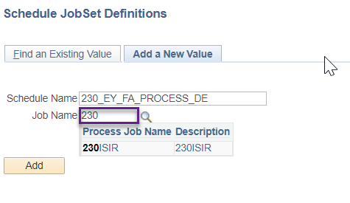

1. Copy and paste your **Schedule Name** into the **Run Control ID** field and after confirming the status is Inactive, click **Save**

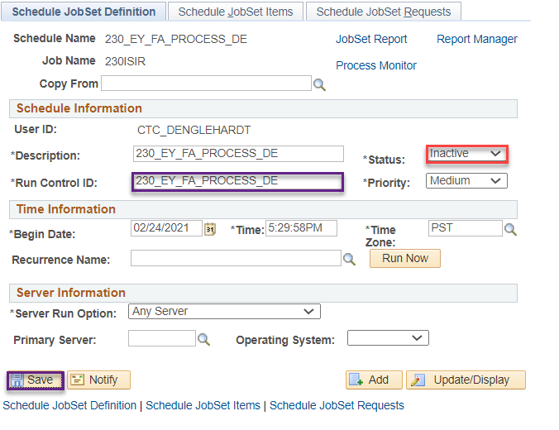

1. Go to **Schedule JobSet Items** tab and click on the **Expand** button next to the **###ISIR** job to see all the blank fields to paste your Run Control

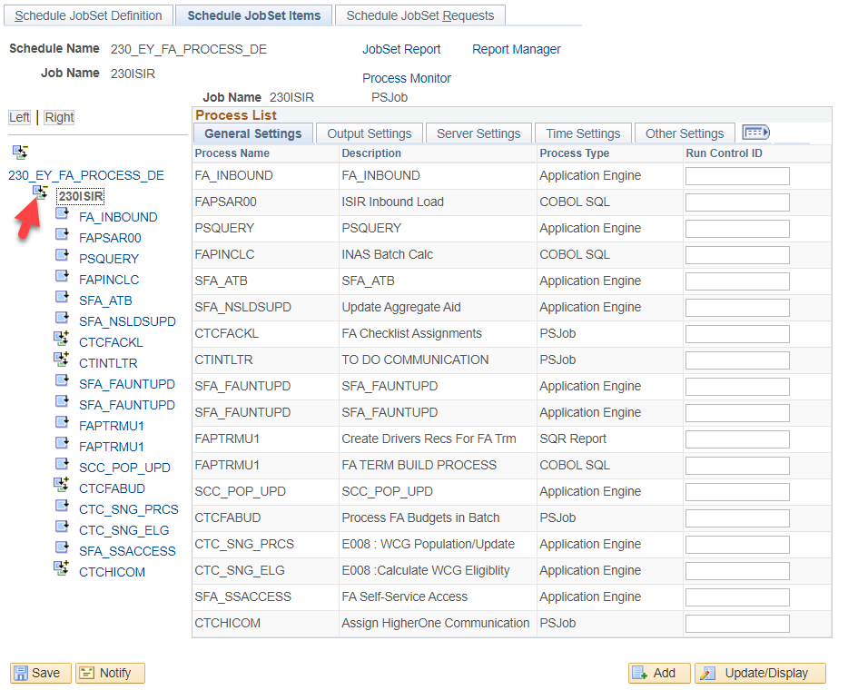

1. Copy Run Control IDs from your spreadsheet to the associated processes
2. Click **Save** often

** Any Process Type that is PS Job, click on the **Expand** button to enter the Run Control IDs for the different processes in that job.

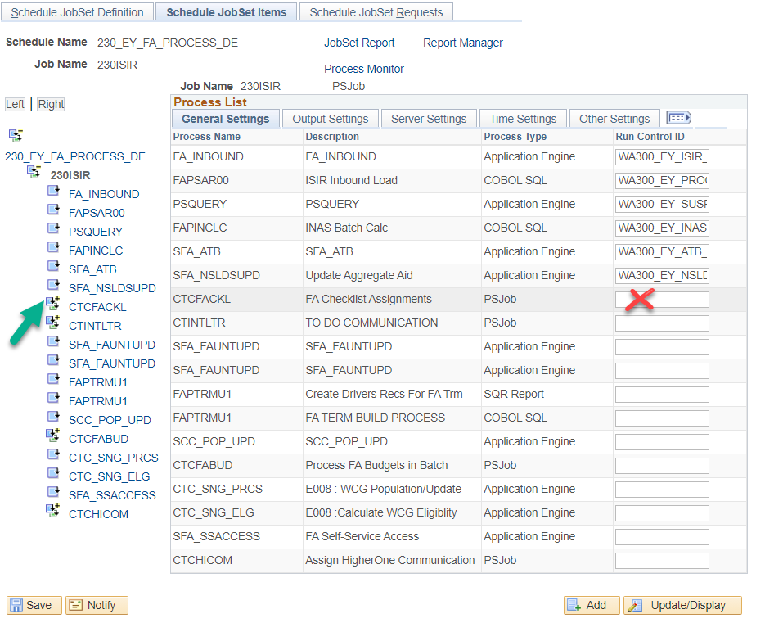

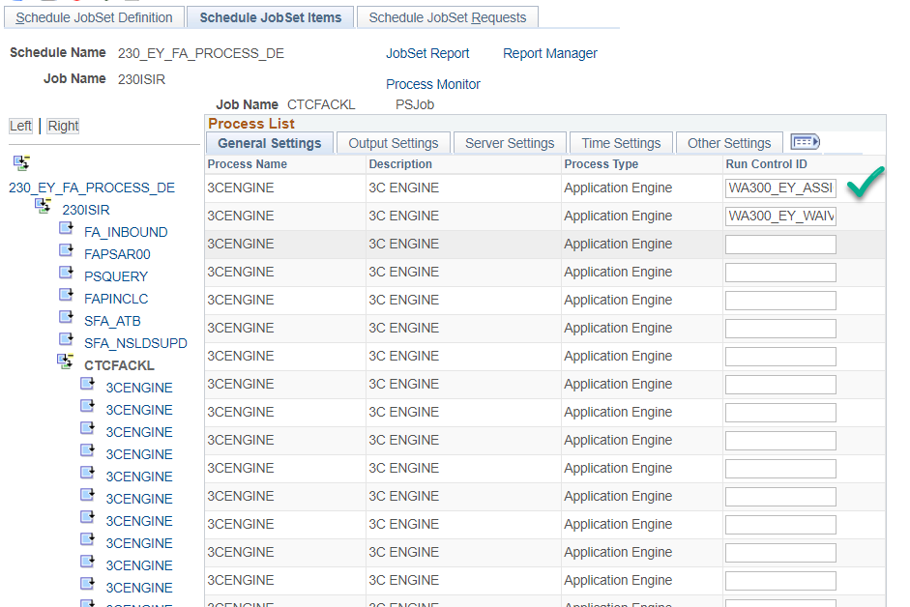

** Click on **###ISIR** blue link when you want to return to the main view

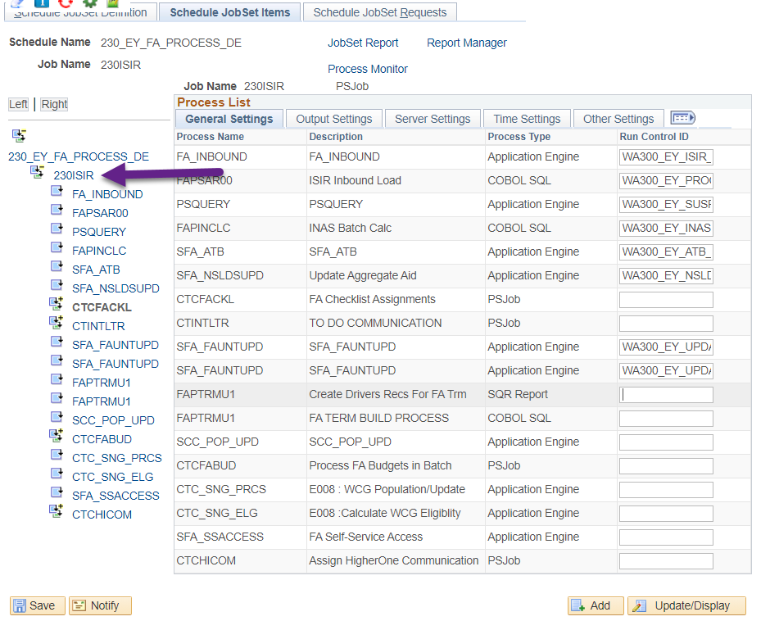

### Processes and Jobs in ISIR Jobset Type 1

|  |  |  |
| --- | --- | --- |
| **Table Name** | **Navigation** | **Action** |
| **FA_INBOUND** | *Main Menu > Financial Aid > File Management > Import Federal Data Files* | ISIR Inbound |
| **FAPSAR00** | *Main Menu > Financial Aid > File Management > ISIR Import > Process ISIR’s* | Process ISIR's |
| **PSQUERY** | *Main Menu > Reporting Tools > Query > Query Viewer* | Suspense Query - CTC_FA_SUSPEND_ISIR_DETAIL |
| **SFA_FAUNTUPD** | *Main Menu > Financial Aid > Financial Aid Term > Update FA Progress Units* | Sets progress units for ABE/AESL on Enrollment page to zero |
| **SFA_FAUNTUPD** | *Main Menu > Financial Aid > Financial Aid Term > Update FA Progress Units* | Sets progress units for drops, W’s or non-completion grades to zero on Enrollment page |
| **FAPTRMU1** | *Main Menu > Financial Aid > Financial Aid Term > Create FA Term Driver Records* | Create FA Term driver records for the batch Financial Aid Term build process |
| **FAPTRMU1** | *Main Menu > Financial Aid > Financial Aid Term > Build FA Term in Batch* | Create Financial Aid Terms in batch |
| **FAPINCLC** | *Main Menu > Financial Aid > File Management > INAS Batch Calculation* | INAS Batch Calc |
| **SCC_POP_UPD** | *Main Menu > Set up SACR > System Administration > Utilities > Population Update > Population Update Process* | Update Week of Instruction to 12 on FA Term |
| **CTCFABUD** |  | **Process FA Budgets in Batch** |
|  | |  |  |  | | --- | --- | --- | | **Table Name** | **Navigation** | **Action** | | **SCC_POP_UPD** | *Main Menu > Set up SACR > System Administration > Utilities > Population Update > Population Update Process* | Set budget flags to "Yes" | | **SCC_POP_UPD** | *Main Menu > Set up SACR > System Administration > Utilities > Population Update > Population Update Process* | Set budget flags all terms to "Yes" | | **SCC_POP_UPD** | *Main Menu > Set up SACR > System Administration > Utilities > Population Update > Population Update Process* | *\*Leave this field blank* | | **FAPBDGTD** | *Maintain Budget Work Table – Use Run Control ID from the Run Equations page* | Delete | | **FAPBDGTS** | *Select Students – Use Run Control ID from the Run Equations page* | Select | | **FAPBDGTF** | *Process Formula – Use Run Control ID from the Run Equations page* | Formulas | | **FAPBDGTM** | *Move Budget to Students – Use Run Control ID from the Run Equations page* | Move | | **FAPBDGTD** | *Maintain Budget Work Table – Use Run Control ID from the Run Equations page* | Delete | | |
| **CTC_SNG_PRCS** | *Main Menu > Financial Aid > CTC Custom > CTC Interfaces > State Need Grant > SNG Population/Update* | SNG Population/Update |
| **CTC_SNG_ELG** | *Main Menu > Financial Aid > CTC Custom > CTC Interfaces > State Need Grant > Calculate SNG Eligibility* | Calculate SNG Eligibility |
| **SFA_ATB** | *Main Menu > Financial Aid > Ability to Benefit > Create Ability to Benefit* | Updating Ability to Benefit data in batch |
| **SFA_SSACCESS** | *Main Menu > Financial Aid > Awards > Self Service Awarding > Assign Self Service Access* | FA Self-Service Access |
| **SFA_NSLDSUPD** | *Main Menu > Financial Aid > File Management > NSLDS > Update Aggregates with NSLDS* | Update Aggregate Aid |
| **CTCHICOM** |  | **Higher One/BankMobile Checklist and Communication** |
|  | |  |  |  | | --- | --- | --- | | **Table Name** | **Navigation** | **Action** | | **3CENGINE** | *Main Menu > Campus Community > 3C Engine > Run 3C Engine* | Assign Higher One/BankMobile Checklist | | **3CENGINE** | *Main Menu > Campus Community > 3C Engine > Run 3C Engine* | Assign Higher One/BankMobile Communication | | **SCC_COMMGEN** | *Main Menu > Campus Community > Communications > Communication Generation* | Send out H1/BankMobile Communication | | |
| **CTCFACKL** |  | **FA Checklist Assignments** |
|  | |  |  |  | | --- | --- | --- | | **Table Name** | **Navigation** | **Action** | | 3CENGINE | *Main Menu > Campus Community > 3C Engine > Run 3C Engine* | Assign Checklist Items -  Up to 60 Checklist Items | | |
| **CTINTLTR** |  | **Initial To Do Communication and 2nd Request Communication** |
|  | |  |  |  | | --- | --- | --- | | **Table Name** | **Navigation** | **Action** | | **3CENGINE** | *Main Menu > Campus Community > 3C Engine > Run 3C Engine* | Initial To Do Letter Assign | | **SCC_COMMGEN** | *Main Menu > Campus Community > Communications > Communication Generation* | Initial To Do Letter Send | | **3CENGINE** | *Main Menu > Campus Community > 3C Engine > Run 3C Engine* | 2nd Request Notification Assign | | **SCC_COMMGEN** | *Main Menu > Campus Community > Communications > Communication Generation* | 2nd Request Notification Send | | |

### Processes and Jobs in ISIR Jobset Type 2

|  |  |  |
| --- | --- | --- |
| **Table Name** | **Navigation** | **Action** |
| **FA_INBOUND** | *Main Menu > Financial Aid > File Management > Import Federal Data Files* | ISIR Inbound |
| **FAPSAR00** | *Main Menu > Financial Aid > File Management > ISIR Import > Process ISIR’s* | Process ISIR's |
| **PSQUERY** | *Main Menu > Reporting Tools > Query > Query Viewer* | Suspense Query - CTC_FA_SUSPEND_ISIR_DETAIL |
| **FAPINCLC** | *Main Menu > Financial Aid > File Management > INAS Batch Calculation* | INAS Batch Calc |
| **SFA_ATB** | *Main Menu > Financial Aid > Ability to Benefit > Create Ability to Benefit* | Updating Ability to Benefit data in batch |
| **SFA_NSLDSUPD** | *Main Menu > Financial Aid > File Management > NSLDS > Update Aggregates with NSLDS* | Update Aggregate Aid |
| **CTCFACKL** |  | **FA Checklist Assignments** |
|  | |  |  |  | | --- | --- | --- | | **Table Name** | **Navigation** | **Action** | | 3CENGINE | *Main Menu > Campus Community > 3C Engine > Run 3C Engine* | Assign Checklist Items -  Up to 60 Checklist Items | | |
| **CTINTLTR** |  | **Initial To Do Communication and 2nd Request Communication** |
|  | |  |  |  | | --- | --- | --- | | **Table Name** | **Navigation** | **Action** | | **3CENGINE** | *Main Menu > Campus Community > 3C Engine > Run 3C Engine* | Initial To Do Letter Assign | | **SCC_COMMGEN** | *Main Menu > Campus Community > Communications > Communication Generation* | Initial To Do Letter Send | | **3CENGINE** | *Main Menu > Campus Community > 3C Engine > Run 3C Engine* | 2nd Request Notification Assign | | **SCC_COMMGEN** | *Main Menu > Campus Community > Communications > Communication Generation* | 2nd Request Notification Send | | |
| **SFA_FAUNTUPD** | *Main Menu > Financial Aid > Financial Aid Term > Update FA Progress Units* | Sets progress units for ABE/AESL on Enrollment page to zero |
| **SFA_FAUNTUPD** | *Main Menu > Financial Aid > Financial Aid Term > Update FA Progress Units* | Sets progress units for drops, W’s or non-completion grades to zero on Enrollment page |
| **FAPTRMU1** | *Main Menu > Financial Aid > Financial Aid Term > Create FA Term Driver Records* | Create FA Term driver records for the batch Financial Aid Term build process |
| **FAPTRMU1** | *Main Menu > Financial Aid > Financial Aid Term > Build FA Term in Batch* | Create Financial Aid Terms in batch |
| **SCC_POP_UPD** | *Main Menu > Set up SACR > System Administration > Utilities > Population Update > Population Update Process* | Update Week of Instruction to 12 on FA Term |
| **CTCFABUD** |  | **Process FA Budgets in Batch** |
|  | |  |  |  | | --- | --- | --- | | **Table Name** | **Navigation** | **Action** | | **SCC_POP_UPD** | *Main Menu > Set up SACR > System Administration > Utilities > Population Update > Population Update Process* | Set budget flags to "Yes" | | **SCC_POP_UPD** | *Main Menu > Set up SACR > System Administration > Utilities > Population Update > Population Update Process* | Set budget flags all terms to "Yes" | | **SCC_POP_UPD** | *Main Menu > Set up SACR > System Administration > Utilities > Population Update > Population Update Process* | *\*Leave this field blank* | | **FAPBDGTD** | *Maintain Budget Work Table – Use Run Control ID from the Run Equations page* | Delete | | **FAPBDGTS** | *Select Students – Use Run Control ID from the Run Equations page* | Select | | **FAPBDGTF** | *Process Formula – Use Run Control ID from the Run Equations page* | Formulas | | **FAPBDGTM** | *Move Budget to Students – Use Run Control ID from the Run Equations page* | Move | | **FAPBDGTD** | *Maintain Budget Work Table – Use Run Control ID from the Run Equations page* | Delete | | |
| **CTC_SNG_PRCS** | *Main Menu > Financial Aid > CTC Custom > CTC Interfaces > State Need Grant > SNG Population/Update* | SNG Population/Update |
| **CTC_SNG_ELG** | *Main Menu > Financial Aid > CTC Custom > CTC Interfaces > State Need Grant > Calculate SNG Eligibility* | Calculate SNG Eligibility |
| **SFA_SSACCESS** | *Main Menu > Financial Aid > Awards > Self Service Awarding > Assign Self Service Access* | FA Self-Service Access |
| **CTCHICOM** |  | **Higher One/BankMobile Checklist and Communication** |
|  | |  |  |  | | --- | --- | --- | | **Table Name** | **Navigation** | **Action** | | **3CENGINE** | *Main Menu > Campus Community > 3C Engine > Run 3C Engine* | Assign Higher One/BankMobile Checklist | | **3CENGINE** | *Main Menu > Campus Community > 3C Engine > Run 3C Engine* | Assign Higher One/BankMobile Communication | | **SCC_COMMGEN** | *Main Menu > Campus Community > Communications > Communication Generation* | Send out H1/BankMobile Communication | | |

# Run Control ID for Mass EFC Calculation (only for 2023-2024)

1. Navigate to *Mass EFC Calculation* (Financial Aid > File Management > Mass EFC Calculation)
2. Select **Add a New Value** then create a new Run Control ID following the standard Run Control ID naming convention:

WA**xxx**_EY_MASS_EFC_CALC_**yy**

(**xxx** is your 3-digit destination and **yy** is your initials)

1. Enter the following parameters

Academic Institution: **(your institution)**

Aid Year: **2024**

Application Type: **F**

Clear Calc Requests? **Y**

1. Select **Run**

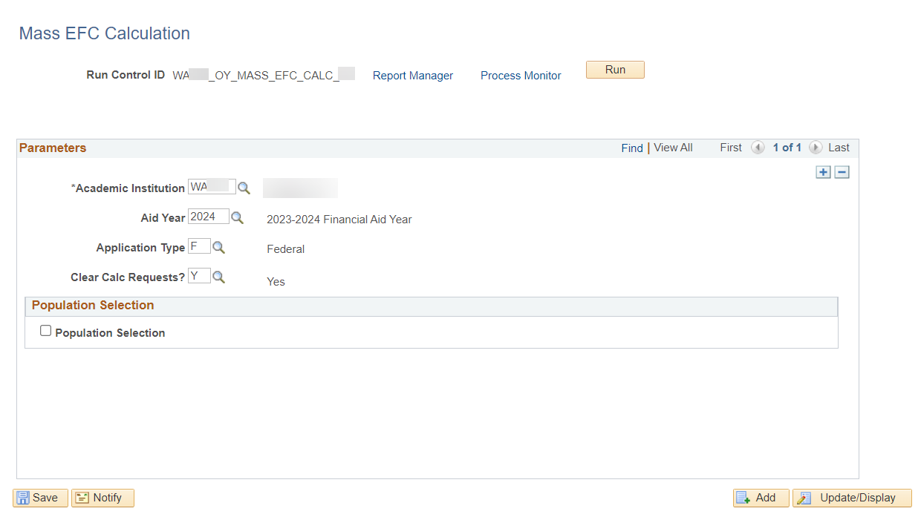

1. Select *Recurrence* **M-F @7:00AM** then *Run Date* of **tomorrow**.

1. Select **OK** and the recurrence is set!

# ISIR Jobset Timeslots

|  |  |  |  |  |
| --- | --- | --- | --- | --- |
| **Institution** | **Description** |  | **Recurrence** |  |
| WA220 | Tacoma CC |  | M-F at 5pm | New Aid Year |
| WA090 | Highline College |  | M-F@11:00PM | Current Aid Year |
| WA110 | Pierce College |  |  |  |
| WA080 | Bellevue College |  |  |  |
| WA062 | Seattle Central College |  |  |  |
| WA050 | Everett Community College |  |  |  |
| WA171 | Spokane CC |  |  |  |
| WA100 | Green River College |  |  |  |
| WA190 | Columbia Basin College |  |  |  |
| WA172 | Spokane Falls CC |  |  |  |
| WA140 | Clark College |  |  |  |
| WA070 | Shoreline Community College |  |  |  |
| WA230 | Edmonds College |  |  |  |
| WA160 | Yakima Valley College |  |  |  |
| WA290 | Clover Park Technical College |  |  |  |
| WA030 | Olympic College |  |  |  |
| WA063 | North Seattle College |  |  |  |
| WA240 | South Puget Sound Comm College |  |  |  |
| WA270 | Renton Technical College |  |  |  |
| WA210 | Whatcom Community College |  |  |  |
|  |  |  |  |  |
| **Institution** | **Description** |  | **Recurrence** |  |
| WA064 | South Seattle College |  | M-F@01:00AM | New Year |
| WA280 | Bates Technical College |  | M-F@04:00AM | Current Year |
| WA150 | Wenatchee Valley College |  |  |  |
| WA040 | Skagit Valley College |  |  |  |
| WA250 | Bellingham Technical College |  |  |  |
| WA200 | Walla Walla Community College |  |  |  |
| WA130 | Lower Columbia College |  |  |  |
| WA120 | Centralia College |  |  |  |
| WA260 | Lake Washington Inst. of Tech. |  |  |  |
| WA180 | Big Bend Community College |  |  |  |
| WA300 | Cascadia College |  |  |  |
| WA020 | Grays Harbor College |  |  |  |
| WA010 | Peninsula College |  |  |  |

Return to Schedule Jobset Definitions.