**ISIR Data Load Parameters (Review)**

**- Review for accuracy (compare 2026 with 2025 setup)**

**Navigation:  Set Up SACR > Product Related > Financial Aid > File Management > ISIR Data Load Parameters**

Image:  2025-2026 ISIR Data Load Parameters Tab 1

Image: 2025-2026 ISIR Data Load Parameters Tab 2

Image:  2025-2026 ISIR Data Load Parameters Tab 3

Image:  2025-2026 ISIR Data Load Parameters Tab 4

**Aggregate Aid Limit**

**Navigation:  Set Up SACR > Product Related > Financial Aid > Awards > Aggregate Aid Limit**

* Pell Aggregate Aid Limit needs to be updated, if applicable
* Add a new Effective row
* Minimum Pell Scheduled Award: 740
* Maximum Pell Scheduled Award: 7395
* Once you SAVE the Aggregate Limit will populate for each Aggregate Level

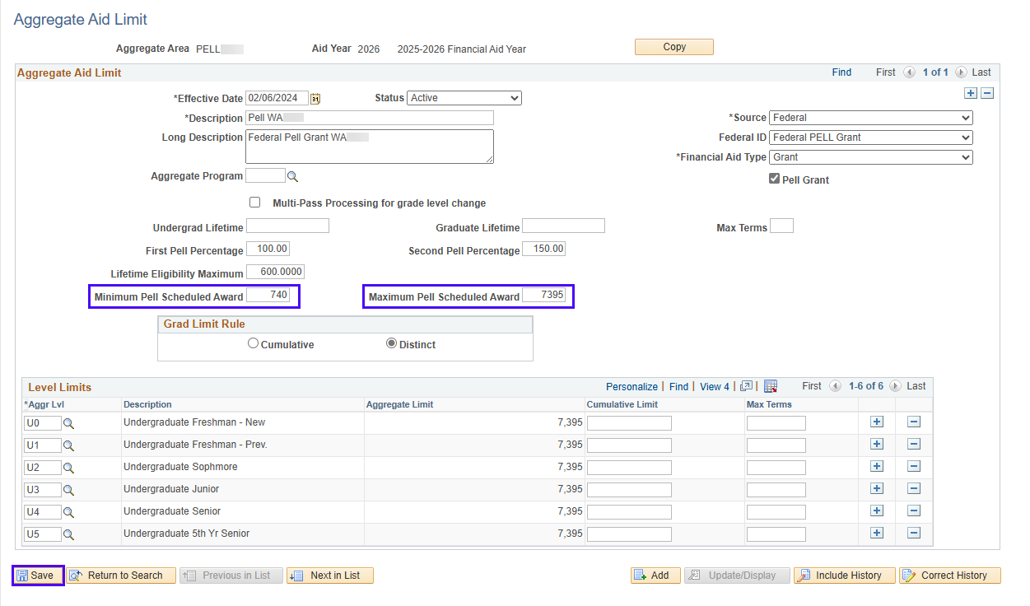

**Pell Payment**

**Navigation:  Set Up SACR > Product Related > Financial Aid > Pell Grants > Pell Payment**

**WCG Equation Processing Options (Review)**

**Navigation:  Set Up SACR > Product Related > Financial Aid > CTC Custom > WA College Grant > Equation Processing Options**

The Equation for WA College Grant Processing Options needs to be updated to the new equation.

* CTCFAWCGELIG

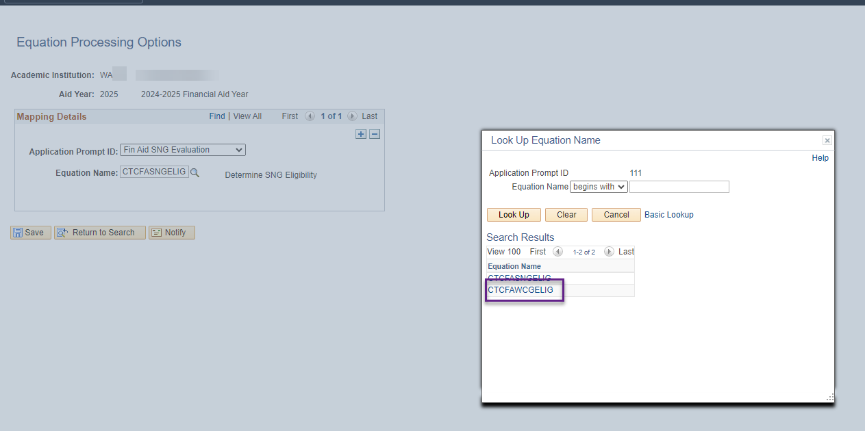

**Updates After 2025-2026 PRP**

**Navigation: Set Up SACR > Product Related > Financial Aid > Application Processing > NA 2025-2026 Global Options**

* Change the *INAS Rule* set to **CSS Rules/Values**
* Confirm *INAS Data* Source is **Institutional**.
* Confirm *Calc Type* is **Institutional.**

Return to **FAPSAR00 - Process ISIRs** section on the ISIR Jobset Guide for your Odd year ISIR Jobset now to select 2026

Nav Bar > Navigator > Financial Aid > File Management > ISIR Import > Process ISIRs

