Updates to WCG CEMLI –

WCG Income & Family Size SQLs

Overview Guide

FA Customer Support

FA Customer Support

Washington State Board for Community and Technical College



CONTENTS

Overview 2

WCG Income Hierarchy 5

Dependent Student 5

Independent Student 6

Out of Scope 7

#1 WSAC’s Inclusion of Optional Income Offsets 7

#2 Married Students or Parents with One Filed ‘Married Filed Jointly’ and the Other Filed a Different Status 7

#3 IRA or Pension Rollovers 8

Family Size Hierarchy 9

Dependent Student 9

Behavior of ‘Unmarried Living Together’ in Family Size SQL 9

Independent Student 10

Dependent Students (DS) Scenarios and Outcomes 12

**DS: Parents Married / Filed Separately / Reported Foreign Income Exclusion** 12

**DS: Parents Married / Filed Separately** 14

**DS: Parents Married / Filed Jointly / Assumed Family Size on ISIR** 16

**DS: Parents Married / No Reported or Assumed Family Size on ISIR** 18

**DS: Parents Married / Both Tax Filers but No FTI Data Present** 20

**DS: Parents Married / Parents Non-Filers / No Reported Family Size** 22

**DS: Parents Remarried / Filed Jointly** 24

**DS: Parents Remarried / Parent Filer / Parent Spouse Non-Filer** 26

**DS: Parents Divorced / Filed Separately / Reported Family Size** 28

**DS: Parents Divorced / Filed Separately / Reported Untaxed Pension** 30

**DS: Parents Divorced / Filed Jointly** 32

**DS: Parents Divorced / Tax Filer but No FTI Data / Reported Untaxed IRA** 34

**DS: Parents Unmarried Living Together / Filed Separately / Negative AGI** 36

Independent Students (IS) Scenarios and Outcomes 38

**IS: Single / Tax Filer / Reported Family Size on ISIR** 38

**IS: Married / Student Filer / Spouse Non-Filer** 40

**IS: Single / Tax Filer / PJ Flag on ISIR** 42

**IS: Divorced / Non-Filer / No Reported or Assumed Family Size on ISIR** 44

**IS: Remarried / Filed Jointly** 46

**IS: Remarried / One Filed Joint and the Other Filed Head of Household** 48

**IS: Married / Filed Separately / Assumed Family Size on ISIR** 50

**IS: Married / Filed Separately / Spouse Non-Tax Filer / PJ Flag on ISIR** 52

**IS: Widowed / Filed ‘Qualifying Surviving Spouse’** 54

**IS: Separated / Filed Jointly** 56

**IS: Divorced / Filed Jointly** 58

**IS: Single / WASFA (no FTI data on ISIR)** 60

**IS: Married / WASFA (no FTI data on ISIR)** 62

**IS: Single / Tax Filer but FTI Data Match Failed / Has Dependents** 64

**IS: Single / Reported Foreign Income Exclusion** 66

# Overview

With the introduction of FTI (Federal Tax Information) data and changes to income fields on the 2024-2025 FAFSA due to FASFA Simplification, the WCG CEMLI needed to be updated to accurately calculate the *WCG Income* and *Family Size* fields.

In July of 2024, we implemented our first phase of WCG CEMLI updates.

*Per the* [*2024-2025 WCG Manual*](https://wsac.wa.gov/sites/default/files/2024-25_WCG-CBS_ProgramManual.pdf) *the WCG Income for 2024-2025 should include AGI (or earned income when FTI AGI data is not available) and only the following untaxed income:*

* + Untaxed portions of Individual Retirement Arrangement (IRA, or Individual Retirement Account) distributions (withdrawals);

NOTE: Do not include any rollover amounts from untaxed IRA distributions.

* + Untaxed portions of pension and annuity distributions (withdrawals);

NOTE: Do not include any rollover amounts from untaxed pension and annuity distributions.

* + IRA deductions and payments to self-employed SEP, SIMPLE, and qualified plans;
  + Tax-exempt interest; and
  + Foreign Earned Income Exclusion

*The WCG CEMLI was updated to include all the following except ‘IRA deductions and payments to self-employed SEP, SIMPLE, and qualified plans’ as more research is needed to determine whether the SFA_xx_FTIM_DEIRA - IRA deductible and payments fields is accurate and doesn’t contain rollovers (reference:* [*https://askregs.nasfaa.org/article/36751/how-do-we-verify-rollovers-of-ira-pension-and-annuity-distributions*](https://askregs.nasfaa.org/article/36751/how-do-we-verify-rollovers-of-ira-pension-and-annuity-distributions) *)*

In November 2024, two queries were introduced into production to assist colleges with finding and cleaning up some WCG Income data:

**QCS_FA_WCG_IRA_DATA** – Query to finds students who have IRA data on their ISIR that should be included in WCG Income

**QCS_FA_WCG_MFJ_RPTD_INC** – Query to find students/parents who filed Married Filed Jointly and both parties reported the same income on the FAFSA.

Query criteria is as follows:

WCG income > 0, Student AGI & Student Spouse AGI not equal to WCG Income

AND

(Student & Student Spouse Tax filing status of married filed joint

OR

Student tax filing status married filed joint & Student spouse Manual AGI is not blank

OR

Student Spouse tax filing status married filed joint & Student Manual AGI is not blank

OR

Parent tax filing status married filed joint & Parent Spouse Manual AGI is not blank

OR

Parent Spouse tax filing status married filed joint & Parent Manual AGI is not blank)

With this second phase of updates implemented in December 2024, we’ve included the following:

* Inclusion of the IRA deductions and payments to self-employed SEP, SIMPLE, and qualified plans into the WCG Income calculation
* Further tweaking of the WCG income SQL to better align with WSAC’s data hierarchy
* Updated the Family Size SQL to align with the following data hierarchy

1. *Reported Family Size on ISIR/WASFA*
2. *Assumed Family Size on ISIR/WASFA*
3. *Exemptions matrix (Appendix C of* [*2024-25 FAFSA Pell Eligibility and SAI Guide*](https://fsapartners.ed.gov/sites/default/files/2024-01/20242025FAFSAPellEligibilityandSAIGuide.pdf)*)*
4. *Assumption Hierarchy Chart provided in the* [*WSAC Manual p.34*](https://wsac.wa.gov/sites/default/files/2024-25_WCG-CBS_ProgramManual.pdf)

Outline of sections in this guide:

* WCG Income Hierarchy
* Family Size Hierarchy
* [Dependent Students (DS) Scenarios and Outcomes](#_Dependent_Students_(DS)_1)
* [Independent Students (IS) Scenarios and Outcomes](#_Independent_Students_(IS)_1)

# WCG Income Hierarchy

## Dependent Student

|  |  |  |  |
| --- | --- | --- | --- |
| **#** | **Parent MARITAL STATUS** | **#** | **FILING STATUS** |
| 1 | Single | 1 | Single |
| 2 | Unmarried living together | 2 | Married Filed Jointly |
| 3 | Married not separated | 3 | Married Filed Separately |
| 4 | Remarried | 4 | Head of Household |
| 5 | Divorced | 5 | Qualifying Surviving Spouse |
| 6 | Separated |  |  |
| 7 | Widowed |  |  |

**Note**: * represents a field being blank in the SQL

**Criteria and order of processing for Dependent Student**

Dependency Override/PJ Flag on ISIR

--- Parent & Spouses’ Manual AGIs & untaxed incomes

* If Manual AGI is not present, use FTI AGI

Parent Marital Status (2, 3, 4) and Parent or Parent Spouse’s Filing Status = 2

--- Parent’s FTI AGI & untaxed income

* If Parent’s income info is blank, use Parent Spouse’s FTI AGI & untaxed income

Parent Marital Status (2, 3, 4) and Parent’s Filing NOT (2, *) and Parent Spouse’s Filing Status NOT (2, *)

--- Parent & Parent Spouses’ FTI AGIs & untaxed incomes

Parent Marital Status (2, 3, 4) and Parent’s Filing Status NOT (2, *) and Parent Spouse’s Filing Status is (* )

--- Parent’s FTI AGI & untaxed income + Parent Spouse’s Manual AGI & untaxed income

* If Parent Spouse’s Manual AGI is not present, use reported income worked

Parent Marital Status (2, 3, 4) and Parent’s Filing Status is (* ) and Parent Spouse’s Filing Status NOT (2, *)

--- Parent’s Manual AGI & untaxed income + Parent Spouse’s FTI AGI & untaxed income

* If Parent’s Manual AGI is not present, use reported income worked

Parent Marital Status NOT (2, 3, 4) and Filing Status NOT (2, *)

--- Parent’s FTI AGI & untaxed income

Parent Marital Status NOT (2, 3, 4) and Filing Status = 2

--- Parent’s Manual AGI & untaxed income

* If Parent’s Manual AGI is not present, use FTI AGI

Parent Marital Status (2, 3, 4)

--- Parent & Spouses’ Manual AGIs & untaxed incomes

* If Manual AGI is not present, use reported income worked

Parent Marital Status NOT (2, 3, 4)

--- Parent Manual AGI & untaxed income

* If Parent’s Manual AGI is not present, use reported income worked

## Independent Student

|  |  |  |  |
| --- | --- | --- | --- |
| **#** | **Student MARITAL STATUS** | **#** | **FILING STATUS** |
| 1 | Single | 1 | Single |
| 2 | Married | 2 | Married Filed Jointly |
| 3 | Remarried | 3 | Married Filed Separately |
| 4 | Divorced | 4 | Head of Household |
| 5 | Separated | 5 | Qualifying Surviving Spouse |
| 6 | Widowed |  |  |

**Note**: * represents a field being blank in the SQL

**Criteria and order of processing for Independent student**

Dependency Override/PJ Flag on ISIR

--- Student & Spouses’ Manual AGIs & untaxed incomes

* If Manual AGI is not present, use FTI AGI

Student Marital Status (2, 3) and Student or Spouse Filing Status = 2

--- Student’s FTI AGI & untaxed income

* If Student’s income info is blank, use Spouse’s FTI AGI & untaxed income

Student Marital Status (2, 3) and Student’s Filing NOT (2, *) and Spouse’s Filing Status NOT (2, *)

--- Student & Spouses’ FTI AGIs & untaxed incomes

Student Marital Status (2, 3) and Student’s Filing Status NOT (2, *) and Spouse’s Filing Status is (* )

--- Student’s FTI AGI & untaxed income + Spouse’s Manual AGI & untaxed income

* If Spouse’s Manual AGI is not present, use reported income worked

Student Marital Status (2, 3) and Student’s Filing Status is (* ) and Spouse’s Filing Status NOT (2, *)

--- Student’s Manual AGI & untaxed income + Spouse’s FTI AGI & untaxed income

* If Student’s Manual AGI is not present, use reported income worked

Student Marital Status NOT (2, 3) and Filing Status NOT (2, *)

----- Student’s FTI AGI & untaxed income

Student Marital Status NOT (2, 3) and Filing Status = 2

----- Student’s Manual AGI & untaxed income

* If Student’s Manual AGI is not present, use FTI AGI

Student Marital Status (2,3)

----- Both Student & Spouse Manual AGIs & untaxed income

* If Manual AGI is not present, use reported income worked

Student Marital Status NOT (2,3)

----- Student’s Manual AGI & untaxed income

* If Student’s Manual AGI is not present, use reported income worked

## Out of Scope

Due to unexpected or “bad” data reported by students or parents on ISIRs/WASFAs, the WCG Income SQL will not calculate *every* student’s WCG Income value correctly, but we aimed for an 80 – 90% accuracy rate!

The following are current known scenarios that are out of scope:

### #1 WSAC’s Inclusion of Optional Income Offsets

The WCG Income in the WSAC Portal includes the optional income offsets mentioned in [*WSAC Manual p.34*](https://wsac.wa.gov/sites/default/files/2024-25_WCG-CBS_ProgramManual.pdf). The income offsets are *allowable* but *not required* so after discussing with FAST, the income offsets were not included in the WCG CEMLI SQL. If an edit appears on the WCG Interim due to this difference of WSAC including the optional offsets while the WCG CEMLI does not, the college would address the edit by indicating the optional offset was not included in the college calculation.

### #2 Married Students or Parents with One Filed ‘Married Filed Jointly’ and the Other Filed a Different Status

There are cases when married Students/Parents have filing statuses that do not appear to be in alignment with one side indicating they filed ‘Married Filed Jointly’ and the other indicating they filed a different status. Querying ISIR data systemwide, these cases are rare.

More common are scenarios where married Students/Parents report the same income data when they filed ‘Married Filed Jointly’. There are many cases systemwide where the WCG Income is incorrectly doubled because of these duplicate data points. Hence, we created QCS_FA_WCG_MFJ_RPTD_INC query for colleges to find these students until the WCG CEMLI was updated to address this population.

In favor of addressing the more common issue of doubling income, the SQL has criteria where it prevents including both incomes when the Student/ Parent marital status is married and filing status of either the Student/Parent OR Student Spouse/Parent Spouse is ‘Married Filed Jointly’.

The following query was developed to address the other issue.

**QCS_FA_WCG_MARITAL_FILING_DISC**

Report to find students who fall under one of the following:

**Independent student** with marital status of ‘Married/Remarried’ AND

* + Student filed a single status and Spouse filed ‘Married Filed Jointly’

OR

* Student filed ‘Married Filed Jointly’ and Spouse filed a single status

**Dependent student** with marital status of ‘Married/Remarried/Not Married Living Together’ AND

* Parent filed a single status and Spouse filed ‘Married Filed Jointly’

OR

* Parent filed ‘Married Filed Jointly’ and Spouse filed a single status

### #3 IRA or Pension Rollovers

There may be cases where IRA or Pension Distributions on an ISIR *appear* to include rollovers. There is no coding that we felt comfortable adding that would automatically remove the manually reported IRA or Pension Rollovers from the IRA or Pension Distributions. Having the same number reported in the distribution fields and rollover fields does not always indicate incorrect reporting.

A query was developed to find these students should your college have a process where you would verify IRA or Pension Distributions that appear to contain IRA or Pension Rollovers.

**QCS_FA_WCG_IRA_PEN_ROLLVR_DISC**

Report to find students who fall under one of the following:

**Independent student** with Student or Spouse reporting IRA or Pension Rollover

**Dependent student** with Parent or Spouse reporting IRA or Pension Rollover

# Family Size Hierarchy

## Dependent Student

|  |  |  |  |
| --- | --- | --- | --- |
| **#** | **Parent MARITAL STATUS** | **#** | **FILING STATUS** |
| 1 | Single | 1 | Single |
| 2 | Unmarried living together | 2 | Married Filed Jointly |
| 3 | Married not separated | 3 | Married Filed Separately |
| 4 | Remarried | 4 | Head of Household |
| 5 | Divorced | 5 | Qualifying Surviving Spouse |
| 6 | Separated |  |  |
| 7 | Widowed |  |  |

**Hierarchy 1** – If Parent Reported Family Size (NUMBER_IN_FAMILY field) exists on ISIR/WASFA, the Family Size SQL will populate that value. If it does not exist, the SQL will move to next criteria

**Hierarchy 2** – If Parent Assumed Family Size (SFA_ASMD_PAR field) exists on ISIR/WASFA, the Family Size SQL will populate that value. If it does not exist, the SQL will move to next criteria

**Hierarchy 3** –If at least one of the parents is a tax filer, the Family Size SQL will calculate the family size according to Appendix C of [2024-25 FAFSA Pell Eligibility and SAI Guide](https://fsapartners.ed.gov/sites/default/files/2024-01/20242025FAFSAPellEligibilityandSAIGuide.pdf). If neither parent are tax filers, the SQL will move to the final criteria

**Hierarchy 4** –If neither parent are tax filers, the Family Size SQL will calculate the family size according to the Assumption Hierarchy chart below

|  |  |
| --- | --- |
| **Family Type** | **Family Size Assumption** |
| Dependent Student; 2 Parent Contributors | 3 |
| Dependent Student;1 Parent Contributor | 2 |

### Behavior of ‘Unmarried Living Together’ in Family Size SQL

Due to unexpected or “bad” data reported by students or parents on ISIRs/WASFAs, the Family Size SQL will not calculate *every* student’s Family Size value correctly, but we aimed for an 80 – 90% accuracy rate!

According to Appendix C of [2024-25 FAFSA Pell Eligibility and SAI Guide](https://fsapartners.ed.gov/sites/default/files/2024-01/20242025FAFSAPellEligibilityandSAIGuide.pdf), **‘Unmarried Living Together’** is categorized as ‘Unmarried’ for Family Size purposes. However, Appendix F of [2024-25 FAFSA Pell Eligibility and SAI Guide](https://fsapartners.ed.gov/sites/default/files/2024-01/20242025FAFSAPellEligibilityandSAIGuide.pdf) (which addresses marital status for SAI purposes) indicates to place ‘Unmarried Living Together’ in a ‘Married’ marital status for SAI calculation.

During our testing , we came across a Dependent student whose Family Size would be inflated if we moved ‘Unmarried Living Together’ to a married marital status in the SQL.

The scenario

Student Filing Status: **Single** Exemptions: **1**

Parent Filing Status: **Head of Household** Exemptions: **3**

Parent Partner Filing Status: **Single** Exemption: **1**

The Parent’s exemptions incorrectly contained the Parent Partner so there would be a double counting of exemptions if the ‘Unmarried Living Together’ was categorized as ‘Married’.

With keeping ‘Unmarried Living Together’ as ‘Unmarried’ in the Family Size SQL, it calculates the more modest family size total. We chose this path after seeing over 90% of students systemwide will have the correct Family Size with this setup.

## Independent Student

|  |  |  |  |
| --- | --- | --- | --- |
| **#** | **Student MARITAL STATUS** | **#** | **FILING STATUS** |
| 1 | Single | 1 | Single |
| 2 | Married | 2 | Married Filed Jointly |
| 3 | Remarried | 3 | Married Filed Separately |
| 4 | Divorced | 4 | Head of Household |
| 5 | Separated | 5 | Qualifying Surviving Spouse |
| 6 | Widowed |  |  |

**Hierarchy 1** – If Student Reported Family Size (NUM_FAMILY_MEMBERS field) exists on ISIR/WASFA, the Family Size SQL will populate that value. If it does not exist, the SQL will move to next criteria

**Hierarchy 2** – If Student Assumed Family Size (SFA_ASMD_STD field) exists on ISIR/WASFA, the Family Size SQL will populate that value. If it does not exist, the SQL will move to next criteria

**Hierarchy 3** –If the student or spouse is a tax filer, the Family Size SQL will calculate the family size according to Appendix C of [2024-25 FAFSA Pell Eligibility and SAI Guide](https://fsapartners.ed.gov/sites/default/files/2024-01/20242025FAFSAPellEligibilityandSAIGuide.pdf). If neither student nor spouse are tax filers, the SQL will move to the final criteria

**Hierarchy 4** –If neither student nor spouse are tax filers, the Family Size SQL will calculate the family size according to the Assumption Hierarchy chart below

|  |  |
| --- | --- |
| **Family Type** | **Family Size Assumption** |
| Independent Student; Not Married | 1 |
| Independent Student; Married | 2 |
| Independent Student; Not Married w/Dependents | 2 |

**Note**: The *Child or Other Dependents* field on ISIR/WASFA is a Yes or blank field, not a number.

# Dependent Students (DS) Scenarios and Outcomes

**Disclaimer:** For testing purposes, we used the access we had to two college’s WSAC Training Portal to verify WSAC’s calculation of income and family size. Between this section and the [*Independent Students (IS) Scenarios and Outcomes section*](#_Independent_Students_(IS)_1), we have tried to touch upon as many scenarios as possible to show how the WCG Income and Family Size SQLs act.

**DS: Parents Married / Filed Separately / Reported Foreign Income Exclusion**

Dependency: **Dependent**

ISIR Transaction #: **2**

Parent Marital Status: **Married**

Parent’s Filing Status: **Head of Household**

Parent Spouse’s Filing Status: **Single**

Reported Family Size: **4**

**\*\*WCG CEMLI Calculation\*\***

WCG Income: **Parent and Spouse’s FTI AGIs & untaxed incomes (includes Foreign Income Exclusion)**

= 65931

Family Size: **Reported Family Size**

= 4

**\*\*WSAC Portal Check\*\***

WCG Income: 65931

**Exact match!**

Family Size: 4

**Exact match!**

**DS: Parents Married / Filed Separately**

Dependency: **Dependent**

ISIR Transaction#: **1**

Parent Marital Status: **Married**

Parent’s Filing Status: **Head of Household**

Parent Spouse’s Filing Status: **Single**

Reported Family Size: **4**

**\*\*WCG CEMLI Calculation\*\***

WCG Income**: Parent’s FTI AGI & untaxed income + Parent Spouse’s FTI AGI & untaxed income**

= 76034

Family Size: **Reported Family Size**

= 4

**\*\*WSAC Portal Check\*\***

WCG Income: 76034

**Exact match!**

Family Size: 4

**Exact match!**

**DS: Parents Married / Filed Jointly / Assumed Family Size on ISIR**

Dependency: **Dependent**

ISIR Transaction#: **1**

Parent Marital Status: **Married**

Parent’s Filing Status: **Married-Filed Joint**

Parent Spouse’s Filing Status: (**blank)**

Reported Family Size: (**blank)**

Assumed Family Size: **3**

**\*\*WCG CEMLI Calculation\*\***

WCG Income**: Parent’s FTI AGI & untaxed income**

= 83262

Family Size: **Assumed Family Size**

= 3

**\*\*WSAC Portal Check\*\***

WCG Income: 83262

**Exact match!**

Family Size: 3

**Exact match!**

**DS: Parents Married / No Reported or Assumed Family Size on ISIR**

Dependency: **Dependent**

ISIR Transaction#: **1**

Parent Marital Status: **Married**

Parent’s Filing Status: **Married-Filed Joint**

Parent Spouse’s Filing Status: (**blank)**

Reported Family Size: (**blank)**

Assumed Family Size: (**blank)**

Parent’s Exemptions: **3**

Parent Spouse’s Exemptions: **(blank)**

Student’s Exemptions: **1**

**\*\*WCG CEMLI Calculation\*\***

WCG Income**: Parent’s FTI AGI & untaxed income**

= 55739

Family Size: **Parent & Student’s** **Exemptions**

= 4

**\*\*WSAC Portal Check\*\***

WCG Income: 55739

**Exact match!**

Family Size: 4

**Exact match!**

**DS: Parents Married / Both Tax Filers but No FTI Data Present**

Dependency: **Dependent**

ISIR Transaction#: **1**

Parent Marital Status: **Married**

Parent’s Filing Status: **(blank)**

Parent Spouse’s Filing Status: (**blank)**

Reported Family Size: **6**

**\*\*WCG CEMLI Calculation\*\***

WCG Income**: Parent’s Manual AGI & untaxed income + Parent Spouse’s Manual AGI & untaxed income**

= 16543

Family Size: **Reported Family Size**

= 6

**Note:** If Manual AGI wasn’t present, the SQL would pick up reported income worked

**\*\*WSAC Portal Check\*\***

WCG Income: 16543

**Exact match!**

Family Size: 6

**Exact match!**

**DS: Parents Married / Parents Non-Filers / No Reported Family Size**

Dependency: **Dependent**

ISIR Transaction #: **1**

Parent Marital Status: **Married**

Parent’s Filing Status: **(blank)**

Parent Spouse’s Filing Status: **(blank)**

Reported Family Size: **(blank)**

Assumed Family Size: **(blank)**

**\*\*WCG CEMLI Calculation\*\***

WCG Income: **Parent’s Manual AGI & untaxed income + Parent’s Spouse’s Manual AGI & untaxed income**

= 0

Family Size: **Assumption Hierarchy (Dependent Student; 2 Parent Contributors)**

= 3

**Note:** If Manual AGI wasn’t present, the SQL would pick up reported income worked

**\*\*WSAC Portal Check\*\***

WCG Income: ?

**Exact match!**

Family Size: ?

**Not data in WSAC Portal to compare.**

**DS: Parents Remarried / Filed Jointly**

Dependency: **Dependent**

ISIR Transaction#: **1**

Parent Marital Status: **Remarried**

Parent’s Filing Status: **Married-Filed Joint**

Parent Spouse’s Filing Status: (**blank)**

Reported Family Size: **6**

**\*\*WCG CEMLI Calculation\*\***

WCG Income**: Parent’s FTI AGI & untaxed income**

= 143024

Family Size: **Reported Family Size**

= 6

**\*\*WSAC Portal Check\*\***

WCG Income: 142752

**Difference in calculation due to WSAC including optional offset of Education Credits.**

See Out Scope #1 WSAC’s Inclusion of Optional Income Offsets section.

Family Size: 6

**Exact match!**

**DS: Parents Remarried / Parent Filer / Parent Spouse Non-Filer**

Dependency: **Dependent**

ISIR Transaction#: **1**

Parent Marital Status: **Remarried**

Parent’s Filing Status: **Head of Household**

Parent Spouse’s Filing Status: (**blank)**

Reported Family Size: **5**

**\*\*WCG CEMLI Calculation\*\***

WCG Income**: Parent’s FTI AGI & untaxed income + Parent Spouse’s Manual AGI & untaxed income**

= 74994

Family Size: **Reported Family Size**

= 5

**Note:** If Spouse’s Manual AGI wasn’t present, the SQL would pick up reported income worked

**\*\*WSAC Portal Check\*\***

WCG Income:74994

**Exact match!**

Family Size: 5

**Exact match!**

**DS: Parents Divorced / Filed Separately / Reported Family Size**

Dependency: **Dependent**

ISIR Transaction#: **1**

Parent’s Marital Status: **Divorced**

Parent’s Filing Status: **Married-Filed Separate**

Reported Family Size: **5**

**\*\*WCG CEMLI Calculation\*\***

WCG Income: **Parent’s FTI AGI & untaxed income**

= 1647

Family Size: **Reported Family Size**

= 5

**\*\*WSAC Portal Check\*\***

WCG Income: 1647

**Exact match!**

Family Size: 5

**Exact match!**

**DS: Parents Divorced / Filed Separately / Reported Untaxed Pension**

Dependency: **Dependent**

ISIR Transaction#: **1**

Parent Marital Status: **Divorced**

Parent’s Filing Status: **Head of Household**

Reported Family Size: **(blank)**

Assumed Family Size: (**blank)**

Parent’s Exemptions: **1**

Student’s Exemptions: **1**

**\*\*WCG CEMLI Calculation\*\***

WCG Income**: Parent’s FTI AGI & untaxed income (includes Pension Distributions)**

= 53009

Family Size: **Parent & Student’s** **Exemptions**

=2

**\*\*WSAC Portal Check\*\***

WCG Income: 53009

**Exact match!**

Family Size: 2

**Exact match!**

**DS: Parents Divorced / Filed Jointly**

Dependency: **Dependent**

ISIR Transaction#: **1**

Parent Marital Status: **Divorced**

Parent’s Filing Status: **Married Filed Joint**

Reported Family Size: **3**

**\*\*WCG CEMLI Calculation\*\***

WCG Income**: Parent’s Manual AGI & untaxed income**

= 40911

Family Size: **Reported Family Size**

= 3

**\*\*WSAC Portal Check\*\***

WCG Income: 40911

**Exact match!**

Family Size: =3

**Exact match!**

**DS: Parents Divorced / Tax Filer but No FTI Data / Reported Untaxed IRA**

Dependency: **Dependent**

ISIR Transaction#: **1**

Parent Marital Status: **Divorced**

Parent’s Filing Status: **(blank)**

Reported Family Size: **2**

**\*\*WCG CEMLI Calculation\*\***

WCG Income**: Parent’s Manual AGI & untaxed income (includes IRA Distributions)**

= 76645

Family Size: **Reported Family Size**

= 2

**Note:** If Parent’s Manual AGI wasn’t present, the SQL would pick up reported income worked

**\*\*WSAC Portal Check\*\***

WCG Income: 76645

**Exact match!**

Family Size: 2

**Exact match!**

**DS: Parents Unmarried Living Together / Filed Separately / Negative AGI**

Dependency: **Dependent**

ISIR Transaction#: **1**

Parent Marital Status: **Unmarried Living Together**

Parent’s Filing Status: **Head of Household**

Parent Partner’s Filing Status: **Single**

Reported Family Size: **(blank)**

Assumed Family Size: (**blank)**

Parent’s Exemptions: **3**

Parent Partner’s Exemptions: **1**

Student Exemptions: **1**

**\*\*WCG CEMLI Calculation\*\***

WCG Income**: Parent’s FTI AGI & untaxed income + Parent Partner’s FTI AGI & untaxed income**

= 26555

Family Size: **Parent & Student’s** **Exemptions**

= 4

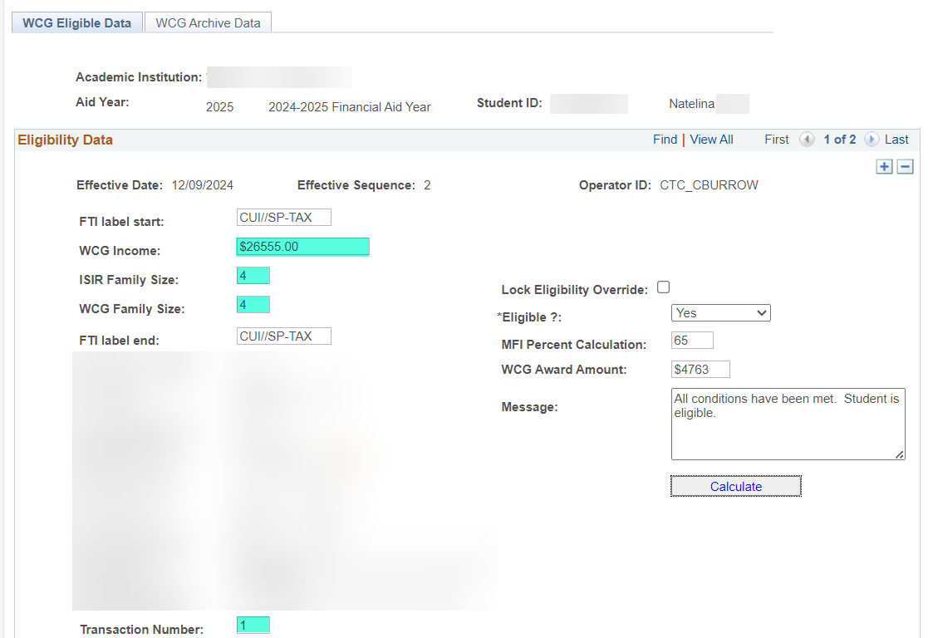

**\*\*WSAC Portal Check\*\***

WCG Income: 26555

**Exact match!**

Family Size: 5

**Difference in calculation due to our SQL categorizing ‘Unmarried Living Together’ as ‘Unmarried’ status.**

See Behavior of ‘Unmarried Living Together’ in Family Size SQL.

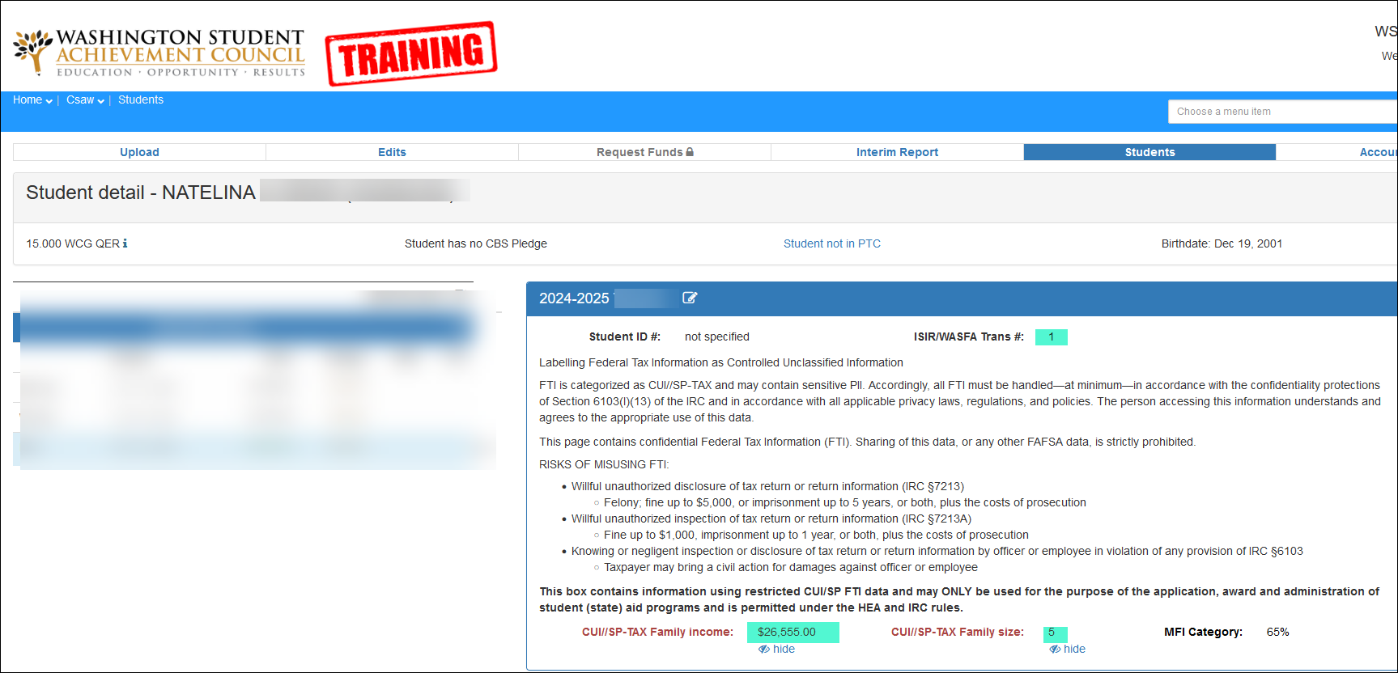

# Independent Students (IS) Scenarios and Outcomes

**Disclaimer:** For testing purposes, we used the access we had to two college’s WSAC Training Portal to verify WSAC’s calculation of income and family size. Between this section and the [*Dependent Students (DS) Scenarios and Outcomes section*](#_Dependent_Students_(DS)_2), we have tried to touch upon as many scenarios as possible to show how the WCG Income and Family Size SQLs act.

**IS: Single / Tax Filer / Reported Family Size on ISIR**

Dependency: **Independent**

ISIR Transaction #: **1**

Student Marital Status: **Single**

Student’s Filing Status: **Head of Household**

Reported Family Size: **2**

**\*\*WCG CEMLI Calculation\*\***

WCG Income: **Student’s FTI AGI & untaxed income**

= 53769

Family Size: **Reported Family Size**

= 2

**\*\*WSAC Portal Check\*\***

WCG Income: 53769

**Exact match!**

Family Size: 2

**Exact match!**

**IS: Married / Student Filer / Spouse Non-Filer**

Dependency: **Independent**

ISIR Transaction #: **1**

Student Marital Status: **Married**

Student’s Filing Status: **Single**

Spouse’s Filing Status: **(blank)**

Reported Family Size: **(blank)**

Assumed Family Size: **(blank)**

Student’s Exemptions: **2**

**\*\*WCG CEMLI Calculation\*\***

WCG Income: **Student’s FTI AGI & untaxed income + Spouse’s Manual AGI & untaxed income**

= 12211

Family Size: **Student’s Exemptions**

= 2

**Note:** If Spouse’s Manual AGI wasn’t present, the SQL would pick up reported income worked

**\*\*WSAC Portal Check\*\***

WCG Income: 12211

**Exact match!**

Family Size: 2

**Exact match!**

**IS: Single / Tax Filer / PJ Flag on ISIR**

Dependency: **Independent**

ISIR Transaction #: **3**

Student Marital Status: **Single**

Student’s Filing Status: **Single**

Reported Family Size: **1**

**Has PJ Flag**

**\*\*WCG CEMLI Calculation\*\***

WCG Income: **Student’s Manual AGI & untaxed income**

= 533

Family Size: **Reported Family Size**

= 1

**\*\*WSAC Portal Check\*\***

WCG Income: 533

**Exact match!**

Family Size: 1

**Exact match!**

**IS: Divorced / Non-Filer / No Reported or Assumed Family Size on ISIR**

Dependency: **Independent**

ISIR Transaction #: 2

Student Marital Status: **Divorced**

Student’s Filing Status: (**blank)**

Reported Family Size: **(blank)**

Assumed Family Size: **(blank)**

**\*\*WCG CEMLI Calculation\*\***

WCG Income: **Student’s Manual AGI & untaxed income**

= 0

Family Size: **Assumption Hierarchy (Independent Student; Not Married)**

= 1

**\*\*WSAC Portal Check\*\***

WCG Income: 0

**Exact match!**

Family Size: 1

**Exact match!**

**IS: Remarried / Filed Jointly**

Dependency: **Independent**

ISIR Transaction #: **1**

Student Marital Status: **Remarried**

Student’s Filing Status: **Married-Filed Joint**

Spouse’s Filing Status: **(blank)**

Reported Family Size: **2**

**\*\*WCG CEMLI Calculation\*\***

WCG Income: **Student’s FTI AGI & untaxed income**

= 79822

Family Size: **Reported Family Size**

= 2

**\*\*WSAC Portal Check\*\***

WCG Income: 79822

**Exact match!**

Family Size: 2

**Exact match!**

**IS: Remarried / One Filed Joint and the Other Filed Head of Household**

Dependency: **Independent**

ISIR Transaction #: **5**

Student Marital Status: **Remarried**

Student’s Filing Status: **Married-Filed Joint**

Spouse’s Filing Status: **Head of Household**

Reported Family Size: **5**

**\*\*WCG CEMLI Calculation\*\***

WCG Income: **Student’s FTI AGI & untaxed income**

= 106837

Family Size: **Reported Family Size**

= 5

**Note:** Student appears on QCS_FA_WCG_MARITAL_FILING_DISC query for review

**\*\*WSAC Portal Check\*\***

WCG Income: 83521

**Difference in calculation due to being out of scope**

See #2 Married Students or Parents with One Filed ‘Married Filed Jointly’ and the Other Filed a Different Status section.

Family Size: 5

**Exact match!**

**IS: Married / Filed Separately / Assumed Family Size on ISIR**

Dependency: **Independent**

ISIR Transaction #: **2**

Student Marital Status: **Married**

Student’s Filing Status: **Single**

Spouse’s Filing Status: **Single**

Reported Family Size: **(blank)**

Assumed Family Size: **2**

**\*\*WCG CEMLI Calculation\*\***

WCG Income: **Student FTI AGIs & untaxed incomes + Spouse’s FTI AGIs & untaxed incomes**

= 28890

Family Size: **Assumed Family Size**

= 2

**\*\*WSAC Portal Check\*\***

WCG Income: 27129

**Difference in calculation due to WSAC including optional offset of FWS earnings.**

See Out Scope #1 WSAC’s Inclusion of Optional Income Offsets section.

Family Size: 2

**Exact match!**

**IS: Married / Filed Separately / Spouse Non-Tax Filer / PJ Flag on ISIR**

Dependency: **Independent**

ISIR Transaction #: **3**

**Has PJ Flag**

Student Marital Status: **Married**

Student’s Filing Status: **Single**

Spouse’s Filing Status: **(blank)**

Reported Family Size: **2**

**\*\*WCG CEMLI Calculation\*\***

WCG Income: **Student’s Manual AGI & untaxed income + Spouse’s Manual AGI & untaxed income**

= 36445

Family Size: **Reported Family Size**

= 2

**Note:** If Manual AGI & untaxed income is not present, the SQL will pull FTI AGI & untaxed income

**\*\*WSAC Portal Check\*\***

WCG Income: 36445

**Exact match!**

Family Size: 2

**Exact match!**

**IS: Widowed / Filed ‘Qualifying Surviving Spouse’**

Dependency: **Independent**

ISIR Transaction #: **2**

Student Marital Status: **Widowed**

Student’s Filing Status: **Qualifying Surviving Spouse**

Reported Family Size: **(blank)**

Assumed Family Size: **(blank)**

Student’s Exemptions: **4**

**\*\*WCG CEMLI Calculation\*\***

WCG Income: **Student’s FTI AGI & untaxed income**

= 6404

Family Size: **Student’s Exemptions**

= 4

**\*\*WSAC Portal Check\*\***

WCG Income: 6404

**Exact match!**

Family Size: 4

**Exact match!**

**IS: Separated / Filed Jointly**

Dependency: **Independent**

ISIR Transaction #: **4**

Student Marital Status: **Separated**

Student’s Filing Status: **Married-Filed Joint**

Reported Family Size: **3**

**\*\*WCG CEMLI Calculation\*\***

WCG Income: **Student’s Manual AGI & untaxed income**

= 0

Family Size: **Reported Family Size**

= 3

**Note:** If Student’s Manual AGI & untaxed income is not present, the SQL will pull FTI AGI & untaxed income

**\*\*WSAC Portal Check\*\***

WCG Income: 0

**Exact match!**

Family Size: 3

**Exact match!**

**IS: Divorced / Filed Jointly**

Dependency: **Independent**

ISIR Transaction #: **2**

Student Marital Status: **Divorced**

Student Filing Status: **Married-Filed Joint**

Reported Family Size: **3**

**\*\*WCG CEMLI Calculation\*\***

WCG Income: **Student’s Manual AGI & untaxed income**

= 24566

Family Size: **Reported Family Size**

= 3

**Note:** If Student’s Manual AGI & untaxed income is not present, the SQL will pull FTI AGI & untaxed income

**\*\*WSAC Portal Check\*\***

WCG Income: 24566

**Exact match!**

Family Size: 3

**Exact match!**

**IS: Single / WASFA (no FTI data on ISIR)**

Dependency: **Independent**

ISIR Transaction #: **53**

Student Marital Status: **Single**

Reported Family Size: **1**

**\*\*WCG CEMLI Calculation\*\***

WCG Income: **Student’s Manual AGI & untaxed income**

= 26114

Family Size: **Reported Family Size**

= 1

**Note:** If Student’s Manual AGI & untaxed income is not present, the SQL will pull reported income worked

**\*\*WSAC Portal Check\*\***

WCG Income: 25091

**Difference in calculation due to WSAC including optional offset of Education Credits.**

See [Out Scope #1 WSAC’s Inclusion of Optional Income Offsets section](https://sbctcedu.sharepoint.com/teams/FinancialAid2024/Shared%20Documents/Global%20Documentation/CEMLIs/Overview%20of%20Updates%20WCG%20CEMLI%20-%20WCG%20Income%20and%20Family%20Size.docx#_Award_Package_Criteria).

Family Size: 1

**Exact match!**

**IS: Married / WASFA (no FTI data on ISIR)**

Dependency: **Independent**

ISIR Transaction #: **53**

Student Marital Status: **Married**

Reported Family Size: **4**

**\*\*WCG CEMLI Calculation\*\***

WCG Income: **Student’s Manual AGIs & untaxed incomes + Spouse’s Manual AGIs & untaxed incomes**

= 0

Family Size: **Reported Family Size**

= 4

**Note:** If Manual AGI is not present, the SQL will pull reported income worked

**\*\*WSAC Portal Check\*\***

WCG Income: 0

**Exact match!**

Family Size: 4

**Exact match!**

**IS: Single / Tax Filer but FTI Data Match Failed / Has Dependents**

Dependency: **Independent**

ISIR Transaction #: **1**

Student Marital Status: **Single**

Student’s Filing Status: **(blank)**

Reported Family Size: **(blank)**

Assumed Family Size: **(blank)**

Exemptions: **0**

Has Dependents: **Yes**

**\*\*WCG CEMLI Calculation\*\***

WCG Income: **Student’s Manual AGI & untaxed income**

= 0

Family Size: **Assumption Hierarchy (Independent Student; Not Married w/Dependents)**

= 2

**Note:** If Student’s Manual AGI & untaxed income is not present, the SQL will pull reported income worked

**\*\*WSAC Portal Check\*\***

WCG Income: 0

**Exact match!**

Family Size: 1

**WSAC’s SQL may be seeing the zero populated for Exemptions as a result of the FTI Data match failure.**

Our SQL does not look at Exemptions if there is no FTI Filing status.

We match the value the college chose for the student.

**IS: Single / Reported Foreign Income Exclusion**

Dependency: **Independent**

ISIR Transaction#: **1**

Student Marital Status: **Single**

Student’s Filing Status: **Head of Household**

Reported Family Size: **2**

**\*\*WCG CEMLI Calculation\*\***

WCG Income**: Student’s FTI AGI & untaxed income (includes Foreign Income Exclusion)**

=24945

Family Size: **Reported Family Size**

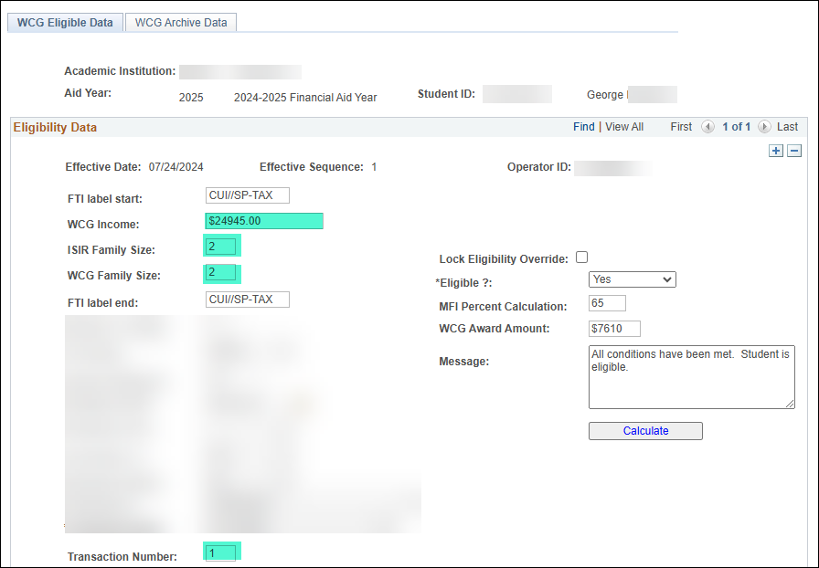=2

**\*\*WSAC Portal Check\*\***

WCG Income: 24945

**Exact match!**

Family Size: 2

**Exact match!**

