- After the WCG Interim reported has been generated in ctcLink, download the Washington College Grant_xxxx.csv
- Open the Washington College Grant_xxxx.csv file and select the IsDelete column (this should be column A)
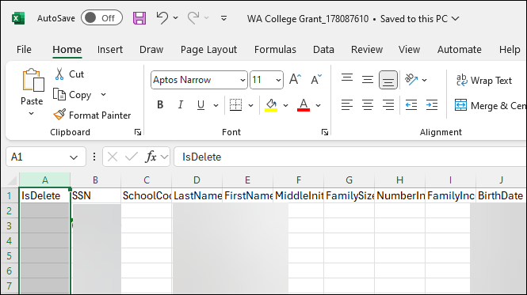

- Once the IsDelete column has been selected, the column can be removed by choosing Delete when Right clicking on a mouse OR by selecting the Delete button on a keyboard
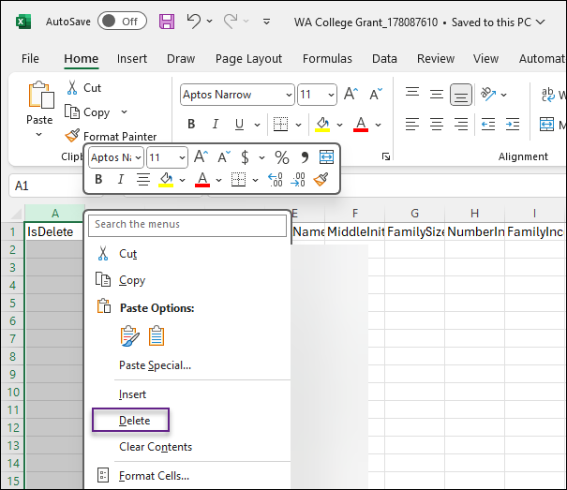
- Once the IsDelete has been removed, column A should now display SSN as the first column
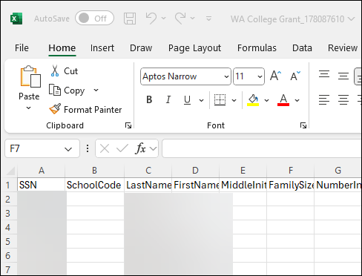
- Select File then Save As. The file must be saved as a CSV (Comma delimited) (*csv) so that SSNs with leading zeroes load correctly in the WSAC Portal. You may rename the file before selecting Save.
