Issue Overview
When Build FA Term is run for census, students with no enrollment activity for the term have the FA Load value set to N while Enrollment Intensity remains at its original value. The expectation is that students with no enrollment activity for the term have FA Load set to N and Enrollment Intensity set to zero.
The resolution to this issue is to be determined by Oracle. FA Support has developed the process below as a workaround. This pop update is intended to be run after the Census Jobset, to set the Enrollment Intensity value to zero for students with no enrollment activity for the term.

Enrollment Intensity Query
Navigation: Reporting Tools > Query > Query Viewer
The query used in the step below can be run in Query Viewer to generate a list of students selected for the pop update. This list may be used later to review student FA Term records.

- Enter the following query name: QCS_FA_ENRL_INTENSITY_FIX
- Select Search
- From the Search Results select HTML or Excel
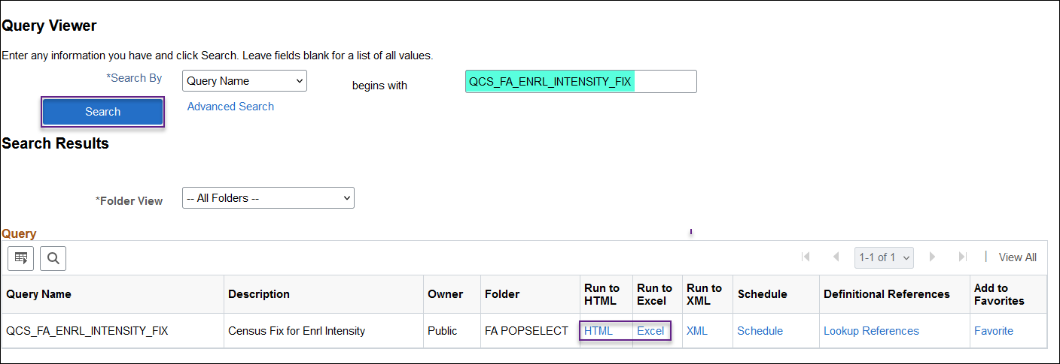
Enter the following fields
- Institution
- Aid Year
- Term
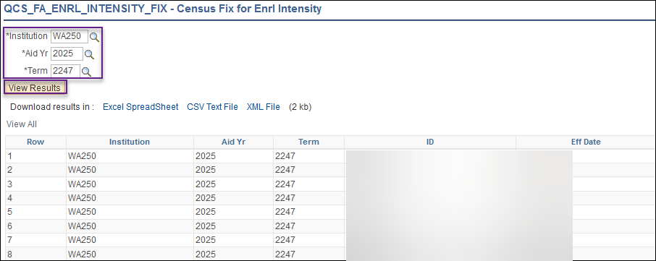

Enrollment Intensity Pop Update
Navigation: Set Up SACR > System Administration > Utilities > Population Update > Population Update Process
This process updates the Enrollment Intensity Percent field on FA Term to 0.00 when FA Load flips to N during Census Jobset.

Enter a New or Existing Run Control ID
- Choose STDNT_FA_TERM – Student FA Term from the Record (Table) Name from the drop-down menu
  - Select the Report Error Messages radio button
- Choose PS Query from the Selection Tool dropdown menu
- Use look up to find the Query Name: QCS_FA_ENRL_INTENSITY_FIX
- Click Edit Prompts and enter the following:
  - Institution
  - Aid Year
  - Term
- For Field Name select Enrollment Intensity Percent
- For Field Value enter 0.00
- Select Preview Selection Results and review student list
- Select Run
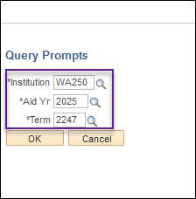
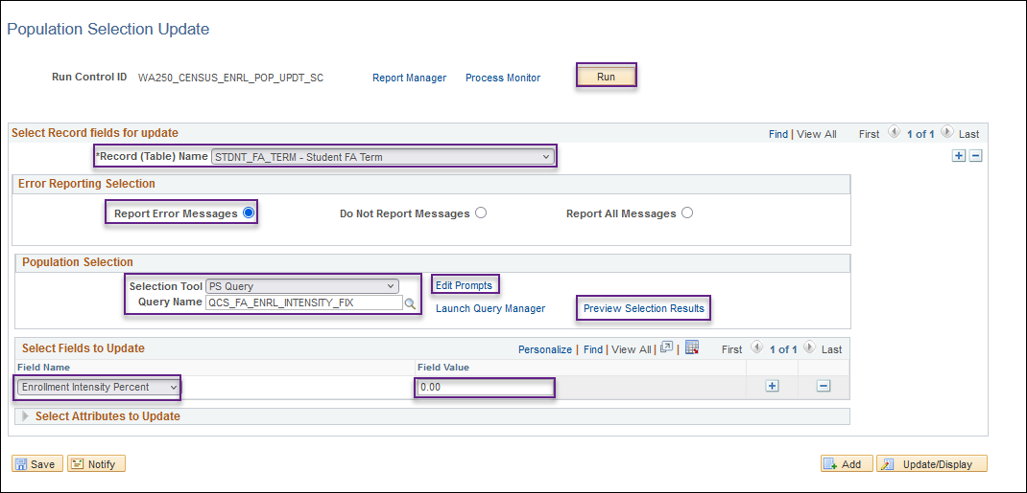

- From the Process Scheduler Request page ensure SCC_POP_UPD is selected. Then select OK.
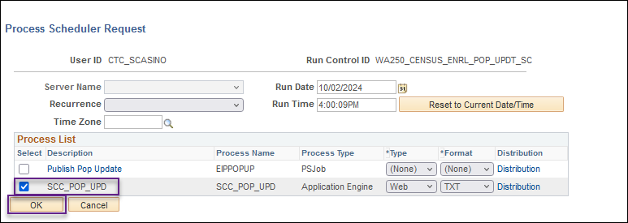
- Ensure process runs to “Success” and “Posted” and select Details 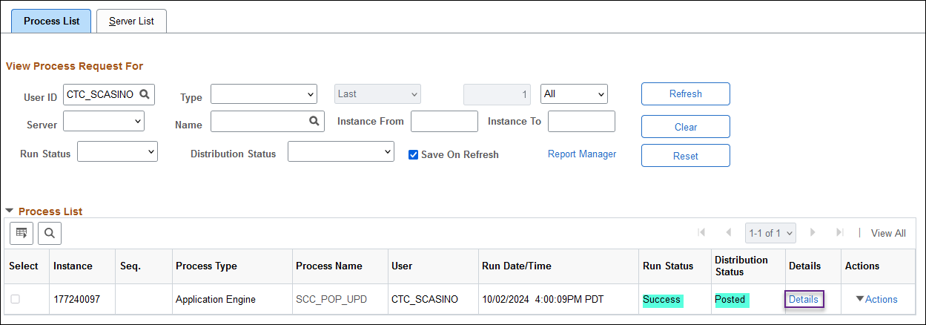
- Select the Message Log link on the Process Detail page to verify the number of students processed
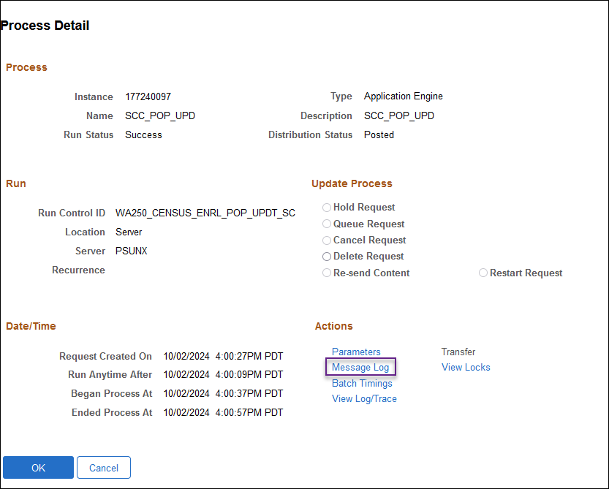
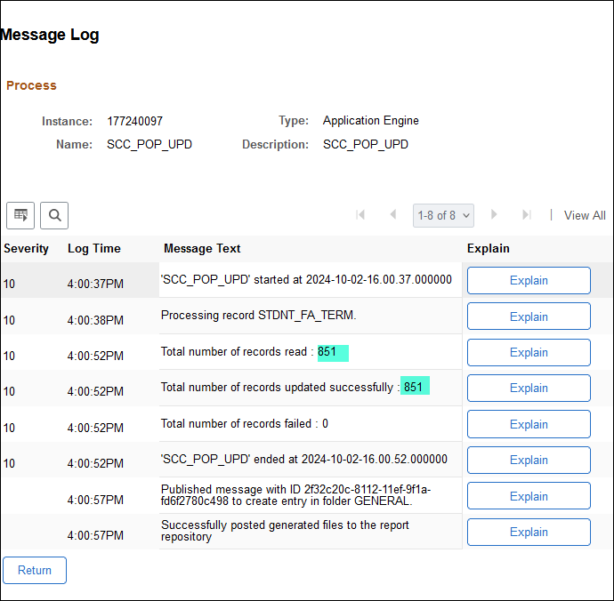

Review Pop Update Results
Navigation: Financial Aid > Financial Aid Term > Maintain Student FA Term
The students processed in the pop update will have the Enrollment Intensity Percent field populated with a value of zero and the override checkbox for Enrollment Intensity Percent is enabled.
