**Enrollment Level Hold/Service Indicator Process-Enrollment Intensity**

The steps in this section support the authorization and disbursement process, preventing the disbursement of financial aid that exceeds the amount for which the student is eligible, based on enrollment intensity. The process identifies students whose enrollment intensity at the time of awarding is different than the enrollment intensity at the time of authorization and disbursement. In addition, the process identifies students who need their awards adjusted from full-time to less-than-full-time.

By following these steps, the colleges will be:

* Mass updating the packaging variables page to include ‘1.00’(full-time) enrollment intensity for all term in the Var **Num** 1-4 fields. The current FLF process uses the Var **Char** 1-4 fields.
* Mass assigning the ‘FLF’ service indicator for students whose Enrollment Intensity value on FA Term is other than full-time and the packaging variable is ‘1.00.’ for the term. As long as the ‘LFTDH’ service impact is included in the Define Item Type Rules setup, disbursement of aid will not occur until colleges have a chance to review and make necessary adjustments.
* Reviewing the Authorization Failure Report (or FLF only query list) and making any necessary adjustments to the packaging variables page, awards, and/or Enrollment Intensity on FA Term.
* Mass releasing the ‘FLF’ service indicator for students whose Enrollment Intensity value on FA Term matches the packaging variable value.

We have added an additional Reason Code of FAEI-*Enroll Intent less than 100%* to each college’s FLF Service Indicator Code. **Please note you will need to have your LSA add this to your** [**Service Indicator Security**](https://ctclinkreferencecenter.ctclink.us/m/56084/l/561287-cs-9-2-sacr-security-service-indicator-security)**.**

**Updating Packaging Variables**

**Set Up SACR > System Administration > Utilities > Population Update > Population Update Process**

This process updates the User Var Num #1 - #4 fields on the Assign Packaging Variables page from ‘0‘ to ‘1.00’; setting all 4 terms to enrollment intensity 100%.

Note:

* User Var Num #1 = Fall Term
* User Var Num #2 = Winter Term
* User Var Num #3 = Spring Term
* User Var Num #4 = Summer Term

1. Enter New or use existing Run Control ID
2. Record (Table) Name = STDNT_PKG_VAR – Student Packaging Variables
3. Enter the following:
   * Institution
   * Aid Year
   * Academic Career = UGRD
4. Error Reporting Selection = Check the “Report Error Messages” radio button
5. Selection Tool = PS Query
6. Query Name = **QCS_FA_ASSIGN_PKG_VARS_EI**
7. Select Edit Prompts and enter the following:
   * Institution
   * Aid Year
   * Select OK
8. Enter the following in the Select Fields to Update section:

Field Name Field Value

* User Var Num #1     1.00
* User Var Num #2         1.00
* User Var Num #3         1.00
* User Var Num #4         1.00

1. Select Preview Selection Results to review list of students receiving update
2. Select Run
3. Ensure the SCC_POP_UPD checkbox is selected, and select OK
4. Ensure process runs to “Success” and “Posted”

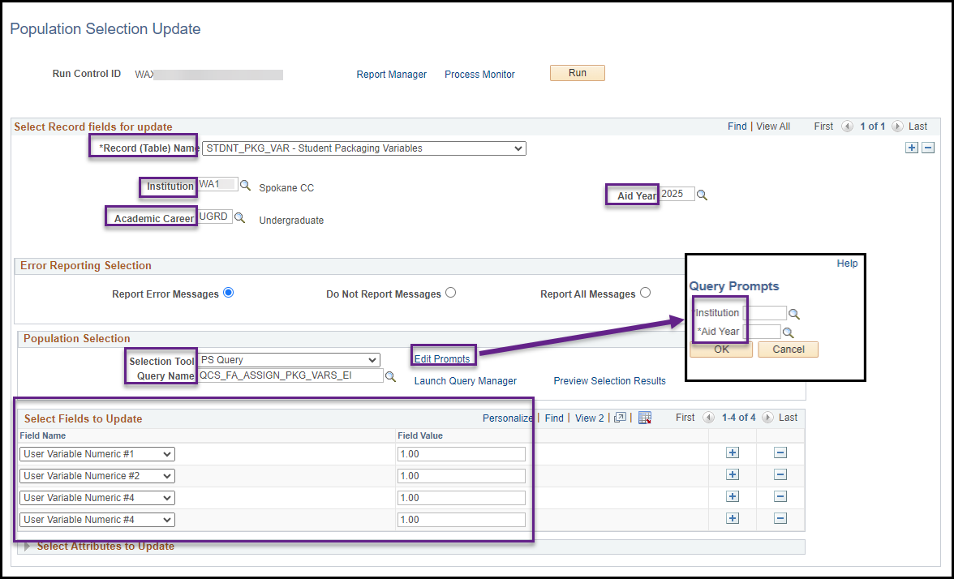

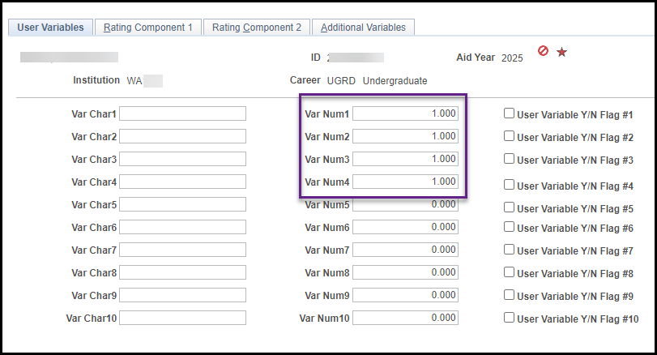

**Assign FLF Service Indicator**

**Campus Community > Service Indicators (Student) > Mass Assign**

This process batch-assigns the ‘FLF’ service indicator to students who have a ‘1.00’ value in the corresponding User Var Num field for the term on which the process is being run, but have a value other than ‘1.00’ in the Enrollment Intensity field on FA Term for the same term.

1. Enter New or use existing Run Control ID
2. Query Name = **QCS_FA_ENROLL_INT_FLF_ADD**
3. Select Edit Prompts and enter the following:
   1. Institution
   2. Aid Year
   3. Term
   4. Select OK
4. Under Service Indicator Data enter the following:
   1. Institution
   2. Service Indicator Code = FLF Financial Aid Less than FT
   3. Reason = FAEI Enroll Intent less than 100%
5. Under Effective Period choose the desired Start Term and End Term
6. Select Run
7. Ensure process runs to “Success” and “Posted”

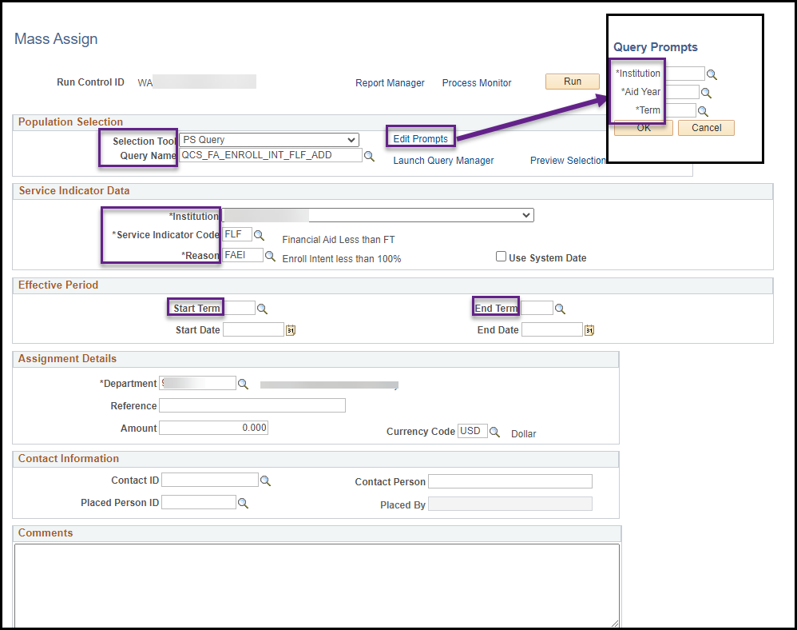

## Service Indicator List Query (Optional)

**Reporting Tools > Query > Schedule Queries**

In addition to using the Authorization Failure Report to identify students who have the ‘FLF’ service indicator assigned that need aid adjusted and Packaging Variables page updated for the appropriate term, colleges have the option to run a query. The query will list only students with the ‘FLF’ service indicator**.**

-use the generated report to update the students listed & adjust aid as necessary

1. Enter New or use existing Run Control ID
2. Query Name = **CTC_FA_SRVC_INDICATOR_LIST**
3. Select Search
4. Choose Appropriate Query
5. Enter the Following when the Edit Prompts appear:

* Institution
* Active Term
* Service Indicator Code = FLF
* Select OK

1. You will be returned to the Schedule Queries page with the fields populated
2. Select Run
3. Ensure process runs to “Success” and “Posted”
4. Use the report generated to update the student listed & adjust aid as necessary

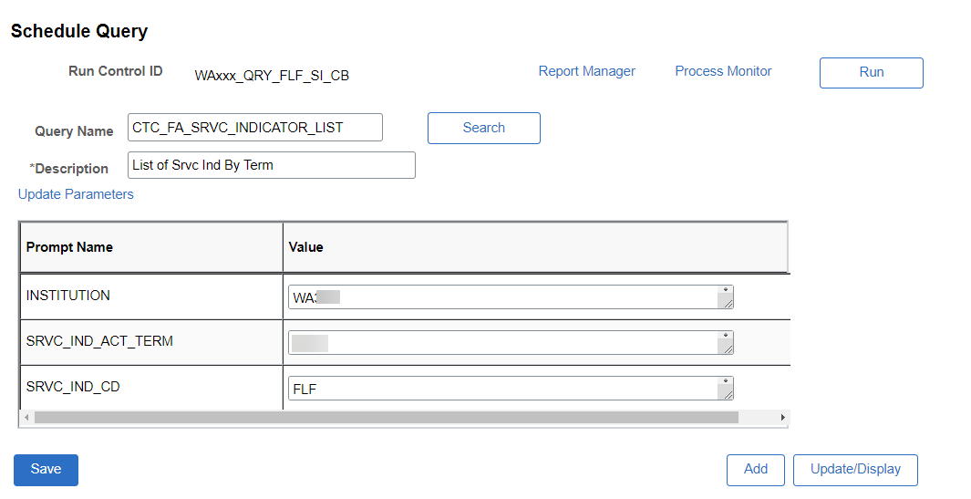

## Updating Packaging Variables

**Awards > Award Processing > Assign Packaging Variables**

Update Packaging Variables to reflect student’s enrollment intensity on FA Term

From the Assign Packaging Variables page enter the following:

* Student ID
* Institution
* Aid Year
* Select Search

Update Packaging Variable Term values.  If, for example, awards for fall are modified, set the Var Num1 to match the FA Term Enrollment Intensity.  The next time the FLF Mass Release runs, the service indicator will be removed.  They can also be removed manually.  Be sure to select Save when updating Packaging Variables.



**Note: when updating the Var Num field manually it must be in decimal format as illustrated in the chart below. For instances where you would have put N in the Var Char field you will now put 0.00 in the Var Num field.**

|  |  |  |
| --- | --- | --- |
| **Credit Hours** | **Enrollment Level** | **Enrollment Intensity** |
| 12 (or more) | Full Time | 1.00 |
| 11 | Three-Quarter Time | .92 |
| 10 | Three-Quarter Time | .83 |
| 9 | Three-Quarter Time | .75 |
| 8 | Half-Time | .67 |
| 7 | Half-Time | .58 |
| 6 | Half-Time | .50 |
| 5 | Less-than-Half-Time | .42 |
| 4 | Less-than-Half-Time | .33 |
| 3 | Less-than-Half-Time | .25 |
| 2 | Less-than-Half-Time | .17 |
| 1 | Less-than-Half-Time | .08 |

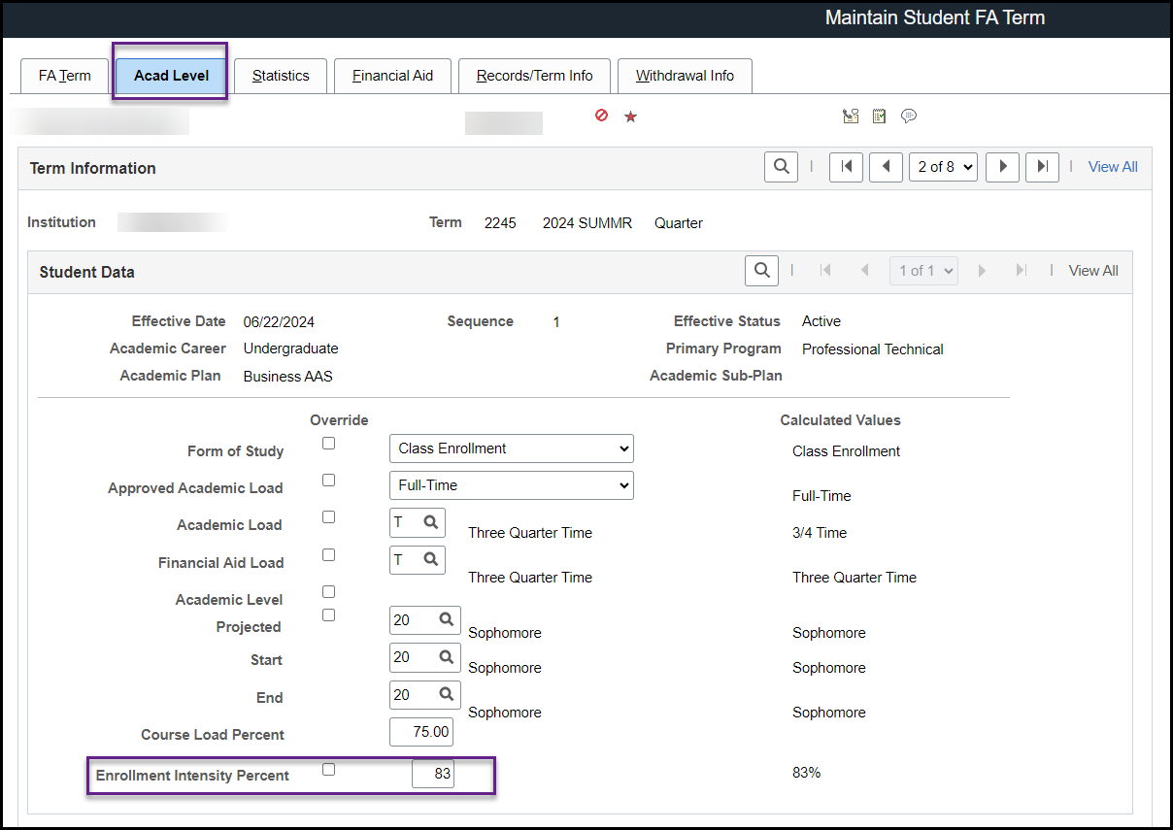

## Remove FLF Service Indicator

**Campus Community > Service Indicators (Student) > Mass Release**

Remove FLF Service Indicators from students where all aid has disbursed, or Packaging Variable now matches the corresponding FA Term row.

1. Enter New or use existing Run Control ID
2. Query Name = **QCS_FA_ENROLL_INT_FLF_REMOVE**
3. Select Edit Prompts and enter the following:
   1. Institution
   2. Aid Year
   3. Term
   4. Select OK
4. Under Service Indicator Data enter the following:
   1. Institution
   2. Service Indicator Code = FLF Financial Aid Less than FT
   3. Reason = FAEI Enroll Intent less than 100%
5. Under Effective Period choose the desired Start Term and End Term
6. Select Run
7. Ensure the select SCC_SI_RLS checkbox is selected and select OK
8. Ensure process runs to “Success” and “Posted”

