**Before mass removing the EA checkbox, it’d be best practice to download the list of students that have the EA checkbox to keep for your records.**

**Navigation:** Reporting Tools > Query > Query Viewer

**Query:** QCS_FA_REMOVE_EA_IND_IN_BATCH

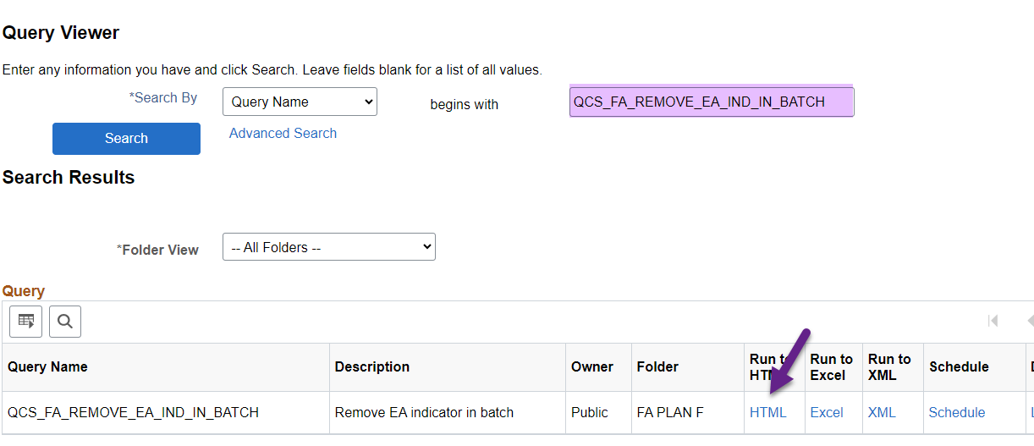

Query prompts are Institutions and Aid Year. 😊

Download the list by selecting **Excel Spreadsheet.**

**When you’re ready, navigate to Population Update Process.**

**Navigation:** Set Up SACR > System Administration > Utilities > Population Update > Population Update Process

Select **Add a New Value** tab

**Create a unique Run Control ID** which includes your college destination and initials

Select the following

**Record (Table) Name:** STDNT_AWARDS – Student Awards

**Error Reporting Selection:** (leave the default of *Report Error Messages* selected)

**Selection Tool:** PS Query

**Query Name:** QCS_FA_REMOVE_EA_IND_IN_BATCH

**Note:** If *Edit Prompt* does not appear, select the Tab button on your keyboard or select Save at the bottom of the screen.

After entering the query prompts, carefully select the following for the *Field to Update* section.

**Field Name:** External Award

**Field Value:** N

Select **Preview Selection Results** to double check the query and parameters are correct

Select **Run**

Select **SCC_POP_UPD** then **OK**

Select **Process Monitor**

Once the process has updated to *Success* and *Posted*, select **Details**.

Select the **Message Log**

The total number of records read should match the total number of records updated successfully!

You’re done! 😊