**Adding Housing into Budgets**

**Security Prerequisites**

Staff that wish to utilize the population update below will require Population Update Security for the **STDNT_AID_ATRBT** Record.

**Global Default Value**

The global default value for the Projected Housing Type is set to *Off Campus*. When the nightly ISIR Jobset runs, CTCFABUD will build all students with a Housing Type of *Off Campus*.

**Note:** The global default value of *Off Campus* will not automatically populate the Housing Type field on the *View Packaging Status Summary* page. The field will appear blank. The Housing Type field on *View Packaging Status Summary* page is only populated through the Housing Type population update process below or through manual intervention.

**Housing Type field & Budget Formulas**

Beginning with aid year 2025, the U.S. Department of Education removed the field for students to indicate their housing plan for each school that will receive their FAFSA. This change has also been implemented on the WASFA. Oracle updated budget processing to consider the selected Housing Type of the student. Budget formulas will read the selected Housing Type from the *View Packaging Status Summary* page or the global default to calculate the appropriate amount for the housing category on the *Maintain Student Budget* page.

The population update process below can be used to batch update students to a Housing Type of *With Parent* or *On Campus.*

**Housing Type Pop Update**

**Creating csv file for External File**

|  |  |
| --- | --- |
| **Navigation** | **Description** |
| Reporting Tools > Query > Schedule Queries | File Review Query |

Based on the results from the query below, staff can identify a population of students to create a csv file to pop update the Housing Type field on the View Packaging Status Summary page. The only required field for this process is EMPLID.

**IMPORTANT:** The projected housing type displayed on the query results pulls from *the Maintain Student Budget* page, not the value on the *View Packaging Status Summary* page.

***Note:*** If a list of students already exists, for example, the Housing Department provides a list of students living in the Dorm, skip to Step 11 to create the .csv file

1. Enter New or use existing Run Control ID
2. Enter the following query name and select **Search: QCS_FA_FILE_REVIEW_DATA**
3. From the Scheduled Query Search page, select the query name

1. When the Edit Prompts open, enter the following:

* Institution
* Aid Year

1. Ensure the parameters are correct and select **Run**

1. Select **OK** from the *Process Scheduler Request* page

1. Select **Process Monitor** from the *Schedule Query* page

1. Ensure the process runs to **Success** and **Posted**
2. Select the **Details** link and then the **View Log/Trace** Option to download the query results

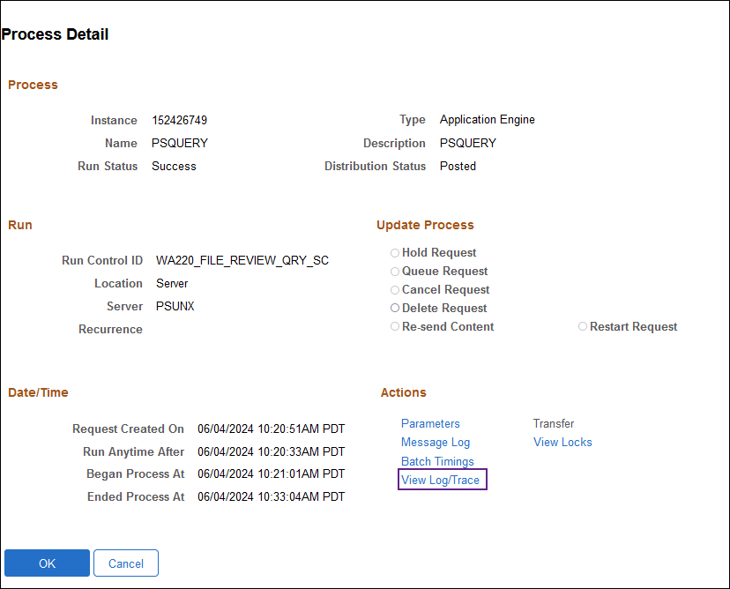

1. Filter query to identify the desired student population
2. Copy and paste the list of EMPLIDs into **column 1** of a new .csv file. *A header is required*. This header name can be either of the following: ***ID*** *or* ***Empl ID.***

**or**

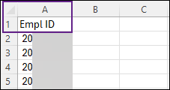

1. When you are ready to save your file, select ***File*** then ***Save As*.** The file must be saved as **CSV (comma delimited) (*csv)**

**Note: Do not open the csv file once it has been saved to your desktop.** Opening the csv may cause the file to error during processing.

**Population Selection Update – Run Control Set Up**

|  |  |
| --- | --- |
| **Navigation** | **Description** |
| Set up SACR > System Administration > Utilities > Population Update > Population Update Process | This process batch updates the Housing Type field on the View Packaging Status Summary page for the selected student population |

This process should be run on demand before the nightly ISIR Jobset is scheduled to run, so that CTCFABUD can pick up any changes to students’ Housing budget. When this pop update runs, it will automatically flip the Budget Required field in FA Term to Yes for the terms in the 2025 aid year. **(*This will occur on an existing row, it will not insert a new effective dated row in FA Term. However, maintain student budgets will have a new effective dated row*)**

1. Enter New or use existing Run Control ID
2. **Choose STDNT_AID_ATRBT –** Packaging Status Summary from the Record (Table) Name from the dropdown menu
3. Enter the following:
   * Institution
   * Aid Year
4. Select the **Report Error Messages** radio button
5. Choose **External File** from the **Selection Tool** dropdown menu
6. Select **Upload File**
   * This will load the list of EMPLIDs from the “***Creating Csv File for External File***” step above
   * Students can be verified in Preview Selection Results
7. Use the lookup tool next to File Mapping to choose **PACK STAT SUMM**
8. For **Field Name** select **Projected Housing Type** from the dropdown menu
9. For **Field Value** select the appropriate housing type for the population of students in your file **(On Campus or With Parent)**
10. Select **Run**

1. From the *Process Scheduler Request* page ensure **SCC_POP_UPD** is selected. Then Select **OK.**

1. Ensure process runs to “**Success**” and “**Posted**”

**Manually Updating Housing Type Field**

|  |  |
| --- | --- |
| **Navigation** | **Description** |
| Financial Aid > View Packaging Status Summary | Update the Housing Type field on the View Packaging Status Summary page for an individual student |

From the *Packaging Status Summary* page enter the following criteria and select **Search**:

* Empl ID
* Institution
* Aid Year

Update the **Housing Type** field to the desired value. Select **Save** when complete

Staff can navigate to *Create Student Budget* to manually rebuild the students budget to reflect the updated Housing Type. Alternatively, the CTCFABUD job in the nightly ISIR jobset will pick up any changes to the students’ housing budget.