Implementing the 2024-2025 Award Offer Template

**Testing the any new communication template in PCD is recommended before uploading it into production.** Since there are no 2024-2025 awards in PCD to test, please upload the template onto your existing award notification letter code and assign it onto a student awarded aid for 2023-2024.

It is important that you test the merge fields to make sure no links are broken, and some colleges may decide to make changes to the financial aid item-type set up for certain item-types after seeing how they populate into the tables.

**Differences from the 2023-2024 global award offer template versus this template**

* **Addition of the disclosure to student:** “Your award package is an estimate and subject to change due to complications with the implementation of the new FAFSA from the Department of Education”

* **Removed *Expected Family Contribution (EFC) verbiage and merge fields,* and replaced it with *Student Aid Index (SAI)* where applicable**
* **Removed Work Study from the section talking about estimated outstanding costs** to match [NASFAA approved 2024-2025 College Financing Plan template](https://www.nasfaa.org/uploads/documents/dependent_aid_offer_model.pdf)

Before

*Estimated outstanding costs not covered by grants, scholarships, other funding, loans and work study*

After

*Estimated outstanding costs not covered by scholarships, grants and loan*

**Responses to award notification inquiry from AYRO** **sessions**

1. **Do we need a new Award Notification Letter Code starting 2024-2025?**

Yes, with the merge fields being different starting 2024-2025, all colleges need two award notification letter codes so that one can continue assigning the current template and the other can start assigning the new template.

Last week we finished creating Odd Year letter codes for 30 colleges (three colleges already had two letter code) so you should be able to see them in production. They are not available in PCD.

1. **Several colleges asked if housing and food will be separated into two different categories since WFAA split them in the table published for the 2024-2025.**

Dept of Ed does not require a separation and WFAA confirmed they separated them in the table merely to show food is considered in the WFAA budgets

1. **A couple of colleges asked about indicating direct or indirect costs for budget items.**

*When possible and known, indicating which costs are direct - billed by the institution versus indirect – not billed by the institution is encouraged. – WSAC*

It is currently not possible to categorize each budget item as direct or indirect costs in ctcLink.

**Steps for downloading the new award offer template**

There are two award offer templates. Select the one that associates to your summer term by double clicking the appropriate icon.

 

Select ‘**Enable Editing**’ so that you can save the tempate to your local drive and start working on modifying the contents of the template with verbiage tied to your college.

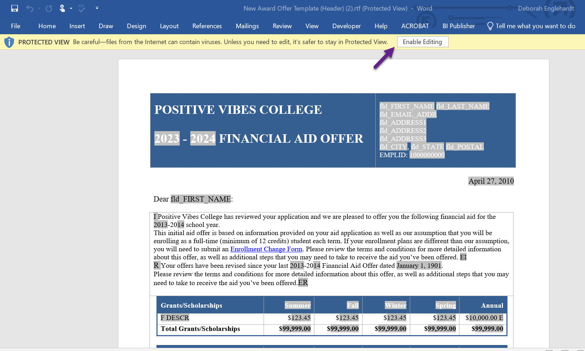

**Be careful when modifying the template**

Fields that are marked grey in the templates are merge fields that populate data from PS so proceed with caution when you are modifying verbiage that includes those fields.

Additional notes about merge fields:

* Changing the font of the merge field is fine, it will not affect the merge fields
* Highlighting words grey will not make an area a merge field

**Financial Aid Item Type setup in relation to the new award offer template**

The **Financial Aid Type** selection determines which table the item-type offer will populate in.

Set Up SACR > Product Related > Financial Aid > Awards > Financial Aid Item Type

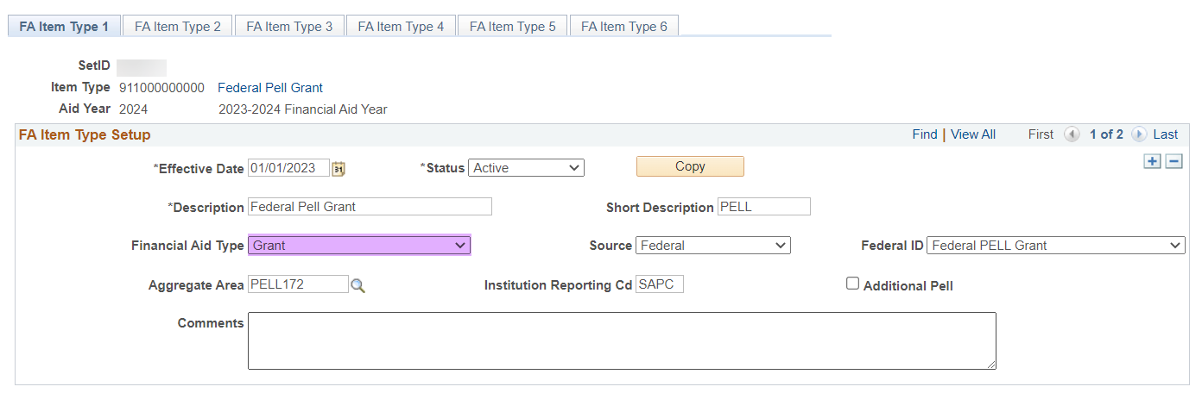

**Note:** When updating the *Financial Aid Type*, add a new effective dates row of today and make the appropriate change then select Save.

|  |  |
| --- | --- |
| **Table** | **Financial Aid Type** |
| Grant/Scholarships | Grant, Scholarship |
| Other Funding | Agency Funding, VA Benefits, Athletic, Bursary, Fellowship, Waiver |
| Work Study | Work/Study |
| Loans | Loan |

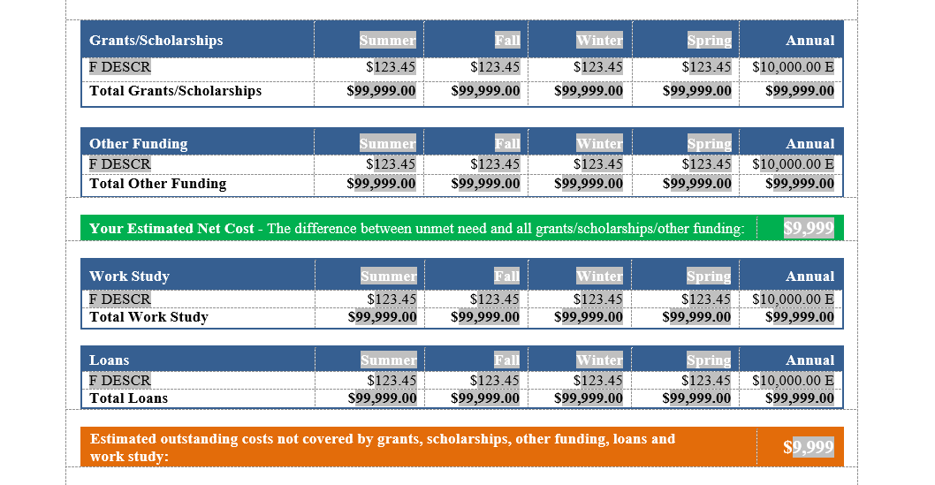

**CTC_FA_LC_AYRO_ITEM_TYPES** query can be run to get a list of all your item-types and the assigned *Financial Aid Type.*

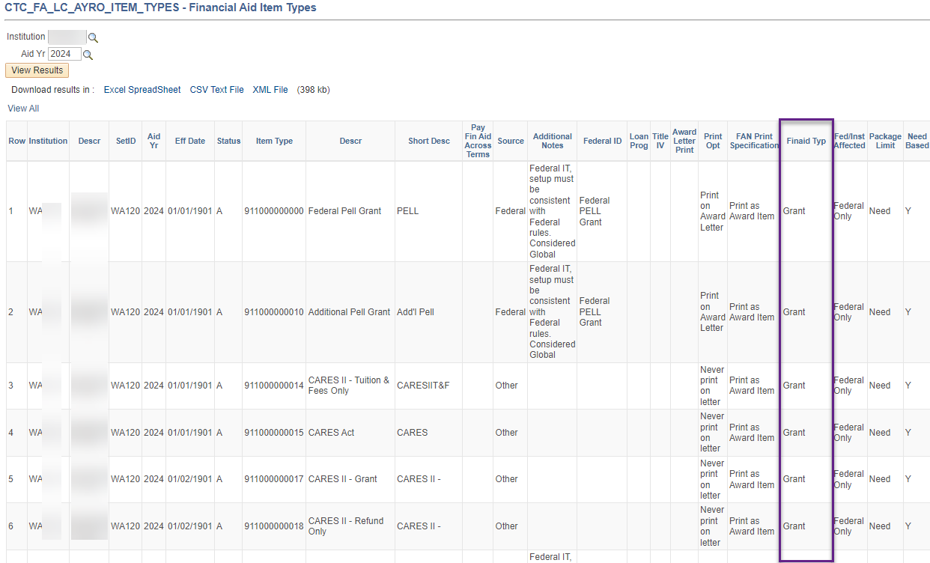

**How to use the “initial offer” message and “revised offer” message feature**

A single letter code can be used for both initial and revised offer notifications. Refer to *the Award Notification* and *Revised Award Notification* section in the *FA Business Flow Guide* for creating the two Run Control IDs if you have not created them already.

<https://ctclinkreferencecenter.ctclink.us/m/92436/l/794730-9-2-fa-business-flow>

The text you place between the **I** and **EI** will appear when the award notification is the initial offer notification for the aid year. In other words, communications that are assigned via the CTC_FA_SB_1ST_AWRD_NOTIF query.

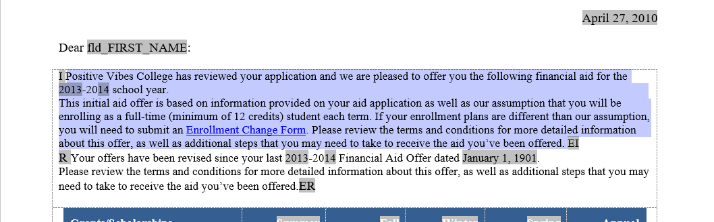

The text you place between the **R** and **ER** will appear when the award notification is a revised offer notification for the aid year. In other words, communications that are assigned via the CTC_FA_SB_AWRD_NOTIF_CHANGE query.

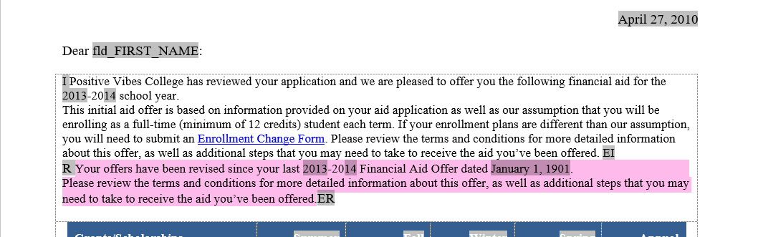

**Uploading the template in PCD/production**

Once you have modified the template with your college-specific verbiage, make sure you have not changed the format and it is still Word RTF then navigate to Reporting Tools > BI Publisher > Create BIP Report Definitions

Change the *Search by* to **Report Category ID** then enter ‘FA’ which will populate a list of colleges to select from. Select your college then select the **Search** button.

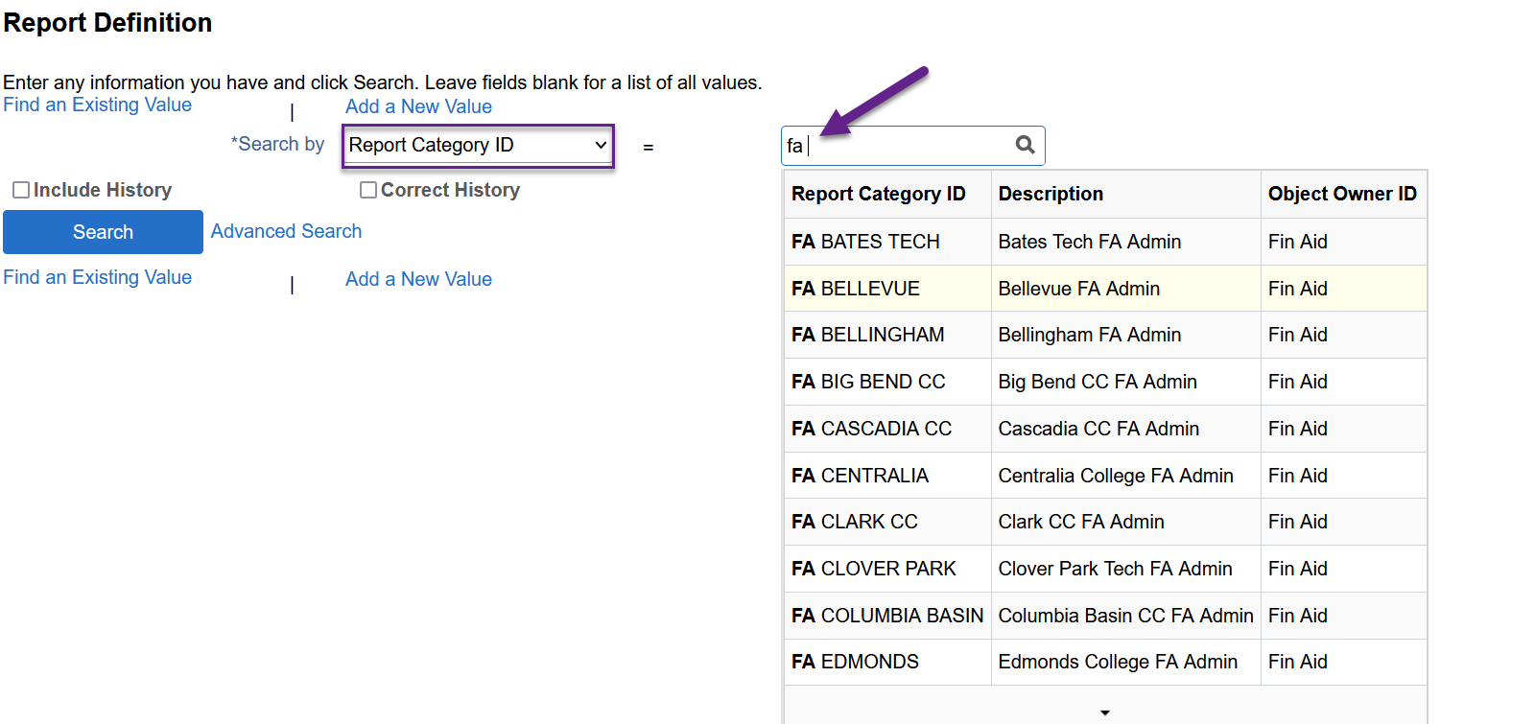

Once you select the award notification letter code for your college, select the **Template** tab, then the **Template File** link. Add a new effective date row of today under the *Template Files* section

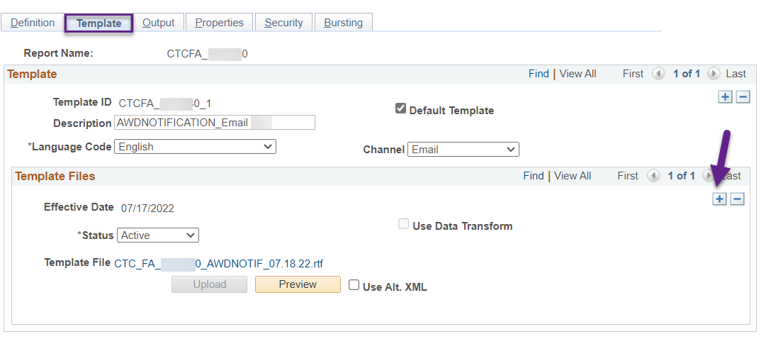

Change the *Status* to **Active** then select the **Upload** button to select your new award offer template.

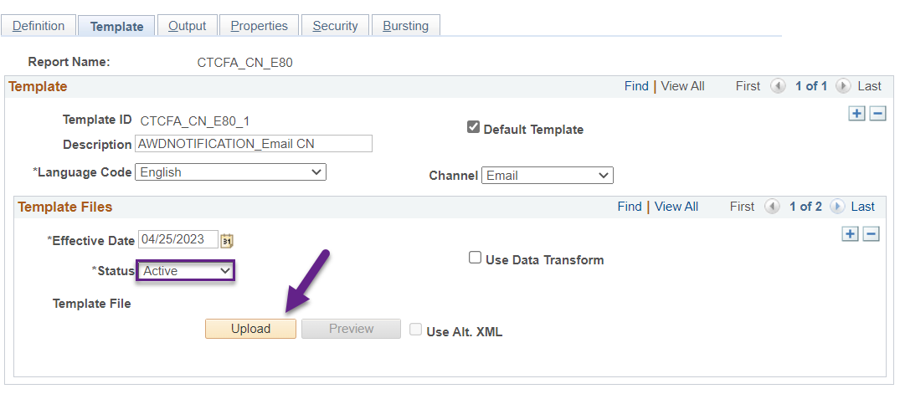

If you get an error message indicating the template cannot be processed when you upload your new award offer template, you may be using a font style that PS does not accept so replace the fancy font with a different font then try uploading again.

Select **Save**.

**Note:** If you have both a Channel: Email and Channel: Printer for your award notification, make sure to update both templates by toggling between the template rows.

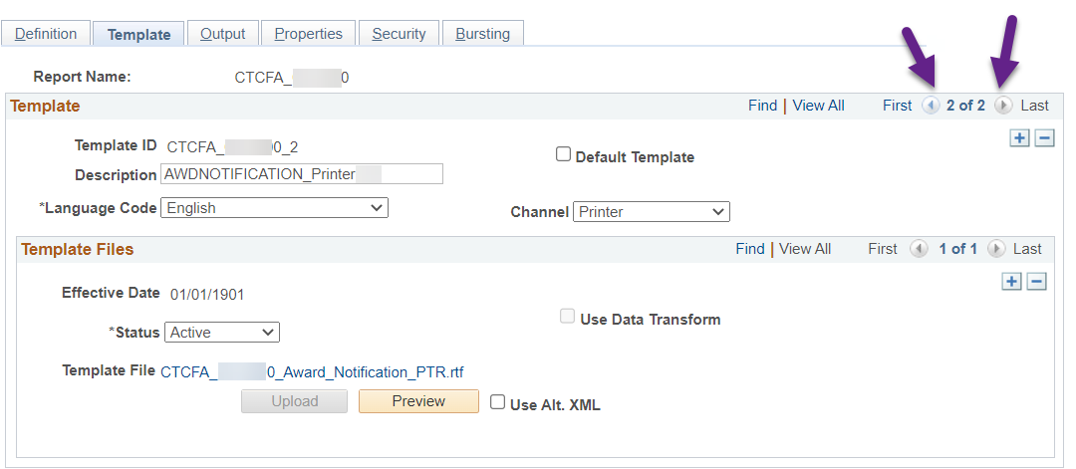

**Recommended testing in PCD**

To make sure the merge fields are working as expected, testing the following scenarios is recommended:

**Scenario 1:** Package a student who has not been awarded for the aid year yet then assign the award notification manually and run Communication Generation

**Expected outcome:** Student should have the “initial offer” message populated and the “revised offer” message should not appear

**Scenario 2:** Adjust aid on a student who has already received an award notification then assign the award notification manually and run Communication Generation

**Expected outcome:** Student should have the “revised offer” message populated and the “initial offer” message should not appear

**Scenario 3:** Assign each type of Financial Aid Type (i.e. a grant item-type, a scholarship item-type, a work study item-type, a loan item-type, an agency item-type, etc.) on one student then assign the award notification manually and run Communication Generation

**Expected outcome:** Each item-type will populate under the correct table, the COA items are correct, and estimated net cost (Unmet need – grants, scholarships and other funding) as well as the estimated outstanding costs (COA – all aid) are accurate.

**Scenario 4:** Package a student for all four terms then assign the award notification manually and run Communication Generation

**Expected outcome:** The award offers populate under the correct terms

**Link to PCD:** [**https://pt-pcd.peoplesoft-nonprod-aws.ctclink.sbctc.edu/ptpcd/signon.html**](https://pt-pcd.peoplesoft-nonprod-aws.ctclink.sbctc.edu/ptpcd/signon.html)