**ISIR Data Load Parameters**

**- Review for accuracy (compare 2025 with 2024 setup)**

**Navigation:  Set Up SACR > Product Related > Financial Aid > File Management > ISIR Data Load Parameters**

Image:  2024-2025 ISIR Data Load Parameters Tab 1

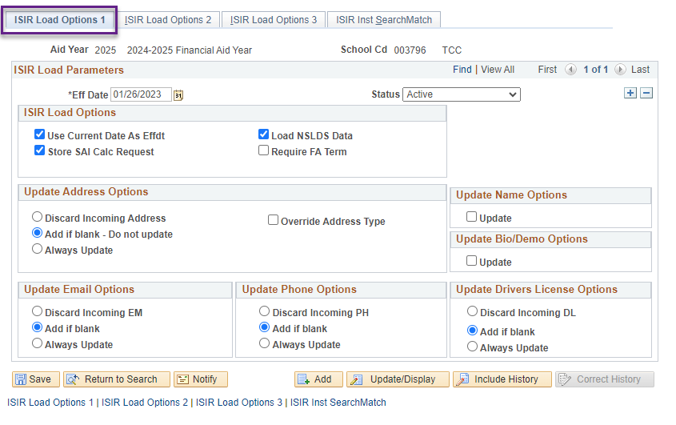

Image:  2024-2025 ISIR Data Load Parameters Tab 2

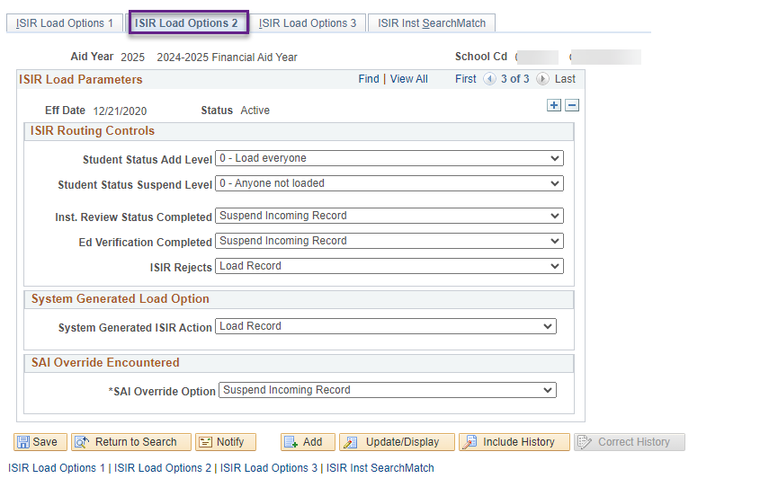  
  
Image:  2024-2025 ISIR Data Load Parameters Tab 3

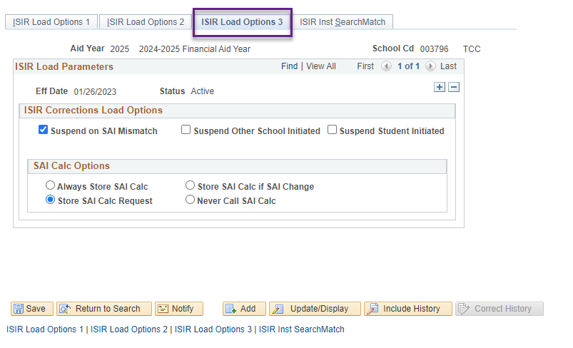

Image:  2024-2025 ISIR Data Load Parameters Tab 4

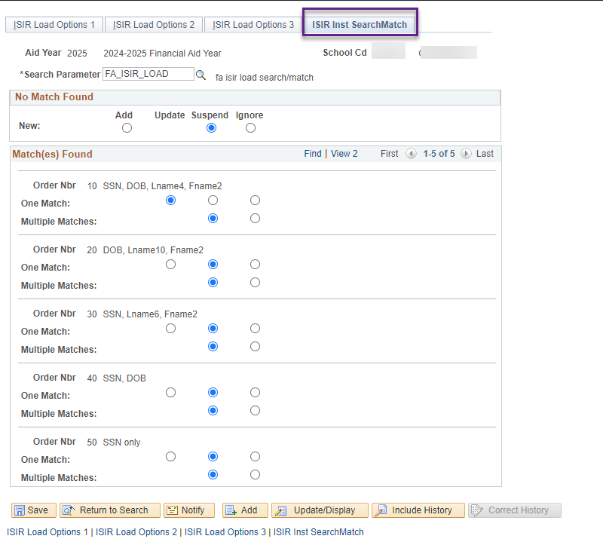

**College Financing Plan**

Housing and meals was updated to Housing and Food by the Dept of Ed on the CFP.

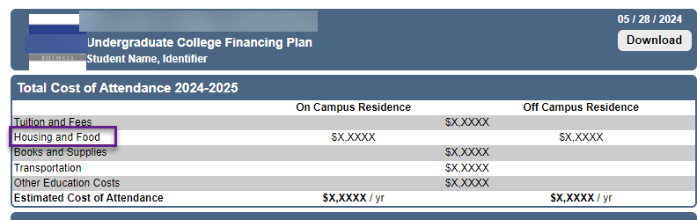

**Navigation:  Set Up SACR > Product Related > Financial Aid > Budgets > Budget Categories**

The description for the Pell Category Housing has be updated to Housing and Food. This will carry over to the Budget Items page & other pages where this field is used.

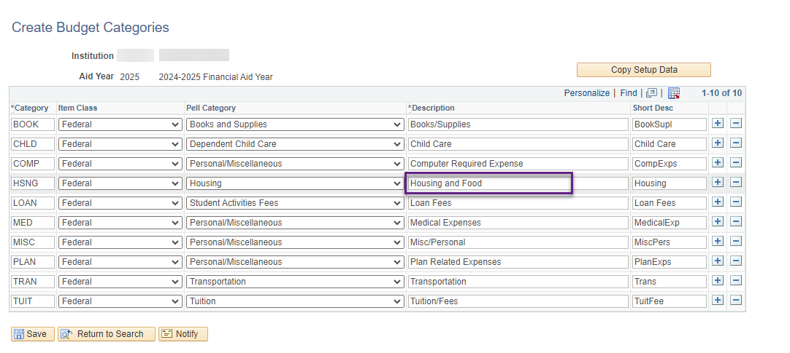

**Navigation:  Set Up SACR > Product Related > Financial Aid > Budgets > Budget Items**

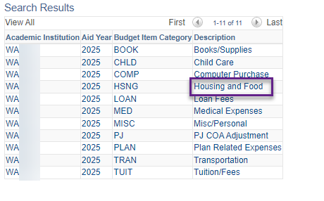

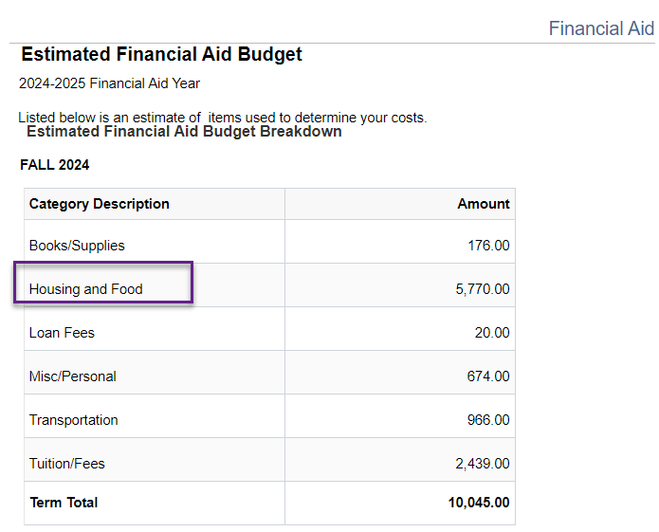

**Aggregate Aid Limit**

**Navigation:  Set Up SACR > Product Related > Financial Aid > Awards > Aggregate Aid Limit**

* Pell Aggregate Aid Limit needs to be updated
* Use Correct History
* Minimum Pell Scheduled Award: 740
* Maximum Pell Scheduled Award: 7395
* Once you SAVE the Aggregate Limit will populate for each Aggregate Level

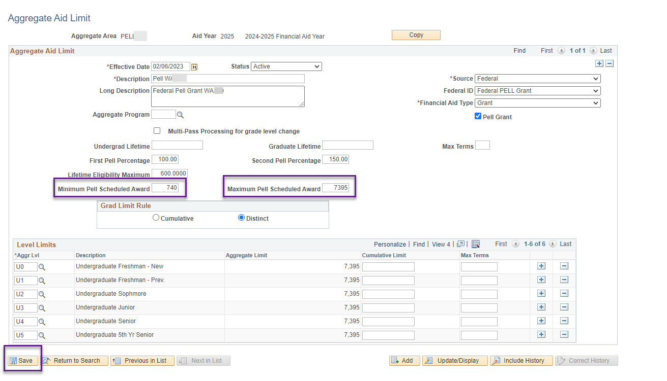

**Pell Payment**

**Navigation:  Set Up SACR > Product Related > Financial Aid > Pell Grants > Pell Payment**

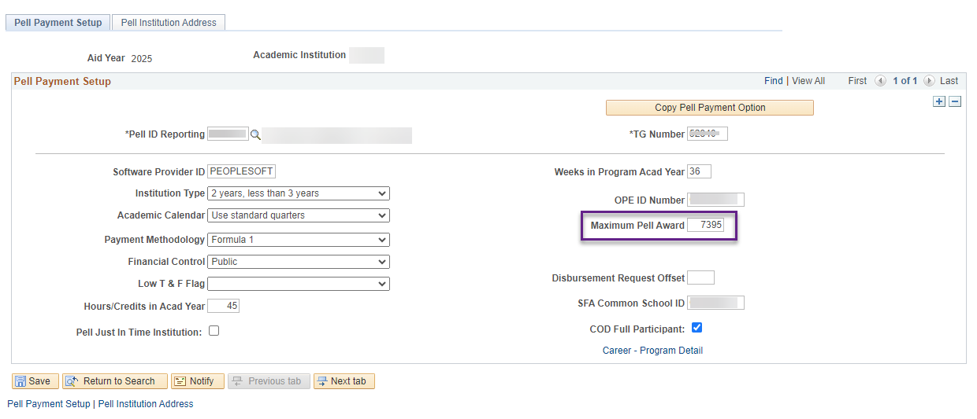

**WCG Equation Processing Options**

**Navigation:  Set Up SACR > Product Related > Financial Aid > CTC Custom > WA College Grant > Equation Processing Options**

The Equation for WA College Grant Processing Options needs to be updated to the new equation.

* CTCFAWCGELIG

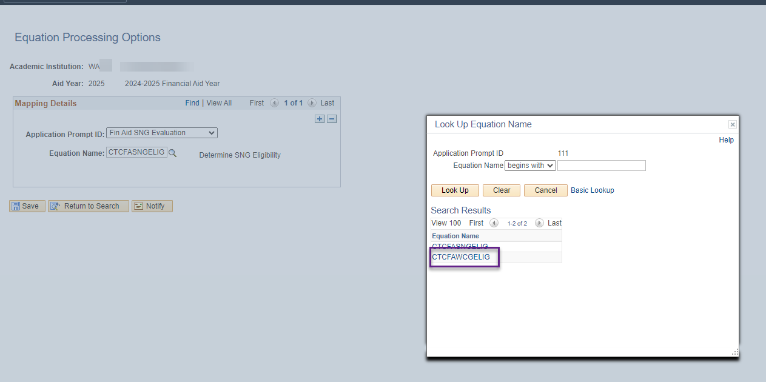

**Updates After 2024-2025 PRP**

**Navigation: Set Up SACR > Product Related > Financial Aid > Application Processing > NA 2024-2025 Global Options**

* Change the *INAS Rule* set to **CSS Rules/Values**
* Confirm *INAS Data* Source is **Federal**.

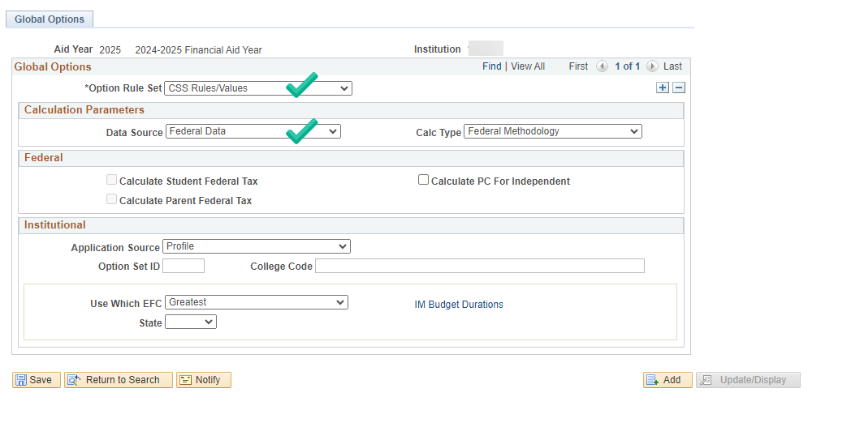

Return to **FAPSAR00 - Process ISIRs** section on the ISIR Jobset Guide for your Odd year ISIR Jobset now to select 2025

Nav Bar > Navigator > Financial Aid > File Management > ISIR Import > Process ISIRs

