9.2 FA Review and Complete Checklist Items

Washington State Board for Community and Technical Colleges

2024-2025 Contingency Awarding Guide

2025

FA Customer Support



**Contents**

Disclaimer 2

Contingency Manual Awarding Process 2

Getting Students Prepped for Awarding 2

Aid Year Activate 3

Build FA Term 4

Build Budgets 6

Changing a Student Budget 8

Manually Award 11

# Disclaimer

The process as it is outlined below is **only** for the contingency plan of awarding due to Financial Ais Administrators’ inability to see all required fields from the FAFSA Submission Summary (FSS) in FPS during this time of the FAFSA Simplification system update delays. It is expected that return to regular processing will begin after June 2024.

# Contingency Manual Awarding Process

During this unprecedented time of delays in awarding due to the technical changes brought forth from the FAFSA Simplification, colleges have the option to use this Contingency Awarding Guide to do manual awarding.

2024-2025 ISIRs will be loaded into an alternative environment to begin review of FAFSA-reported data elements used in the reviewing and packaging process.

Manual awarding will be performed in the PRD environment. Financial Aid staff can award federal and state aid in the PRD environment using 2024-2025 SAI, income, and family size information available from the ISIR in the alternative environment. All Aid Year Rollover steps must be completed in PRD to utilize this Contingency Awarding process, and to award in June/July when FA Support releases the PeopleSoft Release Patchsets (PRP) containing the necessary 2024-2025 updates into PRD.

Award Letters will be sent out through the PRD environment where the awards are made. When the 2024-2025 PRP is in production on June 8th, schools will load the 2024-2025 ISIRs and then revalidate all awards on students whose awards were made using this Contingency Awarding Process in PRD.

When Schema 5.0b for COD reporting is available in PRD in late June, colleges will proceed to originate, disburse, and transmit COD files to and from PRD.

# Getting Students Prepped for Awarding

1. **In PCD**, run in Query Viewer DEV_FA_ISIR_DATA_FOR_VLOOKUP to HTML, *then* Excel Spreadsheet. **Note**: if this query is run directly to Excel, the VLOOKUP in the spreadsheet tool below may not work.
2. Copy and paste the results from the above query into the embedded (below) Excel doc tab: DEV_FA_ISIR_DATA_FOR_VLOOKUP
3. **In production (PRD)**, run in Query Viewer QCS_SR_ENROLLED_STU_SSN to HTML, *then* Excel Spreadsheet. **Note**: if this query is run directly to Excel, the VLOOKUP in the spreadsheet tool below may not work.
4. Copy and paste the results from the above query into the embedded (below) Excel doc tab into the tab: QCS_SR_ENROLLED_STU_SSN
5. **Review tab: Student Info.**  After query results are added into the spreadsheet, the Student Info tab will contain the students who have a valid ISIR loaded into the alternative environment PCD and have summer 2024 term enrollment.



1. Next, after populating the query data into the above embedded spreadsheet, follow the below steps in the **PRD** (Production) environment:

# Aid Year Activate

|  |  |
| --- | --- |
| **Navigation** | **Description** |
| **Financial Aid > Aid Year Activation > Manage Financial Aid Years** | **Manually Aid Year Activate a Student in ctcLink** |

The Aid Year Activation search page displays. On the search page, enter student**ID.**

Select the **Search**button.  The Student Aid Year Activation page will display.

From the **Student Aid Year Activation** page, select the**[+]** button to add a row.  Because a student might be attending more than one college, please ensure that you add the new row to your institution.  In the example provided below, the student has attended one institution for a prior aid year.

Enter the **Institution.**

Enter the **Aid** **Year**.

Select the **Save**button.

Process complete.

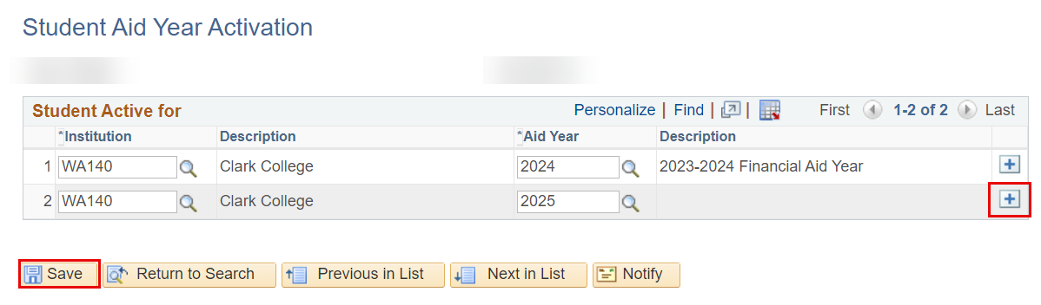

# Build FA Term

|  |  |
| --- | --- |
| **Navigation** | **Description** |
| **Financial Aid >Financial Aid Term >Maintain Student FA Term** | **Manually build FA Term in ctcLink** |

The **Maintain Student FA Term** search page displays.

Enter the student**ID.**

Enter the **Academic Institution**

Enter the**Aid Year**

Select the **Search**button.The**Maintain Student FA Term**page will display.

In the **Term Information** section select the **[+]** button to insert a new row.

In the **Term** **Information** section enter the desired term number in the **Term** field (Use the Lookup tool if you do not know the term number).

In the **Student Data** section select **Build.**

Select**Save.**

Process complete.

**Note:** By building the term for the first term of the AY, the system will automatically build any additional terms for the remainder of the school year.

For example, the Fall, Winter and Spring term should build in projection, but summer will not build unless there is enrollment. So, for header colleges, entering 2245 in FA Term and selecting the **Build** button with the outcome being either 4 terms build (if there's summer enrollment) or 3 terms build (if there's no summer enrollment). For trailer colleges, there would only be 3 terms built.

**Note:** If updating these FA Term fields manually, uncheck the ‘override’ checkboxes so that when a valid ISIR is loaded, the batch FA terms will build reflecting the student’s actual Term Activation, Plan Stack, and enrollment information.

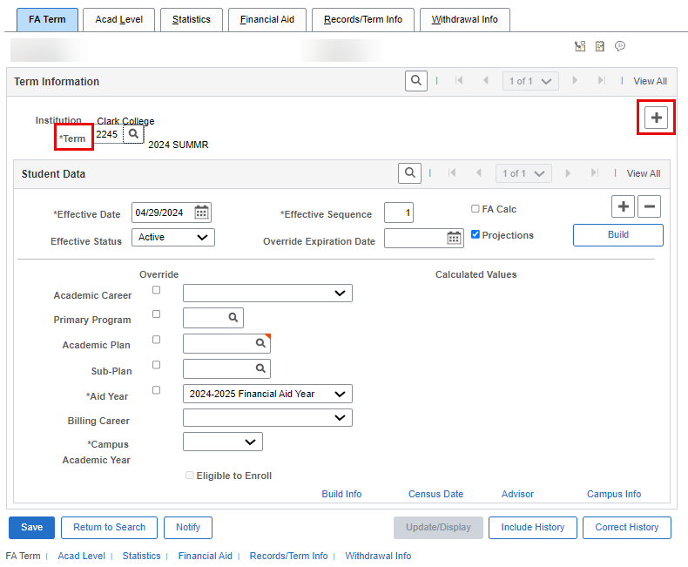

# Build Budgets

|  |  |
| --- | --- |
| **Navigation** | **Description** |
| **Financial Aid > Budgets > Create Student Budget** | **Build a student budget in ctcLink.** |

From the **Create Student Budget** search page, enter the**ID**,**Academic** **Institution** and **Aid Year** and select **Search.**The**Create Student Budget** page will display.

Insert a new **Term** row under **Budget Terms** by selecting the [+] button.

Use the Lookup Tool next to the **Term** field to select the desired term.

**WARNING:** If no terms are available from which to select in the Lookup Tool, this means the FA Term has not been built for that term.

Once the terms are defined, select the **Build Budget**button.

Select the **Detail** link to view the budget information that has been assigned to the terms.

* You can add individual budget items here, i.e., **MISC** budget amount.

**WARNING:** You can add any other items in the individual budget item rows in the **Detail** area.

**Note** that they may not stick when enrollment-based budget changes are made.

If you want to make permanent budget item additions, make them in the Maintain Student Budget page, i.e., Computer allowance, Loan Fees.

**Note:** If your budget formulas include dependency status and/or housing type or any other data element contained within the ISIR record, that budget item will not be populated in the next step, Move Budget, and must be added using the **Changing a Student Budget** step.

The **Detail** link will give a breakdown of the budget term amounts built. Select **OK** to proceed.

Select the **Move Budget**button to assign this budget to the student’s record**.**

The **Move Budget** button will gray out once the process is complete.

Process complete.

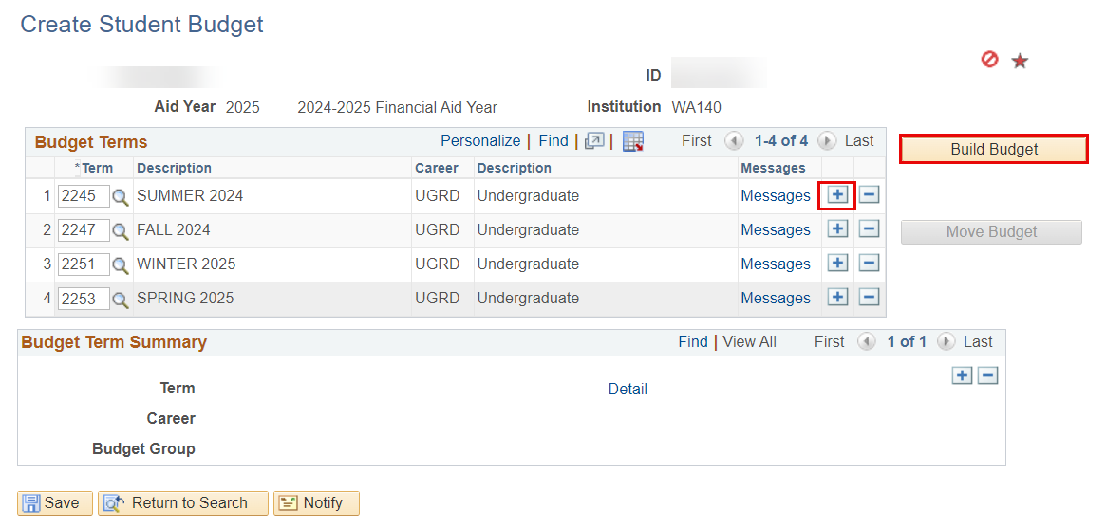

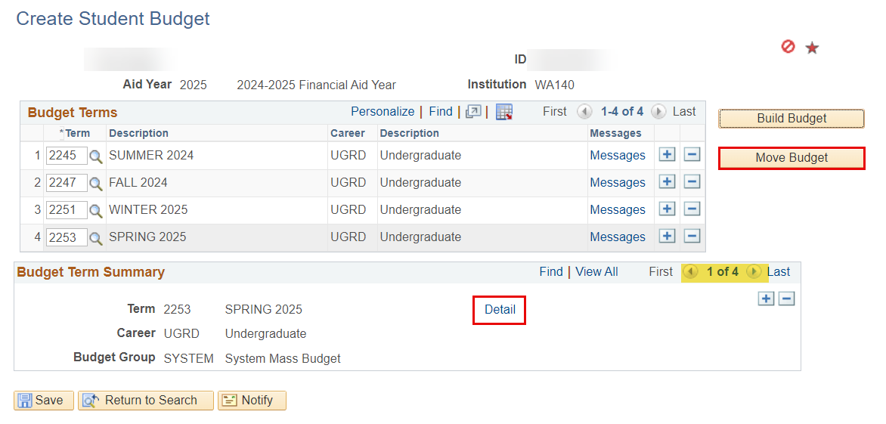

# Changing a Student Budget

|  |  |
| --- | --- |
| **Navigation** | **Description** |
| **Financial Aid > Budgets > Maintain Term Budgets** | **Change a student budget in ctcLink.** |

Some budget group items are tied to responses on the ISIR. To manually build out an accurate budget, you may need to manually update budget items like “Food and Housing” or “Books, course materials, supplies, and equipment”.

On the Budgets Maintenance search page, enter or search for the following fields:

* Student**ID**
* **Academic Institution**
* **Aid Year**

Select the **Search**button.The **Student Budget Maintenance**page will display.

From the Student Budget Maintenance page, insert a new row by selecting the **[+]**button next to the Term COA list within the Budget Group section.

Choose any budget row from the Budget Item section and select the **[+]**button to insert a new budget row.

Repeat for all terms.

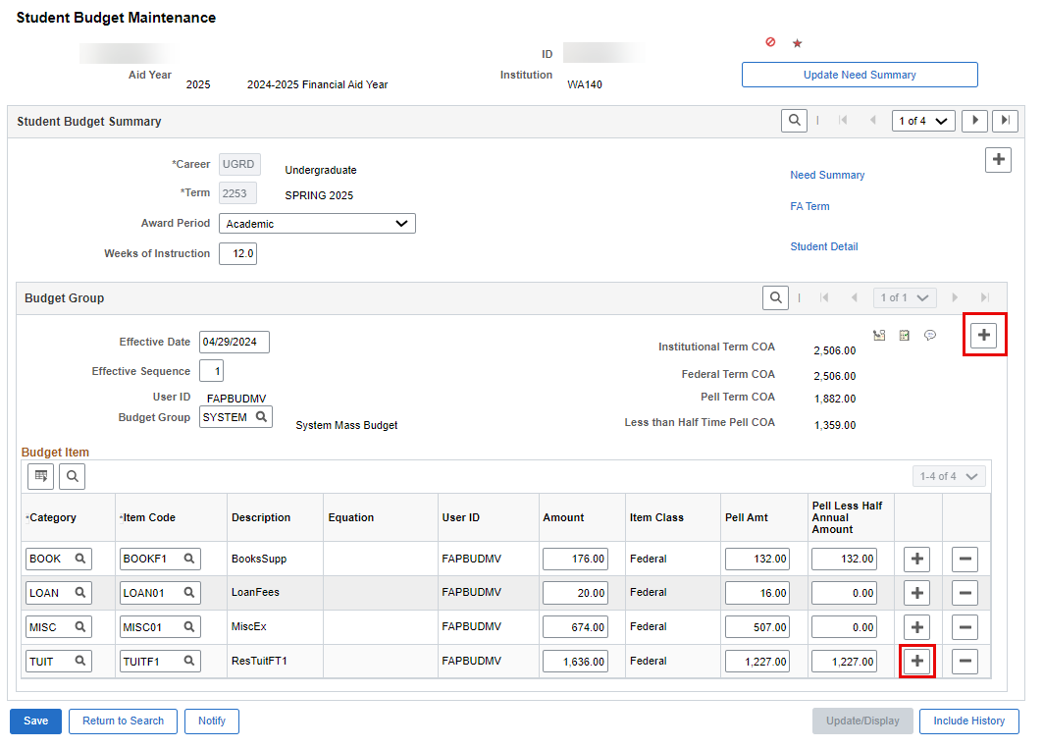

Use the lookup tool to choose a **Budget Category Code**

Use the lookup tool to choose an **Item Code.**

Enter a dollar amount in the**Amount** field of the chosen budget row or let the system auto-populate the amount based on what was built in FA Term.

Select **Save**to save your work.

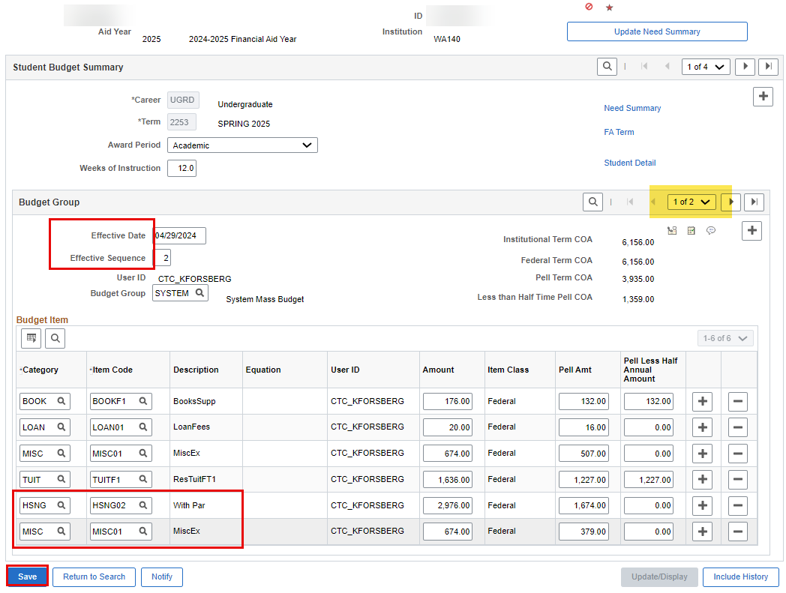

Process Complete.

# Manually Award

|  |  |
| --- | --- |
| **Navigation** | **Description** |
| **Financial Aid > Awards > Award Processing > Assign Awards to a Student** | **Manually enter an award in ctcLink.** |

The **Assign Awards to a Student** search page displays.

Enter a Student**ID**.

Enter the **Academic Institution.**

Enter the **Aid Year.**

Select the **Search** button**.**

The**Assign Awards to a Student** page displays.

Insert a new row by selecting the **[+]** button at the end of the first row (NUM 10).

**Note:** Ensure the proper sequence of all awards, as required by your college's policy. Generally, Need-Based aid should be sequenced before adding other types of aid.

Update the **Action** field to **'O'** if the new award is Offered, or to **'B'** if the new award is both Offered/Accepted. You can type the O or the B directly into the **Action** field, or you can use the lookup tool next to the **Action** field. In this example we type 'B'.

**Note:** If there is an error, do not choose ‘X’ to discard the award. Instead, select the Reset button to restart the process.

Use the lookup tool next to the **Item Type** field to choose the desired award.

The **Look Up Item Type** pagelet displays.

The **Student Aid Package** tab displays its **Item Type** and **Description** fields populated.

Enter the dollar amount in the **Offered** field, then press tab to automatically update the **Accepted** field with the same amount.

The **Disbursement Plan** field will update with **‘09’** to show the disbursement plan is for Summer-Fall-Winter-Spring. If this is wrong, use the **Disbursement Plan** lookup to choose the correct plan.

The **Split Code** field will update to **'AY'**. If this is wrong, use the **Split Code** lookup to choose the correct split.

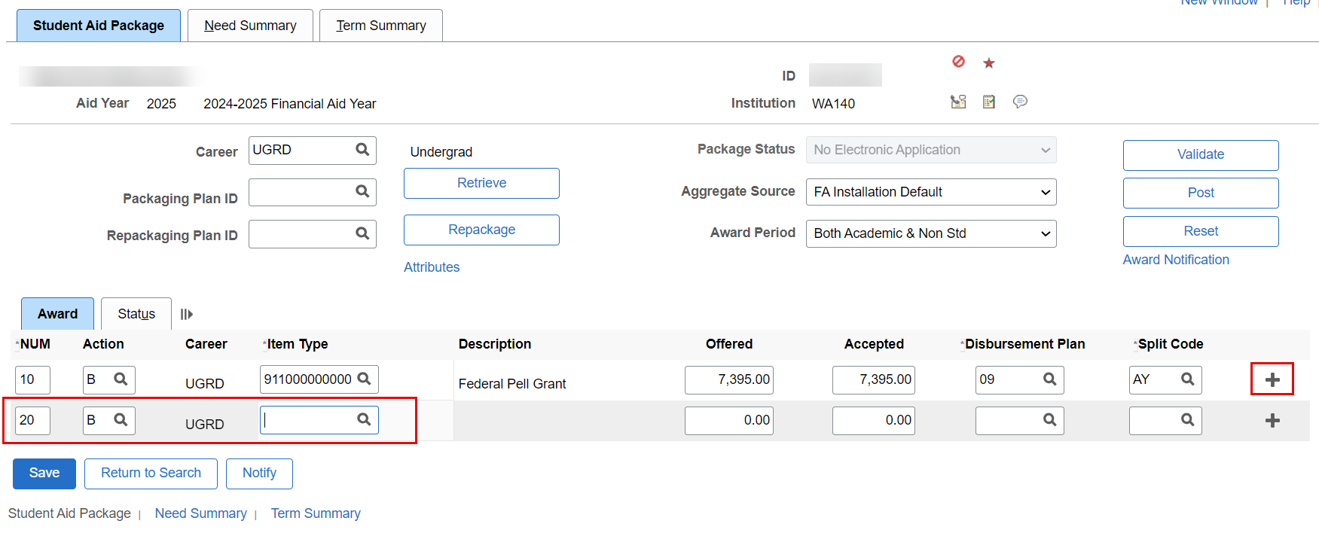

**For all awards in a** *No Electronic Application* **Packaging Status,** you must set them to have the EA checkbox as selected. Select the **Status** tab next to the Award tab.

Select the **External Awards (EA)** check box on all awards that have a **Meet Need/Cost** status of *Conditional, No Effect, Cost Only*, and PLUS item type awarding, then return to the **Award** tab.

**Note:** The **EA checkbox** cannot be manually removed via the **Assign Awards to Student** screen. It must be removed via a **Population Update Process** prior to disbursement of the award. A pop-update process will be provided in early-June to allow for mass removal of the EA checkbox. Once the checkbox is removed, Pell awards can be revalidated with information from the **ISIR** and **Incoming Aggregates**. Leaving the EA checkbox selected will not allow the Pell awards to be validated.

**WARNING:** At this time, this process is **only** for the contingency plan of awarding without a valid ISIR loaded into the production environment, as it can cause ghost disbursements. A ghost disbursement is a disbursement that is reflected on the Customer Account, but not in Award Activity. **This step is not needed if a valid ISIR has been loaded in the production environment.**

Select the **Validate** button to verify that the new award meets your college's awarding requirements.

A confirmation message displays.

Select **OK**.

The **Student Aid Package** tab displays.

Select **Post** to complete the process.

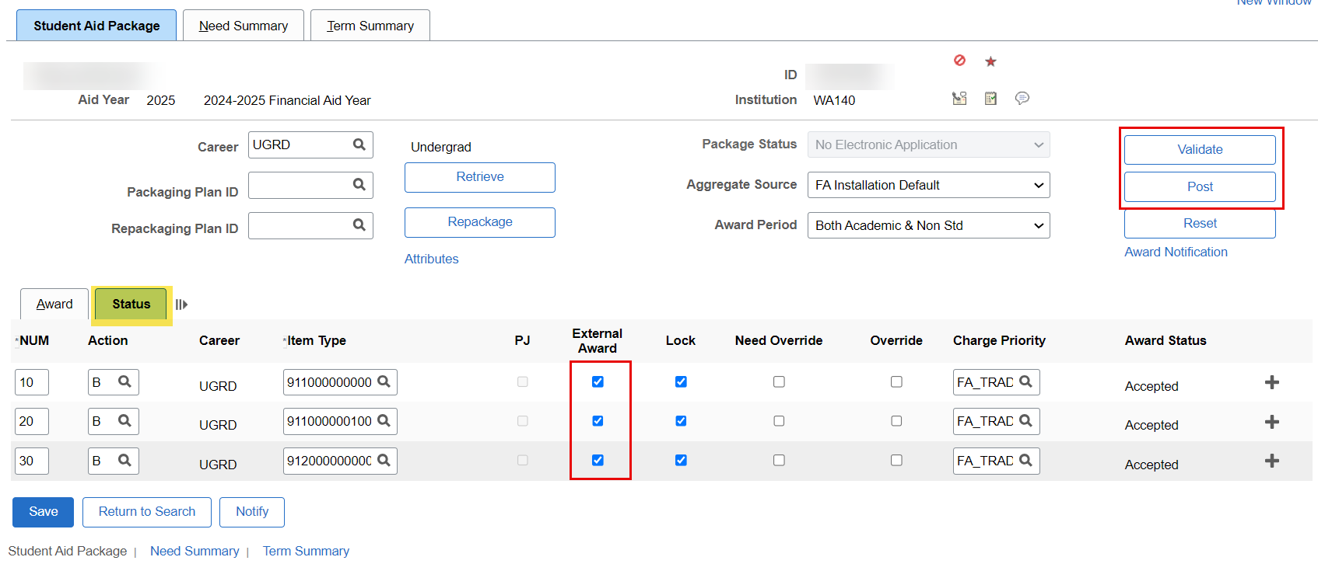

The Award Posting completed message displays.

Select **OK** after reading the confirmation message.

Process complete.

**Note** on Award Letters. Award Letters will be sent out through PRD. All institutions will be assigned new Letter Codes for the 2024-2025 Aid Year. More information forthcoming soon to the list servs.