**Per Oracle**

*'COD Lookup Table not found', may result in the file information not getting updated correctly in the COD staging table(s).*

In other words, it's a warning message. The file will process but skip fields that cannot be populated in PS.

We have reviewed several colleges' data and that does seem to be the case here as well. The message is not stating that the file could not be processed, it's stating the MIDDLENAME was in the file for the student but the field does not exist in the SFA_COD_STUDENT record so it will not be populated into PS.

Example of crpn24op.295

Example of warning message in Message Log.

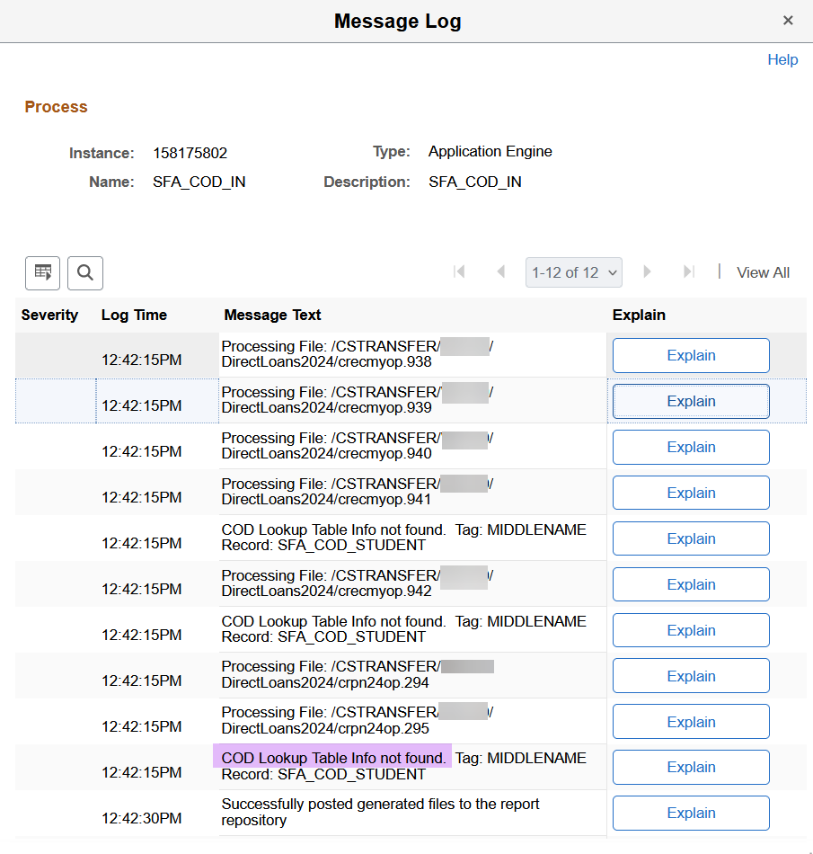

PS shows the file has been processed and other fields have populated.

Middle Initial field is not populated in PS because the file was tagged <MiddleName> not <MiddleInitial>

If you are seeing the same for your students and feel PS is processing the file correctly as is, you do not have to edit the file before loading it. The header having the 5.0b instead of 5.0a is not preventing PS from processing your 2023-2024 students.

Note, if you're not seeing any students in the file process, please open up the file to see if the student only contains students tagged <FinancialAwardYear>**2025**</FinancialAwardYear>. Dept of Ed has started to populate both aid years in the *crecmyop*,*crbn*, and *crpn* per usual during this time of the year.