2024-2025

Aid Year Rollover

Part 1

Financial Aid Business Processing Guide

FA Customer Support

FA Customer Support

Washington State Board for Community and Technical College



# Objective:

With significant changes happening for the 2024-2025 Aid Year, the Aid Year Rollover Sessions have been scheduled to start mid-January 2024 to allow FA Customer Support time to test and understand Oracle’s new aid year updates through December.

With Aid Year Rollover Sessions starting a month later compared to previous years, FA Customer Support reviewed all the processes in Aid Year Rollover and determined areas colleges can start updating on their own before the Aid Year Rollover Sessions. In other words, Aid Year Rollover has been split into two parts: **Part 1** (everyone on their own) & **Part 2** (scheduled work session or drop-in session)

This guide, *Aid Year Rollover Part 1*, walks through the areas that colleges are expected to complete **before** Day 1 of Aid Year Rollover Part 2.

The following is the schedule of AYRO Work Sessions.

**Rescheduled dates due to overlapping with FAC Winter Meeting**

|  |  |  |  |  |  |
| --- | --- | --- | --- | --- | --- |
| **College** | **Group** |  | **Header/Trailer** | **Day 1** | **Day 2** |
| WA171 | DG1 | Spokane | Header | N/A | N/A |
| WA172 | DG1 | Spokane Falls | Header | N/A | N/A |
| WA220 | DG1 | Tacoma | Trailer | N/A | N/A |
| WA140 | DG2 | Clark | Header | N/A | N/A |
| WA130 | DG3A | Lower Columbia | Header | N/A | N/A |
| WA010 | DG3B | Peninsula | Header | N/A | N/A |
| **WA030** | **DG3A** | **Olympic** | **Header** | **2/01** | **2/02** |
| **WA110** | **DG3B** | **Pierce** | **Header** | **2/01** | **2/02** |
| **WA300** | **DG3B** | **Cascadia** | **Header** | **2/01** | **2/02** |
| WA120 | DG4A | Centralia | Header | 1/23 | 1/24 |
| WA230 | DG4A | Edmonds | Header | 1/23 | 1/24 |
| WA040 | DG5A | Skagit Valley | Header | 1/23 | 1/24 |
| WA100 | DG5A | Green River | Header | 1/23 | 1/24 |
| WA180 | DG5B | Big Bend | Header | 1/30 | 1/31 |
| WA250 | DG5B | Bellingham Tech | Header | 1/30 | 1/31 |
| WA020 | DG5C | Grays Harbor | Header | 1/30 | 1/31 |
| WA050 | DG5C | Everett | Header | 2/6 | 2/7 |
| WA080 | DG5C | Bellevue | Header | 2/6 | 2/7 |
| WA070 | DG6A | Shoreline | Header | 2/6 | 2/7 |
| WA260 | DG6A | Lake Washington Tech | Header | 2/6 | 2/7 |
| WA270 | DG6A | Renton Tech | Header | 2/13 | 2/14 |
| WA290 | DG6B | Clover Park Tech | Header | 2/13 | 2/14 |
| WA200 | DG6B | Walla Walla | Header | 2/13 | 2/14 |
| WA240 | DG6C | South Puget Sound | Header | 2/13 | 2/14 |
| WA090 | DG4A | Highline | Trailer | 2/20 | 2/21 |
| WA150 | DG4A | Wenatchee Valley | Trailer | 2/20 | 2/21 |
| WA210 | DG5B | Whatcom | Trailer | 2/20 | 2/21 |
| WA063 | DG4B | North Seattle | Trailer | 2/27 | 2/28 |
| WA062 | DG4B | Seattle Central | Trailer | 2/27 | 2/28 |
| WA064 | DG4B | South Seattle | Trailer | 2/27 | 2/28 |
| WA190 | DG6B | Columbia Basin | Trailer | 3/13 | 3/14 |
| WA280 | DG6C | Bates Tech | Trailer | 3/13 | 3/14 |
| WA160 | DG6C | Yakima Valley | Trailer | 3/13 | 3/14 |

**Note:** The first group (WA171, WA172, WA220, WA140, WA130 and WA010) do not have a scheduled Aid Year Rollover Session as they will do Aid Year Rollover Part 2 on their own. A drop-in support session will be provided for this group.

CONTENTS

Objective: 1

Process 1: Closing Out Prior Year Checklists 4

Identify Checklist 4

Edit Existing/Create New Event Definition 5

Create Event 3C Groups (required for New Event Definitions) 9

Run 3C Engine 10

Reviewing Outcomes 13

Process 2: Review/Update Checklists 14

Checklist Item Table 14

Checklist Table Setup 15

Event Definition 16

Process 3: Communications Review 18

Create BIP Report Definitions 18

Process 4: Define Financial Aid Year 21

Process 5: WCG and College Bound 22

WCG Aid Year Review and Update 22

Equation Processing Options 22

WCG Setup 23

CBS Aid Year Review and Update 26

College Bound Setup 26

Appendix I: Setup Review Queries 29

Appendix II: Solution to Checklist Error Message 30

The Issue 30

The Solution 30

Appendix III: Creating an FA Office EMPLID 31

The Issue 31

The Solution 31

# Process 1: Closing Out Prior Year Checklists

## Identify Checklist

Colleges will use **CTC_FA_PRIOR_YR_CHCKLST_REVIEW** to determine which checklists are in an *Initiated* status for the prompted aid year. Colleges that have already closed out checklists for the previous aid year (2023), you’re welcome to skip this process and move on to Process 2 or run this first portion of Process 1 of reviewing checklists still in Initiated status.

**Navigation: Reporting Tools > Query > Query Viewer**

Enter the query name **CTC_FA_PRIOR_YR_CHCKLST_REVIEW** then select **Search**

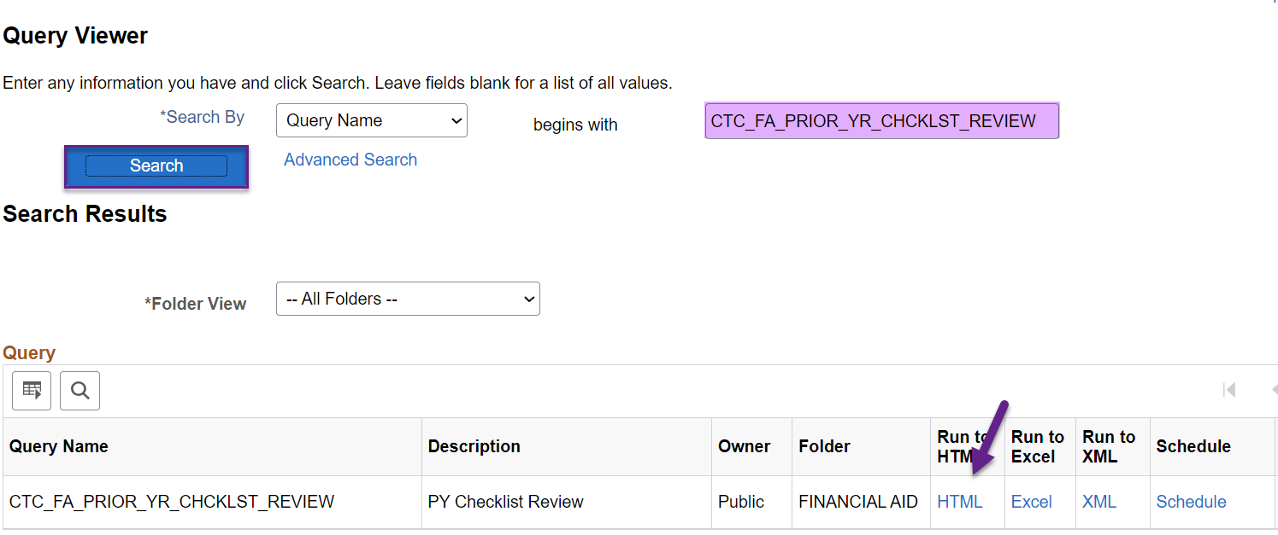

After selecting **HTML**, enter values for the following prompts then select **View Results**

**Institution**

**Aid Year** (i.e. 2023)

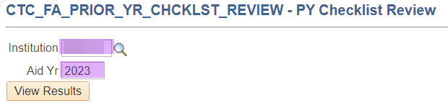

Open a new window to keep this page available to reference or download the results to reference in the next steps.

## Edit Existing/Create New Event Definition

This step drives the information used in the *Run 3C Engine* process. If you have multiple checklists to cancel, you will return to this step multiple times.

**IMPORTANT** Some users may feel the urge to list all the checklist codes in this Event Definition to mass cancel all prior year checklists at once instead of repeating the process multiple times for each checklist. That will have unfavorable consequences! When you stack checklists on an Event Definition that updates the status of existing checklists, know that it will update all the listed checklists on the selected student.

**Example**

Student A has EBB001 in Completed status and EBB002 in Initiated status. On my Event Definition, I listed EBB001, EBB002, EBB003, etc.

When I run the Run 3C Engine process, I start with selecting students with EBB001 in *Initiated* status so the student does not pick up and nothing happens. Nice.

When I run the Run 3C Engine process selecting the students who have EBB002 in *Initiated*, the student gets picked up. As a result, the process updates both EBB001 and EBB002 to Cancelled. Not nice. ☹

**Navigation: Campus Community > 3C Engine > Set Up 3C Engine > Event Definition**

Enter your **Academic Institution** and in the *Event ID* field put **%CAPC** to search for an existing *Event Definition* for cancelling prior year checklists.

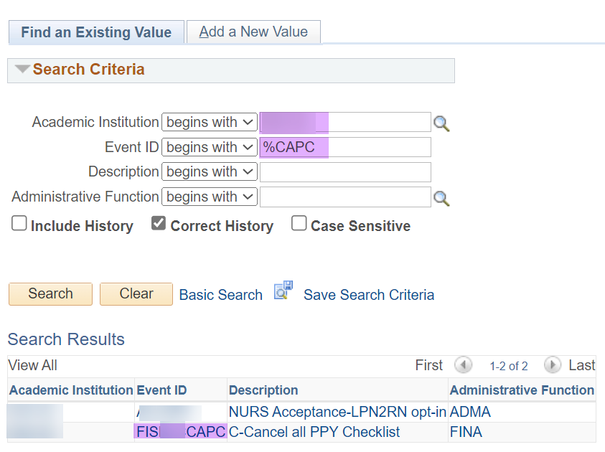

**If the Event ID exists**

Select the **Event ID** then add **a new effective dated row** **of today**

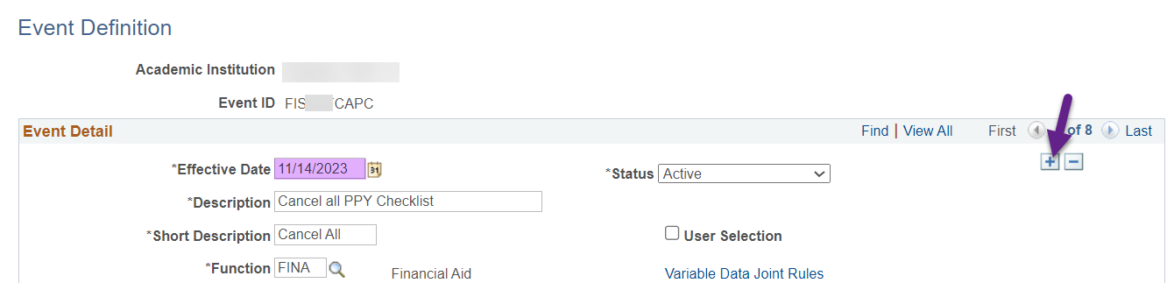

Update the **Checklist Code** field with the first checklist code you’d like to cancel (refer to the query results in the Identify Checklist step)

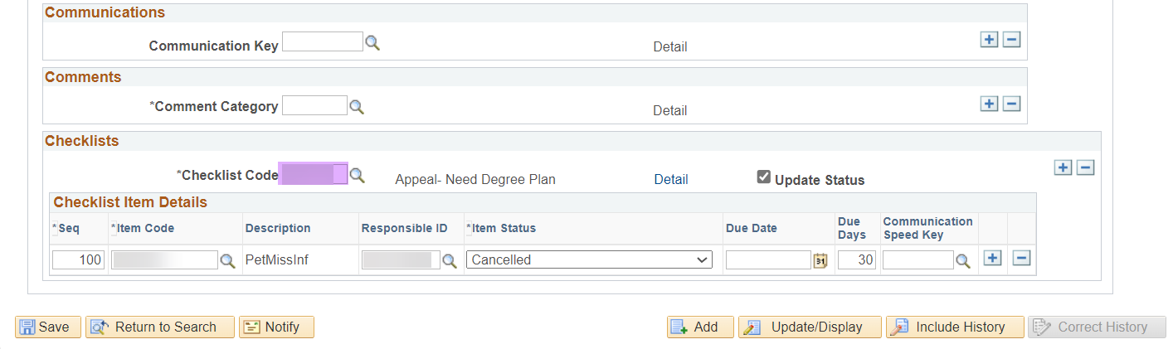

Update the *Item Status* back to **Cancelled** if it changes to a different status

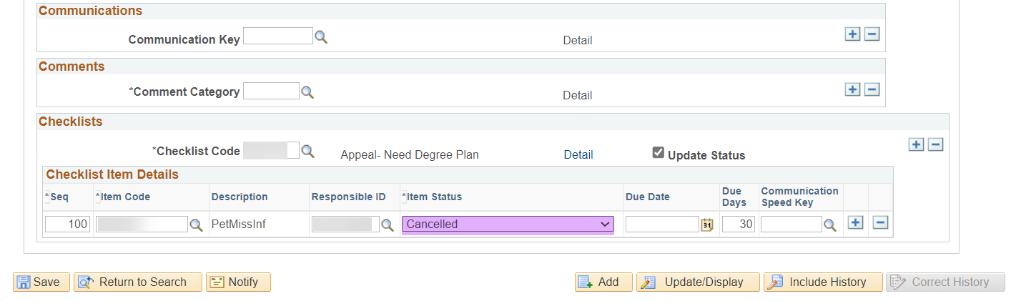

Verify the two *Responsible ID* fields have the Financial Aid Office ID. One of the *Responsible ID* fields is hidden in the **Detail** link

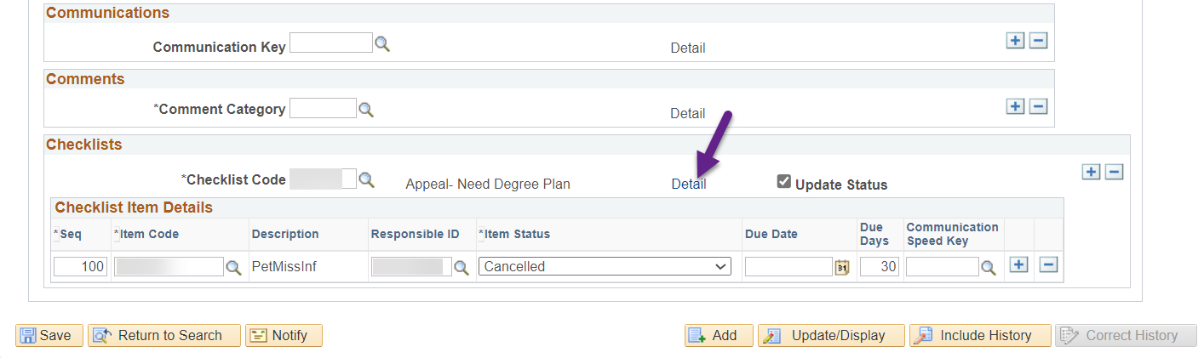

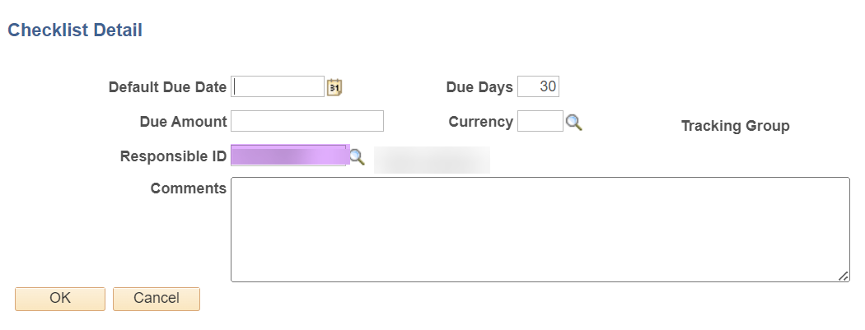

Update *Responsible ID* field if necessary then select **OK** and **Save**

**Note:** When running this process on the same day for multiple checklists, go into the page in **Correct History** mode to edit the *Checklists* section since you cannot add multiple effective dates of the same day. Always verify *Item Status* value remains as ‘**Cancelled**’ before selecting **Save** and moving on to the *Run 3C Engine* process.

Move on to Run 3C Engine process.

**If the Event ID does NOT exist**

Select the **Add a New Value** tab then enter the **Academic Institution** and **Event ID** for your institution using the naming convention ‘**FISXXXCAPC**’ where ‘**XXX**’ represents your institution’s 3-character checklist naming convention prefix (i.e. EBB for Big Bend, ECC or Centralia, etc.)

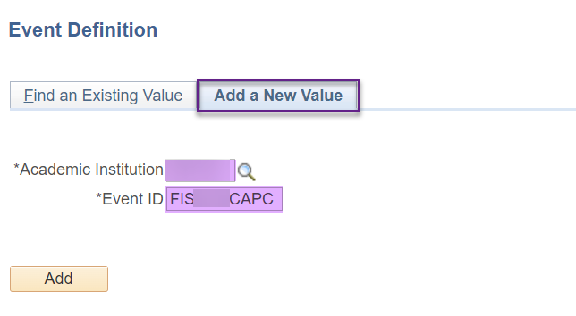

Select **Add** then complete the following areas:

**Description:** C-Cancel all PPY Checklist

**Short Description:** C-Canc All

**Function:** FINA

**Checklist Code:** The first checklist code you’d like to cancel(refer to the query results in the Identify Checklist step

**Item Code:** It should auto-populate

**Responsible ID:** Update tothe institution’s Financial Aid Office ID

**Item Status:** Cancelled

**Update Status:** Selected

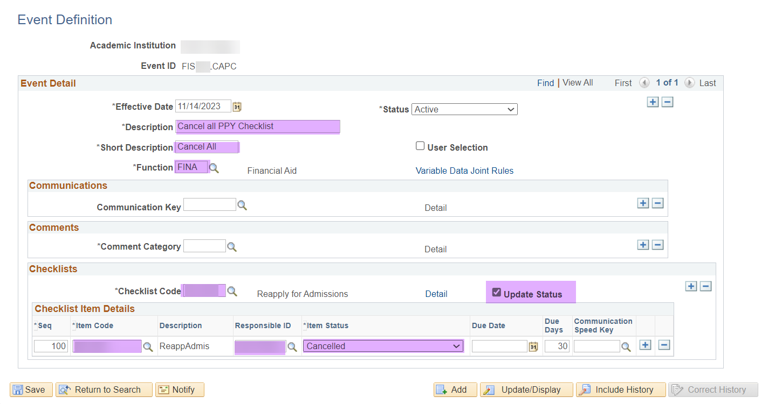

One of the *Responsible ID* fields is hidden in the **Detail** link

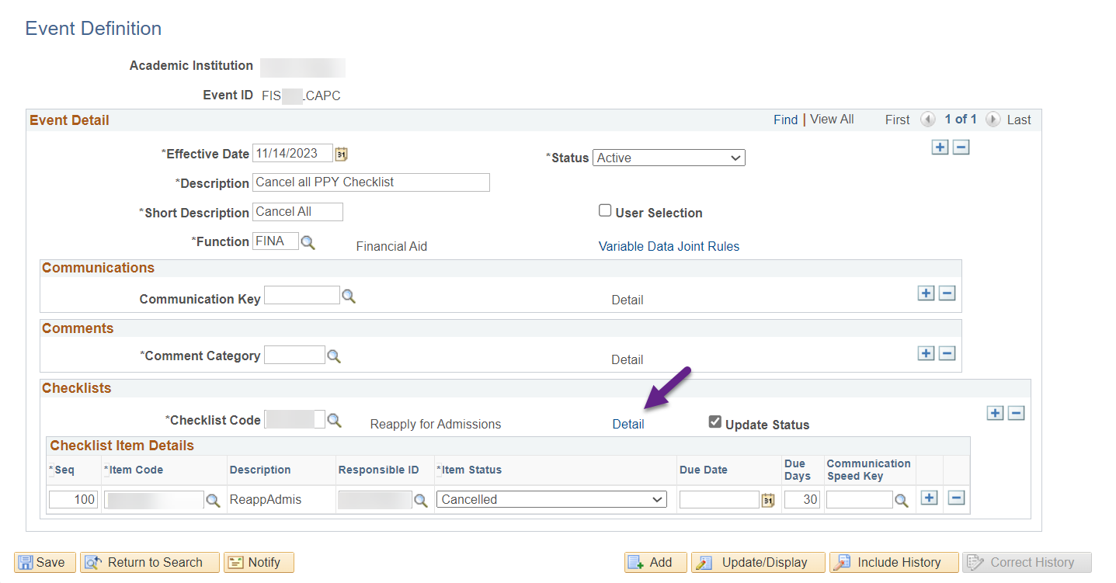

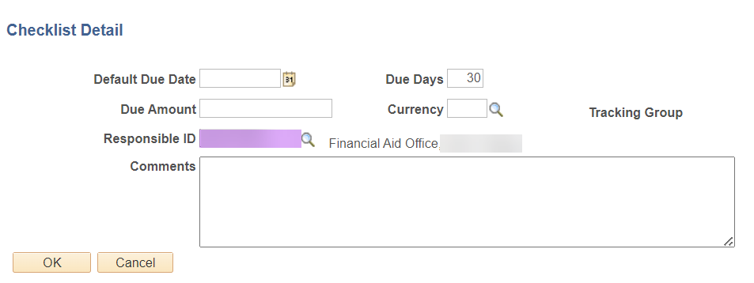

Update the Responsible ID field to the institution’s Financial Aid Office, select **OK** then **Save**.

## Create Event 3C Groups (required for New Event Definitions)

This page is used to assign Event Definition access to specified user groups. If this step is not completed on the Event Definition, you will not be able to see it when you set up your *Run 3C Engine* Run Control ID.

**Navigation: Campus Community > 3C Engine > Set Up 3C Engine > Event 3C Groups**

Enter your **Academic Institution** and **Event ID** then select **Search.**

**Note:** If you moved to this page right after the creating the Event Definition, this page may open without needing to enter parameters.

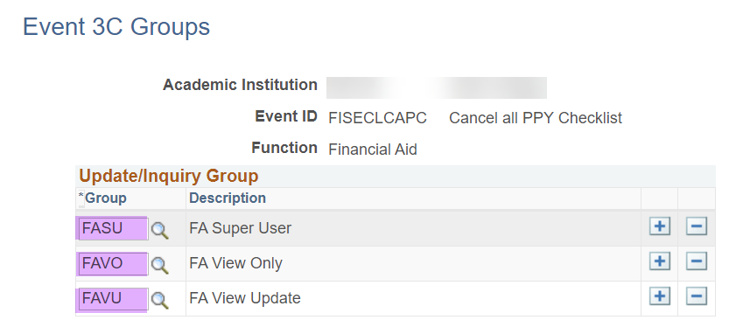

Enter the three FA 3C Security Groups to allow access to the Event Definition. The global Financial Aid 3C Security Groups are listed below.

* + FAVO (FA View Only)
  + FAVU (FA View Update)
  + FASU (FA Super User)

**Note:** You are welcome to limit access to just one or two of the three FA 3C Security Groups by listing only the ones you want for the new Event Definition.

## Run 3C Engine

This step will identify and update selected students and the checklist listed in the Event Definition.

**Navigation: Campus Community > 3C Engine > Run 3C Engine**

1. Enter a New or Existing Run Control ID
   * Run Control ID naming convention example WAXXX_PY_CHECKLIST_CNCL_YY
   * XXX = Institution’s destination (i.e. 030, 160, etc.)
   * YY = User’s initials
2. Under the *Process 3C’s section* select the **Population Selection** check box
3. Under the *Event Selection section* populate the following fields:

**Academic Institution:** Your Institution

**Administrative Function:** FINA

**Event ID:** If you enter **%CAPC**, your Event Definition should appear given there is no typo in your Event Definition and the proper FA 3C Security Groups are assigned

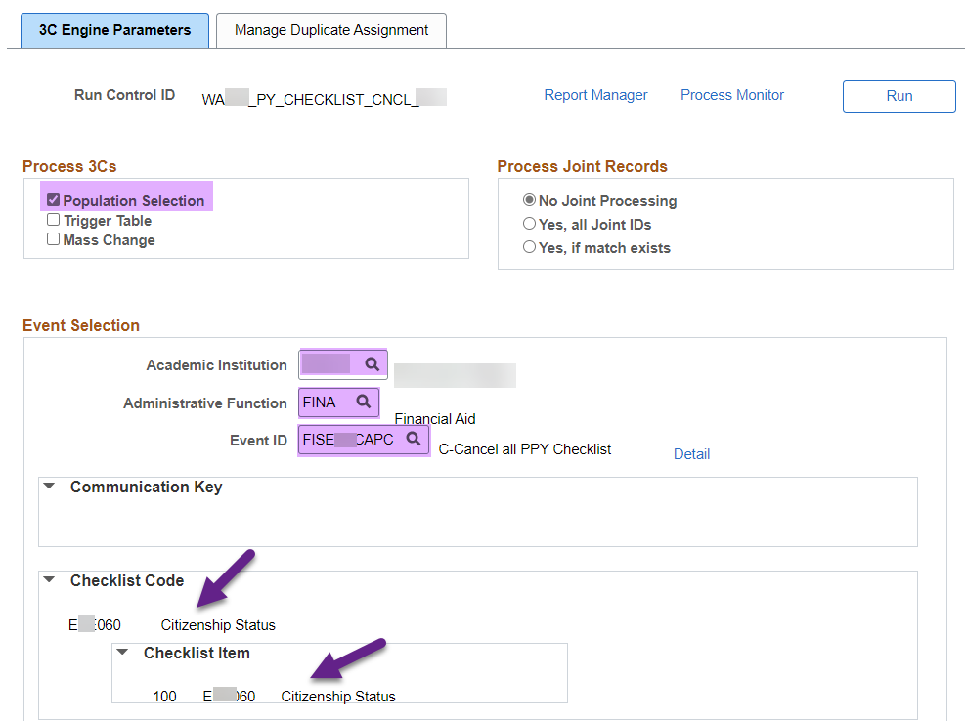

**Note:** The current **Checklist Code** that is selected in the *Event Definition* will populate. If it’s a different checklist than what you’re expecting, return to the Event Definition and select the different Checklist Code.

1. Under the *Population Selection section* set the *Selection Tool* to **PS Query** then enter **CTC_FA_PRIOR_YR_CHCKLST_CANCEL** for the *Query Name*

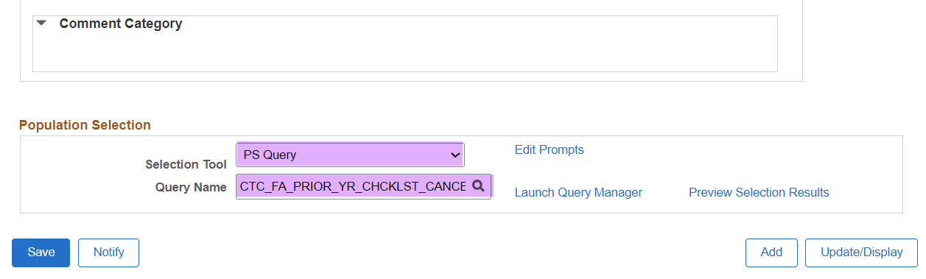

1. Select the **Edit Prompts** link and enter the following parameters:

**Aid Year**

**Institution**

**Checklist Code**

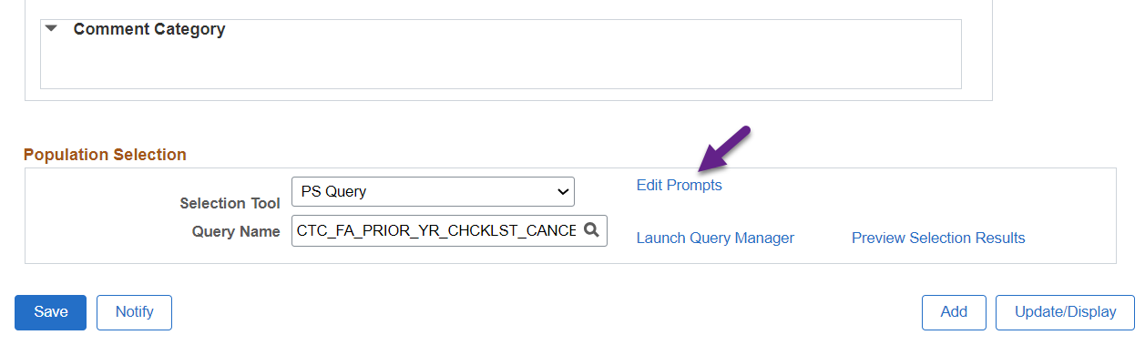

1. Select the **Preview Selection Results** **link** and note some sample students for validation after the process has been run

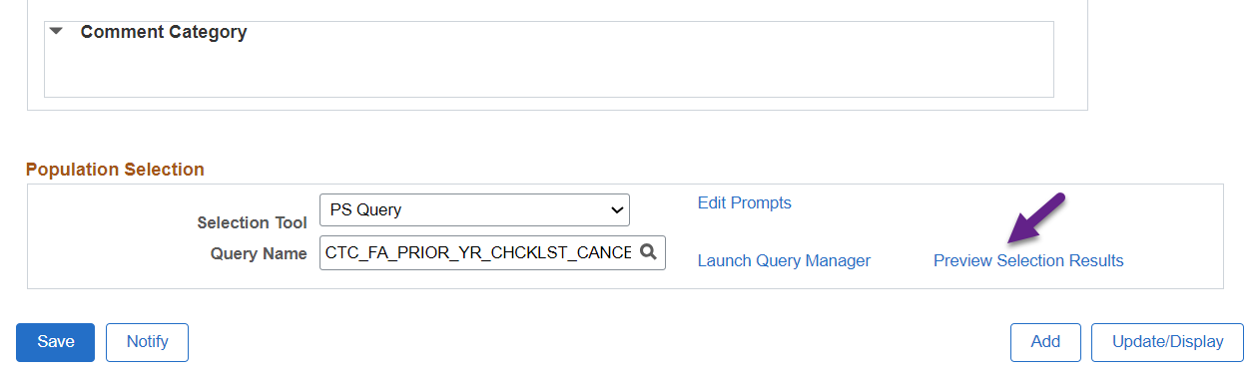

1. Select the **Manage Duplicate Assignment** tab
2. Ensure the **Check Duplicate Checklist** check box is checked
3. Select **Variable Data: Match** and **Checklist Status: Initiated**

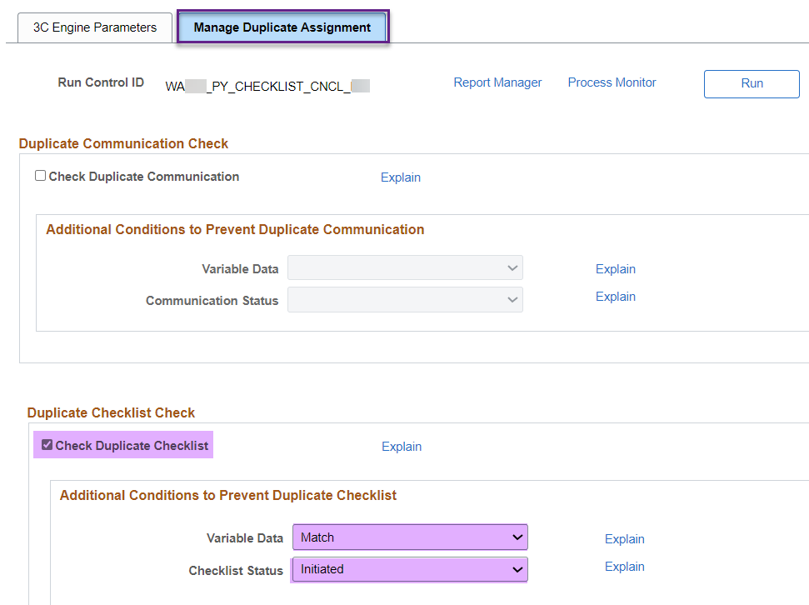

**Note:** The Check Duplicate Communication can be selected or unselected. This Event Definition is tied to checklists and not communications so the checkbox has no effect on this Run Control ID.

**Note 2:** This Run Control ID is tied to an Event Definition that updates existing checklists so there really is no duplicate checking that occurs but just in case your Event Definition is set up incorrectly with the Update Status checkbox not selected, it’s best to set these parameters to avoid additional checklists being added to the student instead of updating the existing checklist.

1. Return to the **3C Engine Parameters** tab and select **Save** then **Run**
2. Wait until the process runs to *Success* and *Posted* in the *Process Monitor* before moving on to reviewing outcomes.

## Reviewing Outcomes

To verify that the students’ checklists updated appropriately, use the students from the Run 3C Engine *Preview Selection Results* and confirm the checklists reflect a status of ‘**Cancelled**’ on the *View Financial Aid Status* page. The checklist should no longer appear on the student’s *To Do List* in the *Student Services Center*.

The query **CTC_FA_CANCEL_PY_CHKLST_VAL** can be used to validate the students who had their checklists cancelled. This query displays the prompted checklist for the prompted aid year, regardless of status. The query could be run before running 3C Engine as well as after as a compare to see which students were updated.

Repeat the process for each checklist that’s listed on **CTC_FA_PRIOR_YR_CHCKLST_REVIEW** until the list has no results. Return to Edit Existing/Create New Event Definition

# Process 2: Review/Update Checklists



Some users like to work on one checklist all the way through then move on to the next one. The important thing is that you update *Checklist Item* first, then update *Checklist Table* then *Event Definition.* You’ll see as you progress through the guide that those pages feed into each other.

## Checklist Item Table

This page allows users to view and update checklist item descriptions. Depending on your security you may go through Set Up SACR or Campus Community to get to the page.

**Navigation 1: Set Up SACR > Common Definitions > Checklists > Checklist Item Table**

**Navigation 2: Campus Community > Checklists > Set up Checklists > Checklist Item Table**

For Aid Year specific Checklist Items, a user will need to insert a new effective dated row of today and update the descriptions. (Example – Parent Tax Transcript)

Even and Odd Coding has been created. Be sure to note the coding and apply to the appropriate aid year.

* **Exx###** - Checklists that start with **E** are non-aid-year specific as well as even-year specific
  + Example of a non-aid year specific checklist Exx000 *Birth Certificate*
  + Example of an even-year specific checklist Exx032 *V5 2023-2024*
* **Fxx###** – Checklists that start with **F** are odd-year specific such as Fxx032 *V5 2024-2025*

The aid year that you’re updating this time around is 2024-2025 which is an odd year so start with looking for your checklists that start with F.

After completing updating the F checklist items, review E checklist items that are non-aid year specific for any wording that will now make them aid year specific and require you to create an odd year version (F checklist with the same number as the E checklist).

For example, College A has an Exx180 checklist item called *High EFC*. That college may want to create an Fxx180 checklist item to use for the 2024-2025 aid year and refer to SAI instead of EFC.

**Note that the checklist *number* is the same: 180.** The college would not create a Fxx181 or Exx181.

Be sure to save changes.

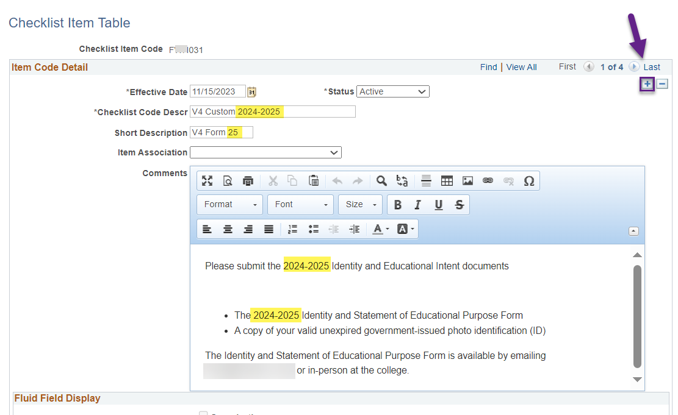

**Note:** Do NOT use correct history. Be sure to insert a new effective dated row of today and keep previous rows active. This step will be essential for keeping a history for checklists that have been assigned with this code in previous Aid Years.

Check out **Appendix II: Solution to Checklist Error Message** if you run into the error message “*Cannot change current or history records unless in Correction mode (15,1),”* when adding a new effective dated row.

## Checklist Table Setup

This setup can include function selection, display in Self Service, and checklist sequencing.

**Navigation 1: Set Up SACR > Common Definitions > Checklists > Checklist Table**

**Navigation 2: Campus Community > Checklists > Set up Checklists > Checklist Table**

For Aid Year specific Checklist Items a user will need to insert a new effective dated row of today and update descriptions. (Example – Parent Tax Transcript)

Even and Odd Coding has been created. Be sure to note the coding and apply to the appropriate aid year.

* **Exx###** - Checklists that start with **E** are non-aid-year specific as well as even-year specific
  + Example of a non-aid year specific checklist is Exx000 *Birth Certificate*
  + Example of an even-year specific checklist is Exx032 *V5 2023-2024*
* **Fxx###** – Checklists that start with **F** are odd-year specific such as Fxx032 *V5 2024-2025*

Be sure to save changes.

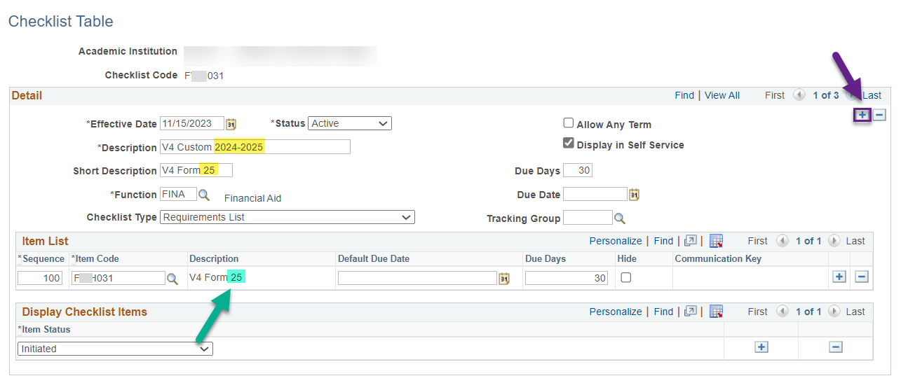

**Note:** Do NOT use correct history. Be sure to insert a new effective dated row of today and keep previous rows active. This step will be essential for keeping a history for checklists that have been assigned with this code in previous Aid Years.

**If you updated the**

**Checklist Item then moved onto this page, the changes you made will pull in here when you add a new effective dated row of today**

## Event Definition

This page allows users to associate selection criteria to certain checklist items and communications for 3C engine to assign or update. Checklist Item and Checklist Table must be updated before updating the associated event definition.

**Navigation: Campus Community > 3C Engine > Set Up 3C Engine > Event Definition**

For Aid Year specific Event Definitions a user will need to add an effective dated row of today and update descriptions. (Example – Verification and Tax Documents)

Even and Odd Coding has been created. Be sure to note the coding and apply to the appropriate aid year.

* **Exx###** - Event IDs that start with **E** are non-aid-year specific as well as even-year specific
  + Example of a non-aid year specific Event ID is FISExx000I *I-Birth Certificate*
  + Example of an even-year specific Event ID is FISExx032I *I-Aggregate 2023-2024*
* **Fxx###** – Event IDs that start with **F** are odd-year specific such as FISFxx032I *I-Aggregate 2024-2025*

Be sure to save changes.

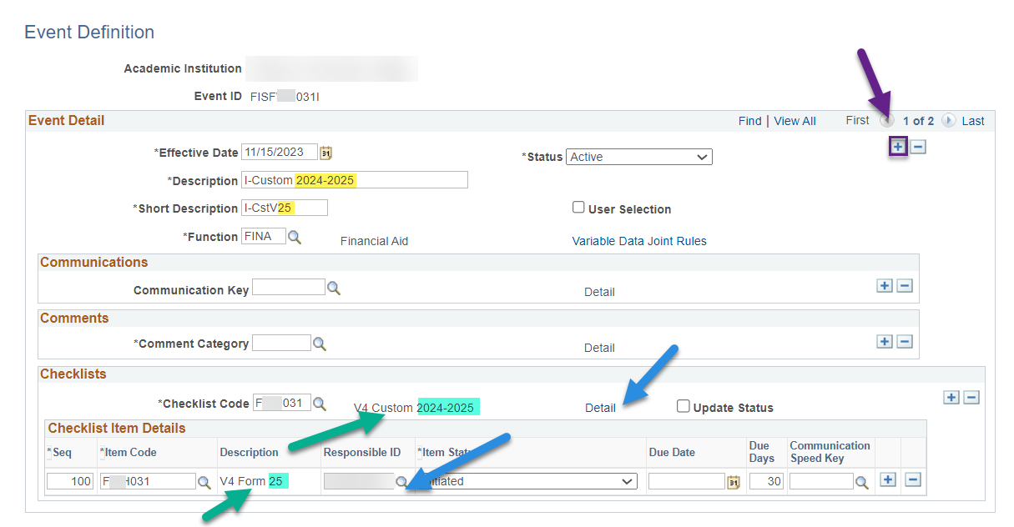

**If your FA office has an EMPLID, update the Responsible ID on this page as well as the *Checklist Detail* page which you can get to by selecting the *Detail* link.**

**Note:** Do NOT use correct history. Be sure to insert a new effective dated row of today and keep previous rows active. This step will be essential for keeping a history for checklists that have been assigned with this code in previous Aid Years.

**If you updated the**

**Checklist Item and Checklist Table, then moved onto this page, the changes you made will pull in here when you add a new effective dated row of today**



There are not many waive Event IDs so it’s easy to forget about them, but don’t forget to update the few **Aid Year specific waive Event IDs**! For example, FISFxx025W *W-Parent Tax Transcript 2022*

Check out **Appendix III: Creating an FA Office EMPLID** if your office does not have an FA Office EMPLID and you will be working with your Student Records office to create one.

# Process 3: Communications Review



Most FA communications have merge fields in areas that mention a specific aid year or term so that the communications could be used for any aid year or term. Common communications that require updating are ones that have links to websites, forms and policies.

## Create BIP Report Definitions

This page during Aid Year Rollover is used to update communication templates.

**Navigation: Reporting Tools > BI Publisher > Create BIP Report Definitions**

Change the *Search by* to **Report Category ID** then type ‘FA’ which will populate a list of colleges to select from. Select your college then select the *Search* button.

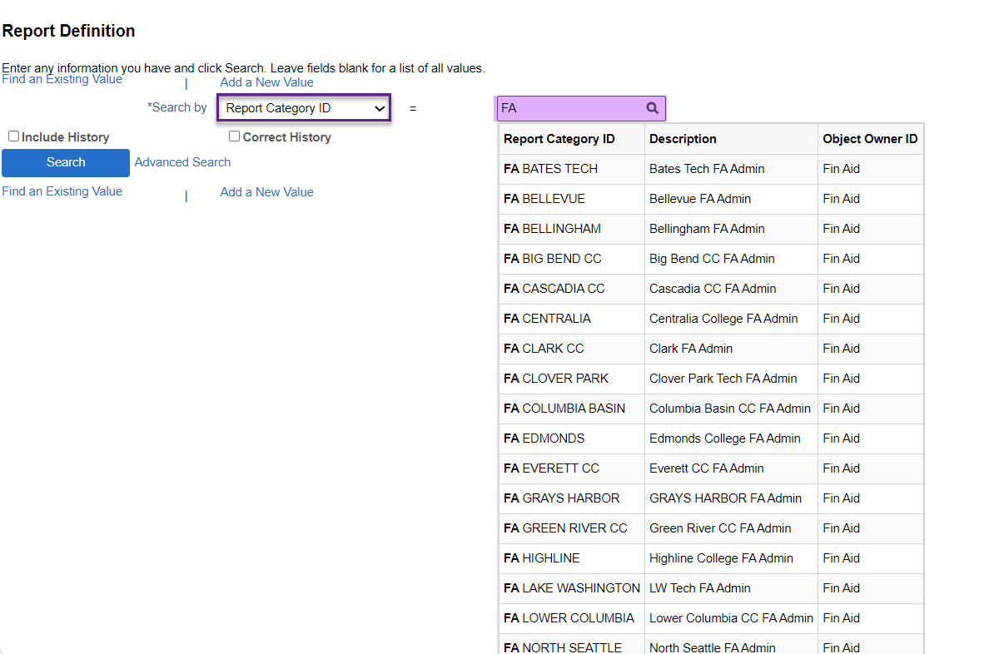

**Note:** You can continue typing after FA to narrow down to a smaller list of colleges to select from. For example, typing “FA E” will limit the results to FA EDMONDS and FA EVERETT CC. 😊

Once the communication to review is chosen, select the **Template** tab, then the **Template File** link

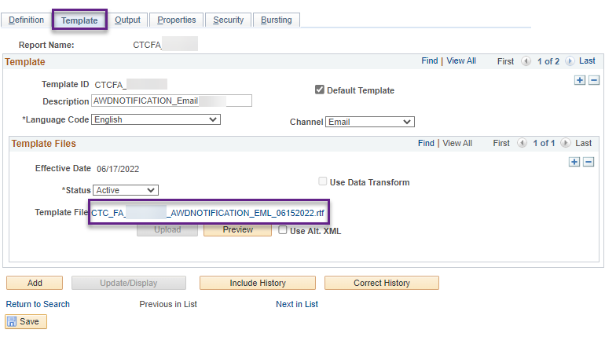

To update the template:

* Open up the Word RTF template you downloaded from PS
* Make your changes avoiding the merge fields indicated in grey
* Save As the revised template with a new name
  + Including the date the changes were made in the name is a best practice
  + Keep the format Word RTF
  + Avoid using fancy fonts as PS does not accept all fonts. If you upload your template and get an error message indicating the template cannot be processed, you may be using an unacceptable font
* Insert a new effective dated row of today under the *Template Files* section
* Update the *Status* from to **Active**
* Select **Upload** to add your updated template
* Select Save

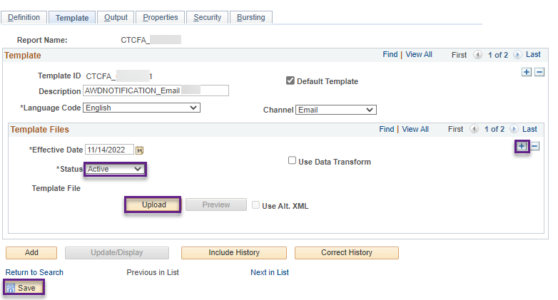

**Note:** If the communication you are reviewing has both a *Channel: Email* and *Channel: Printer*, make sure to update both templates.

**Award Notifications for 2024-2025**

With the 2024-2025 aid year not having certain data elements such as EFC that populates in the current global Award Notification template, there may be a need for all colleges to have Even Year and Odd Year Award Notification Letter Codes. A few colleges already have them.

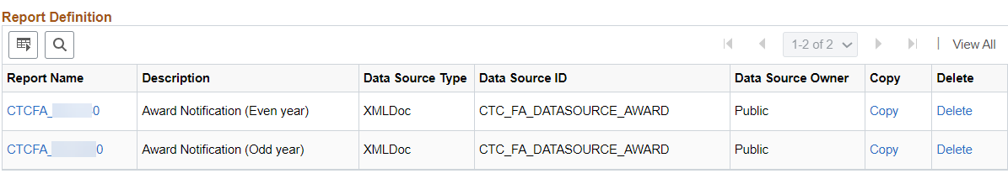

We’ll be reviewing the existing global Award Notification template to see if the changes between two very different aid years can be accomplished with coding and not require all colleges to have another Letter Code to manage. More information will come at a later time.

# Process 4: Define Financial Aid Year

**Navigation: Set Up SACR > Product Related > Financial Aid > Aid Year > Define Financial Aid Years**

Complete the new aid year row with the *Start Date* and *End Date* for the Academic Year then select **Save**.

* Be careful of typos (last AYRO there were a couple colleges that made a typo on End Date, specifically the year)
* Be sure that the date range **includes all four terms** included in the Academic Year

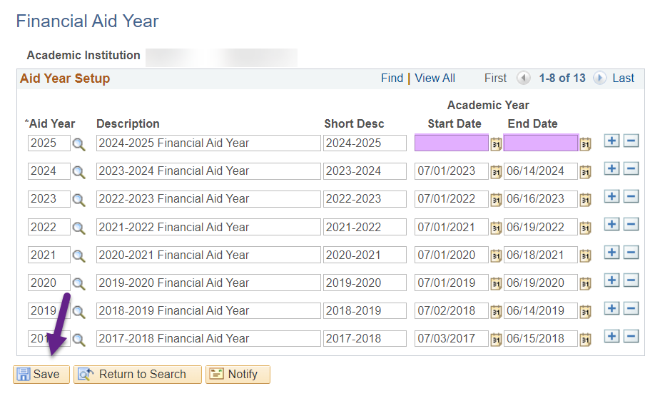

**These dates are used by the DL Origination process and populates the Academic Year values in the COD XML file**

**Note: *Headers and Trailers will have different dates***

# Process 5: WCG and College Bound

## WCG Aid Year Review and Update

### Equation Processing Options

**Navigation: Set Up SACR > Product Related > Financial Aid > CTC Custom > CTC Interfaces > WA College Grant > Equation Processing Options**

Enter your **Academic Institution** and desired **Aid Year** then select **Search**

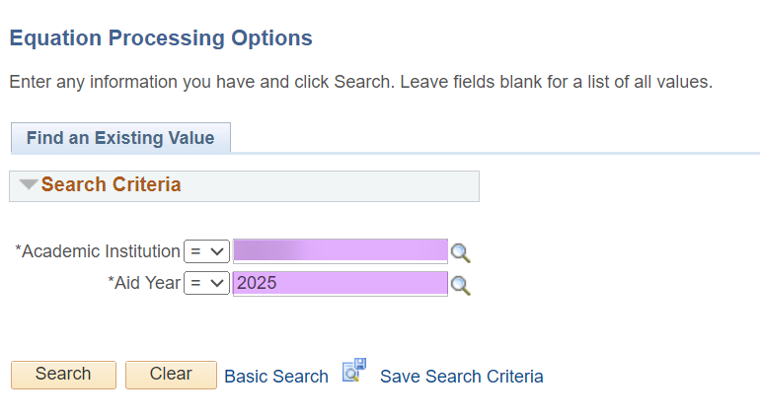

Select the following then save:

**Application Prompt ID:** Fin Aid SNG Evaluation

**Equation Name:** CTCFASNGELIG

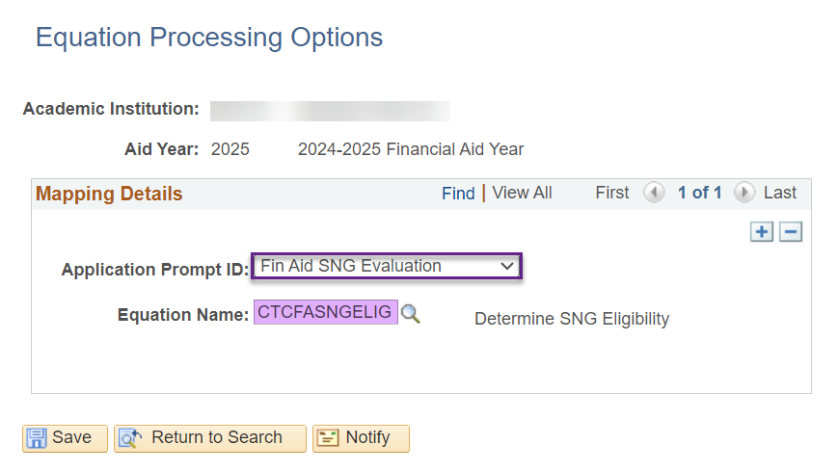

**Make sure to save changes**

### WCG Setup

**Navigation: Set Up SACR > Product Related > Financial Aid > CTC Custom > CTC Interfaces > WA College Grant > WCG Setup**

WCG and CBS pages are add-ons to PS so they do not get captured during Aid Year Setup rollover processes. For these pages, colleges will copy the existing numbers from the prior aid year to the new aid year. Tables will need to be updated when new figures are released from WSAC.

**The following steps are required for updating WCG tables for the upcoming aid year**

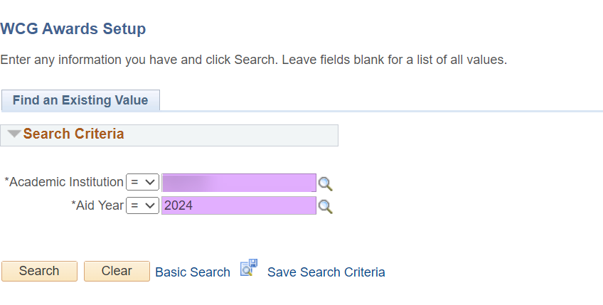

Open the page for the **current aid year** to copy to the upcoming aid year

**Awards Amounts Table tab**

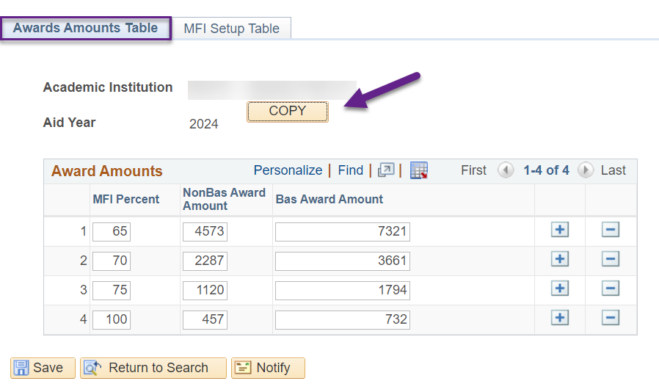

**Selecting Copy will open the page below**

Enter the following in the **Copy To** fields then select **OK**:

* Academic Institution
* Aid Year

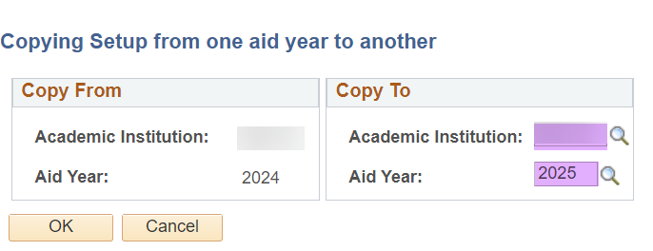

Move on to the MFI Setup Table tab and perform the same steps

**MFI Setup Table tab**

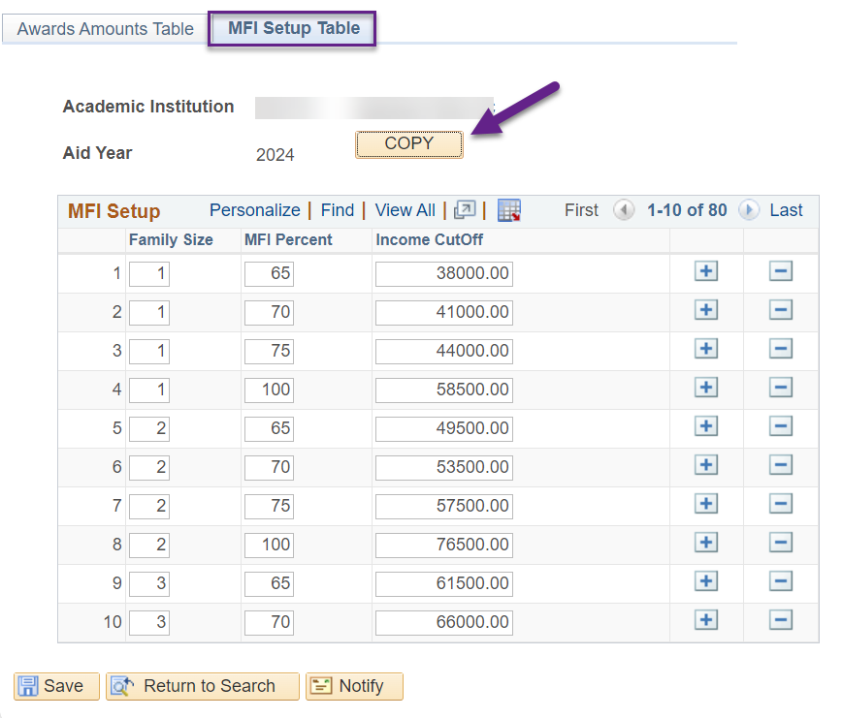

Select the **Copy** button

**Enter the following** in the **Copy To** fields then select **OK**:

* Academic Institution
* Aid Year

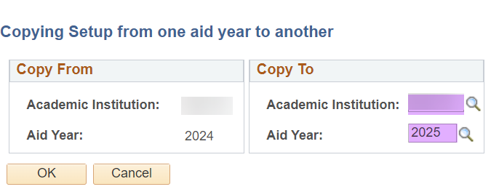

Select **Save**

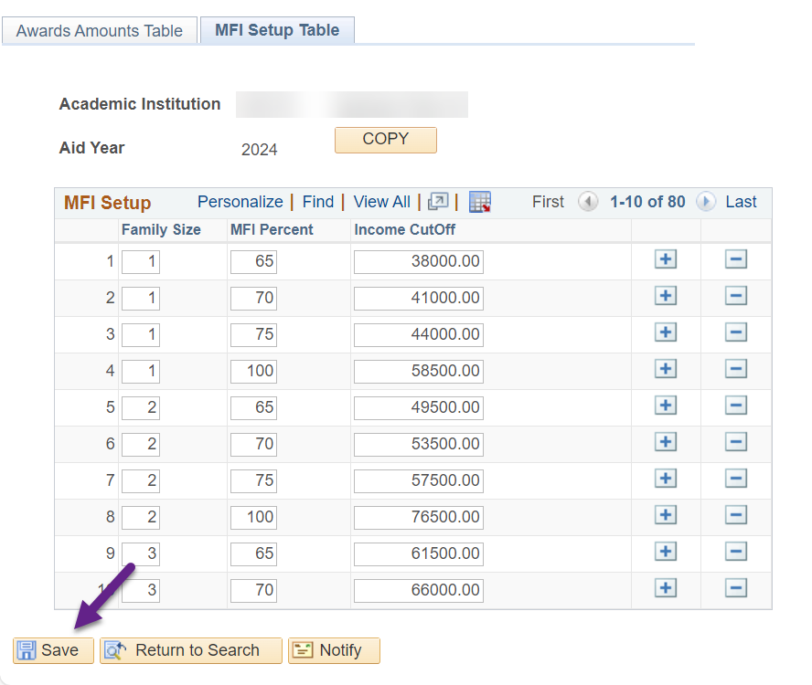

***After copying is complete, you will see values in the 2025 aid year WCG tables.***

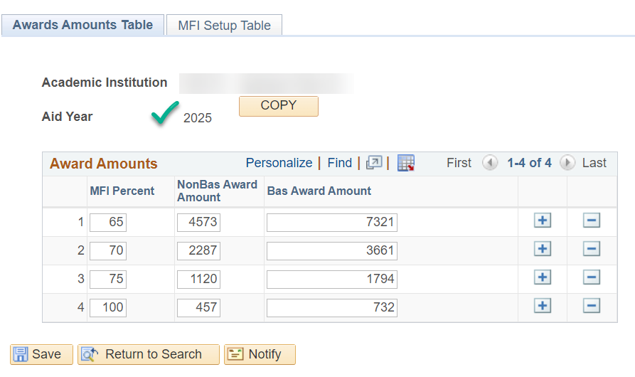

**Estimated 2024-2025 Award Amounts and MFI table were given to colleges by WSAC on 11/02/2023.**

**They are estimates and the values can change so it’s up to the college to wait for the final numbers or update now and update again later should the values change.**

## CBS Aid Year Review and Update

### College Bound Setup

**Navigation: Set Up SACR > Product Related > Financial Aid > CTC Custom > CTC Interfaces > College Bound Scholarship > College Bound Setup**

WCG and CBS pages are add-ons to PS so they do not get captured during Aid Year Setup rollover processes. For these pages, colleges will copy the existing numbers from the prior aid year to the new aid year. Tables will need to be updated when new figures are released from WSAC.

**The following steps are required for updating CBS table for the upcoming aid year**

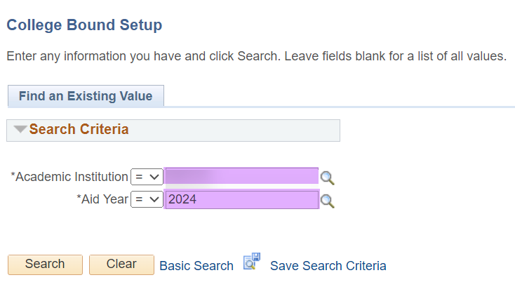

Open the page for the **current aid year** to copy to the upcoming aid year

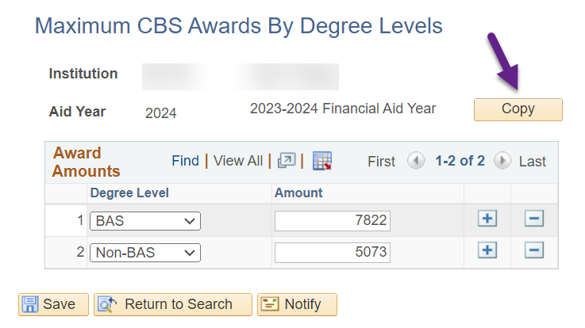

**Selecting Copy will open the page below**

Enter the following in the **Copy To** fields then select **OK**:

* Academic Institution
* Aid Year

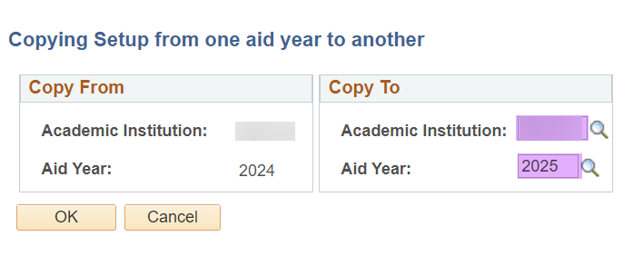

Select **Save**

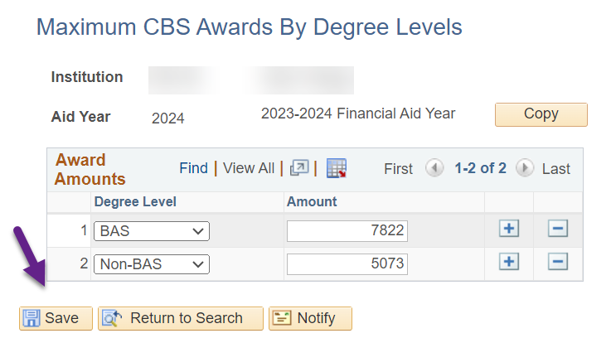

***After copy is complete, you will see values in the new aid year WCG tables.***

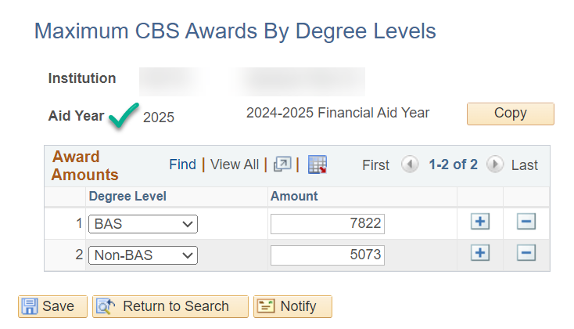

**Estimated 2024-2025 Award Amounts and MFI table were given to colleges by WSAC on 11/02/2023.**

**They are estimates and the values can change so it’s up to the college to wait for the final numbers or update now and update again later should the values change.**

# Appendix I: Setup Review Queries

List of queries mentioned throughout this guide as well as other helpful ones.

|  |  |
| --- | --- |
| **Query** | **Description** |
| **QCS_FA_CHKLST_DESCRP** | List of all FINA checklists and their descriptions. |
| **CTC_FA_LC_AYRO_CHECKLIST_ITEMS** | List of all E and F checklists and their descriptions. |
| **CTC_FA_LC_AYRO_3CEVENT_DEFINED** | Allows users to query the Event IDs and review the values in order to verify the setup. |
| **CTC_FA_LC_AYRO_3C_EVENT_GROUPS** | Allows users to query the Event 3C Groups and review the values in order to verify the setup. |
| **QCS_CC_COMM_INST** | List of Communications for the prompted institution. |

# Appendix II: Solution to Checklist Error Message

## The Issue

You attempt to add a row to the Checklist Item, and the below error message “Cannot change current or history records unless in Correction mode” comes up immediately before you can make any changes.

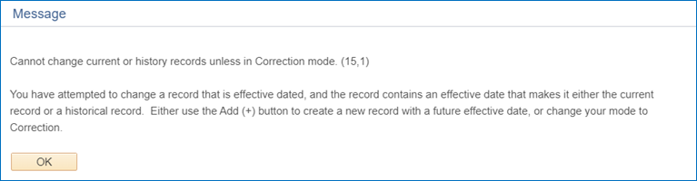

## The Solution

**If you know you have Correct History access:**

1. Back out of the Checklist Item
2. Click the Correct History checkbox
3. Add a row and move forward with your adjustments (Make sure not to make changes to preexisting rows.)

***\*\**** ***This workaround should only be used when you see this error message. Otherwise, as a general rule, Correct History mode should not be used to make changes to Checklist Items.\*\****

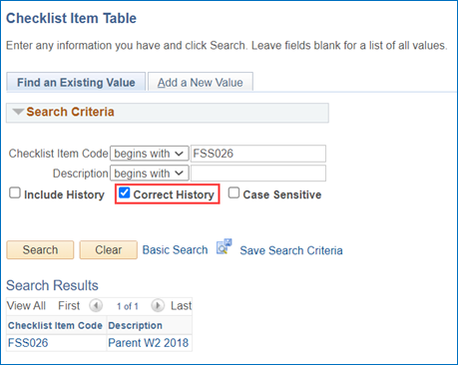

**If you need Correct History access** (you are not able to check the box in the screenshot above):

1. Request that your local security team to grant you the security role ZC FA Local Configuration
2. Follow the steps above.

***\*\*Correct History access is typically only granted to FA Directors and super users, and this level of access should be granted sparingly.\*\****

Return to Checklist Item Table section

# Appendix III: Creating an FA Office EMPLID

## The Issue

Using an actual staff member’s EMPLID leads to a large volume of calls and emails directed at the assigning person. In response, colleges have asked how to set up a “Financial Aid Office” EMPLID that can be used instead; similar to what Spokane and TCC use in their Event Definitions.

**Event Definitions will need to be updated with the new FA Office EMPLID prior to activating the ISIR Jobset for the new aid year**

## The Solution

**Step 1: Work with your local Records team to create a new “Financial Aid Office” EMPLID.**

Below please find two screenshots with examples of the set up for Add/Update Person AND a search on **the "Financial Aid Office" EMPLID containing NO SECURITY ROLES WHATSOEVER.** This record is to be created solely to display contact information tied to the assigned checklist item. **NO ONE should have any ability to log into the account.**

Example of Add/Update Person screen values:

***Name:*** *Financial Aid XXX Office*

***Date of Birth:*** *01/01/1901*

***SSN:*** *All XXX’s*

***Phone Number:*** *Campus Phone Number you want the student to call (Financial Aid Office #)*

***Email:*** *Campus Email with your desired email address (Financial Aid Office email address)*

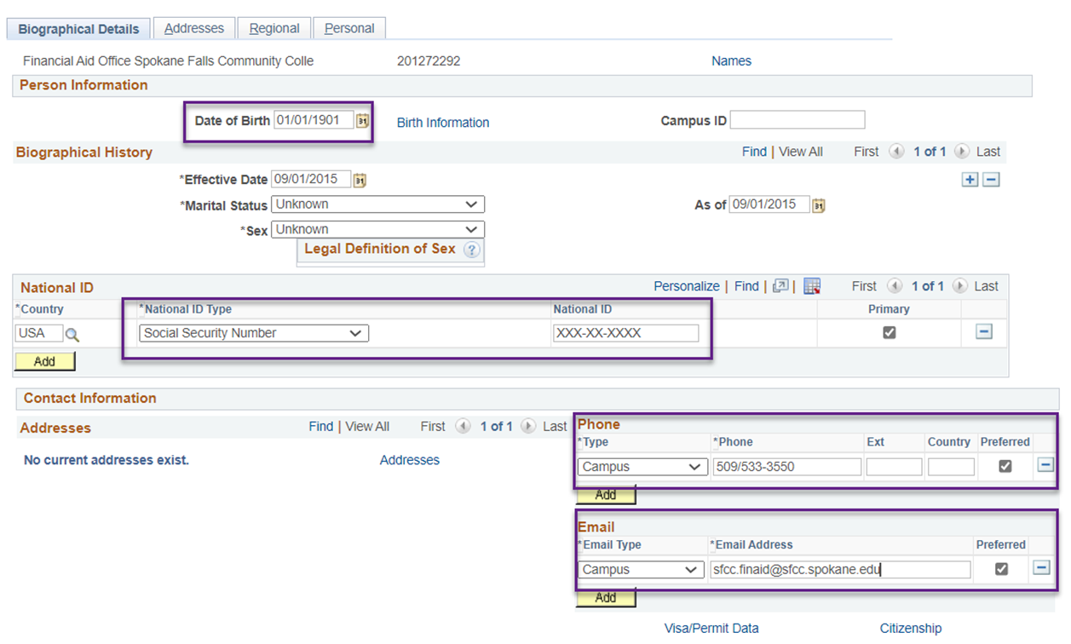

Example of User ID Security Access (No Roles at all):

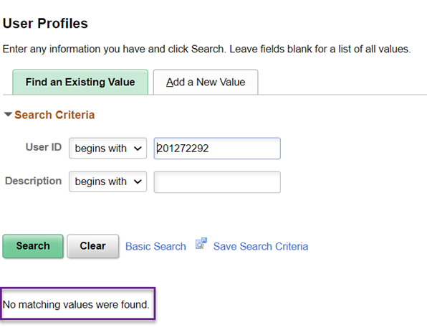

**Step 2: Update Event Definitions with the new Responsible ID**

Return to your Event Definition Configuration page and add a new effective dated row of today then enter the newly created Responsible ID in the two Responsible ID fields.

**Please DO NOT use Correct History,** and be sure to leave previous rows as “Active”. This will be essential for keeping a history for checklists that have been assigned with this code in previous aid years.

**Navigation:  Nav Bar > Navigator > Campus Community > 3C Engine > Set Up 3C Engine > Event Definition**

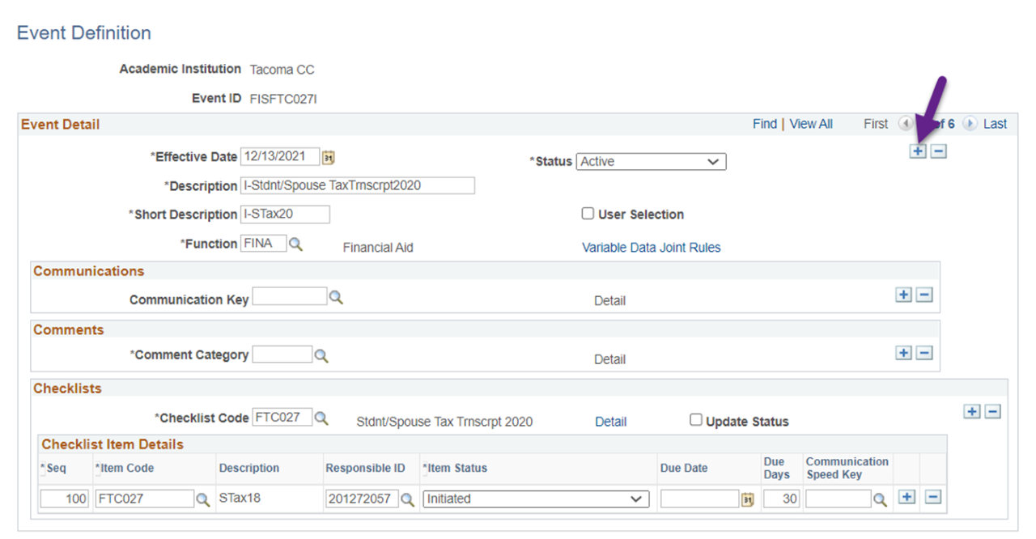

The first Responsible ID field is on the Event Definition page. Enter your newly created "Financial Aid Office" EMPLID in that field.

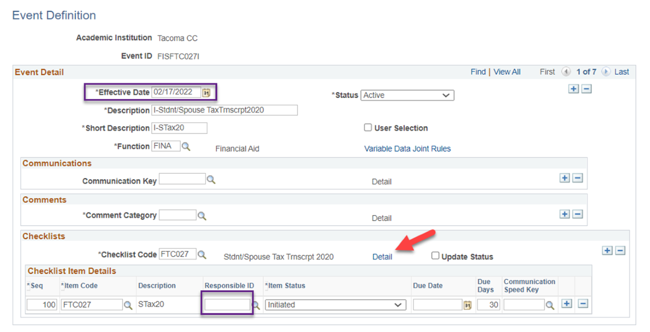

The second Responsible ID fields is hidden in the **Detail link.** Enter your newly created "Financial Aid Office" EMPLID then click OK.

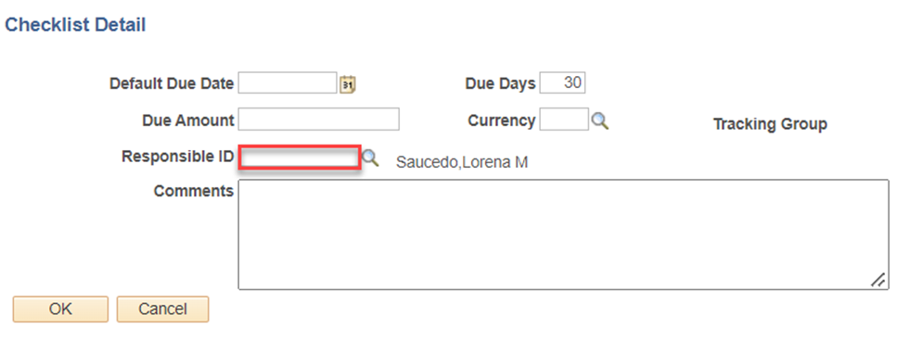

After completing both areas, select Save.

Return to Event Definition section