SBCTC

Abstract

*Per the 9/14/2022 Financial Aid Maintenance List from FAC on Satisfactory Academic Progress change requests, a solution is needed that will ensure the FA SAP Process can accurately count the attempted and earned units for a student, even if that student’s academic record was manually rebuilt in ctcLink from legacy and the student’s data does not exist in the Enrollment record in ctcLink. This solution will address the Cumulative Attempted Units value calculated by the Maximum Attempted Units Test. This customization utilizes a custom view, which combines both enrollment and manually entered transfer data. The Cumulative Earned Units value will be addressed in a separate project.*

solution design   
fa sap customization

Legacy Transfer Units in Maximum Attempted Units Test (MAXT) Course Exclusions

# Issue Overview

## Clarified Problem and Change Request Statements – Transfer Units in MAXT Course Exclusions

The below Revised Problem Statement was defined during the Special SAP Sessions held on December 16th, 2022 and January 24th, 2023, and formed the basis off of which we analyzed the issue and created the final solution design put forth later in this document.

### Original Problem Statement from Maintenance List

"does not automatically exclude from MAXT calculation as they are treated like transferred credits.”

### Revised Problem Statement

If a student returns to a college and has previous enrollment records that were not captured in the conversion to ctcLink, the legacy data manually entered as Transfer Units is not included in MAXT calculations. Remedial units entered manually are not being excluded from the MAXT evaluation (up to the Max Remedial Units to Exclude value set by colleges) under Course Exclusions in their SAP configurations.

## Background Information

In this Solution Design Document, the issue with legacy units is identified and addressed in the Maximum Attempted Units SAP Test only to ensure clarity and accuracy during all phases of the project execution. Other related SAP Tests will be addressed in separate SAP projects.

### Delivered Functionality – Maximum Attempted Units Test Logic Flow

The Maximum Attempted Units Test configurations work in tandem with the Course Exclusions setup, so long as both are enabled. This test calculates the Cumulative Attempted Units value following the logic as outlined below.

1. Check that the Maximum Attempted Units Test is enabled
   1. **If** it is enabled, **then** proceed
   2. **If** it is not enabled, **then** skip test
2. Retrieve the Total Enrolled Attempted Units from Student Enrollment (STDNT_ENRL)
3. Determine total units from Student Enrollment in courses that are listed in the Course Exclusions of SAP setup
4. Compare the total Enrolled ESL Units against the Max ESL Units to Exclude value, if Course Exclusions is enabled
   1. **If** the total Enrolled ESL Units is *greater than* the Max ESL Units to Exclude value,  
       **then** the ESL units to exclude *is equal to* the Max ESL Units to Exclude value
   2. **If** the total Enrolled ESL Units is *less than* the Max ESL Units to Exclude value,  
       **then** the ESL units to exclude *is equal to* the sum of all Enrolled ESL Units from the Course Exclusions list
   3. **If** the Max ESL Units to Exclude value is blank,  
       **then** the Enrolled ESL units to exclude *is equal to* the sum of all Enrolled ESL Units from the Course Exclusions list
5. Compare the total Remedial Units against the Max Remedial Units to Exclude value, if Course Exclusions is enabled
   1. **If** the total Enrolled Remedial Units is *greater than* the Max Remedial Units to Exclude value,  
       **then** the Enrolled Remedial units to exclude *is equal to* the Max Remedial Units to Exclude value
   2. **If** the total Enrolled Remedial Units is *less than* the Max Remedial Units to Exclude value,  
       **then** the Enrolled Remedial units to exclude *is equal to* the sum of all Enrolled Remedial Units from the Course Exclusions list
   3. **If** the Max Remedial Units to Exclude value is blank,  
       **then** the Enrolled Remedial units to exclude *is equal to* the sum of all Enrolled Remedial Units from the Course Exclusions list
6. Calculate the Cumulative Attempted Units:  
   Total Enrolled Attempted Units (step 2) **minus** Enrolled ESL Units to Exclude (step 4) **minus** Enrolled Remedial Units to Exclude (step 5)
7. Calculate the total Transfer Units per the local configuration of the Maximum Attempted Transfer Unit Criteria
   1. **If** the Towards GPA box is checked  
       **then** add the total Towards GPA Transfer Units from Student Term History (STDNT_CAR_TERM)
   2. **If** the No GPA box is checked  
       **then** add the total No GPA Transfer Units from Student Term History (STDNT_CAR_TERM)
   3. **If** the Course Credit box is checked  
       **then** add the total Course Credit Transfer Units from Student Term History (STDNT_CAR_TERM)
   4. **If** the Test Credit box is checked  
       **then** add the total Test Credit Transfer Units from the Test Credit Extract View (TEST_EXTR2_VW)
   5. **If** the Other Credit box is checked  
       **then** add the total Other Credit Transfer Units from the Other Credit Extract View (OTHR_EXTR2)
   6. **If** the TC Units Adjust box is checked  
       **then** *subtract* the total TC Units Adjust Transfer Units from Student Term History (STDNT_CAR_TERM)
8. Calculate the final Cumulative Attempted Units by adding the Total Transfer Units from step 7 to the Enrolled Attempted Units in step 6
9. Compare the student’s Cumulative Attempted Units against the ranges specified in the locally configured Max Attempted Units Rules
   1. **If** the student data matches one of the rules,   
      **then** assign the corresponding SAP Status, per the local configuration, for the Maximum Attempted Units Test
   2. **If** the student data does not match one of the rules,   
      **then** assign the Career Pass Default Status (configured on the Setup tab of the Define Set Up Criteria page) for the Maximum Attempted Units Test

### Delivered Functionatliy - High-Level Diagram of Cumulative Attempted Units calculation

*\*All items checked in the Maximum Attempted Transfer Unit Criteria configuration are considered by the SAP test as part of the Transfer Units value calculated here (Towards GPA, No GPA, Course Credit, Test Credit, Other Credit, and TC Units Adjust).*

### Delivered SAP Functionality – Maximum Attempted Units Configuration Pages

#### Image: Maximum Attempted Units Test setup

*Navigation: Set Up SACR > Product Related > Financial Aid > Satisfactory Academic Progress > Define Set Up Criteria > Criteria 1 (tab)*

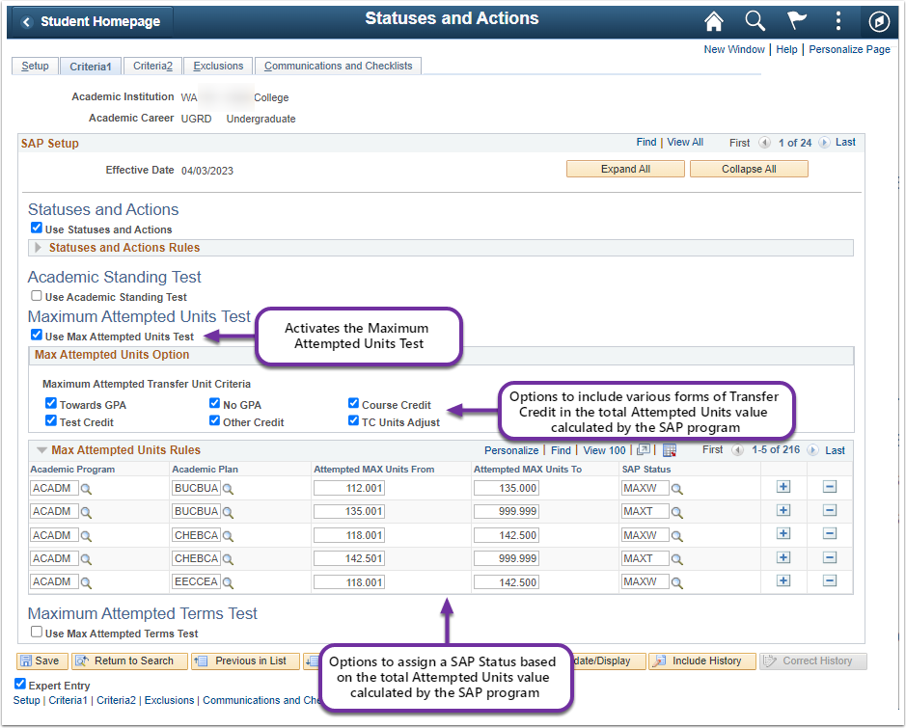

#### Image: Course Exclusions setup

*Navigation: Set Up SACR > Product Related > Financial Aid > Satisfactory Academic Progress > Define Set Up Criteria > Exclusions (tab)*

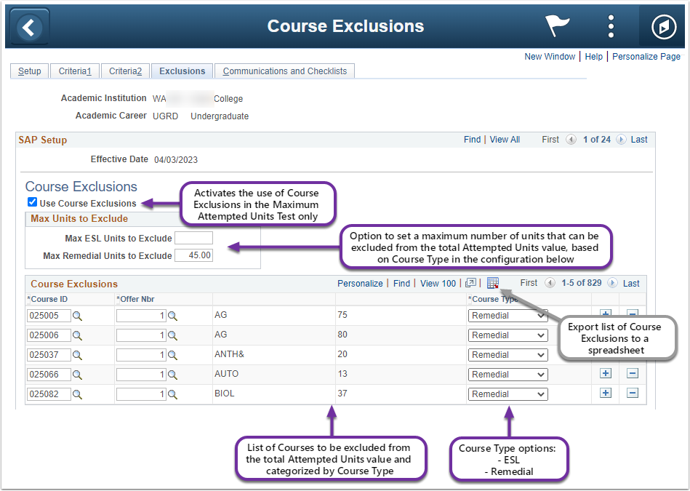

### The Problem with Delivered SAP Functionality and Legacy Data in ctcLink

The SAP program uses the following records in order to calculate the Cumulative Attempted Units value:

* **Term History Cumulative Statistics *(STDNT_CAR_TERM)*** – Used by the SAP program to count the total units for the Maximum Attempted Units Test.
* **Test Credit Extract View (TEST_EXTR2_VW)** – Used by the SAP program to count the total units for the Maximum Attempted Units Test.
* **Other Credit Extract View (OTHR_EXTR2)** – Used by the SAP program to count the total units for the Maximum Attempted Units Test.
* **Student Enrollment *(STDNT_ENRL)*** – Used by the SAP program to determine the number of units to exclude based on the Course Exclusions configuration from the Cumulative Attempted Units value.

In the ctcLink system, Legacy units are manually entered as transfer units. However, transfer units do not exist on the Student Enrollment (STDNT_ENRL) record, which is used when determining courses to exclude. This means that if a student took courses at the college while the college was still using the legacy system, then all those units are counted against the student’s Cumulative Attempted Units; they are not compared against the college’s local Course Exclusions configuration.

The delivered functionality will not identify those units as having been attempted at the college, and therefore will not exclude them from the Cumulative Attempted Units as it has been configured for the college. This can cause students to meet their Maximum Attempted Units limit prematurely. An incorrect Cumulative Attempted Units value can impact the student’s Pace of Progression, as well, as it is a key component in the calculation for Pace of Progression.

### Student Example of the Identified Problem

The screenshots below show the Cumulative Statistics page for a student with 115 units transferred from legacy. 60 of those transfer units were ESL courses and 55 of those transfer units were Remedial courses, all of which are listed in the college’s SAP Course Exclusions setup.

The Max Remedial Units to Exclude value on the college’s local SAP setup is set to 45, so only 10 of the Remedial units should count toward the Cumulative Attempted Units value in the SAP calculation.

The Max ESL Units to Exclude value on the college’s local SAP setup is set to [blank], so none of the ESL units should count toward the Cumulative Attempted Units value in the SAP calculation.

#### Image: Example student’s Cumulative Statistics from Student Term History page

Navigation: Records and Enrollment > Student Term Information > Term History > Cumulative Statistics (tab)

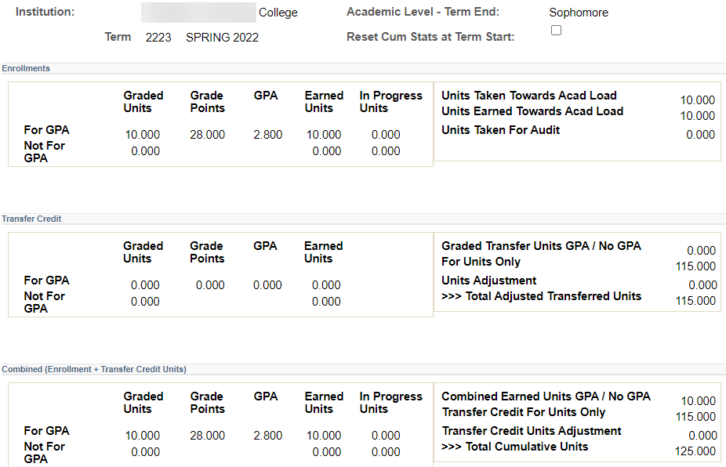

Units from

Student Enrollment

Transfer Units (includes legacy data)

#### Image: Example student’s Maintain Student SAP Data page

Navigation: Financial Aid > Satisfactory Academic Progress > Maintain Student SAP Data

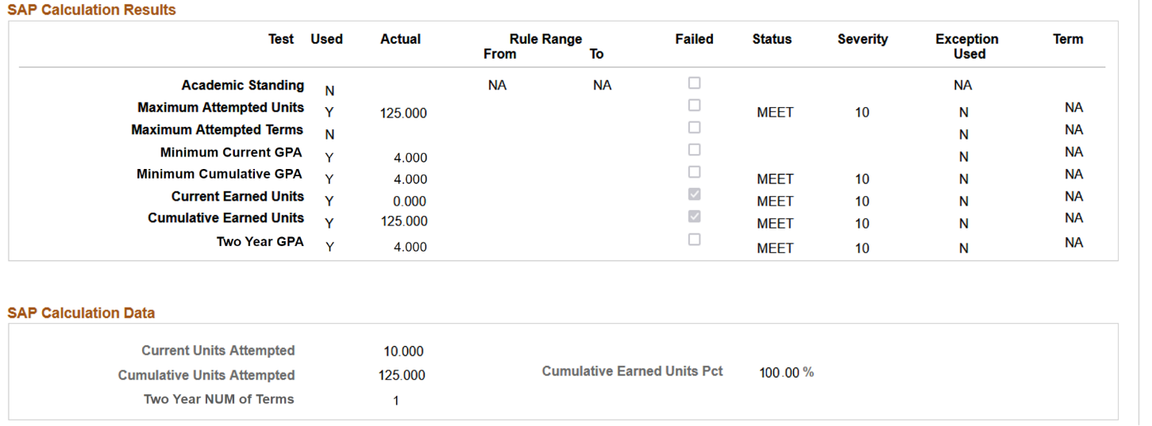

Cumulative Attempted Units currently includes all transfer units, even those that should be excluded per the Course Exclusions setup.

# Proposed Solution

## Solution Overview

Create a custom view to identify legacy units and corresponding course information added manually in ctcLink. Clone the delivered PeopleSoft Financial Aid SAP Application Engine for the Maximum Attempted Units Test. Modify the copied code to compare the custom view against additional delivered enrollment tables to pull the data points necessary to compare these legacy transfer units to the Course Exclusions configuration. Update the SAP AE Process Setup configuration page for each institution to point to the custom code.

### Proposed Solution – Maximum Attempted Units Test Logic Flow

1. Check that the Maximum Attempted Units Test is enabled
   1. **If** it is enabled, **then** proceed
   2. **If** it is not enabled, **then** skip test
2. Retrieve the Total Cumulative Attempted Units from Student Enrollment (STDNT_ENRL)
3. NewRetrieve the Total Cumulative Attempted Units from the RebuiltTrnscrpts & PSTrnscrpts custom view (VCS_TRNS_CRSE), per the local configuration of the Maximum Attempted Transfer Unit Criteria
4. Calculate the total Transfer Units per the local configuration of the Maximum Attempted Transfer Unit Criteria
   1. **If** the Towards GPA box is checked  
       **then** add the total Towards GPA Transfer Units from a clone of the RebuiltTrnscrpts & PSTrnscrpts custom view (VCS_TRNS_CRSE)
   2. **If** the No GPA box is checked  
       **then** add the total No GPA Transfer Units from a clone of the RebuiltTrnscrpts & PSTrnscrpts custom view (VCS_TRNS_CRSE)
   3. **If** the Course Credit box is checked  
       **then** add the total Course Credit Transfer Units from a clone of the delivered from a clone of the RebuiltTrnscrpts & PSTrnscrpts custom view (VCS_TRNS_CRSE)
   4. **If** the Test Credit box is checked  
       **then** add the total Test Credit Transfer Units from the delivered Test Credit Extract View (TEST_EXTR2_VW)
   5. **If** the Other Credit box is checked  
       **then** add the total Other Credit Transfer Units from the delivered Other Credit Extract View (OTHR_EXTR2)
   6. **If** the TC Units Adjust box is checked  
       **then** *subtract* the total TC Units Adjust Transfer Units from a clone of the RebuiltTrnscrpts & PSTrnscrpts custom view (VCS_TRNS_CRSE)
5. Sum values from step 2 and step 3



1. Determine total ESL units and Remedial units from the total in step 4 to exclude from the Total Cumulative Attempted Units value based on Course Exclusions configuration



1. Calculate the Final Cumulative Attempted Units value:   
   Total Enrolled Units (step 2) **plus** Total Transfer Units (step 3) **minus** Enrolled ESL and Remedial units to exclude **minus** Transferred ESL and Remedial units to exclude



1. Compare the student’s Cumulative Attempted Units against the ranges specified in the locally configured Max Attempted Units Rules
   1. **If** the student data matches one of the rules,  
      **then** assign the corresponding SAP Status, per the local configuration, for the Maximum Attempted Units Test
   2. **If** the student data does not match one of the rules,  
      **then** assign the Career Pass Default Status configured on the Setup tab of the Define Set Up Criteria page, for the Maximum Attempted Units Test

### Proposed Solution – High-Level Diagram of Cumulative Attempted Units calculation

|  |
| --- |
|  |
|  |
|  |
| Term History and New Custom View Data |
|  |
| *\*All items checked in the Maximum Attempted Transfer Unit Criteria configuration are considered by the SAP test as part of the Transfer Units value calculated here (Towards GPA, No GPA, Course Credit, Test Credit, Other Credit, and TC Units Adjust).* |

### Student Example with the Solution Applied

The screenshots below show the Cumulative Statistics page for a student with 115 units transferred from legacy. 60 of those units were ESL courses and 55 of those units were Remedial courses, all of which are listed in the college’s SAP Course Exclusions setup.

The Max Remedial Units to Exclude value on the college’s local SAP setup is set to 45, so any remaining Remedial Units (10 units) should count toward the Cumulative Attempted Units value in the SAP calculation.

The Max ESL Units to Exclude value on the college’s local SAP setup is set to [blank], so none of the ESL units should count toward the Cumulative Attempted Units value in the SAP calculation.

#### Image: Example student’s Cumulative Statistics from Student Term History page

Navigation: Records and Enrollment > Student Term Information > Term History > Cumulative Statistics (tab)



Units from

Student Enrollment

Transfer Units (includes legacy data)

#### Image: Example student’s Maintain Student SAP Data page with solution customization

Navigation: Financial Aid > Satisfactory Academic Progress > Maintain Student SAP Data

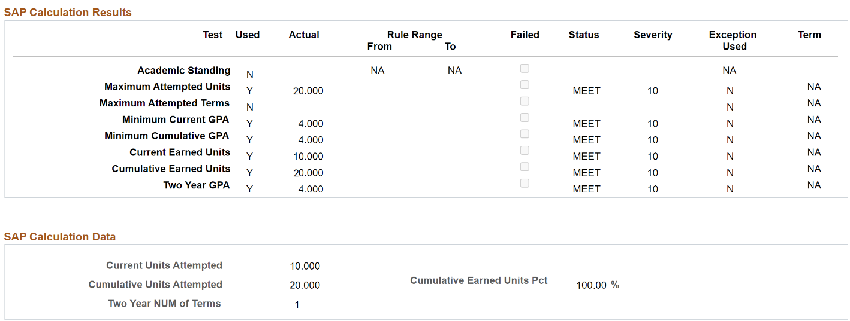

Cumulative Attempted Units now excludes the legacy transfer units, per the Course Exclusions setup.

## Technical Details of Solution

### When running from Process SAP run control page

New custom Application Engine section will be created by reusing the delivered SFA_SAP_LIB Application Engine – Maximum Attempted Units test section. Modify the logic to accommodate the requirement mentioned in the section The Problem with Delivered SAP Functionality and Legacy Data in ctcLink.

### Modification logic includes below steps

1. Retrieve the transfer course details from a clone of the custom view [VCS_TRNS_CRSE] and clones of two delivered views [TEST_EXTR2_VW and OTHR_EXTR2_VW] in order to compare Course IDs to the local SAP configuration for Max Remedial Excluded Units and Max ESL Excluded Units.
2. Revise logic to combine the sum of excluded remedial units and the sum of excluded ESL units for both enrollment and transfer before comparison to Max Excluded Unit configuration.
3. Revise logic to combine the sum of all units taken from enrollment with the sum of all transfer units taken before subtracting the total units excluded for Remedial and ESL courses taken (attempted).

### When running for individual Student from Maintain Student SAP Data page

The same custom Application Engine created for the Process SAP batch process will also be called when the Calculate SAP button on the Maintain Student SAP page is selected. Student SAP data calculated from this page using the Calculate SAP button will be processed the same as it processes through the Process SAP process with the new custom logic.

#### Image: Calculate SAP button on the Student SAP Data page

Navigation: Financial Aid > Satisfactory Academic Progress > Maintain Student SAP Data

