Adding WBG Equation Engine to Packaging Plans

Setup Guide

FA Customer Support

FA Customer Support

Washington State Board for Community and Technical College



# Overview

A Washington Bridge Grant (WBG) Equation Engine has been built for colleges to add to packaging plans starting from the 2023-2024 aid year. Should eligibility criteria change in a future year, aid year criteria can be added to the equation engine to accommodate utilizing the equation engine in multiple aid years with differing criteria.

**Selection Criteria**

* WCG eligible
* 0-65% MFI
* CBS is not ‘Okay to Award’ and not ‘Okay to Pay’

There are two ways that the $500 of WBG can be offered in packaging plans. After going through the steps in the ‘Preparation’ section, move to the Award Package Criteria that fits your awarding process.

**Award Package Criteria 1** - Evenly split across all terms in packaging plan

**Award Package Criteria 2** - Lump sum in the first quarter but all future buckets open

CONTENTS

Overview 1

Preparation 3

Award Package Criteria 1 – Evenly split across all terms in packaging plan 5

SUFAWISP or FAWISPSU Packaging Plans 5

FA-WI-SP Packaging Plan 7

SU-FA-WI Packaging Plan **HEADER ONLY** 8

WI-SP-SU Packaging Plan **TRAILER ONLY** 9

FA-WI Packaging Plan 10

WI-SP Packaging Plan 11

SU-FA Packaging Plan **HEADER ONLY** 12

SP-SU Packaging Plan **TRAILER ONLY** 13

FALL ONLY Packaging Plan 14

WINTR ONLY Packaging Plan 15

SPRG ONLY Packaging Plan 16

SUMR ONLY Packaging Plan 17

Award Package Criteria 2 – Lump sum in the first quarter but all future buckets open 18

SUFAWISP or FAWISPSU Packaging Plans 18

FA-WI-SP Packaging Plan 20

SU-FA-WI Packaging Plan **HEADER ONLY** 21

WI-SP-SU Packaging Plan **TRAILER ONLY** 22

FA-WI Packaging Plan 23

WI-SP Packaging Plan 24

SU-FA Packaging Plan **HEADER ONLY** 25

SP-SU Packaging Plan **TRAILER ONLY** 26

FALL ONLY Packaging Plan 27

WINTR ONLY Packaging Plan 28

SPRG ONLY Packaging Plan 29

SUMR ONLY Packaging Plan 30

# Preparation

The WBG item-type needs to be set up to be a selectable in packaging plans. Make sure to review the *Financial Aid Item Types* page for the WBG item-type and update tab 2 if needed.

**Navigation: Set Up SACR > Product Related > Financial Aid > Awards > Financial Aid Item Types**

Navigate to the *Financial Aid Item Types* page then select the **WBG item-type (912000000250)**

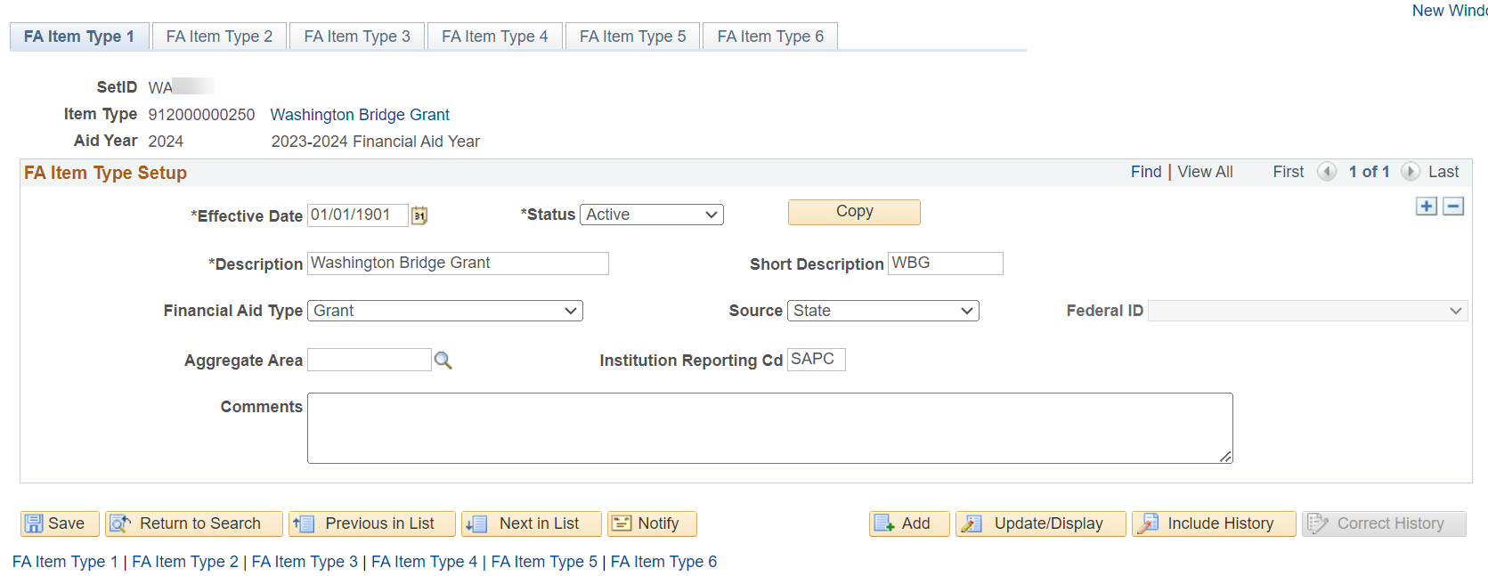

Select **FA Item Type 2** tab and confirm the **Auto Package** checkbox is selected.

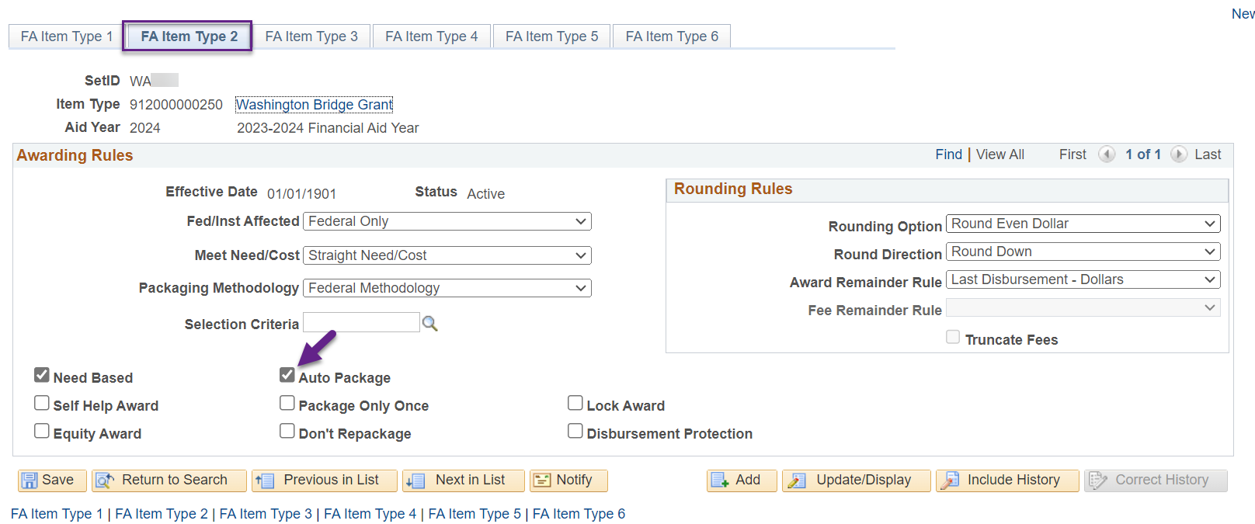

**Note:** If the **Auto Package** checkbox is not selected, return to the **FA Item Type 1** tab, add **a new effective dated row** of today, select the **FA Item Type 2** tab, select the **Auto Package** checkbox then save.

Run the **CTC_FA_PACKAGING_PLANS** query and download the results into a spreadsheet to plan out the Sequence Numbers for WBG in each of your packaging plans.

**Example of a college planning out the sequence number for WBG in packaging plans, placing it after College Bound Scholarship.**

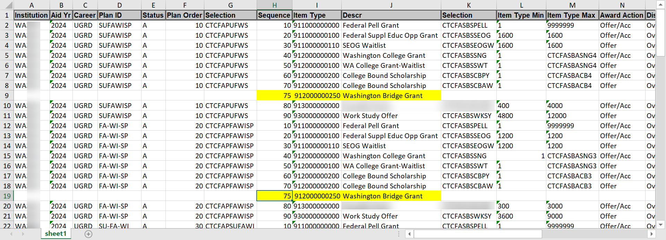

**Sequence Number 75 is what they’re selecting for each packaging plan in this case. Maybe for your college it’s 55 or 65.**

Once you’ve determined where (the Sequence Number) you’re putting the WBG item-type in each packaging plan, select the awarding criteria that fits your awarding process (Ctrl button + select link)

Award Package Criteria 1 – Evenly split across all terms in packaging plan

Award Package Criteria 2 – Lump sum in the first quarter but all future buckets open

# Award Package Criteria 1 – Evenly split across all terms in packaging plan

#### SUFAWISP or FAWISPSU Packaging Plans

**Navigation: Set Up SACR > Product Related > Financial Aid > Awards > Packaging Plan**

Select your college’s four-term packaging plan (**SUFAWISP-header** or **FAWISPSU-trailer**) for 2024 aid year then add an effective dated row of today

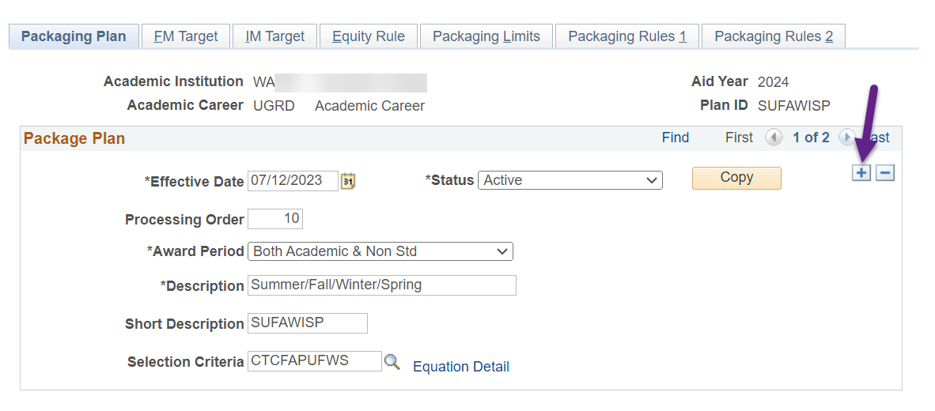

Select **Packaging Rules 1** tab and add a new row

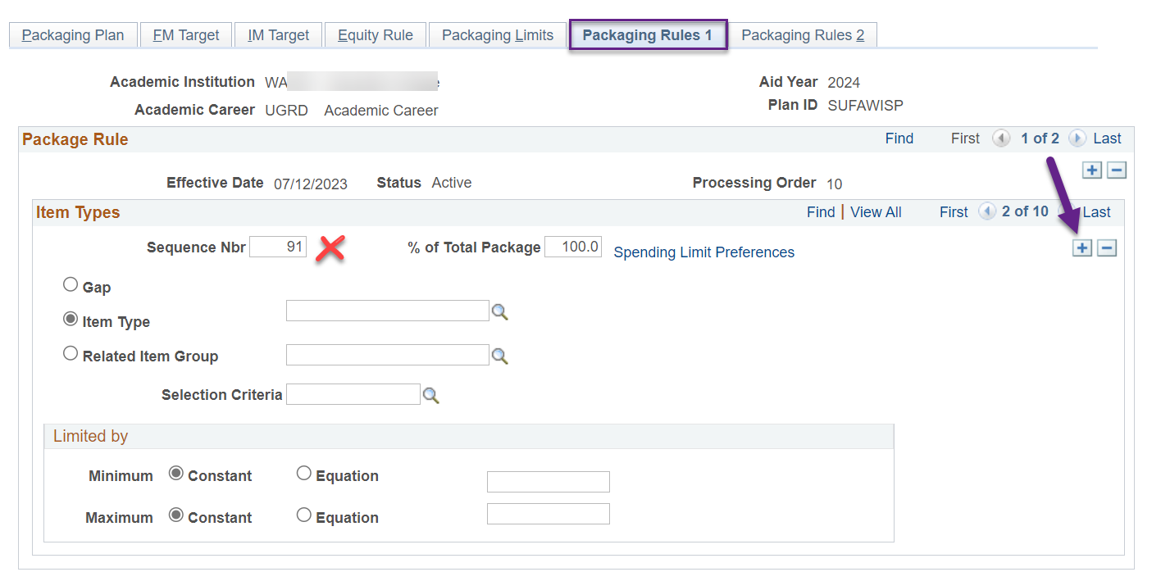

Update the following areas

*Sequence Nbr*: **(the Sequence Nbr you chose for WBG in this packaging plan i.e. 75)**

*Item Type*: **912000000250**

*Selection Criteria*: **CTCFASBSWBG (Select for WBG)**

*Limited by*: Maximum **Constant** of **500**

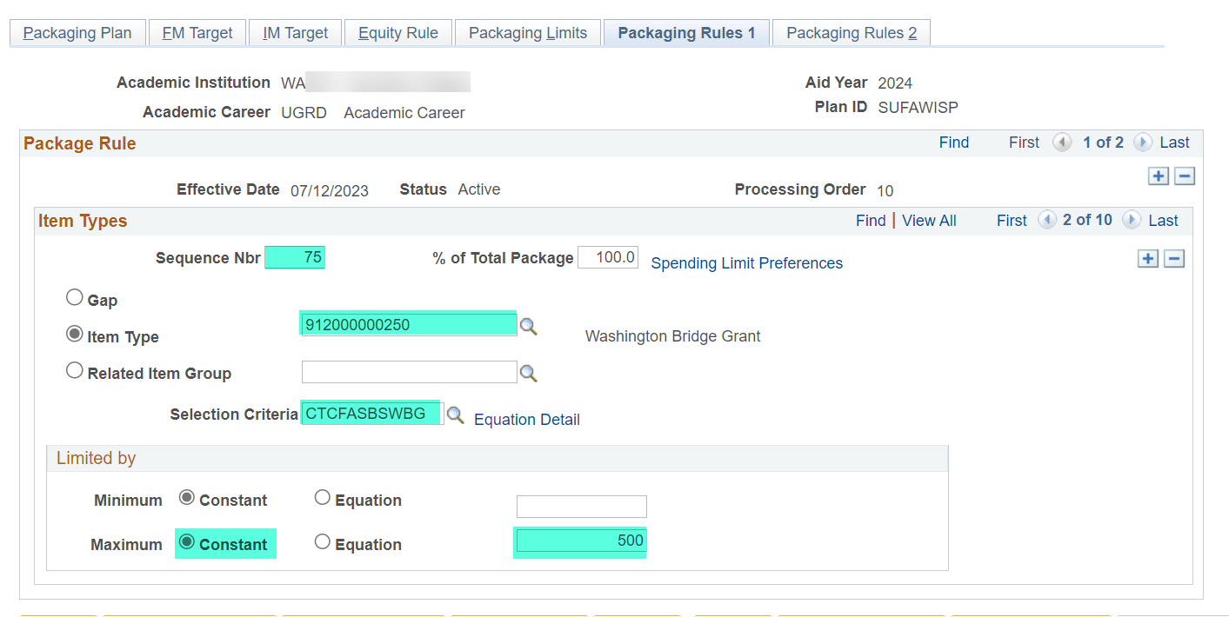

Select the **Packaging Rules 2** tab and update the following

*Disbursement Plan*: **Override Default** then **Su-Fa-Wi-Sp** or **Fa-Wi-Sp-Su**

*Split Code*: **Override Default** then **Su-Fa-Wi-Sp** or **Fa-Wi-Sp-Su**

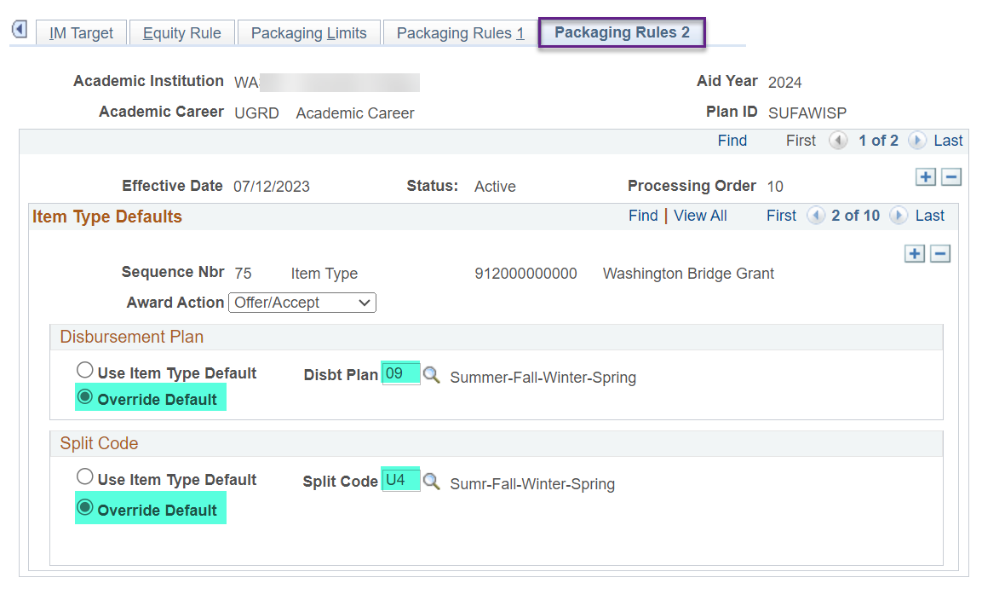

**SAVE YOUR WORK!!**

**YOU ARE DONE WITH THIS PACKAGING PLAN! 🎉**

#### FA-WI-SP Packaging Plan

**Navigation: Set Up SACR > Product Related > Financial Aid > Awards > Packaging Plan**

Select the **FA-WI-SP** for 2024 aid year then add an effective dated row of today

Select **Packaging Rules 1** tab and add a new row

Update the following areas

*Sequence Nbr*: **(the Sequence Nbr you chose for WBG in this packaging plan i.e. 75)**

*Item Type*: **912000000250**

*Selection Criteria*: **CTCFASBSWBG (Select for WBG)**

*Limited by*: Maximum **Constant** of **500**

Select the **Packaging Rules 2** tab and update the following

*Disbursement Plan*: **Override Default** then **Fa-Wi-Sp** or **Fa-Wi-Sp-Su**

*Split Code*: **Override Default** then **Fa-Wi-Sp**

**SAVE YOUR WORK!!**

**YOU ARE DONE WITH THIS PACKAGING PLAN! 🎉**

#### SU-FA-WI Packaging Plan **HEADER ONLY**

**Navigation: Set Up SACR > Product Related > Financial Aid > Awards > Packaging Plan**

Select the **SU-FA-WI** for 2024 aid year then add an effective dated row of today

Select **Packaging Rules 1** tab and add a new row

Update the following areas

*Sequence Nbr*: **(the Sequence Nbr you chose for WBG in this packaging plan i.e. 75)**

*Item Type*: **912000000250**

*Selection Criteria*: **CTCFASBSWBG (Select for WBG)**

*Limited by*: Maximum **Constant** of **500**

Select the **Packaging Rules 2** tab and update the following

*Disbursement Plan*: **Override Default** then **Su-Fa-Wi** or **Su-Fa-Wi-Sp**

*Split Code*: **Override Default** then **Su-Fa-Wi**

**SAVE YOUR WORK!!**

**YOU ARE DONE WITH THAT PACKAGING PLAN! 🎉**

#### WI-SP-SU Packaging Plan **TRAILER ONLY**

**Navigation: Set Up SACR > Product Related > Financial Aid > Awards > Packaging Plan**

Select the **WI-SP-SU** for 2024 aid year then add an effective dated row of today

Select **Packaging Rules 1** tab and add a new row

Update the following areas

*Sequence Nbr*: **(the Sequence Nbr you chose for WBG in this packaging plan i.e. 75)**

*Item Type*: **912000000250**

*Selection Criteria*: **CTCFASBSWBG (Select for WBG)**

*Limited by*: Maximum **Constant** of **500**

Select the **Packaging Rules 2** tab and update the following

*Disbursement Plan*: **Override Default** then **Wi-Sp-Su**

*Split Code*: **Override Default** then **Wi-Sp-Su**

**SAVE YOUR WORK!!**

**YOU ARE DONE WITH THAT PACKAGING PLAN! 🎉**

#### FA-WI Packaging Plan

**Navigation: Set Up SACR > Product Related > Financial Aid > Awards > Packaging Plan**

Select the **FA-WI** for 2024 aid year then add an effective dated row of today

Select **Packaging Rules 1** tab and add a new row

Update the following areas

*Sequence Nbr*: **(the Sequence Nbr you chose for WBG in this packaging plan i.e. 75)**

*Item Type*: **912000000250**

*Selection Criteria*: **CTCFASBSWBG (Select for WBG)**

*Limited by*: Maximum **Constant** of **500**

Select the **Packaging Rules 2** tab and update the following

*Disbursement Plan*: **Override Default** then **Fa-Wi** or **Fa-Wi-Sp** or **Fa-Wi-Sp-Su**

*Split Code*: **Override Default** then **Fa-Wi**

**SAVE YOUR WORK!!**

**YOU ARE DONE WITH THAT PACKAGING PLAN! 🎉**

#### WI-SP Packaging Plan

**Navigation: Set Up SACR > Product Related > Financial Aid > Awards > Packaging Plan**

Select the **WI-SP** for 2024 aid year then add an effective dated row of today

Select **Packaging Rules 1** tab and add a new row

Update the following areas

*Sequence Nbr*: **(the Sequence Nbr you chose for WBG in this packaging plan i.e. 75)**

*Item Type*: **912000000250**

*Selection Criteria*: **CTCFASBSWBG (Select for WBG)**

*Limited by*: Maximum **Constant** of **500**

Select the **Packaging Rules 2** tab and update the following

*Disbursement Plan*: **Override Default** then **Wi-Sp** or **Wi-Sp-Su**

*Split Code*: **Override Default** then **Wi-Sp**

**SAVE YOUR WORK!!**

**YOU ARE DONE WITH THAT PACKAGING PLAN! 🎉**

#### SU-FA Packaging Plan **HEADER ONLY**

**Navigation: Set Up SACR > Product Related > Financial Aid > Awards > Packaging Plan**

Select the **SU-FA** for 2024 aid year then add an effective dated row of today

Select **Packaging Rules 1** tab and add a new row

Update the following areas

*Sequence Nbr*: **(the Sequence Nbr you chose for WBG in this packaging plan i.e. 75)**

*Item Type*: **912000000250**

*Selection Criteria*: **CTCFASBSWBG (Select for WBG)**

*Limited by*: Maximum **Constant** of **500**

Select the **Packaging Rules 2** tab and update the following

*Disbursement Plan*: **Override Default** then **Su-Fa** or **Su-Fa-Wi-Sp**

*Split Code*: **Override Default** then **Su-Fa**

**SAVE YOUR WORK!!**

**YOU ARE DONE WITH THAT PACKAGING PLAN! 🎉**

#### SP-SU Packaging Plan **TRAILER ONLY**

**Navigation: Set Up SACR > Product Related > Financial Aid > Awards > Packaging Plan**

Select the **SP-SU** for 2024 aid year then add an effective dated row of today

Select **Packaging Rules 1** tab and add a new row

Update the following areas

*Sequence Nbr*: **(the Sequence Nbr you chose for WBG in this packaging plan i.e. 75)**

*Item Type*: **912000000250**

*Selection Criteria*: **CTCFASBSWBG (Select for WBG)**

*Limited by*: Maximum **Constant** of **500**

Select the **Packaging Rules 2** tab and update the following

*Disbursement Plan*: **Override Default** then **Sp-Su**

*Split Code*: **Override Default** then **Sp-Su**

**SAVE YOUR WORK!!**

**YOU ARE DONE WITH THAT PACKAGING PLAN! 🎉**

#### FALL ONLY Packaging Plan

**Navigation: Set Up SACR > Product Related > Financial Aid > Awards > Packaging Plan**

Select the **FALL ONLY** for 2024 aid year then add an effective dated row of today

Select **Packaging Rules 1** tab and add a new row

Update the following areas

*Sequence Nbr*: **(the Sequence Nbr you chose for WBG in this packaging plan i.e. 75)**

*Item Type*: **912000000250**

*Selection Criteria*: **CTCFASBSWBG (Select for WBG)**

*Limited by*: Maximum **Constant** of **500**

Select the **Packaging Rules 2** tab and update the following

*Disbursement Plan*: **Override Default** then **Fall Only**

*Split Code*: **Override Default** then **Fall**

**SAVE YOUR WORK!!**

**YOU ARE DONE WITH THAT PACKAGING PLAN! 🎉**

#### WINTR ONLY Packaging Plan

**Navigation: Set Up SACR > Product Related > Financial Aid > Awards > Packaging Plan**

Select the **WINTR ONLY** for 2024 aid year then add an effective dated row of today

Select **Packaging Rules 1** tab and add a new row

Update the following areas

*Sequence Nbr*: **(the Sequence Nbr you chose for WBG in this packaging plan i.e. 75)**

*Item Type*: **912000000250**

*Selection Criteria*: **CTCFASBSWBG (Select for WBG)**

*Limited by*: Maximum **Constant** of **500**

Select the **Packaging Rules 2** tab and update the following

*Disbursement Plan*: **Override Default** then **Winter Only**

*Split Code*: **Override Default** then **Winter**

**SAVE YOUR WORK!!**

**YOU ARE DONE WITH THAT PACKAGING PLAN! 🎉**

#### SPRG ONLY Packaging Plan

**Navigation: Set Up SACR > Product Related > Financial Aid > Awards > Packaging Plan**

Select the **SPRG ONLY** for 2024 aid year then add an effective dated row of today

Select **Packaging Rules 1** tab and add a new row

Update the following areas

*Sequence Nbr*: **(the Sequence Nbr you chose for WBG in this packaging plan i.e. 75)**

*Item Type*: **912000000250**

*Selection Criteria*: **CTCFASBSWBG (Select for WBG)**

*Limited by*: Maximum **Constant** of **500**

Select the **Packaging Rules 2** tab and update the following

*Disbursement Plan*: **Override Default** then **Spring Only**

*Split Code*: **Override Default** then **Spring**

**SAVE YOUR WORK!!**

**YOU ARE DONE WITH THAT PACKAGING PLAN! 🎉**

#### SUMR ONLY Packaging Plan

**Navigation: Set Up SACR > Product Related > Financial Aid > Awards > Packaging Plan**

Select the **SUMR ONLY** for 2024 aid year then add an effective dated row of today

Select **Packaging Rules 1** tab and add a new row

Update the following areas

*Sequence Nbr*: **(the Sequence Nbr you chose for WBG in this packaging plan i.e. 75)**

*Item Type*: **912000000250**

*Selection Criteria*: **CTCFASBSWBG (Select for WBG)**

*Limited by*: Maximum **Constant** of **500**

Select the **Packaging Rules 2** tab and update the following

*Disbursement Plan*: **Override Default** then **Summer Only**

*Split Code*: **Override Default** then **Summer**

**SAVE YOUR WORK!!**

**YOU ARE DONE WITH THAT PACKAGING PLAN! 🎉**

Run the **CTC_FA_PACKAGING_PLANS** query again to check your work making sure the WBG item-type is in the correct place in you packaging plans, the selection equation engine is **CTCFASBSWBG**, and you split codes are correct.

# Award Package Criteria 2 – Lump sum in the first quarter but all future buckets open

#### SUFAWISP or FAWISPSU Packaging Plans

**Navigation: Set Up SACR > Product Related > Financial Aid > Awards > Packaging Plan**

Select your college’s four-term packaging plan (**SUFAWISP-header** or **FAWISPSU-trailer**) for 2024 aid year then add an effective dated row of today

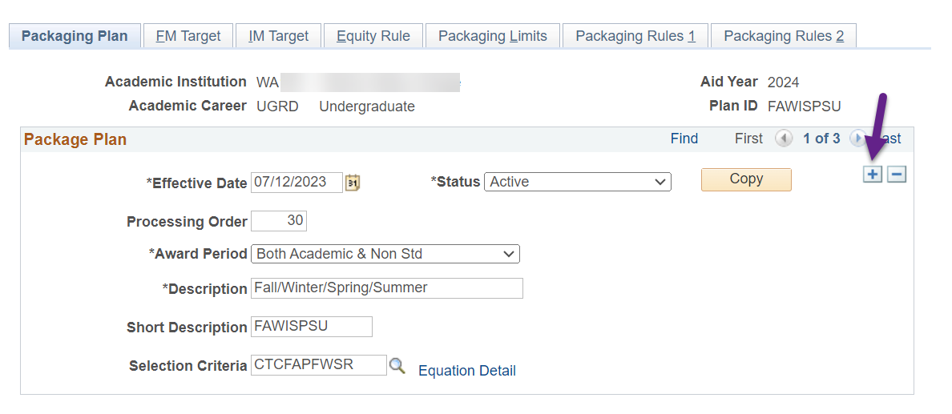

Select **Packaging Rules 1** tab and add a new row

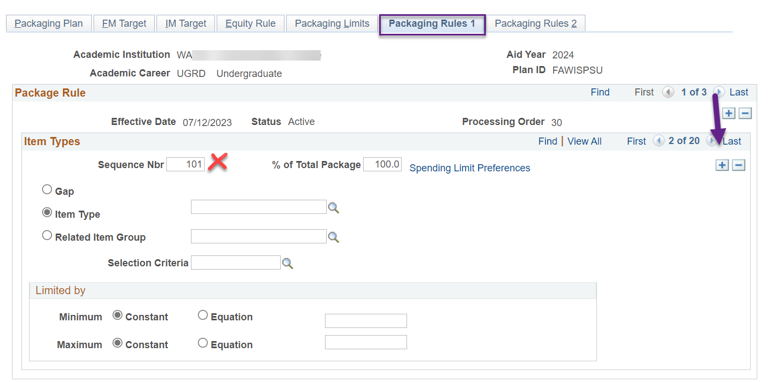

Update the following areas

*Sequence Nbr*: **(the Sequence Nbr you chose for WBG in this packaging plan i.e. 55)**

*Item Type*: **912000000250**

*Selection Criteria*: **CTCFASBSWBG (Select for WBG)**

*Limited by*: Maximum **Constant** of **500**

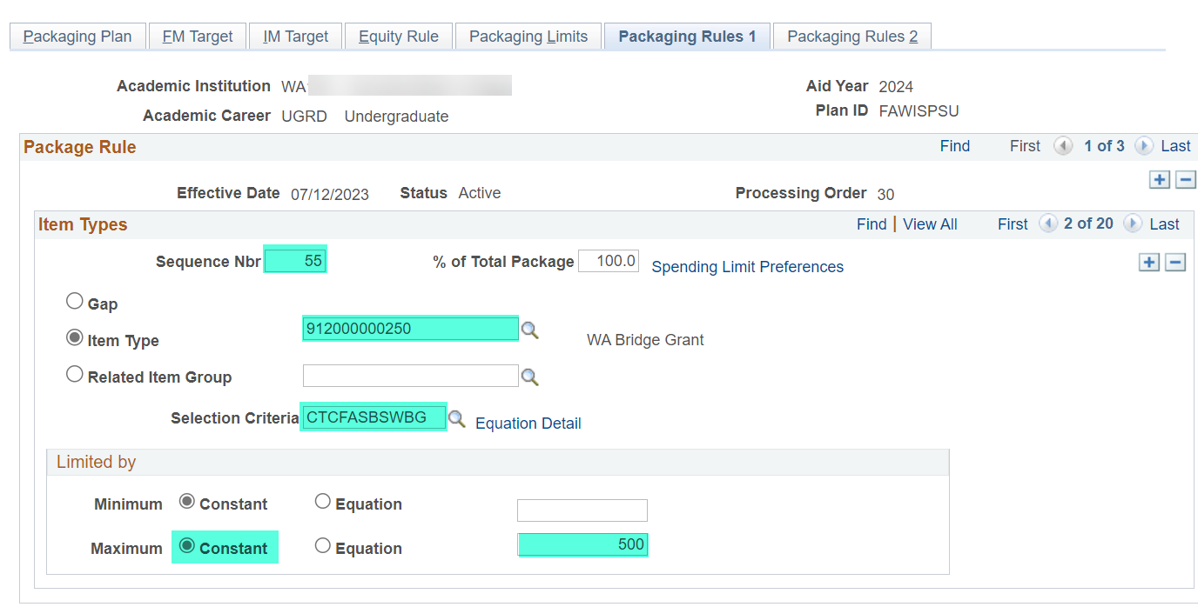

Select the **Packaging Rules 2** tab and update the following

*Disbursement Plan*: **Override Default** then **Su-Fa-Wi-Sp** or **Fa-Wi-Sp-Su**

*Split Code*: **Override Default** then **Summer-header** or **Fall-trailer**

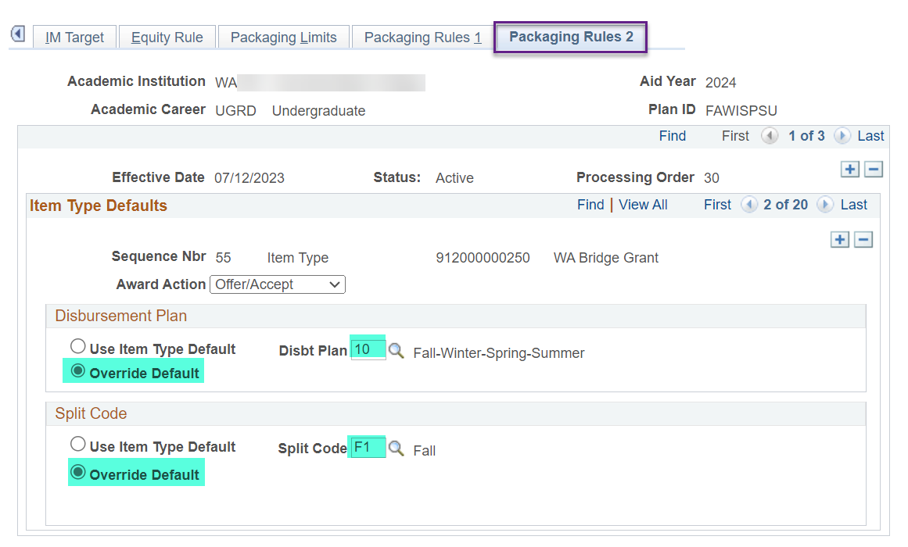

**SAVE YOUR WORK!!**

**YOU ARE DONE WITH THIS PACKAGING PLAN! 🎉**

#### FA-WI-SP Packaging Plan

**Navigation: Set Up SACR > Product Related > Financial Aid > Awards > Packaging Plan**

Select the **FA-WI-SP** for 2024 aid year then add an effective dated row of today

Select **Packaging Rules 1** tab and add a new row

Update the following areas

*Sequence Nbr*: **(the Sequence Nbr you chose for WBG in this packaging plan i.e. 55)**

*Item Type*: **912000000250**

*Selection Criteria*: **CTCFASBSWBG (Select for WBG)**

*Limited by*: Maximum **Constant** of **500**

Select the **Packaging Rules 2** tab and update the following

*Disbursement Plan*: **Override Default** then **Fa-Wi-Sp** or **Fa-Wi-Sp-Su**

*Split Code*: **Override Default** then **Fall**

**SAVE YOUR WORK!!**

**YOU ARE DONE WITH THIS PACKAGING PLAN! 🎉**

#### SU-FA-WI Packaging Plan **HEADER ONLY**

**Navigation: Set Up SACR > Product Related > Financial Aid > Awards > Packaging Plan**

Select the **SU-FA-WI** for 2024 aid year then add an effective dated row of today

Select **Packaging Rules 1** tab and add a new row

Update the following areas

*Sequence Nbr*: **(the Sequence Nbr you chose for WBG in this packaging plan i.e. 55)**

*Item Type*: **912000000250**

*Selection Criteria*: **CTCFASBSWBG (Select for WBG)**

*Limited by*: Maximum **Constant** of **500**

Select the **Packaging Rules 2** tab and update the following

*Disbursement Plan*: **Override Default** then **Su-Fa-Wi** or **Su-Fa-Wi-Sp**

*Split Code*: **Override Default** then **Summer**

**SAVE YOUR WORK!!**

**YOU ARE DONE WITH THAT PACKAGING PLAN! 🎉**

#### WI-SP-SU Packaging Plan **TRAILER ONLY**

**Navigation: Set Up SACR > Product Related > Financial Aid > Awards > Packaging Plan**

Select the **WI-SP-SU** for 2024 aid year then add an effective dated row of today

Select **Packaging Rules 1** tab and add a new row

Update the following areas

*Sequence Nbr*: **(the Sequence Nbr you chose for WBG in this packaging plan i.e. 55)**

*Item Type*: **912000000250**

*Selection Criteria*: **CTCFASBSWBG (Select for WBG)**

*Limited by*: Maximum **Constant** of **500**

Select the **Packaging Rules 2** tab and update the following

*Disbursement Plan*: **Override Default** then **Wi-Sp-Su**

*Split Code*: **Override Default** then **Winter**

**SAVE YOUR WORK!!**

**YOU ARE DONE WITH THAT PACKAGING PLAN! 🎉**

#### FA-WI Packaging Plan

**Navigation: Set Up SACR > Product Related > Financial Aid > Awards > Packaging Plan**

Select the **FA-WI** for 2024 aid year then add an effective dated row of today

Select **Packaging Rules 1** tab and add a new row

Update the following areas

*Sequence Nbr*: **(the Sequence Nbr you chose for WBG in this packaging plan i.e. 55)**

*Item Type*: **912000000250**

*Selection Criteria*: **CTCFASBSWBG (Select for WBG)**

*Limited by*: Maximum **Constant** of **500**

Select the **Packaging Rules 2** tab and update the following

*Disbursement Plan*: **Override Default** then **Fa-Wi** or **Fa-Wi-Sp** or **Fa-Wi-Sp-Su**

*Split Code*: **Override Default** then **Fall**

**SAVE YOUR WORK!!**

**YOU ARE DONE WITH THAT PACKAGING PLAN! 🎉**

#### WI-SP Packaging Plan

**Navigation: Set Up SACR > Product Related > Financial Aid > Awards > Packaging Plan**

Select the **WI-SP** for 2024 aid year then add an effective dated row of today

Select **Packaging Rules 1** tab and add a new row

Update the following areas

*Sequence Nbr*: **(the Sequence Nbr you chose for WBG in this packaging plan i.e. 55)**

*Item Type*: **912000000250**

*Selection Criteria*: **CTCFASBSWBG (Select for WBG)**

*Limited by*: Maximum **Constant** of **500**

Select the **Packaging Rules 2** tab and update the following

*Disbursement Plan*: **Override Default** then **Wi-Sp** or **Wi-Sp-Su**

*Split Code*: **Override Default** then **Winter**

**SAVE YOUR WORK!!**

**YOU ARE DONE WITH THAT PACKAGING PLAN! 🎉**

#### SU-FA Packaging Plan **HEADER ONLY**

**Navigation: Set Up SACR > Product Related > Financial Aid > Awards > Packaging Plan**

Select the **SU-FA** for 2024 aid year then add an effective dated row of today

Select **Packaging Rules 1** tab and add a new row

Update the following areas

*Sequence Nbr*: **(the Sequence Nbr you chose for WBG in this packaging plan i.e. 55)**

*Item Type*: **912000000250**

*Selection Criteria*: **CTCFASBSWBG (Select for WBG)**

*Limited by*: Maximum **Constant** of **500**

Select the **Packaging Rules 2** tab and update the following

*Disbursement Plan*: **Override Default** then **Su-Fa** or **Su-Fa-Wi-Sp**

*Split Code*: **Override Default** then **Summer**

**SAVE YOUR WORK!!**

**YOU ARE DONE WITH THAT PACKAGING PLAN! 🎉**

#### SP-SU Packaging Plan **TRAILER ONLY**

**Navigation: Set Up SACR > Product Related > Financial Aid > Awards > Packaging Plan**

Select the **SP-SU** for 2024 aid year then add an effective dated row of today

Select **Packaging Rules 1** tab and add a new row

Update the following areas

*Sequence Nbr*: **(the Sequence Nbr you chose for WBG in this packaging plan i.e. 55)**

*Item Type*: **912000000250**

*Selection Criteria*: **CTCFASBSWBG (Select for WBG)**

*Limited by*: Maximum **Constant** of **500**

Select the **Packaging Rules 2** tab and update the following

*Disbursement Plan*: **Override Default** then **Sp-Su**

*Split Code*: **Override Default** then **Spring**

**SAVE YOUR WORK!!**

**YOU ARE DONE WITH THAT PACKAGING PLAN! 🎉**

#### FALL ONLY Packaging Plan

**Navigation: Set Up SACR > Product Related > Financial Aid > Awards > Packaging Plan**

Select the **FALL ONLY** for 2024 aid year then add an effective dated row of today

Select **Packaging Rules 1** tab and add a new row

Update the following areas

*Sequence Nbr*: **(the Sequence Nbr you chose for WBG in this packaging plan i.e. 55)**

*Item Type*: **912000000250**

*Selection Criteria*: **CTCFASBSWBG (Select for WBG)**

*Limited by*: Maximum **Constant** of **500**

Select the **Packaging Rules 2** tab and update the following

*Disbursement Plan*: **Override Default** then **Fall Only**

*Split Code*: **Override Default** then **Fall**

**SAVE YOUR WORK!!**

**YOU ARE DONE WITH THAT PACKAGING PLAN! 🎉**

#### WINTR ONLY Packaging Plan

**Navigation: Set Up SACR > Product Related > Financial Aid > Awards > Packaging Plan**

Select the **WINTR ONLY** for 2024 aid year then add an effective dated row of today

Select **Packaging Rules 1** tab and add a new row

Update the following areas

*Sequence Nbr*: **(the Sequence Nbr you chose for WBG in this packaging plan i.e. 55)**

*Item Type*: **912000000250**

*Selection Criteria*: **CTCFASBSWBG (Select for WBG)**

*Limited by*: Maximum **Constant** of **500**

Select the **Packaging Rules 2** tab and update the following

*Disbursement Plan*: **Override Default** then **Winter Only**

*Split Code*: **Override Default** then **Winter**

**SAVE YOUR WORK!!**

**YOU ARE DONE WITH THAT PACKAGING PLAN! 🎉**

#### SPRG ONLY Packaging Plan

**Navigation: Set Up SACR > Product Related > Financial Aid > Awards > Packaging Plan**

Select the **SPRG ONLY** for 2024 aid year then add an effective dated row of today

Select **Packaging Rules 1** tab and add a new row

Update the following areas

*Sequence Nbr*: **(the Sequence Nbr you chose for WBG in this packaging plan i.e. 55)**

*Item Type*: **912000000250**

*Selection Criteria*: **CTCFASBSWBG (Select for WBG)**

*Limited by*: Maximum **Constant** of **500**

Select the **Packaging Rules 2** tab and update the following

*Disbursement Plan*: **Override Default** then **Spring Only**

*Split Code*: **Override Default** then **Spring**

**SAVE YOUR WORK!!**

**YOU ARE DONE WITH THAT PACKAGING PLAN! 🎉**

#### SUMR ONLY Packaging Plan

**Navigation: Set Up SACR > Product Related > Financial Aid > Awards > Packaging Plan**

Select the **SUMR ONLY** for 2024 aid year then add an effective dated row of today

Select **Packaging Rules 1** tab and add a new row

Update the following areas

*Sequence Nbr*: **(the Sequence Nbr you chose for WBG in this packaging plan i.e. 55)**

*Item Type*: **912000000250**

*Selection Criteria*: **CTCFASBSWBG (Select for WBG)**

*Limited by*: Maximum **Constant** of **500**

Select the **Packaging Rules 2** tab and update the following

*Disbursement Plan*: **Override Default** then **Summer Only**

*Split Code*: **Override Default** then **Summer**

**SAVE YOUR WORK!!**

**YOU ARE DONE WITH THAT PACKAGING PLAN! 🎉**

Run the **CTC_FA_PACKAGING_PLANS** query again to check your work making sure the WBG item-type is in the correct order in you packaging plans, the selection equation engine is **CTCFASBSWBG**, and you split codes are correct.