SBCTC

Abstract

*Per the 9/14/2022 Financial Aid Maintenance List from FAC on Satisfactory Academic Progress change requests, a solution is needed that will ensure the FA SAP Process does not trigger a failure to meet SAP for minimum GPA when a student’s only attempted units have Pass/Fail or Satisfactory/Unsatisfactory grades.*

solution design   
fa sap customization

S & P Grades Trigger Invalid Fail on   
Minimum Current GPA Test

# Issue Overview

## Clarified Problem Statement S & P Grades

### Original Problem Statement

S/P Grades Not Showing as "MEET" no GPA for these classes, SAP will fail GPA test if these are the student only credits.

### Revised Problem Statement

Classes with a Grading Basis configuration of Exclude from GPA = No GPA Earned Units on the Term History > Term Statistics page. For Pass/Fail type classes, SAP is incorrectly failing.  If a student ONLY has Graded Units for Pass/Fail classes, the system should not “FAIL” to meet the minimum GPA for the term.

### Problem Background Information

Students who have completed classes that are configured with a Grading Basis of “SUS” or “PNP” are incorrectly failing SAP.

The situation occurs due to the way data must be stored on the student’s Term History in the Student Records module.

* Grading Bases of “SUS” and “PNP” are correctly configured with the “Include in GPA” checkbox set to ‘unchecked.’
* When the only classes a student attempts in a term are not included in the GPA, the system correctly posts the Attempted Units in the “No GPA” field on the *Term History > Term Statistics* page.
* When the only classes a student attempts in a term are not included in the GPA, the system posts the Attempted Units value of 0.00 in the “For GPA” field.
* When the only classes a student attempts in a term are not included in the GPA, the system posts a GPA value of 0.00 in the “GPA” field associated with the “For GPA” Attempted Units.
  + The grades used in the “SUS” and “PNP” Grading Bases might have grade points assigned to them, but will still result in no GPA.
  + The GPA field must have a numerical value and cannot be null.
* The FA SAP Program is attempting to read the GPA value associated with Attempted Units in the “For GPA” field even when no “For GPA” Attempted Units exist for that term, thus generating an ***inaccurate*** student SAP Status indicating failure to meet SAP.

#### Image: Example “SUS” Grading Basis setup

Navigation: Set Up SACR > Foundation Tables > Academic Structure> Grade Scheme Table

#### Image: Example “PNP” Grading Basis setup

Navigation: Set Up SACR > Foundation Tables > Academic Structure> Grade Scheme Table

### Regulatory Background Information

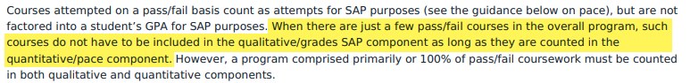

*From 2022-2023 Federal Student Aid Handbook:* [*https://fsapartners.ed.gov/sites/default/files/2022-2023-Federal-Student-Aid-Handbook/School-Determined-Requirements.pdf*](https://fsapartners.ed.gov/sites/default/files/2022-2023-Federal-Student-Aid-Handbook/School-Determined-Requirements.pdf)

### Visual Flow Diagram of Issue

**Example:** A student took two 5 credit classes with a Pass/Fail grading basis. They successfully completed both classes and earned 10 credits. Since neither class generated a GPA, the student’s GPA value was 0.00 for the term and resulted in a failure to meet SAP.

### Sample Data Visuals of Problem Student

The Fall 2022 term on the transcript below demonstrates a student who took one pass/fail course in the term and was assigned a “P” grade with the “PNP” Grading Basis. The grade does not generate a GPA and results in a term GPA of 0.00.

#### Image: Transcript example of the issue

Navigation: Records & Enrollment > Transcripts > Request Transcript Report

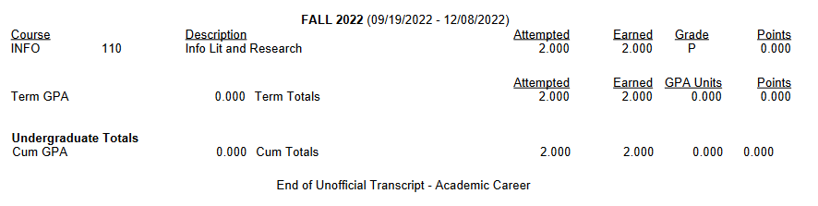

On the Student Career Term record below the student’s GPA for the term is set to 0.00, because the PNP Grading Basis setup specifies that the course grade is “Not For GPA”. There are no courses with a “For GPA” grade. However, since the GPA field must contain a numerical value and cannot accept a value of null, it is set to 0.000.

#### Image: Term History data example of the issue

Navigation: Records & Enrollment > Student Term Information > Term History

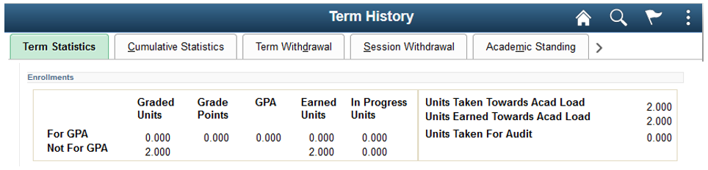

The underlying SAP Program is using the term GPA value displayed above on the “For GPA” row of the student’s Term History for the Minimum Current GPA Rules evaluations. In the SAP setup example below for the Minimum Current GPA Test, the SAP program is assigning a negative WARN SAP Status when a student has a CurrentEarned Units value greater than zero, and the term GPA is between 0.000 and 1.999.

#### Image: Minimum Cumulative GPA Test setup example

Navigation: Set Up SACR > Product Related > Financial Aid > Satisfactory Academic Progress > Define Set Up Criteria >> Criteria 2 tab

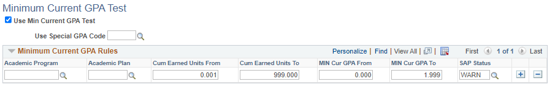

This example student has 2.000 earned units and a GPA of 0.000, so the resulting SAP Status for the test is WARN. The Student SAP page below illustrates this example student’s resulting SAP Status of WARN for the Minimum Current GPA Test.

#### Image: Student SAP example where the Minimum Current GPA results in a WARN Status

*Navigation: Financial Aid > Satisfactory Academic Progress > Maintain Student SAP Data*

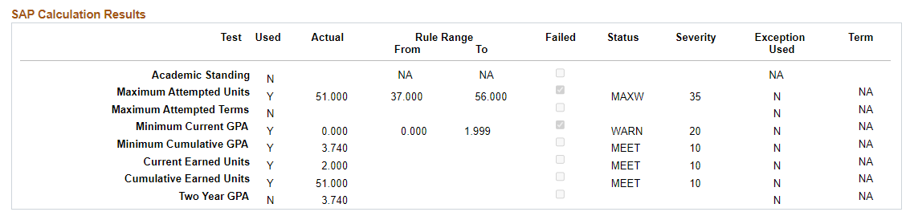

## Clarified Request Statement for S & P Grades from Special SAP Session on January 17, 2023

Modify the SAP program in the Minimum Current GPA Test [MINCURGPA] to evaluate the “For GPA**”** graded units field. If the value is greater than zero, then proceed to the locally defined Minimum Current GPA Rules. If the “For GPA” grade units field has a value of 0.00, then use the locally configured “Career Pass Default” value to assign the “MEET” SAP Status for the Minimum Current GPA Test on the Student SAP page.

***Note****: The FA Support Team determined that an alternative solution would be to set a new value of “NGPA” that would enable the colleges to set their own severity, search for those records that triggered this unique SAP Status, or default to the Undetermined Default value. This document proposes that solution as opposed to the original request from the colleges. If colleges do not have an “NGPA” SAP Status configured locally, then the program will not use this customization.*

#### Image: Delivered Page: Financial Aid > Satisfactory Academic Progress> Maintain Student SAP Data

*Navigation: Financial Aid > Satisfactory Academic Progress > Maintain Student SAP Data*

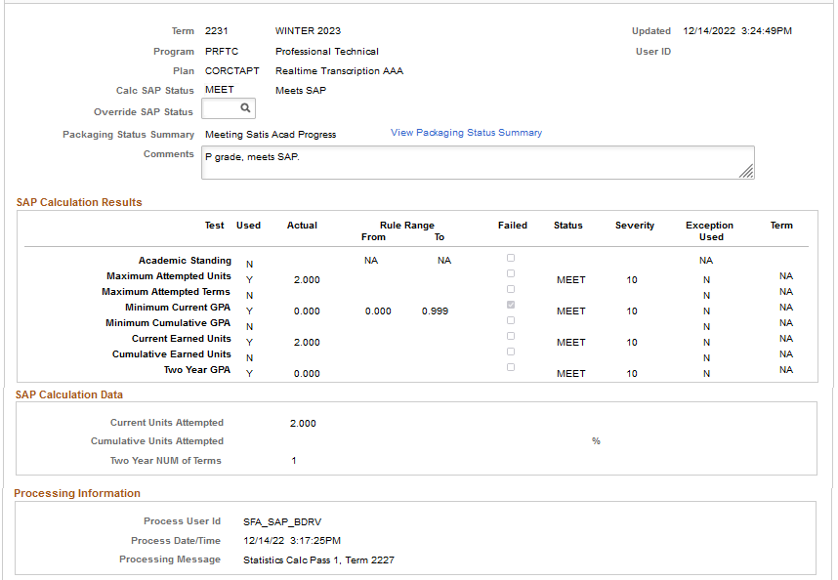

# Proposed Solution

Clone the delivered PeopleSoft Financial Aid SAP Processing code and customize to change the behavior on Pass 1 & 2 logic to first determine whether the student took any classes that term that count toward the GPA, before determining if the GPA meets the configured rules for the Minimum Current GPA Test.

If none of the student’s classes have grade points that count toward the term GPA, then skip the evaluation process for the Minimum Current GPA Test. Then set the student's SAP status for that test to “NGPA”, if it exists in the college’s local configuration. If the college’s local configuration does not have an “NGPA” SAP Status, then this customization will not work, and the program will move to the delivered Minimum Current GPA Test process.

Colleges will have the option to configure the “NGPA” SAP Status, which allows them to control the severity of the status, and what the final SAP status result will be on the student Packaging Status Summary page. Using a unique SAP Status will also make it easier to identify these students, if they require additional review.

## Solution Overview

1. Clone existing Oracle Delivered code.
2. Modify the SAP Process for the Minimum Current GPA test [MINCURGPA] to change the programming logic to look for student who has:
   1. (*Current Program Logic*) Cumulative Earned Units greater than 0.00 AND
   2. *(New Program Logic*) Read the Term Statistics (STDNT_CAR_TRM) that have a “For GPA” graded units [UNT_TAKEN_GPA] value.
      1. If “For GPA” Graded Units [UNT_TAKEN_GPA] value = 0.00
         1. Then check for existence of “NGPA” Calc Status value in the Status Codes section on the Setup tab of the SAP Define Set Up Criteria page.
         2. If the value exists, use “NGPA” value for the Minimum Current GPA test.
            1. Colleges have the ability to define the “NGPA” value with a severity that aligns with their business practices. Colleges can opt to set the severity to equal that of MEET, or set the severity to be higher than MEET, which would require the FA office to take action.
         3. If the value DOES NOT exist, use the Undetermined Default Status value as configured.
      2. If **For GPA** Graded Units [UNT_TAKEN_GPA] value is GREATER THAN (>) 0.00
         1. Then continue program logic as designed. Read the GPA [CUR_GPA] value and compare that value to the configuration rules ranges for the Minimum Current GPA test.
3. Update SAP AE Process Setup page for each Institution to point to custom code.

#### Image: Status Codes setup on SAP Define Set Up Criteria page

Navigation: Set Up SACR > Product Related > Financial Aid > Satisfactory Academic Progress > Define Set Up Criteria

### Example Data Scenario

Fall 2022

Enrolled

SAP = MEET

Enrolled

SAP = MEET

Enrolled

**Before Fix:**SAP = SUSP

**After Fix:**  
SAP = NGPA

Winter 2023

Spring 2023

“P” grades  
for all classes







* Student took two 5 credit classes with Pass/Fail Grading Bases in Winter 2023.
* Student successfully completed both classes and earned 10 credits. However, since neither class had grade points to count toward the GPA, the student’s GPA was 0.00 for Winter 2023.
* **BEFORE FIX**: When SAP ran for Spring 2023, the program determined that this student had not met the minimum GPA and resulted in a negative SAP Status of “SUSP”, per the college’s local Minimum Current GPA Rules configuration.
* **AFTER FIX**: When SAP runs for Spring 2023, the program will:
  + Read the Attempted Units value in the “For GPA” field and determine that it does not exceed 0.00.
  + Then it will skip reading the GPA field and instead default to “NGPA”, if locally configured.
  + If “NGPA” is not a SAP Status configured by the college, then it will use the delivered Minimum Current GPA Test program.

### Visual Flow Diagram of Processing Logic Change

NO

NO

End

Proceed with other tests based on local configuration and post the SAP Status on the Student SAP page

NO

**Custom SAP Application Engine Solution for S&P Grades**

If student Term Exclusion exists, compare GPA to exclusion value and determine SAP Status

**Delivered Minimum Current GPA Test program**

If student Course Exclusion exists, compare GPA to exclusion value and determine SAP Status

If there are no Exceptions on student SAP, then use Min Current GPA Rules to determine SAP Status

If GPA does not result in a SAP Status, per Exclusions or Min Current GPA Rules, then set to Career Pass Default Status (typically “MEET”)

Set the SAP Status for the Minimum Current GPA Test to “NGPA”

YES

Does GPA value for  
the term = 0.00?

*(STDNT_CAR_TERM.CUR_GPA)*

Does Attempted Units  
value for the term = 0.00?

*(STDNT_CAR_TERM.  
UNT_TAKEN_GPA)*

YES

YES

Does “NGPA” SAP  
Status exist in local configuration?

YES

Execute SAP test based on Institution setup and determine the test statuses and overall SAP Status

Begin SAP process

Set the SAP Status for the Minimum Current GPA Test to “N/A”

Determine and assign Pass 1 or Pass 2 flag for selected student based on enrollment data

NO

Load SAP temporary table based on the population selection

Is Min Current  
GPA Test used?

## Technical Details of Solution

### When Processing SAP from the Batch Process SAP Run Control Page

A new custom Application Engine section will be created by reusing the delivered SFA_SAP_LIB Application Engine – Minimum Current GPA Test section. The logic will be modified as outlined in the following section.

Note: The logic of checking the active Enrollment and associated class grades will be modified, but only when the SAP Process Type configuration is set to “Term” for term-based processing (Pass 1 & Pass 2). All ctcLink colleges are currently using the Term Process Type. Since the logic for the SAP Process Type of Aid Year is vastly different and no ctcLink college utilizes Aid Year based processing, NO logic for Aid Year processing will be modified.

#### Image: “Term” SAP Process Type configuration on SAP Define Set Up Criteria page

Navigation: Set Up SACR > Product Related > Financial Aid > Satisfactory Academic Progress > Define Set Up Criteria

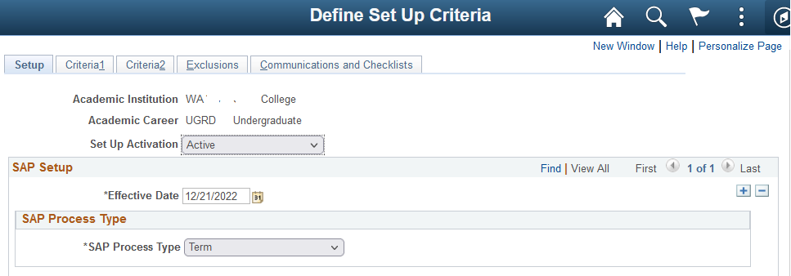

### Modification Logic Steps

1. Retrieve the Evaluation Term for Students processed, based on Pass 1 or Pass 2 processing and the setup of SAP Evaluation Term.

2. If STDNT_CAR_TERM.CUR_GPA for Term retrieved is zero, check for STDNT_CAR_TERM.UNT_TAKEN_GPA. If this field value is zero, then default the Minimum Current GPA Test Results field = NGPA SAP Status, if configured. If NGPA is not configured, then proceed with delivered logic.

### When Running for an Individual Student from Maintain Student SAP Data Page

The same custom Application Engine created for the “Process SAP” batch process will also be called when the “Calculate SAP” button on the Maintain Student SAP page is selected.

#### Image: Calculate SAP button on the Student SAP Data page

Navigation: Financial Aid > Satisfactory Academic Progress > Maintain Student SAP Data

