Adding Loan Fees to Budgets

Jobset Setup Guide

FA Customer Support

FA Customer Support

Washington State Board for Community and Technical College



# Overview

Adding loan fees in the cost of attendance for students offered Direct Loan (DL) funding is recommended by the Department of Education so a process was created.

The following is an overview of process the Loan Fee Jobset will go through:

1. The **four *remove Student Group Run Control IDs*** *(one for each term in the aid year)* will look for students in the Loan Fee Student Groups but no longer offered a Direct Loan item-type for the term(s) and remove the student from the Student Group(s)
2. The **four *assign Student Group Run Control IDs*** *(one for each term in the aid year)* will look for students offered a Direct Loan item-type and assign them to the Loan Fee Student Groups

For example, a student offered DL for Fall, Winter and Spring will be placed into three Student Groups: Loan Fall, Loan Winter and Loan Spring

1. The ***assign Budget Flag ‘Y’ Run Control ID*** will flag the students that were added or removed from each Loan Fee Student Group so that the college’s ISIR Jobset will pick up the students for a budget update
2. The **Loan Fee budget item(s)** will be added to the student’s budgets via Budget Formulas referencing the Loan Fee Student Group(s) the student is in or recognize the student is no longer in the Loan Fee Student Group(s) and remove the Loan Fee budget item(s)

**Before you go through the guide, you will need to calculate the average loan fee rate for your students and determine the loan fee amount for a single term.**

CONTENTS

Overview 1

Preparation 3

Prep 1: Student Group Security 3

Prep 2: Budget Items 4

Prep 3: Budget Formulas 8

Prep 4: Budget Assignment 15

Create *Remove* Student Group Run Control IDs (x4) 18

Create *Assign* Student Group Run Control IDs (x4) 20

Create Assign Budget Flag ‘Y’ Run Control ID 23

Create and Schedule Loan Fee Job 25

# Preparation

## Prep 1: Student Group Security

The role you will need to perform the assigning and removing of Student Groups is: ZZ CS Student Groups. If you do not have this role, work with your Security Administrator to have it added to your EMPLID.

You will also need to work with your Security Administrator to get access to the following eight new Loan Fee Student Groups set up by FA ERP Support:

Even Year

FLE1 – Financial Aid Loan EY Winter

FLE3 – Financial Aid Loan EY Spring

FLE5 – Financial Aid Loan EY Summer

FLE7 – Financial Aid Loan EY Fall

Odd Year

FLO1 – Financial Aid Loan OY Winter

FLO3 – Financial Aid Loan OY Spring

FLO5 – Financial Aid Loan OY Summer

FLO7 – Financial Aid Loan OY Fall

You will need both *Inquiry Indicator* and *Update Indicator* selected for your EMPLID.

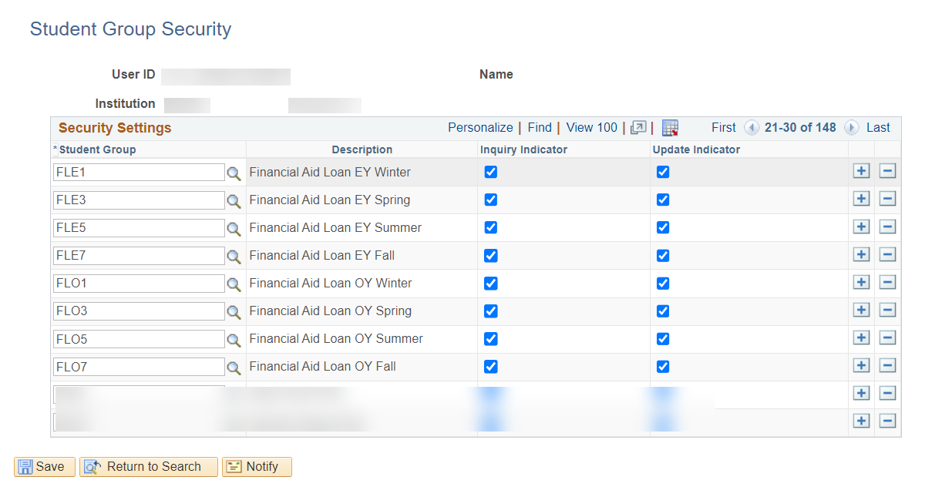

**Note:** If it’s important for everyone in your office to see these new Student Groups, make sure to have your Security Administrator give them Inquiry Indicator.

## Prep 2: Budget Items

**Navigation: Set Up SACR > Product Related > Financial Aid > Budgets > Budget Items**

Navigate to *Budget Items* then select your college’s LOAN Budget Item Category for the aid year (2024 is the aid year that will be used throughout the guide) and update the following areas on the existing row

**Budget Item Code:** LOANZN

**Description:** ZERO LOAN FEES NO LOAD

**Short Description:** Zero Loan

**Budget Multiplier:** *Selected* then FA_NUMBER_OF_WEEKS

**Pell Annual Amount:** 1.00

**Pell Less Half Annual Amount:** 1.00

**Long Description:** ZERO LOAN FEES NO LOAD

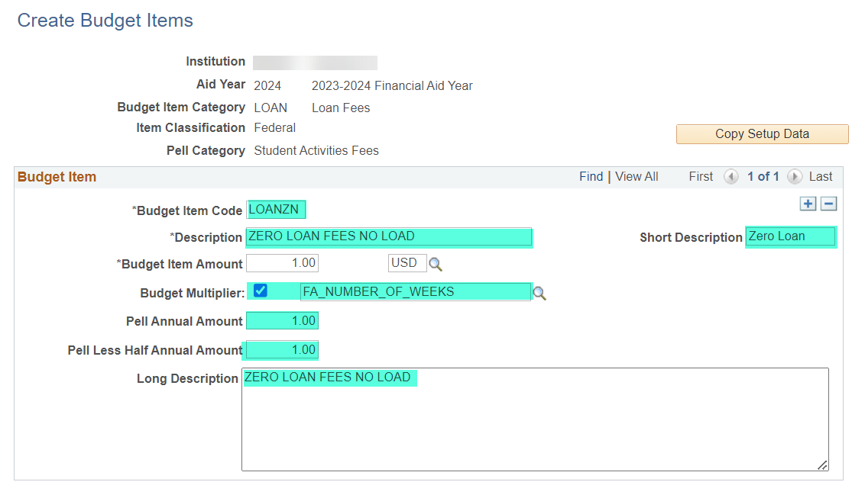

Add a second row then update the following areas

**Budget Item Code:** LOANZL

**Description:** ZERO LOAN FEES LESS ½ TIME

**Short Description:** LoanFeeZ

**Budget Item Amount:** 1.00

**Budget Multiplier:** *Selected* then FA_NUMBER_OF_WEEKS

**Pell Annual Amount:** 1.00

**Pell Less Half Annual Amount:** 1.00

**Long Description:** ZERO LOAN FEES LESS ½ TIME

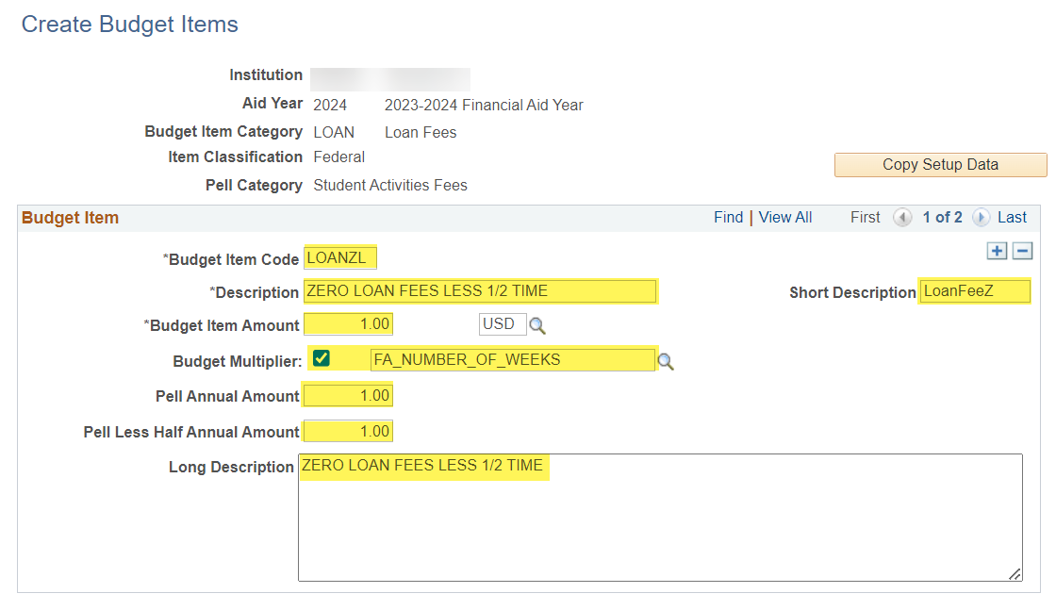

Add a third row then update the following areas

**Budget Item Code:** LOANF1

**Description:** WINTER LOAN FEES

**Short Description:** LoanFee1

**Budget Item Amount:** (one term loan fee amount)

**Pell Annual Amount:** (three quarter total loan fee amount)

**Pell Less Half Annual Amount:** (three quarter loan fee amount)

**Long Description:** WINTER LOAN FEES

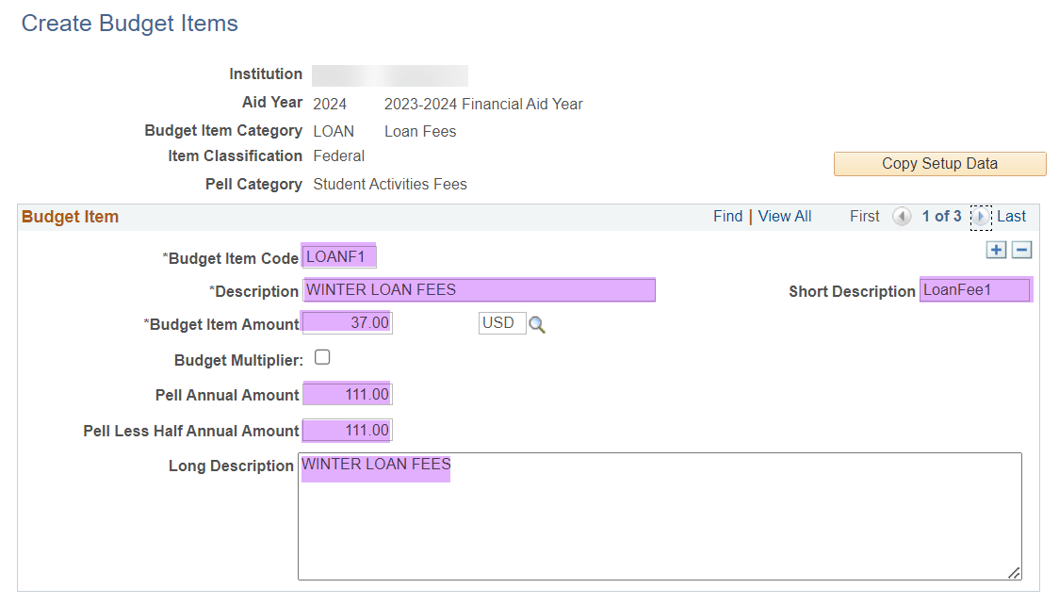

**Budget Item Code:** LOANF3

**Description:** SPRING LOAN FEES

**Short Description:** LoanFee3

**Budget Item Amount:** (one term loan fee amount)

**Pell Annual Amount:** (three quarter total loan fee amount)

**Pell Less Half Annual Amount:** (three quarter loan fee amount)

**Long Description:** SPRING LOAN FEES

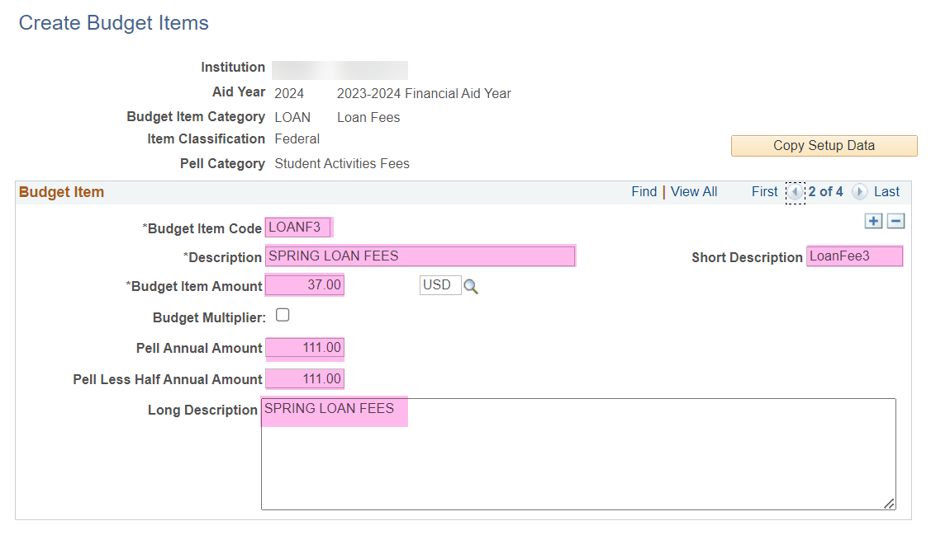

**Budget Item Code:** LOANF5

**Description:** SUMMER LOAN FEES

**Short Description:** LoanFee5

**Budget Item Amount:** (one term loan fee amount)

**Pell Annual Amount:** (three quarter total loan fee amount)

**Pell Less Half Annual Amount:** (three quarter loan fee amount)

**Long Description:** SUMMER LOAN FEES

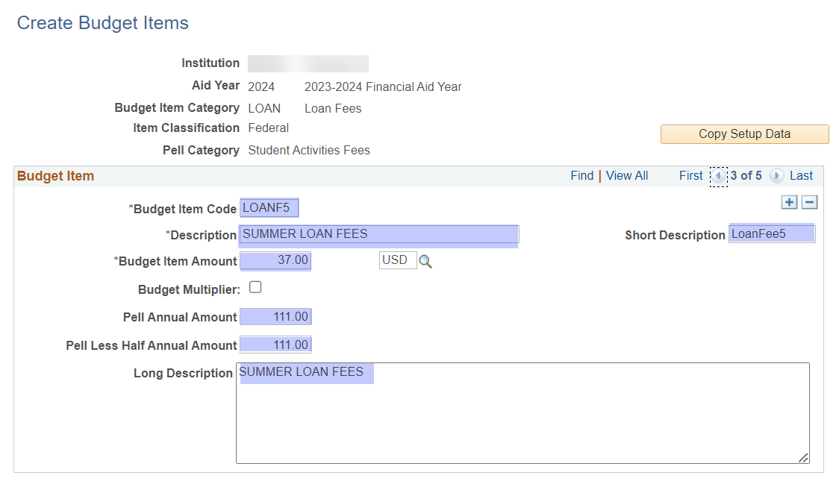

**Budget Item Code:** LOANF7

**Description:** FALL LOAN FEES

**Short Description:** LoanFee1

**Budget Item Amount:** (one term loan fee amount)

**Pell Annual Amount:** (three quarter total loan fee amount)

**Pell Less Half Annual Amount:** (three quarter loan fee amount)

**Long Description:** FALL LOAN FEES

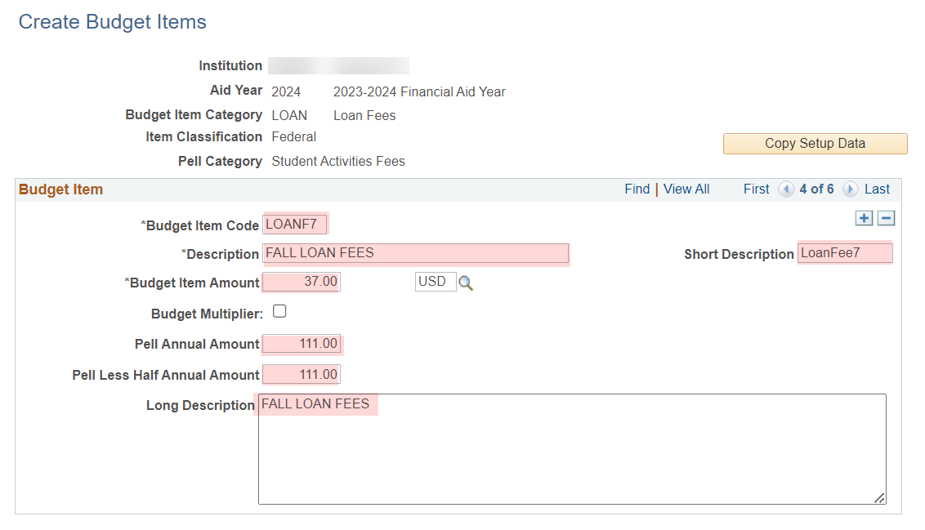

Save your work!

## Prep 3: Budget Formulas

**Navigation: Set Up SACR > Product Related > Financial Aid > Budgets > Budget Formulas**

Navigate to *Budget Formulas* then search for your college’s LOAN Budget Item Category for the aid year and confirm you do not have one then select **Add a New Value**

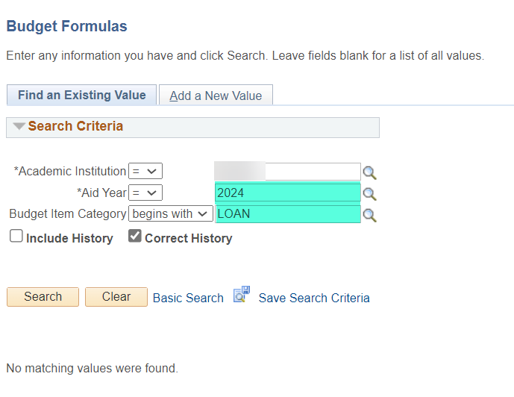 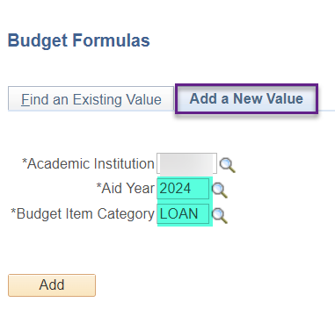

**Note:** If you already have a LOAN Budget Item Category, you will select it and your first step will be to add a new effective dated row of today and update existing rows with the parameters in this section. You may need to add or delete more rows of formulas depending on how many rows already exist.

Fill In the following areas on the first processing order row

**Processing Order:** 5

**Budget Item Code:** LOANZN

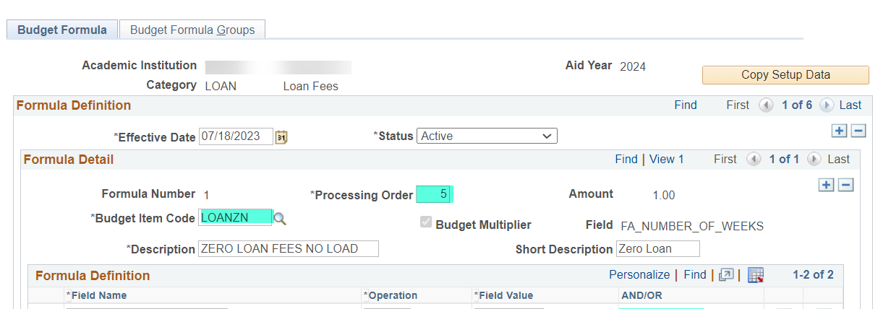

Add one more row under *Formula Definitions* and select the following parameters

**1 Field Name:** FA_LOAD **Operation**: = **Field Value:** N **AND/OR:** AND

**2 Field Name:** STDNT_GROUP

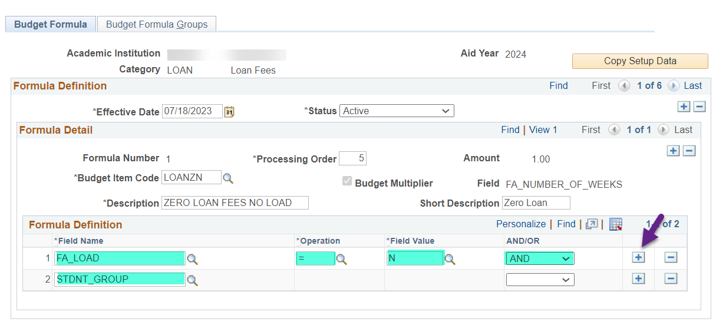

Add a second processing order row then fill In and add the following areas

**Processing Order:** 10

**Budget Item Code:** LOANZL

**1 Field Name:** FA_LOAD **Operation**: = **Field Value:** L **AND/OR:** AND

**2 Field Name:** STDNT_GROUP

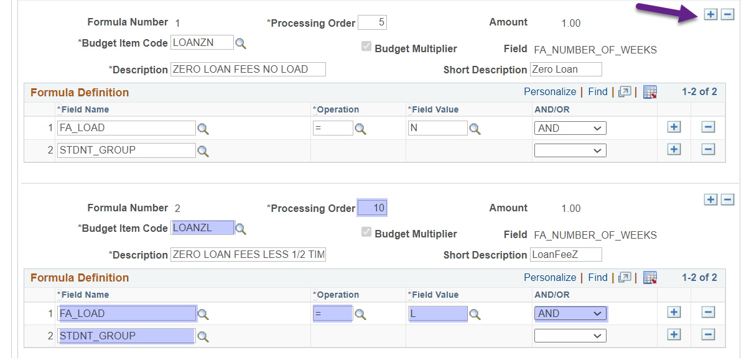

Add a third processing order row then fill In and add the following areas

**Processing Order:** 15

**Budget Item Code:** LOANF7

**1 Field Name:** STRM **Operation**: = **Field Value:** (Fall Term) **AND/OR:** AND

**2 Field Name:** FA_LOAD **Operation**: <> **Field Value:** L **AND/OR:** AND

**3 Field Name:** STDNT_GROUP

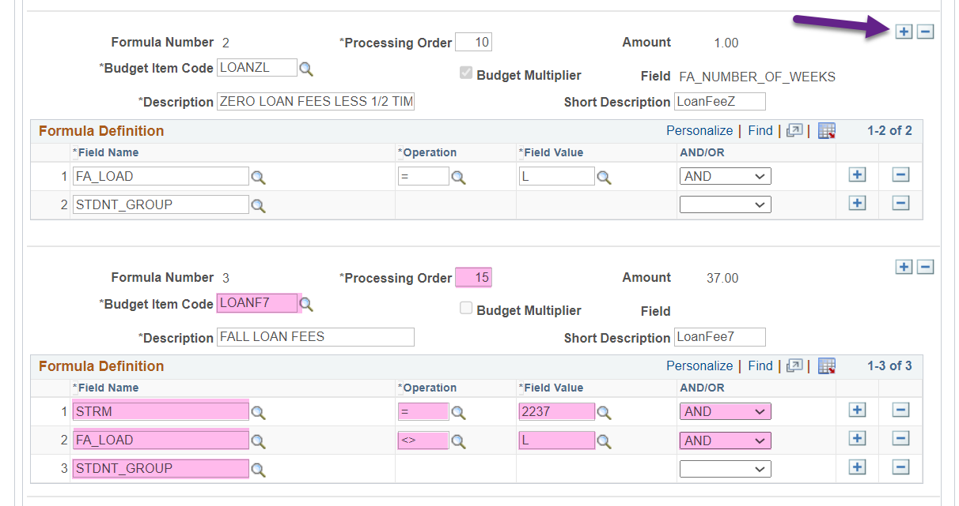

Add a fourth processing order row then fill In and add the following areas

**Processing Order:** 20

**Budget Item Code:** LOANF1

**1 Field Name:** STRM **Operation**: = **Field Value:** (Winter Term) **AND/OR:** AND

**2 Field Name:** FA_LOAD **Operation**: <> **Field Value:** L **AND/OR:** AND

**3 Field Name:** STDNT_GROUP

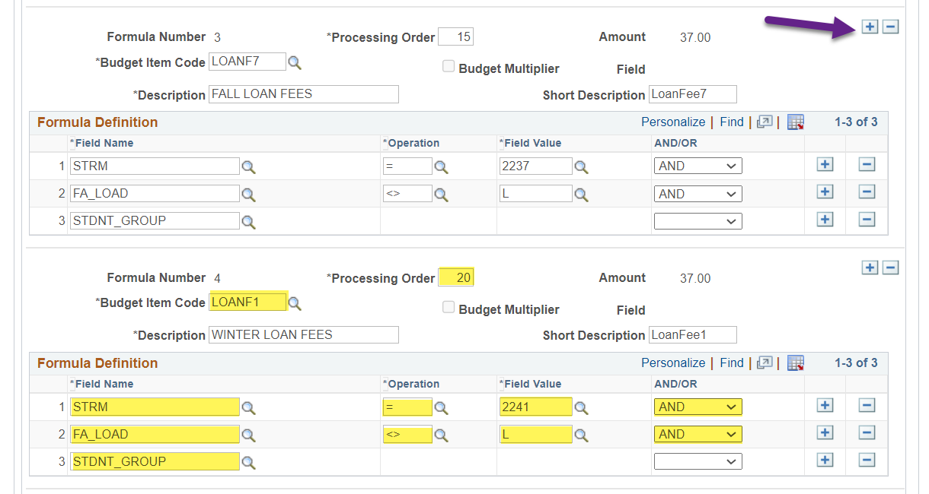

Add a fifth processing order row then fill In and add the following areas

**Processing Order:** 25

**Budget Item Code:** LOANF3

**1 Field Name:** STRM **Operation**: = **Field Value:** (Spring Term) **AND/OR:** AND

**2 Field Name:** FA_LOAD **Operation**: <> **Field Value:** L **AND/OR:** AND

**3 Field Name:** STDNT_GROUP

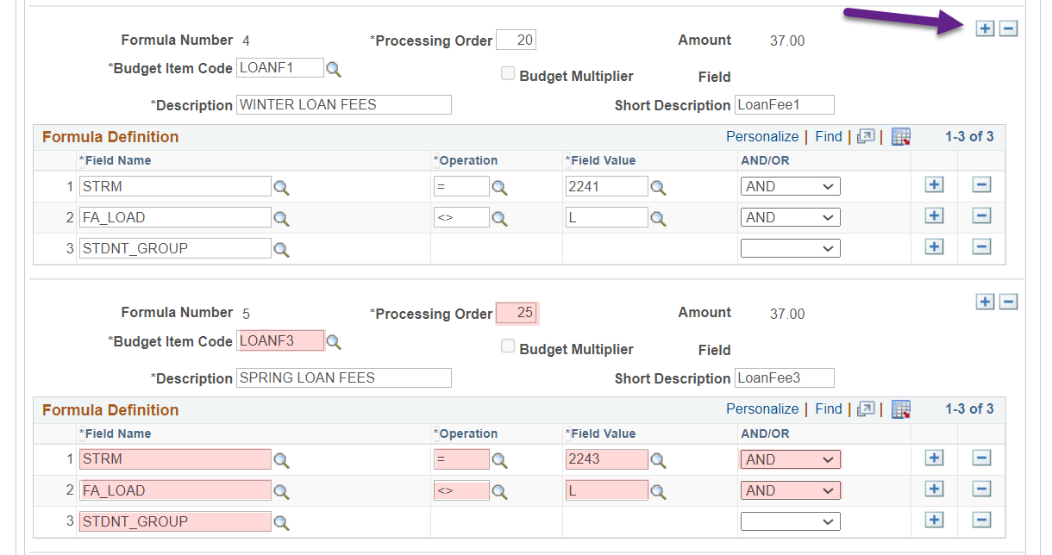

Add a sixth processing order row then fill In and add the following areas

**Processing Order:** 30

**Budget Item Code:** LOANF5

**1 Field Name:** STRM **Operation**: = **Field Value:** (Summer Term) **AND/OR:** AND

**2 Field Name:** FA_LOAD **Operation**: <> **Field Value:** L **AND/OR:** AND

**3 Field Name:** STDNT_GROUP

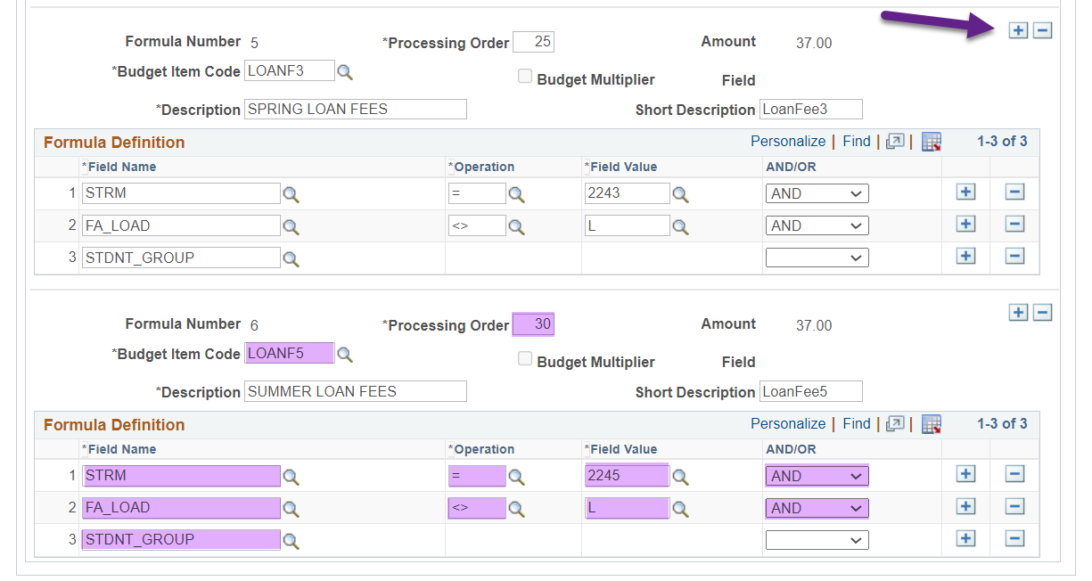

Select the **Budget Formula Groups** tab then add three more rows to the Student Groups section of Formula Number 1 Processing Order 5

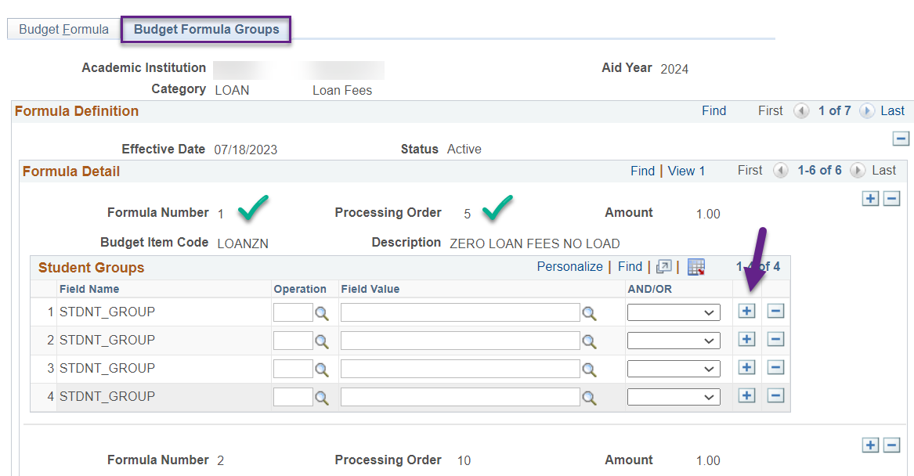

Fill in the four rows with the following parameters

**Operation:** = **Field Value:** FLE7 **AND/OR:** OR

**Operation:** = **Field Value:** FLE1 **AND/OR:** OR

**Operation:** = **Field Value:** FLE3 **AND/OR:** OR

**Operation:** = **Field Value:** FLE5

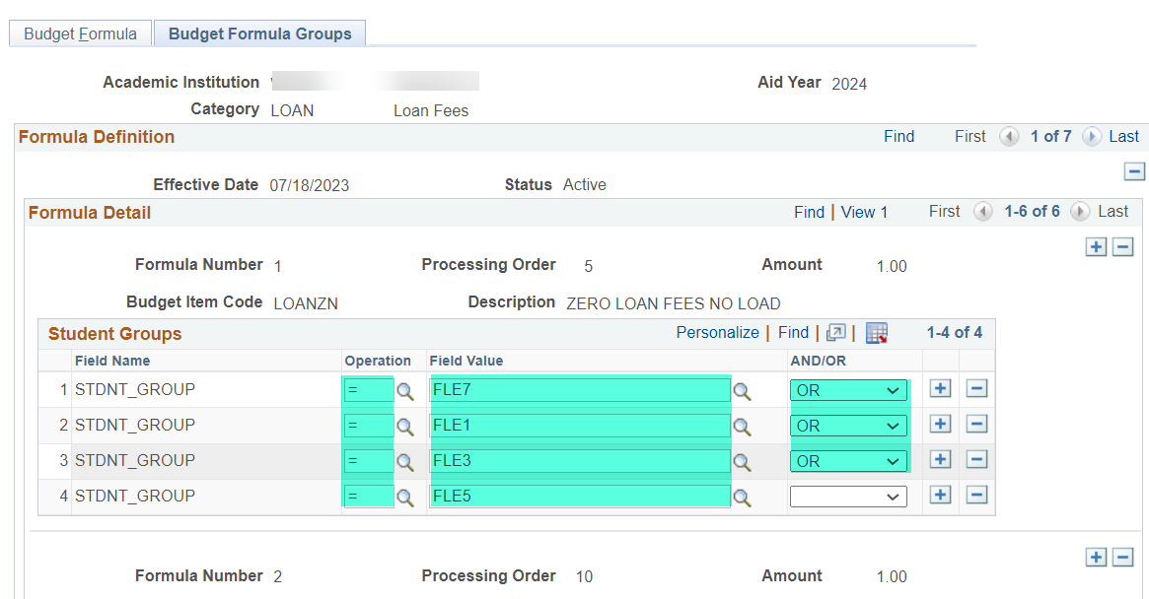

**Note:** When creating the Run Control IDs for an odd year, the Student Groups you will be selecting are FLO1, FLO1, FLO3 and FLO5.

Move down to Formula Number 2 Processing Order 10 and add three more rows to the Student Groups section fill in the four rows with the following parameters

**Operation:** = **Field Value:** FLE7 **AND/OR:** OR

**Operation:** = **Field Value:** FLE1 **AND/OR:** OR

**Operation:** = **Field Value:** FLE3 **AND/OR:** OR

**Operation:** = **Field Value:** FLE5

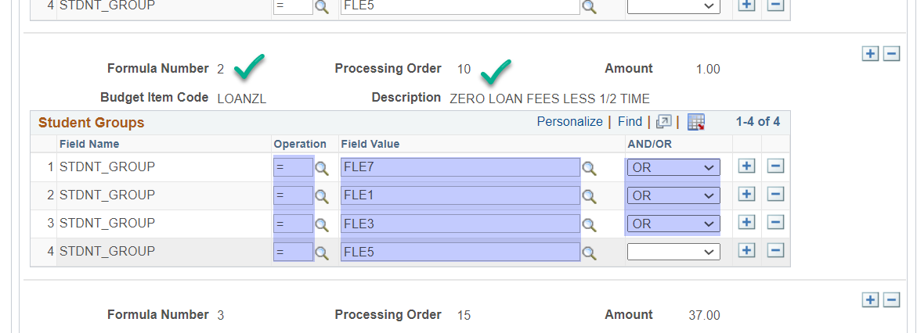

Move down to Formula Number 3 Processing Order 15 and fill in the row with the following parameters

**Operation:** = **Field Value:** FLE7

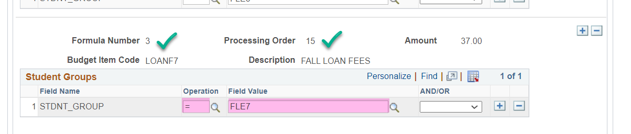

Move down to Formula Number 4 Processing Order 20 and fill in the row with the following parameters

**Operation:** = **Field Value:** FLE1

Move down to Formula Number 5 Processing Order 25 and fill in the row with the following parameters

**Operation:** = **Field Value:** FLE3

Move down to Formula Number 6 Processing Order 30 and fill in the row with the following parameters

**Operation:** = **Field Value:** FLE5

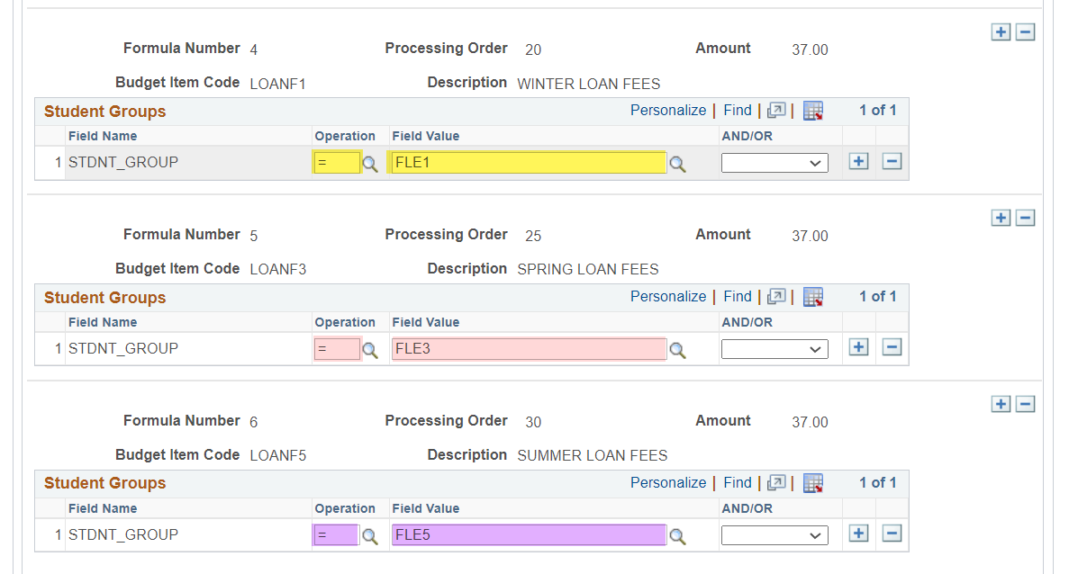

Save your work!

## Prep 4: Budget Assignment

**Navigation: Set Up SACR > Product Related > Financial Aid > Budgets > Budget Assignment**

Navigate to *Budget Assignment* for the aid year then add a new effective dated row of today on the first tab

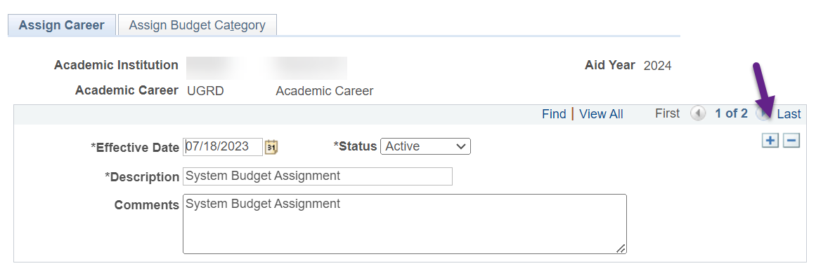

Select the **Assign Budget Category** tab

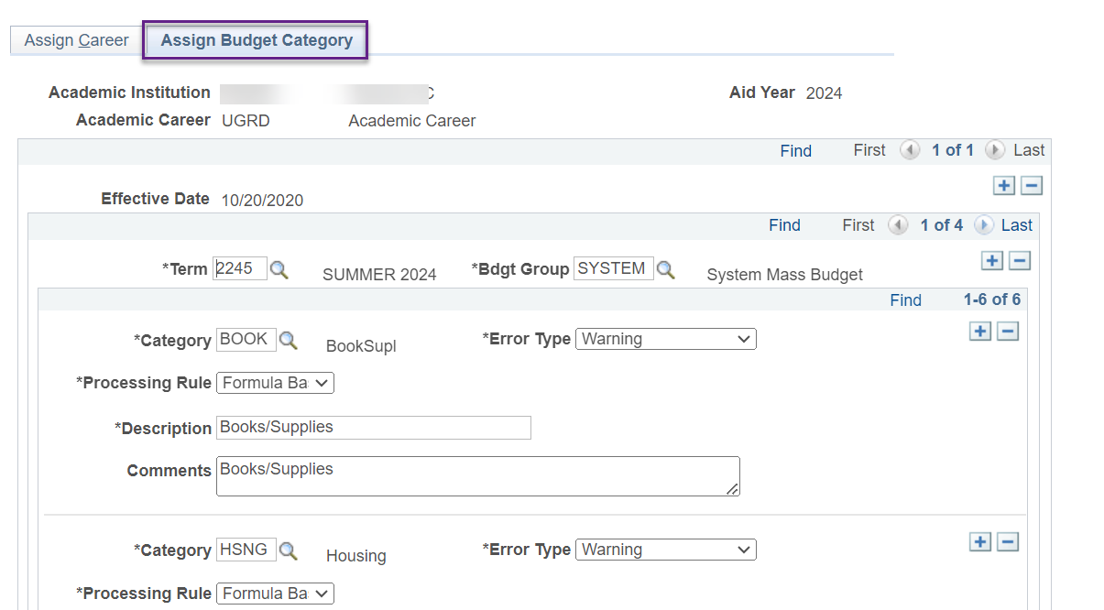

Add a new row to so you can add the LOAN Category

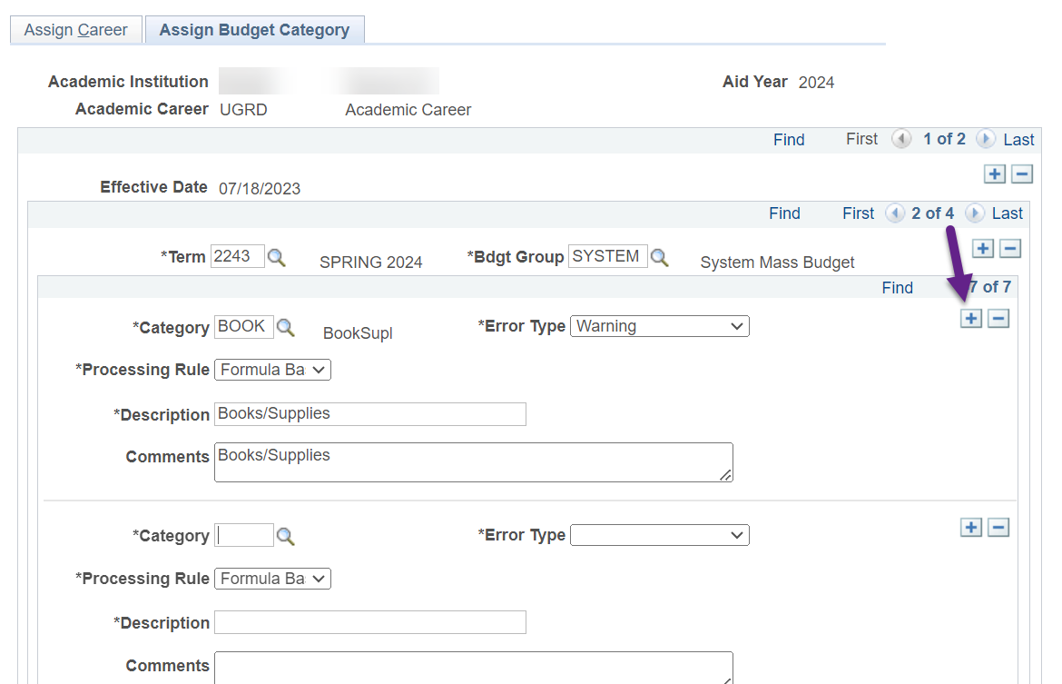

Select the following parameters on the new row

**Category:** LOAN

**Error Type:** Warning

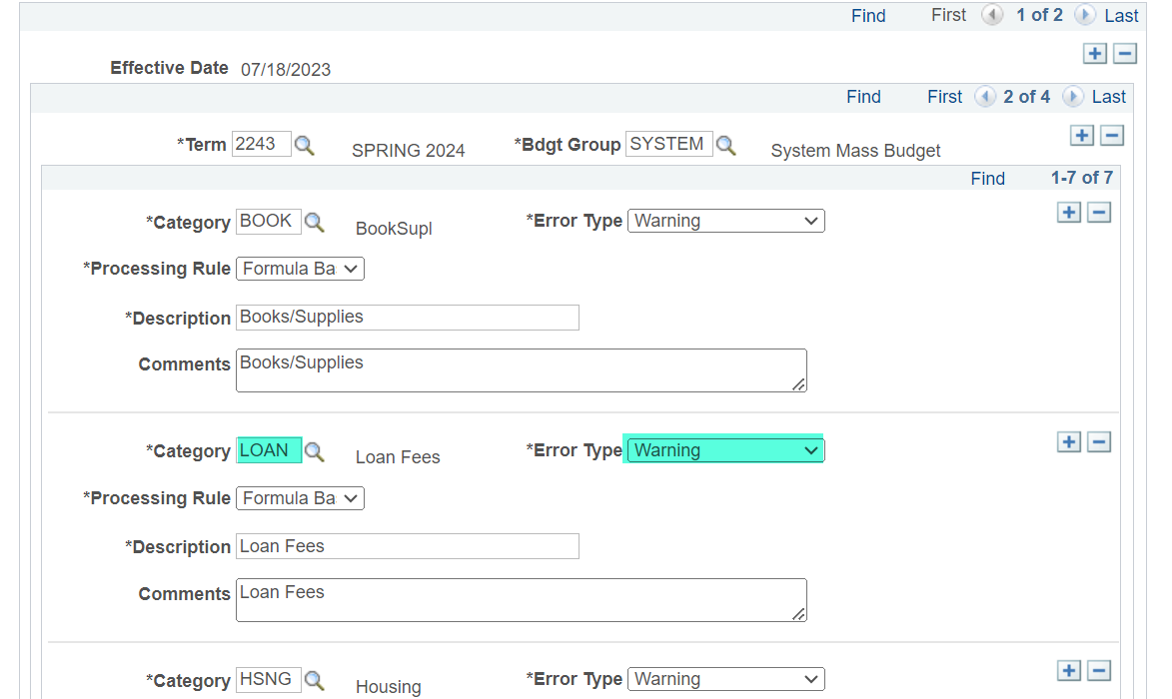

Toggle to the next term and repeat the same steps of adding a new row then selecting **Category:** LOAN and **Error Type:** Warning for all four terms.

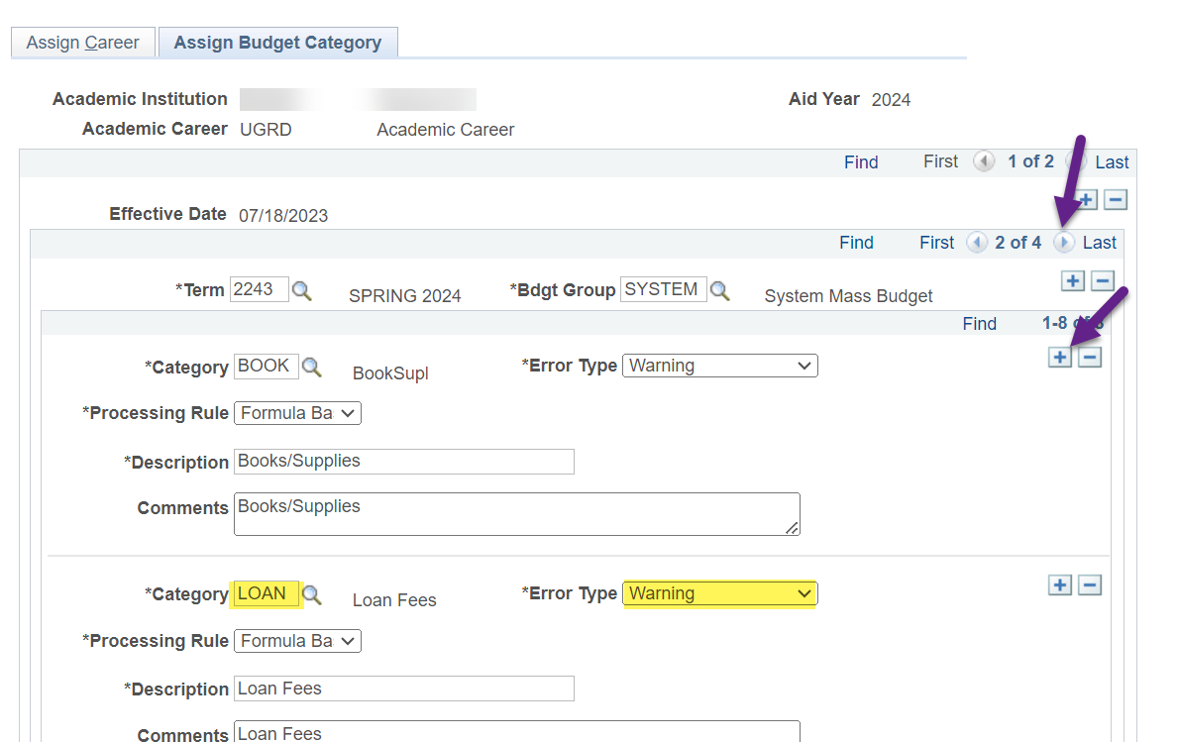

After adding the LOAN Category to each term, save your work!

# Create *Remove* Student Group Run Control IDs (x4)

**Navigation: Records and Enrollment > Career and Program Information > Process Student Groups**

Navigate to *Process Student Groups* then select **Add a New Value** to create a new Run Control ID for removing Fall Loan Student Group

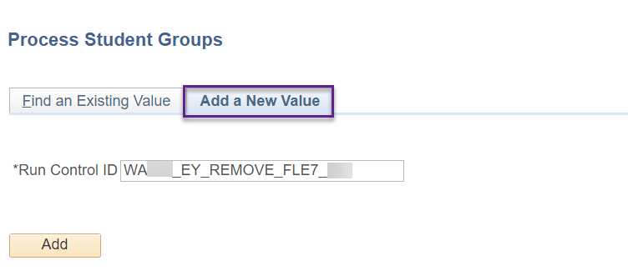

**Note:** Make sure to put your college, EY or OY (depending on the aid year) and your initials in the Run Control ID. Example even year Run Control ID: WA123_EY_REMOVE_FLE7_DE

Select the following parameters for the Population Selection:

**Selection Tool:** PS Query

**Query Name:** QCS_FA_REMOVE_LOAN_FEES_TERM

Edit Prompts

**Institution:** (your college)

**Aid Yr:** (the aid year i.e. 2024)

**Term:** (Fall term i.e. 2237)

**Group:** FLE7 (since we’re using the 2024 aid year in this guide)

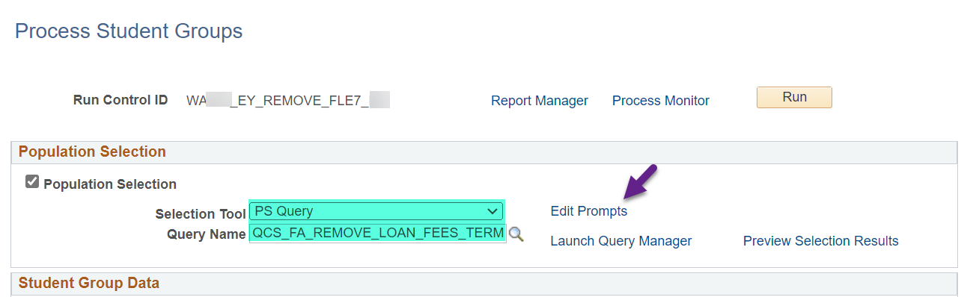

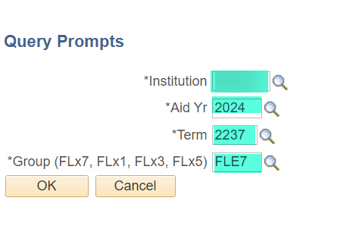

Select the following parameters in the *Student Group Data* section

**Academic Institution:** (your institution)

**Student Group:** FLE7

**Effective Status:** Inactive

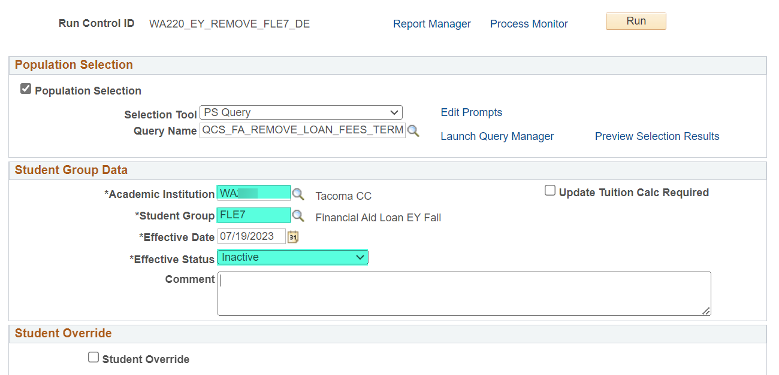

**Note:** The *Effective Date* defaults to today’s date. When you place this Run Control ID in the Loan Fee Budget jobset, there is a process in there that updates the effective date to the current date.

Save your work and note this Run Control ID in Excel or Word so that you can copy and paste it in the jobset.

Create Run Control IDs for each term in the aid year following the same steps but choosing FLE1, FLE3 or FLE5 accordingly. Make sure you’ve saved all the Run Control IDs and noted them before moving onto the next section.

**Additional Info:** If you would like to run the Run Control ID before putting it in a jobset, select the option: **Mass Student Group schedule to**. If you select **SCC_STD_GRP** option, the effective date will not be updated by the system to the current date and you will need to manually update the *Effective Date* field each day you manually run it.

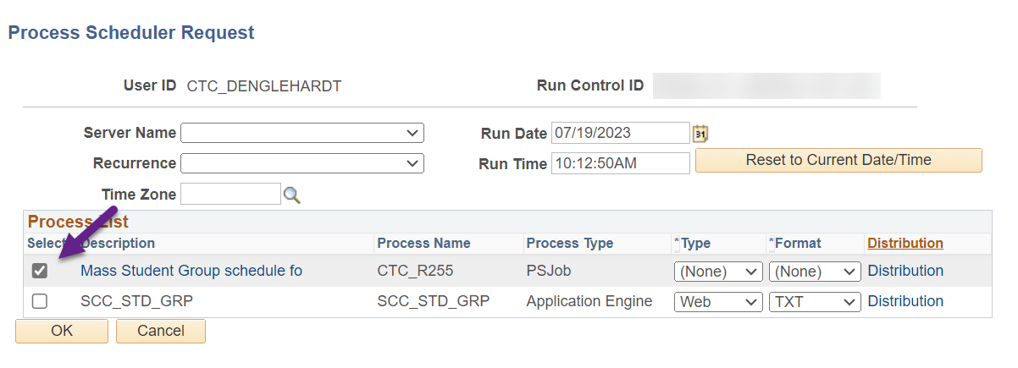

# Create *Assign* Student Group Run Control IDs (x4)

**Navigation: Records and Enrollment > Career and Program Information > Process Student Groups**

Navigate to *Process Student Groups* then select **Add a New Value** to create a new Run Control ID for assigning Fall Loan Student Group

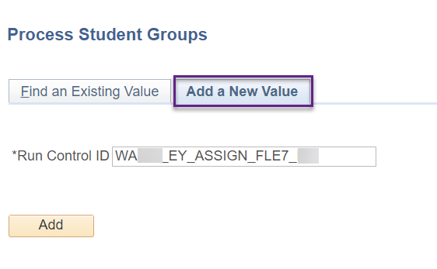

**Note:** Make sure to put your college, EY or OY (depending on the aid year) and your initials in the Run Control ID. Example even year Run Control ID: WA123_EY_ASSIGN_FLE7_DE

Select the following parameters for the Population Selection:

**Selection Tool:** PS Query

**Query Name:** QCS_FA_INCLUDE_LOAN_FEES_TERM

Edit Prompts

**Institution:** (your college)

**Aid Yr:** (the aid year i.e. 2024)

**Term:** (Fall term i.e. 2237)

**Group:** FLE7 (since we’re using the 2024 aid year in this guide)

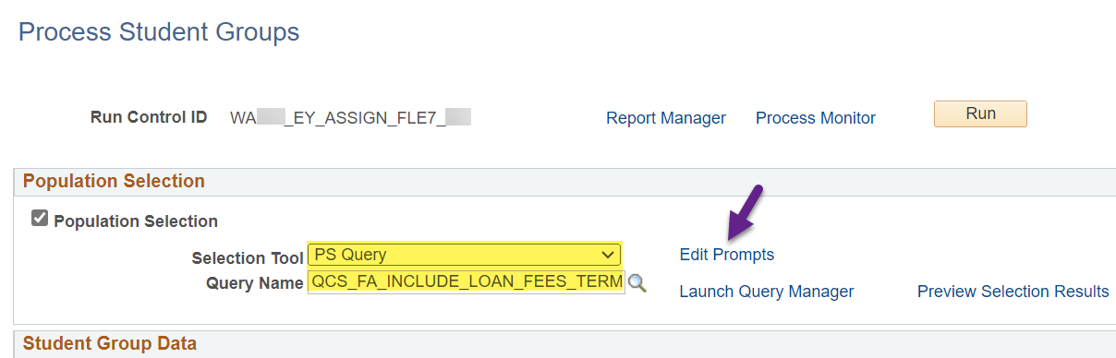

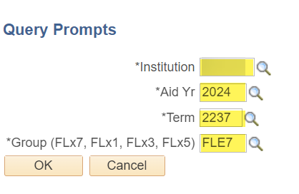

Select the following parameters in the *Student Group Data* section

**Academic Institution:** (your institution)

**Student Group:** FLE7

**Effective Status:** Active

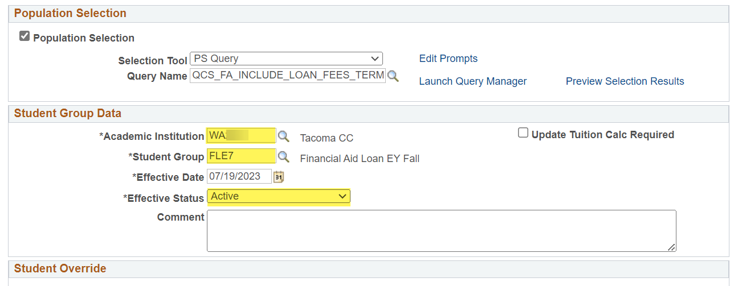

**Note:** The *Effective Date* defaults to today’s date. You do not have to change the date unless you are running this Run Control ID ad hoc. When you place this Run Control ID in the Loan Fee Budget jobset, there is a process in there that updates the effective date to the current date.

Save your work and note this Run Control ID in Excel or Word so that you can copy and paste it in the jobset.

Create Run Control IDs for each term in the aid year following the same steps but choosing FLE1, FLE3 or FLE5 accordingly. Make sure you’ve saved all the Run Control IDs and noted them before moving onto the next section.

**Additional Info:** If you would like to run the Run Control ID before putting it in a jobset, select the option: **Mass Student Group schedule to**. If you select **SCC_STD_GRP** option, the effective date will not be updated by the system to the current date and you will need to manually update the *Effective Date* field each day you manually run it.



# Create Assign Budget Flag ‘Y’ Run Control ID

**Navigation: Set Up SACR > System Administration > Utilities > Population Update > Population Update Process**

Navigate to *Population Update Process* then select **Add a New Value** to create a new Run Control ID

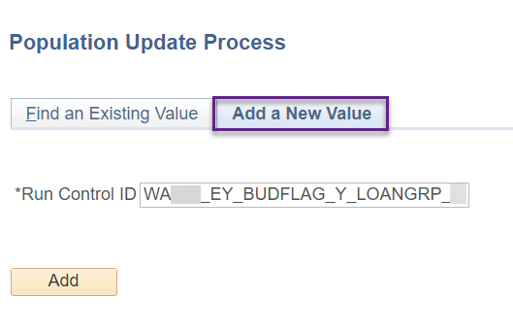

**Note:** Make sure to put your college, EY or OY (depending on the aid year) and your initials in the Run Control ID. Example even year Run Control ID: WA123_EY_BUDFLAG_Y_LOANGRP_DE

Select the following parameters

**Record (Table) Name:** STNDT_FA_TERM – Student FA Term

**Selection Tool:** PS Query

**Query Name:** QCS_FA_SETBUDFLAG_Y_LOAN_GRP

Edit Prompts

**Institution:** (your college)

**Aid Yr:** (the aid year i.e. 2024)  
**Fall Group:** FLE7 (since we’re using the 2024 aid year in this guide)

**Winter Group:** FLE1

**Spring Group:** FLE3

**Summer Group:** FLE5

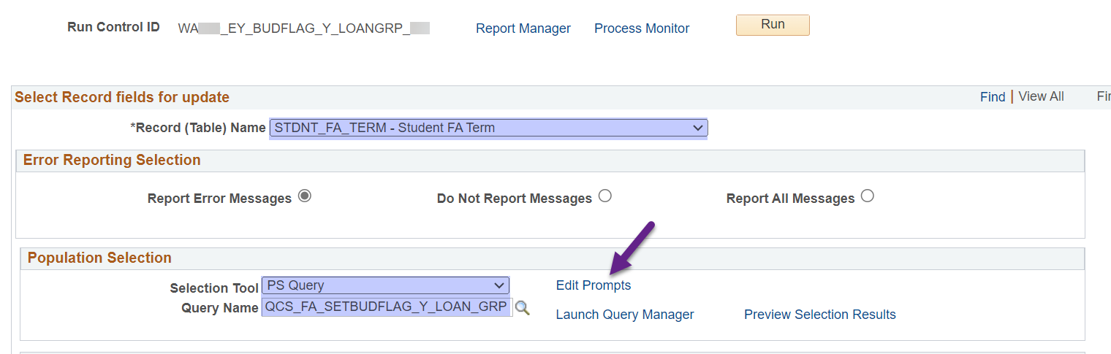

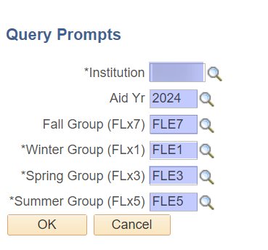

Select the following parameters in the *Student Fields to Update* section

**Field Name:** Budget Required

**Field Value:** Yes – Budget Assign Required

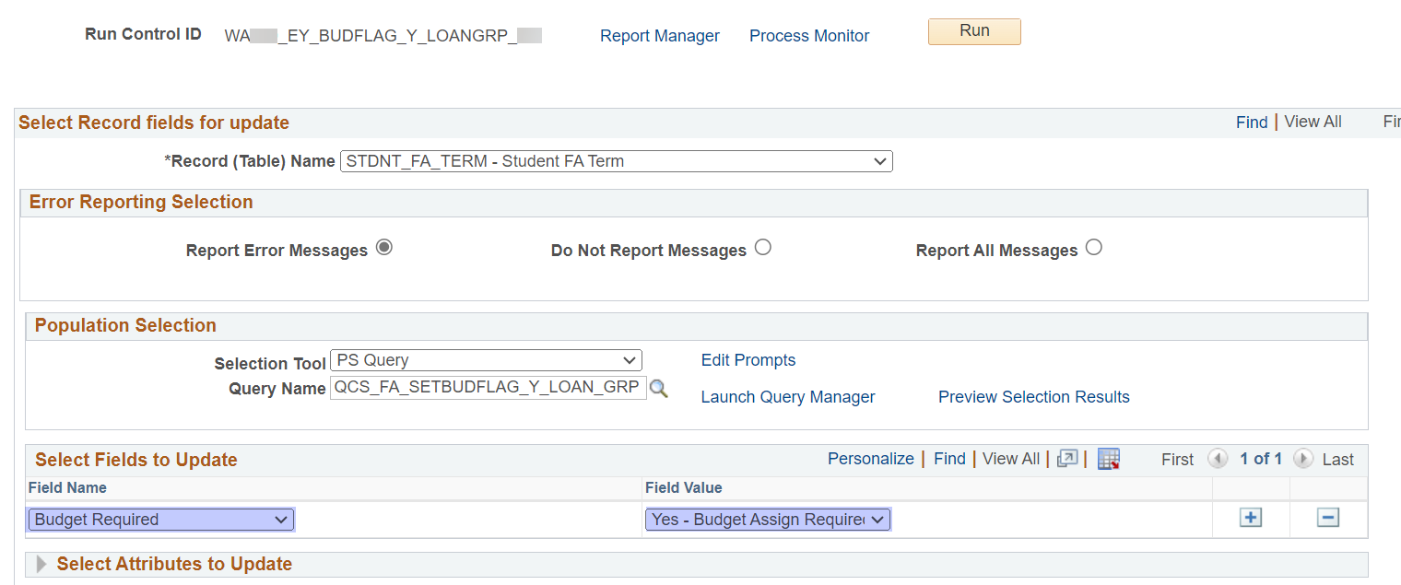

Save your work and note this Run Control ID in Excel or Word so that you can copy and paste it into your ISIR Jobset. All colleges have an empty field in CTCFABUD mini job in the ISIR Jobbset.

This Run Control ID will go in the first *SCC_POP_UPD* field of CTCFABUD so if your top field is not blank, move the Run Control IDs down to the next field, keeping the order the Run Control IDs are in. See screenshot.

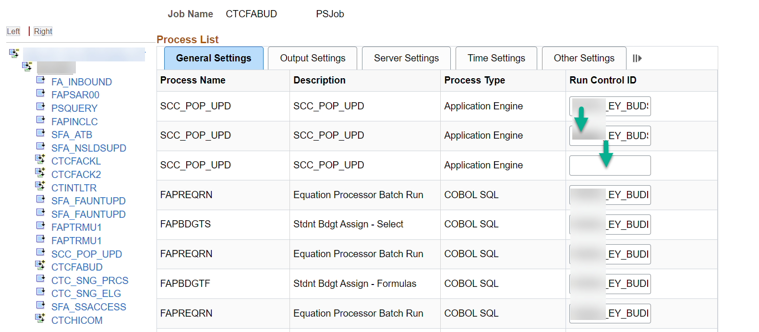

The order of the SCC_POP_UPD fields in CTCFABUD needs to be:

SCC_POP_UPD: Loan Budget Set Flag ‘Y’ Run Control ID

SCC_POP_UPD: Budget Set Flag ‘Y’ Run Control ID

SCC_POP_UPD: Budget Set Flag ALL ‘Y’ Run Control ID

# Create and Schedule Loan Fee Job

**Navigation: PeopleTools > Process Scheduler > Schedule JobSet Definitions**

Navigate to *Schedule JobSet Definitions* then select **Add a New Value** to create a new Schedule Name and select Job Name: LOANFEE

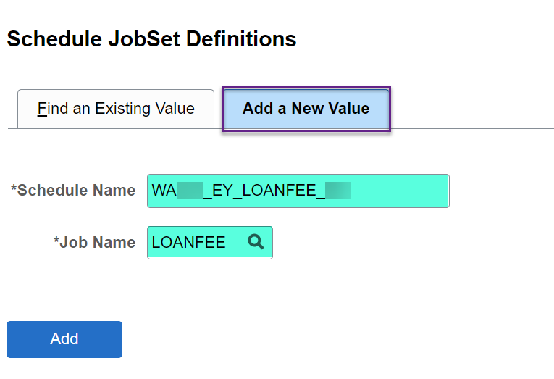

**Note:** Make sure to put your college, EY or OY (depending on the aid year) and your initials in the Schedule Name. Example even year Schedule Name: WA123_EY_LOANFEE_DE

Copy the what’s in the *Description* field and paste it in the *Run Control ID* field then select Save

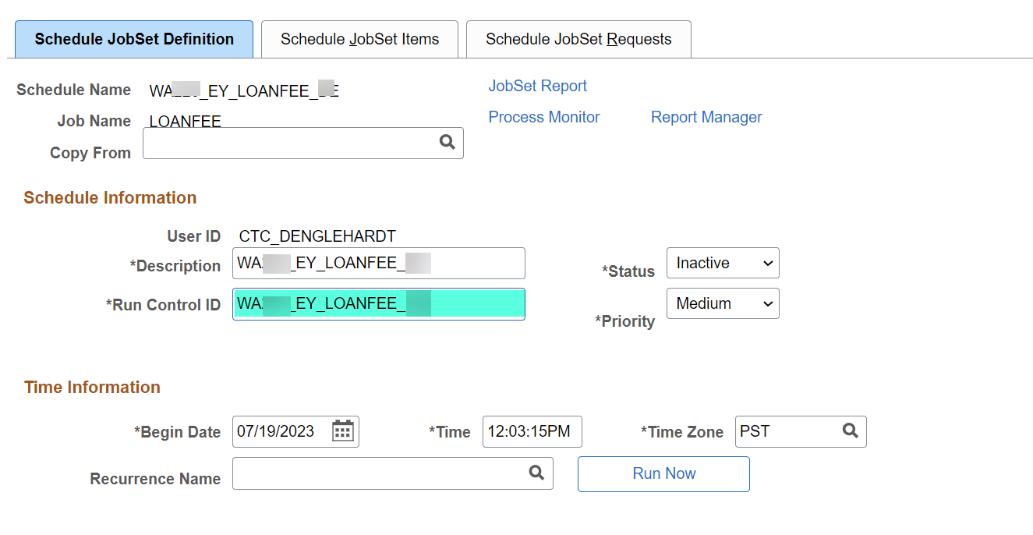

Select the **Schedule JobSet Items** tab

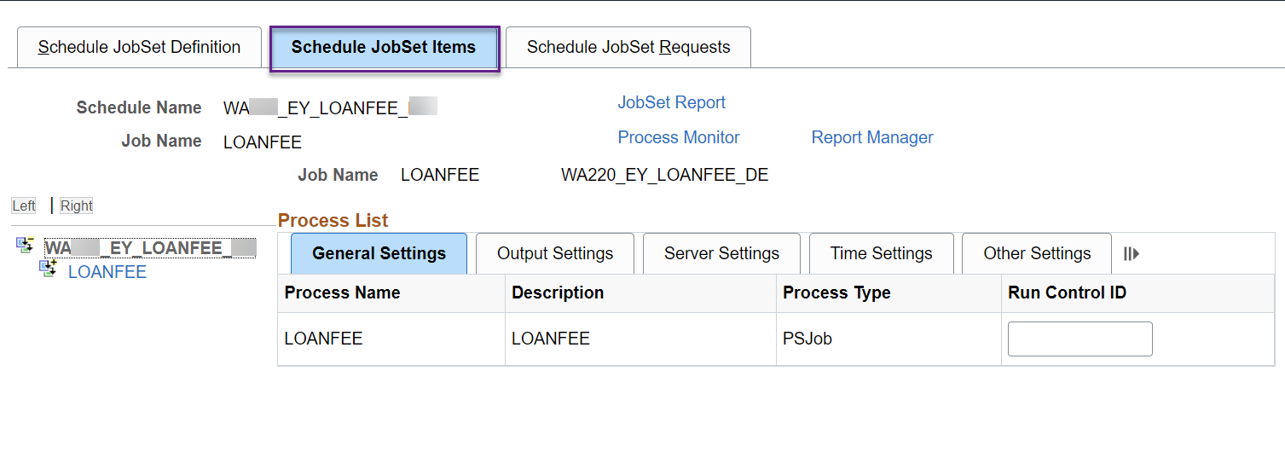

Select the **Expand Node** button next to the LOANFEE jobset so that the *CTC_R255* mini jobs appear

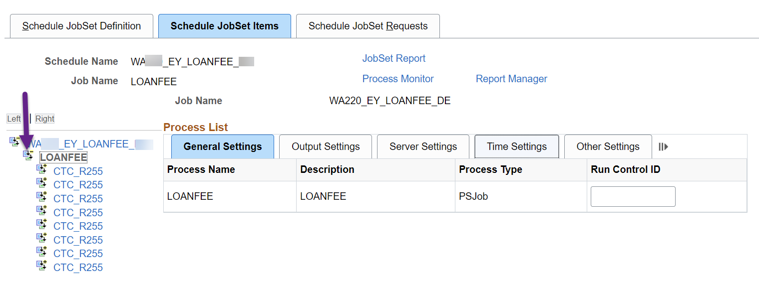

Select the **Expand Node** button next to the first CTC_R255 mini job so that CTC_R255_DT and SCC_STD_GRP appears

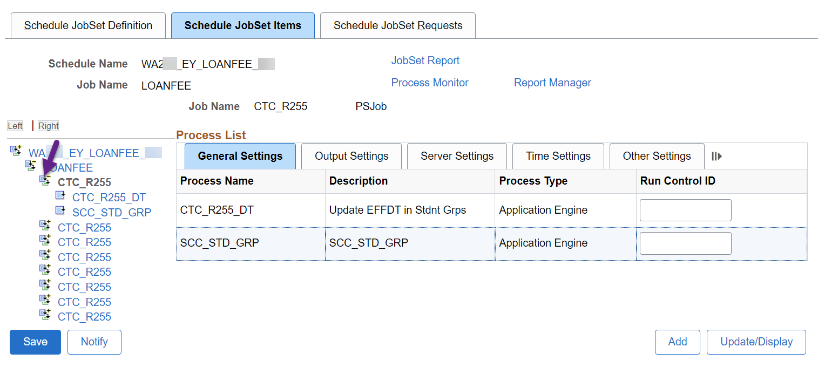

Paste your Fall Loan Student Group REMOVE Run Control ID in both fields. CTC_R255_DT updates the effective date in the Run Control ID to the current date and SCC_STD_GRP runs the Student Group process

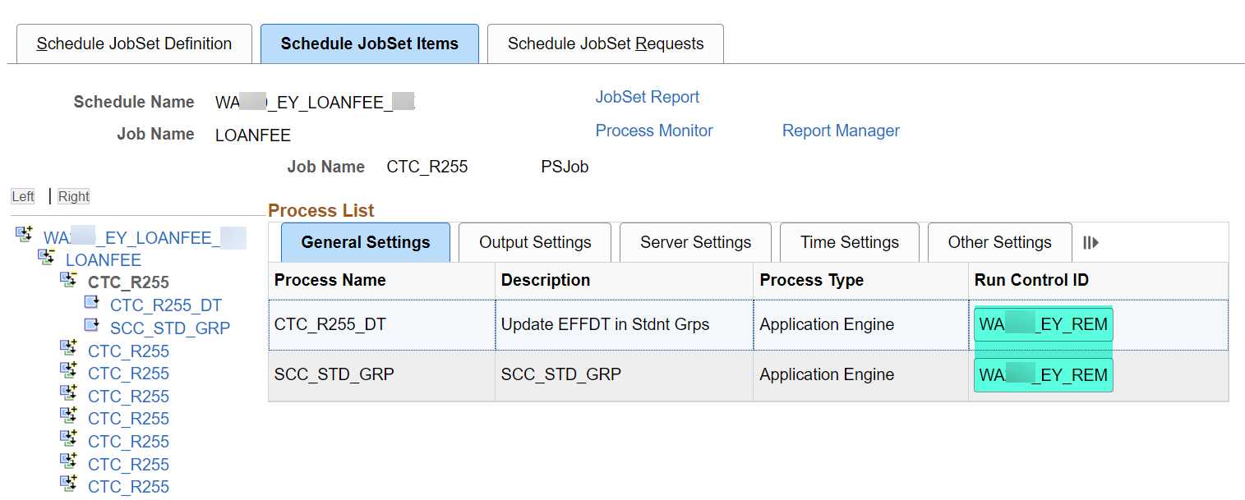

Move onto the next CTC_R255 by selecting the Expand Node button

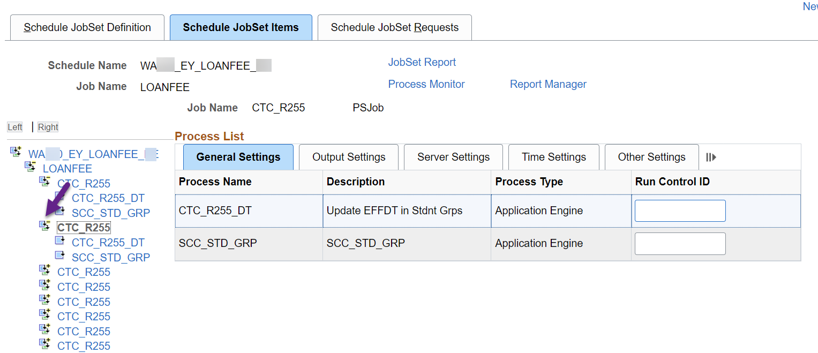

Paste your Winter Loan Student Group REMOVE Run Control ID in both fields.

Continue filling in the Run Control ID fields for each CTC_R255. After putting in the REMOVE Run Controls IDs for each term, proceed on to adding the ASSIGN Run Control IDs on the remaining four CTC_R255 mini jobs.

Save your work!

When you’re ready to schedule your jobset, return to the **Schedule JobSet Definition** tab

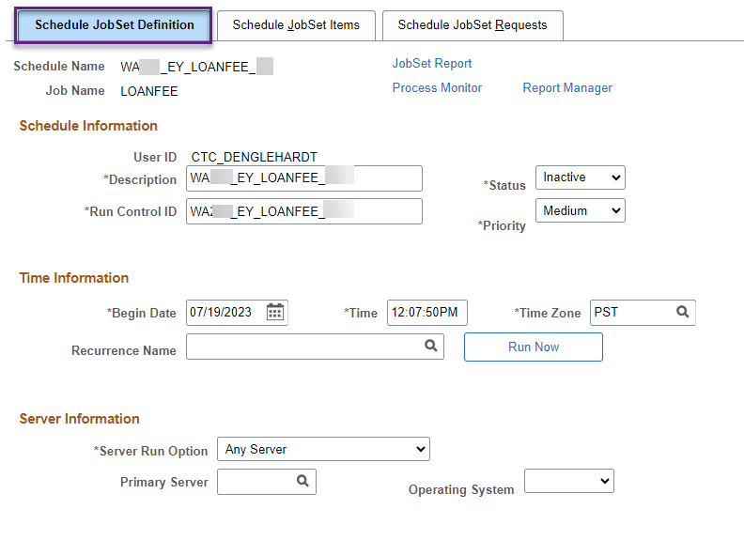

Complete the following parameters in order

**Begin Date:** (Select or enter today’s date or tomorrow’s date depending on your ISIR Jobset timeslot)

**Time:** (30 minutes to an hour before your ISIR Jobset timeslot)

**Recurrence Name:** (select the recurrence that is 30 minutes to an hour before your ISIR Jobset timeslot)

**Status:** Active

Select **Save** then go to a different page in PS and come back to the jobset to confirm the recurrence stuck. Sometimes you have to set the recurrence twice.

*Header colleges, at this point (07/25/2023), if you’ve turned off your Odd Year ISIR Jobset (aid year 2023), you can move your Even Year Jobset (aid year 2024) to the later time of 11PM or 4AM depending on your group.

|  |  |  |  |  |
| --- | --- | --- | --- | --- |
| **Institution** | **Description** |  | **Recurrence** |  |
| WA220 | Tacoma CC |  | M-F at 5pm | New Aid Year |
| WA090 | Highline College |  | M-F@11:00PM | Current Aid Year |
| WA110 | Pierce College |  |  |  |
| WA080 | Bellevue College |  |  |  |
| WA062 | Seattle Central College |  |  |  |
| WA050 | Everett Community College |  |  |  |
| WA171 | Spokane CC |  |  |  |
| WA100 | Green River College |  |  |  |
| WA190 | Columbia Basin College |  |  |  |
| WA172 | Spokane Falls CC |  |  |  |
| WA140 | Clark College |  |  |  |
| WA070 | Shoreline Community College |  |  |  |
| WA230 | Edmonds College |  |  |  |
| WA160 | Yakima Valley College |  |  |  |
| WA290 | Clover Park Technical College |  |  |  |
| WA030 | Olympic College |  |  |  |
| WA063 | North Seattle College |  |  |  |
| WA240 | South Puget Sound Comm College |  |  |  |
| WA270 | Renton Technical College |  |  |  |
| WA210 | Whatcom Community College |  |  |  |
|  |  |  |  |  |
| **Institution** | **Description** |  | **Recurrence** |  |
| WA064 | South Seattle College |  | M-F@01:00AM | New Year |
| WA280 | Bates Technical College |  | M-F@04:00AM | Current Year |
| WA150 | Wenatchee Valley College |  |  |  |
| WA040 | Skagit Valley College |  |  |  |
| WA250 | Bellingham Technical College |  |  |  |
| WA200 | Walla Walla Community College |  |  |  |
| WA130 | Lower Columbia College |  |  |  |
| WA120 | Centralia College |  |  |  |
| WA260 | Lake Washington Inst. of Tech. |  |  |  |
| WA180 | Big Bend Community College |  |  |  |
| WA300 | Cascadia College |  |  |  |
| WA020 | Grays Harbor College |  |  |  |
| WA010 | Peninsula College |  |  |  |