SBCTC

Abstract

*Per the Financial Aid Maintenance List on Mass Packaging change requests, a solution is needed to package College Bound Scholarship (CBS) accurately for students pursuing a bachelor’s degree.*

solution design   
fa PACKAGING customization

Package CBS for BA Degree Students

# Issue Overview

## Clarified Problem Statement: CBS Does Not Package Accurately for ba degree Students

CBS eligible students pursuing a bachelor’s degree are not packaged CBS or receive an award amount lower than what they are eligible for. This is not due to unmet need or other aid reducing the student’s eligibility. As a result, staff must manually enter or adjust the CBS awards for BAS students

***Figure 1-3: Student A is in a Bachelor’s program plan - Financial Aid > Awards > Award Processing > Assign Awards to a Student > Term Summary (tab)***

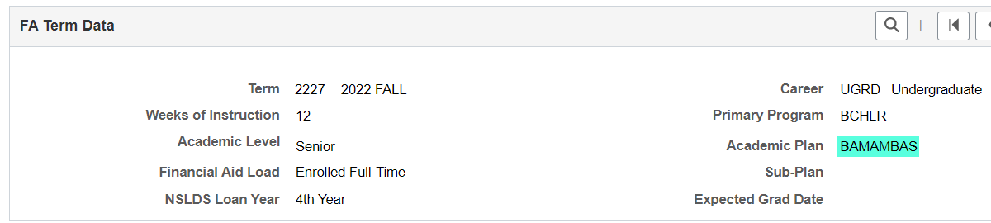

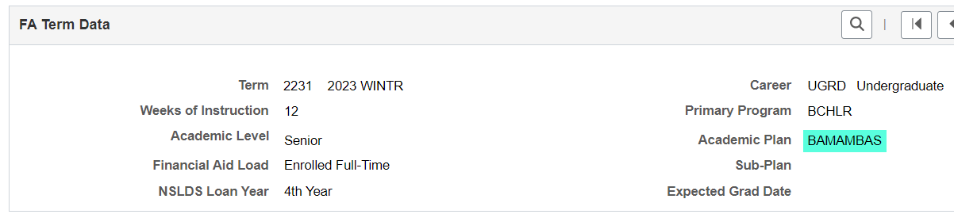

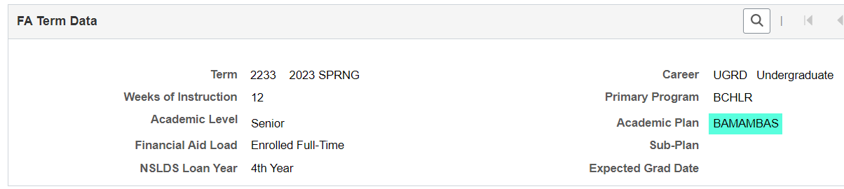

***Figure 4: Student A is eligible for CBS– Financial Aid > CTC Custom > CTC Interfaces > College Bound Scholarship > College Bound Eligibility View (tab)***

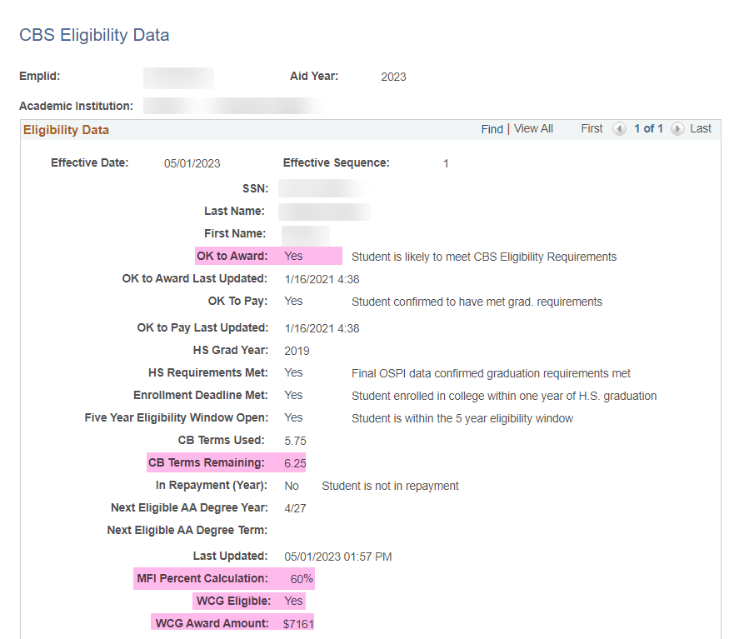

***Figure 5: CBS does not get packaged for the student - Financial Aid > Awards > Award Processing > Assign Awards to a Student***

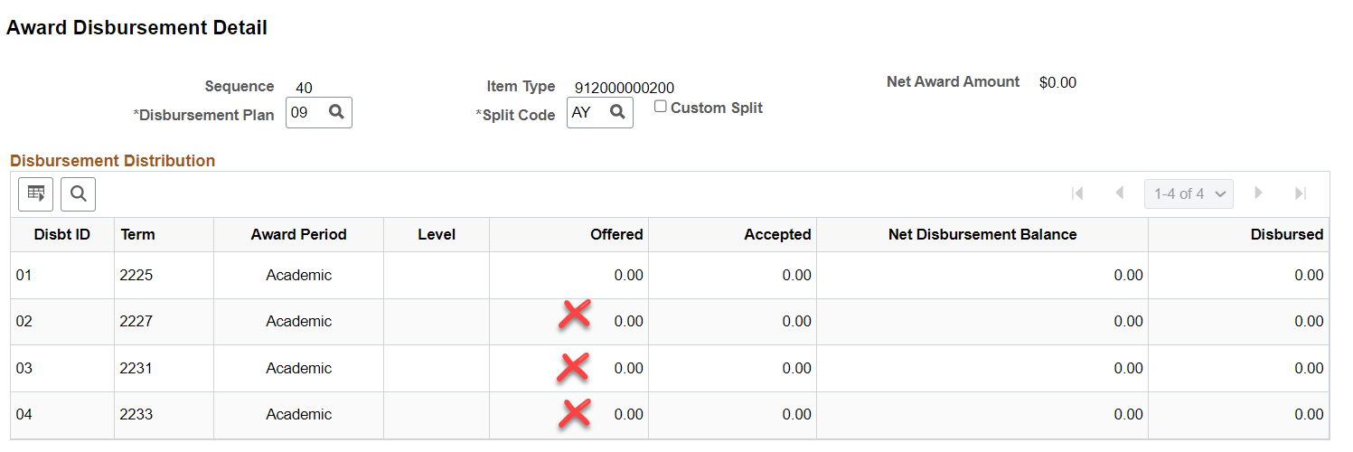

***Figure 6: Packaging message indicates the CBS amount calculated to a negative number - Financial Aid > Awards > Award Processing > Assign Awards to a Student***

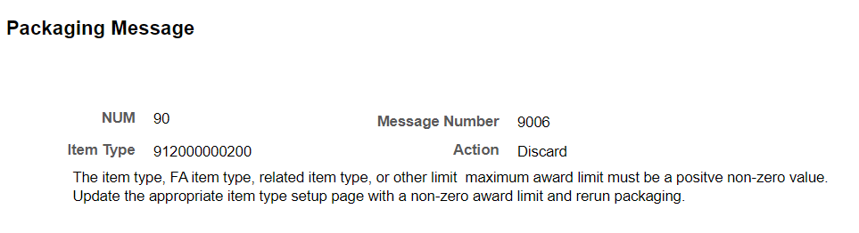

### Background Information

***Regulatory Language for Awarding CBS from Washington Student Achievement Council (WSAC)***

***College Bound Scholarships and/or Washington College Grant for All Terms of Enrollment, Including Summer(s)***

*Ensure that 100 percent of eligible CBS Scholars and/or WCG eligible students are awarded full Washington College Grant and/or College Bound Scholarship for all periods of enrollment, including summer(s), subject to need limits.*

***Figure 7: CBS Award Amounts chart for 2022-2023***

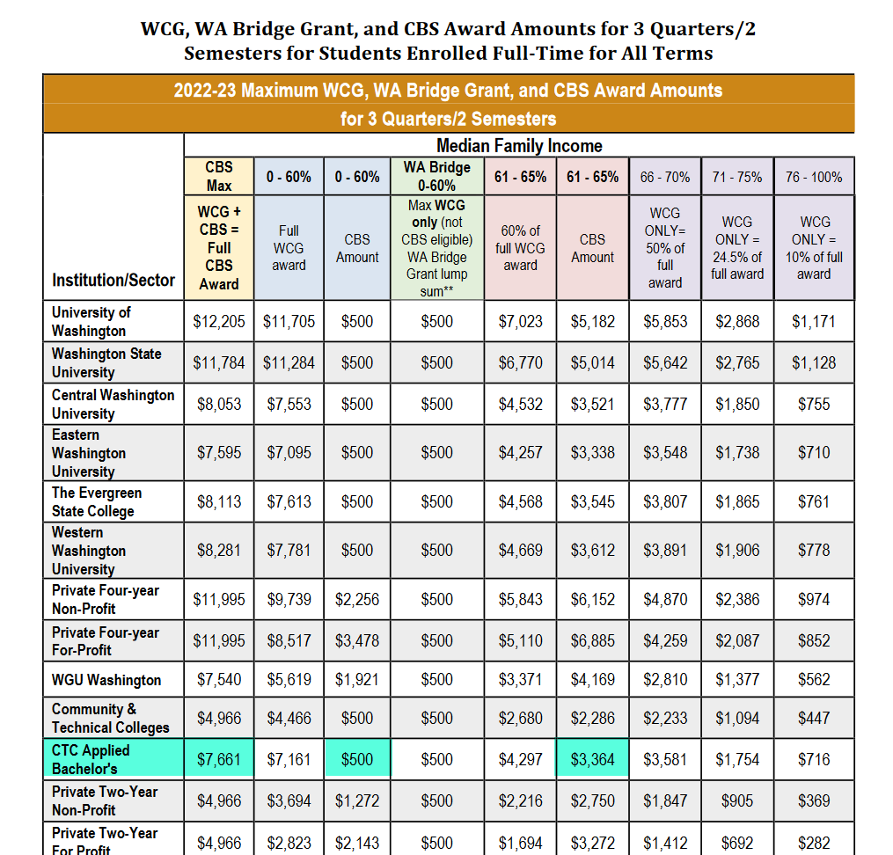

Reference: <https://wsac.wa.gov/sites/default/files/2022-23_WCGandCBS_ProgramManual-Rev1-23.pdf>

### Visual Flow Diagram of How CBS is currently Calculated for BA Degree Students

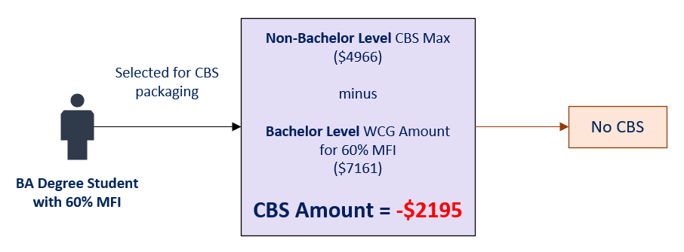

### Sample Data Visuals of Problem Student

The visual below shows a student who meets all requirements for CBS packaging. The student is pursuing a Bachelor’s degree and is 60% MFI, therefore, the WCG amount for the student is $7161 and CBS amount is $500.

***Figure 7 & 8: College Bound Eligibility View page in PeopleSoft and CBS Award Amounts chart from WSAC***

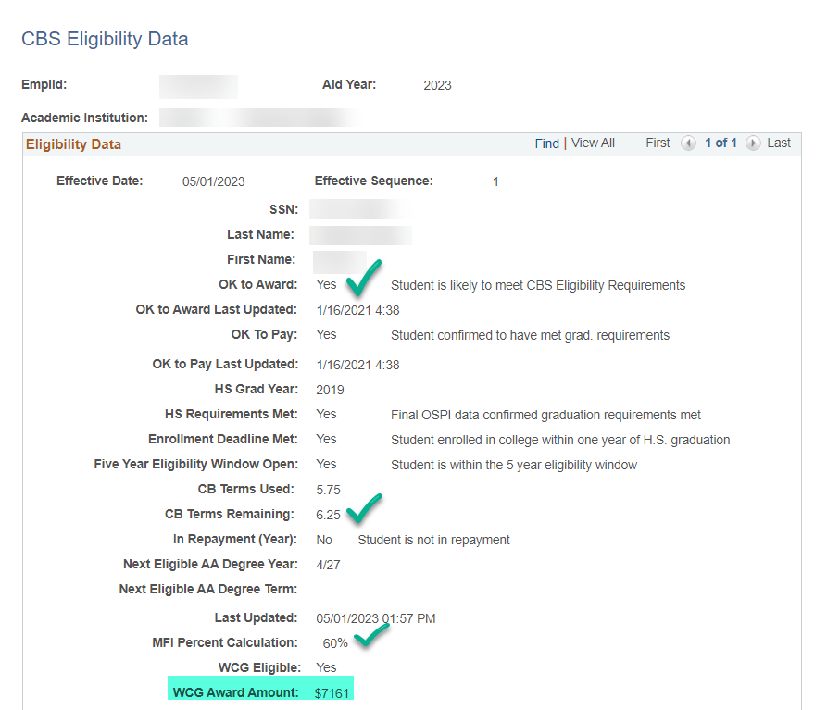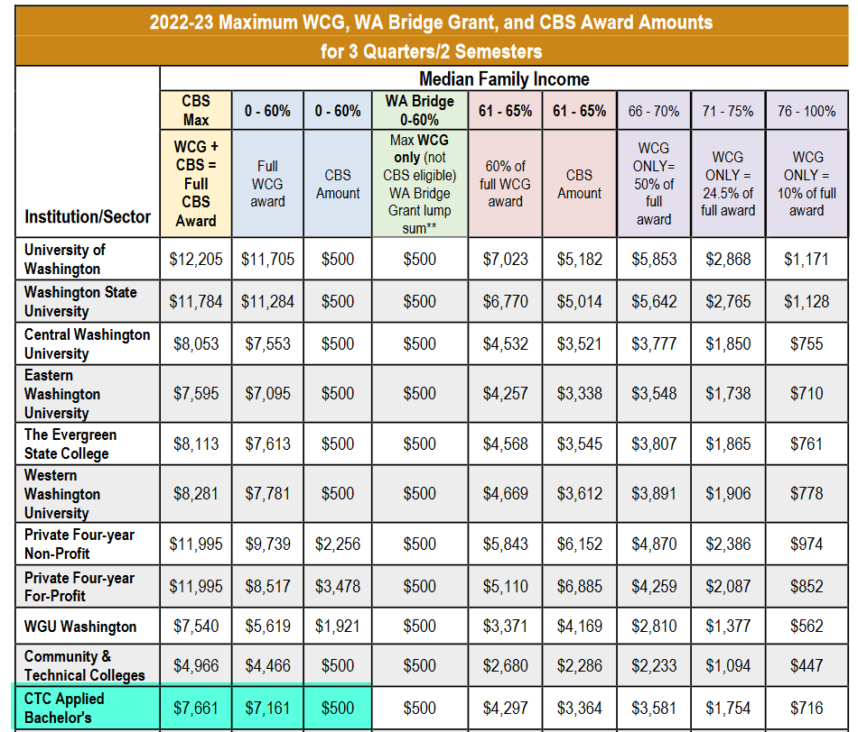

The student attends Full Time for Fall, Winter and Spring term for the aid year, has enough unmet need and is meeting Satisfactory Academic Progress.

***Figure 9 & 10: Unmet need and SAP status***

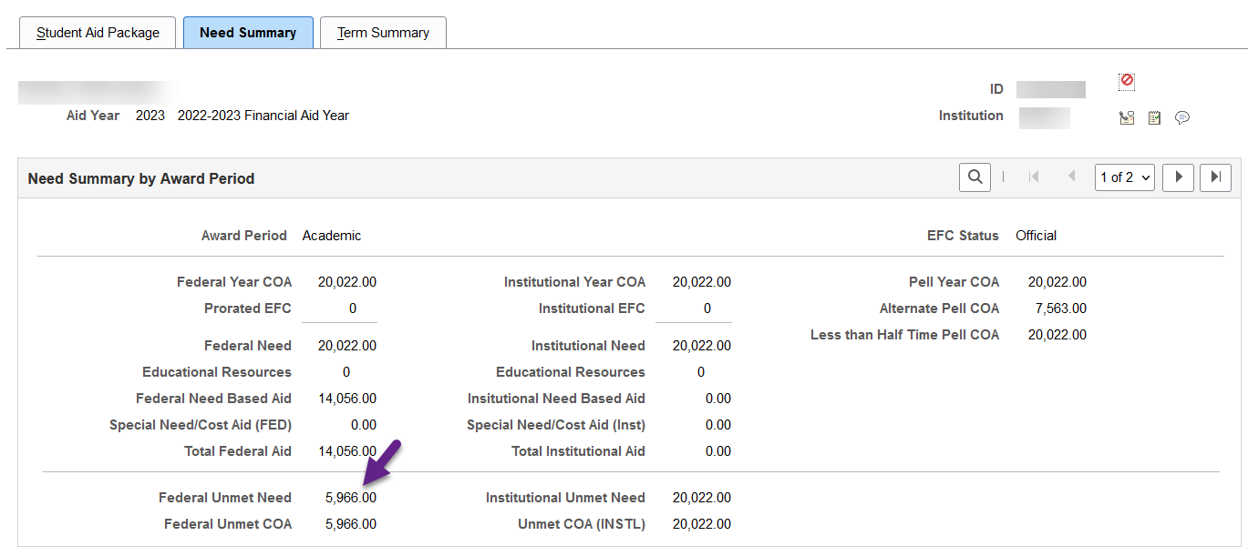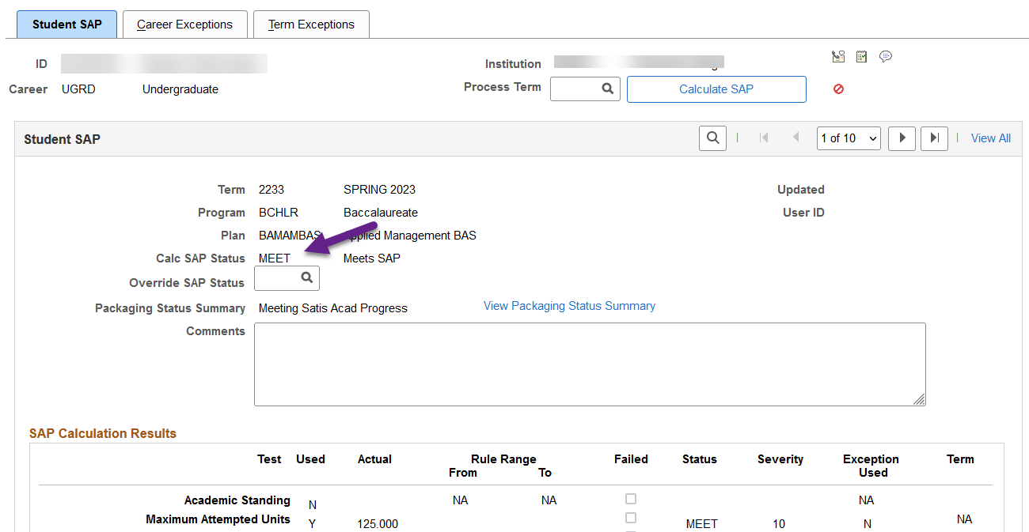

The student is not receiving any other state grant or scholarship that would require the $500 CBS amount to be reduced.

***Figure 11: No other state grant or scholarship awarded to student***

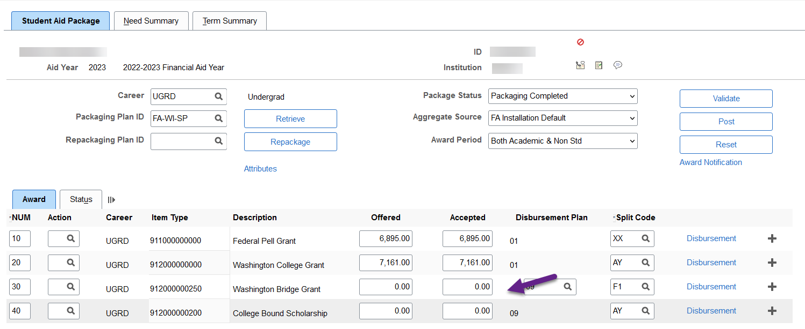

Staff are expecting the CBS item-type (912000000200) to package $500 (Fall $166/Winter $167/Spring $167) for the student. However, the student does not get packaged the CBS item-type due to the student’s CBS amount calculating to a negative amount.

***Figure 12: Student is not packaged any CBS for all three eligible terms***



***Figure 13: Packaging message indicates the CBS amount calculated to a negative amount***



The cause for this packaging error is as a result of the CBS Setup page having one field to store a Full Time Level CBS Maximum Amount per aid year. Currently, colleges enter the Community & Technical College Full Time CBS Maximum amount of $4966 into the Full-Time Level Amount field, then prorate the amount accordingly to populate the other enrollment levels. The CBS Setup page does not have a field to store the CTC Applied Bachelor’s Full-Time CBS Maximum amount of $7661.

***Figure 14: Up SACR > Product Related > Financial Aid > CTC Custom > CTC Interfaces > College Bound Setup***

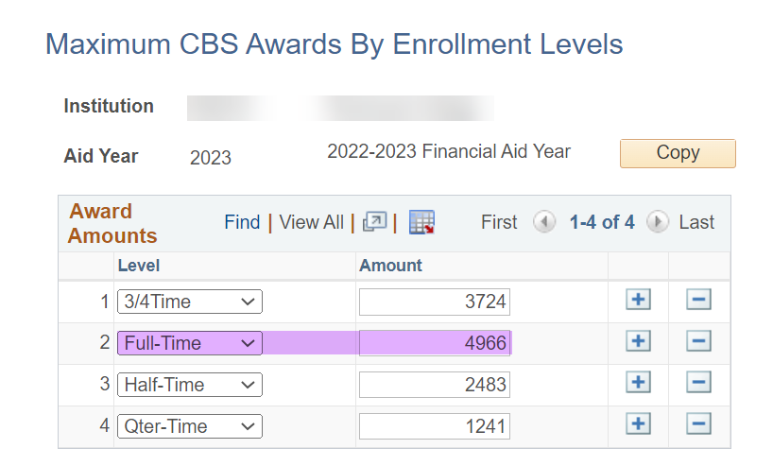

The CBS Award Amount equation engines take the value entered in the Full-Time Level and subtracts the student’s WCG Award Amount.

***Figure 15: Example of a CBS Award Amount Equation***

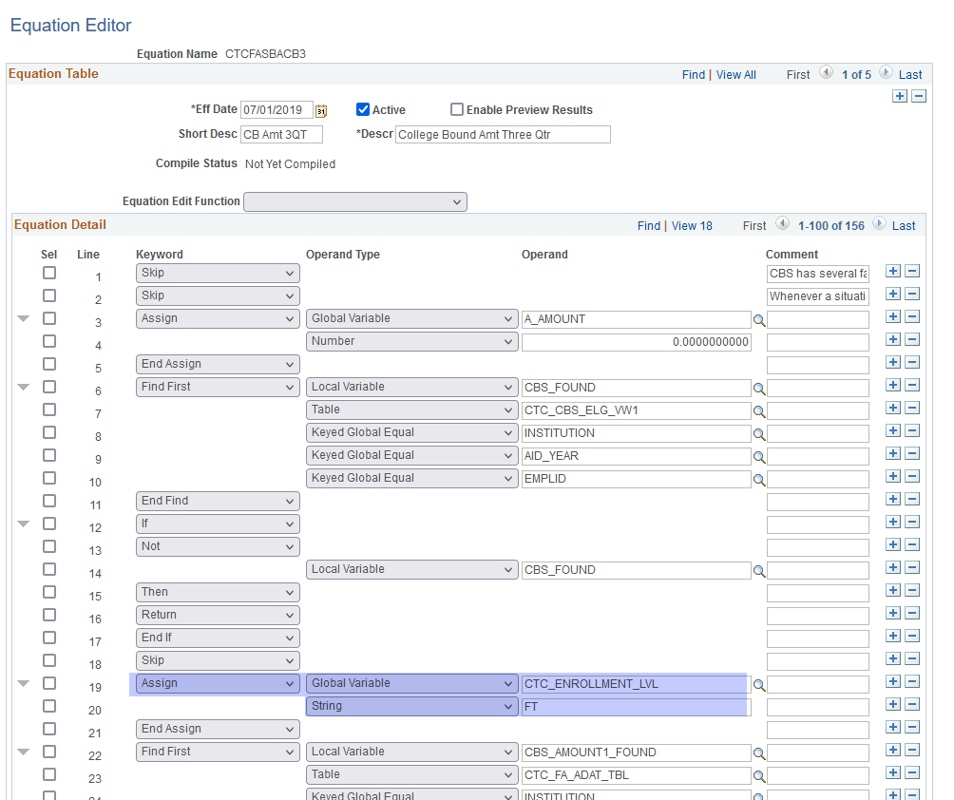

PS calculates as designed.

$4966 (Non-Bachelor FT Max CBS) - $7161 (Bachelor WCG Amount) = -$2195

-$2195 is a negative number and cannot be packaged.

# Proposed Solution

Re-design the CBS Setup page from “Maximum CBS Awards By *Enrollment* Levels” to “Maximum CBS Awards By *Degree* Levels” so colleges can enter the Full-Time CBS Max Amount for both Non-BAS and BAS degree levels. The CBS equation engines will be updated to pull the new values accordingly.

## Solution Overview

1. Move away from the current design of the CBS Setup page storing CBS award amounts per enrollment level (Full-Time, ¾ Time, Half-Time and Qter-Time) to Full-Time CBS award amounts per degree level (Non-BAS and BAS)

Current Design

CBS Setup page requires colleges to enter Non-BAS CBS Max amounts according to enrollment level of ‘Full-Time’, ‘¾ Time’, ‘Half-Time’ and ‘Qter-Time.’

***Figure 16: Maximum CBS Awards By Enrollment - Set Up SACR > Product Related > Financial Aid > CTC Custom > CTC Interfaces > College Bound Setup*** ***Levels***

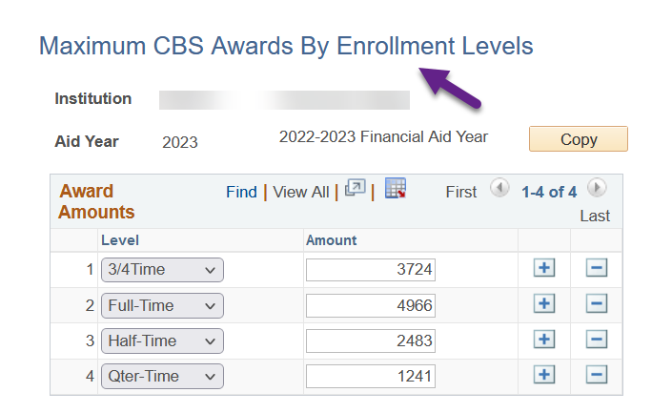

New Design

CBS Setup page will require colleges to enter Full-Time CBS Max amounts according to degree level of ‘Non-BAS’ and ‘BAS.’

***Figure 17: Maximum CBS Awards By Degree - Up SACR > Product Related > Financial Aid > CTC Custom > CTC Interfaces > College Bound Setup*** ***Levels***

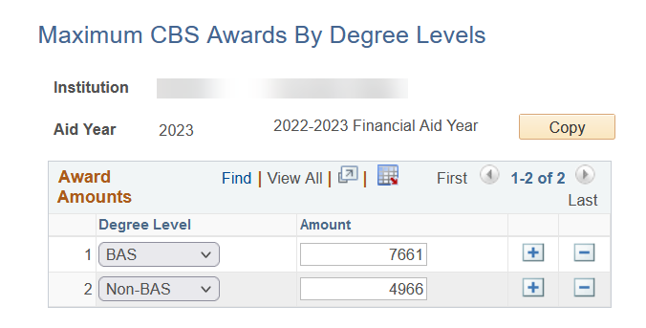

We have confirmed there is no need for the CBS Setup page to list CBS amounts according to enrollment level as there are no queries, equation engines or processes that use the ‘¾ Time’, ‘Half-Time’ and ‘Qter-Time’ values.

1. Update CBS Award Amount equations with new criteria of looking for degree the student is pursuing (Non-BAS vs. BAS) and pulling the associated Full-Time Max CBS Amount from the CBS Setup page.

### Visual Flow Diagram of Processing Logic Change

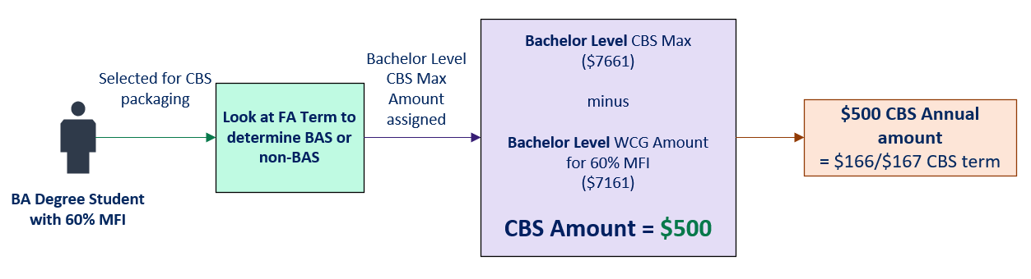

## Technical Details of Solution

### Modify CBS Setup page:

College Bound Setup page will be modified as stated below to accommodate the new requirements:

1. Modify the page title from ‘Maximum CBS Awards By Enrollment Levels’ to ‘Maximum CBS Awards by Degree Level’.
2. Modify the page field description from ‘Level’ to ‘Degree Level’.
3. Inactivate the existing Translate values of field ‘CTC_ENROLLMENT_LVL – Level’:
   1. 3/4 Time
   2. Full Time
   3. Half Time
   4. Quarter Time
4. Add new Translate values to field ‘CTC_ENROLLMENT_LVL – Level’:
   1. BAS - BA
   2. Non-BAS - NB
5. Script the SQL to delete the existing Inactive translate values from record as part of cleanup.

### Update CBS Award Amount Equation engines:

All eight CBS Award Amount equations will be updated with criteria to find the student’s program plan then pull the associated Full-Time Max CBS amount from the CBS Setup page to calculate the CBS amount for the student.

CBS Award Amount equations

CTCFASBACB1 – College Bound Amt One Quarter

CTCFASBACB2 – College Bound Amt Two Quarter

CTCFASBACB3 – College Bound Amt Three Quarter

CTCFASBACB4 – College Bound Amt Four Quarter

CTCFASBACBF – CBS Award Fall

CTCFASBACBW – CBS Award Winter

CTCFASBACBS – CBS Award Spring

CTCFASBACBU – CBS Award Summer

***Figure 18: Example CBS Award Amount Equation***

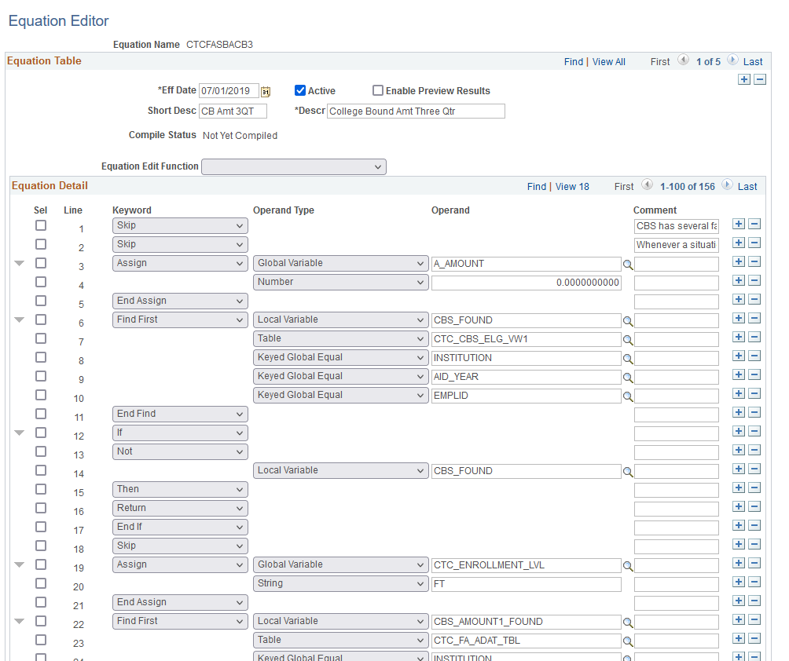

The equation engine will look for the student’s program plan from FA Term to determine whether the student is non-BAS or BAS then do the following:

When student is BAS, equation engine will pull CTC_ENROLLMENT_LVL = BA

When student is non-BAS, equation engine will pull CTC_ENROLLMENT_LVL = NB

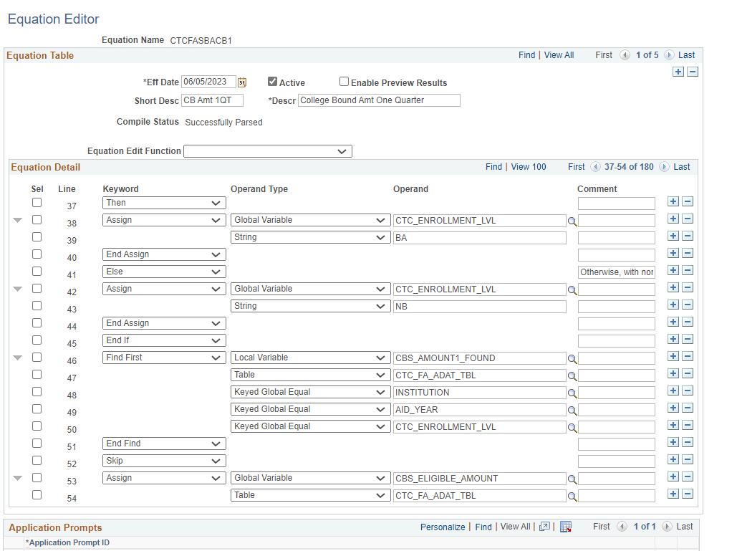

***Figure 19: New criteria of looking at FA Term to determine non-BAS or BAS then pulling the associated value from the CBS Setup page***

## Test Scope

### Out of Scope for Testing the Solution

N/A

### In Scope for Testing the Solution

CBS amounts will accurately package for students pursing a Bachelor’s degree.

### Recommended Test Scenarios

Select ‘Retrieve’ on the following scenario of students to confirm the behavior of the updated CBS award amount equations.

**Scenario 1:** Student is non-BAS and eligible for CBS

**Expected outcome:** CBS is packaged accurately

**Scenario 2:** Student is BAS and eligible for CBS

**Expected outcome:** CBS is packaged accurately

**Scenario 3:** Student is not eligible for CBS

**Expected outcome:** CBS is not packaged.