SBCTC

Abstract

*Per the 9/14/2022 Financial Aid Maintenance List from FAC on Satisfactory Academic Progress change requests, a solution is needed that will enable the FA SAP Process to read a prior term FA SAP Student Status when there is a break in enrollment and generate an amended SAP Status based on a combination of current Calculated SAP Status and Prior Term SAP Status. Additionally, with the approach taken on Pass 2, the issue of handling Summer Drops can be addressed without the need to add a custom check box to the Term Exceptions page.*

solution design   
fa sap customization

Using Statuses & Actions Rules Configurations for Students with Breaks in Enrollment [Pass 2]

+ Summer Drops Resolution

# Issue Overview

## Clarified Problem Statement Pass 2

Students with breaks in enrollment require manual overrides because the Statuses and Actions rules logic is not used in Pass 2 processing to evaluate students who have a break in enrollment. These students should result in a different SAP Status when compared to the most recent term’s SAP Calculated Status or Override Status.

### Background Information

**Pass 1**

* When executed, the SAP program will first perform a Pass 1 evaluation for all students who were enrolled[1] in the SAP Evaluation Term[2], and the Fully Graded Date[3] for that term has passed.
  + If more than one Evaluation Term is configured, then the program will refer to the Final SAP Status on the more recent (or “Max”) Evaluation term.
* The Calculated SAP Status is determined by running all applicable SAP tests, per the college’s local SAP configuration, then selecting the SAP Status with the highest Severity Level.
* The Statuses and Actions Rules are then used to compare the *Calculated SAP Status* to the student’s *Previous SAP Status* to determine the *Final SAP Status* for the term.

**Pass 2**

* If no data exists for Pass 1, student had a break in enrollment, the SAP processing logic will perform Pass 2.
* Pass 2 SAP Status is determined by running all applicable SAP tests and selecting the SAP Status with the highest Severity Level.
* ***Statuses and Actions Rules are not used in Pass 2;*** the Calculated SAP Status will ***not*** be compared to a Previous SAP Status.
* On the Run Control for the Process SAP option:
  + If the “Update using Most Recent Evaluation Terms (Pass 2)” is selected, then when the program runs Pass 2 it will update the Student SAP page with the results of Pass 2.
  + Otherwise, the program will not update that student’s SAP Status, as Pass 1 results did not exist and Pass 2 will not be posted.

### Visual Flow diagram of issue

### Sample Data Visuals of Problem Student

The visual below shows that SAP was run for Winter 2020 (2201) and evaluated the progress made in Fall 2019 (2197). The highest priority Calculated SAP Status for that term was WARN, but since this was a Pass 1 (no break in enrollment) the SAP program referenced the prior term attended that also resulted in a WARN status. The program then used both WARN statuses in the Statuses and Actions rule of WARN + WARN = SUSP, resulting in the final SAP Status of a Suspension.

#### Figure 1: Delivered Page: Financial Aid > Satisfactory Academic Progress > Maintain Student SAP Data

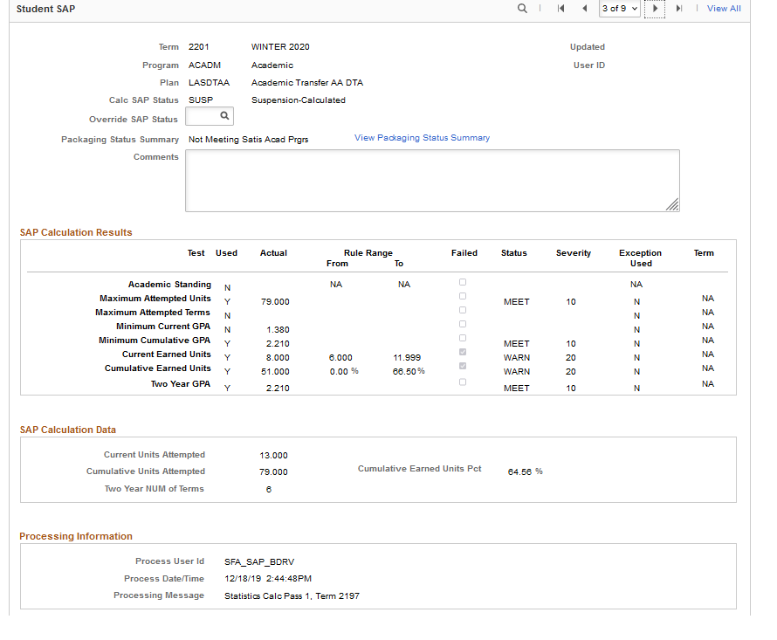

The next term that SAP ran for was Spring 2020 (2203). The student did not enroll in Winter 2020 (2201), so the FA SAP Process went back and again evaluated that last term where the student was actively enrolled: Fall 2019 (2197). That term again resulted in a Calculated SAP Status of WARN. Since there was a break in enrollment, the Pass 2 logic was engaged and no evaluation of the Student SAP Status for a prior term was performed. The Final SAP Status was set to WARN. This forced the Financial Aid Office to manually override the Student SAP Status from WARN to SUSP.

#### Figure 2: Delivered Page: Financial Aid > Satisfactory Academic Progress > Maintain Student SAP Data

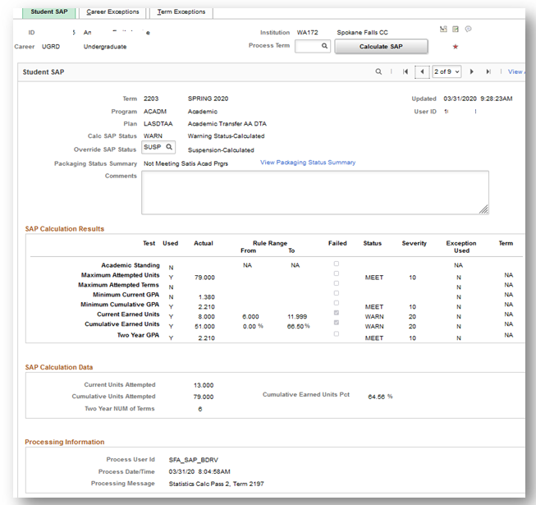

## Clarified Request statement for Pass 2

Modify the programming logic for the SAP program on Pass 2 processing to use Statuses and Actions configurations to determine the Final SAP Status for the term being processed. Just as in Pass 1, the Pass 2 Statuses and Actions must prioritize the Override Status from the previous term if one exists. Pass 2 Statuses and Actions should only consider the most recent Calculated SAP Statuses that were calculated based on statistics from terms of enrollment prior to the term driving the statistics.

[*Note: The use of Override Status prioritization only pertains to when the Previous SAP Status is read to compare Previous and Calculated SAP Statuses to determine the Final SAP Status while the program is processing. See* *Proposed Solution* *for details*.]

## Clarified Problem Statement for Summer Drops

Summer Term SAP is built with a SAP Calc Status based on an evaluation from a previously graded term; however if the student drops enrollment for Summer Term, the Summer Term SAP Status remains and is used in the Fall SAP calculation in the Statuses and Actions logic. The Summer Term, which now has a SAP Status despite the student no longer being enrolled, is used as the “Previous Term” SAP Status (1) to compare against the calculated value “Calc SAP Status” (2) that is temporarily stored (while the SAP process is executing) to reach a “Final SAP Status” (3) that will post to the Student SAP page.

#### Figure 3: Statuses and Actions Configuration on Delivered Page: Set Up SACR > Product Related > Financial Aid > Satisfactory Academic Progress > Define Set Up Criteria

## Clarified Request Statements for Summer Drops

**Request 1**: Provide the capability to exclude a term from being read as the value for the “Previous SAP Status**”** in the Status and Actions Rules configuration.

[*Note: No custom checkbox is needed to address this request. See* *Proposed Solution* *for Details.*]

#### Figure 4: Delivered Page: Financial Aid> > Satisfactory Academic Progress > Maintain Student SAP Data > Term Exceptions (tab)

Initially proposed use of a custom check box. With a shift in the logic for Pass 2, this customization would not be necessary.

**Request 2**: Develop a process to automatically apply a checkbox for a term where a student does not have valid enrollment in order to automate the ability to skip a term from consideration in the Statuses and Actions Rules logic.

This solution option is dependent upon the decision for Pass 2 processing to utilize the Statuses and Action Rules.

## ***Revised*** Solution Recommendation for Summer Drops

A minor modification to the solution design approach for Pass 2 would eliminate the need for the use of a custom check box articulated in the request statements above. See the flow diagram in technical section (*Visual Flow Diagram of Processing Logic Change*) for an explanation of the alteration to the program logic.

# Proposed Solution

Clone and customize the delivered PeopleSoft code for Financial Aid SAP Processing to change the behavior on Pass 2 processing to perform the comparison between the Calculated SAP Status (2) from the SAP program to the Previous Term SAP Status (1) from the Student SAP page (ignoring terms where there was a break in enrollment) and, using the SAP Setup Configuration rules for Statuses and Actions, set the resulting SAP Status to be posted on the Student SAP page to the Final SAP Status configured in the Statuses and Actions rules.

[*Note: Override Status will be used as one of the considerations in the Statuses and Actions logic (Previous Status) but is* not *simply carried forward from the prior term as the Final Calc Status.]*

* For Pass 1, the Previous SAP Status is the prior term SAP Status.
* For Pass 2, read the SAP Status from the Enrolled Term prior to the last Enrolled Term (where the current Calc SAP Status is sourced).

#### Figure 5: Statuses and Actions Configuration on Delivered Page: Set Up SACR > Product Related > Financial Aid > Satisfactory Academic Progress > Define Set Up Criteria

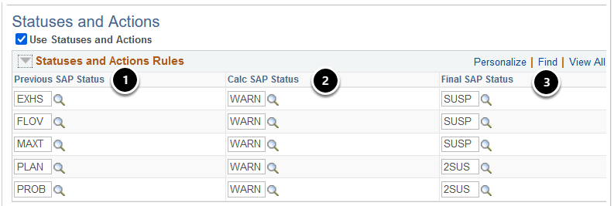

[*Note: See* *Example Data Scenarios* *for Details*.]

## Solution Overview

1. Clone the existing Oracle delivered code.
2. Modify the code at the point where Pass 2 processing is triggered to:
   1. Perform standard Pass 2 SAP analysis and return a Calculated SAP Status;
   2. Read the Previous Term SAP Status from the Student SAP page maximum term with enrollment (*Pass 2 only*);
   3. Read the Statuses and Actions Rules configuration to compare the Previous Term Status to the Calculated SAP Status and determine the Final SAP Status from the configuration;
   4. Check if the “Update on Pass 2” check box is checked on the Process SAP run control (Oracle delivered).
      1. If yes then update the Student SAP page.
      2. If no then end program.
3. Update the SAP Application Engine Process Setup page for each Institution to point to the custom code.

### Example Data Scenarios

**Scenario 1 - Bob New:**

* Failed to meet SAP after grading occurred for Winter 2021 Term, which placed the Student SAP Status for Spring 2021 at “WARN.”
* Failed to meet SAP again after grading occurred for Spring 2021 Term, which placed the Student SAP Status for Summer 2021 at “SUSP.”
* Student enrolled in Summer 2021 but withdrew from all classes before the start of the term.
* **BEFORE FIX**: When SAP would have been run for Fall 2021 it would determine that this student had a ‘break in enrollment’ and therefore would skip the Statuses and Actions Rules evaluation, thus the student would have a Final SAP Status of “WARN.”
* **AFTER FIX**: When SAP runs for Fall 2021 it will determine that this student had a ‘break in enrollment’ and therefore the new logic would read this as a Pass 2 and will perform the Statuses and Actions Rules evaluation as follows:
  + The program will skip the Student SAP Status of “SUSP” from Summer 2021 since there was no enrollment record for Summer 2021.
  + The Statuses and Actions Rules evaluation would instead read the Student SAP Status of “WARN” from Spring 2021 since that is the term with the last enrollment record.
  + The program will treat the Student SAP Status of “WARN” from Spring 2021 as the “Previous” SAP Status and compare it to the Calculated SAP Status of “WARN.”
  + Thus “WARN” plus “WARN”, as seen in the sample rules below, will result in a Final Calc Status of “SUSP”.

**

* Failed to meet SAP after grading occurred for Fall 2021 Term and resulted in a Student SAP Status of SUSP. Student appealed suspension and was placed on Probation for Winter 2021 and manually assigned an Override Status of PROB.
* Failed to meet cumulative GPA so would have failed SAP again after grading occurred for Winter 2021 Term, however the student did not enroll for Spring and SAP was not run.
* **BEFORE FIX**: When SAP would have been run for Summer 2021 it would be determined that this student had a ‘break in enrollment’ and therefore the program would skip the Statuses and Actions Rules evaluation, thus the student would have a Final SAP Status of WARN for Summer 2021.
* **AFTER FIX**: When SAP runs for Summer 2021 it will determine that this student had a ‘break in enrollment’, read this as a Pass 2, and perform the Statuses and Actions Rules evaluation as follows:
  + The program will skip Spring 2021 since there was no enrollment record for Spring 2021.
  + The Statuses and Actions Rules evaluation will instead read the overridden Student SAP Status of “PROB” from Winter 2021 as the “Previous” SAP Status and compare it to the Calculated SAP Status of “WARN.”
  + Thus “PROB” plus “WARN”, as seen in the sample rules below, will result in a Final Calc Status of “SUSP”.

**Scenario 3 – Tan Old Legacy**

* In Legacy Tan was on a roll and successfully earned 93 credits by Winter 2007 Term, but then left the college.
* Tan returns to college in Fall 2022, and the registrar’s office rebuilds his old legacy transcript with 93 credits.
* Tan’s certificate needs 75 credits, but Tan needs 15 credits he’s not taken before, and he enrolls for 20 credits.
* **BEFORE FIX**: When SAP ran for Fall 2022 the student would have a Final SAP Status of “MEET” for Fall 2022, since the program would not compare his certificate requirements to the total credits he’s earned, and instead determine he’s attempted in excess of the total credits needed for his program requirements. The Financial Aid Office would put Tan on a Plan to ensure he stays on track to complete his certificate and set the Override SAP Status to “PLAN”.
* **AFTER FIX**: The situation for Tan does not change, as this fix does not address his specific scenario. The Financial Aid Office will still put Tan on a Plan to ensure he stays on track to complete his certificate, and, like before, set the Override SAP Status to “PLAN”.

**Scenario 4 – Dan Old Legacy**

* In Legacy Dan was really struggling and was on repeated SAP probation.
* Dan left after his third term of poor academic performance and since he hadn’t applied for aid again, the Financial Aid office at that time didn’t evaluate his SAP.
* Dan returns to college in Fall 2022, and the registrar’s office rebuilds his old legacy transcript. He has his 22 credits from before, but the Attempted 40 credits to the Earned 22 credits might land him in a “WARN” status.
* **BEFORE FIX**: When ran for Fall 2022 the student would have a Final SAP Status of “MEET” for Fall 2022, since the program would not have access to his poor performance in legacy. The Financial Aid Office would put Dan on suspension and manually set the Override SAP Status to “SUSP”.
* **AFTER FIX**: The situation for Dan does not change, as this fix does not address this specific scenario. The Financial Aid Office will still put Dan on suspension and manually set the Override SAP Status to “SUSP” just like before.

### Visual Flow Diagram of Processing Logic Change

Begin SAP process

NO

End

**Enhanced Logic for Summer Drops Solution for both Pass 1 and Pass 2**

Define Current SAP Status as SAP Status from most recent term of enrollment. Define Previous SAP Status as SAP Status from the most recent term of enrollment prior to the “Current” SAP Status. (Eliminates need for custom check box to exclude a term.)

YES

End

Update SAP Status  
on Student SAP page

YES

Pass 2 option selected in Process SAP run control?

**Enhanced Processing Logic for Pass 2 Solution**

Define Previous SAP Status as SAP Status from the most recent term of enrollment prior to the “Current” SAP Status.

Custom Application Engine to use Statuses and Actions Rules to compare current SAP Status to previous SAP Status and determine new Pass 2 SAP Status

NO

Determine and assign Pass 1 or Pass 2 flag for selected student based on enrollment data

Load SAP temporary table based on the population selection

Execute SAP test based on Institution setup and determine the test statuses and overall SAP Status

Use Statuses and Actions Rules to compare processed results with previous results and determine  
new SAP Status

Update SAP Status  
on Student SAP page

End

Student flagged for Pass 1?

## Technical Details of Solution

### When Running SAP from Process SAP Run Control Page

A new custom Application Engine[4] (AE) section will be created by reusing the section of delivered code that currently compares the SAP status for Pass 1with adjustments in logic to accommodate the newly requested Pass 2 logic.

To match delivered functionality, the comparison of SAP Statuses in Pass 2 processing will be posted to the Student SAP data page only if the below check box is checked on the Process SAP run control page (see reference in the Background Information section above in this document).

#### Figure 6: Batch Process SAP Delivered Page: Financial Aid > Satisfactory Academic Progress > Process SAP

Adjustments to the delivered comparison logic will be made based on Pass 2 data. Detailed information on adjustments to the logic will be updated in the Technical Design document once the development is complete and ready for functional and user testing.

### When Running SAP for Individual Students from Maintain Student SAP Data Page

The same custom Application Engine created for the Process SAP batch process will also be called when the Calculate SAP button on the Maintain Student SAP page is selected. Student SAP data calculated from this page using the Calculate SAP button defaults the process to use and update the Pass 2 data if it is available.

#### Figure 8: Calculate SAP Button on Delivered Page: Financial Aid > Satisfactory Academic Progress > Maintain Student SAP Data

# Glossary of Terms

1. **Enrolled**

   Not to be confused with the term “Dropped”, the SAP program considers a student as “enrolled” when they were enrolled in the class and have received or will receive a grade (including “W” for “Withdrew”).
2. **Maximum Evaluation Term**

   The phrase “Max Evaluation Term” in the program refers to the latest term in a range of terms listed as values on the Define Evaluation Term configuration page for a specific term being processed.

   *Navigation: Set Up SACR > Product Related > Financial Aid > Satisfactory Academic Progress > Define Evaluation Terms*

   Graphical user interface, application

   Description automatically generated
3. **Fully Graded Date**

   The date set on an Academic Term when grades posted to that student’s record are considered official. This is configured by Student Records staff on the Academic Calendar page.

   *Navigation: Set Up SACR > Foundation Tables > Term Setup > Academic Calendar*Graphical user interface, text, application, email

   Description automatically generated
4. **Application Engine (AE)**

   The programming logic that drives the processing of Satisfactory Academic Progress handling is executed either in batch, by running the SAP Process, or by selecting the “Calculate SAP” button on the Maintain Student SAP Data page. In either case, this launches an Application Engine program that performs the analysis and returns the results to the Maintain Student SAP Data page.

   When enhancements are requested that deviate from the Oracle delivered code, this is referred to as a Custom AE, or customized application engine program.