WCG & CBS Enrollment-Based Packaging

Setup Guide

FA Customer Support

FA Customer Support

Washington State Board for Community and Technical College



# Overview

Per the *Financial Aid Maintenance List* on Mass Packaging change requests, a solution to package Washington College Grant (WCG) and College Bound Scholarship (CBS) based on enrollment level (Financial Aid Load) was requested.

**In Scope for this new design**

* WCG amounts for each term automatically pro-rates depending on the FA Load for the term.
* CBS amounts for each term automatically pro-rates depending on the FA Load for the term.
* WCG/CBS packages for students who have limited WCG/CBS terms of eligibility and DO NOT have a break in enrollment within the aid year

**Out of Scope for this new design**

Students in the cases outlined below are not in scope and will remain requiring manual adjustments by staff:

* WCG/CBS correctly packaging students who have limited WCG/CBS terms of eligibility and breaks in enrollment within the aid year
* CBS packaging correct amount for BAS students (this is a separate change request not yet addressed)

The following solution design document contains detailed info about the new design.



**If you would like to continue packaging full-time WCG regardless of FA Load and budget, you will not make the changes outlined in this guide.**

CONTENTS

Overview 1

Review/Update Disbursement Split Codes 3

Disbursement Split Codes 3

Disbursement Split Cd Formula 6

Review/Update WCG and College Bound Setup Tables 8

WCG Setup 8

College Bound Setup 9

Updating Packaging Plans 10

SUFAWISP or FAWISPSU Packaging Plans 12

FA-WI-SP Packaging Plan 31

SU-FA-WI Packaging Plan **HEADER ONLY** 36

WI-SP-SU Packaging Plan **TRAILER ONLY** 41

FA-WI Packaging Plan 46

WI-SP Packaging Plan 49

SU-FA Packaging Plan **HEADER ONLY** 52

SP-SU Packaging Plan **TRAILER ONLY** 55

FALL ONLY Packaging Plan 58

WINTR ONLY Packaging Plan 60

SPRG ONLY Packaging Plan 62

SUMR ONLY Packaging Plan 64

# Review/Update Disbursement Split Codes

Before you proceed updating the 2024 packaging plans, confirm the required disbursement split codes and split code formulas exist and are accurate for your college. We noticed some colleges were missing a few required split codes and split code formulas so we created them for you for the 2024 aid year but we still ask that you review them to make sure nothing is amiss.

#### Disbursement Split Codes

You can run the **CTC_FA_GC_AYRO_DISB_SPLIT_CODE** to get a list of all your split codes or navigate to the Disbursement Split Codes page.

**Navigation: Set Up SACR > Product Related > Financial Aid > Awards > Disbursement Split Codes**

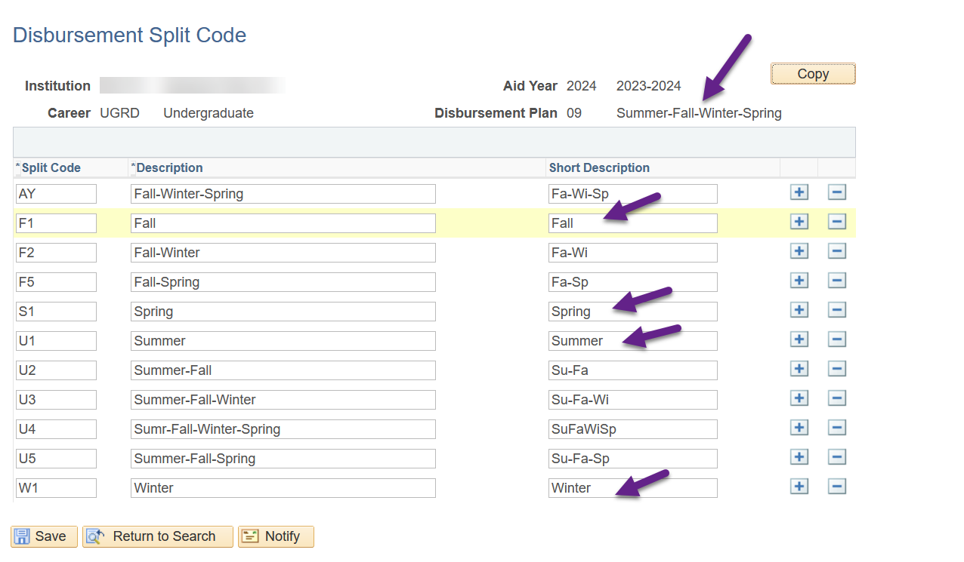

**Header colleges will need the following disbursement split codes:**

|  |  |
| --- | --- |
| **Disbursement Plan** | **Disbursement Split Code** |
| **Fall-Winter-Spring** | Fall |
| Winter |
| Spring |
| **Fall-Winter** | Fall |
| Winter |
| **Fall Only** | Fall |
| **Winter-Spring** | Winter |
| Spring |
| **Winter Only** | Winter |
| **Spring Only** | Spring |
| **Summer Only** | Summer |
| **Summer-Fall-Winter-Spring** | Summer |
| Fall |
| Winter |
| Spring |
| **Summer-Fall-Winter** | Summer |
| Fall |
| Winter |
| **Summer-Fall** | Summer |
| Fall |

**Note:** You may have other Disbursement Plans such as Fall-Spring, Summer-Winter, etc. but there is no packaging plan designed for those Disbursement Plans.

**Header college’s 10 packaging plans**

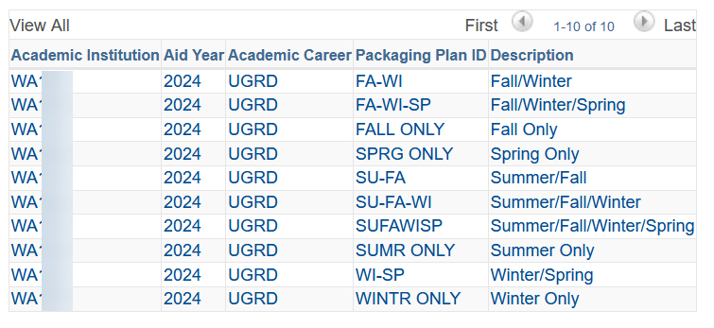

**Trailer colleges will need the following disbursement split codes:**

|  |  |
| --- | --- |
| **Disbursement Plan** | **Disbursement Split Code** |
| **Fall-Winter-Spring** | Fall |
| Winter |
| Spring |
| **Fall-Winter** | Fall |
| Winter |
| **Fall Only** | Fall |
| **Winter-Spring** | Winter |
| Spring |
| **Winter Only** | Winter |
| **Spring Only** | Spring |
| **Summer Only** | Summer |
| **Fall-Winter-Spring-Summer** | Fall |
| Winter |
| Spring |
| Summer |
| **Winter-Spring-Summer** | Winter |
| Spring |
| Summer |
| **Spring-Summer** | Spring |
| Summer |

**Note:** You may have other Disbursement Plans such as Fall-Spring, Winter-Spring, etc. but there is no packaging plan designed for those Disbursement Plans.

**Trailer college’s 10 packaging plans**

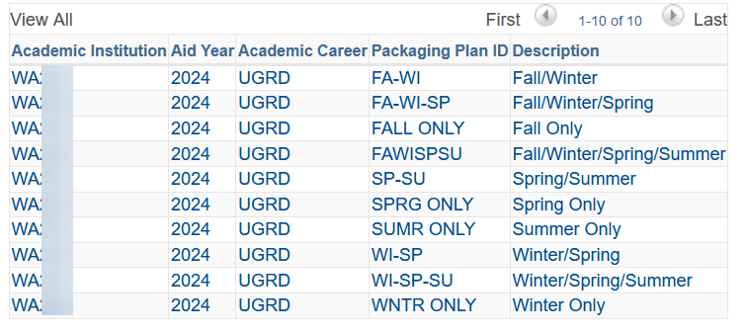

#### Disbursement Split Cd Formula

You can run the **CTC_FA_GC_AYRO_DISB_SPLIT_CODE** to get a list of all your split code formulas or navigate to the Disbursement Split Codes page.

**Navigation: Nav Bar > Navigator > Set Up SACR > Product Related > Financial Aid > Awards > Disbursement Split Cd Formula**

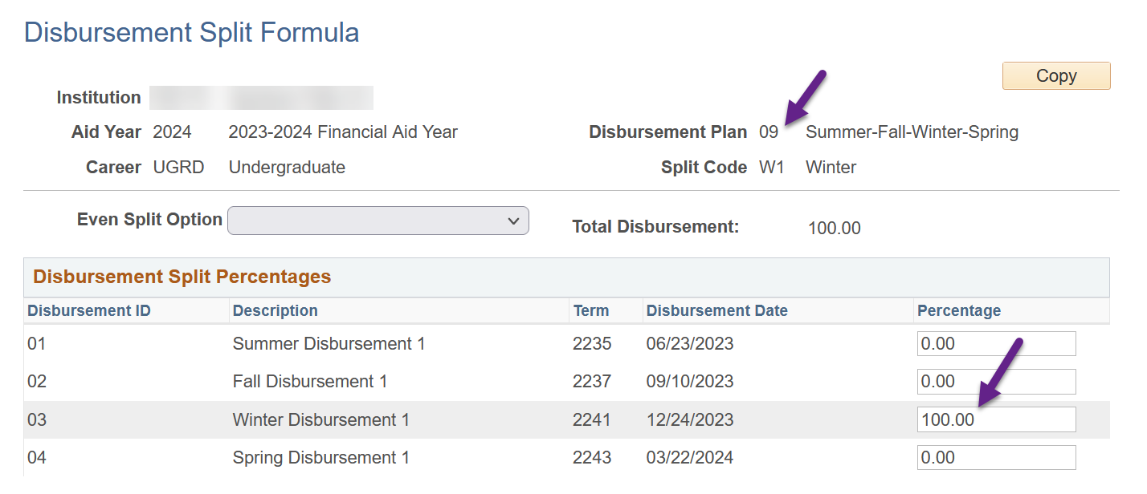

**Header colleges - review each disbursement split code that is listed and confirm 100% of the aid is going into the correct term.** For example, a Summer-Fall-Winter-Spring Disbursement Plan with Winter Split Code should have 100% in Winter Term.

|  |  |
| --- | --- |
| **Disbursement Plan** | **Disbursement Split Code** |
| **Fall-Winter-Spring** | Fall |
| Winter |
| Spring |
| **Fall-Winter** | Fall |
| Winter |
| **Fall Only** | Fall |
| **Winter-Spring** | Winter |
| Spring |
| **Winter Only** | Winter |
| **Spring Only** | Spring |
| **Summer Only** | Summer |
| **Summer-Fall-Winter-Spring** | Summer |
| Fall |
| Winter |
| Spring |
| **Summer-Fall-Winter** | Summer |
| Fall |
| Winter |
| **Summer-Fall** | Summer |
| Fall |

**Trailer colleges will review each disbursement split code that is listed and confirm 100% of the aid is going into the correct term.** For example, a Fall-Winter-Spring-Summer Disbursement Plan with Winter Split Code should have 100% in Winter Term.

|  |  |
| --- | --- |
| **Disbursement Plan** | **Disbursement Split Code** |
| **Fall-Winter-Spring** | Fall |
| Winter |
| Spring |
| **Fall-Winter** | Fall |
| Winter |
| **Fall Only** | Fall |
| **Winter-Spring** | Winter |
| Spring |
| **Winter Only** | Winter |
| **Spring Only** | Spring |
| **Summer Only** | Summer |
| **Fall-Winter-Spring-Summer** | Fall |
| Winter |
| Spring |
| Summer |
| **Winter-Spring-Summer** | Winter |
| Spring |
| Summer |
| **Spring-Summer** | Spring |
| Summer |

# Review/Update WCG and College Bound Setup Tables

With the existing WCG/CBS packaging design WCG/CBS annual amounts that are not divisible by 3 needed to be adjusted by $1 on the WCG Setup and CBS Setup pages. **This new design eliminates the need for the $1 adjustments in setup.**

**Note:** If you did not make any dollar adjustments to amounts on the WCG/CBS tables for 2024 aid year, you do not have to run a re-calc on your students until WSAC releases the 2023-2024 WCG/CBS award amounts and you update the table with those new values.

#### WCG Setup

**Navigation: Set Up SACR > Product Related > Financial Aid > CTC Custom > CTC Interfaces > WA College Grant > WCG Setup**

Enter the 2024 aid year and review the WCG award amounts. If you had adjusted some WCG amounts by a dollar to make them divisible by three, adjust them back to the original amounts given by WSAC.

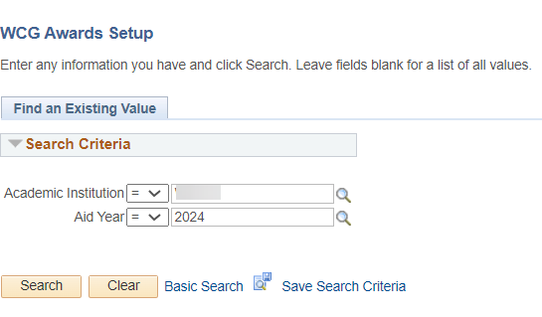

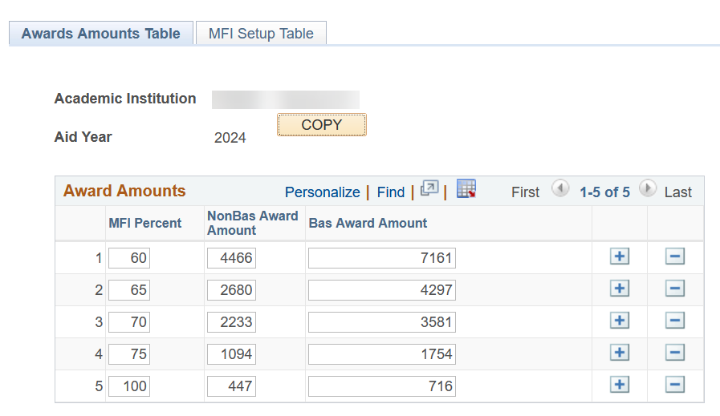

**Watch** [**https://wsac.wa.gov/FAA-resources**](https://wsac.wa.gov/FAA-resources)

**for 2023-2024 Award Amounts table updates from WSAC**

#### College Bound Setup

**Navigation: Set Up SACR > Product Related > Financial Aid > CTC Custom > CTC Interfaces > College Bound Scholarship > College Bound Setup**

Enter the 2024 aid year and review the CBS award amounts. If you had adjusted some CBS amounts by a dollar to make them divisible by three, adjust them back to the original amounts given by WSAC.

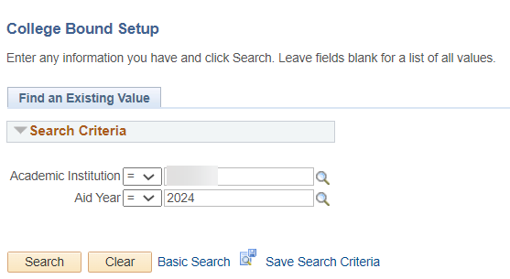

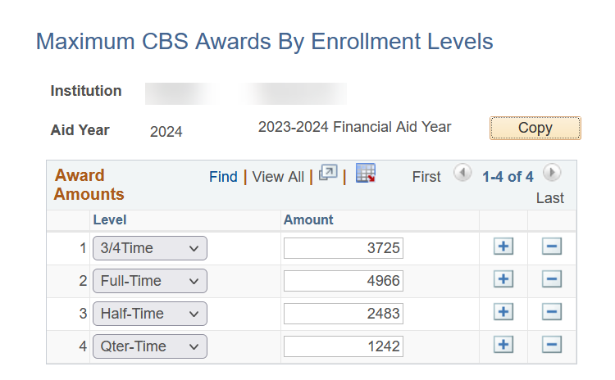

**Watch** [**https://wsac.wa.gov/FAA-resources**](https://wsac.wa.gov/FAA-resources)

**for 2023-2024 Award Amounts table updates from WSAC**

After adjusting both WCG and CBS tables back to the original award amounts given by WSAC, run the recalculation process mentioned on **p.11** of the *WCG and CBS Business Processing Guide*

<https://ctclinkreferencecenter.ctclink.us/m/92427/l/1375615-9-2-wcg-and-cbs-processing-business-process-guide>

# Updating Packaging Plans

This section will walk you through updating each type of packaging plan but we will start with an overview of what will be happening.

There are four types of packaging plans: one-term (i.e. FALL ONLY), two-term (i.e. FA-WI), three-term (i.e. FA-WI-SP) and four-term (i.e. FA-WI-SP-SU).

The number of WCG item-types in the packaging plan will depend on the number of terms to award in that packaging plan:

* Four-term packaging plans will have WCG listed four times in the packaging plan
* Three-term packaging plans will have WCG listed three times in the packaging plan
* Two-term packaging plans will have WCG listed twice in the packaging plan
* One-term packaging plans will have WCG listed once in the packaging plan

The number of CBS item-types in the packaging plan will depend on the number of terms to award in that packaging plan times two due to having ‘Okay to Pay’ and ‘Okay to Award’ eligibility statuses:

* Four-term packaging plans will have CBS listed eight times in the packaging plan
* Three-term packaging plans will have CBS listed six times in the packaging plan
* Two-term packaging plans will have CBS listed four times in the packaging plan
* One-term packaging plans will have CBS listed twice in the packaging plan

There are 20 new equation engines in production:

* 4 new WCG selection equation engines
* 4 new WCG award amount equations
* 4 new CBS ‘Okay to Award’ selection equation engines
* 4 new CBS ‘Okay to Pay’ selection equation engines
* 4 new CBS award amount equations

The equation engines will be placed in specific locations within the packaging plans.

Running the **CTC_FA_PACKAGING_PLANS** query and downloading the results into a spreadsheet and planning out the Sequence Numbers can be helpful! 😊 Not all college’s sequences are spread out by 10s between item-types like the examples provided. There are colleges who have sequence numbers right next to each other like sequence number 60 for CBS ‘Okay to Pay’ and sequence number 61 for CBS ‘Okay to Award.’ In cases like those, the college will need to adjust the Sequence Numbers of other item-types within that packaging plan.

**Example of a college planning out the sequence number for the new WCG and CBS rows that will be added for a four-term packaging plan.**

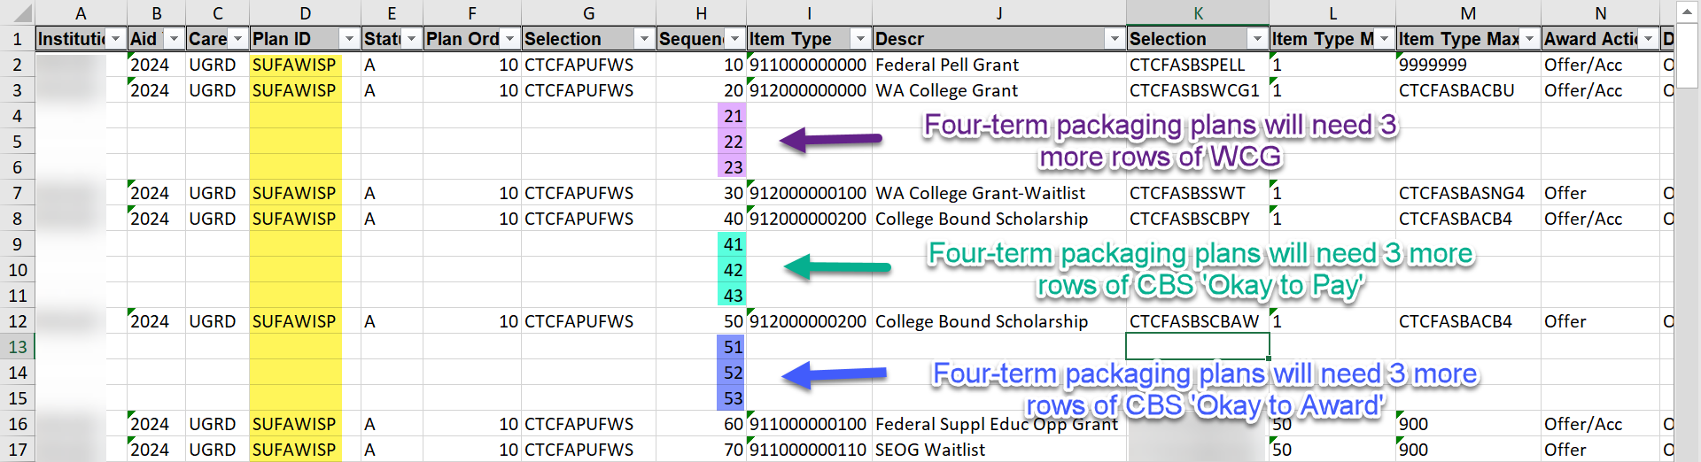

**Example of a college planning out the sequence number for the new WCG and CBS rows that will be added for a three-term packaging plan.**

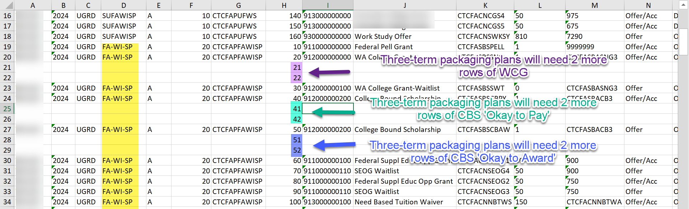

#### SUFAWISP or FAWISPSU Packaging Plans

Four-term packaging plans will have WCG listed four times in the packaging plan, one row for each term.

Four-term packaging plans will have CBS listed eight times in the packaging plan, two rows for each term.

**Navigation: Set Up SACR > Product Related > Financial Aid > Awards > Packaging Plan**

Select your college’s four-term packaging plan (**SUFAWISP-header** or **FAWISPSU-trailer**) for 2024 aid year then add an effective dated row of today

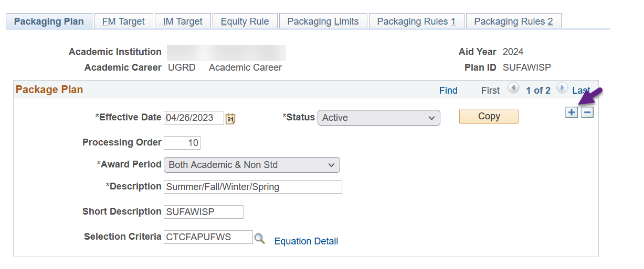

**THE FIRST ROW OF WCG** will be tied to the **1st quarter** in your packaging plan: **Summer quarter for headers** versus **Fall quarter for trailers**.

Select the **Packaging Rules 1** tab then toggle to the WCG item-type (912000000000) using the right arrow

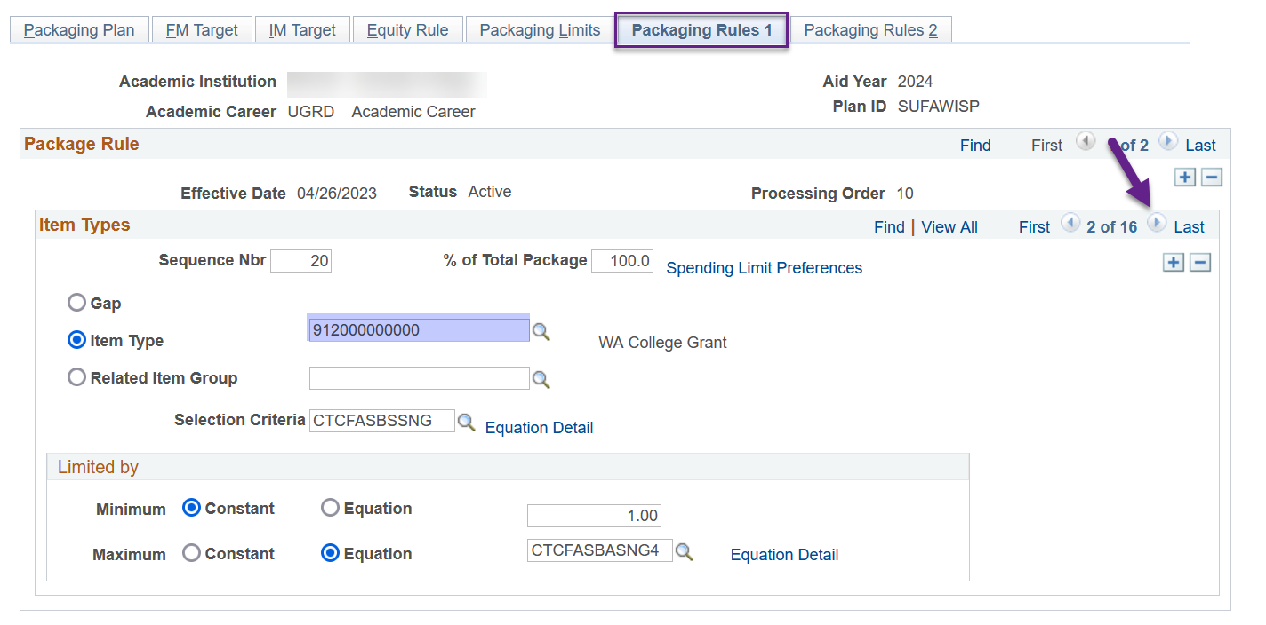

Update the following areas

*Selection Criteria*: **CTCFASBSWCG1 (WCG 1 Qtr check)**

*Limited by*: **CTCFASBAWCGU (WCG Award Summer)** or **CTCFASBAWCGF (WCG Award Fall)**

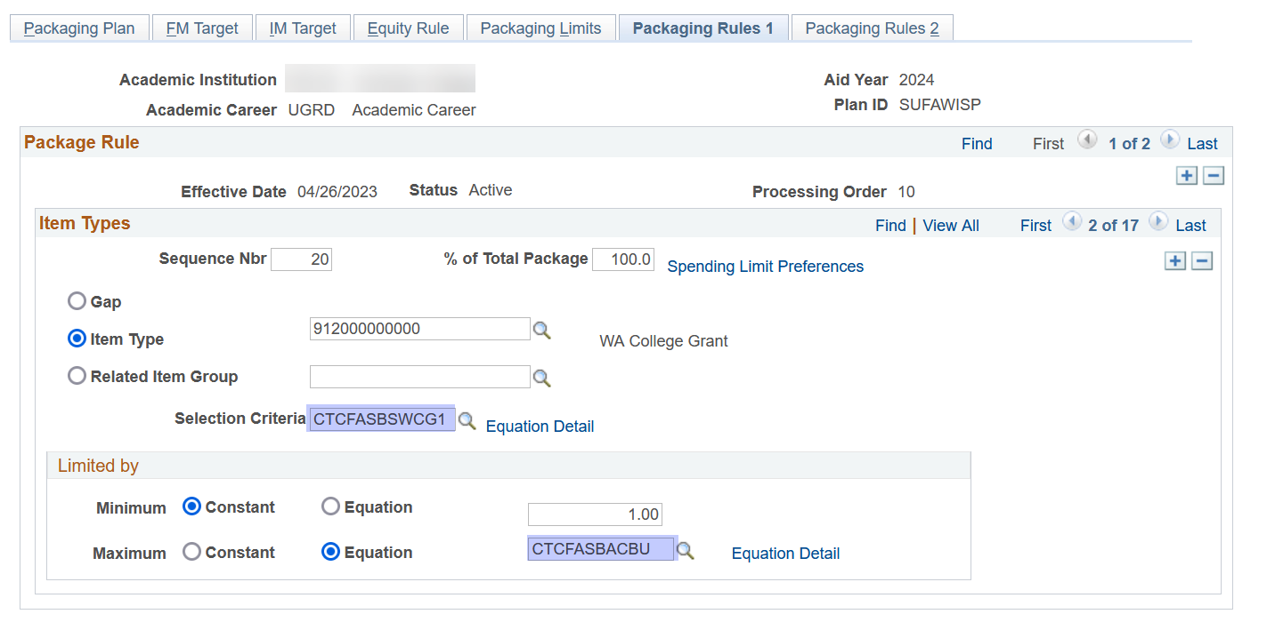

Select the **Packaging Rules 2** tab and update the *Split Code* to **Summer–header** or **Fall-trailer**

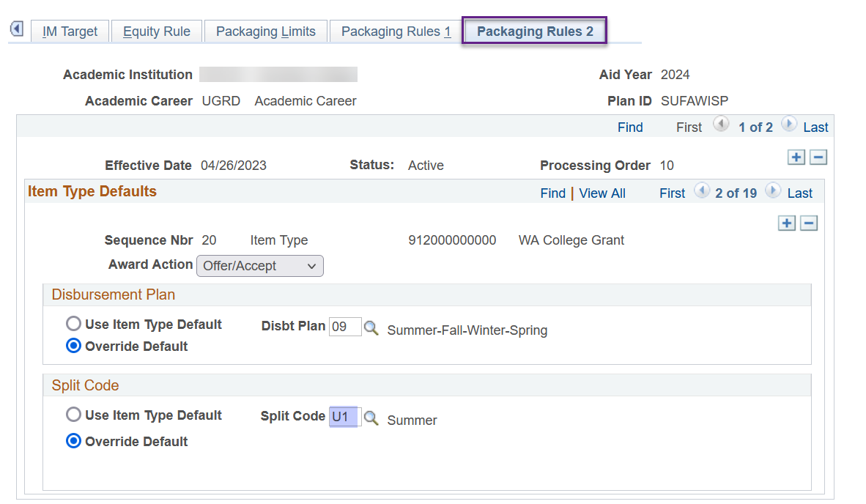

**THE SECOND ROW OF WCG** will be tied to the **2nd** **quarter** in your packaging plan: **Fall quarter** **for headers** versus **Winter quarter for trailers**.

Return to the **Packaging Rules 1** tab and add a new row

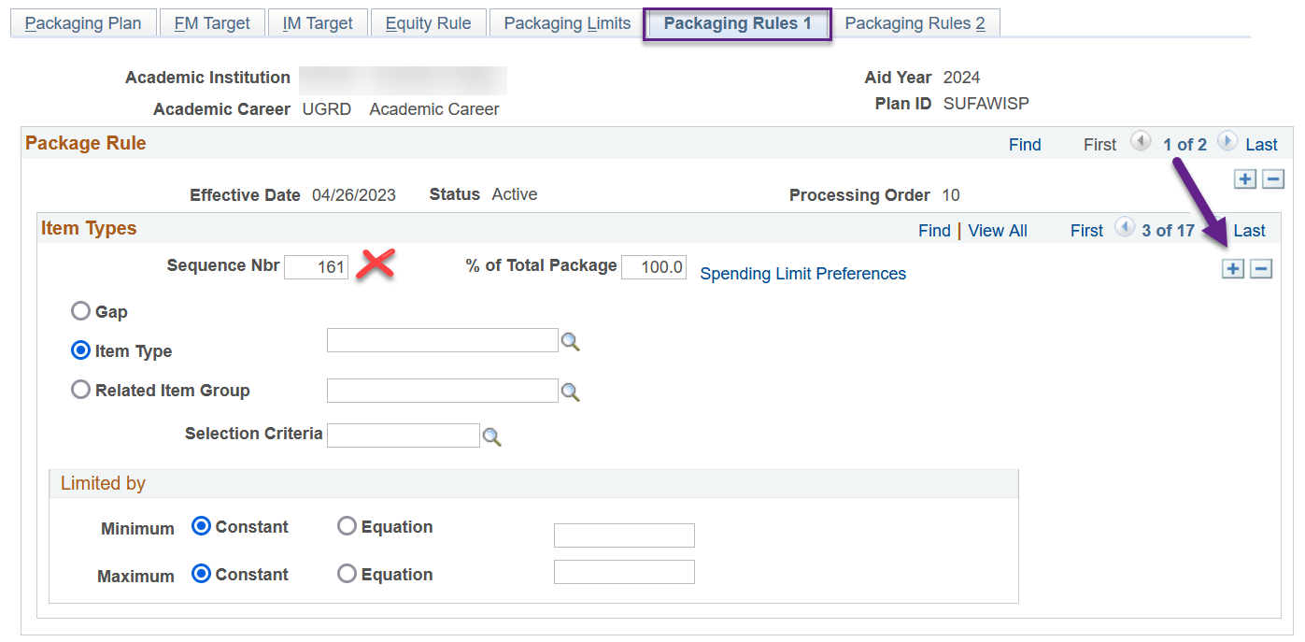

Update the following areas

*Sequence Nbr*: **(the next Sequence Nbr i.e. 21)**

*Item Type*: **912000000000**

*Selection Criteria*: **CTCFASBSWCG2 (WCG 2 Qtr check)**

*Limited by*: **Equation** then **CTCFASBAWCGF (WCG Award Fall)** or **CTCFASBAWCGW (WCG Award Winter)**

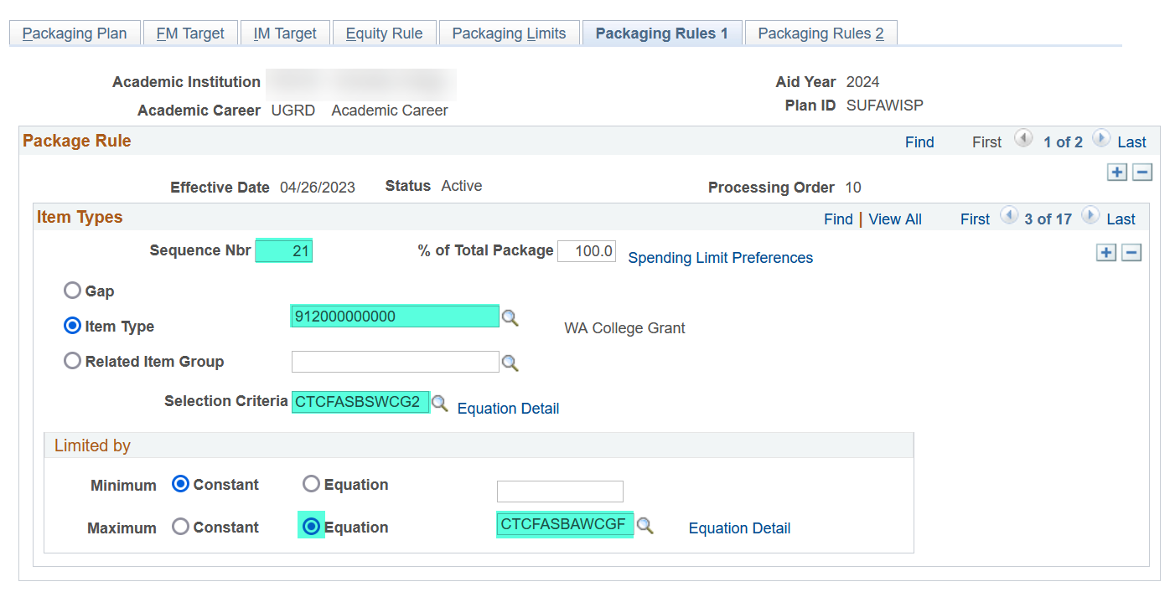

Select the **Packaging Rules 2** tab and update the following

*Disbursement Plan*: **Override Default** then **Su-Fa-Wi-Sp** or **Fa-Wi-Sp-Su**

*Split Code*: **Override Default** then **Fall–header** or **Winter-trailer**

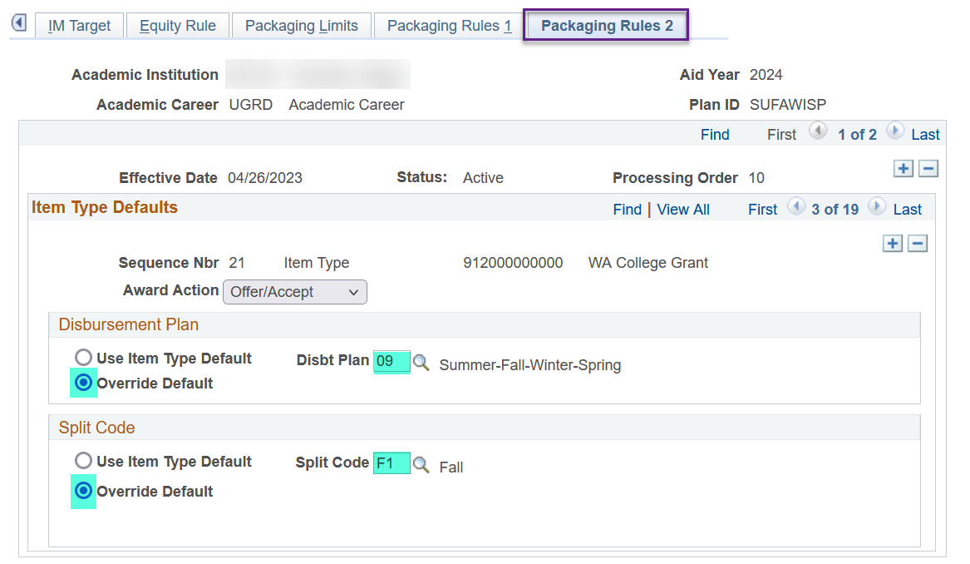

**THE THIRD ROW OF WCG** will be tied to the **3rd quarter** in your packaging plan: **Winter quarter for headers** versus **Spring quarter for trailers**.

Return to the **Packaging Rules 1** tab and add a new row

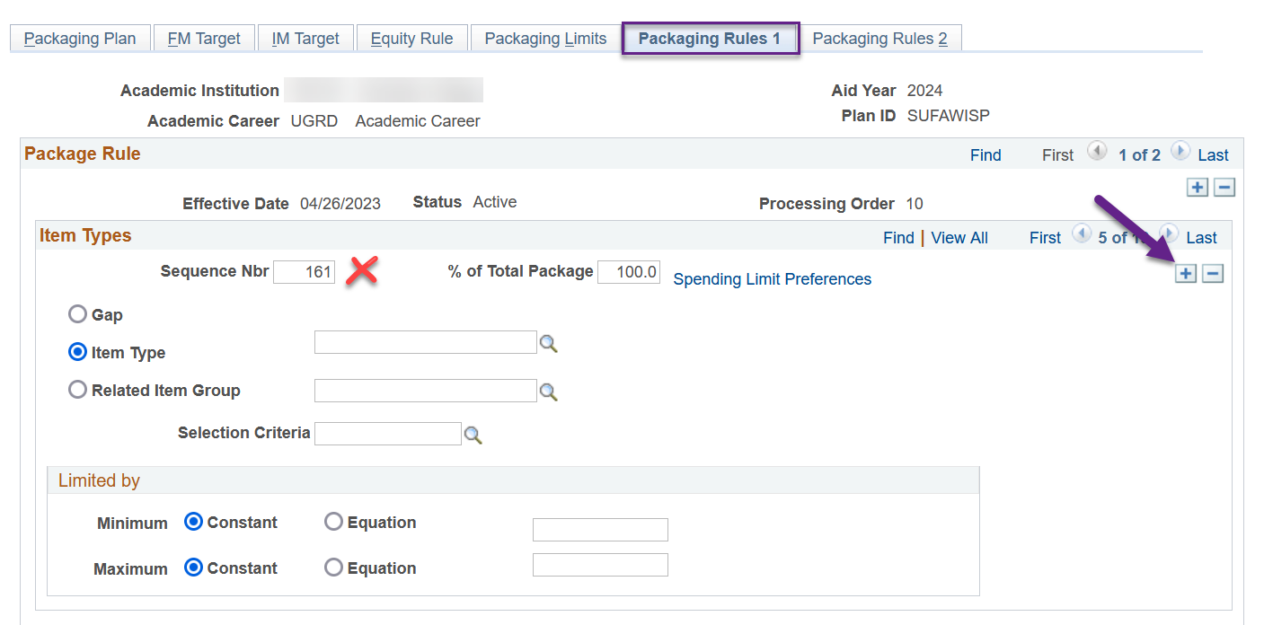

Update the following areas

*Sequence Nbr*: **(the next Sequence Nbr i.e. 22)**

*Item Type*: **912000000000**

*Selection Criteria*: **CTCFASBSWCG3 (WCG 3 Qtr check)**

*Limited by*: **Equation** then **CTCFASBAWCGW (WCG Award Winter)** or **CTCFASBAWCGS (WCG Award Spring)**

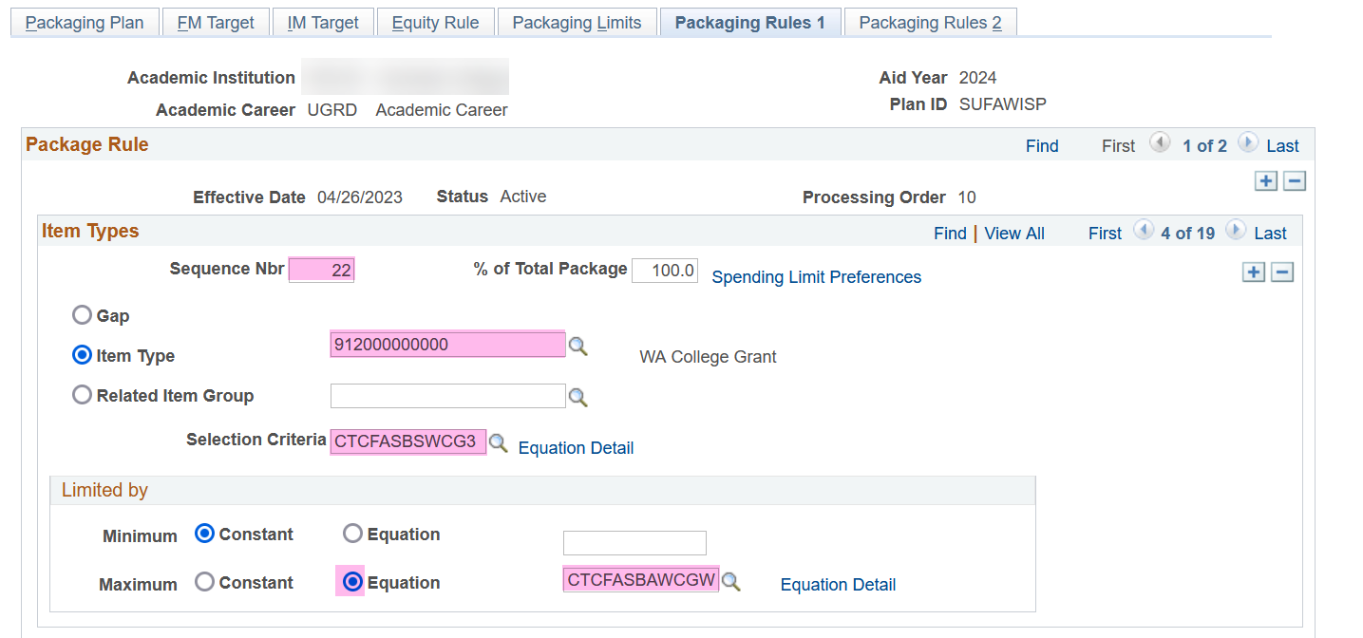

Select the **Packaging Rules 2** tab and update the following

*Disbursement Plan*: **Override Default** then **Su-Fa-Wi-Sp** or **Fa-Wi-Sp-Su**

*Split Code*: **Override Default** then **Winter–header** or **Spring-trailer**

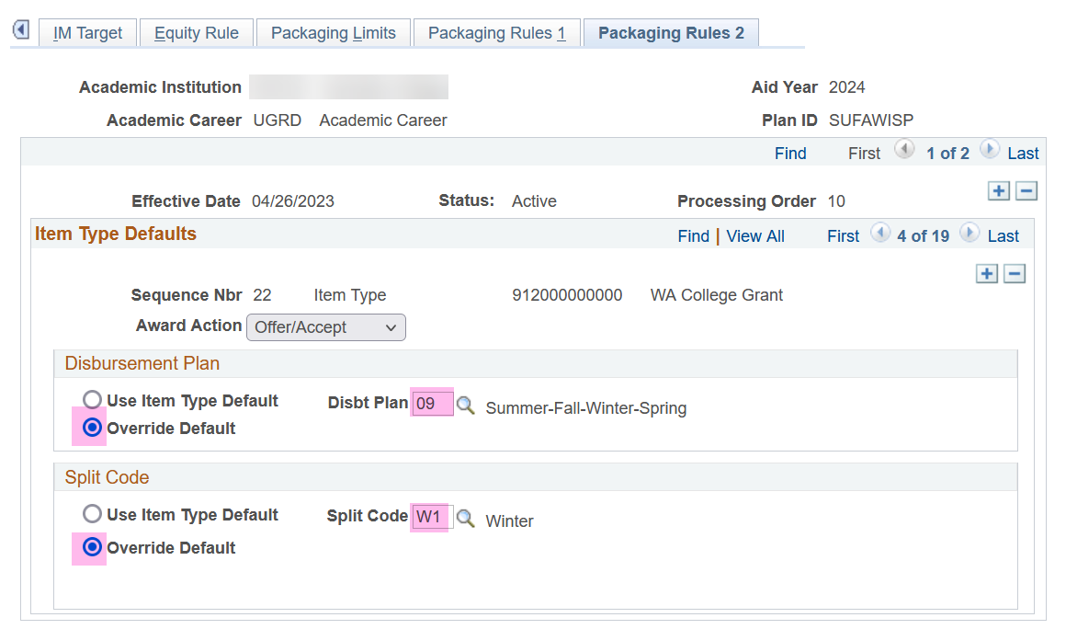

**THE FOURTH ROW OF WCG** will be tied to the **4th quarter** in your packaging plan: **Spring quarter for headers** versus **Summer quarter for trailers**.

Return to the **Packaging Rules 1** tab and add a new row



Update the following areas

*Sequence Nbr*: **(the next Sequence Nbr i.e. 23)**

*Item Type*: **912000000000**

*Selection Criteria*: **CTCFASBSWCG4 (WCG 4 Qtr check)**

*Limited by*: **Equation** then **CTCFASBAWCGS (WCG Award Spring)** or **CTCFASBAWCGU (WCG Award Summer)**

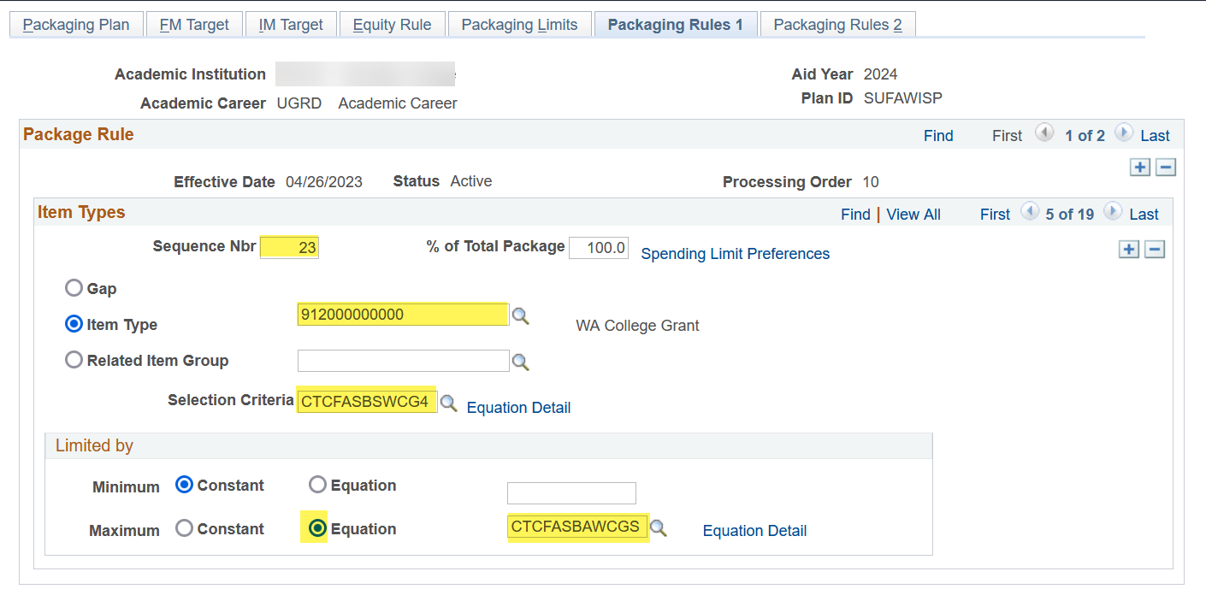

Select the **Packaging Rules 2** tab and update the following

*Disbursement Plan*: **Override Default** then **Su-Fa-Wi-Sp** or **Fa-Wi-Sp-Su**

*Split Code*: **Override Default** then **Spring–header** or **Summer-trailer**

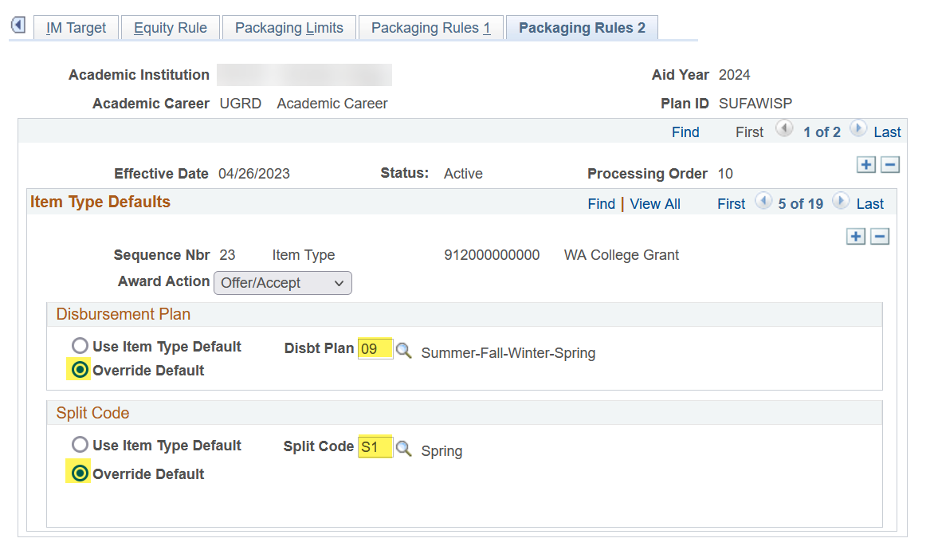

Toggle to the **WCG** **Waitlist** item-type (912000000**100**) by selecting the right arrow once. Select the **minus sign** in the *Item Type Defaults* section to remove the item-type from the packaging plan. The new CBS equation engines are not dependent on this item-type being in the packaging plan.

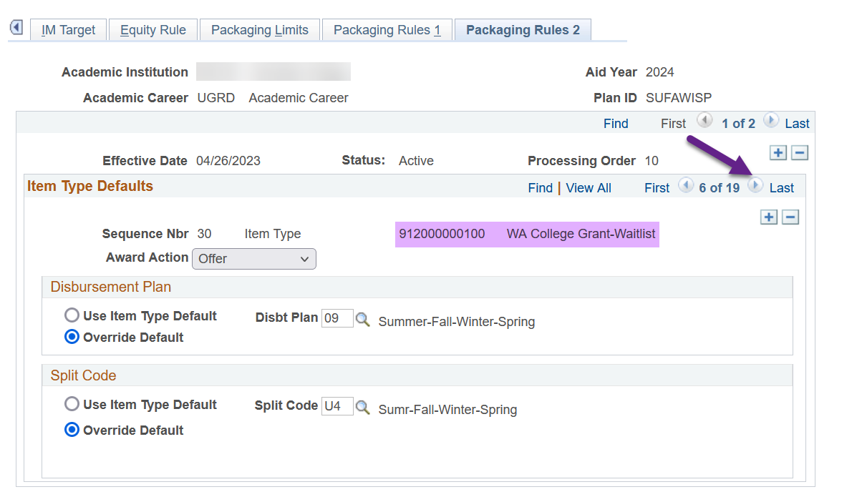

**Once you delete the WCG Waitlist row, you will see you are now going to work on CBS ‘Okay to Pay’!**

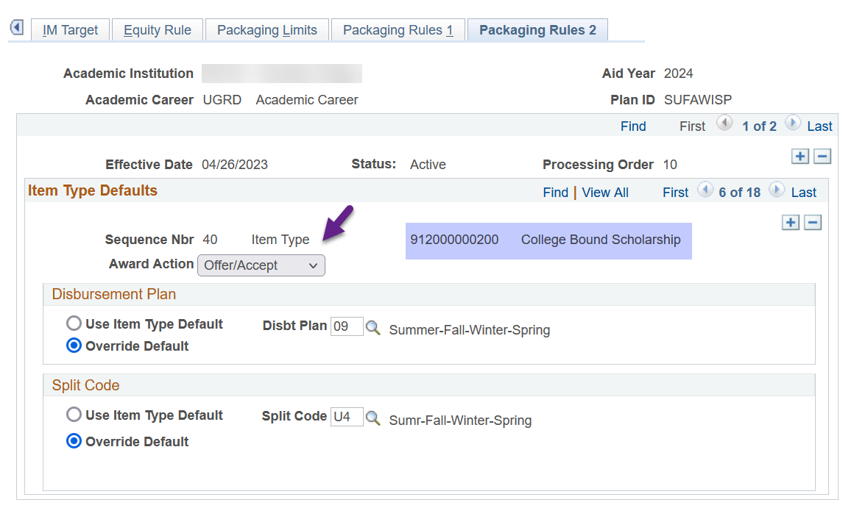

**THE FIRST ROW OF CBS ‘Okay to Pay’** will be tied to the **1st quarter** in your packaging plan: **Summer quarter for headers** versus **Fall quarter for trailers**.

Return to the **Packaging Rules 1** tab then update the following areas

*Selection Criteria*: **CTCFASBSCBP1 (CBS OK2P 1 Qtr check)**

*Limited by*: **CTCFASBACBU (CBS Award Summer)** or **CTCFASBACBF (CBS Award Fall)**

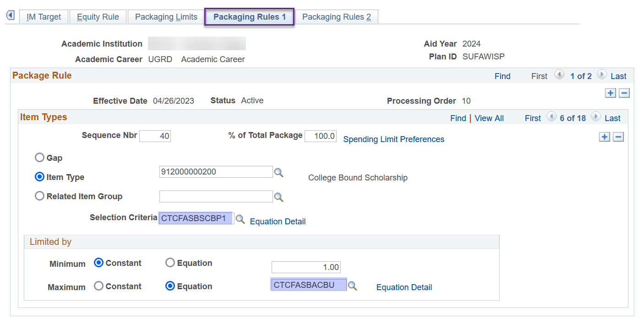

Select the **Packaging Rules 2** tab and update the *Split Code* to **Summer–header** or **Fall-trailer**

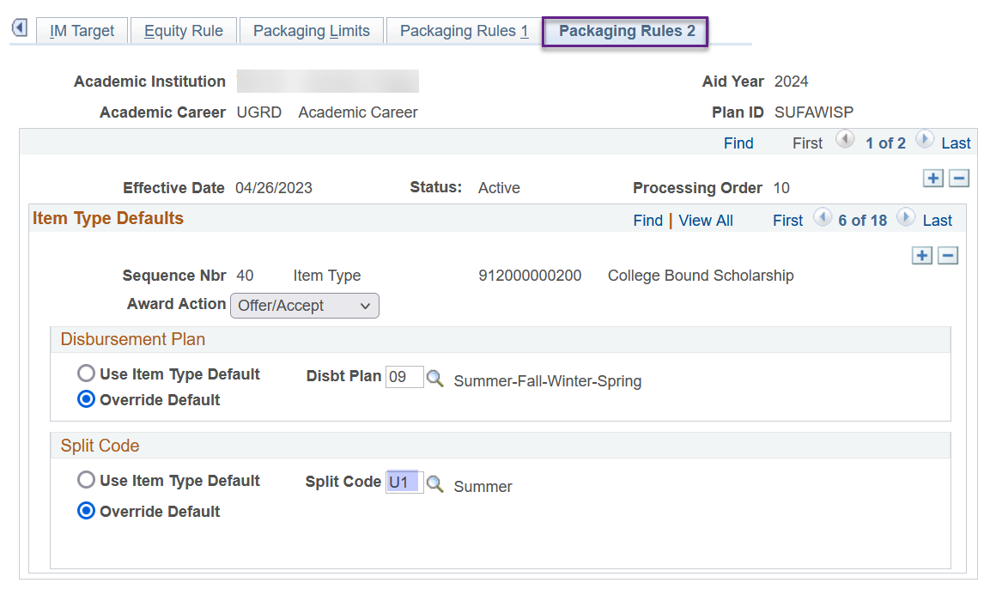

**THE SECOND ROW OF CBS ‘Okay to Pay’** will be tied to the **2nd** **quarter** in your packaging plan: **Fall quarter** **for headers** versus **Winter quarter for trailers**.

Return to the **Packaging Rules 1** tab and add a new row



Update the following areas

*Sequence Nbr*: **(the next Sequence Nbr i.e. 41)**

*Item Type*: **912000000200**

*Selection Criteria*: **CTCFASBSCBP2 (CBS OK2P 2 Qtr check)**

*Limited by*: **CTCFASBACBF (CBS Award Fall)** or **CTCFASBACBW (CBS Award Winter)**

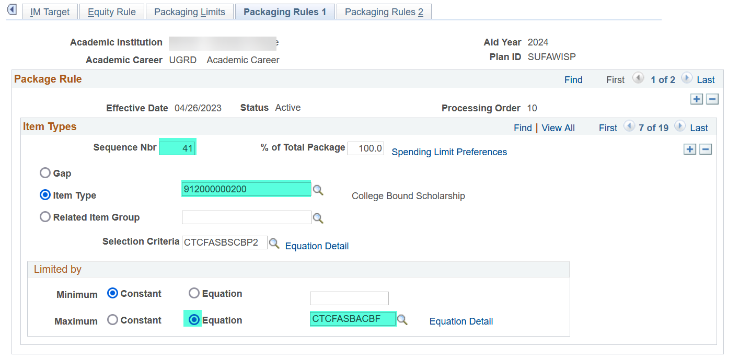

Select the **Packaging Rules 2** tab and update the following

*Disbursement Plan*: **Override Default** then **Su-Fa-Wi-Sp** or **Fa-Wi-Sp-Su**

*Split Code*: **Override Default** then **Fall–header** or **Winter-trailer**

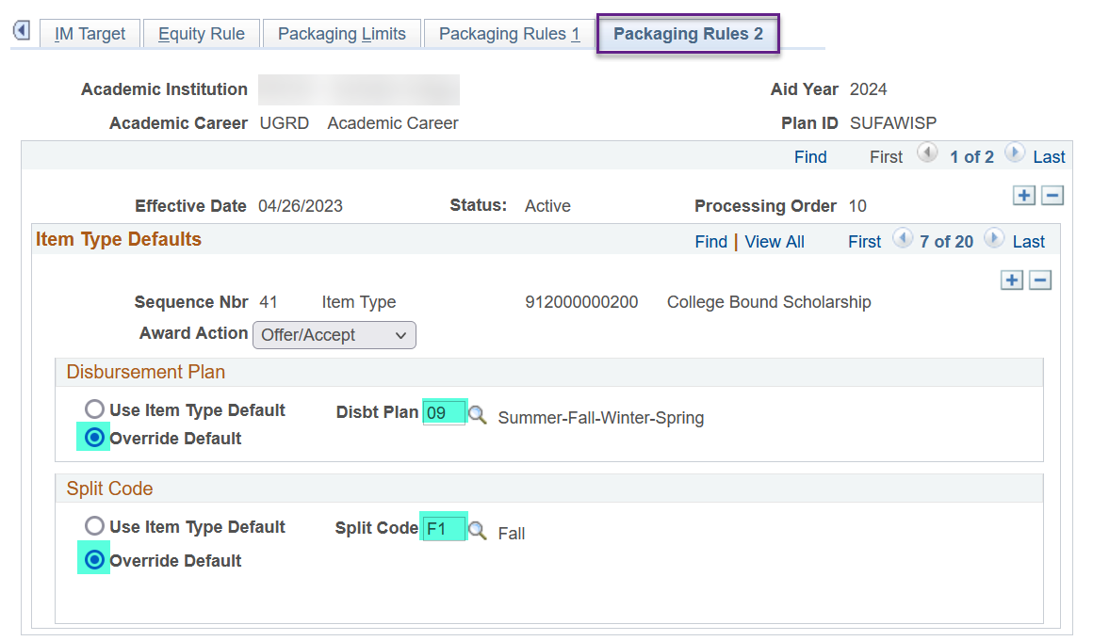

**THE THIRD ROW OF CBS ‘Okay to Pay’** will be tied to the **3rd quarter** in your packaging plan: **Winter quarter for headers** versus **Spring quarter for trailers**.

Return to the **Packaging Rules 1** tab and add a new row



Update the following areas

*Sequence Nbr*: **(the next Sequence Nbr i.e. 42)**

*Item Type*: **912000000200**

*Selection Criteria*: **CTCFASBSCBP3 (CBS OK2P 3 Qtr check)**

*Limited by*: **CTCFASBACBW (CBS Award Winter)** or **CTCFASBACBS (CBS Award Spring)**

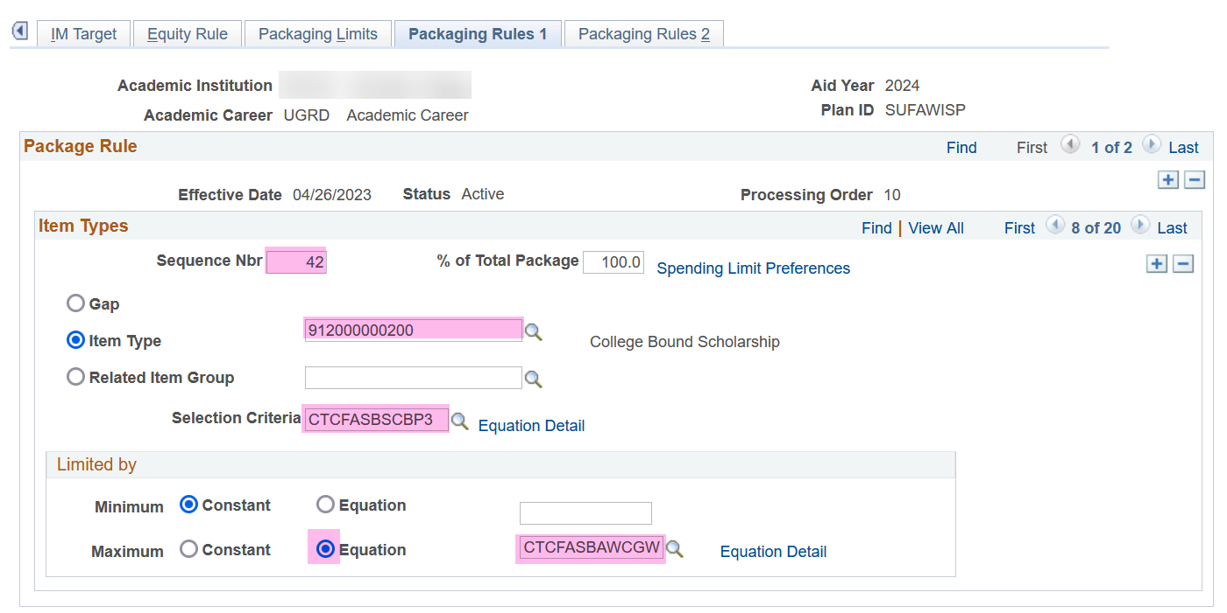

Select the **Packaging Rules 2** tab and update the following

*Disbursement Plan*: **Override Default** then **Su-Fa-Wi-Sp** or **Fa-Wi-Sp-Su**

*Split Code*: **Override Default** then **Winter–header** or **Spring-trailer**

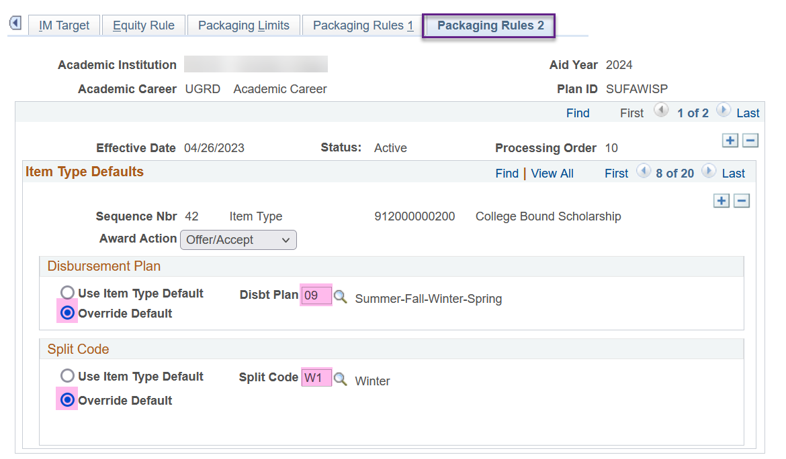

**THE FOURTH ROW OF CBS ‘Okay to Pay’** will be tied to the **4th quarter** in your packaging plan: **Spring quarter for headers** versus **Summer quarter for trailers**.

Return to the **Packaging Rules 1** tab and add a new row



Update the following areas

*Sequence Nbr*: **(the next Sequence Nbr i.e. 43)**

*Item Type*: **912000000200**

*Selection Criteria*: **CTCFASBSCBP4 (CBS OK2P 4 Qtr check)**

*Limited by*: **CTCFASBACBS (CBS Award Spring)** or **CTCFASBACBU (CBS Award Summer)**

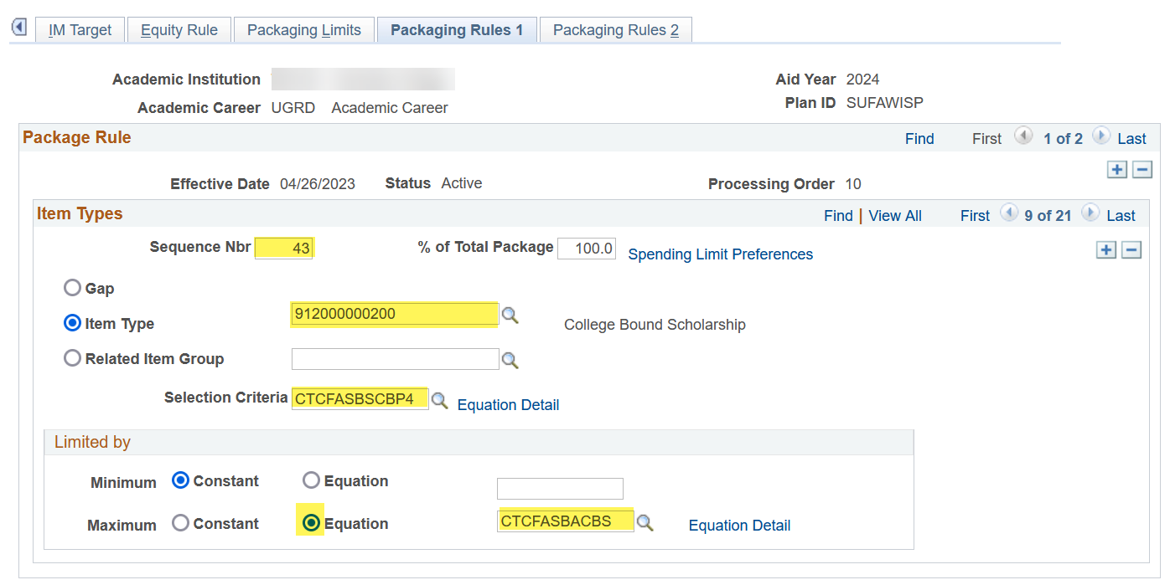

Select the **Packaging Rules 2** tab and update the following

*Disbursement Plan*: **Override Default** then **Su-Fa-Wi-Sp** or **Fa-Wi-Sp-Su**

*Split Code*: **Override Default** then **Spring–header** or **Summer-trailer**

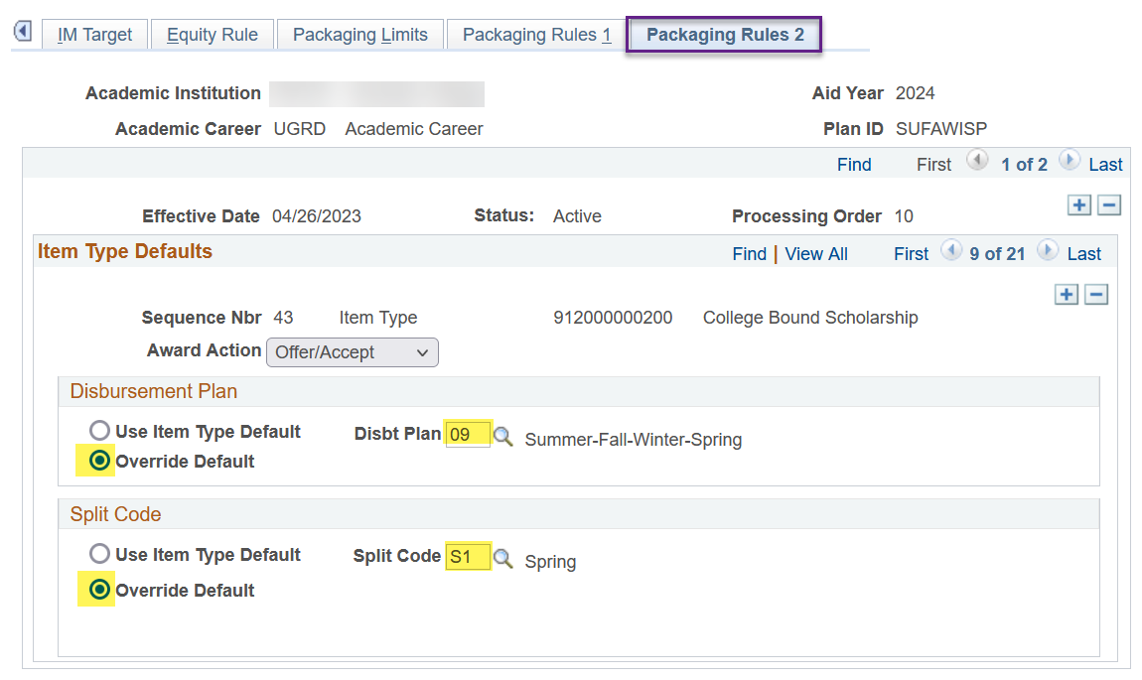

Toggle to the CBS ‘Okay to Award’ row by selecting the right arrow once. The ‘Okay to Award’ row will have an Award Action status of ‘Offer’ 😊

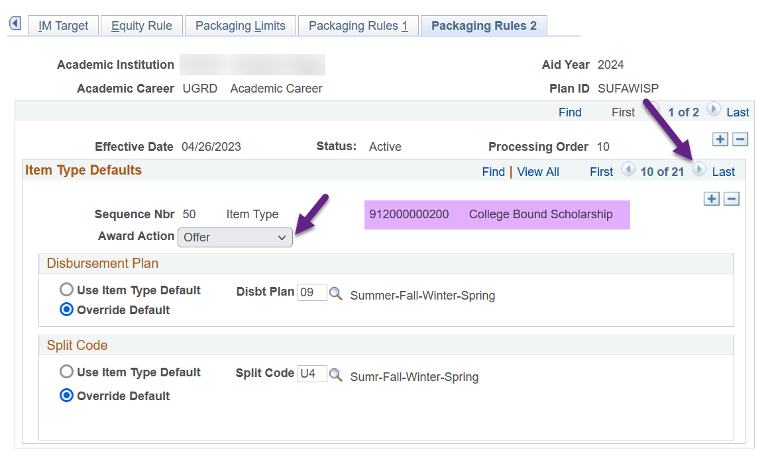

**THE FIRST ROW OF CBS ‘Okay to Award’** will be tied to the **1st quarter** in your packaging plan: **Summer quarter for headers** versus **Fall quarter for trailers**.

Return to the **Packaging Rules 1** tab then update the following areas

*Selection Criteria*: **CTCFASBSCBA1 (CBS OK2A 1 Qtr check)**

*Limited by*: **CTCFASBACBU (CBS Award Summer)** or **CTCFASBACBF (CBS Award Fall)**

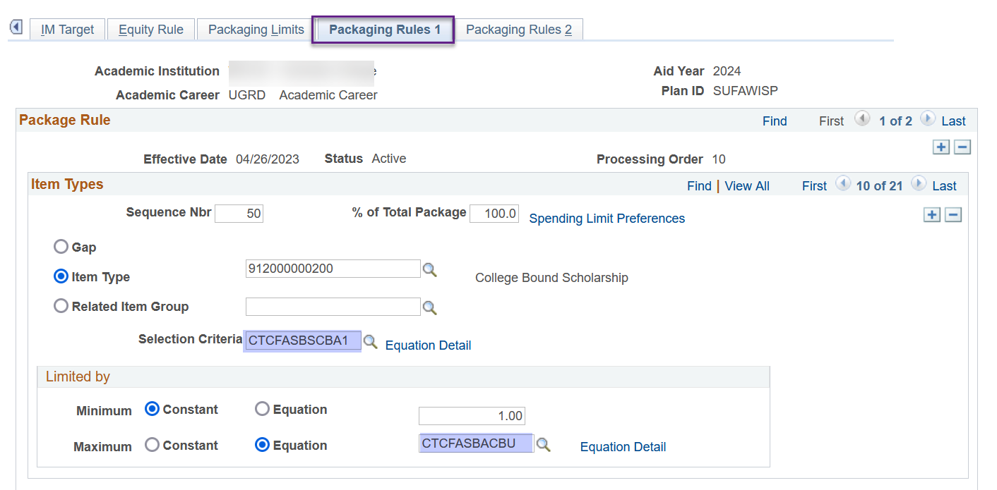

Select the **Packaging Rules 2** tab and update the *Split Code* to **Summer–header** or **Fall-trailer**

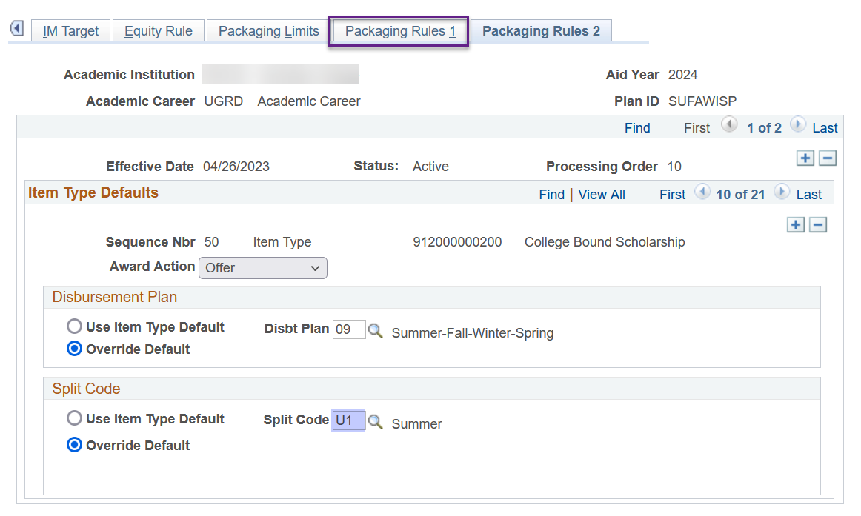

**THE SECOND ROW OF CBS ‘Okay to Award’** will be tied to the **2nd** **quarter** in your packaging plan: **Fall quarter** **for headers** versus **Winter quarter for trailers**.

Return to the **Packaging Rules 1** tab and add a new row



Update the following areas

*Sequence Nbr*: **(the next Sequence Nbr i.e. 51)**

*Item Type*: **912000000200**

*Selection Criteria*: **CTCFASBSCBA2 (CBS OK2A 2 Qtr check)**

*Limited by*: **CTCFASBACBF (CBS Award Fall)** or **CTCFASBACBW (CBS Award Winter)**

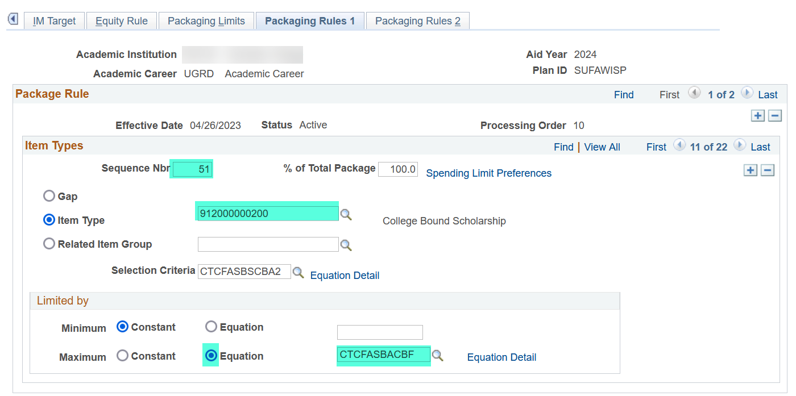

Select the **Packaging Rules 2** tab and update the following

*Award Action*: **Offer**

*Disbursement Plan*: **Override Default** then **Su-Fa-Wi-Sp** or **Fa-Wi-Sp-Su**

*Split Code*: **Override Default** then **Fall–header** or **Winter-trailer**

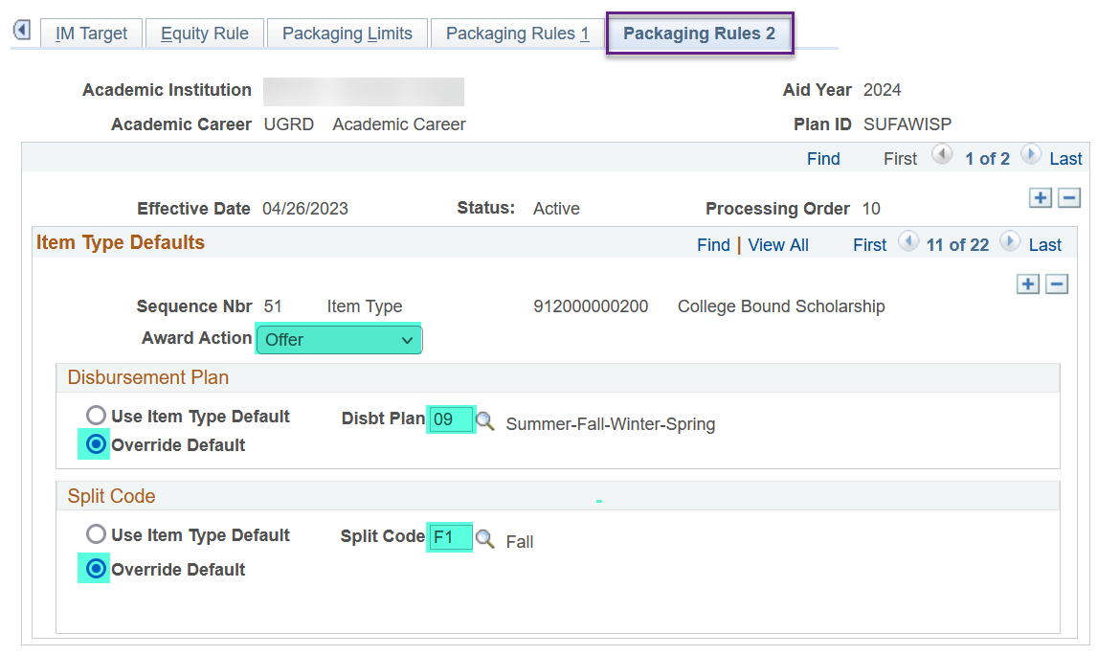

**THE THIRD ROW OF CBS ‘Okay to Award’** will be tied to the **3rd quarter** in your packaging plan: **Winter quarter for headers** versus **Spring quarter for trailers**.

Return to the **Packaging Rules 1** tab and add a new row



Update the following areas

*Sequence Nbr*: **(the next Sequence Nbr i.e. 52)**

*Item Type*: **912000000200**

*Selection Criteria*: **CTCFASBSCBA3 (CBS OK2A 3 Qtr check)**

*Limited by*: **CTCFASBACBW (CBS Award Winter)** or **CTCFASBACBS (CBS Award Spring)**

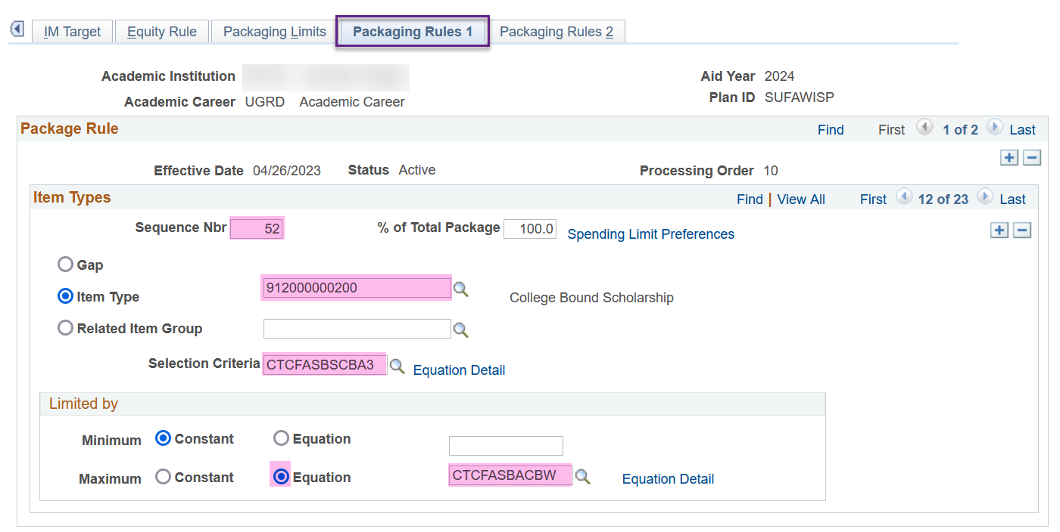

Select the **Packaging Rules 2** tab and update the following

*Award Action*: **Offer**

*Disbursement Plan*: **Override Default** then **Su-Fa-Wi-Sp** or **Fa-Wi-Sp-Su**

*Split Code*: **Override Default** then **Winter–header** or **Spring-trailer**

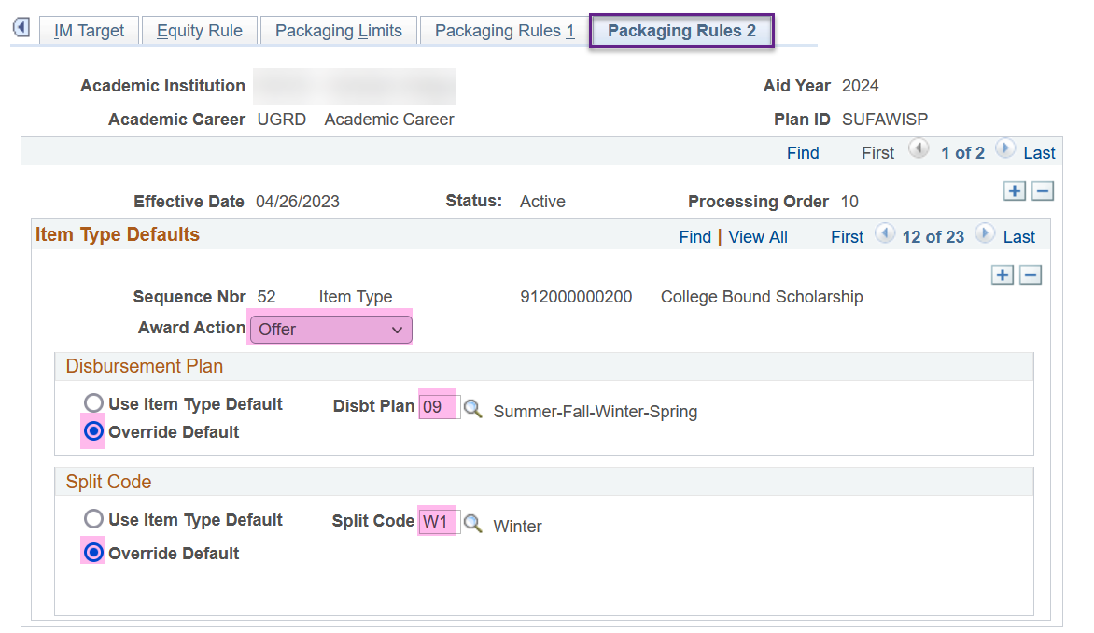

**THE FOURTH ROW OF CBS ‘Okay to Award’** will be tied to the **4th quarter** in your packaging plan: **Spring quarter for headers** versus **Summer quarter for trailers**.

Return to the **Packaging Rules 1** tab and add a new row



Update the following areas

*Sequence Nbr*: **(the next Sequence Nbr i.e. 53)**

*Item Type*: **912000000200**

*Selection Criteria*: **CTCFASBSCBA4 (CBS OK2A 4 Qtr check)**

*Limited by*: **CTCFASBACBS (CBS Award Spring)** or **CTCFASBACBU (CBS Award Summer)**

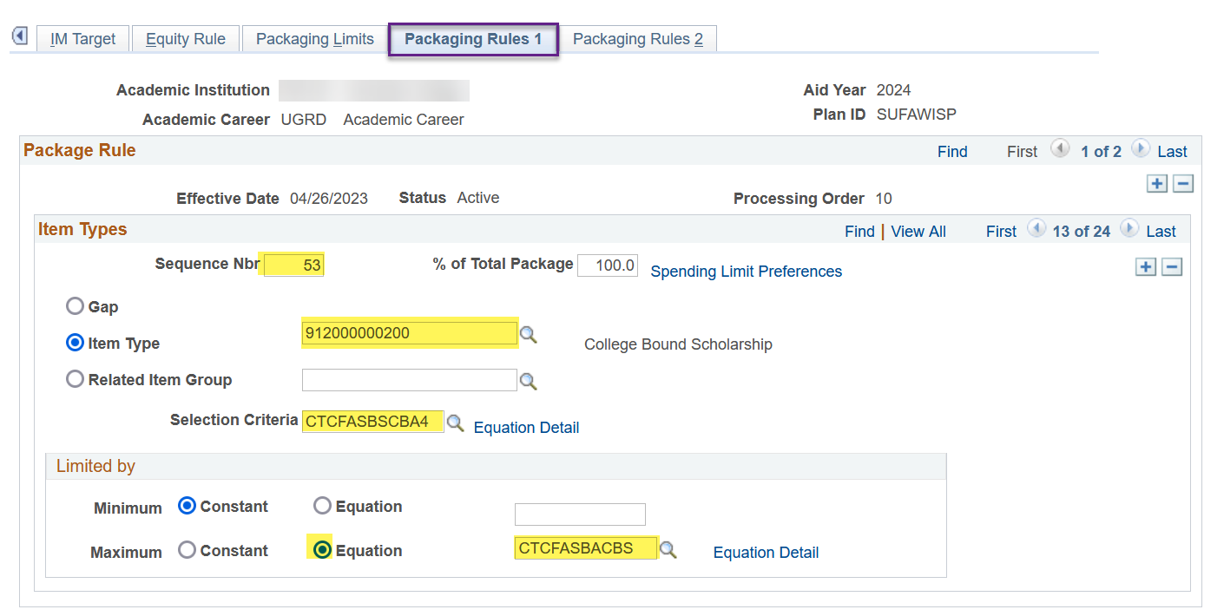

Select the **Packaging Rules 2** tab and update the following

*Award Action*: **Offer**

*Disbursement Plan*: **Override Default** then **Su-Fa-Wi-Sp** or **Fa-Wi-Sp-Su**

*Split Code*: **Override Default** then **Spring–header** or **Summer-trailer**

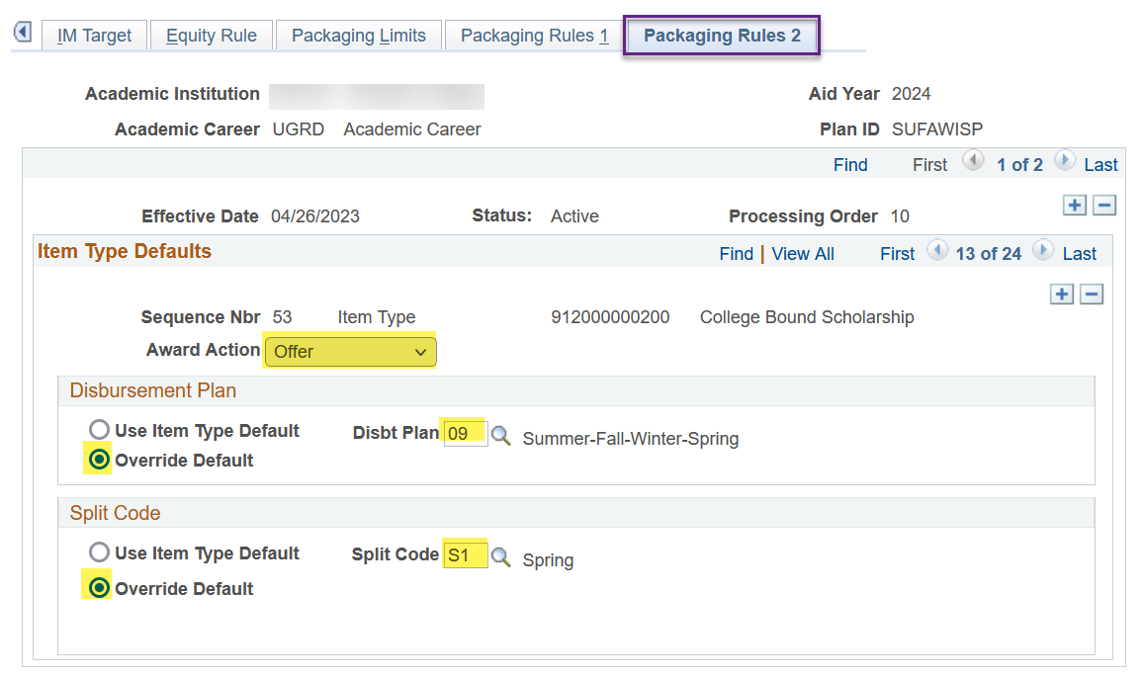

**SAVE YOUR WORK!!**

**YOU ARE DONE WITH THIS PACKAGING PLAN! 🎉**

#### FA-WI-SP Packaging Plan

Three-term packaging plans will have WCG listed three times in the packaging plan, one row for each term.

Three-term packaging plans will have CBS listed six times in the packaging plan, two rows for each term.

**Navigation: Set Up SACR > Product Related > Financial Aid > Awards > Packaging Plan**

Select the FA-WI-SP for 2024 aid year then add an effective dated row of today

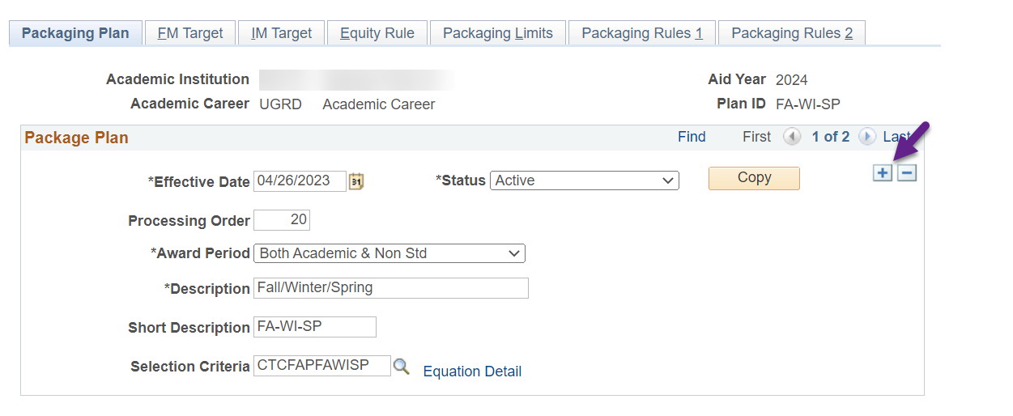

**THE FIRST ROW OF WCG** will be tied to the **1st quarter** in your packaging plan: **Fall quarter**.

Select the **Packaging Rules 1** tab then toggle to the WCG item-type (912000000000) using the right arrow

Update the following areas

*Selection Criteria*: **CTCFASBSWCG1 (WCG 1 Qtr check)**

*Limited by*: **CTCFASBAWCGF (WCG Award Fall)**

Select the **Packaging Rules 2** tab and update *Split Code* to **Fall**

**THE SECOND ROW OF WCG** will be tied to the **2nd** **quarter** in your packaging plan: **Winter quarter**.

Return to the **Packaging Rules 1** tab and add a new row

Update the following areas

*Sequence Nbr*: **(the next Sequence Nbr i.e. 21)**

*Item Type*: **912000000000**

*Selection Criteria*: **CTCFASBSWCG2 (WCG 2 Qtr check)**

*Limited by*: **Equation** then **CTCFASBAWCGW (WCG Award Winter)**

Select the **Packaging Rules 2** tab and update the following

*Disbursement Plan*: **Override Default** then **Fa-Wi-Sp** or **Fa-Wi-Sp-Su**

*Split Code*: **Override Default** then **Winter**

**THE THIRD ROW OF WCG** will be tied to the **3rd quarter** in your packaging plan: **Spring quarter**.

Return to the **Packaging Rules 1** tab and add a new row

Update the following areas

*Sequence Nbr*: **(the next Sequence Nbr i.e. 22)**

*Item Type*: **912000000000**

*Selection Criteria*: **CTCFASBSWCG3 (WCG 3 Qtr check)**

*Limited by*: **Equation** then **CTCFASBAWCGS (WCG Award Spring)**

Select the **Packaging Rules 2** tab and update the following

*Disbursement Plan*: **Override Default** then **Fa-Wi-Sp** or **Fa-Wi-Sp-Su**

*Split Code*: **Override Default** then **Spring**

Toggle to the **WCG** **Waitlist** item-type (912000000**100**) by selecting the right arrow once. Select the **minus sign** in the *Item Type Defaults* section to remove the item-type from the packaging plan. The new CBS equation engines are not dependent on this item-type being in the packaging plan.

**Once you delete the WCG Waitlist row, you will see you are now going to work on CBS ‘Okay to Pay’!**

**THE FIRST ROW OF CBS ‘Okay to Pay’** will be tied to the **1st quarter** in your packaging plan: **Fall quarter**.

Return to the **Packaging Rules 1** tab then update the following areas

*Selection Criteria*: **CTCFASBSCBP1 (CBS OK2P 1 Qtr check)**

*Limited by*: **CTCFASBACBF (CBS Award Fall)**

Select the **Packaging Rules 2** tab and update the *Split Code* to **Fall**

**THE SECOND ROW OF CBS ‘Okay to Pay’** will be tied to the **2nd** **quarter** in your packaging plan: **Winter quarter**.

Return to the **Packaging Rules 1** tab and add a new row

Update the following areas

*Sequence Nbr*: **(the next Sequence Nbr i.e. 41)**

*Item Type*: **912000000200**

*Selection Criteria*: **CTCFASBSCBP2 (CBS OK2P 2 Qtr check)**

*Limited by*: **CTCFASBACBW (CBS Award Winter)**

Select the **Packaging Rules 2** tab and update the following

*Disbursement Plan*: **Override Default** then **Fa-Wi-Sp** or **Fa-Wi-Sp-Su**

*Split Code*: **Override Default** then **Winter**

**THE THIRD ROW OF CBS ‘Okay to Pay’** will be tied to the **3rd quarter** in your packaging plan: **Spring quarter**.

Return to the **Packaging Rules 1** tab and add a new row

Update the following areas

*Sequence Nbr*: **(the next Sequence Nbr i.e. 42)**

*Item Type*: **912000000200**

*Selection Criteria*: **CTCFASBSCBP3 (CBS OK2P 3 Qtr check)**

*Limited by*: **CTCFASBACBS (CBS Award Spring)**

Select the **Packaging Rules 2** tab and update the following

*Disbursement Plan*: **Override Default** then **Fa-Wi-Sp** or **Fa-Wi-Sp-Su**

*Split Code*: **Override Default** then **Spring**

Toggle to the CBS ‘Okay to Award’ row by selecting the right arrow once. The ‘Okay to Award’ row will have an Award Action status of ‘Offer’ 😊

**THE FIRST ROW OF CBS ‘Okay to Award’** will be tied to the **1st quarter** in your packaging plan: **Fall quarter**.

Return to the **Packaging Rules 1** tab then update the following areas

*Selection Criteria*: **CTCFASBSCBA1 (CBS OK2A 1 Qtr check)**

*Limited by*: **CTCFASBACBF (CBS Award Fall)**

Select the **Packaging Rules 2** tab and update the *Split Code* to **Fall**

**THE SECOND ROW OF CBS ‘Okay to Award’** will be tied to the **2nd** **quarter** in your packaging plan: **Winter quarter**.

Return to the **Packaging Rules 1** tab and add a new row

Update the following areas

*Sequence Nbr*: **(the next Sequence Nbr i.e. 51)**

*Item Type*: **912000000200**

*Selection Criteria*: **CTCFASBSCBA2 (CBS OK2A 2 Qtr check)**

*Limited by*: **CTCFASBACBW (CBS Award Winter)**

Select the **Packaging Rules 2** tab and update the following

*Award Action*: **Offer**

*Disbursement Plan*: **Override Default** then **Fa-Wi-Sp-**or **Fa-Wi-Sp-Su**

*Split Code*: **Override Default** then **Winter**

**THE THIRD ROW OF CBS ‘Okay to Award’** will be tied to the **3rd quarter** in your packaging plan: **Spring quarter**.

Return to the **Packaging Rules 1** tab and add a new row

Update the following areas

*Sequence Nbr*: **(the next Sequence Nbr i.e. 52)**

*Item Type*: **912000000200**

*Selection Criteria*: **CTCFASBSCBA3 (CBS OK2A 3 Qtr check)**

*Limited by*: **CTCFASBACBS** **(CBS Award Spring)**

Select the **Packaging Rules 2** tab and update the following

*Award Action*: **Offer**

*Disbursement Plan*: **Override Default** then **Fa-Wi-Sp** or **Fa-Wi-Sp-Su**

*Split Code*: **Override Default** then **Spring**

**SAVE YOUR WORK!!**

**YOU ARE DONE WITH THIS PACKAGING PLAN! 🎉**

#### SU-FA-WI Packaging Plan **HEADER ONLY**

Three-term packaging plans will have WCG listed three times in the packaging plan, one row for each term.

Three-term packaging plans will have CBS listed six times in the packaging plan, two rows for each term.

**Navigation: Set Up SACR > Product Related > Financial Aid > Awards > Packaging Plan**

Select the SU-FA-WI for 2024 aid year then add an effective dated row of today

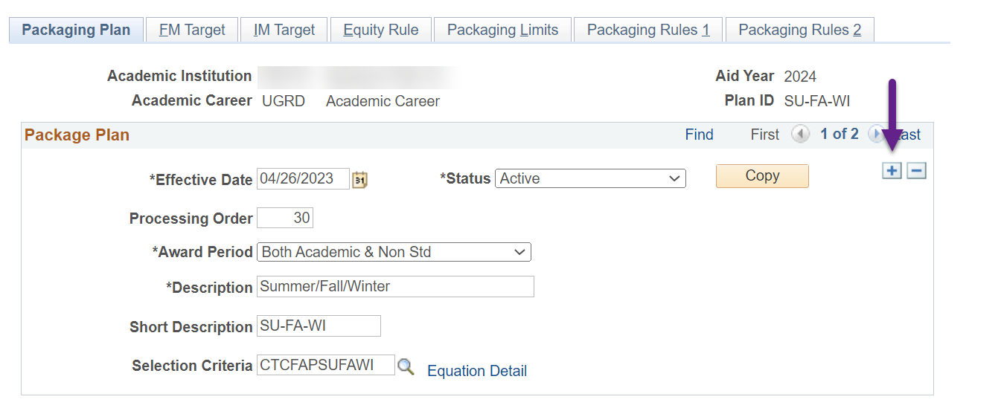

**THE FIRST ROW OF WCG** will be tied to the **1st quarter** in your packaging plan: **Summer quarter**.

Select the **Packaging Rules 1** tab then toggle to the WCG item-type (912000000000) using the right arrow

Update the following areas

*Selection Criteria*: **CTCFASBSWCG1 (WCG 1 Qtr check)**

*Limited by*: **CTCFASBAWCGU (WCG Award Summer)**

Select the **Packaging Rules 2** tab and update *Split Code* to **Summer**

**THE SECOND ROW OF WCG** will be tied to the **2nd** **quarter** in your packaging plan: **Fall quarter**.

Return to the **Packaging Rules 1** tab and add a new row Update the following areas

*Sequence Nbr*: **(the next Sequence Nbr i.e. 21)**

*Item Type*: **912000000000**

*Selection Criteria*: **CTCFASBSWCG2 (WCG 2 Qtr check)**

*Limited by*: **Equation** then **CTCFASBAWCGF (WCG Award Fall)**

Select the **Packaging Rules 2** tab and update the following

*Disbursement Plan*: **Override Default** then **Su-Fa-Wi** or **Su-Fa-Wi-Sp**

*Split Code*: **Override Default** then **Fall**

**THE THIRD ROW OF WCG** will be tied to the **3rd quarter** in your packaging plan: **Winter quarter**.

Return to the **Packaging Rules 1** tab and add a new row

Update the following areas

*Sequence Nbr*: **(the next Sequence Nbr i.e. 22)**

*Item Type*: **912000000000**

*Selection Criteria*: **CTCFASBSWCG3 (WCG 3 Qtr check)**

*Limited by*: **Equation** then **CTCFASBAWCGW (WCG Award Winter)**

Select the **Packaging Rules 2** tab and update the following

*Disbursement Plan*: **Override Default** then **Su-Fa-Wi** or **Su-Fa-Wi-Sp**

*Split Code*: **Override Default** then **Winter**

Toggle to the **WCG** **Waitlist** item-type (912000000**100**) by selecting the right arrow once. Select the **minus sign** in the *Item Type Defaults* section to remove the item-type from the packaging plan. The new CBS equation engines are not dependent on this item-type being in the packaging plan.

**Once you delete the WCG Waitlist row, you will see you are now going to work on CBS ‘Okay to Pay’!**

**THE FIRST ROW OF CBS ‘Okay to Pay’** will be tied to the **1st quarter** in your packaging plan: **Summer quarter**.

Return to the **Packaging Rules 1** tab then update the following areas

*Selection Criteria*: **CTCFASBSCBP1 (CBS OK2P 1 Qtr check)**

*Limited by*: **CTCFASBACBU (CBS Award Summer)**

Select the **Packaging Rules 2** tab and update the *Split Code* to **Summer**

**THE SECOND ROW OF CBS ‘Okay to Pay’** will be tied to the **2nd** **quarter** in your packaging plan: **Fall quarter**.

Return to the **Packaging Rules 1** tab and add a new row

Update the following areas

*Sequence Nbr*: **(the next Sequence Nbr i.e. 41)**

*Item Type*: **912000000200**

*Selection Criteria*: **CTCFASBSCBP2 (CBS OK2P 2 Qtr check)**

*Limited by*: **CTCFASBACBF (CBS Award Fall)**

Select the **Packaging Rules 2** tab and update the following

*Disbursement Plan*: **Override Default** then **Su-Fa-Wi** or **Su-Fa-Wi-Sp**

*Split Code*: **Override Default** then **Fall**

**THE THIRD ROW OF CBS ‘Okay to Pay’** will be tied to the **3rd quarter** in your packaging plan: **Winter quarter**.

Return to the **Packaging Rules 1** tab and add a new row

Update the following areas

*Sequence Nbr*: **(the next Sequence Nbr i.e. 42)**

*Item Type*: **912000000200**

*Selection Criteria*: **CTCFASBSCBP3 (CBS OK2P 3 Qtr check)**

*Limited by*: **CTCFASBACBW (CBS Award Winter)**

Select the **Packaging Rules 2** tab and update the following

*Disbursement Plan*: **Override Default** then **Su-Fa-Wi** or **Su-Fa-Wi-Sp**

*Split Code*: **Override Default** then **Winter**

Toggle to the CBS ‘Okay to Award’ row by selecting the right arrow once. The ‘Okay to Award’ row will have an Award Action status of ‘Offer’ 😊

**THE FIRST ROW OF CBS ‘Okay to Award’** will be tied to the **1st quarter** in your packaging plan: **Summer quarter**.

Return to the **Packaging Rules 1** tab then update the following areas

*Selection Criteria*: **CTCFASBSCBA1 (CBS OK2A 1 Qtr check)**

*Limited by*: **CTCFASBACBU (CBS Award Summer)**

Select the **Packaging Rules 2** tab and update the *Split Code* to **Summer**

**THE SECOND ROW OF CBS ‘Okay to Award’** will be tied to the **2nd** **quarter** in your packaging plan: **Fall quarter**.

Return to the **Packaging Rules 1** tab and add a new row

Update the following areas

*Sequence Nbr*: **(the next Sequence Nbr i.e. 51)**

*Item Type*: **912000000200**

*Selection Criteria*: **CTCFASBSCBA2 (CBS OK2A 2 Qtr check)**

*Limited by*: **CTCFASBACBF (CBS Award Fall)**

Select the **Packaging Rules 2** tab and update the following

*Award Action*: **Offer**

*Disbursement Plan*: **Override Default** then **Su-Fa-Wi** or **Su-Fa-Wi-Sp**

*Split Code*: **Override Default** then **Fall**

**THE THIRD ROW OF CBS ‘Okay to Award’** will be tied to the **3rd quarter** in your packaging plan: **Winter quarter**.

Return to the **Packaging Rules 1** tab and add a new row

Update the following areas

*Sequence Nbr*: **(the next Sequence Nbr i.e. 52)**

*Item Type*: **912000000200**

*Selection Criteria*: **CTCFASBSCBA3 (CBS OK2A 3 Qtr check)**

*Limited by*: **CTCFASBACBW (CBS Award Winter)**

Select the **Packaging Rules 2** tab and update the following

*Award Action*: **Offer**

*Disbursement Plan*: **Override Default** then **Su-Fa-Wi** or **Su-Fa-Wi-Sp**

*Split Code*: **Override Default** then **Winter**

**SAVE YOUR WORK!!**

**YOU ARE DONE WITH THAT PACKAGING PLAN! 🎉**

#### WI-SP-SU Packaging Plan **TRAILER ONLY**

Three-term packaging plans will have WCG listed three times in the packaging plan, one row for each term.

Three-term packaging plans will have CBS listed six times in the packaging plan, two rows for each term.

**Navigation: Set Up SACR > Product Related > Financial Aid > Awards > Packaging Plan**

Select the WI-SP-SU for 2024 aid year then add an effective dated row of today

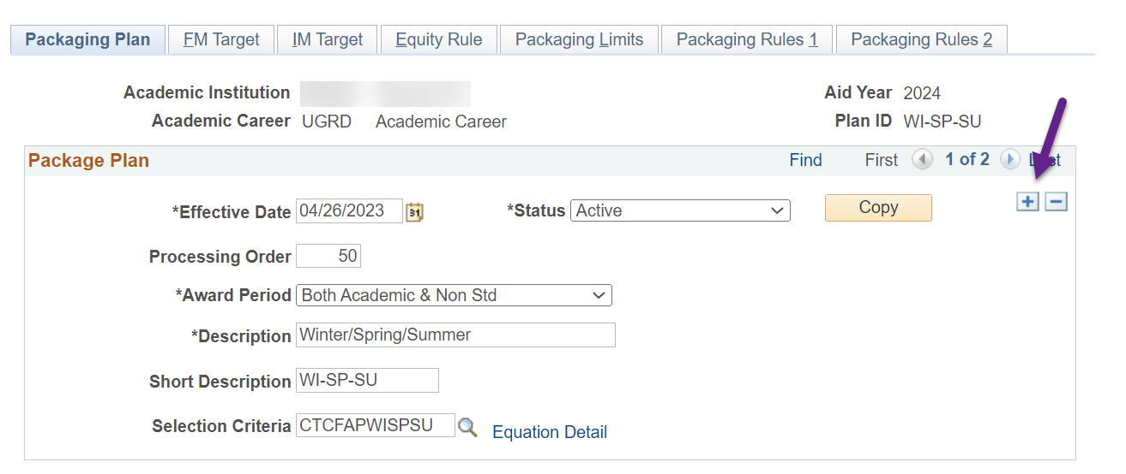

**THE FIRST ROW OF WCG** will be tied to the **1st quarter** in your packaging plan: **Winter quarter**.

Select the **Packaging Rules 1** tab then toggle to the WCG item-type (912000000000) using the right arrow

Update the following areas

*Selection Criteria*: **CTCFASBSWCG1 (WCG 1 Qtr check)**

*Limited by*: **CTCFASBAWCGW (WCG Award Winter)**

Select the **Packaging Rules 2** tab and update *Split Code* to **Winter**

**THE SECOND ROW OF WCG** will be tied to the **2nd** **quarter** in your packaging plan: **Spring quarter**.

Return to the **Packaging Rules 1** tab and add a new row

Update the following areas

*Sequence Nbr*: **(the next Sequence Nbr i.e. 21)**

*Item Type*: **912000000000**

*Selection Criteria*: **CTCFASBSWCG2 (WCG 2 Qtr check)**

*Limited by*: **Equation** then **CTCFASBAWCGS (WCG Award Spring)**

Select the **Packaging Rules 2** tab and update the following

*Disbursement Plan*: **Override Default** then **Wi-Sp-Su**

*Split Code*: **Override Default** then **Spring**

**THE THIRD ROW OF WCG** will be tied to the **3rd quarter** in your packaging plan: **Summer quarter**.

Return to the **Packaging Rules 1** tab and add a new row

Update the following areas

*Sequence Nbr*: **(the next Sequence Nbr i.e. 22)**

*Item Type*: **912000000000**

*Selection Criteria*: **CTCFASBSWCG3 (WCG 3 Qtr check)**

*Limited by*: **Equation** then **CTCFASBAWCGU (WCG Award Summer)**

Select the **Packaging Rules 2** tab and update the following

*Disbursement Plan*: **Override Default** then **Wi-Sp-Su**

*Split Code*: **Override Default** then **Summer**

Toggle to the **WCG** **Waitlist** item-type (912000000**100**) by selecting the right arrow once. Select the **minus sign** in the *Item Type Defaults* section to remove the item-type from the packaging plan. The new CBS equation engines are not dependent on this item-type being in the packaging plan.

**Once you delete the WCG Waitlist row, you will see you are now going to work on CBS ‘Okay to Pay’!**

**THE FIRST ROW OF CBS ‘Okay to Pay’** will be tied to the **1st quarter** in your packaging plan: **Winter quarter**.

Return to the **Packaging Rules 1** tab then update the following areas

*Selection Criteria*: **CTCFASBSCBP1 (CBS OK2P 1 Qtr check)**

*Limited by*: **CTCFASBACBW (CBS Award Winter)**

Select the **Packaging Rules 2** tab and update the *Split Code* to **Winter**

**THE SECOND ROW OF CBS ‘Okay to Pay’** will be tied to the **2nd** **quarter** in your packaging plan: **Spring quarter**.

Return to the **Packaging Rules 1** tab and add a new row

Update the following areas

*Sequence Nbr*: **(the next Sequence Nbr i.e. 41)**

*Item Type*: **912000000200**

*Selection Criteria*: **CTCFASBSCBP2 (CBS OK2P 2 Qtr check)**

*Limited by*: **CTCFASBACBS (CBS Award Spring)**

Select the **Packaging Rules 2** tab and update the following

*Disbursement Plan*: **Override Default** then **Wi-Sp-Su**

*Split Code*: **Override Default** then **Spring**

**THE THIRD ROW OF CBS ‘Okay to Pay’** will be tied to the **3rd quarter** in your packaging plan: **Summer quarter**.

Return to the **Packaging Rules 1** tab and add a new row

Update the following areas

*Sequence Nbr*: **(the next Sequence Nbr i.e. 42)**

*Item Type*: **912000000200**

*Selection Criteria*: **CTCFASBSCBP3 (CBS OK2P 3 Qtr check)**

*Limited by*: **CTCFASBACBU (CBS Award Summer)**

Select the **Packaging Rules 2** tab and update the following

*Disbursement Plan*: **Override Default** then **Wi-Sp-Su**

*Split Code*: **Override Default** then **Summer**

Toggle to the CBS ‘Okay to Award’ row by selecting the right arrow once. The ‘Okay to Award’ row will have an Award Action status of ‘Offer’ 😊

**THE FIRST ROW OF CBS ‘Okay to Award’** will be tied to the **1st quarter** in your packaging plan: **Winter quarter**.

Return to the **Packaging Rules 1** tab then update the following areas

*Selection Criteria*: **CTCFASBSCBA1 (CBS OK2A 1 Qtr check)**

*Limited by*: **CTCFASBACBW (CBS Award Winter)**

Select the **Packaging Rules 2** tab and update the *Split Code* to **Winter**

**THE SECOND ROW OF CBS ‘Okay to Award’** will be tied to the **2nd** **quarter** in your packaging plan: **Spring quarter**.

Return to the **Packaging Rules 1** tab and add a new row

Update the following areas

*Sequence Nbr*: **(the next Sequence Nbr i.e. 51)**

*Item Type*: **912000000200**

*Selection Criteria*: **CTCFASBSCBA2 (CBS OK2A 2 Qtr check)**

*Limited by*: **CTCFASBACBS (CBS Award Spring)**

Select the **Packaging Rules 2** tab and update the following

*Award Action*: **Offer**

*Disbursement Plan*: **Override Default** then **Wi-Sp-Su**

*Split Code*: **Override Default** then **Spring**

**THE THIRD ROW OF CBS ‘Okay to Award’** will be tied to the **3rd quarter** in your packaging plan: **Summer quarter**.

Return to the **Packaging Rules 1** tab and add a new row

Update the following areas

*Sequence Nbr*: **(the next Sequence Nbr i.e. 52)**

*Item Type*: **912000000200**

*Selection Criteria*: **CTCFASBSCBA3 (CBS OK2A 3 Qtr check)**

*Limited by*: **CTCFASBACBU (CBS Award Summer)**

Select the **Packaging Rules 2** tab and update the following

*Award Action*: **Offer**

*Disbursement Plan*: **Override Default** then **Wi-Sp-Su**

*Split Code*: **Override Default** then **Summer**

**SAVE YOUR WORK!!**

**YOU ARE DONE WITH THAT PACKAGING PLAN! 🎉**

#### FA-WI Packaging Plan

Two-term packaging plans will have WCG listed twice in the packaging plan, one row for each term.

Two-term packaging plans will have CBS listed four times in the packaging plan, two rows for each term.

**Navigation: Set Up SACR > Product Related > Financial Aid > Awards > Packaging Plan**

Select the FA-WI for 2024 aid year then add an effective dated row of today

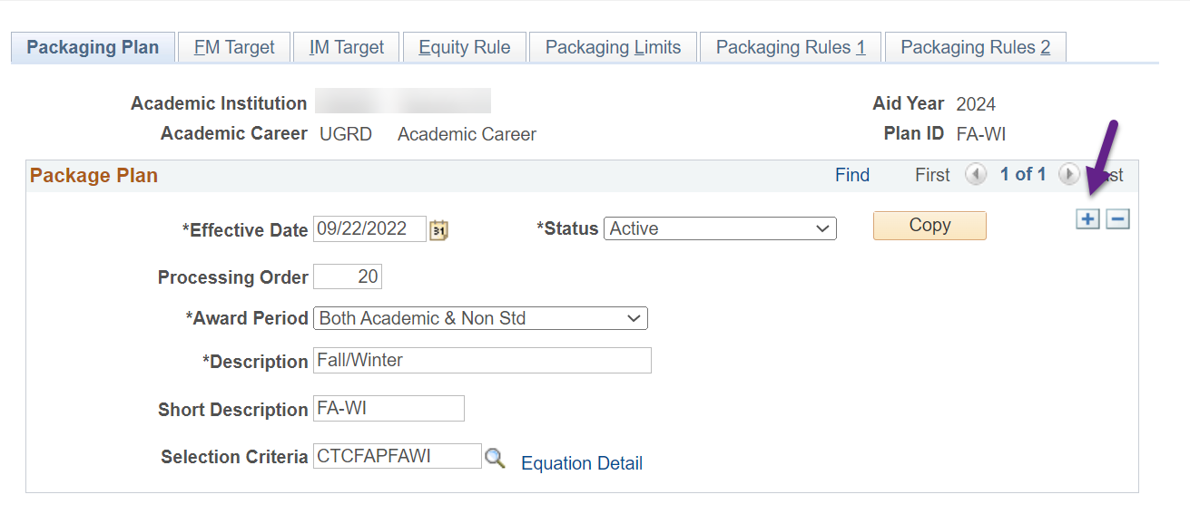

**THE FIRST ROW OF WCG** will be tied to the **1st quarter** in your packaging plan: **Fall quarter**.

Select the **Packaging Rules 1** tab then toggle to the WCG item-type (912000000000) using the right arrow

Update the following areas

*Selection Criteria*: **CTCFASBSWCG1 (WCG 1 Qtr check)**

*Limited by*: **CTCFASBAWCGF (WCG Award Fall)**

Select the **Packaging Rules 2** tab and update *Split Code* to **Fall**

**THE SECOND ROW OF WCG** will be tied to the **2nd** **quarter** in your packaging plan: **Winter quarter**.

Return to the **Packaging Rules 1** tab and add a new row

Update the following areas

*Sequence Nbr*: **(the next Sequence Nbr i.e. 21)**

*Item Type*: **912000000000**

*Selection Criteria*: **CTCFASBSWCG2 (WCG 2 Qtr check)**

*Limited by*: **Equation** then **CTCFASBAWCGW (WCG Award Winter)**

Select the **Packaging Rules 2** tab and update the following

*Disbursement Plan*: **Override Default** then **Fa-Wi** or **Fa-Wi-Sp** or **Fa-Wi-Sp-Su**

*Split Code*: **Override Default** then **Winter**

Toggle to the **WCG** **Waitlist** item-type (912000000**100**) by selecting the right arrow once. Select the **minus sign** in the *Item Type Defaults* section to remove the item-type from the packaging plan. The new CBS equation engines are not dependent on this item-type being in the packaging plan.

**Once you delete the WCG Waitlist row, you will see you are now going to work on CBS ‘Okay to Pay’!**

**THE FIRST ROW OF CBS ‘Okay to Pay’** will be tied to the **1st quarter** in your packaging plan: **Fall quarter**.

Return to the **Packaging Rules 1** tab then update the following areas

*Selection Criteria*: **CTCFASBSCBP1 (CBS OK2P 1 Qtr check)**

*Limited by*: **CTCFASBACBF (CBS Award Fall)**

Select the **Packaging Rules 2** tab and update the *Split Code* to **Fall**

**THE SECOND ROW OF CBS ‘Okay to Pay’** will be tied to the **2nd** **quarter** in your packaging plan: **Winter quarter**.

Return to the **Packaging Rules 1** tab and add a new row

Update the following areas

*Sequence Nbr*: **(the next Sequence Nbr i.e. 41)**

*Item Type*: **912000000200**

*Selection Criteria*: **CTCFASBSCBP2 (CBS OK2P 2 Qtr check)**

*Limited by*: **CTCFASBACBW (CBS Award Winter)**

Select the **Packaging Rules 2** tab and update the following

*Disbursement Plan*: **Override Default** then **Fa-Wi** or **Fa-Wi-Sp** or **Fa-Wi-Sp-Su**

*Split Code*: **Override Default** then **Winter**

Toggle to the CBS ‘Okay to Award’ row by selecting the right arrow once. The ‘Okay to Award’ row will have an Award Action status of ‘Offer’ 😊

**THE FIRST ROW OF CBS ‘Okay to Award’** will be tied to the **1st quarter** in your packaging plan: **Fall quarter**.

Return to the **Packaging Rules 1** tab then update the following areas

*Selection Criteria*: **CTCFASBSCBA1 (CBS OK2A 1 Qtr check)**

*Limited by*: **CTCFASBACBF (CBS Award Fall)**

Select the **Packaging Rules 2** tab and update the *Split Code* to **Fall**

**THE SECOND ROW OF CBS ‘Okay to Award’** will be tied to the **2nd** **quarter** in your packaging plan: **Winter quarter**.

Return to the **Packaging Rules 1** tab and add a new row

Update the following areas

*Sequence Nbr*: **(the next Sequence Nbr i.e. 51)**

*Item Type*: **912000000200**

*Selection Criteria*: **CTCFASBSCBA2 (CBS OK2A 2 Qtr check)**

*Limited by*: **CTCFASBACBW (CBS Award Winter)**

Select the **Packaging Rules 2** tab and update the following

*Award Action*: **Offer**

*Disbursement Plan*: **Override Default** then **Fa-Wi** or **Fa-Wi-Sp** or **Fa-Wi-Sp-Su**

*Split Code*: **Override Default** then **Winter**

**SAVE YOUR WORK!!**

**YOU ARE DONE WITH THAT PACKAGING PLAN! 🎉**

#### WI-SP Packaging Plan

Two-term packaging plans will have WCG listed twice in the packaging plan, one row for each term.

Two-term packaging plans will have CBS listed four times in the packaging plan, two rows for each term.

**Navigation: Set Up SACR > Product Related > Financial Aid > Awards > Packaging Plan**

Select the WI-SP for 2024 aid year then add an effective dated row of today

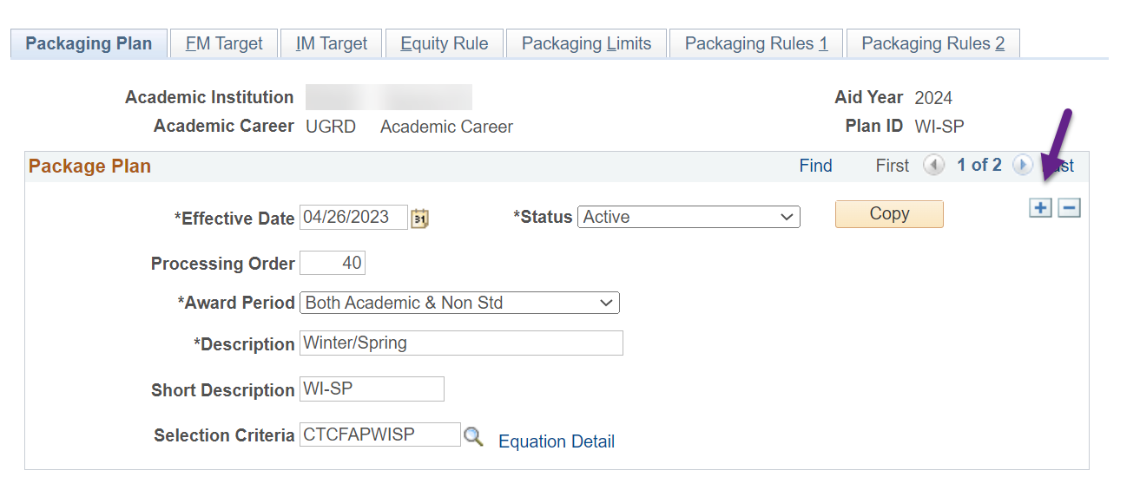

**THE FIRST ROW OF WCG** will be tied to the **1st quarter** in your packaging plan: **Winter quarter**.

Select the **Packaging Rules 1** tab then toggle to the WCG item-type (912000000000) using the right arrow

Update the following areas

*Selection Criteria*: **CTCFASBSWCG1 (WCG 1 Qtr check)**

*Limited by*: **CTCFASBAWCGW (WCG Award Winter)**

Select the **Packaging Rules 2** tab and update *Split Code* to **Winter**

**THE SECOND ROW OF WCG** will be tied to the **2nd** **quarter** in your packaging plan: **Spring quarter**.

Return to the **Packaging Rules 1** tab and add a new row

Update the following areas

*Sequence Nbr*: **(the next Sequence Nbr i.e. 21)**

*Item Type*: **912000000000**

*Selection Criteria*: **CTCFASBSWCG2 (WCG 2 Qtr check)**

*Limited by*: **Equation** then **CTCFASBAWCGS (WCG Award Spring)**

Select the **Packaging Rules 2** tab and update the following

*Disbursement Plan*: **Override Default** then **Wi-Sp** or **Wi-Sp-Su**

*Split Code*: **Override Default** then **Spring**

Toggle to the **WCG** **Waitlist** item-type (912000000**100**) by selecting the right arrow once. Select the **minus sign** in the *Item Type Defaults* section to remove the item-type from the packaging plan. The new CBS equation engines are not dependent on this item-type being in the packaging plan.

**Once you delete the WCG Waitlist row, you will see you are now going to work on CBS ‘Okay to Pay’!**

**THE FIRST ROW OF CBS ‘Okay to Pay’** will be tied to the **1st quarter** in your packaging plan: **Winter quarter**.

Return to the **Packaging Rules 1** tab then update the following areas

*Selection Criteria*: **CTCFASBSCBP1 (CBS OK2P 1 Qtr check)**

*Limited by*: **CTCFASBACBW (CBS Award Winter)**

Select the **Packaging Rules 2** tab and update the *Split Code* to **Winter**

**THE SECOND ROW OF CBS ‘Okay to Pay’** will be tied to the **2nd** **quarter** in your packaging plan: **Spring quarter**.

Return to the **Packaging Rules 1** tab and add a new row

Update the following areas

*Sequence Nbr*: **(the next Sequence Nbr i.e. 41)**

*Item Type*: **912000000200**

*Selection Criteria*: **CTCFASBSCBP2 (CBS OK2P 2 Qtr check)**

*Limited by*: **CTCFASBACBS (CBS Award Spring)**

Select the **Packaging Rules 2** tab and update the following

*Disbursement Plan*: **Override Default** then **Wi-Sp** or **Wi-Sp-Su**

*Split Code*: **Override Default** then **Spring**

Toggle to the CBS ‘Okay to Award’ row by selecting the right arrow once. The ‘Okay to Award’ row will have an Award Action status of ‘Offer’ 😊

**THE FIRST ROW OF CBS ‘Okay to Award’** will be tied to the **1st quarter** in your packaging plan: **Winter quarter**.

Return to the **Packaging Rules 1** tab then update the following areas

*Selection Criteria*: **CTCFASBSCBA1 (CBS OK2A 1 Qtr check)**

*Limited by*: **CTCFASBACBW (CBS Award Winter)**

Select the **Packaging Rules 2** tab and update the *Split Code* to **Winter**

**THE SECOND ROW OF CBS ‘Okay to Award’** will be tied to the **2nd** **quarter** in your packaging plan: **Spring quarter**.

Return to the **Packaging Rules 1** tab and add a new row

Update the following areas

*Sequence Nbr*: **(the next Sequence Nbr i.e. 51)**

*Item Type*: **912000000200**

*Selection Criteria*: **CTCFASBSCBA2 (CBS OK2A 2 Qtr check)**

*Limited by*: **CTCFASBACBS (CBS Award Spring)**

Select the **Packaging Rules 2** tab and update the following

*Award Action*: **Offer**

**SAVE YOUR WORK!!**

**YOU ARE DONE WITH THAT PACKAGING PLAN! 🎉**

*Disbursement Plan*: **Override Default** then **Wi-Sp** or **Wi-Sp-Su**

*Split Code*: **Override Default** then **Spring**

#### SU-FA Packaging Plan **HEADER ONLY**

Two-term packaging plans will have WCG listed twice in the packaging plan, one row for each term.

Two-term packaging plans will have CBS listed four times in the packaging plan, two rows for each term.

**Navigation: Set Up SACR > Product Related > Financial Aid > Awards > Packaging Plan**

Select the SU-FA for 2024 aid year then add an effective dated row of today

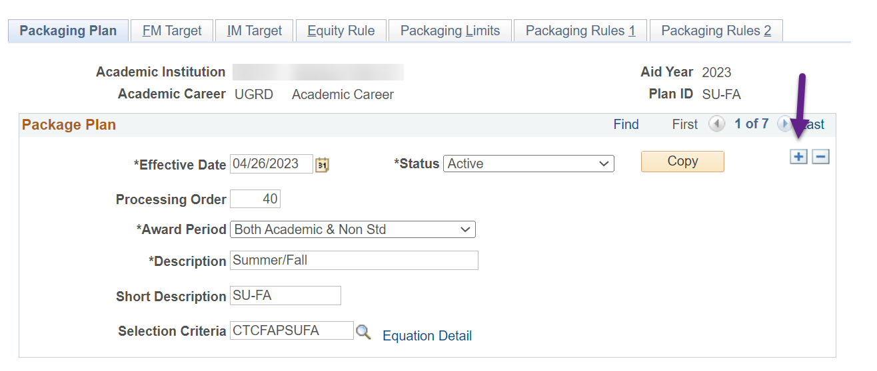

**THE FIRST ROW OF WCG** will be tied to the **1st quarter** in your packaging plan: **Summer quarter**.

Select the **Packaging Rules 1** tab then toggle to the WCG item-type (912000000000) using the right arrow

Update the following areas

*Selection Criteria*: **CTCFASBSWCG1 (WCG 1 Qtr check)**

*Limited by*: **CTCFASBAWCGU (WCG Award Summer)**

Select the **Packaging Rules 2** tab and update *Split Code* to **Fall**

**THE SECOND ROW OF WCG** will be tied to the **2nd** **quarter** in your packaging plan: **Fall quarter**.

Return to the **Packaging Rules 1** tab and add a new row

Update the following areas

*Sequence Nbr*: **(the next Sequence Nbr i.e. 21)**

*Item Type*: **912000000000**

*Selection Criteria*: **CTCFASBSWCG2 (WCG 2 Qtr check)**

*Limited by*: **Equation** then **CTCFASBAWCGF (WCG Award Fall)**

Select the **Packaging Rules 2** tab and update the following

*Disbursement Plan*: **Override Default** then **Su-Fa** or **Su-Fa-Wi-Sp**

*Split Code*: **Override Default** then **Fall**

Toggle to the **WCG** **Waitlist** item-type (912000000**100**) by selecting the right arrow once. Select the **minus sign** in the *Item Type Defaults* section to remove the item-type from the packaging plan. The new CBS equation engines are not dependent on this item-type being in the packaging plan.

**Once you delete the WCG Waitlist row, you will see you are now going to work on CBS ‘Okay to Pay’!**

**THE FIRST ROW OF CBS ‘Okay to Pay’** will be tied to the **1st quarter** in your packaging plan: **Summer quarter**.

Return to the **Packaging Rules 1** tab then update the following areas

*Selection Criteria*: **CTCFASBSCBP1 (CBS OK2P 1 Qtr check)**

*Limited by*: **CTCFASBACBU (CBS Award Summer)**

Select the **Packaging Rules 2** tab and update the *Split Code* to **Summer**

**THE SECOND ROW OF CBS ‘Okay to Pay’** will be tied to the **2nd** **quarter** in your packaging plan: **Fall quarter**.

Return to the **Packaging Rules 1** tab and add a new row

Update the following areas

*Sequence Nbr*: **(the next Sequence Nbr i.e. 41)**

*Item Type*: **912000000200**

*Selection Criteria*: **CTCFASBSCBP2 (CBS OK2P 2 Qtr check)**

*Limited by*: **CTCFASBACBF (CBS Award Fall)**

Select the **Packaging Rules 2** tab and update the following

*Disbursement Plan*: **Override Default** then **Su-Fa** or **Su-Fa-Wi-Sp**

*Split Code*: **Override Default** then **Fall**

Toggle to the CBS ‘Okay to Award’ row by selecting the right arrow once. The ‘Okay to Award’ row will have an Award Action status of ‘Offer’ 😊

**THE FIRST ROW OF CBS ‘Okay to Award’** will be tied to the **1st quarter** in your packaging plan: **Summer quarter**.

Return to the **Packaging Rules 1** tab then update the following areas

*Selection Criteria*: **CTCFASBSCBA1 (CBS OK2A 1 Qtr check)**

*Limited by*: **CTCFASBACBU (CBS Award Summer)**

Select the **Packaging Rules 2** tab and update the *Split Code* to **Fall**

**THE SECOND ROW OF CBS ‘Okay to Award’** will be tied to the **2nd** **quarter** in your packaging plan: **Fall quarter**.

Return to the **Packaging Rules 1** tab and add a new row

Update the following areas

*Sequence Nbr*: **(the next Sequence Nbr i.e. 51)**

*Item Type*: **912000000200**

*Selection Criteria*: **CTCFASBSCBA2 (CBS OK2A 2 Qtr check)**

*Limited by*: **CTCFASBACBF (CBS Award Fall)**

Select the **Packaging Rules 2** tab and update the following

**SAVE YOUR WORK!!**

**YOU ARE DONE WITH THAT PACKAGING PLAN! 🎉**

*Award Action*: **Offer**

*Disbursement Plan*: **Override Default** then **Su-Fa** or **Su-Fa-Wi-Sp**

*Split Code*: **Override Default** then **Fall**

#### SP-SU Packaging Plan **TRAILER ONLY**

Two-term packaging plans will have WCG listed twice in the packaging plan, one row for each term.

Two-term packaging plans will have CBS listed four times in the packaging plan, two rows for each term.

**Navigation: Set Up SACR > Product Related > Financial Aid > Awards > Packaging Plan**

Select the SP-SU for 2024 aid year then add an effective dated row of today

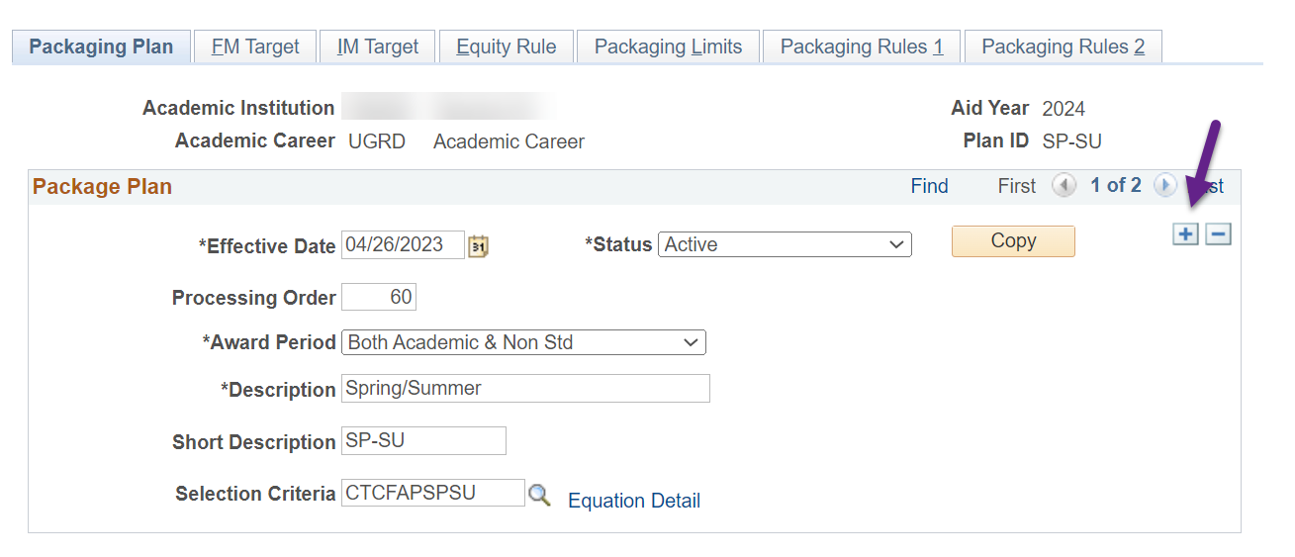

**THE FIRST ROW OF WCG** will be tied to the **1st quarter** in your packaging plan: **Spring quarter**.

Select the **Packaging Rules 1** tab then toggle to the WCG item-type (912000000000) using the right arrow

Update the following areas

*Selection Criteria*: **CTCFASBSWCG1 (WCG 1 Qtr check)**

*Limited by*: **CTCFASBAWCGS (WCG Award Spring)**

Select the **Packaging Rules 2** tab and update *Split Code* to **Spring**

**THE SECOND ROW OF WCG** will be tied to the **2nd** **quarter** in your packaging plan: **Summer quarter**.

Return to the **Packaging Rules 1** tab and add a new row

Update the following areas

*Sequence Nbr*: **(the next Sequence Nbr i.e. 21)**

*Item Type*: **912000000000**

*Selection Criteria*: **CTCFASBSWCG2 (WCG 2 Qtr check)**

*Limited by*: **Equation** then **CTCFASBAWCGU (WCG Award Summer)**

Select the **Packaging Rules 2** tab and update the following

*Disbursement Plan*: **Override Default** then **Sp-Su**

*Split Code*: **Override Default** then **Summer**

Toggle to the **WCG** **Waitlist** item-type (912000000**100**) by selecting the right arrow once. Select the **minus sign** in the *Item Type Defaults* section to remove the item-type from the packaging plan. The new CBS equation engines are not dependent on this item-type being in the packaging plan.

**Once you delete the WCG Waitlist row, you will see you are now going to work on CBS ‘Okay to Pay’!**

**THE FIRST ROW OF CBS ‘Okay to Pay’** will be tied to the **1st quarter** in your packaging plan: **Spring quarter**.

Return to the **Packaging Rules 1** tab then update the following areas

*Selection Criteria*: **CTCFASBSCBP1 (CBS OK2P 1 Qtr check)**

*Limited by*: **CTCFASBACBS (CBS Award Spring)**

Select the **Packaging Rules 2** tab and update the *Split Code* to **Spring**

**THE SECOND ROW OF CBS ‘Okay to Pay’** will be tied to the **2nd** **quarter** in your packaging plan: **Summer quarter**.

Return to the **Packaging Rules 1** tab and add a new row

Update the following areas

*Sequence Nbr*: **(the next Sequence Nbr i.e. 41)**

*Item Type*: **912000000200**

*Selection Criteria*: **CTCFASBSCBP2 (CBS OK2P 2 Qtr check)**

*Limited by*: **CTCFASBACBU (CBS Award Summer)**

Select the **Packaging Rules 2** tab and update the following

*Disbursement Plan*: **Override Default** then **Sp-Su**

*Split Code*: **Override Default** then **Summer**

Toggle to the CBS ‘Okay to Award’ row by selecting the right arrow once. The ‘Okay to Award’ row will have an Award Action status of ‘Offer’ 😊

**THE FIRST ROW OF CBS ‘Okay to Award’** will be tied to the **1st quarter** in your packaging plan: **Spring quarter**.

Return to the **Packaging Rules 1** tab then update the following areas

*Selection Criteria*: **CTCFASBSCBA1 (CBS OK2A 1 Qtr check)**

*Limited by*: **CTCFASBACBS (CBS Award Spring)**

Select the **Packaging Rules 2** tab and update the *Split Code* to **Spring**

**THE SECOND ROW OF CBS ‘Okay to Award’** will be tied to the **2nd** **quarter** in your packaging plan: **Summer quarter**.

Return to the **Packaging Rules 1** tab and add a new row

Update the following areas

*Sequence Nbr*: **(the next Sequence Nbr i.e. 51)**

*Item Type*: **912000000200**

*Selection Criteria*: **CTCFASBSCBA2 (CBS OK2A 2 Qtr check)**

*Limited by*: **CTCFASBACBU (CBS Award Summer)**

Select the **Packaging Rules 2** tab and update the following

*Award Action*: **Offer**

**SAVE YOUR WORK!!**

**YOU ARE DONE WITH THAT PACKAGING PLAN! 🎉**

*Disbursement Plan*: **Override Default** then **Sp-Su**

*Split Code*: **Override Default** then **Summer**

#### FALL ONLY Packaging Plan

One-term packaging plans will have WCG listed once in the packaging plan.

One-term packaging plans will have CBS listed twice in the packaging plan.

**Navigation: Set Up SACR > Product Related > Financial Aid > Awards > Packaging Plan**

Select the FALL ONLY for 2024 aid year then add an effective dated row of today

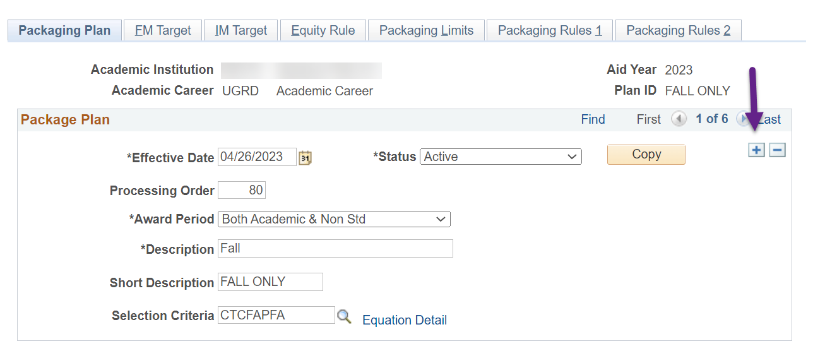

Select the **Packaging Rules 1** tab then toggle to the WCG item-type (912000000000) using the right arrow

Update the following areas

*Selection Criteria*: **CTCFASBSWCG1 (WCG 1 Qtr check)**

*Limited by*: **CTCFASBAWCGF (WCG Award Fall)**

Select the **Packaging Rules 2** tab and confirm *Split Code* is **Fall**

Toggle to the **WCG** **Waitlist** item-type (912000000**100**) by selecting the right arrow once. Select the **minus sign** in the *Item Type Defaults* section to remove the item-type from the packaging plan. The new CBS equation engines are not dependent on this item-type being in the packaging plan.

**Once you delete the WCG Waitlist row, you will see you are now going to work on CBS ‘Okay to Pay’!**

Return to the **Packaging Rules 1** tab then update the following areas

*Selection Criteria*: **CTCFASBSCBP1 (CBS OK2P 1 Qtr check)**

*Limited by*: **CTCFASBACBF (CBS Award Fall)**

Select the **Packaging Rules 2** tab and confirm *Split Code* is **Fall**

Toggle to the CBS ‘Okay to Award’ row by selecting the right arrow once. The ‘Okay to Award’ row will have an Award Action status of ‘Offer’ 😊

Return to the **Packaging Rules 1** tab then update the following areas

*Selection Criteria*: **CTCFASBSCBA1 (CBS OK2A 1 Qtr check)**

*Limited by*: **CTCFASBACBF (CBS Award Fall)**

Select the **Packaging Rules 2** tab and confirm *Split Code* is **Fall**

**SAVE YOUR WORK!!**

**YOU ARE DONE WITH THAT PACKAGING PLAN! 🎉**

#### WINTR ONLY Packaging Plan

One-term packaging plans will have WCG listed once in the packaging plan.

One-term packaging plans will have CBS listed twice in the packaging plan.

**Navigation: Set Up SACR > Product Related > Financial Aid > Awards > Packaging Plan**

Select the WINTR ONLY for 2024 aid year then add an effective dated row of today

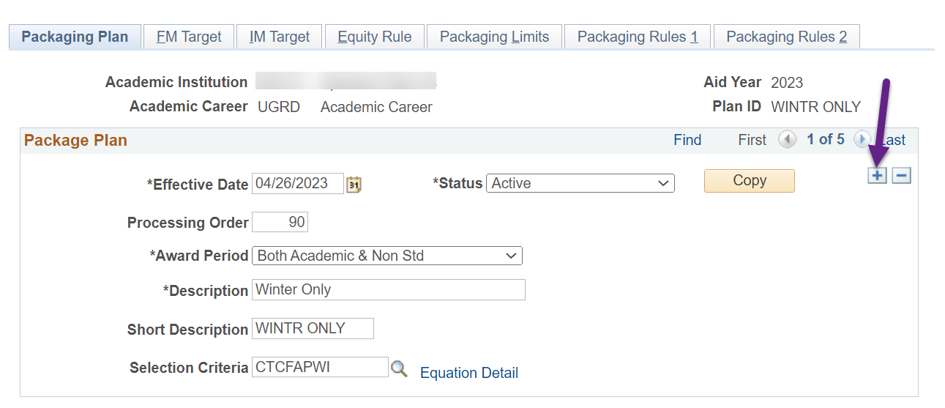

Select the **Packaging Rules 1** tab then toggle to the WCG item-type (912000000000) using the right arrow

Update the following areas

*Selection Criteria*: **CTCFASBSWCG1 (WCG 1 Qtr check)**

*Limited by*: **CTCFASBAWCGW (WCG Award Winter)**

Select the **Packaging Rules 2** tab and confirm *Split Code* is **Winter**

Toggle to the **WCG** **Waitlist** item-type (912000000**100**) by selecting the right arrow once. Select the **minus sign** in the *Item Type Defaults* section to remove the item-type from the packaging plan. The new CBS equation engines are not dependent on this item-type being in the packaging plan.

**Once you delete the WCG Waitlist row, you will see you are now going to work on CBS ‘Okay to Pay’!**

Return to the **Packaging Rules 1** tab then update the following areas

*Selection Criteria*: **CTCFASBSCBP1 (CBS OK2P 1 Qtr check)**

*Limited by*: **CTCFASBACBW (CBS Award Winter)**

Select the **Packaging Rules 2** tab and confirm *Split Code* is **Winter**

Toggle to the CBS ‘Okay to Award’ row by selecting the right arrow once. The ‘Okay to Award’ row will have an Award Action status of ‘Offer’ 😊

Return to the **Packaging Rules 1** tab then update the following areas

*Selection Criteria*: **CTCFASBSCBA1 (CBS OK2A 1 Qtr check)**

*Limited by*: **CTCFASBACBW (CBS Award Winter)**

Select the **Packaging Rules 2** tab and confirm *Split Code* is **Winter**

**SAVE YOUR WORK!!**

**YOU ARE DONE WITH THAT PACKAGING PLAN! 🎉**

#### SPRG ONLY Packaging Plan

One-term packaging plans will have WCG listed once in the packaging plan.

One-term packaging plans will have CBS listed twice in the packaging plan.

**Navigation: Set Up SACR > Product Related > Financial Aid > Awards > Packaging Plan**

Select the SPRG ONLY for 2024 aid year then add an effective dated row of today

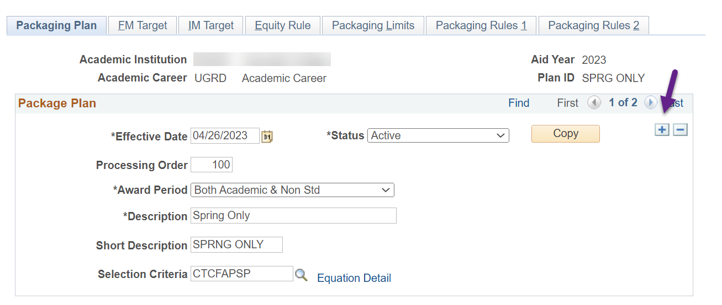

Select the **Packaging Rules 1** tab then toggle to the WCG item-type (912000000000) using the right arrow

Update the following areas

*Selection Criteria*: **CTCFASBSWCG1 (WCG 1 Qtr check)**

*Limited by*: **CTCFASBAWCGS (WCG Award Spring)**

Select the **Packaging Rules 2** tab and confirm *Split Code* is **Spring**

Toggle to the **WCG** **Waitlist** item-type (912000000**100**) by selecting the right arrow once. Select the **minus sign** in the *Item Type Defaults* section to remove the item-type from the packaging plan. The new CBS equation engines are not dependent on this item-type being in the packaging plan.

**Once you delete the WCG Waitlist row, you will see you are now going to work on CBS ‘Okay to Pay’!**

Return to the **Packaging Rules 1** tab then update the following areas

*Selection Criteria*: **CTCFASBSCBP1 (CBS OK2P 1 Qtr check)**

*Limited by*: **CTCFASBACBS (CBS Award Spring)**

Select the **Packaging Rules 2** tab and confirm *Split Code* is **Spring**

Toggle to the CBS ‘Okay to Award’ row by selecting the right arrow once. The ‘Okay to Award’ row will have an Award Action status of ‘Offer’ 😊

Return to the **Packaging Rules 1** tab then update the following areas

*Selection Criteria*: **CTCFASBSCBA1 (CBS OK2A 1 Qtr check)**

*Limited by*: **CTCFASBACBS (CBS Award Spring)**

Select the **Packaging Rules 2** tab and confirm *Split Code* is **Spring**

**SAVE YOUR WORK!!**

**YOU ARE DONE WITH THAT PACKAGING PLAN! 🎉**

#### SUMR ONLY Packaging Plan

One-term packaging plans will have WCG listed once in the packaging plan.

One-term packaging plans will have CBS listed twice in the packaging plan.

**Navigation: Set Up SACR > Product Related > Financial Aid > Awards > Packaging Plan**

Select the SUMR ONLY for 2024 aid year then add an effective dated row of today

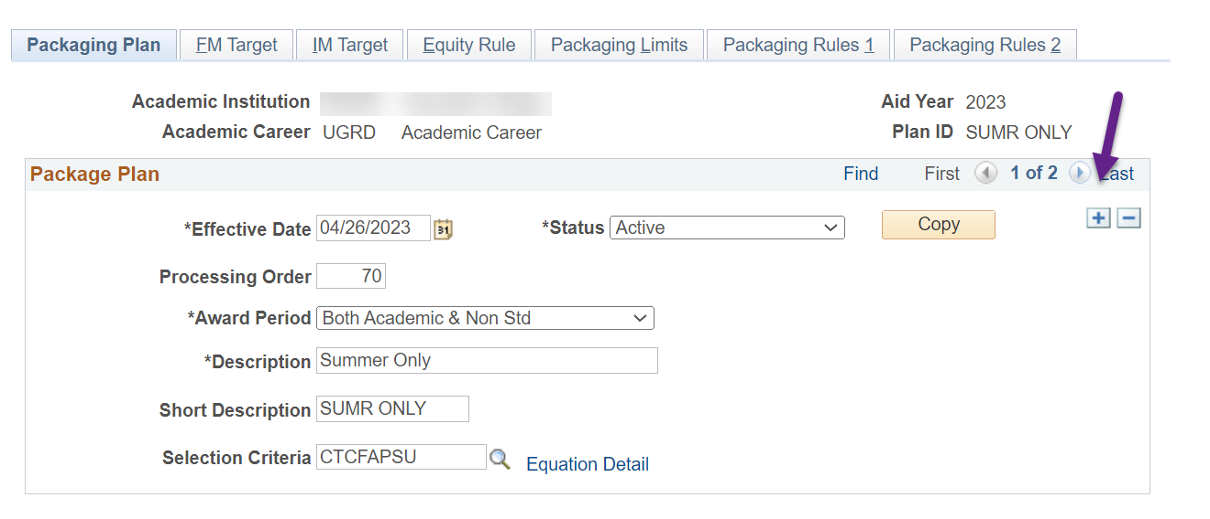

Select the **Packaging Rules 1** tab then toggle to the WCG item-type (912000000000) using the right arrow

Update the following areas

*Selection Criteria*: **CTCFASBSWCG1 (WCG 1 Qtr check)**

*Limited by*: **CTCFASBAWCGU (WCG Award Summer)**

Select the **Packaging Rules 2** tab and confirm *Split Code* is **Summer**

Toggle to the **WCG** **Waitlist** item-type (912000000**100**) by selecting the right arrow once. Select the **minus sign** in the *Item Type Defaults* section to remove the item-type from the packaging plan. The new CBS equation engines are not dependent on this item-type being in the packaging plan.

**Once you delete the WCG Waitlist row, you will see you are now going to work on CBS ‘Okay to Pay’!**

Return to the **Packaging Rules 1** tab then update the following areas

*Selection Criteria*: **CTCFASBSCBP1 (CBS OK2P 1 Qtr check)**

*Limited by*: **CTCFASBACBU (CBS Award Summer)**

Select the **Packaging Rules 2** tab and confirm *Split Code* is **Summer**

Toggle to the CBS ‘Okay to Award’ row by selecting the right arrow once. The ‘Okay to Award’ row will have an Award Action status of ‘Offer’ 😊

Return to the **Packaging Rules 1** tab then update the following areas

*Selection Criteria*: **CTCFASBSCBA1 (CBS OK2A 1 Qtr check)**

*Limited by*: **CTCFASBACBU (CBS Award Summer)**

Select the **Packaging Rules 2** tab and confirm *Split Code* is **Summer**

**SAVE YOUR WORK!!**

**YOU ARE DONE WITH THAT PACKAGING PLAN! 🎉**