





**Managing Financial Aid Job Recurrences During ctcLink Outages for Updates/Upgrades**

## Introduction

The owners of scheduled JobSets and any recurring jobs or processes will need to manage their respective processes both prior to and after scheduled ctcLink outages and/or the implementation of updates and upgrades.

## Stopping Recurring JobSets, Jobs, and Processes

### Stopping Scheduled JobSets

#### Navigation

PeopleTools > Process Scheduler > Schedule JobSet Definitions

#### Steps

1. Navigate to the **Schedule JobSet Definiti**ons page and select the desired JobSet
2. Change the **JobSet Status** from “Active” to “Completed” and select **Save**
3. *DO NOT* select Run Now

#### Image: Setting Scheduled JobSet to Completed

### Stopping Recurring Jobs/Processes

#### Navigation

PeopleTools > Process Scheduler > Process Monitor

#### Steps

1. Navigate to **Process Monitor**, enter your **User ID**, and select the **Run Status** of “Queued”
2. Select the **Refresh** button
3. Select the **Details** link
4. Select **Cancel Request** radio button in the Update Process section
5. Select **OK.**

#### Image: Stopping a Recurring Job or Process (1)

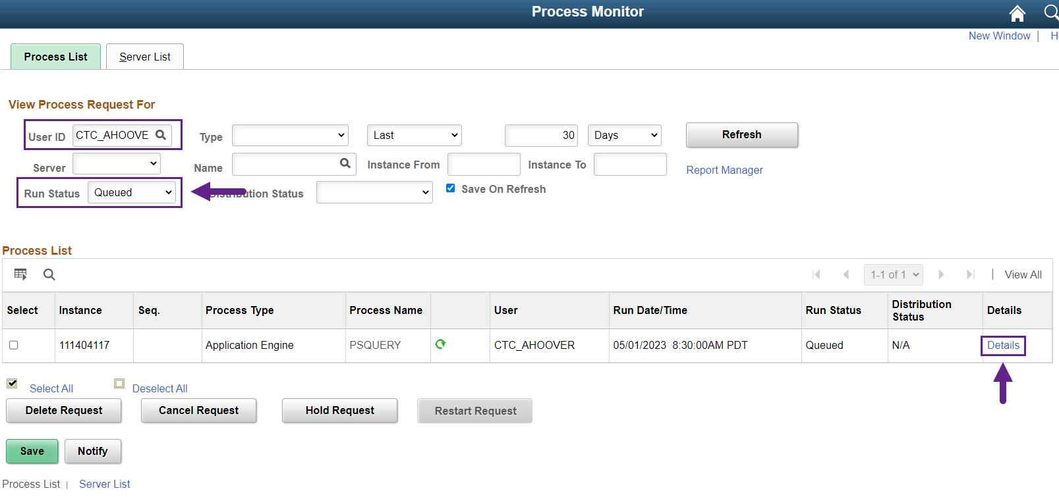

#### Image: Stopping a Recurring Job or Process (2)

## Rescheduling Recurring JobSets, Jobs, and Processes

### Rescheduling JobSets

#### Navigation

PeopleTools > Process Scheduler > Schedule JobSet Definitions

#### Steps

1. Navigate to the **Schedule JobSet Definitions** page and select the desired JobSet
2. Set the **Begin Date** to the new start date
3. Set the **Status** to “Active”
4. Select **Save**
5. Select **Return to Search**, then open the JobSet again. Verify that **Begin Date**, **Time**, and **Recurrence Name** are still correct

#### Image: Rescheduling a JobSet

### Restarting Recurring Jobs/Processes

#### Steps

1. Navigate to the process page for the process you want to reschedule
2. Enter the **Run Control ID** and select **Search**
3. Verify Run Control settings, then select **Run**
4. Confirm the **Recurrence** and/or select the desired Recurrence
5. Update the **Run Date** to the first day the job or process should start running
6. Select **OK**

#### Image: Restarting a Recurring Job or Process

