1. After running the PS Interim Report and downloading the ***WA College Grant.csv,*** open the file then select the **Sort & Filter** button and select **Filter**

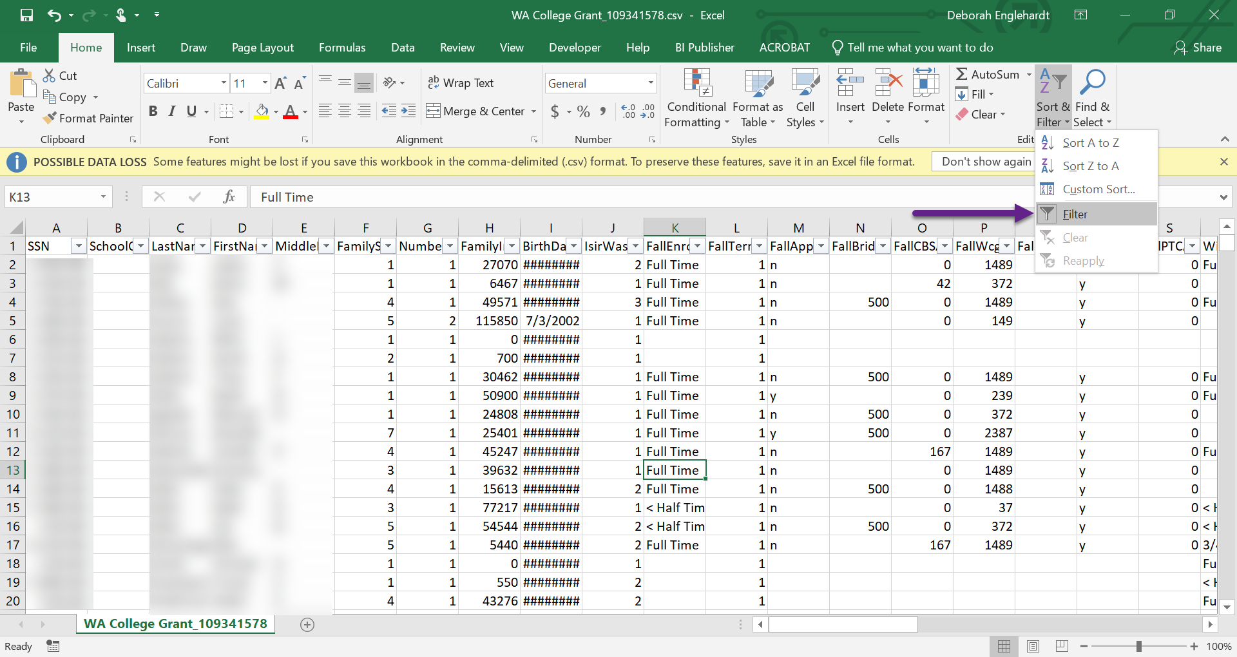

1. Find the *FallCBSAwardAmount* column and select the **filter menu** (downward arrow button)

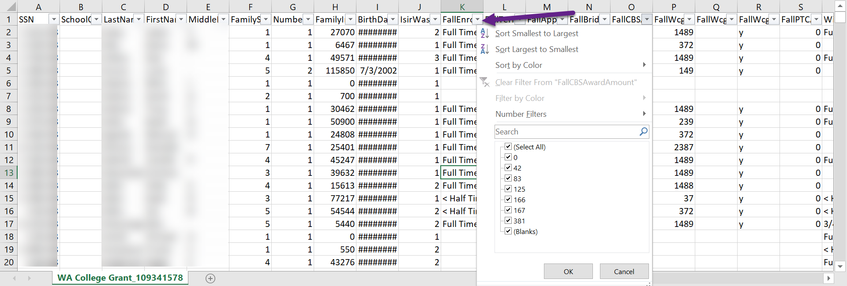

1. Unselect the **Select All checkbox** then select **0 checkbox** and **OK** button

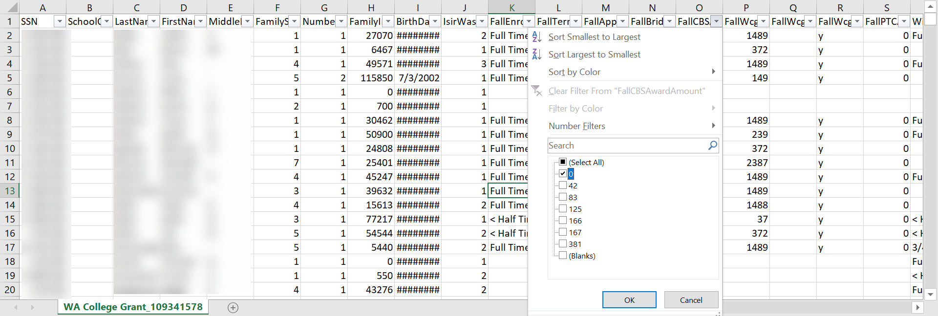

1. You should see that you’ve filtered down to all the zeroes. Delete the zeroes.

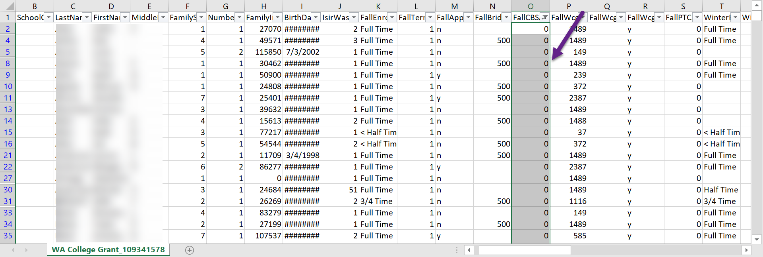

1. Select the **filter menu** (downward arrow button) again then select the **Select All checkbox** and **OK button**

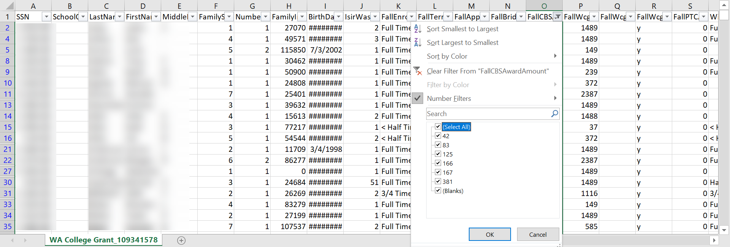

1. Follow the same steps of filtering so you only get the zeroes then deleting those zeroes for each CBS and PTC column in the Interim Report CSV
2. Once all 8 columns (four CBS and four PTC) are cleaned up, select **File** then **Save As** and make sure you save the file as **CSV (Comma delimited) (*csv) so that SSNs with leading zeroes load correctly in the WSAC Portal.** You can rename the file before selecting Save.

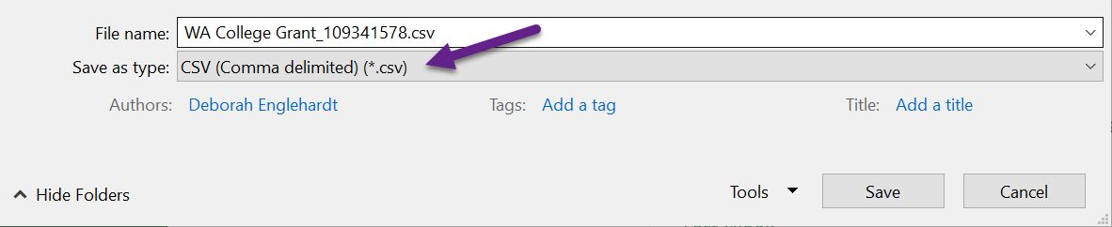

1. Load the modified CSV into the WSAC Portal.
2. Run the **QCS_FA_WCG_INTERIM_CSV** query. The zeroes you see in the CBS columns on that report are the ones that meet the criteria that WSAC mentions in the manual: Students who are eligible for CBS but did not get CBS because unmet need was filled with other aid. Make sure to report these zeroes in the WSAC Portal.