Please read this document fully and complete required steps before turning on your Even Year ISIR Jobset so that your jobset does not run into an error or mass assign the wrong aid year checklists.

In addition, you should be informed of the bugs that still exist which will affect packaging.

BACKGROUND
Image 27 (2023-2024 Aid Year Updates) came with many reported bugs and introduced Mass EFC Calculation Application Engine, which replaces INAS Batch Calculation COBOL beginning with aid year 2023-2024.

Note: The bugs listed in this document are related to 23-24 processing, therefore, details of the fix were not included in the FA PRP 2 Overview document

Bugs that were resolved as of loading fixes in December
- Calc EFC button fails to calculate FM EFC
- Calc EFC button redirects to earliest effective dated row on Correct 20xx – 20xx Records page
- Navigating through the different tabs on Correct 20xx – 20xx Records page results in returning to the earliest effective dated row
- Mass EFC Calculation page reverts Clear Calc Request from ‘Y’ to ‘N’ despite saving ‘Y’
- EFC calculates for only one institution for students with ISIRs loaded under multiple institutions
Bugs that will be resolved as of loading fixes tonight
- Process ISIRs (FAPSAR00) goes to ‘Error’ when the ISIR file(s) contain students who have multiple ISIR transactions
- FM EFC (Calc EFC button/Mass EFC Calculation) calculated an EFC that differs by $1 from the CPS Primary EFC on the ISIR file
- Calc EFC button generated an incorrect DOB warning for those born before ‘01/01/1999’
- Calc EFC button not displaying Auto-Zero EFC flag on eligible students

Bugs that remain and are targeted for a fix in Image 29
- In some cases, Calc EFC button unexpectedly changes the dependency status of a Dependent student to Independent status when it should just re-calculate from Simple Formula to Regular
- Making a correction to an ISIR in PS does not update the EFC Status to ‘Unofficial’ on Need Summary Pages including Financial Aid Status, Assign Awards to a Student, and Maintain Term Budgets
One more thing that came with Image 27 you should know about
The Mass EFC Calculation App Engine comes with a new log in the View Log/Trace: SFA_NAC_PDRM_xxxxxxxx.log. The new log contains sensitive info reported on the ISIR in it. We’ve tested to confirm the Process Monitor security would protect anyone other than the user from accessing this log.

REQUIREMENTS FOR TURNING ON YOUR EVEN YEAR ISIR JOBSET
- Complete Aid Year Rollover and create/update Even Year ISIR Jobset

- Wait until the evening of February 22nd (upcoming Wednesday). As mentioned above, the 2nd layer of bug fixes are going in tonight and we’ll be validating production for several days to make sure everything went in okay

- Put your 2023 INAS Batch Calc Run Control ID in the Even Year ISIR Jobset in the FAPINCLC field

Starting from the 2023-2024 Aid Year, there is no INAS Batch Calculation but the process cannot be deleted from your shell and the field cannot be left blank. We suggest copying your Odd Year INAS Batch Calc Run Control and pasting it in there.

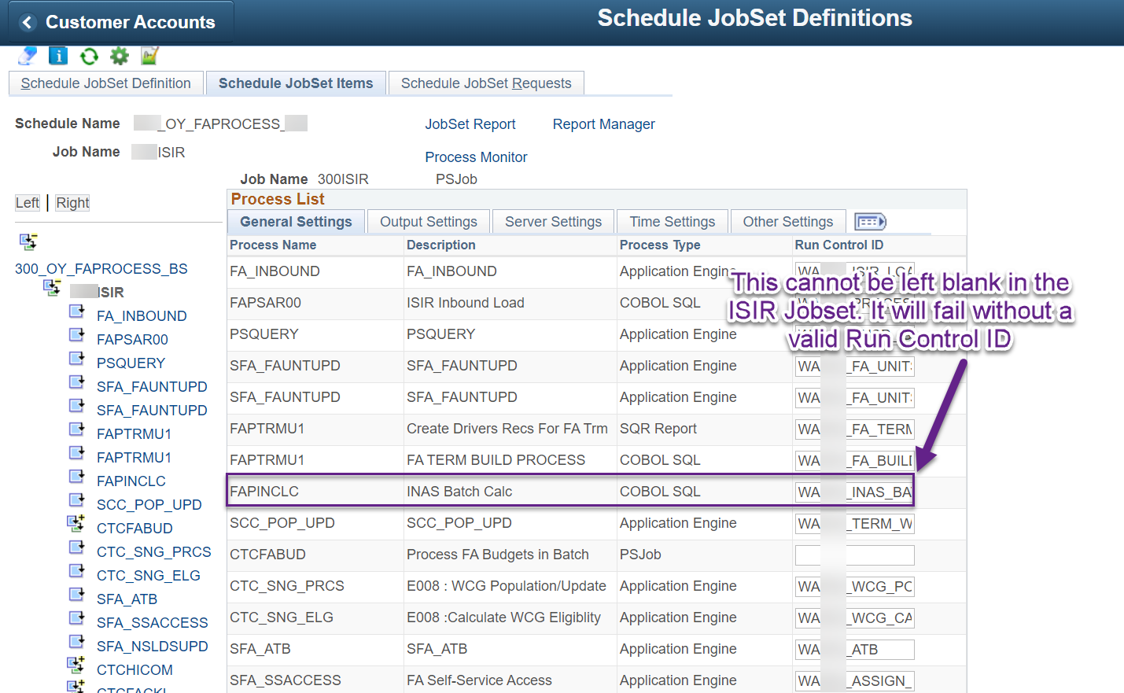

If you are a college that already has an Even Year INAS Batch Calc Run Control ID from 2022, you can leave that Run Control ID in the Even Year Jobset and update the parameter from 2022 to 2023. Whichever is easier for you.

Navigate to Navigator > Financial Aid > File Management > INAS Batch Calculation

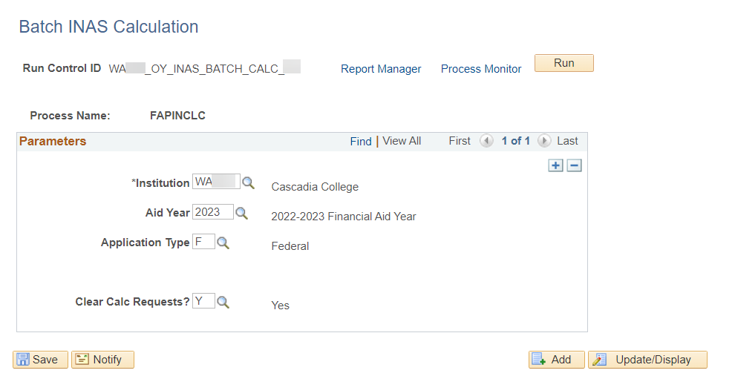

- Confirm there are NO assignment of F checklists in your Even Year ISIR Jobset

- Confirm the assignment of the V1 checklist is in your Even Year ISIR Jobset. V1 is not waived for 2023-2024 Aid Year

- Remove the assign and send Communication Run Control ID until you’ve caught up loading all the ISIR

- Turn off the 2024 Aid Year access on the Financial Aid tile until you’re ready for students to access that aid year’s info

Navigate to Navigator > Set Up SACR > Common Definitions > Self Service > Financial Aid > Self Service Options

Go into the 2024 Aid Year and uncheck the Allow Access checkbox then select Save.
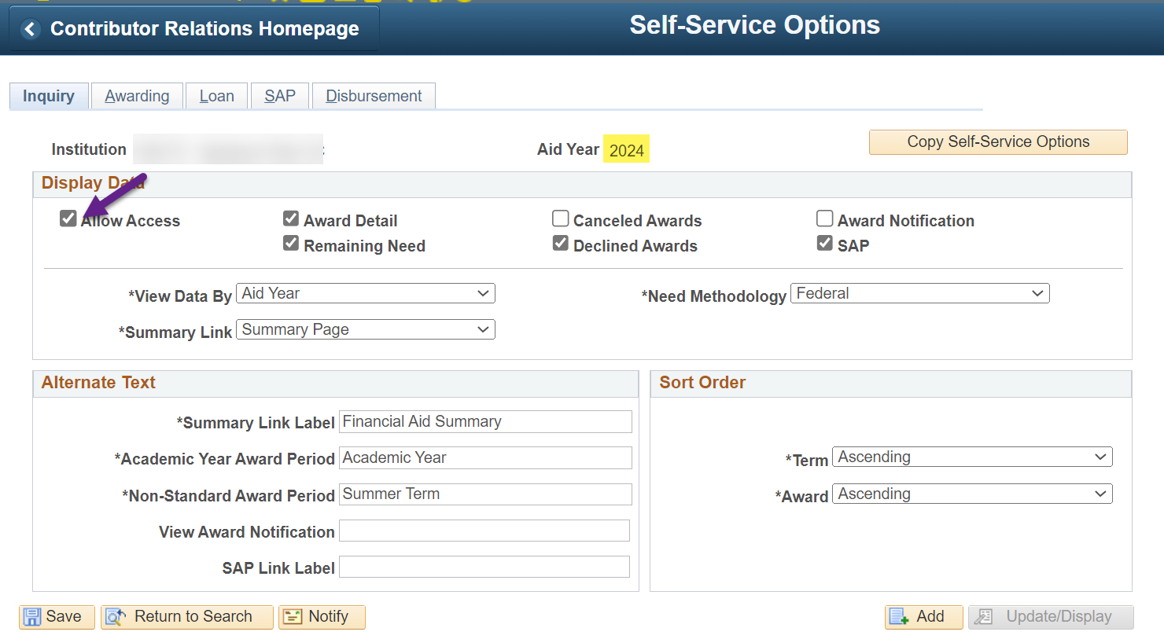

- If you are not loading an YTD file and you’ve loaded all your ISIR files up to now in the ISIR2024 folder, you can submit a ticket requesting the text file now

- Create a New Run Control ID for Mass EFC Calculation and put it on a recurrence of M-F 7AM

Step 1
Navigate to Mass EFC Calculation

Nav Bar > Navigator > Financial Aid > File Management > Mass EFC Calculation

Step 2
Select Add a New Value then create a new Run Control ID following the standard Run Control ID naming convention:

WAxxx_EY_MASS_EFC_CALC_yy
(xxx is your 3-digit destination and yy is your initials)
Step 3
Enter the following parameters

Academic Institution: (your institution)
Aid Year: 2024
Application Type: F
Clear Calc Requests? Y

Step 4
Select Run

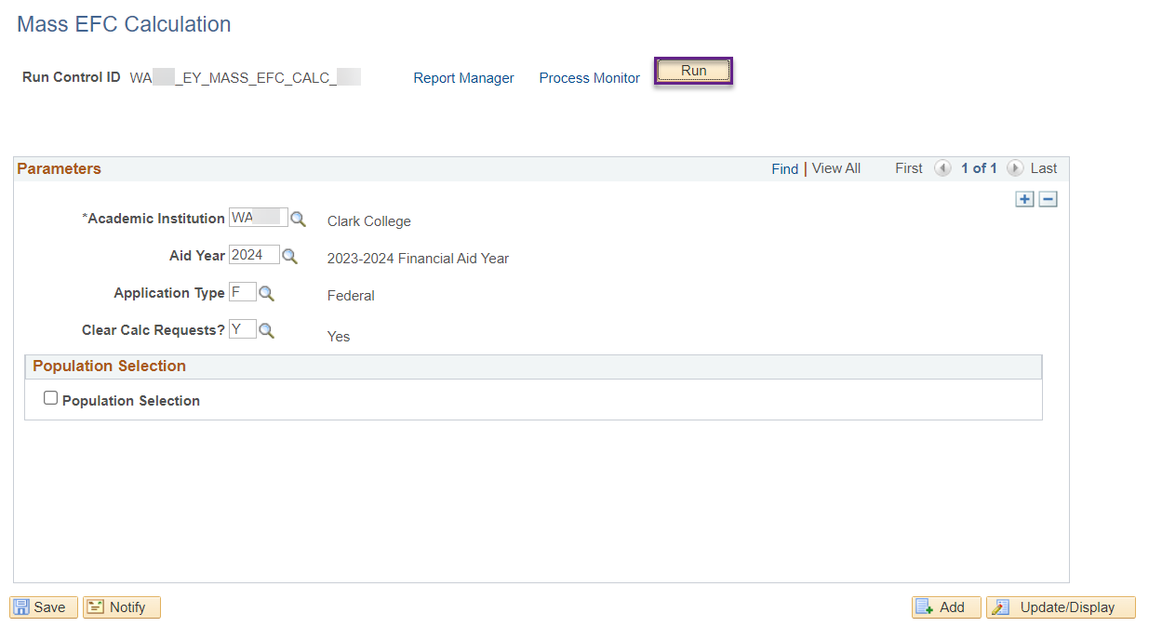

Step 5
Select recurrence M-F @7:00AM then Run Date of tomorrow.

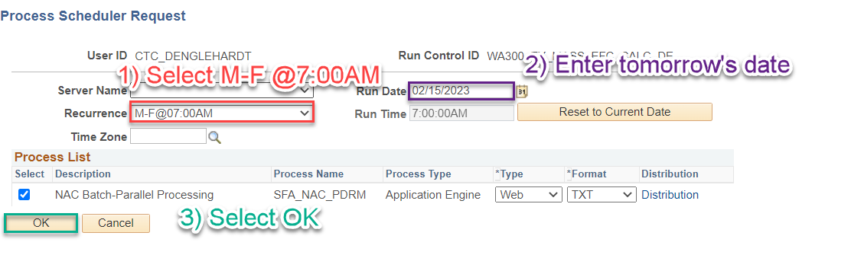

Finally, select OK and recurrence is set!

NEW ISIR JOBSET TIMESLOTS
We did not finish testing the budget optimization work with App Services but we’re going to change everyone’s timeslots in preparation for it. Please move to these new timeslots when you turn on your Even Year ISIR Jobset.
Institution | Description |  | Recurrence
WA220 | Tacoma CC |  | M-F at 5pm | New Aid Year
WA090 | Highline College |  | M-F@11:00PM | Current Aid Year
WA110 | Pierce College
WA080 | Bellevue College
WA062 | Seattle Central College
WA050 | Everett Community College
WA171 | Spokane CC
WA100 | Green River College
WA190 | Columbia Basin College
WA172 | Spokane Falls CC
WA140 | Clark College
WA070 | Shoreline Community College
WA230 | Edmonds College
WA160 | Yakima Valley College
WA290 | Clover Park Technical College
WA030 | Olympic College
WA063 | North Seattle College
WA240 | South Puget Sound Comm College
WA270 | Renton Technical College
WA210 | Whatcom Community College
Institution | Description |  | Recurrence
WA064 | South Seattle College |  | M-F@01:00AM | New Year
WA280 | Bates Technical College |  | M-F@04:00AM | Current Year
WA150 | Wenatchee Valley College
WA040 | Skagit Valley College
WA250 | Bellingham Technical College
WA200 | Walla Walla Community College
WA130 | Lower Columbia College
WA120 | Centralia College
WA260 | Lake Washington Inst. of Tech.
WA180 | Big Bend Community College
WA300 | Cascadia College
WA020 | Grays Harbor College
WA010 | Peninsula College

A separate email will be sent out next week regarding the Unusual Circumstance checklist process requested through FAC.

Thank you!
FA ERP Support

