FA ERP Support

Washington State Board for Community and Technical Colleges
Cancelling Prior Year Checklist
2022

Contents
Identify Checklist 2
Create/Edit Event Definition 3
Create Event 3C Groups 5
Run 3C Engine 6
Reviewing Outcomes 8

This process has been developed to cancel any outstanding initiated checklists from a prior aid year so the checklists will no longer appear on the student’s To Do list on Self Service. This process should be run before renaming the even/odd year checklists done during the Aid Year Rollover process.

Note: The checklist cancel process should only be run once a college is no longer disbursing aid for the aid year in which they are cancelling checklists. Because the first tab will remain in an initiated status, the cancelled checklist could block disbursements.

Identify Checklist
Navigation | Description
Main Menu > Reporting Tools > Query > Query Viewer | Colleges will use this query to determine which checklists are in an Initiated status based on prompted aid year

- Enter the query name CTC_FA_PRIOR_YR_CHCKLST_REVIEW
- Select Search
- Enter values for the following Prompts:
- Institution
- Aid Year
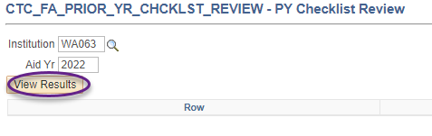

Create/Edit Event Definition
Navigation | Description
Main Menu > Campus Community > 3C Engine > Set Up 3C Engine > Event Definition | This process drives the information on Run 3C Engine parameters

Create/Edit Event definition
- If the Event ID doesn’t exist
  - Select the Add a New Value tab
  - Enter the Academic Institution
  - Enter the desired Event ID for your institution using the naming convention ‘FISXXXCAPC’ where ‘XXX’ represents your institution’s 3-character checklist naming convention prefix
  - Select Add
- If the Event ID does exist
- Select the Event ID
- Add a new effective dated row at the top using the ‘+’ icon
- Update to the desired Checklist Code
- Verify the Item Status value remains as ‘Cancelled’
- Select Save when satisfied and proceed to the Run 3C Engine step
Steps for defining a new Event Definition
- Enter a Description that follows Event ID naming convention
- Enter a Short Description
- Enter ‘FINA’ as a Function
- On the Checklists section, enter a Checklist Code from the query results in the Identify Checklist step
  - Enter Item Code
  - Set the Responsible ID to the ID for the institution’s Financial Aid Office
  - Select the Update Status option
  - Change the Item Status to ‘Cancelled’
- Select Save.

Note: When running this process for multiple checklists, use Correct History to edit the Checklists section. Verify Item Status value remains as ‘Cancelled’ before selecting Save and moving on to the Run 3C Engine process.

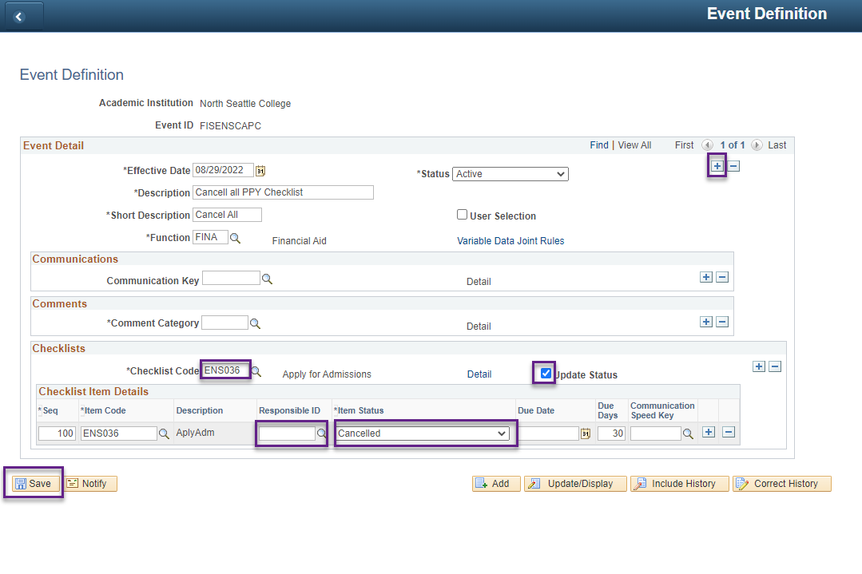

Create Event 3C Groups
Navigation | Description
Main Menu > Campus Community > 3C Engine > Set Up 3C Engine > Event 3C Groups | Assigns access to specified user group

This step is ONLY necessary when setting up a NEW Event Definition
Add event 3C group security
- Enter the following values
    - Academic Institution
    - Event ID
- Select Search
- Enter the desired 3C Security group(s) to allow access to this Event definition. Common Financial Aid 3C Security groups are listed below.
  - FAVO (FA View Only)
  - FAVU (FA View Update)
  - FASU (FA Super User)

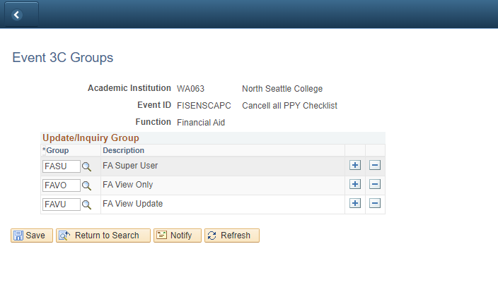

Run 3C Engine
Navigation | Description
Main Menu > Campus Community > 3C Engine > Run 3C Engine | Allows system to identify which students and checklists get updated

- Enter New or Existing Run Control ID
- Under the Process 3C’s section select the Population Selection check box
- Under the Event Selection section populate the following fields:
  - Academic Institution
  - Administrative Function: FINA
  - Event ID
- Under the Population Selection section set the Selection Tool to PS Query. Enter the Query Name CTC_FA_PRIOR_YR_CHCKLST_CANCEL.
- Select the Edit Prompts link and enter the following values:
  - Aid Year
  - Institution
  - Checklist Code
- Select the Preview Selection Results link and note some sample students for validation after the process has been run.
- Select the Manage Duplicate Assignment tab
- Select the Check Duplicate Checklist check box
- Select ‘Match’ from the Variable Data dropdown menu
- Ensure Checklist Status is set to ‘Initiated’
- Return to the 3C Engine Parameters tab
- Select Save
- Select Run
- Process should run to Success and Posted in the Process Monitor

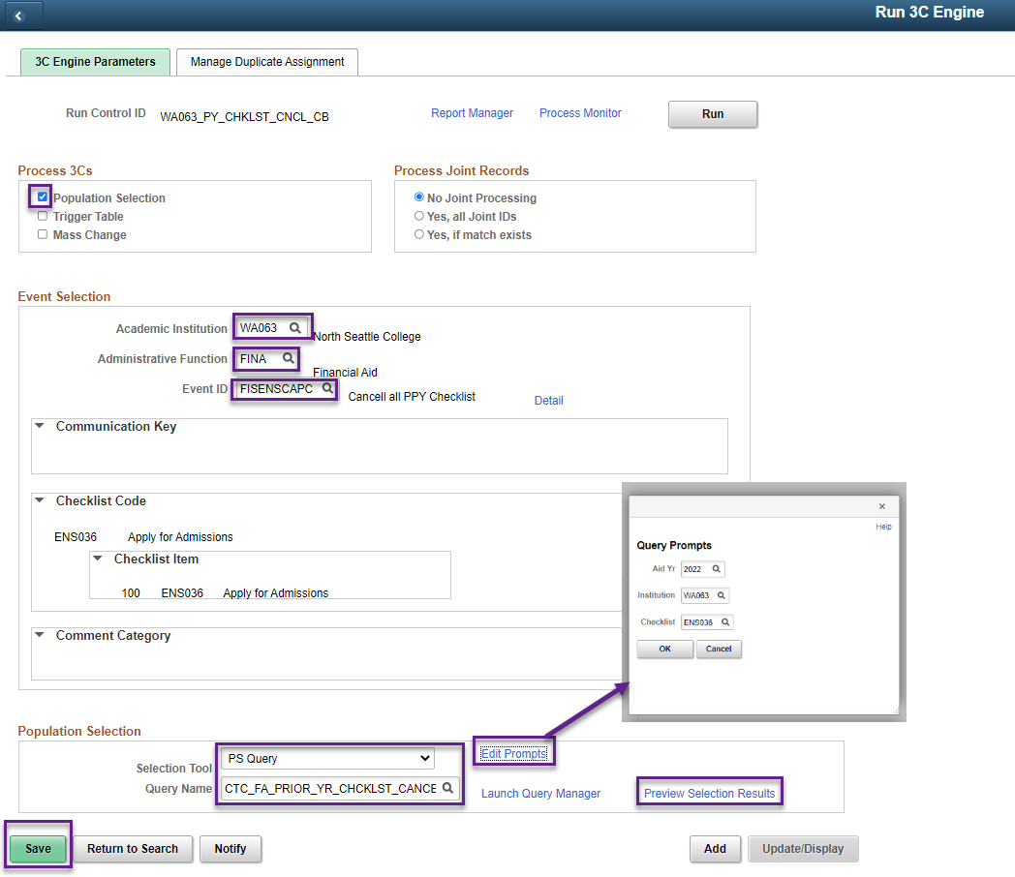

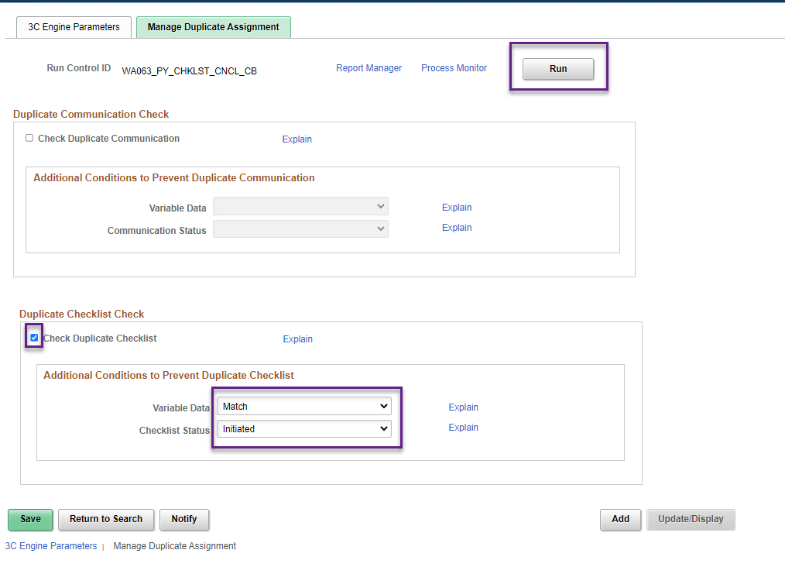

Reviewing Outcomes

To verify that the students’ Checklists updated appropriately, use the students from the Run 3C Engine Preview Selection Results and confirm the checklists reflect a status of ‘Cancelled’ on the View Financial Aid Status page. The Checklist should no longer appear on the student’s To Do List in the Student Services Center.

The query CTC_FA_CANCEL_PY_CHKLST_VAL can be used to validate the students who had their Checklists cancelled. This query displays the prompted checklist for the prompted aid year, regardless of status. The query could be run before running 3C Engine as well as after as a compare to see which students were updated.

