File Processing in ctcLink
Step-by-Step Guide
(Best viewed with Navigation Pane activated)
Financial Aid Office
Spokane Community College
Created December 2017 by Sharon Gerlach
Contents

Checklist 1
Quick Tips 2
Use the View Financial Aid Status page for a quick overview of most file processing items 2
Arrange your Favorites in order of use 3
Add pages to your NavBar for quick links 4
Add new Homepages with commonly used pages 5
Important Links 6
Admissions 7
Ability to Benefit 9
Career Pathway Eligibility 9
High School Completion 10
Recent High School Graduates 10
Program of Study (Career Plan) 11
Troubleshooting Students Career Plans 14
Program Updates – Future-Dated Program Changes 14
Multiple Plans in Program Stack 14
Residency 16
Residency Mismatch 16
Non-resident in Admissions and Resident on FAFSA 16
Resident in Admissions and Non-Resident on FAFSA 17
Citizenship 18
Comment Codes 18
Documentation 18
Secondary Confirmation – ISIR 18
SAVE System 19
ISIR vs Bio Demo Mismatch & Residency Mismatch 20
NSLDS 22
Loan Page 22
Pell Page 23
Pell Lifetime Eligibility Used (LEU) 24
Subsidized Usage Limit Applies (SULA) 25
Updating Incoming Aggregate Amounts 25
Satisfactory Academic Progress 26
Student SAP Section 26
SAP Calculation Results 26
Simulate Student Eligibility 27
EXHS status (formerly “GD” Suspension) 27
SAP Contracts and Attending at Own Expense 27
Graded Adult Basic Education Coursework 28
Non-Graded Adult Basic Education Coursework 28
Actions to Take for Ineligible SAP Status 28
Verification 31
Step 1: Manage 20xx-20xx Verification 31
Step 2: Perform Auto Verification 34
Step 3: Correct 20xx-20xx ISIR Records 35
Required Fields for All Verification Tracking Groups 36
Tax Transcript Decoder 38
Taxes Paid Clarification: 38
ISIRs in ctcLink 39
Anatomy of an ISIR in ctcLink 39
All Tabs 39
Student Information Tab 39
Parent Information Tab 40
Assumptions\School Codes Tab 40
EFC\DB Matches\Corr Tab 40
ISIR Review 41
Using Previous ISIRs 41
Information to Review 41
New ISIRs After File Has Been Reviewed 46
Submitting Corrections on Non-Verification Files 48
Changing Marital Status 49
Academic Plans 50
Previously Approved Academic Plans 50
Tracking an Academic Plan from a Prior Year 50
New Academic Plans 51
Tracking a New Academic Plan 51
User Edit Messages (UEM) 52
Reasons for User Edit Messages: 52
Maintenance of UEMs 52
Checklist Items 54
Rollover Checklist Items 54
Waiving vs Completing vs Cancelling Checklist Items 54
File Processing Comments 56
To Add a Comment 56
To Edit a Comment 56
Comment Categories 57
Budget Adjustments 58
If increasing for actual tuition costs 58
If adding program costs (such as tool allowance) to a student’s budget 58
If cost of attendance is missing a quarter 58
If funding fewer credits than the student is enrolled 58
Prepare Student Record for Packaging 60
Non-Verification Files 60
Verification Files 60
Database Match Override 60
Package Awards 62
Update Incoming Aggregates 63
Invoke Professional Judgment 65
Institutional Funding 65
FSEOG 65
SCC Grant and Need-Based Tuition Waiver 65
Order of Awards 65
Award Order Flowchart 67
Awarding When Student Attended Summer Transitional Studies Coursework 68
Update Summer Financial Aid Term 68
Summer Term Awarding 68
Before Awarding Summer Term 68
Processing Financial Aid Package for Students Not Previously Funded 69
Revising Financial Aid Package for Previously Funded Students 69
Packaging Student Loans 71
Loans that Will Disburse After October 1 71
No Change in Origination Fees 71
Minimum Loan Amounts 72
Loan prorations 72
Loans at Another Institution 72
Expired Master Promissory Notes 72
Recycling Loan Item Types 72
30-Day Delay Loans 73
Second Year Loan Amounts 73
Parent PLUS Loans 74
Awarding Respiratory Care BAS Students 74
First and Second Year BAS Students: 74
Third & Fourth Year BAS Students: 74
Reactivating Previously Cancelled Aid 75
Awarding non-FAFSA Students 75
Activate Aid Year 76
Build Financial Aid Term 76
Create Budget 76
Adjust Budget 76
Award Error Messages 77
Completing the File Processing Worksheet 0
Loan-Only Communication 1
Speed Key 1
Assign Communication 1
Professional Judgment 3
Dependency Override (Dependent to Independent) 3
ctcLink: 3
FAA Access 3
Change of Financial Circumstances 4
ctcLink: 4
FAA Access 4
Separation/Divorce after Awarded 5
ctcLink: 5
FAA Access 5
Tax Return Line Items for 2020-21 & 21-22 Professional Judgment 6
Adjusting Awards (Increases and Decreases) 9
How to adjust awards 9
Sample worksheet 11
Set up Merge Document for FA Worksheet: 12
Watermark for NSLDS Printouts 13
Index 14

Checklist

Print worksheets
Sample Worksheet in this guide

Review SAP (in ctcLink and in FAM/SMS)
Navigator > Financial Aid > Satisfactory Academic Progress > Maintain Student SAP Data

Check program of study
Navigator > Campus Community > Student Services Center
Navigator > Records and Enrollment > Career and Program Information > Student Program/Plan

Check residency
Navigator > Campus Community > Personal Information > Identification > Residency Data

Review NSLDS
https://www.nsldsfap.ed.gov/nslds_FAP/

*Do verification (if selected; make sure current transaction is not rejected)
Navigator > Financial Aid > Verification > Manage 20xx-20xx Verification
Navigator > Financial Aid > Verification > Perform Auto Verification
Navigator > Financial Aid > Federal Application Data > Correct 20xx-20xx ISIR

Review ISIR
Navigator > Financial Aid > Federal Application Data > Correct 20xx-20xx ISIR

Review any new academic plans or requirements for previous ones
Navigator > Financial Aid > View Financial Aid Status
Navigator > Financial Aid > Disbursement > Maintain User Edit Messages

Resolve any checklist items
Navigator > Financial Aid > View Financial Aid Status, or
Navigator > Campus Community > Checklists > Person Checklists > Checklist Management-Person

Resolve any relevant service indicators
Navigator > Campus Community > Service Indicators (Student) > Manage Service Indicators

Check for updated WCG/CBS information if packaging on a newly loaded ISIR correction
Navigator > Financial Aid > CTC Custom > CTC Interfaces

Complete View Packaging Summary page
Navigator > Financial Aid > View Packaging Status Summary

Make any necessary notes on worksheet

On the View Financial Aid Status page, add a comment with the ISIR # and EFC used for packaging

Package awards
Navigator > Financial Aid > Awards > Award Processing > Assign Awards to a Student

Assign Loan-Only Communication (if applicable)
Navigator > Financial Aid > View Financial Aid Status, or
Navigator > Campus Community > Communications > Person Communications > Communication Management

Quick Tips

Use the View Financial Aid Status page for a quick overview of most file processing items
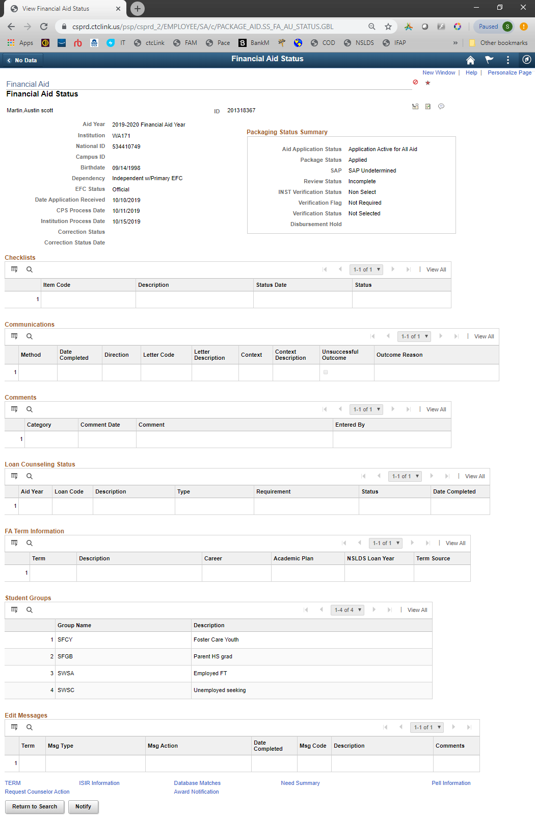
6
10
5
9
8
7
4
3
2
1
- EFC – official or other  - Application date (  - SAP  - Verification flags  - ISIR Correction Status & Status Date | - Missing checklist items (click View All)  - Financial Aid academic plans and restrictions  - Program linked to FA terms  - Waitlisted for or accepted to program  - User edit messages

Arrange your Favorites in order of use

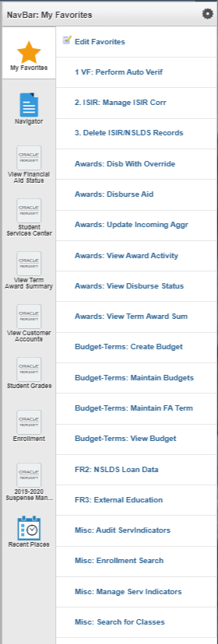
Here’s a sample of an ordered Favorites list (left).
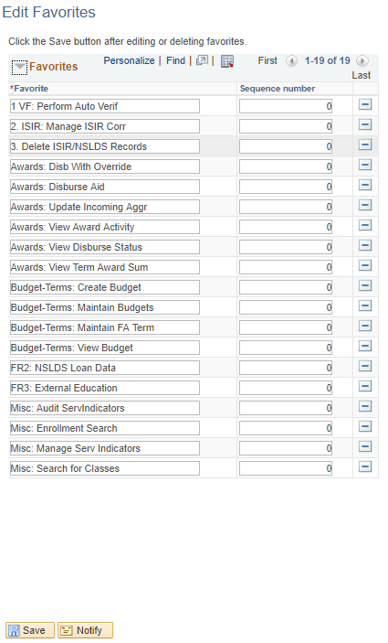
You can customize the name of the favorited pages to determine the order they show in the list. Numbers will default to the top of the list.
My Favorites > Edit Favorites

To edit the order of your favorites, change only the sequence number (right side).

To edit the name and maintain alphabetic order, edit only the name (left side)

Home Search Actions NavBar Settings

Add pages to your NavBar for quick links

To simplify customer service or daily tasks, add pages to your NavBar:
- Navigate to the desired page
- Click the Actions icon in the upper right hand corner of the page
- Click Add to NavBar

When you click the NavBar icon , the NavBar will appear, and you will see the pages you saved as tiles.

To change the order of the NavBar icons:
- Select the Settings icon
- Drag the tiles until they are in the order desired
- Click the green Done button

Browser Tip: Zoom in and out quickly!

Zoom in: CTRL + +
Zoom out: CTRL + –
Normal: CTRL + 0 (zero)

This will work in any browser (Firefox, Chrome,
and Internet Explorer)

Add new Homepages with commonly used pages

It can be helpful to add new Homepages to contain tiles for the pages used for a certain function, such as file processing.

- To create a new Homepage:
- Click the Actions icon
- Select Personalize Homepage
- Click Add Homepage (above the list of current Homepages on the left-hand side)
- In the pop-up window, enter the desired name for the new Homepage in the field under Or create a new Homepage
- Click Add
Your new Homepage is created. You can add tiles using the Add Tiles button (very limited options), or you can navigate to the pages you want to include on your new Homepage and add them.

- Click the NavBar icon to open the NavBar
- Click the Navigator tile
- Find the page desired and click the link
- Click the three stacked dots icon
- Click Add to Homepage
- In the pop-up, selected the Homepage desired
- Repeat for all pages desired

The pages added to a Homepage will show as tiles.
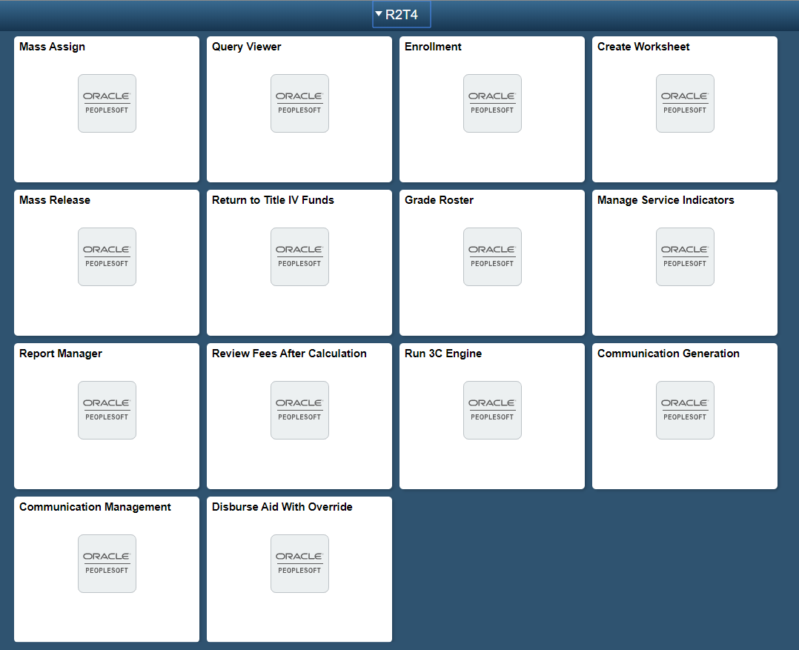

Important Links

BankMobile
FAA: https://www.bankmobileadminsupport.com/adminsite/login/start.do
Students: https://mybigfootcard.vibeaccount.com/

Common Origination & Disbursement Website (COD)
https://cod.ed.gov/cod/LoginPage

Community Colleges of Spokane IT Support Center
https://ccspokane.freshservice.com/support/home

ctcLink
http://ctclink.spokane.edu/

FAA Access to CPS Online
https://faaaccess.ed.gov/FOTWWebApp/faa/faa.jsp

Federal Student Aid Page
https://studentaid.gov/

FSA Partners (formerly IFAP)
https://fsapartners.ed.gov/home/

National Association of Financial Aid Administrators
Main Site: http://www.nasfaa.org/
AskRegs: https://askregs.nasfaa.org/MyAccount/LogOn?ReturnUrl=%2f

National Student Loan Data System (NSLDS)
FAA: https://nsldsfap.ed.gov
Students: https://nsldsfap.ed.gov/nslds_SA/

SBCTC Help Desk
https://servicedesk.sbctc.edu/helpdesk/WebObjects/Helpdesk.woa

State Board for Community and Technical Colleges (SBCTC)
https://www.sbctc.edu/colleges-staff/

Mood Music for Productivity
(Be sure to stream from your phone, not from your work computer)
https://www.brain.fm/
https://www.accuradio.com/workplace-moods/

Admissions

Navigator > Campus Community > Student Services Center

If a student has not applied for admission to the college, their FAFSA information will not load into the system. If a student completed their FAFSA long enough ago that we should have received it but the View Financial Aid Status page does not show their information, check the student’s admission information first.

Admission information can be found on the Admissions tab in the Student Services Center. To view SCC’s admissions information, click on ACADM or PRFTC under the institution WA171 – Spokane CC. The admissions information will display below in the Applicant Progression section, UNLESS:

- The student applied for Admission before the 2015 conversion to ctcLink
Students returning within 6 years of last attendance do not have to reapply for admission to the college; they will simply submit a Student Information Update Form.

Look for:
  - Updated program information and/or
  - Open upcoming term
- The student is transitioning from Running Start admit to full admit
Students who entered the college under the Running Start program and who have now graduated from high school must apply for full admission to the college. This is done with the submission of a Student Information Update Form and a copy of the high school diploma or high school transcript with a graduation date
Look for:
  - Inactivated Running Start group(s)
  - Open upcoming term
  - Citizenship status populated in the Actual Bio/Demo Data section on ISIR
  - Copy of high school transcript with graduation date or high school diploma in Halfile

Below is an example of a typical new admissions page:

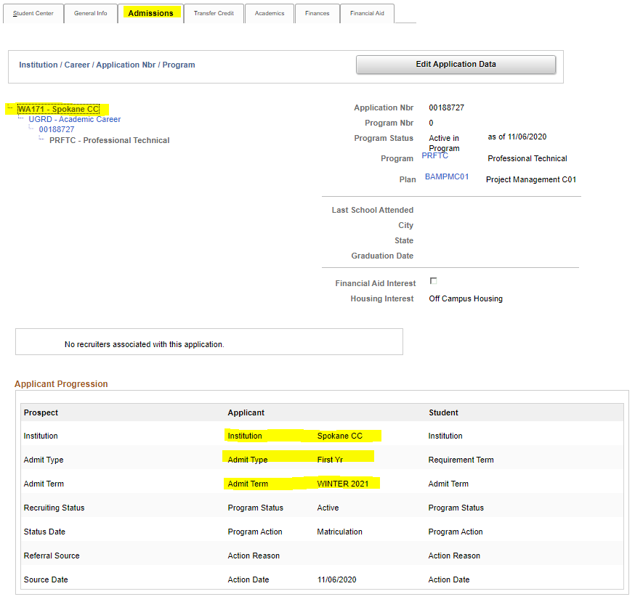

Ability to Benefit

Students without a high school diploma or GED certificate may be eligible to attend in specific career pathways in order to become eligible for financial aid.

Currently, ATB files are reviewed at the director level, but for informational purposes, some general highlights are listed below:

- Student must be in six or more college-level credits (course numbers 100+)
- Developmental or remedial coursework is not counted toward enrollment level
- Student should be in approved program; see chart below for eligible programs
- Associate in Arts is not an approved program
- Student should have been assigned the ATB service indicator (ARQ)
- Registration staff should not change ATB students’ programs
- For more information, see the Ability to Benefit folder in the Share drive

Career Pathway Eligibility
The following certificates and degrees at SCC are approved career pathways that require no additional documentation:
Certificates | AAS
Accounting Clerk | Accounting Assistant
Baking: Professional Pastries & Specialty Cakes | Administrative Assistant
Business Occupations | Administrative Office Management
Clerical Assistant | Automotive Technology
Front Office Professional | Aviation Maintenance Technology
Industrial and Manufacturing Technology | Business General
Legal Office Software Specialist | Business Software Specialist
Legal Receptionist | Culinary Arts
Machinist/CNC Technology | Customer Service Representative
Management | Hotel and Restaurant Management
Medical Office Receptionist | HVAC/R
Paralegal | Legal Administrative
Pharmacy Technician | Machinist/CNC Technology
Resort Food and Beverage | Management
Resort Lodging | Medical Office Billing and Coding
Resort Management | Medical Office Specialist
 | Paralegal
 | Pharmacy Technician
 | Restaurant Management

High School Completion

Navigator > Financial Aid > Federal Application Data > Correct 20xx-20xx ISIR Records

Students are required to confirm high school completion at the time of admission to the college. A high school completion service indicator will be added by Admissions staff to all incoming students who are required to provide documentation of high school completion; the service indicator will block enrollment activity.

For Financial Aid, the student’s high school completion status on the ISIR should be either High School Diploma, GED, or Home Schooled. If None of the above is checked, a checklist item will automatically be added to the student’s record upon ISIR import. The student should then correct the FAFSA or provide us with a copy of the high school diploma or transcript, a copy of the GED certificate or transcript, or homeschool completion information to allow us to correct the ISIR.

Recent High School Graduates

Navigator > Records and Enrollment > Transfer Credit Evaluation > External Education

- Students who have recently graduated high school must provide us with a copy of their high school diploma, as they would have answered no to high school completion on the admissions application and/or the FAFSA
  - Once the Admissions Office has received a copy of the transcript or diploma, this section will be completed all the way through

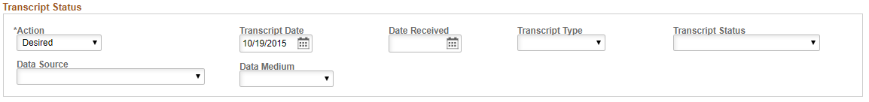

Program of Study (Career Plan)

Navigator > Campus Community > Student Services Center

Definitions:
Program stack: list of programs the student has applied to (sorted by college)
Program: Academic or Professional Technical (ACADM and PRFTC)
Plan: Academic degrees (i.e. Associate of Arts) or Professional/Technical degrees (i.e. Culinary Arts)
CAR: Career (or Student Career Number)

- Go to the Academics tab
- Click on each item in the program stack to find the most current program
  - Status will show Active as of mmddyyy
  - The Student Career Nbr (CAR) should be an active program and should be the CAR attached to the current (or upcoming) term in Edit Term Data

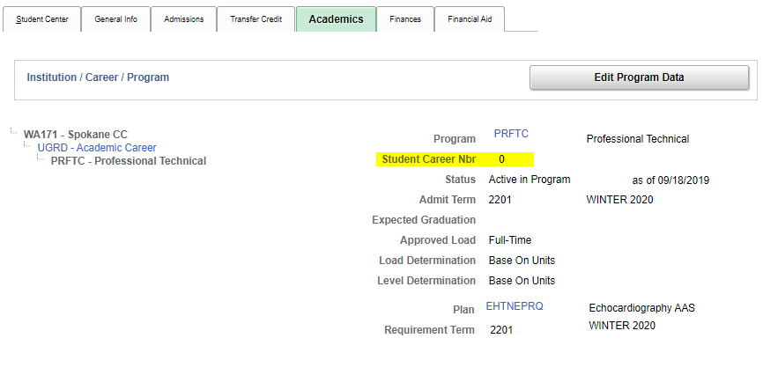

- Make sure the program is eligible to receive financial aid; if it’s not an eligible program, the student cannot be awarded
  - Click on the degree name by Plan in the Edit Program Data section
  - The short description should start with 9 if it’s financial aid eligible; 0 if it’s not eligible
- With most AAS programs, the student is not considered admitted to the program unless they have been placed in an “admitted” student group (General Info tab, Student Groups link). Associate of Arts students are not placed in a student group.
- If the student is completing prerequisites to be admitted to a program, or is completing preparatory coursework to be admitted to a program at another school, s/he will be eligible for student loans only, with a reduced subsidized maximum of $2,625, for a period of 12 months.
- If the program listed does not require prerequisites but the student has not yet been admitted, we cannot offer funding. The student must be admitted to the program to receive financial aid, even if they are taking “non-program-specific courses (classes that are not exclusively part of a particular program) that are required as part of their program.
- If the student is enrolled, review the courses to make certain they are required for the listed program of study
  - The Requirement Term indicates the program outline that should be used to verify the student is taking program-required courses. If the Requirement Term is Fall 2016, for example, the Fall 2016 program outline should be consulted for acceptable courses.

Program outlines: http://catalog.spokane.edu/CoursesAndPrograms/Default.aspx
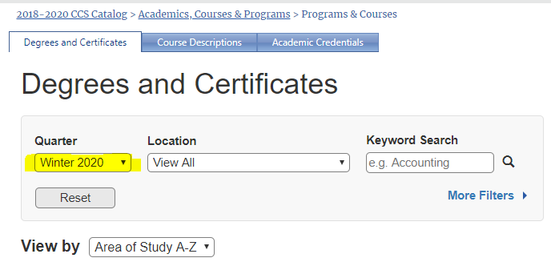
These things must be connected to the same plan:

- Student Career Number in Program/Plan should match CAR number in Edit Term Data  - Active Program Plan must match plan linked to current term in Term Summary | - FA Terms and Edit Term Data CAR should match  - SAP must match CAR number in Edit Term Data  - SAP & FA Terms should match

Student Services > Academic Tab

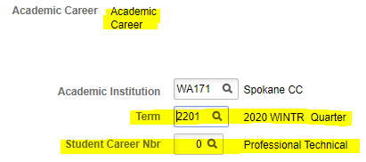
Edit Term Data Window
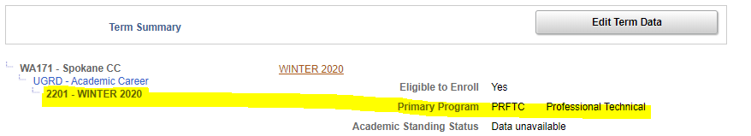

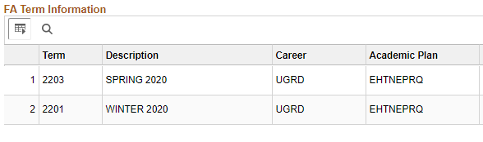
View Financial Aid Status (FA Term Information section)

Maintain Student SAP Data (Student SAP section)
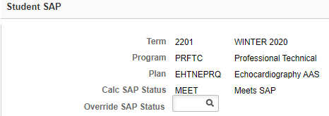

Troubleshooting Students Career Plans

Program Updates – Future-Dated Program Changes
Navigator > Records and Enrollment > Career and Program Information > Student Program/Plan

If the student hasn’t attended for a while, check to see if a Student Information Update form has been processed as a “future-dated” program change before advising the student to submit another update form.
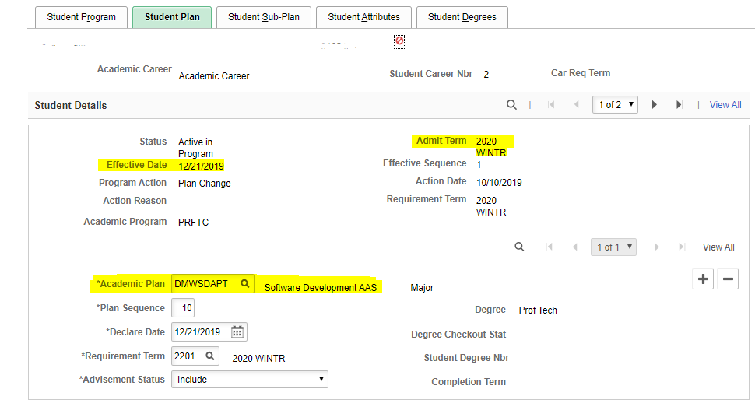

Multiple Plans in Program Stack

Ideally, there will be only instance of ACADM or PRFTC (or one of both) in the program stack, and only one active plan in either program. Due to the 2015 conversion to ctcLink, in some records there will frequently be multiple instances of ACADM and PRFTC in the stack listing different ACADM or PRFTC plans. Again, ideally, for these students there should only be one active plan and all the rest should be discontinued.

If there are multiple active plans in program stacks, click the current term in the Term Summary section, then click the Edit Term Data button. Note the CAR number, then find that plan in the program stack. That should be the student’s current program. If there is no plan with that CAR number, check the Student Program/Plan page for a future-dated program.

If in doubt, check halFILE for the latest Student Information Update form, and if still unsure, contact the student to ask what program they intend to complete.

What to do if the plans don’t match:

- If SAP is the only thing not matching, SAP will update when the job is run for the current quarter. As long as the FA Term shows the correct plan, SAP should update the plan accordingly.
- If FA Terms are the only things that don’t match (usually in this case, SAP won’t match either) and you’re certain the plan is correct in Academics, you can change the plan for the term or terms involved. (You will not need to do this if the plan was just changed that day; the system will update overnight.)

  - Navigator > Financial Aid > Financial Aid Term > Maintain Student FA Term
  - Scroll using the arrows in the Term Information section
  - For each quarter affected, click the in the Student Data section to add a new row
  - Now you can change the Prim Prog or Acad Plan (or both if necessary) to the appropriate ones
  - Click Save

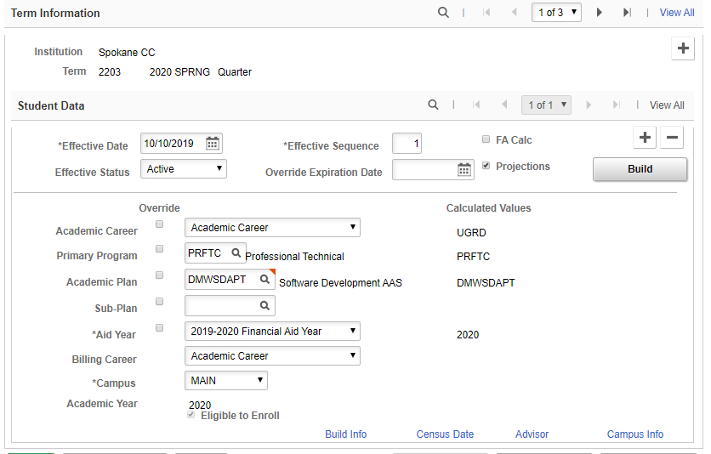

  - Navigator > Financial Aid > Satisfactory Academic Progress > Maintain Student SAP Data
  - Enter the term they will be starting and click the Calc SAP button

- If the plan in Navigator > Campus Community > Student Services Center, Academics tab, Term Summary section doesn’t match the most recent plan in Navigator > Campus Community > Student Services Center, Academics tab, Institution / Career / Program section, email the Registration team and request that the affected Term Summary quarters be linked to the correct plan. (This most frequently happens when students change from Transitional Studies to UGRD-Academic Career, but occasionally a plan will be changed without it being linked to the current term.)

Residency

Navigator > Campus Community > Personal Information > Identification > Residency Data

Academic Career: if this says “Continuing Education,” use the scroll arrows to scroll to the next row, which should say “Academic Career.”

Student’s residency is in the Official Residency Data section, Residency field.

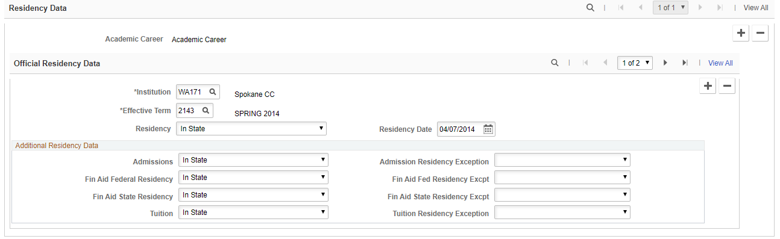

NOTE: Some students may have an exception, so they may pay in-state tuition but be a non-resident for FA purposes. There should be something noted by the exemption on the right that pertains to their situations as well as a comment on the View Financial Aid Status page. Also, be sure to look at the Residency Appeal tab regarding any notes on appeals the student may have filed. If in doubt, email the Residency Classification staff to get clarification.

Residency Mismatch

Do not complete the file and award until the residency mismatch is resolved; there is no way to tell what budget will be appropriate until they resolve the issue. Put in a Temp sleeve and notify the student of their next steps.

Non-resident in Admissions and Resident on FAFSA

- If the student will become a Washington State resident within the academic year
  - Do not change the FAFSA
  - Complete the Residency Mismatch checklist item (both tabs)
  - Student will have a non-resident cost of attendance until they are officially changed to a resident
  - Do not award state aid of any kind until we are notified by the Residency Office that the student has become a resident
    - State aid can only be funded starting with the term the student became a resident
  - Add a comment on the Financial Aid Status page to the effect of “Student will become a resident within the XX-XX academic year”

- If the student will not become a resident during the academic year
  - Instruct the student to change their state of residence and residency date on their FAFSA
  - Do not waive, complete, or cancel the Residency Mismatch checklist item – the system will waive this when the FAFSA correction is loaded
  - Do not award any state aid; the student will not be eligible at any time during the academic year
  - Add a comment on the Financial Aid Status page to the effect of “Student will not become a resident with the XX-XX academic year”

- When non-resident student becomes a resident within academic year
  - Adjust cost of attendance on the file processing worksheet for affected terms
  - Check the cost of attendance to make sure the budget updated to resident amounts; manually fix relevant cost of attendance elements if they are still showing non-resident amounts for all relevant terms
  - Award any eligible state grant aid
  - Add a comment on the Financial Aid Status page to the effect of “Student became WA resident as of XXXX Quarter”

Resident in Admissions and Non-Resident on FAFSA

- If the student actually is a resident:
  - Instruct them to change their state of residence and date of residency on their FAFSA
  - Do not complete, waive, or cancel the Residency Mismatch checklist item; the system will automatically waive this when the FAFSA correction is loaded
  - When the FAFSA correction is loaded, check the cost of attendance to make sure the budget updated to resident amounts; manually fix relevant cost of attendance elements if they are still showing non-resident amounts for all relevant terms
Navigator > Financial Aid > Budgets > Maintain Term Budgets

- If the student is actually a non-resident:
  - No FAFSA correction is required
  - Refer the student to the Residency Office to complete a residency questionnaire
  - Do not complete, waive, or cancel the Residency Mismatch checklist item
  - TEMP the file with a comment on the Financial Aid Status page to the effect of “Student indicates s/he should be coded as non-resident; referred to Residency Office” – review and awarding cannot be completed until the residency issue is resolved

Citizenship

Comment Codes

Pay close attention to what citizenship issue is reflected on the FAFSA; each requires different documents and/or resolutions. See current academic year’s SAR Comment Codes and Text for resolution on a specific comment code at https://ifap.ed.gov/ifap/publications.jsp.

Documentation
- Citizenship documents must be copies that we made of the original documents.
- For V4 or V5 verification groups, government-issued photo identification, including passports, cannot be expired
- For proof of U.S. citizenship, an expired passport is acceptable
- For third-step confirmation of citizenship status (through SAVE – formerly the form G-845), we must have the most current, non-expired documentation
- We can use documents scanned into Halfile by Admissions/Registration Office with the assumption that they took copies of the original documents

Secondary Confirmation – ISIR

If citizenship match isn’t made on the first ISIR, secondary confirmation will be needed. The ISIR will look like this on the EFC/DB Matches/Corr tab (the DHS verification number will be different for every student and every transaction):

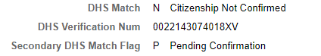

Secondary confirmation must be performed for these students and must be done through FAA Access (https://faaaccess.ed.gov/FOTWWebApp/faa/faa.jsp).

Once logged in to FAA Access, pull up the student’s record, then:
- Click the transaction number you need to correct (it most likely will be 01, but not always; there may be previous transactions SCC doesn’t have access to)
- Click the Make Corrections button
- Click Next to bypass creating a transaction password
- Click “bottom” in the links above the FAFSA data
- In Step 7, click the down arrow in the field Resend Record to Matches
- Select Yes
- Click the Submit button

CPS will reprocess the record and send an updated transaction. Look at the EFC/DB Matches/Corr tab to see if citizenship was confirmed.

- Y match flag: successful confirmation; no further steps required
- C match flag: citizenship status has not yet been verified; wait 10 business days for another ISIR with an updated match result; iIf there is no update, begin third step verification through SAVE (comment code 105)
- N match flag: immigration status was not confirmed; begin third step verification through SAVE (comment code 046)
- X match flag: DHS did not have enough information to make a determination; begin third step verification through SAVE (comment code 109)

SAVE System

Navigation: https://save.uscis.gov/web/vislogin.aspx

Occasionally, third step verification of citizenship status is required for a student. Form G-845, available from United States Citizenship and Immigration Services (USCIS), has been replaced with the electronic system SAVE. Form G-845 will still be used in rare instances, but most third-step verifications will be done through SAVE.

ISIR vs Bio Demo Mismatch & Residency Mismatch

Actual Bio/Demo Data and ISIR Bio/Demo Data
- These items must match in both sections:
  - Name (middle initial does not matter)
  - SSN
  - Date of Birth
  - Citizenship – the table below shows the only acceptable matches:

Actual Bio/Demo Data | ISIR Bio/Demo Data
U.S. Citizen | U.S. Citizen
Perm Resident  Resident | Eligible Non-Citizen
Not a Citizen  Ineligible Non-Citizen | *Ineligible for aid*

Note: Resident in Actual Bio/Demo Data is not a match for U.S. Citizen in ISIR Bio/Demo Data; it could be that the student has become a naturalized citizen and failed to provide the Admissions Office with a copy of the naturalization certificate. Mismatches in any of the above must be resolved before we can award. The Admissions office will accept a screen shot of the SSA ISIR match (match flag 4) in lieu of other documentation.

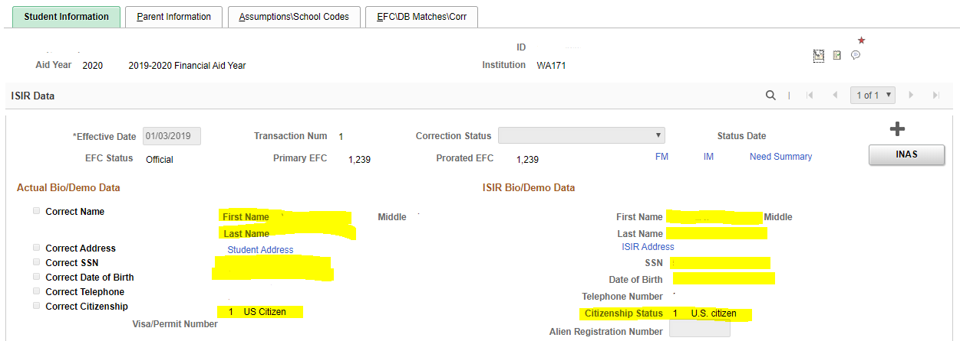

- State of residence in ISIR BIO/Demo Data must reflect the student’s residency status in the student’s admission records:

Navigator > Campus Community > Personal Information > Identification > Residency Data

  - If Academic Career says “Continuing Education,” scroll to the next row, which should be “Academic Career”
  - Washington resident will say “In State”
  - Non-resident will say “Out of State”

Residency exceptions will be noted on the right hand side of the Residency Data page in the Residency Official 1 tab. Sometimes a student can be a resident for tuition purposes but not for financial aid (such as military dependents). An exception like that would show in that section.

Residency
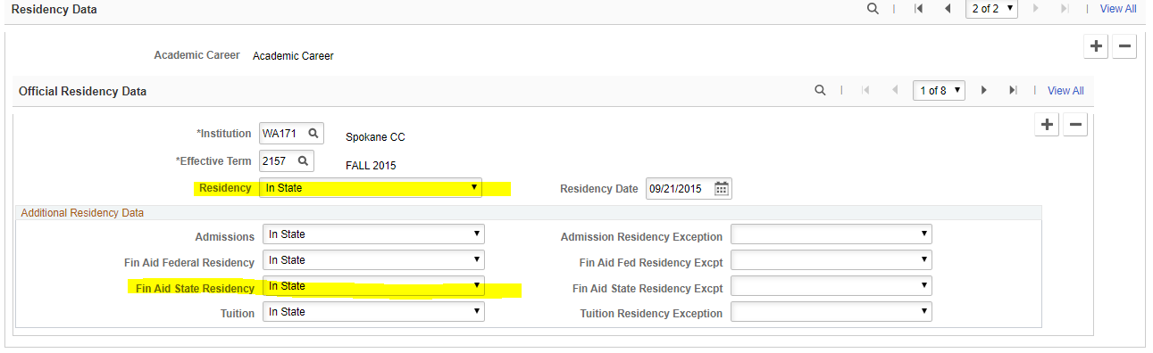

ISIR

NSLDS

https://www.nsldsfap.ed.gov/nslds_FAP/
Navigator > Financial Aid > Awards > View NSLDS Loan Data

It’s best to look at the NSLDS website rather than what is in ctcLink to get the most recent information.

- Print Loan page, Grants page, and SULA page
  - Mark each page with “PII” (Personally Identifying Information) and your initials
  - SULA information: click the Enroll tab, and then click the Subsidized Usage button

Loan Page

- Pay special attention to Pending Disbursements column
- Make sure the student hasn’t exceeded maximum aggregate loan limits for undergraduate students:
  - Subsidized aggregate: $23,000
  - Combined aggregate (subsidized and unsubsidized):
$57,500 independent students
$31,000 dependent students
- If the student is close to one or both aggregate limits, loan funds will be limited to what is left – we cannot exceed aggregate loan limits
- If the student already exceeds one or both aggregate loan limits, s/he will not be eligible for any financial aid

- Make sure there are no pending loan disbursements (Loan History):
  - If there are pending disbursements, we cannot award until the other school cancels the student’s awards and/or reports the loan changes
    - Add checklist item ESP086 (Active Aid at Another College) to student’s ctcLink record

Pell Page

- Check Pell to see if anything has been disbursed at another school (Grants):

- If the student has been awarded at another school in the current academic year, we are limited to what has not been used
  - In the example below, the student has used 50.0086% ($2,888) of the annual award.
    - If the EFC has not changed, the student would be eligible to receive 49.9914% of the scheduled $5,775 ($2887)
    - If the EFC has changed, the student is eligible to receive 49.9914% of the scheduled award for the new EFC
    - Make notes on file worksheet showing what has been used and what is remaining
  - Add a comment to the View Financial Aid Status page:
    - $2888/50.0086% used at Other University Name

Pell Lifetime Eligibility Used (LEU)

- If the Pell LEU percentage is close to or over 500%
  - Log in to the Common Origination and Disbursement (COD) system at https://cod.ed.gov.
  - Enter the student’s SSN and click the Search button
  - Click the Pell link
  - Click the Full Pell LEU History link
  - Print the Pell LEU History page and mark with PII and your initials
  - Add up all Total Percent Eligibility Used line amounts, excluding any for the current academic year
  - Subtract the grand total from 600%
  - The remainder is what is left in the student’s lifetime eligibility

Example 1: 600% - 461.6651% used = 138.3349% remaining (is OK to award a full year of Pell for current academic year)

Example2 : 600% - 561.6651% used = 38.3349% remaining (multiply full scheduled Pell award by .383349 to get maximum amount of Pell the student can receive in the current academic year: $5920 x .383349 = $2269.42 – the student can receive $2269 in Pell Grant

  - If the student is eligible for less than a full scheduled award, the remainder of eligibility must be disbursed with the full amount the student is eligible for per enrollment, with the uneven remainder in the last quarter of eligibility

Example 1: $1973 in Fall Quarter for full-time
$296 in Winter Quarter – the remaining LEU eligibility

Example 2: $1480 in Fall Quarter for three-quarter time
$789 in Winter Quarter – the remaining LEU eligibility

Subsidized Usage Limit Applies (SULA)

SULA was repealed as of June 2021.

Updating Incoming Aggregate Amounts

Navigator > Financial Aid > Awards > Aggregates > Update Incoming Aggregates

Be sure to check the incoming aggregate amounts against the amounts in NSLDS. Students apply early, and the incoming aggregates don’t update with new ISIR information.

For students who have limited eligibility for the academic year, these aggregates should be updated according to the amounts in NSLDS before awarding, so that Pell and loans don’t reject.

For others, sometimes the incoming aggregate comes in with all 9’s in the Percent Schedule Used field, which will trigger an awarding error code (usually code 9111); these students will need to be updated to the correct amount to enable awarding.

- Enter student’s EMPLID number and Search
- Click on the funding source you want to update
  - Be sure to update only SCC’s incoming aggregates; do not update SFCC’s
  - Be sure to update all funding sources
- Check Override box next to Lifetime Eligibility Used (Pell) or NSLDS Total (Subsidized and Unsubsidized loans)
- Enter the correct amount according to NSLDS
- Save

Satisfactory Academic Progress

Navigator > Financial Aid > Satisfactory Academic Progress > Maintain Student SAP Data

Student SAP Section

Do not manually run SAP UNLESS:

- The student has no SAP status (blank screen) and should be a status other than MEET, or if student should be a status other than what shows on the SAP screen

- The student’s status will be MEET or WARN and SAP page is blank and SAP job has already been run to update for the next quarter (or current quarter, if awarding after the quarter has begun)

- Follow these steps to run SAP manually:
  - Enter the term the student will start attending and click the Calc SAP button
  - If the status doesn’t change to the correct one, enter correct status in Override SAP Status and save

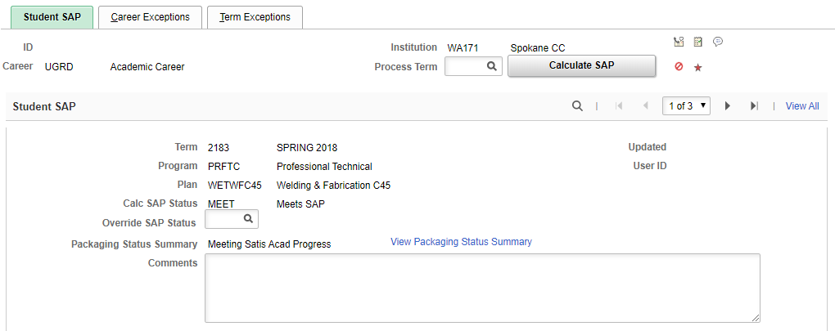
NOTE: SAP will not run if the student has alternative funding. In that instance, if SAP must be run before you award, enter in $1 of federal aid such as Pell, run SAP, and then remove the $1 from the awards page.

SAP Calculation Results
- Check cumulative earned credits to be sure student isn’t close to or over 150%
  - Look in Halfile or in previous years’ physical file to see if there is a current academic plan in place; previous plans should also be noted in comments in the previous academic year Financial Aid Status page
  - If student is close to the end of program or close to 150% of program length, request an academic plan before awarding
- IMPORTANT! If the student has not attended for several quarters, SAP might reset to MEET when it should be a different status. It is important to check the status of all students who have a SAP history.
  - Scroll through previous rows to see if there was a previous status other than MEET
  - Check student’s enrollment since the status other than MEET occurred
    - If student hasn’t attended since that term, override the SAP to what it previously was after their last term
    - If student has attended successfully since that term, no action needed
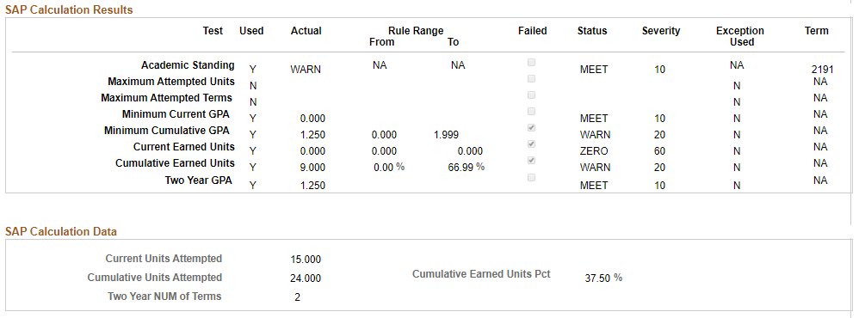
- Check to be sure a student being placed on SUSP when SAP is run wasn’t in just ABE classes that quarter (generally speaking, ABE credits are entered as an exception in the Career Exceptions tab and are entered by the Grade Team each quarter)

Simulate Student Eligibility

Sometimes the student won’t have a SAP row for the current term; this happens when the student was last enrolled in a Spring quarter and did not have a FAFSA for the upcoming academic year. This option determines the student’s eligibility without actually running SAP.

- Enter the student’s ID number in the ID field and Search
- In the Process Term field, enter the upcoming term
- Click the Calculate SAP button
- Research any status that is not financial aid-eligible to make sure the system is assessing the correct status
  - Have one of the SAP Team members look at the student’s progress if SAP status appears to be incorrect

EXHS status (formerly “GD” Suspension)

- Students who have exhausted their eligibility to appeal will need to attend at own expense, which requires an academic plan so classes and progress can be tracked
- EXHS students will be assigned a user-edit message with the Msg Type of Informational and the Msg Code of GDSUSP

SAP Contracts and Attending at Own Expense

- Students under SAP contracts
  - Are put on SAP contracts only if appealing a suspension
  - Ad hoc communications outline the terms of the contract and can be viewed in the Communications section of the Financial Aid Status page
  - SAP contract details are also noted on the Maintain Student SAP Data page in the Comments section
  - Contract terms are based on calculations performed to determine the possibility and the timeframe of getting the student back to acceptable standards
  - A User-Edit Message is added to each contracted student’s record, with the Msg Type of Informational and the Msg Code of FPLAN

- Students attending at their own expense (self-paying)
  - Academic plans are required for DTA/MRP programs
    - Technical programs don’t require an academic plan; let the SAP team know the student is self-paying to regain eligibility so that the appropriate tracking can be added to the student’s record
    - A User-Edit Message is added to each self-paying student’s record by SAP team, with the Msg Type of Informational and the Msg Code of @OWN

Graded Adult Basic Education Coursework

At this time, students who are enrolled in graded Adult Basic Education coursework are subject to satisfactory progress policies, to be applied the same as to any other student.

Non-Graded Adult Basic Education Coursework

Non-graded Adult Basic Education (ABE) credits will be excluded from the student’s SAP calculation. The number of non-graded ABE credits for the term will be added by the SAP team to the Career Exceptions tab in the Cum Att Units to Exclude field.

Actions to Take for Ineligible SAP Status

The only eligible SAP statuses are MEET, WARN, and PROB. If the student’s record displays any other status, the student is not currently eligible for financial aid funding.

For students displaying an ineligible status:
- Send the student a letter directing them to the PDF or online appeal forms
  - If the student is EXHS due to it being mathematically impossible to achieve SAP, do not have the student appeal; they are ineligible for appeals
    - If the student changes programs, alert SAP staff so the student’s requirements can be re-evaluated
  - If the student is EXHS due to exceeding number of allowed appeals, inform the student of the “at own expense” process
- Add the appropriate SAP Appeal checklist item (unless status is EXHS)
  - Check the Financial Aid Status Page first to see if there are existing SAP Appeal checklist item types already used, then choose the next one in the series
- TEMP the file in the correct color file sleeve
  - Don’t forget to add the TEMP comment on the FA Status page

SAP Status Chart
SAP Status Code | Description | Reason/Result
ACAD | SR-Academic Suspension | Student failed to meet academic standards according to policy  Student is prevented from enrolling for the period of time specified in the academic suspension service indicator
EXHS  (aka GD SUSP in comments) | Exhausted Eligibility-Calculated | Student will be unable to meet required SAP standards before degree is completed OR student has exhausted the two allowed appeals and a subsequent appeal has been denied  Student may not receive funding for that particular degree; this status can be recalculated if the student changes degrees  OR  If EXHS due to exhausting allowed number of appeals, student must attend at own expense until meeting the required standards (“at own expense” requires an academic plan)  Blocks future disbursements
FLEX | Failed Student Exception | Failed to meet terms set in Career Exceptions tab  Blocks future disbursements
MEET | Meets SAP | Student met SAP standards
PROB | Probation-Manually Assigned | Student was on a suspension status of some form, but either appealed or attended successfully at own expense
SUSP | Suspension-Calculated | Student did not meet SAP standards according to the final grade posting  Blocks future disbursement
WARN | Warning-Calculated | Student did not quite meet all SAP standards but enough to avoid Suspension; must meet all requirements in the next term to avoid suspension
ZERO | Zero Units Earned-Calculated | Student earned no passing grades (all 0.0 or Z grades) according to the final grade posting (occasionally calculates ZERO for official withdrawals)  Blocks future disbursements

Verification

There are three steps to the verification process: Manage 20xx-20xx Verification, Perform Auto Verification, and Correct 20xx-20xx ISIR Records.

Step 1: Manage 20xx-20xx Verification

Navigator > Financial Aid > Verification > Manage 20xx-20xx Verification

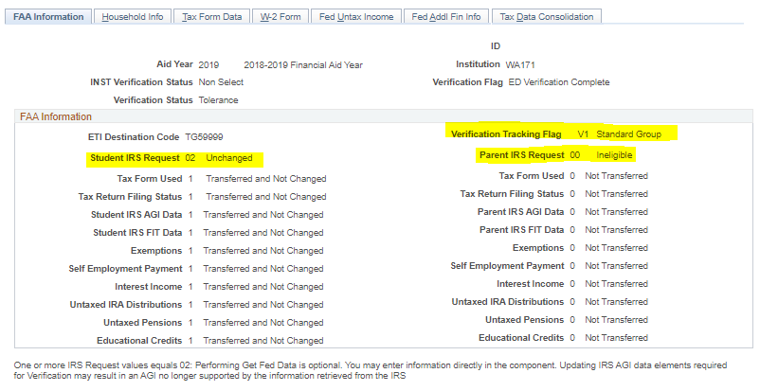

Tabs we use:

- FAA Information tab
  - Student IRS Request: 02 Unchanged means student or parent used the IRS Data Retrieval Tool and did not change anything after the data was imported to the FAFSA
    - Anything other than 02 Unchanged requires a paper tax return or transcript
  - Verification Tracking Flag: Shows the type of verification
    - Make sure the student submitted the appropriate verification worksheet
      - We can verify a V1 verification using the V5 verification worksheet if the student mistakenly turned in the wrong one; V5 contains everything required to be verified on V1

- Household Info tab
  - Click the Get Fed Data button
    - If Independent, compare number in household to the verification worksheet
      - Correct the numbers according to the verification worksheet
      - Check the box next to Override Family Members
    - If Dependent, scroll to the next row and compare the household number to the verification worksheet
      - If the parents are divorced, make sure the student is using the same parent on the verification documentation as on the FAFSA
      - Correct the numbers according to the verification worksheet
        - Remember that if the parent is also in college, they cannot include themselves in the number in college

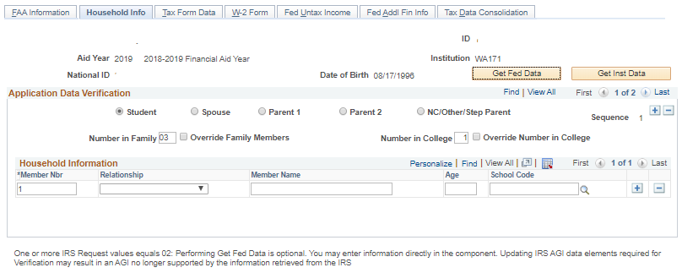

- Tax Data Consolidation tab
  - Click the Consolidate button

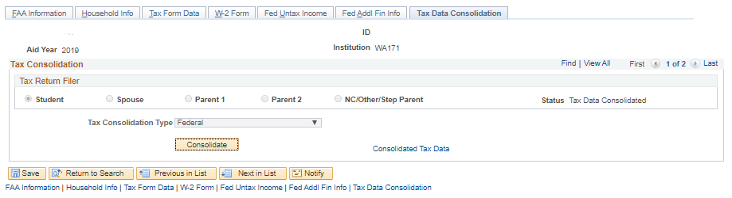

  - Once the data has been consolidated, click the Consolidated Tax Data link
    - All required verification fields will show here. Verify only what is required by the type of verification it is (Required Fields for All Verification Tracking Groups)
    - Make any necessary corrections
    - Click OK
    - Click Save – even if you made no changes

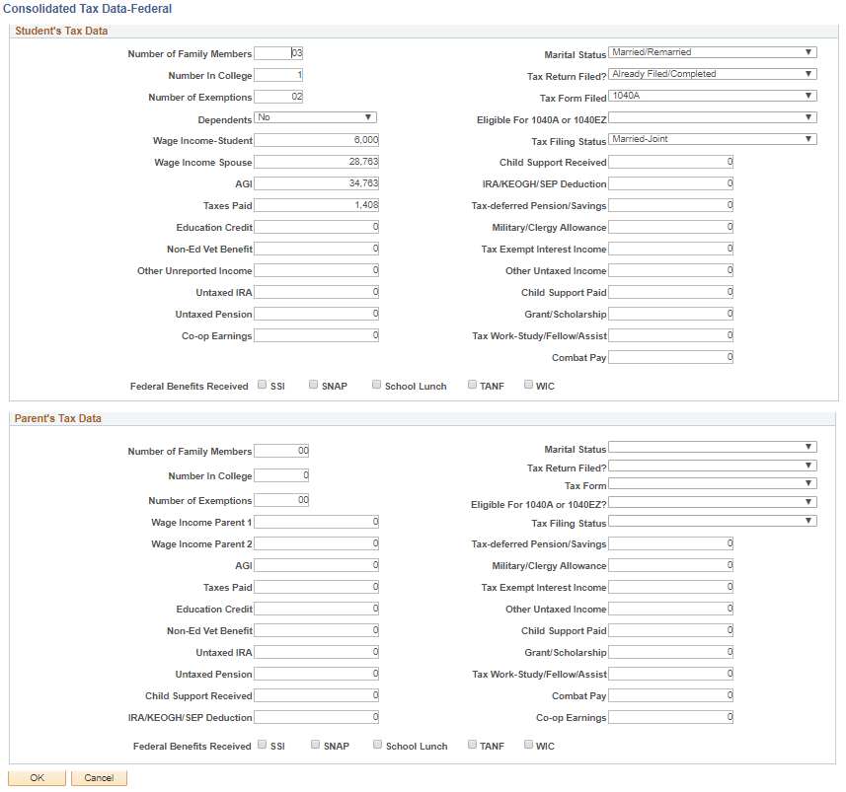
Other tabs: (most of these will be pulled into the Tax Data Consolidation)

- Tax Form Data tab (generally not used)
- W-2 Form tab (generally not used)
- Fed Untax Income tab
- Fed Addl Fin Info tab
- Inst Untax Income

Step 2: Perform Auto Verification

Navigator > Financial Aid > Verification > Perform Auto Verification

NOTE: In the comment section of the File Processing Worksheet, enter the transaction number you are verifying and whether you sent a correction
(EXAMPLES: “Verified #03 – sent corr” or “Verified #03 – no corr”)
- Verification Type: (should already be set to “Federal”)
- Source: Tax/Verif
- Target: ISIR
- If you had to make corrections, check the box next to Set to Send ISIR Correction
- Click the Perform Compare button and look at Pass or Fail (in the Results section)
  - If Passed, print this page and attach to the verification documentation
    - Click Save
  - If Failed, click the Field Comparison Detail link
    - Check the box for “Apply” next to the changes you made in Step One
    - Print this page and attach to the verification documentation
    - Click OK
    - Click Apply Changes
    - Click Save

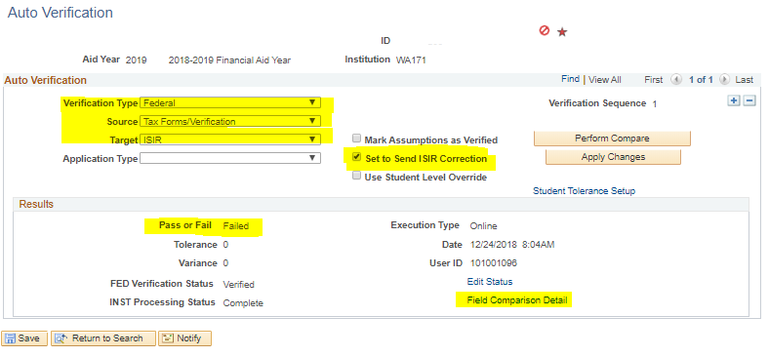

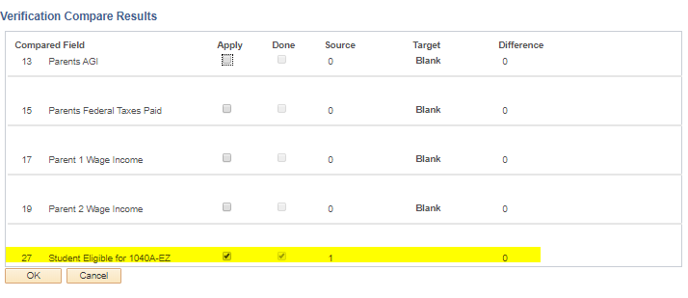

Step 3: Correct 20xx-20xx ISIR Records

Navigator > Financial Aid > Federal Application Data > Correct xxxx-xxxx ISIR Records (you will use the current academic year in place of xxxx-xxxx)

- The ISIR Correction Status should already be set to Send Correction(s)
- Click the INAS button
- The new EFC should be calculated, with the EFC Status being Unofficial

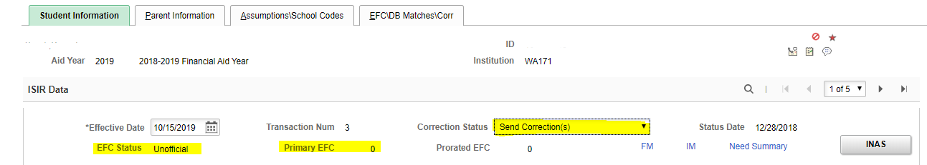

Required Fields for All Verification Tracking Groups

(Greyed out groups are not currently being used by Department of Education)

Flag | Required Fields
V1 (Standard) | Tax Filers  - Adjusted Gross Income  - U.S. Income Tax Paid  - Untaxed Portions of Individual Retirement Account (IRA) Distributions  - Untaxed Portions of Pensions  - IRA Deductions and Payments  - Tax Exempt Interest Income  - Education Tax Credits  Nontax Filers  - Income Earned from Work  Tax Filers and Nontax Filers  - Number of Household Members  - Number in College
V2 (SNAP)  (inactive) | - Snap benefits for prior year and prior-prior year
V3 (Child Support Paid)  (inactive) | - Child Support Paid by the student (or spouse), the student’s parents, or both, if indicated on the ISIR
V4 (Custom) | - High School Completion Status removed as of 2022-23 AY  - Identity verification  - Statement of Educational Purpose
V5 (Aggregate) | Tax Filers  - Adjusted Gross Income  - U.S. Income Tax Paid  - Untaxed Portions of IRA Distributions  - Untaxed Portions of Pensions  - IRA Deductions and Payments  - Tax Exempt Interest Income  - Education Tax Credits  Nontax Filers  - Income earned from work  Tax Filers and Nontax Filers  - Number of Household Members  - Number in College  - High School Completion Status removed as of 2022-23 AY  - Identity verification  - Statement of Educational Purpose
V6 (Household Resources)  (inactive) | Tax Filers  - Adjusted Gross Income  - U.S. Income Tax Paid  - Untaxed Portions of IRA Distributions  - Untaxed Portions of Pensions  - IRA Deductions and Payments  - Tax Exempt Interest Income  - Education Tax Credits  Nontax Filers  - Income Earned from Work  Tax Filers and Nontax Filers  - Other Untaxed Income on the 2015–2016 FAFSA–  - Payments to tax-deferred pension and savings (Questions 45a and 94a)  - Housing, food, and other living allowances paid to members of the military, clergy, and others (Questions 45g and 94g)  - Veterans noneducation benefits (Questions 45h and 94h)  - Other untaxed income (Questions 45i and 94i)  - Money received or paid on the applicant’s behalf (Question 45j)  - Number of Household Members  - Number in College

Tax Transcript Decoder

Navigation: https://www.nasfaa.org/tax_transcript_decoder

- Do NOT include any amount from Other Taxes
- Schedule C can be used as proof of business income from line 12; not all business income will generate a 1099-MISC form

Taxes Paid Clarification:
Use these lines to calculate the actual amount of tax liability.

2020 Tax Return Tax Transcript
1040 Line 22 Total Tax Liability TP Figures Per Computer
-Schedule 2, Line 2 -Excess Advance Premium Tax Credit Repayment
=Income Tax Paid =Income Tax Paid

ISIRs in ctcLink

Anatomy of an ISIR in ctcLink

Navigator > Financial Aid > Federal Application Data > Correct 20xx-20xx ISIR Records

ISIRs in ctcLink can be confusing at first. Below is a guide to help locate the information needed for file review.

All Tabs
ISIR Data (carries over to all tabs)
Transaction number
EFC status
Primary EFC
Prorated EFC
Correction status

Student Information Tab
Actual Bio/Demo Data (from Records & Enrollment side)
Name
SSN
Date of Birth
Citizenship
ISIR Bio/Demo data
Name
SSN
Date of Birth
Citizenship
Alien Registration Number
Student Data – Background Info
State of residence
Residency date
Degree/certificate working toward
Grade level
High school/GED completion
High school information
Bachelor’s degree by July 1 of current year
Interested in Work Study
Drug conviction information
Student Data – Financial Information
SSI – WIC – SNAP – TANF – School Lunch
Dislocated worker
Tax filing status
Tax return information
Other income information
Child support paid and received
Veteran’s non-educational benefits
Military allowance (BAS/BAQ)
Student Data – Dependency Status Information
Step Three FAFSA questions to determine dependency
Marital status
Dependency status
Student Data – Independent Student Information
Number in family
Number in college

Parent Information Tab
Parent Data – Background Information
Marital status
Marital status date
State of residence
Residency date
Number in family
Number in college
Parent Data – Financial Information
SSI – WIC – SNAP – TANF – School Lunch
Dislocated worker
Tax filing status
Tax return information
Other income information
Child support paid and received
Veteran’s non-educational benefits
Military allowance (BAS/BAQ)

Assumptions\School Codes Tab
Miscellaneous Information
Dependency Override information
Adjusted EFC Calculation Requested
Applicant/Parent signature information
Student Data – Housing\School Code Information
Housing code
Assumptions and Reject Overrides
Assumptions to be reviewed
Reject codes to be reviewed
FAA Information
Process dates – CPS and institution
Change flags for Rejected status, C flag, and verification select
Flags for CPS pushed ISIR, Duplicate SSN code, and Special circumstances
Student IRS Flags
Data Retrieval flags
Reject Reasons
Reasons for rejected transaction
Comments
Comment codes and text
Field Review
Highlighted fields on ISIR that should be reviewed

EFC\DB Matches\Corr Tab
EFC Information
Primary, Secondary, and Prorated EFC
EFC Change flag
Monthly EFC
EFC Formula Type
Intermediate values used for EFC calculation
Database Matches\Flags
SSA, Selective Service, DHS, VA, Dept of Defense, & NSLDS match flags
Secondary DHS match flag and verification number
TIV Eligibility
Pell Eligibility
Corrected\Verified Fields
Fields corrected against previous transaction/s
Correction source

ISIR Review

Using Previous ISIRs

Navigator > Financial Aid > File Management > ISIR Import > Delete ISIR/NSLDS Records

If reviewing and awarding on a previous ISIR rather than the most current ISIR
- Delete all ISIRs after the one you are using so that the correct information is loaded into the system
  - This must be done before awarding

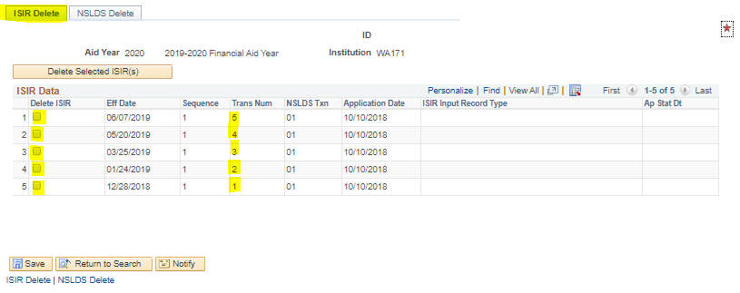

Information to Review

Student Information tab

ISIR Data:
- Make sure there is an official EFC; if it is Unofficial or Rejected, you cannot award on this transaction

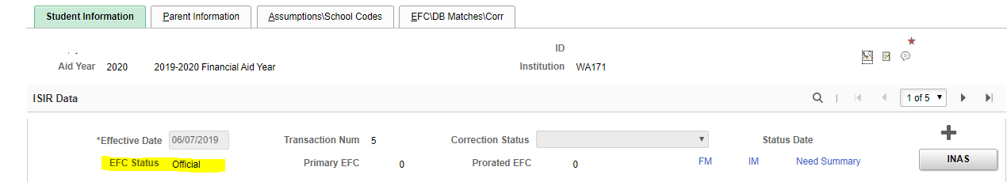

Student Data – Background Info
- Current grade level should not be greater than 2nd yr Sophomore
- Must have high school diploma or GED – cannot say “None of the above”
- High school name, code, city, and state should not be blank (this information may be slightly different for foreign high schools)
- Rcvd 1st Bach Deg by July 1, 20xx
  - If yes, student is eligible for only student loans and we may require an academic plan depending on the student’s program of study
    - If student is accepted into an AAS program, we generally do not need an academic plan
- Interested in Work Study
  - Yes – check the date the student filed the FAFSA (on Assumptions/School Codes tab)
    - If April 1 or before, check “Yes” on the worksheet
      - If we’re out of work study funding, write “out of funds” below it
    - If after April 1, check “No” on the worksheet
  - Drug Conviction Affecting Elig
    - No – eligible for funds
    - Yes (Part Year) – have student complete Question 23 worksheet to determine date of eligibility or submit confirmation of completion of acceptable drug rehabilitation program – there should be a SAR Comment Code of 054
    - Yes/Don’t Know - not eligible this academic year – there should be a SAR Comment Code of 056
Comment codes are available on the Assumptions/School Codes tab

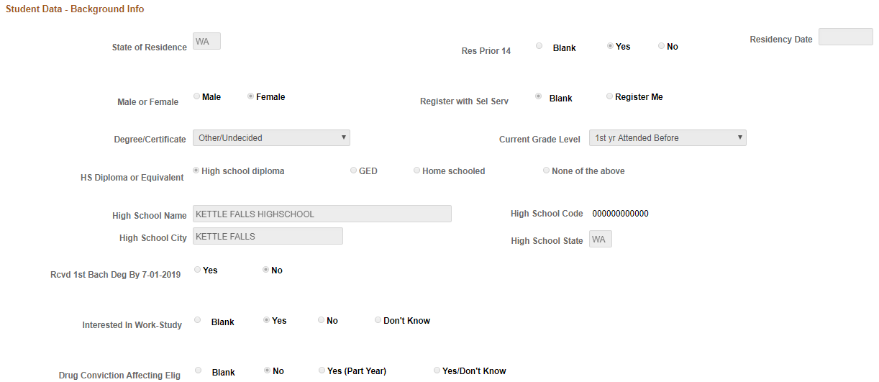

Student Data – Financial Information
- Tax Return Filed
  - Cannot say “Will File” – this must be updated before we can award (student must file taxes or update information on the FAFSA)
- Tax Filing Status
  - Should match student’s marital status except in cases of:
    - Recent separation or divorce
    - Marriage that occurred after filing of taxes but before filing of FAFSA
- Scan income information – you may need to request clarification or additional information if any amounts seem questionable or if amounts are too low to support listed household size
  - Military allowance may indicate student received BAH/BAS, which may require adjustments to the budget

Per guidance in May 2015:
        - Independent students who receive BAH (military housing allowance) – reduce COA by Room portion:
          - See current academic year COA chart
        - Dependent students who are living with parents who receive military housing allowance or who live on a military base
          - Do not reduce as COA only includes Board costs

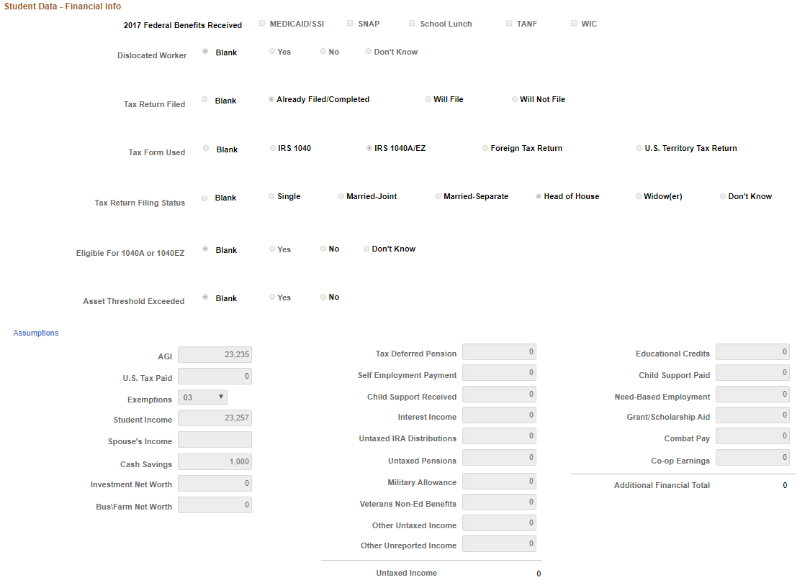

Student Data – Dependency Status Information
- Things to watch for:
  - Graduate Student
    - If yes, student should also have said Yes to the “Rcvd 1st Bach Deg by 7/1/20xx” question
    - If student answered No to “1st Bach Deg” question, the answer to the “Graduate Student” question is probably No – seek clarification from the student
  - Marital Status – if Married, the student’s Marital Status should be either Married or Separated
  - Marital Status Date – can be a good indicator on whether the student divorced or remarried after taxes but before filing the FAFSA
  - Dependents (other than children) – if this is the only factor that determines a student is an Independent student, documentation will be required to support the claim
    - Documentation should be a statement from adult dependents, or a statement from the student if dependents are minors
    - The statement should include income amounts for adult dependents
    - If the EFC will not be impacted by excluding dependents other than children, there is no need to take any action
  - Emancipated Minor/Legal Guardianship/Orphan, Ward, Foster Care/Youth Determined by SDL/Unaccompanied Youth (HUD)/Risk of Homelessness – these may require additional documentation such as court documents, letters from the student’s McKinney Vento Homeless liaison at their high school, etc.
  - Number in Family & Number in College – anything over 1/1, make sure student is married or has checked the buttons for children and/or other dependents

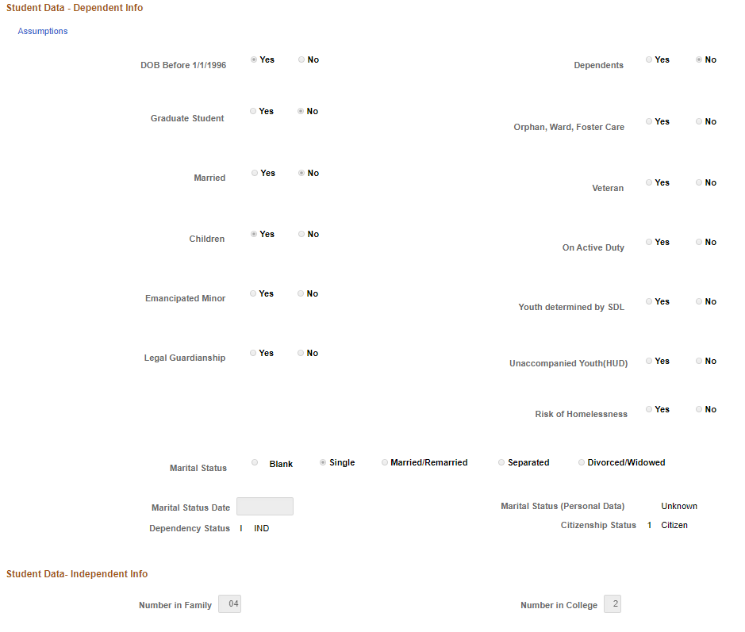

Parent Information tab (Dependent students only)

- Family size
- Number in household
- Marital Status – can’t list Divorced or Separated and include spouse income
- Marital Status Date – can be a good indicator on whether the student divorced or remarried after taxes but before filing the FAFSA
- Tax Filing Status: make sure this matches Marital Status
  - If they don’t match, look at Marital Status Date
- Scan income information for anything that looks unusual

Assumptions/School Codes tab

This tab shows any professional judgments, schools and housing options, assumptions made by Department of Education in order to process the FAFSA, reject overrides, flags, processing dates, and comments.

- Housing code will determine the budget the student is assigned
- Assumptions may require resolution
- Special Circumstances flags may require additional documentation from the student
- Comments may show items that require resolution or special attention

EFC/DB Matches/Corr tab

This tab gives general information about the EFC formula, database match flags, and corrections submitted.

- SSN Match: 4 SSN, Name, and DOB Match
- Title IV Fund Eligibility: Y
- Federal PELL Eligibility: If this is No, follow up to determine why

Monthly EFC link: This gives a breakdown of the EFC by month
- Check 11-month amount for EFCs greater than zero – it could differ from the 9-month EFC

FM link: This allows you to adjust the monthly EFC according to how many months the student is attending, if less than or more than 9
- INAS Rule Set: select CSS Rules – the rest of the necessary fields will automatically populate
- Click Budget Durations
- Enter number of months student will attend
- Click OK
- Click OK again
- Click the INAS button
- The new EFC will show in the ISIR Data section as Prorated EFC
- You must change the EFC months even if the EFC is zero if the student is attending less or more than an academic year; otherwise, it impacts the Unit Record and will cause numerous edits that have to be corrected

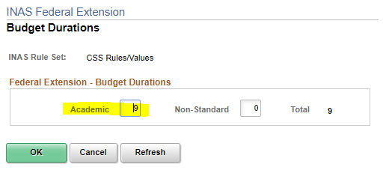
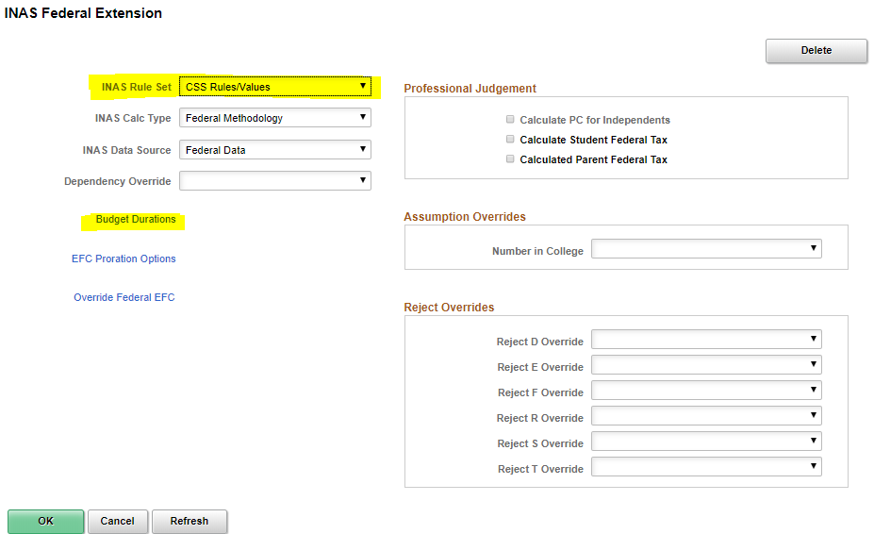

New ISIRs After File Has Been Reviewed

In addition to checking new ISIR transactions for changes that may impact the student’s eligibility, new ISIRs may trigger new flags within ctcLink. Many of these will come in as Suspended. To review changes, use either the Compare Transactions in FAA Access or the suspended ISIR file: Navigator > Financial Aid > File Management > ISIR Import > 20xx-20xx Suspense Management.
Be sure to check the following for every new ISIR:
- New checklist items
  - If the issue resolved, flip to Completed on both tabs
- Database matches
  - If a database match has been previously overridden, the new ISIR will overwrite that; redo the database match override (Pell LEU, SULA, Selective Service, etc)
- For students previously selected for verification
  - Verification flags to see if the student’s verification group has changed
  - New checklist items for verification documentation (if verification group changed)
- For students not previously selected for verification
  - Verification flags
  - New checklist items for verification documentation
- Any CPS-pushed ISIR must be loaded
  - In 20xx-20xx Suspense Management page, click on the suspended ISIR in the list
  - Check the ID Lock box
  - Click Add ISIR
  - Click the Process ISIR button
  - Click Save
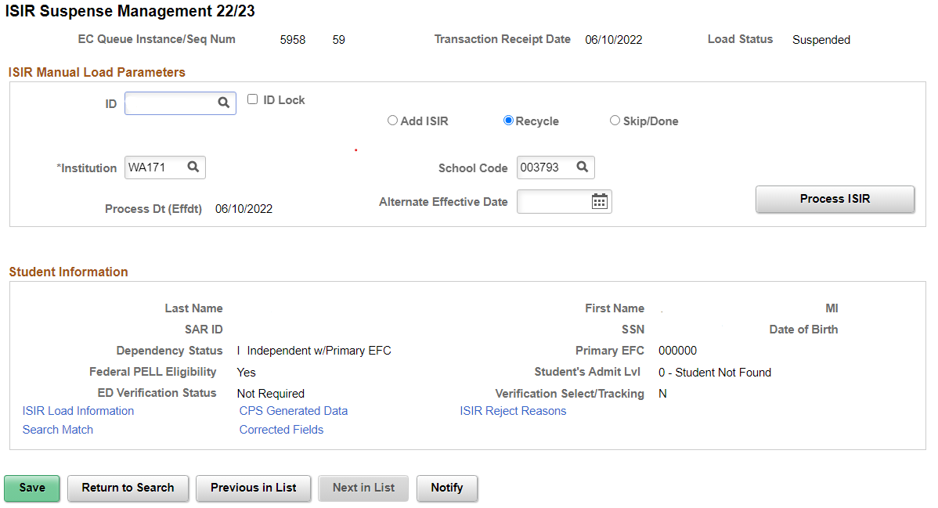

Add an F01 service indicator to clock disbursements if a new ISIR has been selected for verification, or the verification group has changed for a previously verified application. Otherwise, funds might be disbursed before verification is completed once the verification checklist items are marked completed. Use F03 service indicator if disbursements have already been run.
Add a new comment to the View Financial Aid Status page, using the ISIR comment category:
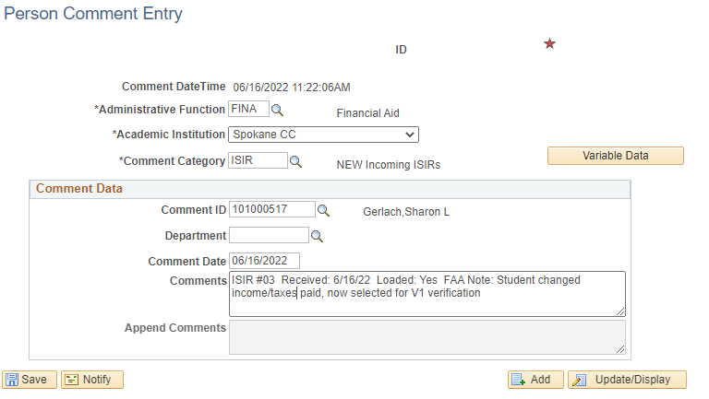

Submitting Corrections on Non-Verification Files

Occasionally, you may need to send a correction on a file that was not selected for verification, such as in the case of a professional judgment.

Navigator > Financial Aid > federal Application Data > Correct 20xx-20xx ISIR Records
- Click the + to add a new row
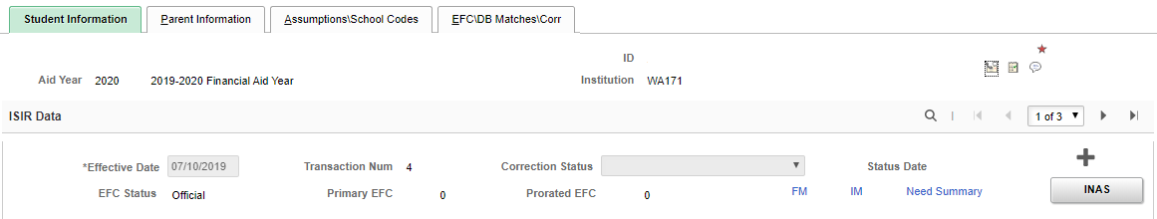
- Make the necessary changes
- If the change is due to a professional judgment, do one of the following on the Assumptions/School Codes tab according to the student’s circumstances:
  - Dependency Override: click the radio button next to Dependent to Independent
  - Homelessness determination: click the radio button nest to Homeless Youth determination
  - Change of financial circumstances or other allowable situations: check the box next to Adjusted EFC Calc Requested
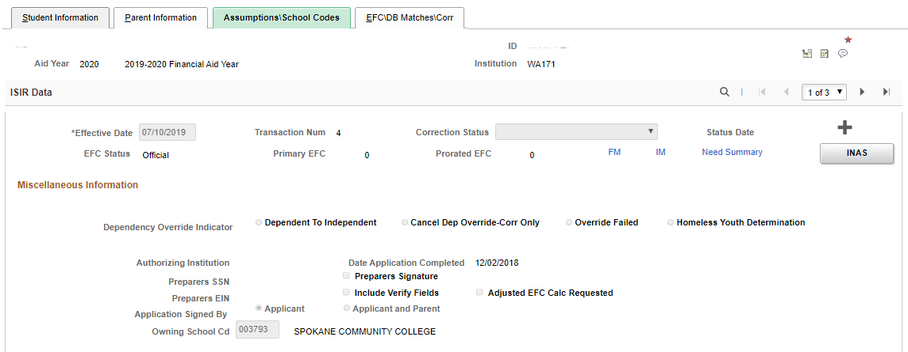
- Change Correction Status to Send
- Click INAS
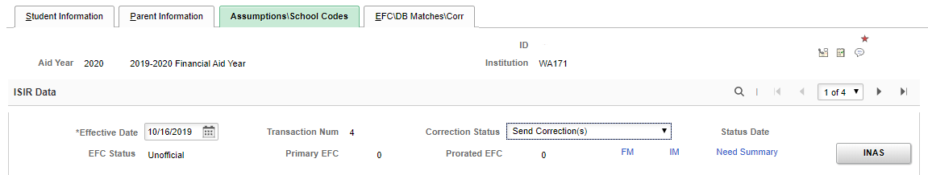

Changing Marital Status

A student’s marital status may be updated after the FAFSA is filed in specific circumstances to give a more accurate picture of the student’s ability to pay or to address an inequity. Please follow guidance in the FSA Handbook to determine when a student’s status may be updated.

If it is determined that a marital status update is allowed under regulations, it is best to do the update directly in FAA Access, so that ED software can verify the information being entered to avoid a rejected ISIR.

However, if a student’s marital status is updated through ctcLink and the new transaction is rejected, it is easily fixed. Simply redo the correction directly in FAA Access; ED software will confirm the changes being made before submission, and the new transaction will not reject.

Academic Plans

Academic plans are generally needed only for DTA/MRP programs, although one may be requested for a professional/technical program if the student has a lot of substitutions or is taking coursework not required for their listed program of study.

Previously Approved Academic Plans

Tracking an Academic Plan from a Prior Year

Navigator > Financial Aid > View Financial Aid Status (Comment section)
Navigator > Campus Community > Comments > Comments – Person > Person Comment Detail

The specific conditions of a Financial Aid academic plan should be noted as a Comment in the academic year in which the plan was approved. Comments appear on the View Financial Aid Status page or can be viewed in Person Comment Detail.

It is helpful to staff working before-quarter reports for a previous academic plan to be noted in the current year’s comments, for example: “Previous academic plan approved thru F21 for Biology DTA”.

View Financial Aid Status Page
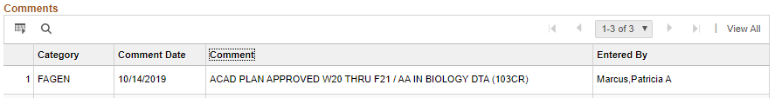

Person Comment Detail
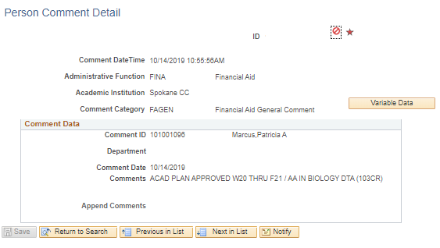

New Academic Plans

Tracking a New Academic Plan

Navigator > Financial Aid > View Financial Aid Status

Click the Comment icon at the upper right hand side of the screen

A new page will open for entering the comment. Be sure you select the correct academic year in Variable Data to it shows up in the right View Financial Aid session

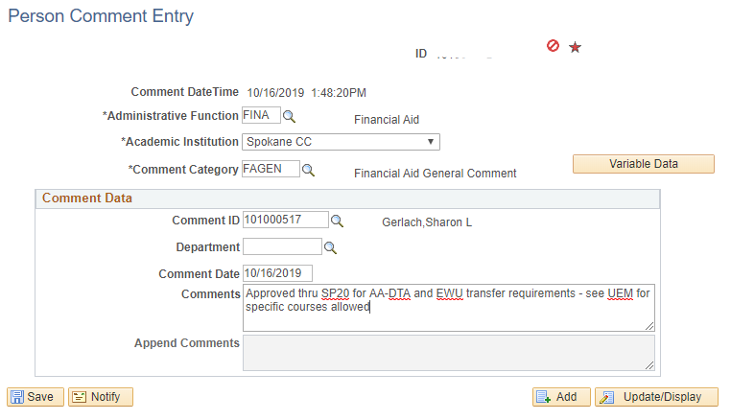

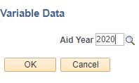

*Add a User Edit Message only if the plan is very restrictive (a few specific classes only)

User Edit Messages (UEM)

Navigator > Financial Aid > View Financial Aid Status (Edit Messages section)
Navigator > Financial Aid > Disbursements > Maintain User Edit Messages

User Edit Messages (UEM)* block financial aid from being disbursed until restrictions on the student’s eligibility have been checked. This replaces the old HR/IR track codes and report from the legacy system.

They are academic-year specific but are carried over from term to term by changing the Term after the student’s restrictions are checked and schedule or program is confirmed as acceptable.

*User Edit Messages should only be placed for unusual or restrictive circumstances

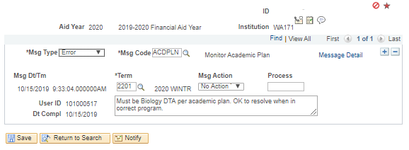

Reasons for User Edit Messages:

- Academic plan is limited to a very few, specific courses or a particular program
- Student consistently doesn’t follow program outline or academic plan
- Student is waitlisted for a program and is ineligible until admitted
- Student is on FA contract and pace/GPA must be checked before disbursing
- Student has exhausted allowed petitions and is attending at own expense
- Repayment arrangements were made with Department of Education (requires FSA repayment arrangement letter)

Maintenance of UEMs

- Update the remaining courses required when moving a “limited classes” UEM forward – such as add a “Completed” section at the bottom of the UEM comment and move completed coursework there so that remaining coursework is clear
- If the student must be coded in certain program by a specific quarter, enter that quarter in the *Term field; don’t enter current term and keep moving it forward until accepted
  - If waitlisted for a program or has finished prerequisites or didn’t get admitted this round, enter the next entry quarter for the program (some are Fall only starts, etc)
- If the student gets admitted or otherwise resolves the reason for the UEM, please mark the UEM as resolved; don’t keep moving it forward
- DO NOT USE UEMs FOR LISTING ACADEMIC PLAN REQUIREMENTS unless you are strictly limiting classes or the student has a history of not following academic plans or program outlines
  - These are not for tracking academic plans for several quarters; they are for making sure the student completes their last few credits
  - Track general academic plans on the View Financial Aid Status page in a comment

Checklist Items

Navigator > Financial Aid > View Financial Aid Status,
Navigator > Campus Community > Checklists > Person Checklists > Checklist Management-Person

- Check for any incomplete checklist items
  - The easiest way to do this is in View Financial Aid Status in the Checklists section

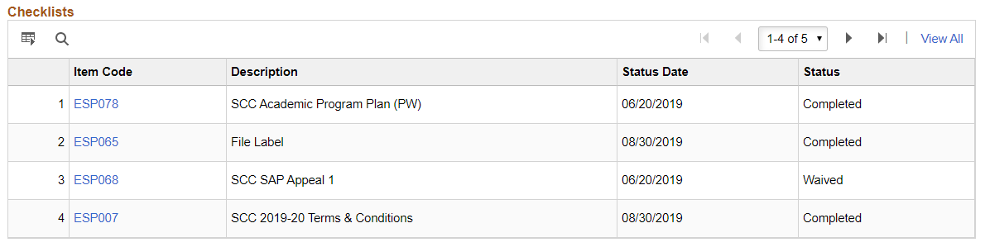

- Mark completed if appropriate and change the Responsible ID number to your ID number
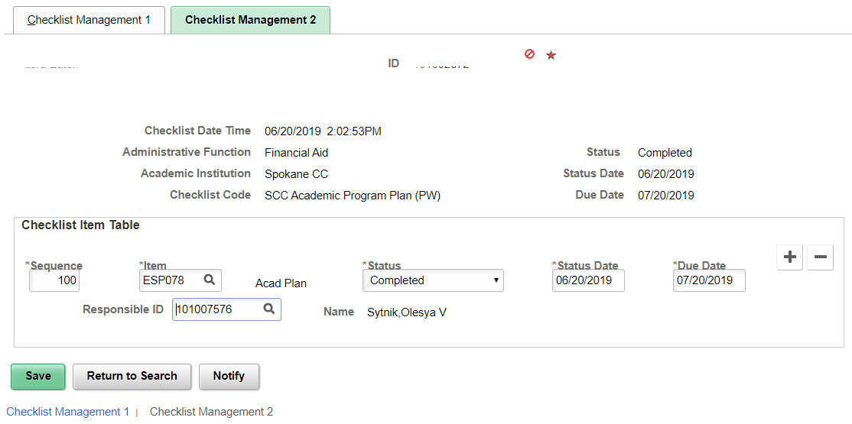

Rollover Checklist Items

Rollover checklist items from the previous academic year(s) are designated with Tammy Zibell’s EMPLID number for clarification, beginning 2020-2021 academic year.

Waiving vs Completing vs Cancelling Checklist Items

- Waived = automated system action; won’t have supporting documentation in most cases
  - In some circumstances, staff might waive a required document due to ED guidance (such as verification requirements being waived in the 21-22 academic year)
- Completed = staff action; will usually have supporting documentation
- Cancelled = staff action; might have documentation depending on the checklist item
  - Don’t complete if we don’t have documentation; cancel instead (such as with BA=yes on FAFSA but student gives us a statement that they do not have a BA degree, do not mark Completed, as staff may in later academic years look for confirmation that the student has earned a BA degree)

File Processing Comments

Navigator > Financial Aid > View Financial Aid Status

Comments are the history of the file review and packaging process and serve as documentation for delays in packaging, requests for additional documents, and other important issues. They should never be deleted (unless added to the student’s record in error), but they can be amended when the situation has been resolved.

To Add a Comment

Click the comment icon at the top right of the page to add comments for:
- ISIR transaction and EFC used to package
- Academic Plans
- TEMP and reason why the file can’t be completed
- Professional judgments
- Any other unusual situation that should be documented
- Follow the established protocol for comments as listed in the Comment Categories section

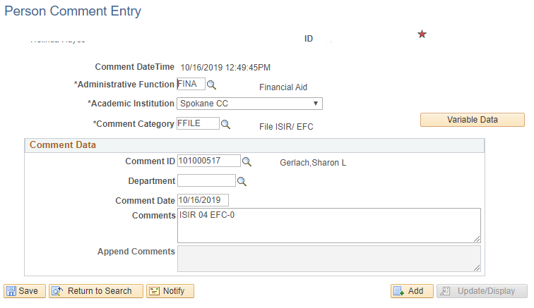

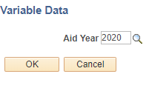

To Edit a Comment

Navigator > Campus Community > Comments > Comments – Person > Person Comment Summary

- Enter the student’s ID number and click Search
- Click the Search button to bring up all existing comments
- Click the Edit link beside the comment to be edited
- Make the desired changes
- Click Save

Comment Categories

ADMINISTRATIVE  FUNCTION | COMMENT  CATEGORY | USE:
FINA | FAGEN | Used for general, non-award or non-packaging related comments and TEMP comments  EXAMPLES: “Gave D.O. at front desk” or “Not attending 18-19 per phone” or “TEMP – need student’s nonfiling verification letter from IRS”
 | TEMP | Used to document why the student’s file cannot be completed
 | FFILE | Used to track ISIR and EFC only  ISIR transaction can be inserted after the word ISIR and EFC after EFC (ex: ISIR 02/EFC-2154) or just enter both numbers after the leading text (ex: ISIR/EFC: 02/2154
 | FCANCL | Used for tracking cancelled checks, reversed refunds, and unclaimed property  Please use the following protocol when tracking:  Reversed refund: Term, $amount, reversal reason  Unclaimed property: Term, $amount, what it was applied to  Manual check: Term, $ amount, reason for cancellation
 | FAWDS | Used for information that specifically impacts awarding or packaging  EXAMPLES: PLEU, loan aggregates, SULA; any other unusual thing related to the student’s awards
 | FLOANS | For Ronda’s use only – used for tracking reductions or eligibility comments
FINT | FRECAL | Used for tracking recalculation of aid due to dropped classes during census  Please use the following protocol when tracking:  R/C F18 - 10CR to 5CR - Reduced Aid
 | FREDUC | Used for when student is paid at a lower enrollment level  EXAMPLE: “Paid F18 @ 10CR; PSYC 200 not required for program”
 | FREPAY | Not in use at this time; reserved for future use

Budget Adjustments

If increasing for actual tuition costs
Navigator > Financial Aid > Budgets > Maintain Term Budgets

If student’s actual tuition costs exceed the built-in tuition amount in the cost of attendance, it is acceptable to increase the COA tuition element by the difference.
- If adding for one term:
  - Click the + in the Budget Group section
  - In the TUIT line, enter the actual tuition costs
  - Click Save
  - Click Update Need Summary button

If adding program costs (such as tool allowance) to a student’s budget

- If adding for all terms attended:
  - Divide the amount being added to the budget by the number of terms attending
  - For each term being adjusted, click the + beside the last item in the list
  - In the blank line added, enter:
    - Category: PLAN
    - Item code: PLAN
    - Amount: the amount being added for that term
    - DO NOT add the program costs to an existing line; add a new line and use PLAN
    - Click Update Need Summary button
- If adding for one term:
  - Click the + beside the last item in the list
  - In the blank line added, enter:
    - Category: PLAN
    - Item code: PLAN
    - Amount: the full amount you’re adding
    - Click Update Need Summary button

If cost of attendance is missing a quarter
Navigator > Financial Aid > Budgets > Create Student Budget
- If the student just registered that day, wait until the next day to award; the term and budget will rebuild automatically overnight
- Otherwise, enter term in Term field and click Build Budget for each term that should be included in the budget
- When all have been built, click Move Budget

If funding fewer credits than the student is enrolled
Navigator > Financial Aid > Awards > Award Processing > Assign Awards to a Student
- Adjust math on the worksheet; COA in the worksheet calculations will need to be adjusted for the enrollment level being funded
- Adjust the award down to the correct amount for the credits we are funding
- Loans may need adjusted downward due to budget decrease
- Validate
- CHECK DISBURSEMENTS AFTER VALIDATING TO MAKE SURE NOTHING MOVED!!!
- Post
- CHECK DISBURSEMENTS AFTER POSTING TO MAKE SURE NOTHING MOVED!!!
- Add a comment to the View Financial Aid Status page (see To Add a Comment for steps)
- DO NOT CHANGE ANYTHING ON THE FA TERM PAGE!!
- Do not adjust the budget; it will only revert to the original amounts overnight

Prepare Student Record for Packaging

Navigator > Financial Aid > View Packaging Status Summary

Non-Verification Files

- Counselor: enter your ID number
- Academic Career: UGRD (should already be populated)
- Aid Processing Status: Ready for Packaging
- Aid Application Status: Active (should already be populated)
- Review Status: Complete
- Click Save
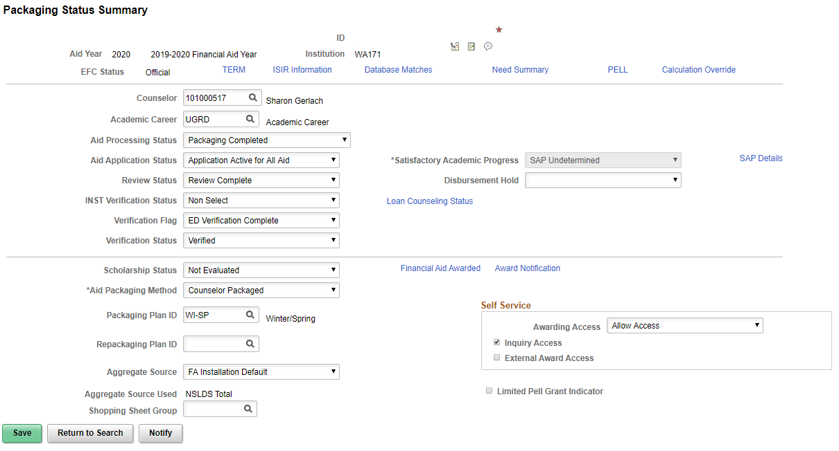

Verification Files

In addition to the above fields, also complete the following fields:
- Verification Flag: ED Verification Complete
- Verification Status: Verified
- Click Save

Database Match Override

Some messages may require database match overrides. Be sure appropriate documentation supporting the override has been submitted before initiating an override.

Navigator > Financial Aid > View Packaging Status Summary

- Click the Database Matches link at the top of the page

- Check the box beside the database match you want to override
- Click OK
- Click Save on the View Packaging Status Summary
- Go back to Awards and try awarding again

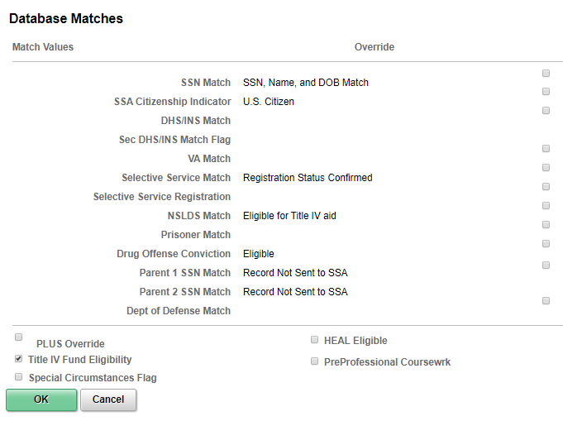

Package Awards

Navigator > Financial Aid > Awards > Award Processing > Assign Awards to a Student

IMPORTANT NOTE 1: If reviewing before Summer term registration begins ( the student will not be enrolled in Summer Quarter courses), package for FWSP. Assign the checklist item ESP135 so the student is notified that Summer enrollment is required before we can add Summer aid.

Use disbursement plan 09 (SUFWSP) when awarding to open all quarters’ “buckets.”

IMPORTANT NOTE 2: Do not package the funding the same day that a new ISIR loaded into the system. If packaging on a newly loaded correction to an ISIR, wait until the day after it is loaded so that the Washington College Grant and College Bound Scholarship pages can update with the student’s most current eligibility. Check the Washington College Grant and College Bound Scholarship eligibility pages before awarding to make sure the information has updated since the new ISIR was loaded.

Navigator > Financial Aid > CTC Custom > CTC Interfaces

Make sure the budget is correct
- Click the Need Summary link at bottom (or the tab at the top)
- Fed Year COA should reflect any documented increases or reductions
  - If budget is incorrect, see next section Budget Adjustments – MAKE BUDGET ADJUSTMENTS BEFORE AWARDING AND RELOAD ASSIGN AWARDS PAGE

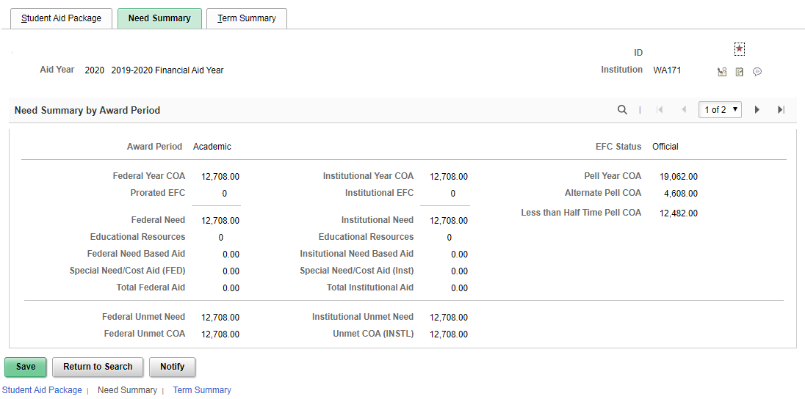

  - Adjust COA on the worksheet if the student is being paid for fewer credits than s/he is enrolled in, but don’t make any changes in the budget in ctcLink; the system will not retain it
- Click the Student Aid Package link at bottom (or the tab at the top)
- Click the magnifying glass beside Packaging Plan ID field
- Choose the quarter or combination of quarters the student is attending in the pop-up box

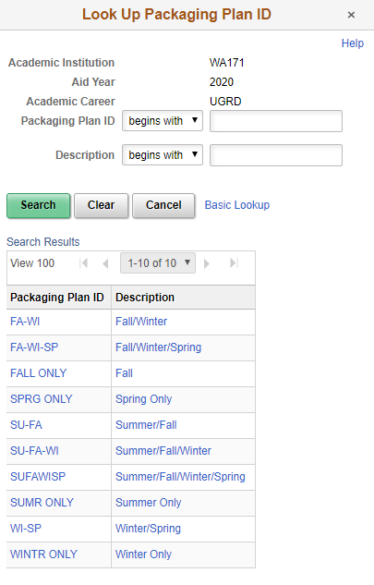
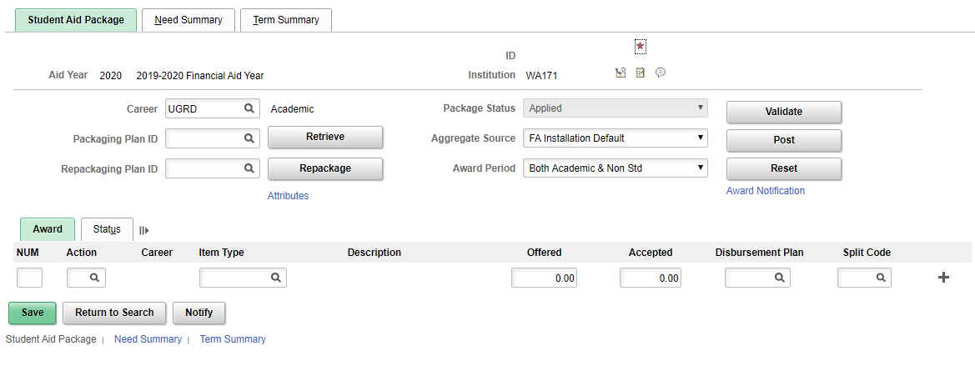
- Click Retrieve
- Make sure all awards look correct and package doesn’t exceed student’s need or cost of attendance
- Look at the messages beside any item type the student is eligible to receive before validating
- If you have to make adjustments or overrides elsewhere
  - Click Reset
  - Do the overrides (see Database Overrides section)
- Validate
- Post

Occasionally an error message will appear when awarding. The Award Error Messages chart shows how to resolve these errors.

Update Incoming Aggregates

Navigator > Financial Aid > Awards > Aggregates > Update Incoming Aggregates

Student records often come in well before the Spring term, and the aggregates won’t include the Spring disbursements.

If NSLDS indicates the student has limited funding for loans or Pell Grant, it’s essential to update the incoming aggregate amounts to reflect the NSLDS amounts that include Spring awards BEFORE awarding. Be certain that you are updating the aggregates for SCC only (do not under any circumstances update SFCC’s aggregates).

- Enter student’s ID and call up record
- Click on the award that needs to be updated (such as PELL171)
- Check the Override box beside NSLDS Total (rarely updated), Percent Scheduled Used, or the Lifetime Eligibility Used field (whichever needs to be corrected) – they greyed-out field should now become active
- Enter the new amount per NSLDS records
- Click Save

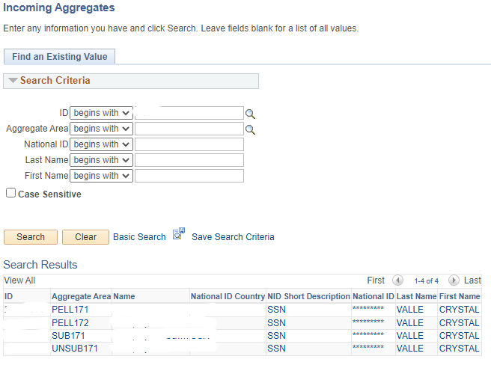

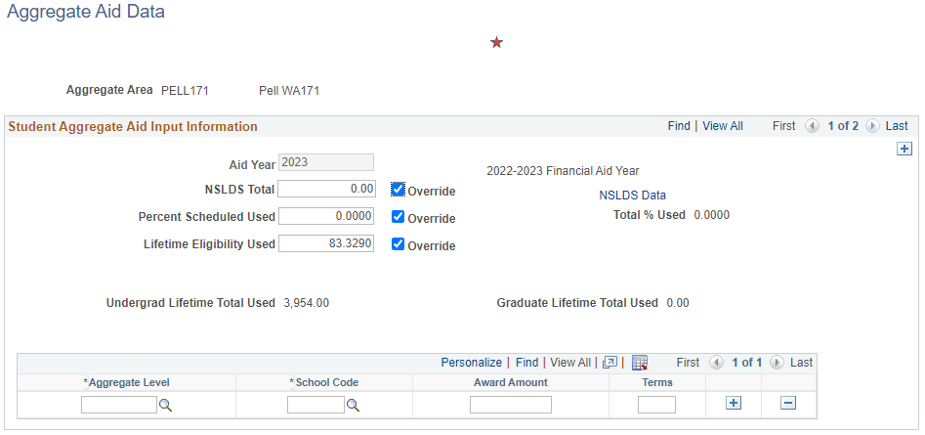

Invoke Professional Judgment

This function is used when awarding students who are in non-standard or clock-hour programs that require different Pell Grant calculations (such as the Manicurist and Esthetician clock-hour certificates). Occasionally, posting errors can’t be resolved with any of the resolutions in the Award Error Messages chart, and the last-resort option is to use Invoke Professional Judgment.

Awarding and revising awards are done the same as in the Assign Awards to a Student page. Make the required revisions to the amounts, and validate and post.

Using the Invoke Professional Judgment page will prevent the awards from being changed to the standard amounts when other changes are made to the student’s aid package.

Institutional Funding

These funds are eligible to be disbursed in Summer Quarter. Be sure to include them when revising awards to include Summer Quarter.

FSEOG

There is no longer a minimum 6 credit requirement to receive FSEOG. Funds can be disbursed as long as the student is enrolled in 1 or more credits. The grant will be prorated for enrollment levels as follows:

1-5 credits $350
6 or more credits $700

The proration will be applied at the time awards are adjusting for the Less-than-Full-Time Authorization report.

SCC Grant and Need-Based Tuition Waiver

At this time (2/28/2022), the minimum 6 credit requirement remains in place for SCC Grant and Need-Based Tuition Grant until otherwise instructed by WSAC.

Order of Awards

The order of the awards is important. Some aid is entitlement or is otherwise required to be given before outside sources. Please refer to this list when packaging. You can change the order the awards appear by reordering the numbers in the far left column:

- Pell
- Institutional funds
- Washington College Grant
- College Bound
- Passport
- Student Success funds (BFET, Worker Retraining, Opportunity Grant, etc)
- Scholarships
- Work Study
- Athletic Work Study
- Agency
- Subsidized loans (less than $200, roll into Unsub)
- Unsubsidized loans
- No Need Tuition Waiver (ABE)

Example of Incorrect Ordering:
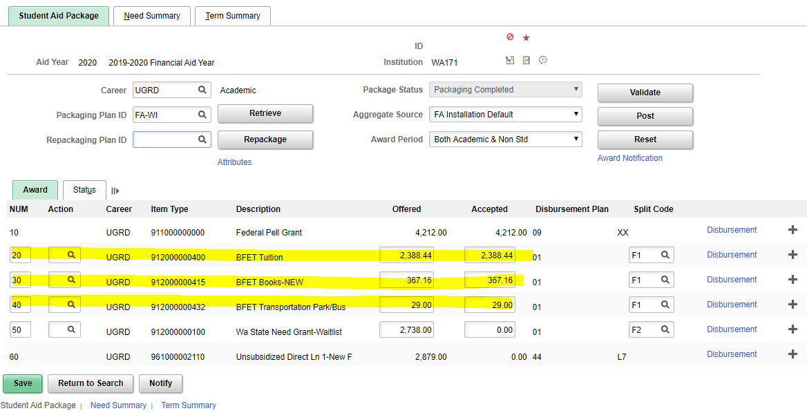

Example of Correct Ordering:
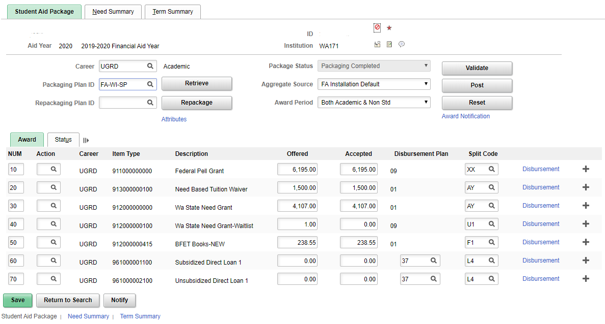

Award Order Flowchart

Standard Awards | Additional Funding
Pell Grant
Washington College Grant
College Bound
Scholarship
Passport
Institutional funds
(TWND/SEOG/SCC Grant)
Student Success Funds
(BFET, Worker Retraining, etc)
 | Scholarships
Work Study
 | Athletic Work Study
 | Agency
Subsidized Loan
Unsubsidized Loan
 | No Need Tuition Waiver (ABE)

Awarding When Student Attended Summer Transitional Studies Coursework

Sometimes student will attend Transitional Studies coursework during the Summer and then enter college credit programs in the Fall. Without a quick tweak, ctcLink will have difficulty trying to award funds for Fall-Winter-Spring.

Update Summer Financial Aid Term

Navigator > Financial Aid > Financial Aid Term > Maintain Student FA Term

- Scroll through the rows to the Summer term
- On the FA Term tab, click the in the Term Information section
- Click on the Financial Aid tab
  - In the Student Data section:
    - Click in the NSLDS Loan Year field and change to 1st Year – Never Attended
    - Click in the Direct Lending Year field and change to First year, never attended
- Save
- Return to Assign Awards to a Student and retry packaging

Summer Term Awarding

Unlike all other terms, Summer term cannot be awarded unless the student has enrolled in classes for the Summer term. The Financial Aid Term and Summer budget will build overnight after the student enrolls.

State funds (Washington College Grant and College Bound Scholarship) will award automatically at full-time amounts, just like Pell.

Some institutional funds (Need-based Tuition Waiver and SCC Grant) aren’t funded in Summer term. FSEOG will award as long as the student is enrolled in at least 1 credit.

Before Awarding Summer Term

Check these before funding Summer term:

- When the student enrolled
  - Funding must wait until the day after the student enrolls
- How many credits did the student enroll in?
  - If LTHT, some funds will not automatically award (loans and SCC Grant/NBTW)
  - Is the student concurrently enrolled at SFCC? Funded at SFCC?
- Has the student already been awarded for future terms?
  - If yes, see section Revising Existing Package to Include Summer Term
- Is there a program change between Summer and Fall terms? Will it impact funding (such as completing a program in Summer and beginning prerequisite requirements for a new program in Fall)?
  - Be sure to check the Student Program/Plan page for any future-dated program changes
Navigator > Records and Enrollment > Career and Program Information > Student Program/Plan
- Are the Summer courses required for the student’s listed program of study?

Do these before funding Summer term:

- Change the EFC months in the ISIR to include Summer term
  - See FM Link in ISIR Review > Information to Review > EFC/DB Matches/Corr tab section for instructions
- If concurrently enrolled at both SCC and SFCC, ask the concurrent enrollment FA staff to make the necessary adjustments to the FA term and the summer budget so that you can award the appropriate amounts

Processing Financial Aid Package for Students Not Previously Funded

There are no differences in processing financial aid packages for Summer-enrolled students who have not been previously funded as opposed to funding students who are not attending Summer. Follow the process outlined in the Package Awards section above.

Revising Financial Aid Package for Previously Funded Students

It is not unusual for a student to decide to enroll in Summer term classes after being funded for future terms. Take care when revising a student’s package; the system may try to cancel funds that are fully expended. There are some work-arounds that can be employed in such cases, which are outlined in the section Tips for “jiggling” when the system rejects Summer award changes.

Steps for revising existing package to include summer term

All aid, including loans that have not been sent to COD yet
- In the Assign Awards to Students page, click the Status tab above the award grid
- In the Lock column, check the box for any item type that should remain unchanged (such as work study funds, loans for students in less than 6 credits for the Summer term, and FSEOG, which should not be automatically updated using this process as it is subject to limited funding levels and the entire award could zero out)
- Click the Award tab so the awards are visible
- Click the look-up icon in the Packaging Plan ID field
- Select the appropriate packaging plan
- Click Retrieve
- Check awards to make sure everything looks correct
  - There will be new rows for the updated Pell, Washington College Grant, College Bound Scholarship, and loans – all but the loan rows will disappear when the package is validated and posted
  - Additional Federal Pell Grant should now be awarded for Pell-eligible students – this awards automatically for Spring only
  - In the *NUM field, order the awards as they should appear (even the blank rows, for consistency):
    - Federal Pell Grant
    - Additional Federal Pell Grant
    - FSEOG
    - Other institutional aid (SCC Grant, Need Based Tuition Waiver)
    - Washington College Grant
    - College Bound Scholarship
    - Scholarships and other special funding such as Worker Retraining and BFET
    - Work Study funds
    - Agency funding
    - Subsidized loans
    - Unsubsidized loans
- Validate and Post

FSEOG must be manually revised:
- Enter a C in the Action field
- Validate and Post
- Enter a B in the Action field
- Enter the new amount of the award
- Click the Disbursement Plan search icon and select 09 (Summer-Fall-Winter-Spring)
- Click the Split code search icon and select U4 (Summer-Fall-Winter-Spring)
- Validate and Post
- Check award to make sure it divides into four equal disbursements in whole numbers

Direct Loan Student Loans when the record has been sent to COD
- If the student is not enrolled in more than 5 credits (check for concurrent enrollment), don’t cancel the loans that are set up for future terms; the student is not eligible for loans for Summer
  - Lock the loan rows in the Status tab above the award grid so that they aren’t redistributed or zeroed out
- If the student is enrolled in more than 5 credits and the record has been sent to COD, use the following procedure:
  - Enter a C in the Action field for each loan
  - Validate and Post
  - Wait for the amounts in COD to clear to $0.00 before entering the new loan; otherwise, it will reject
    - The same Item Types cannot be re-used in this instance; use the next Item Type in the series
  - Validate and Post

Tips for “jiggling” when the system rejects Summer award changes

Sometimes the system has to be “tricked” into saving revisions. This is due to all of the built-in checks and balances. Be sure regulations allow these changes before employing these work-arounds.

When ctcLink won’t perform the revisions the way you’ve entered them, here are a couple of tips to try:

- Exit the student record (use either Return to Search or just reload the page)
  - Change to another page entirely
  - Go back in to the Assign Awards to Students page
  - Make revisions (be sure to choose the correct Disbursement Plan and Split Code)
  - Validate and Post
- If the above doesn’t work:
  - Cancel the award(s) that needs to be revised
  - Validate and Post
  - Exit the student record
  - Change to another page entirely
  - Go back to the Assign Awards to Students page
  - Make revisions(choose the correct Disbursement Plan and Split Code)
  - Validate and Post
- If neither of the above work:
  - Cancel all aid
  - Validate and Post
  - Clear browser cache
  - Close browser window
  - Restart browser
  - Log back in to ctcLink
  - In the Assign Awards to Students page:
    - Choose the appropriate Packaging Plan ID
    - Click the Retrieve button
    - Check awards and adjust any numbers to order the awards correctly
    - Validate and Post

- If you still encounter a posting error, try making the revisions manually, one award at a time, making sure you’re choosing the correct Disbursement Plan and Split Code, posting and validating between each
  - This method will help identify the award that is causing the posting error so troubleshooting can be targeted to it specifically
- Sometimes nothing works, and you must enter the funds in using Invoke Professional Judgment. This should be the last resort.

Packaging Student Loans

While student loans generally package automatically with the rest of federal and state aid, sometimes a loan must be entered manually, loans must be re-entered after being cancelled or declined, or automatically packaged loans must be adjusted. Please keep the following guidelines in mind when revising loans.

Loans that Will Disburse After October 1

Any loan (regardless of whether 30-delay or regular) that will disburse on or after October 1 must use the NEW FEE item types.

No Change in Origination Fees

Occasionally, there will be no change from one academic year to the next to the Direct Loan origination fees. In such a case, best practices are to continue to originate loans with current fee and NEW FEE (after October 1) item types as would normally be done in years where the origination fees change, to maintain consistency and habit.

Minimum Loan Amounts

ctcLink is set up to not originate loans for amounts below $200 per quarter.

Loan prorations

Loans will not automatically prorate even if there is a graduation term entered on the student’s program plan in the Academic tab. The loans will populate according to remaining Need and/or cost of attendance.

Perform the required proration calculation and adjust the loan amounts manually before validating and posting.

REMINDER: Loan prorations should use the following calculation:

Credit Hours Remaining / Credit Hours in Academic Year = Proration Percentage x Annual Loan Maximum

Loans at Another Institution

Students may receive student loans at another institution for the same or other enrollment periods. The total amount of loan funds received from both institutions may not exceed the annual maximum allowed.

If awarding loans for the same period of enrollment, both schools must work together to make sure the student is not overawarded loan funds for the academic year.

Pay attention to incoming aggregate amounts in case they need to be adjusted to allow eligible loan amounts to be funded. Be sure to document in the student’s physical file and on the Financial Aid Status page for the benefit of the loan program specialist.

Navigator: Financial Aid > Awards > Aggregates > Update Incoming Aggregates

Expired Master Promissory Notes

If a student’s Master Promissory Note expires during a loan period and the student completes a new one, alert the Direct Loan program specialist so that the MPN record can be manually overridden to allow the loan to disburse.

IMPORTANT: The loan will never disburse unless the manual override is processed; the loan specialist must be made aware of these records to prevent delays in funding affected students.

Recycling Loan Item Types

Reusing loan items types inappropriately can cause loans to be rejected by the Common Origination and Disbursement system (COD). The following chart shows when loan item types can or should not be reused after having been cancelled.

Status | Acceptable Actions
Before first loan origination batch (offered and accepted loans)
Not accepted | Increase, decrease, reuse item types if previously cancelled
Accepted | Increase, decrease, reuse item types if previously cancelled
After first loan origination batch (accepted loans only)
Loan is rejecting | OK to correct and redo using the same item type ONLY IF the loan is rejecting before going to COD (enrollment issue, missing student address, etc); do not have to wait for COD adjustment  To view pre-COD rejects:  Navigator > Financial Aid > Loans > Direct Lending Management > View Loan Processing Actions  If the reject is after the loan has gone to COD, use the next item types
Loan has been accepted by COD | Do not reuse item type even if loan is being reactivated for the same loan period. Use next item types.

30-Day Delay Loans

With the exception of Summer Quarter, all 30-day delay loans must use the NEW FEE item type because they will originate after October 1.

TIP FOR AUTOMATICALLY PACKAGED LOANS: If the system tries to award regular (current fee) loans but the loans should be 30-day delay:
- Remove the X in the NEW FEE loan item types with the 30-day delay disbursement plan and split code and manually enter the amounts the student is eligible to receive
- Enter an X in each of the regular loan item types so that they’re removed when the awards are validated and posted

Second Year Loan Amounts

Occasionally you will need to award loan funds at the second year level but the system will not allow it and will change the loan amount back to the $3,500 first-year maximum. In these cases, the Financial Aid terms must be modified. All terms covered by the loan must be modified. Be sure to document in the student’s file supporting information for the second-year status.

Navigator > Financial Aid > Financial Aid Term > Maintain Student FA Term

Do this for each term covered by the loan:
- On the FA Term tab, click the in the Student Data section to create a new row
- Click the Financial Aid tab
- Change the NSLDS Loan Year to 2nd Year
- Change the Direct Lending Year to Second Year
- Save

Parent PLUS Loans

More than one parent may take out a PLUS loan on behalf of the same student. The loan amounts may not exceed the student’s unmet cost of attendance. Parents can apply for PLUS loans at https://studentaid.gov/ under the Apply for Aid menu.

Awarding Respiratory Care BAS Students

First and Second Year BAS Students:

Students taking the first year general education requirements (45 credits) must be enrolled in either RCTRTPRQ (Respiratory Care BAS prerequisites) or LASDTAA (Associate in Arts DTA). Students coded in RCTRTPRQ will be eligible for student loans only at the preparatory coursework amounts and timeframe. AA-DTA-coded students must intend to complete the AA-DTA as well as the BAS.

Quarters 1, 2, and 3 are eligible for normal level aid, including two-year undergraduate level loan amounts.

Quarters 2 and 4 will result in tuition adjustments after the term begins, as they include both 200 level and 300 level courses; 300 level courses have a higher tuition rate. Students will be assessed the higher tuition rate and then later refunded after the adjustments are made.

Once admitted to the BAS portion of the program, students in the second year of the Respiratory Care Bachelor’s degree (RT 200 courses) are processed like another other financial aid-eligible program because there is no tuition difference (no longer eligible only for preparatory coursework loans).

Third & Fourth Year BAS Students:

Starting in the Quarter 5, students are eligible for normal Pell and institutional funds and the higher amounts of Washington College Grant (WCG) and student loans.
The third and fourth year students (RT 300 & RT 400 courses) pay a higher tuition rate and have an increased budget. These instructions are for the third and fourth year students only.

Navigator > Campus Community > Student Services Center, Academic tab
- Check that active program is Respiratory Care BAS
- Check that the Respiratory Care BAS CAR is the one linked to the terms
- Check that the courses are 3rd & 4th level (300 & 400 numbers)
NOTE: Fourth Quarter, which has both 200 & 300 level courses, is considered 3rd level

Navigator > Financial Aid > Financial Aid Term > Maintain Student FA Term
- Make sure that FA Term lists the correct Program Plan for the terms the student will be enrolled in the BAS program

Navigator > Financial Aid > Budgets > Maintain Term Budgets
- Increase the tuition for all terms the student will be enrolled in the BAS program
  - Resident Tuition: $2300 (2021-22); $2,574 (2022-23)
  - Nonresident Tuition: $2900 (2021-22), $3149 (2022-23)
    - In the Budget Item section, click the at the end of any row
    - In the new row, enter PLAN in the Category column and PLAN in the Item Code column,
    - Add the difference between standard tuition and BAS tuition in the Pell Amt, and LHT Pell Amount columns
    - Save
    - Repeat for each term the student is attending.
    - Click the Update Need Summary button

Navigator > Financial Aid > Awards > Award Processing > Assign Awards to a Student
- Make sure that the cost of attendance is correct; chart is in the Share drive in the current academic year folder > Internal Forms
- Pell should package according to the Pell chart (no special award increases)
- Washington College Grant and College Bound Scholarship – check the WCG and CBS eligibility pages to make sure students are awarded according to the MFI table for BAS degrees (located in the Share drive in the current academic year folder > Internal Forms > SNG, CBS Charts
- Loans:
  - Dependent maximums: $5,500 subsidized; $2,000 unsubsidized
  - Independent maximums: $5,500 subsidized; $7,000 unsubsidized
- Institutional funds: assign item type manually if students met priority and other requirements

Reactivating Previously Cancelled Aid

If aid for the academic year was cancelled because the student didn’t attend, do not select a new Packaging Plan ID or change the Disbursement Plan. Doing so will cause issues with Pell origination and disbursements.

Use the same Packaging Plan ID and Disbursement Plan, and enter the funds for just the terms being reactivated.

Awarding non-FAFSA Students

Occasionally, you might need to award non-standard funding to an Adult Basic Education student, a Non-Award Seeking student, or a student who has not completed a FAFSA. There are four steps to this process: Activate the aid year, build the Financial Aid Term, create and move the budget, and adjust the budget to make sure there’s enough room to enter the funding.

Activate Aid Year

Navigator > Financial Aid > Aid Year Activation > Manage Financial Aid Years

- Click the at the end of a row to add a new row
  - If this is the first aid year activated, you won’t have to add a row
- Enter the aid year into the Aid Year field
- Make sure the Institution field says “WA171”
- Save

Build Financial Aid Term

Navigator > Financial Aid > Financial Aid Term > Maintain Student FA Term

- On the FA Term tab, click the in the Term Information section
- In the Term field, enter the term code
- In the Student Data section:
  - Change Academic Career to Undergraduate
  - Change Primary Program to ACADM
  - Change Campus to MAIN
- Save

Create Budget

Navigator > Financial Aid > Budgets >Create Student Budget

- In Budget Terms, enter the term code
- Click the Build Budget button
- Click the Move Budget button
- Save

Adjust Budget

Navigator > Financial Aid > Budgets > Maintain Term Budgets

- In the Budget Item section, make sure the budget built with a high enough amount to accommodate the funding
- If an increase is needed:
  - Click the at the end of a row in the Budget Items section
  - In the new row, enter PLAN in the Category field and PLAN in the Item code field
  - Enter the required increase in the Amount field
  - Click Save
  - Repeat for any other terms that need to be increased for funding
- Click the Update Need Summary button

Award Error Messages

Msg Nbr | Message | Description | Action
9006 | Item Type Maximum Award limit is zero; Invalid Item Type | The item type, FA item type, related item type, or other limit maximum award limit must be a positive non-zero value. Update the appropriate item type setup page with a non-zero award limit and rerun packaging. | Retrieve looks at all FA terms for the aid year. If a student has FA Load of LTHT fall, and you try to award a loan W/SP, Retrieve looks at all FA terms and will throw this error. In this instance, you would want to manually award the item type
9022 | PELL -Invalid Title IV eligibility indicator. | Student is not Title IV eligible for Federal Funds bases on the Title IV eligibility indicator. | Check Title IV elig indicator on 4th tab of ISIR in PS
9023 | PELL - Not Title IV eligible. | Student is not Title IV eligible for Federal Funds bases on the Title IV eligibility indicator. | Check Title IV elig indicator on 4th tab of ISIR in PS
9038 | No matching aggregate level limit for a defined aggregate table. | No matching aggregate level limit for a defined aggregate table. The aggregate level is specific in the item type to be awarded, but has not been specified in the aggregate limit table. Please update the aggregate limit tables as appropriate. | Check the set up of the Aggregate Aid Limits
9039 | Total disbursed award amounts exceed maximum award amount | The student's total disbursed amounts exceed the maximum allowable award amount. The award has been reduced to the value of the sum of the disbursed amounts. This has created an over award condition. | Verify aggregate aid limits table is populated with correct information. Cumulative Limit and Max Terms should be blank.
9050 | NSLDS loan year is missing or has no corresponding Aggregate Level. | The NSLDS loan year level (on the FA Term record) is missing or not found on the cross reference table of NSLDS/HERA levels with Aggregate levels. As a result, aggregate limits cannot be applied, and the award is rejected. Make the appropriate change and repackage this student. | Navigate to the Financial Aid Info tab for the students' FA Term. Verify the NSLDS Loan Year is populated. If it is not, the student is likely not enrolled in an FA elig program. Once student is in FA elig program and FA Term rebuilds, the NSLDS field will populate
9102 | Zero remaining spending limits for item type. | If the packaging rule remaining spending limits for item type is a zero value, then an award is not made. Check the packaging rule for the remaining spending limit value and check the item type fiscal balances. If this is in not correct, please make the appropriate change, and repackage this student. | Check the fiscals for the item type in question. If award is truly out of funds, update packaging plan selection criteria query for that item type.
9104 | Award less than minimum award limit | After initial assignment (either manually by the user or by the packaging process), the award value has been reduced below the minimum required award limit and the award cannot be made. | Check item type set up.
9111 | Student fully packaged. | The student is fully packaged for this item type, and the award will be discarded. | Item type max has been reached
9117 | Not eligible for a PLUS loan; student does not have dependent status. | This student does not have dependent status, and as a result, is not eligible for a PLUS loan. If this is incorrect, make the appropriate change, and repackage this student. | Check dependency status to ensure its truly Dependent
9125 | The custom split code percentages do not sum to 100%. Please contact our Financial Aid systems specialist or administrator for further explanation of this problem. |  | Check the quarters you are awarding; wrong quarter/s are probably selected
9126 | Prof. Judgment, Need Override, or Locked award cannot have zero value. | An award that is coded with a professional judgment, need override, or a locked award indicator cannot have a zero value. If required, please make the appropriate corrections and repackage this student.
9127 | The student aggregate area NSLDS level does match to aggregate area level. | The student aggregate area NSLDS level does not exist in the aggregate area level table for this item type. To correct this, make the appropriate change to the student's NSLDS level or add a new level limit entry to the aggregate area table associated with this item type, and then repackage the student. | Verify aggregates are correct on the student's aggregate page (Update Incoming Aggregate). Also check the aggregate level and aggregate limit on Aggregate Aid Limits page
9129 | Aggregate Limits reached for Federal programs. | The student has reached the aggregate limits for this Federal program. As a result, the student cannot be awarded this item type.
9137 | Student not Title-IV eligible. | This student is not Title-IV eligible for Federal funds. If this is incorrect, make the appropriate change to the students Title-IV eligibility and repackage the student | Send necessary corrections in PS or FAA
9142 | Unsatisfactory Academic Progress; student Federally ineligible | Satisfactory Academic Progress indicator is set as unsatisfactory ('N') and the student is ineligible for Federal funds. If this is incorrect, make the appropriate change, and repackage the student. | Review the SAP status on PSS page
9149 | Not PELL eligible based on combination PELL Index and PELL COA | The student is not PELL eligible based on the PELL Index and the PELL COA. | Review student's Pell COA and budget on Maintain Term Budgets. EFC information can also be viewed by clicking Need Summary.
9165 | Manual Award reduced to be consistent with Financial Aid Need target | The manual award has been reduced to be consistent with Financial Aid Need target | Review Need Summary on Assign Awards page. If necessary, the item type's Meet/Need Cost may need to be altered
9182 | No App Status only allows Conditional, No Effect, Cost Only, PLUS item type | No Application status only allows for Conditional, No Effect, Cost Only, and PLUS item type awarding. | Determine what Meet/Need Cost set up should be on tab 2 of item type set up. Meet/Need Cost will determine how an item type affects unmet need balance and unmet COA balance.
9193 | At least one Net Scheduled Disbursement amount for this award has a value greater than it's corresponding Gross Scheduled Disbursement amount. Please consult your system administrator. |  | FAO Note: Check Satisfactory Progress status – this message displays when student’s SAP status is other than MEET, WARN, or PROB
9239 | Pell award has been reduced by student's remaining Lifetime Eligibility | Pell award has been reduced due to student's Lifetime Eligibility Used percent value greater than 500 percent but less than Lifetime Eligibility Maximum percent | Verify that the Update Incoming Aggregate page has the most current information. If the page is inaccurate, use the override fields on the page
9338 | Data Corruption -- Mismatch between Award and Disbursement Totals | The student failed the posting process due to a mismatch between Award and Disbursement Totals. The student's awards were not posted.
9401 | Award reduced by FA or Fiscal item type limits | The original award value has been reduced by 1 or more FA, Fiscal, or Packaging Plan Item Type limits. | Check the available amount remaining on the fiscals for the item type in question
9405 | PELL award reduced by Aggregate limits | PELL award reduced by Aggregate limits. | Ensure the students FA Load on FA Term matches the students units of enrollment. If FA term is accurate, check Aggregate Aid Limits set up. If set up is correct, verify Pell amt on maintain term budgets is accurate
9410 |  |  | Ensure student qualifies for 2nd-year Subsidized Loan amounts, then update the Financial Aid tab on the Maintain Student FA Term page to reflect 2nd-year status
9419 | This award is for an In-Transit loan; the award cannot be reviewed or changed | This award is for an In-Transit loan; the award cannot be reviewed or changed | Wait until file comes back from COD and adjust
9510 | Student failed the Selection Criteria at the Packaging Rule level | The student failed to qualify for this Item Type because Selection Criteria, at the Packaging Rule level, was not met. | Check selection criteria for that packaging plan
9528 | Award was auto-canceled. | The award was canceled by an Auto Cancel Item Type. | Colleges have the ability of setting up awards to auto cancel when another award is placed. This can be done on tab 3 of the item type set up
N/A | Award Posting Process Encountered Error(s) (14420,62) | Award Posting process encountered errors and is unable to continue processing. It may be necessary to consult your System Administrator | Go in to the Financial Aid Item Type setup panel/page and change the item type back to Active. To prevent staff from using the item type, set the fiscal limits to $0.00. Verify that the term is associated with the correct Aid Year on FA Term. Change the setup back to where it was until the next aid year setup occurs. Only make changes to Aggregate Areas when you're completing the setup for a new award year, i.e. - before any aid has been awarded on an aggregating item type. Sync up at least the "Max to Offer" and "Max to Accept" fields.  FAO WORKAROUND: Try canceling Pell, validate, and post. DO NOT UNDISBURSE. Make your changes, validate, and post. Put Pell back in, validate, and post.  If that doesn’t work, cancel all aid, clear the browser cache, close the browser, restart the browser, and log back in to ctcLink. Then re-award with the Retrieve button and appropriate Packaging Plan ID.

Completing the File Processing Worksheet

- The mathematical calculations must be shown for grant and loan eligibility
  - Any resources known at the time of processing should be noted in the Resources section and accounted for in the math
    - If student receives an outside resource that could possibly be awarded for future terms, include an estimate for all future terms being awarded to prevent overawards when those funds are later entered
    - Add a comment to the Financial Aid Status page that the resource funding was estimated for future terms
    - Include 4th quarter Pell in calculation if student is attending all four quarters
  - Any reductions, or childcare- and program-related increases known to us at the time of processing should be noted in the Cost of Attendance Adjustments section and accounted for in the math
- Use full-time budget amounts unless the quarter has begun and the student is enrolled in less than full time
  - If reducing the budget for less than full-time attendance, note the reduction in the Cost of Attendance Adjustments section
- The Notes section is for any unusual issues that should be documented. Keep in mind that for every issue noted, its resolution must also be documented. (Ex: It is noted, “Student on suspension.” When the student has successfully appealed and the file is completed, the resolution is documented, “Appeal approved; now Probation.”)
  - The ISIR transaction that was verified must be noted on the worksheet, along with whether or not a correction was sent
  - If TEMPing a file that needs more documentation/other issues, the reason you are not completing the file at the time of your initial review must be documented on the worksheet (as well as the resolution once the issue has been resolved)
- The Professional Judgment section is for changes in financial circumstances or dependency status, or any other acceptable situation for which professional judgment was invoked; these must be documented

Loan-Only Communication

If a student is eligible for only student loans due to a high EFC, Pell LEU, BA degree, prereqs/preparatory coursework, etc., be sure to assign the Loan-Only communication to go out to the student.

Speed Key

First, it helps to set up a speed key so you don’t have to keep entering the same information over and over for every loan-only student. You only need to do this once.

Navigator > Set Up SACR > User Defaults

- Use the arrow until the Communication Speed Keys tab is visible and click on it
- Academic Institution: WA171 (should prepopulate if you’ve set up User Defaults)
- Administrative Function: FINA
- Comm Key: LNONLY
- Save

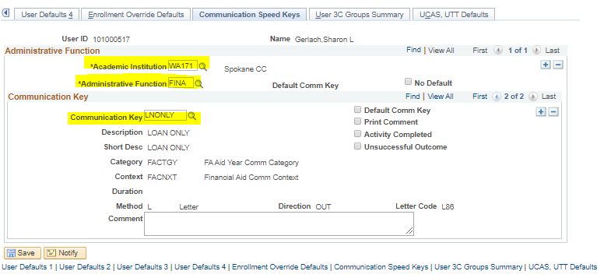

Assign Communication

Navigator > Financial Aid > View Financial Aid Status (click Communication icon)
Navigator > Campus Community > Communications > Person Communications > Communication Management

- *Function: FINA
- *Institution: Spokane CC (should be prepopulated)
- Comm Key: LNONLY
- The rest of the fields will populate automatically
- Click Save

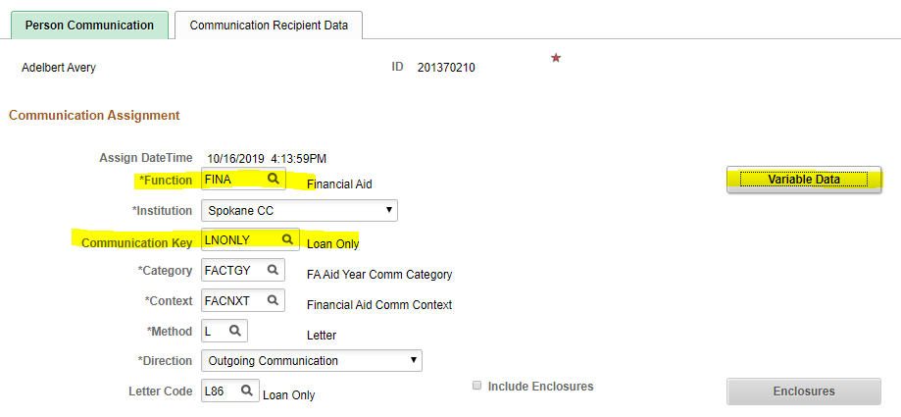

Professional Judgment

When exercising professional judgment, please use the following processes for consistency within the office.

Navigator > Financial Aid > Federal Application Data > Correct 20xx-20xx ISIR Records
Alternative: https://faaaccess.ed.gov/FOTWWebApp/faa/faa.jsp

Dependency Override (Dependent to Independent)

Requires dependency override packet and third-party affidavit from student unless a homeless/risk of homelessness determination has been made

ctcLink:
- In Correct 20xx-20xx ISIR Records, go to Assumptions\School Codes tab
- Click the + sign above the INAS button to create a new row
- In the Miscellaneous Information section, click the radio button next to Dependent to Independent
- Click the INAS button
- Make sure the Correction Status is set to Send; if not, select Send and click the Save button

FAA Access
- Log in to FAA Access
- TG# is 51866 and school code is 003793
- Select applicable academic year
- Enter students social security number, last name, and first name
- Select transaction number to correct
- Click the Make Corrections button
- Create a transaction password or leave blank and click Next
- Click the Step 3 link at the top of the page
- In the Dependency Override drop-down box, select FAA override from dependent to independent (if a homeless/risk of homelessness determination has been made by FA supervisors, select the option FAA homeless youth determination)
- Click the Calculate EFC button at the bottom of the page
- Click the Print this Page button at the top of the new page
- In the Pages section of the Print window, enter 1 to print only the first page with the EFC determination and Click Print
- At bottom of page, click the Submit button and print the resulting page

Tracking

Navigator > Financial Aid > View Financial Aid Status

- Click the Add a New Comment icon at the top of the page
- Administrative Function:  - Comment Category:  - Variable Data:  - Department:  - Comments:  - Save | FINA  FAGEN  current academic year  99304  Dependency override approved

Worksheet

- Make clear notes in the Professional Judgment box of the current year file worksheet the action taken and the reason for the action

Change of Financial Circumstances

Requires Change of Financial Circumstances form and supporting documentation. If the student is dependent, both student’s and parents’ information must be from the same tax year.

ctcLink:
- In Correct 20xx-20xx ISIR Records, go to the Student Information tab
- Click the + sign above the INAS button to create a new row
- Enter the new information according to the Change of Financial Circumstances document and supporting documentation
- If the student is dependent, repeat this step on the Parent Information tab
- In the Miscellaneous Information section, Check the box next to Adjusted EFC Cal Requested
- Click the INAS button
- Make sure the Correction Status is set to Send; if not, select Send and click the Save button

FAA Access
- Log in to FAA Access
- TG# is 51866 and school code is 003793
- Select applicable academic year
- Enter students social security number, last name, and first name
- Select transaction number to correct
- Click the Make Corrections button
- Create a transaction password or leave blank and click Next
- Click the Step 2 link at the top of the page and make corrections to the student’s income according to the documentation
- If the student is dependent, go to Step 4 and correct the parents’ income according to the documentation
- In the Professional Judgment drop-down box, select 1 – EFC Adjustment Requested
- Click the Calculate EFC button at the bottom of the page
  - Click the Print this Page button at the top of the new page
  - In the Pages section of the Print window, enter 1 to print only the first page with the EFC determination and Click Print
- At bottom of page, click the Submit button and print the resulting page

Tracking

Navigator > Financial Aid > View Financial Aid Status

- Click the Add a New Comment icon at the top of the page
- Administrative Function:  - Comment Category:  - Variable Data:  - Department:  - Comments:  - Save | FINA  FAGEN  current academic year  99304  AY eligibility was based on 20xx income. EFC changed from XXXX to XXX. Awards increased.

Worksheet

- Make clear notes in the Professional Judgment box of the current year file worksheet the action taken and the reason for the action

Separation/Divorce after Awarded

Requires V1 Verification Worksheet, copy of tax return or transcript, and W-2 forms or other documentation of income, if applicable.

ctcLink:
- In Correct 20xx-20xx ISIR Records, go to the Student Information tab
- Click the + sign above the INAS button to create a new row
- Enter the new information according to the Change of Financial Circumstances document and supporting documentation
- If the student is dependent, repeat this step on the Parent Information tab
- In the Miscellaneous Information section, Check the box next to Adjusted EFC Cal Requested
- Click the INAS button
- Make sure the Correction Status is set to Send; if not, select Send and click the Save button

FAA Access
- Log in to FAA Access
- TG# is 51866 and school code is 003793
- Select applicable academic year
- Enter students social security number, last name, and first name
- Select transaction number to correct
- Click the Make Corrections button
- Create a transaction password or leave blank and click Next
- Click the Step 2 link (step four if the situation applies to the parents) at the top of the page and make corrections to the student’s income information according to the documentation
  - Zero out the spouse income from work
  - Remove spouse’s income from the AGI
  - Remove any other income that belongs to the spouse
  - Remove spouse from the exemptions
  - Remove spouse from the number in household and number in college, if applicable
  - Click the Student Taxes Paid Calculator button (or Parent Taxes Paid Calculator button, if situation applies to the parent)
- In the Professional Judgment drop-down box, select 1 – EFC Adjustment Requested
- Click the Calculate EFC button at the bottom of the page
  - Click the Print this Page button at the top of the resulting page
  - In the Pages section of the Print window, enter 1 to print only the first page with the EFC determination and Click Print
- At bottom of page, click the Submit button and print the resulting page

Tracking

Navigator > Financial Aid > View Financial Aid Status

- Click the Add a New Comment icon at the top of the page
- Administrative Function:  - Comment Category:  - Variable Data:  - Department:  - Comments:  Save | FINA  FAGEN  current academic year  99304  Student (or parents) separated or divorced after FAFSA filed; removing spouse income better benefits student and demonstrates actual financial circumstances.

Worksheet

- Make clear notes in the Professional Judgment box of the current year file worksheet the action taken and the reason for the action

Tax Return Line Items for 2020-21 & 21-22 Professional Judgment

2019 Tax Return Line Items for 2020-2021 Professional Judgment
 | 1040 and Schedules | 2020-21 FAFSA Question
AGI | 1040 Line 8b | 36 (S) and 84 (P)
Income tax paid* | 1040 Line 14 minus 1040 Schedule 2, Line 2 | 37 (S) and 85 (P)
Education credits | 1040 Schedule 3, Line 3 | 43a (S) and 91a (P)
IRA deductions and payments | 1040 Schedule 1, Line 15 + Line 19 | 44b (S) and 92b (P)
Tax-exempt interest income | 1040 Line 2a | 44d (S) and 92d (P
Untaxed portions of IRA, pension, and annuity distributions (withdrawals)* | 1040 Line 4a minus 4b (exclude rollovers) | 44e (S) and 92e (P)

2020 Tax Return Line Items for 2021-22 Professional Judgment
 | 1040 and Schedules | 2021-22 FAFSA Question
AGI | 1040 Line 11 | 36 (S) and 84 (P)
Income tax paid* | 1040 Line 22 minus 1040 Schedule 2, Line 2 | 37 (S) and 85 (P)
Education credits | 1040 Schedule 3, Line 3 | 43a (S) and 91a (P)
IRA deductions and payments | 1040 Schedule 1, Line 15 + Line 19 | 44b (S) and 92b (P)
Tax-exempt interest income | 1040 Line 2a | 44d (S) and 92d (P
Untaxed portions of IRA, pension, and annuity distributions (withdrawals)* | 1040 Line 4a minus 4b (exclude rollovers) | 44e (S) and 92e (P)

2021 Tax Return Line Items for 2022-2023 Professional Judgment
 | 1040 and Schedules | 2021-22 FAFSA Question
AGI | 1040 Line 11  1040X Line 1C | 36 (S) and 84 (P)
Income earned from work | 1040 Line 1 + Schedule 1 Line 3 + Schedule 1 Line 6 + Schedule K-1 (Form 1065) Box 14 Code A  Form W-2 Box 1 | 38-39 (S) and 86-87 (P)
Income tax paid* | 1040 Line 22 minus Schedule 2, Line 2  1040X Line 8 if Box 896 is checked on Line 15, use Line 8 – Form 8962 Line 29) | 37 (S) and 85 (P)
Untaxed portions of IRA, pension, and annuity distributions (withdrawals)* | 1040 Line (4a + 5a) minus (4b + 5b)  (exclude rollovers) | 44e (S) and 92e (P)
Education credits | 1040 Schedule 3, Line 3  Nonrefundable education tax credits included in Line 7 | 43a (S) and 91a (P)
IRA deductions and payments | 1040 Schedule 1, Line 15 + Line 19 | 44b (S) and 92b (P)
Tax-exempt interest income | 1040 Line 2a | 44d (S) and 92d (P)
Tax-deferred payments to pensions & savings plans | Form W-2 Boxes 12a-12d, Codes D, E, F, G, H, S ONLY | 44a (S)  92a (P)

Adjusting Awards (Increases and Decreases)

ctcLink operates on a carefully constructed system of cause-and-effect; numerous factors can cause a student’s data to post incorrectly when an adjustment is made. It’s best to make the following process a habit:

- Adjust awards
- Validate
- CHECK DISBURSEMENTS OF EACH FUND
- Post
- CHECK DISBURSEMENTS OF EACH FUND

You do not want to check just the award you added or adjusted, because data stored elsewhere in the system may cause another award to change.

How to adjust awards

- Enter a B (offer and accept) or a C (cancel) in the Action Box
- Adjust the award amount – remember, this is the gross amount for the entire academic year
- Click the Disbursement link and adjust the quarterly amounts
- Validate
- CHECK DISBURSEMENTS OF EACH FUND
- Post
- CHECK DISBURSEMENTS OF EACH FUND

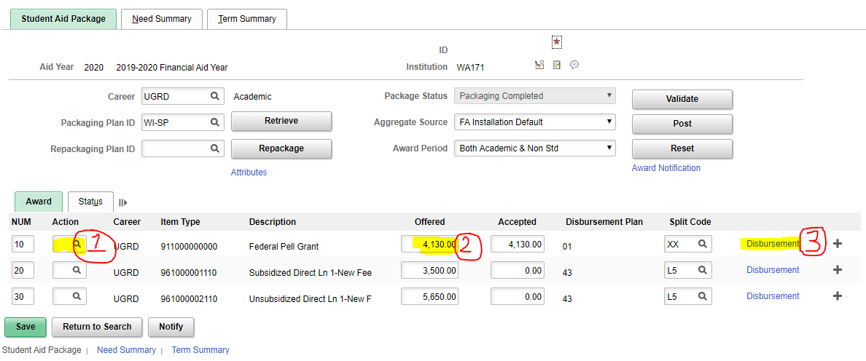

If the disbursements for an award will not stay as you designated, you might have to lock the award to get it to stick:

In the Assign Awards to a Student page:
- Adjust your gross award and the quarterly disbursements
- Click the Status tab just above the awards
- Check the Override box for the award you are adjusting (there should be a B in the Action box)
- Click the Award tab just above the awards
- Validate
- CHECK DISBURSEMENTS
- Post
- CHECK DISBURSEMENTS
- DO NOT USE THE EA CHECK BOX – it causes issues elsewhere
- If this does not work, use Invoke Professional Judgment
Navigator > Financial Aid > Awards > Award Processing > Invoke Professional Judgment
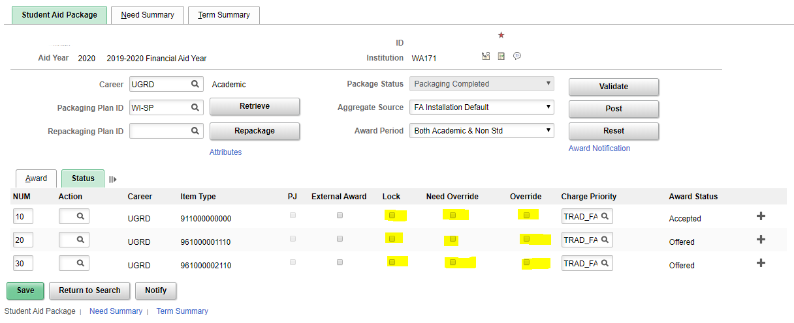

Sample worksheet
NAME: |  |  |  | PROGRAM:
SSN: |  |  |  | PRQ ADMITTED WAITLISTED |  | PRIOR EDUCATION: CERT AA AAS BA
EMPLID: |  |  |  | ACADEMIC PLAN FOR THRU
ADVISOR: |  | DOB: |  | DUAL DEGREE PROGRAMS:

NOTES:
PROFESSIONAL JUDGMENT: Income Dependency Override DATE: BY:
ACTION & RATIONALE:

Verified ISIR # Sent Corr No Corr PJ ISIR #: New EFC:
ISIR / 9 mo. EFC: # EFC: |  |  |  | COST OF ATTENDANCE ADJUSTMENTS
Residency: |  | Res Nonres |  | Reason | SU |  | F |  | W |  | SP
Dependency Status: |  | Indep Dep |  | LTFT
Housing: |  | Non Com |  | Tools/Prg Costs
HS/GED: |  | Yes No |  | Daycare
Met FA Priority: |  | Yes No |  | Other
 |  |  |  | RESOURCES
Workstudy: Y N |  | Out of Funds |  | Source | SU |  | F |  | W |  | SP
Met Priority: Y N |  | Ineligible
SAP: | MEETS WARN PROB SUSP GD
Pace: % |  | Meets Below
Pell LEU: |  | Near At/Over |  | LOAN PRORATION: Completing Degree 2-Qtr Certificate
% Used: %Rem.: |  |  |  | Type | Ln Amt | Rem Cr |  | Proration % |  | Max Amt
Loan Aggr: |  | Sub Comb. |  | Subsidized
Amount/s Remaining: |  |  |  | Unsubsidized
WCG Total Qtrs: |  |  |  | 2nd Year Loans: Yes No Elig Qtr (if no): 30-day: Yes No
Misc Info:

DATE | QTRS | COA | EFC | RESOURCES | NEED
DATE | QTRS | COA | EFC | RESOURCES | NEED
DATE | LOAN PERIOD | COA | EFC | FIN AID | NEED | SUB AMT
DATE | LOAN PERIOD | COA | SUB LN FEE | FIN AID | ELIG | UNSUB AMT
DATE | LOAN PERIOD | COA | EFC | FND AID | NEED | SUB AMT
DATE | LOAN PERIOD | COA | SUB LN FEE | FIND AID | ELIG | UNSUB AMT
Once the sample worksheet is saved as a separate Word document, add this header (replace the XX with the current academic year):
20XX – 20XX WORKSHEET – PERSONALLY IDENTIFIABLE INFORMATION

Set up Merge Document for FA Worksheet:

- Save FA worksheet in your own drive
- Create an Excel spreadsheet with the field headings you want to merge (such as name, SSN, and EMPLID)
  - Enter data for your students
  - Save spreadsheet
- Open FA worksheet in Word
  - Go to Mailings tab
  - Click Select Recipients and choose Use an Existing List
  - Navigate to your saved spreadsheet and double-click it
  - Click in the blank box beside Name on the FA worksheet
  - Click Insert Merge Field
  - Select Name
  - Repeat for remaining fields
  - Save document
  - Go to Finish & Merge
  - Select Edit Individual documents
  - In the Merge to New Document pop-up dialog box, select All (alternately, you can enter From and To information)
  - Click OK
  - A new document will be created showing your merged data
  - Print merged worksheets

To use merge document:

- Open Excel merge document
  - Clear data from previous use
  - Enter new data
  - Save document
- Open FA worksheet in Word
  - Go to Mailings tab
  - Click Select Recipients and choose Use an Existing List
  - Navigate to your saved spreadsheet and double-click it
  - Go to Finish & Merge
  - Select Edit Individual documents
  - In the Merge to New Document pop-up dialog box, select All (alternately, you can enter From and To information)
  - Click OK
  - A new document will be created showing your merged data
  - Print merged worksheets

Watermark for NSLDS Printouts
PERSONALLY IDENTIFIABLE INFORMATION - XX

Index

@OWN 28
“GD” Suspension 27
150% of program 26
2019 Tax Return Line Items 6
30-Day Delay Loans 73
Ability to Benefit 9
Academic Plans 50
Academics tab 11
ACADM 11
Activate Aid Year 76
Add a Comment 56
adding program costs 58
Adjust Budget 76
adjust the monthly EFC 45
Admissions 7
admissions information 7
Adult Basic Education 75
Append a Comment 56
Applicant Progression 7
Assign Awards 58, 62
Assign Communication 1
ATB service indicator (ARQ) 9
Attending at Own Expense 27
Award Error Messages 77
Award Order Flowchart 67
awarded at another school 23
awarding on a previous ISIR 41
awards 1, 22, 63
BAH 43
Bio/Demo Data 20
Build Budget 58
Build Financial Aid Term 76
Change of financial circumstances 48
Change of Financial Circumstances 4
Changing Marital Status 49
checklist items 1, 54
Checklist Management-Person 54
Citizenship 18
Comment Codes 18
Documentation 18
original documents 18
V4 or V5 verification groups 18
Citizenship status 7
Comment Categories 57
cost of attendance 58
CPS-pushed ISIR 46
Create Budget 76
Create Student Budget 58
CTC Custom 62
CTC Interfaces 62
Cum Att Units to Exclude 28
cumulative earned credits 26
Current grade level 42
database match overrides 60
Database matches 46
Dependency Override 48, 3
Dependent to Independent 3
Direct Lending Year 74
Disburse After October 1 71
Disbursement Plan 75
disbursement plan 09 62
eligibility pages 62
expired passport 18
External Education 10
F01 service indicator 47
F03 service indicator 47
FAA Access 49
FAGEN 57
FAWDS 57
FCANCL 57
FFILE 57
File Processing Comments 56
File Processing Worksheet 0
FLOANS 57
FM link 45
Form G-845 19
FPLAN 28
FRECAL 57
FREDUC 57
FREPAY 57
full admit 7
Future-Dated Program Changes 14
G-845 18
GDSUSP 27
Graded Adult Basic Education Coursework 28
High School Completion 10
How to adjust awards 9
HR/IR 52
Inactivated Running Start group 7
INAS Rule Set 45
incoming aggregate amounts 72
Incoming Aggregate Amounts 25
Increases and Decreases 9
increasing for actual tuition costs 58
Ineligible SAP Status 28
Invoke Professional Judgment 65
ISIR 1, 20, 21, 31, 34, 35, 36, 37, 39, 41, 45, 48, 3
ISIR comment category 47
ISIR transaction 0
ISIR transaction and EFC used 56
ISIR vs Bio demo Mismatch 20
LEU 24
LNONLY 1
Loan prorations 72
Loans at Another Institution 72
Maintain Student FA Term 15, 73
Maintenance of UEMs 52
mathematical calculations 0
maximum aggregate 22
Minimum Loan Amounts 72
Monthly EFC 45
Move Budget 58
Multiple Program Plans 14
New Academic Plans 51
New checklist items 46
NEW FEE 71
New ISIRs 46
new verification group 47
Non-Award Seeking 75
non-FAFSA Students 75
Non-Graded Adult Basic Education Coursework 28
Non-resident 16
NSLDS 1, 22
NSLDS Loan Year 74
Order of Awards 65
Origination Fees 71
outside resource 0
Packaging Plan ID 75
Parent PLUS Loans 74
Pell Lifetime Eligibility Used 24
pending loan disbursements 22
Perform Auto Verification 34
Person Comment Detail 50
Personally Identifying Information 22
PII 22
Plan 11
PLAN 75
Post 63
preparatory coursework 11
prerequisites 11
Previously Approved Academic Plans 50
PRFTC 11
Professional Judgment 0
program 1, 11, 12, 26, 42
Program 11
proof of U.S. citizenship 18
Reactivating 75
Reasons for User Edit Messages 52
Recent High School Graduates 10
Recycling Loan Item Types 72
Required Fields for All Verification Tracking Groups 36
residency 1, 16, 20
Residency Mismatch 16, 20
Resident 16
Respiratory Care BAS 74
Revising Financial Aid Package 69
revising loans 71
Rollover Checklist Items 54
Sample worksheet 11
SAP 1, 26
SAP Contracts 27
SAP Status Chart 29
Satisfactory Academic Progress 1, 26
SAVE System 19
second year level 73
Second Year Subsidized Loans 73
Secondary Confirmation 18
Separation/Divorce after Awarded 5
Set Up SACR 1
Simulate Student Eligibility 27
Speed Key 1
Student Groups 11
Student Information Update form 14
Student Information Update Form 7
Student Program/Plan 14, 69
Student Services Center 7, 11, 74
Subsidized Usage Limit Applies 25
SULA 25
Summer enrollment 62
Summer Term Awarding 68
Suspense Management 46
Tax Transcript Decoder 38
Taxes Paid Clarification 38
TEMP 56, 0
third step verification 19
third-step confirmation of citizenship 18
Tips for “jiggling” 70
tool allowance 58
transitioning from Running Start 7
Update Incoming Aggregates 63
Update Need Summary 58, 76
User Defaults 1
User Edit Messages 52
V1 36
V2 36
V3 36
V4 36
V5 36
V6 37
Validate 63
verification 1, 31, 32, 34, 48
Verification flags 46
View Packaging Status Summary 60
View Packaging Summary 1
Waiving vs Completing vs Cancelling 54
Watermark 13
within 6 years of last attendance 7
work study 42
worksheet 1, 31, 32, 42

