Usually when a user runs a process in PS, the user running the process is the only one who needs to access the reports generated by that process. However, there are times when you need to give another user access to the reports generated by the process you run. The steps listed in this document are for two common processes where FA users need access to the report but these steps can be used for giving access to reports tied to other processes as well.

Give a Different User Access to the ISIR Suspense Report in the ISIR Jobset
Audience: FA user that runs the ISIR Jobset for the college
- Navigate to Navigator > Reporting Tools > Query > Schedule Query and find your existing ISIR Suspense Run Control ID that is in your ISIR Jobset
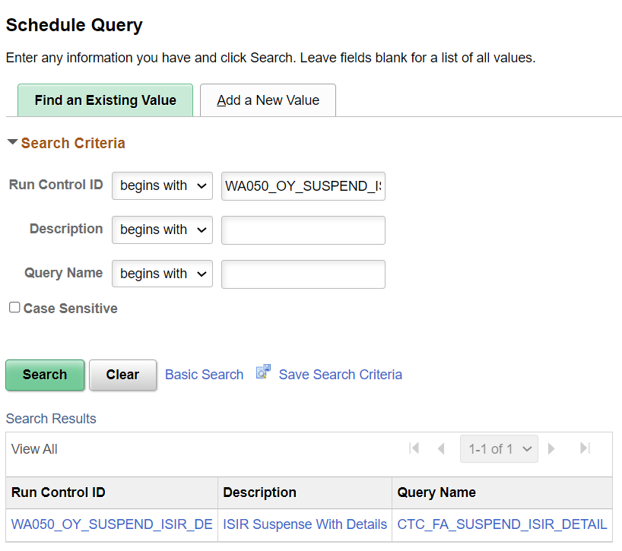

- Select the Run button
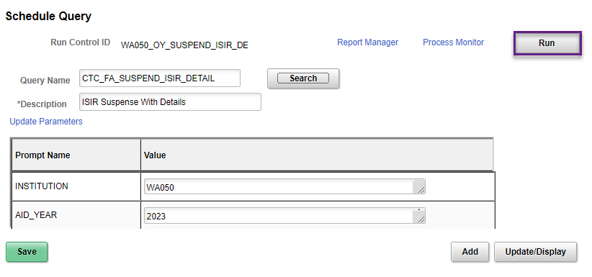
- Select the Distribution link
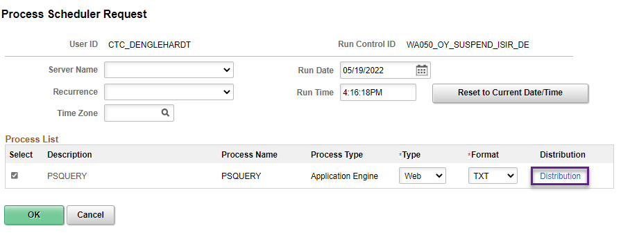

- Under Distribute To section, add a row and select User for ID Type and enter the EMPLID of the other user for Distribution ID. You can add more rows as necessary.
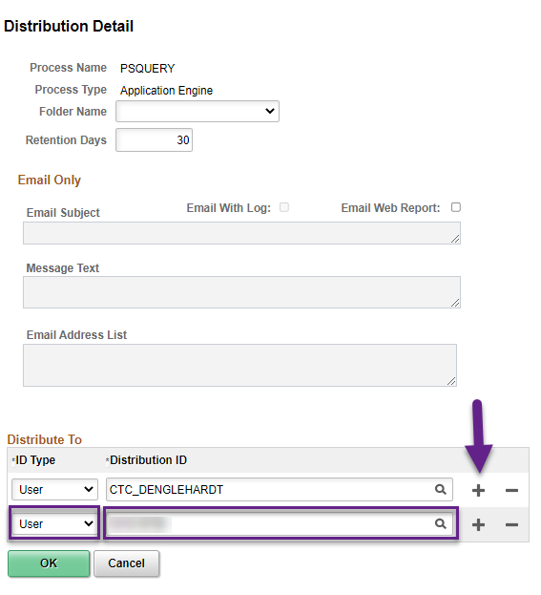

After you’ve added all the users that need access to the report, select the OK button

- Select the OK button and you’re done.
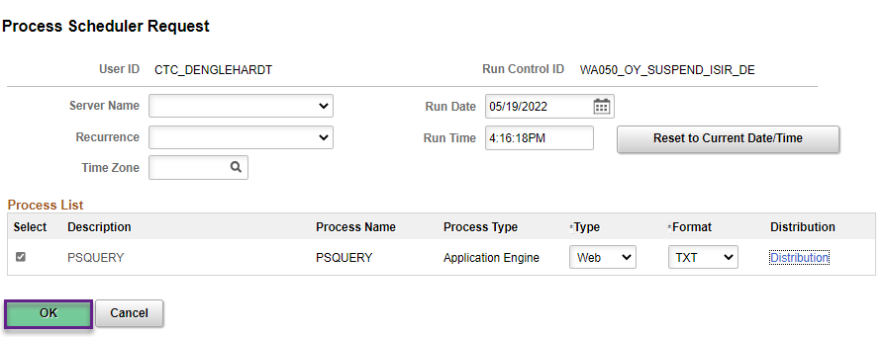

The ISIR Suspense Report will run immediately and once it’s Success and Posted, those that you added access to can navigate to Navigator > Reporting Tools > Report Manager and see the report.

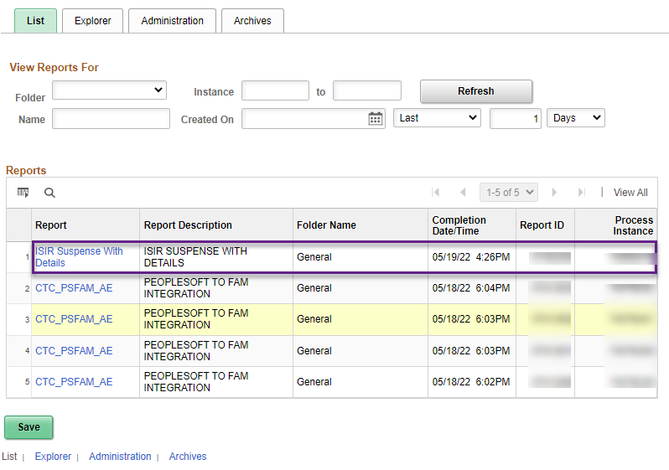

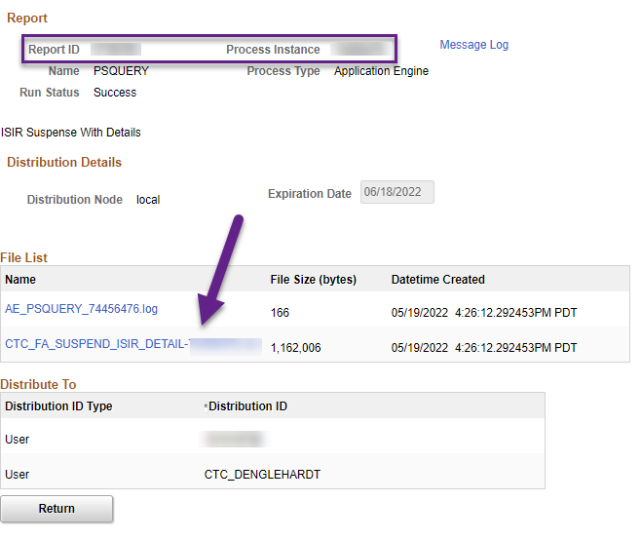

Send Email and Give a Different User Access to the BankMobile Student Data File Reports
Audience: SF user that runs the BankMobile Student Data file for the college
Note: This process is set on a recurrence for the colleges so you will need to go to PeopleTools > Process Scheduler > Process Monitor and remove the recurrence before proceeding to the first step.

- Navigate to Navigator > Student Financials > CTC Custom > CTC Interfaces > Higher One Student Data and find your existing BankMobile Student Data Run Control ID
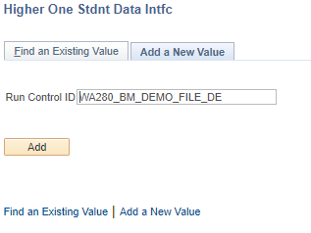

- Select the Run button
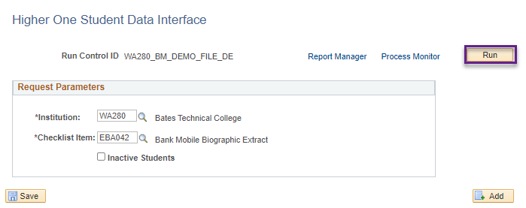

- Select the Distribution link

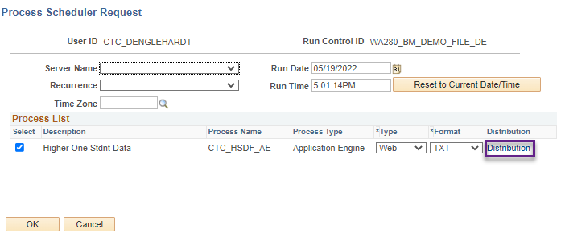

- Under Email Only section, select the Email Web Report checkbox and enter a message in the Email Subject box
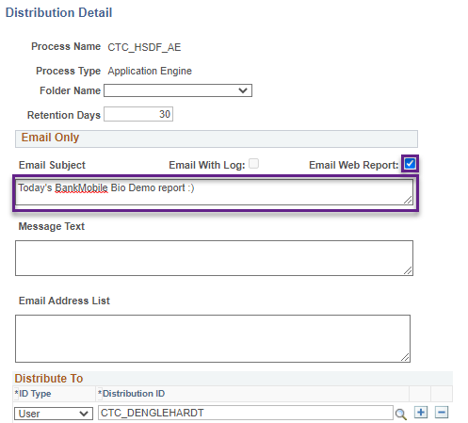

- Under Distribute To section, add a row and select User for ID Type and enter the EMPLID of the other user for Distribution ID. You can add more rows as necessary.
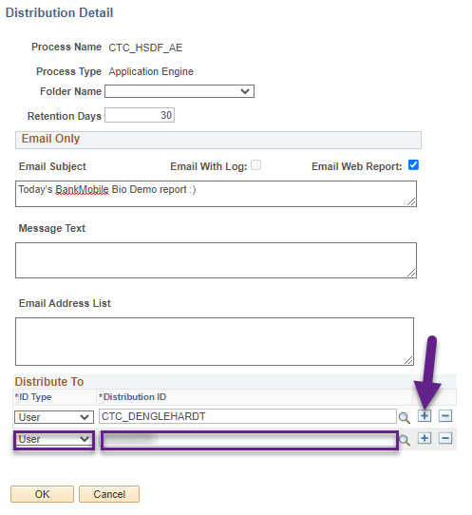

After you’ve added all the users that need access to the report, select the OK button

- Set the recurrence by selecting the Recurrence then the Time Zone and lastly the Run Date. After all three areas are correct, select the OK button.
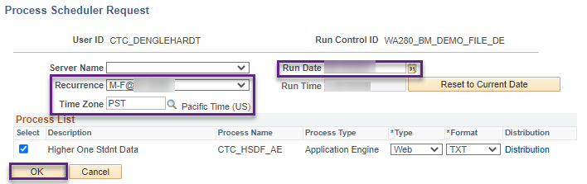

After the process runs at the set time you designated, users you listed to have access will see an email in their inbox with a link to the report.
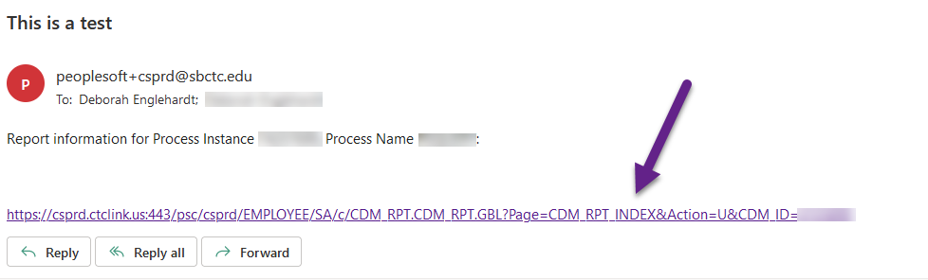
They can either select the link and log into ctcLink to access the report OR if they are already logged into ctcLink, they can navigate to Navigator > Reporting Tools > Report Manager to access the report.
