JOB RECURRENCE PRE AND POST GO-LIVE CONVERSION
The owners of scheduled JobSets and any recurring processes/jobs will need to manage their respective processes both prior to and after the go-live weekend as explained below.

PRE GO-LIVE CONVERSION TASKS REQUIRED
Before 3PM on THURSDAY, April 21st, you will need to do this for ALL of your JobSets, Recurring Processes AND Jobs

JOBSETS
Main Menu >> PeopleTools >> Process Scheduler >> Schedule JobSet Definitions

- For JobSets:
  - Navigate to the Schedule JobSet Definitions page and select the JobSet
  - Change the JobSet status from Active to Completed and click save.
DO NOT select “Run Now”.
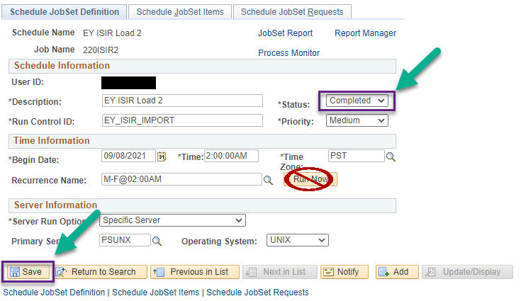

RECURRENCES – Jobs and Processes (not in JobSets above)
Main Menu >> PeopleTools >> Process Scheduler >> Process Monitor

- For Recurring Jobs / Processes
  - Navigate to the Process Monitor, enter your user ID and select the Run Status of Queued then Refresh the page using the Refresh button. As mentioned above, you will need to do this for each process and job.

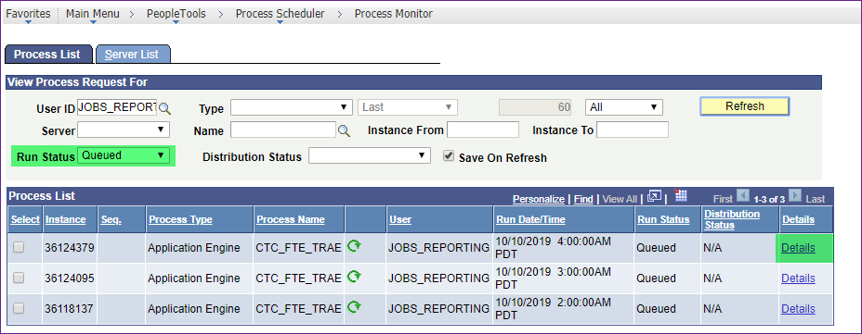

  - Next click on the Details link.
  - Select Cancel Request radio button in the Update Process section and click OK.
DO NOT select Restart Process.

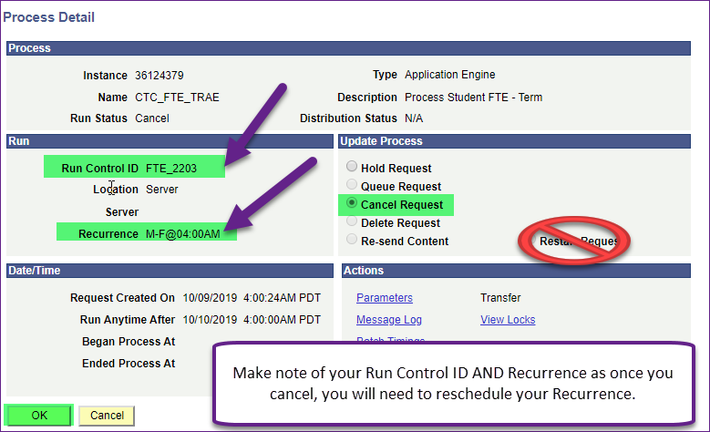

POST GO-LIVE CONVERSION
On Monday morning, April 25th
First - we will notify you when it is OK to reset your JobSets, Processes and Jobs. Please do not restart JobSets, process/jobs until we have notified you.
In addition – the times referenced were based on conversion activities.
JOBSETS
Main Menu >> PeopleTools >> Process Scheduler >> Schedule JobSet Definitions

- JobSets
  - Reschedule the job set recurrence paying close attention to date/time
  - Set the status to Active
  - Save
  - Go out, and come back in to your page to verify your changes were saved.

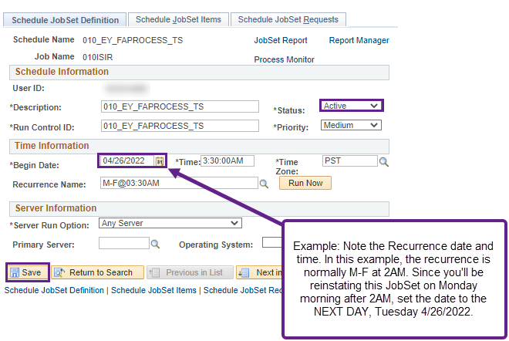

RECURRENCES – Jobs and Processes (not in Jobsets above)
Main Menu >> PeopleTools >> Process Scheduler >> Process Monitor

- Recurring Jobs / Processes
  - Navigate to your Run Control page for your Jobs / Processes.
  - In the example shown in below, for THIS user, in THIS example – type in your existing Run Control.
  - Verify your Run Control fields are correct – trust but verify all looks good.
  - IF so - Click “Run”

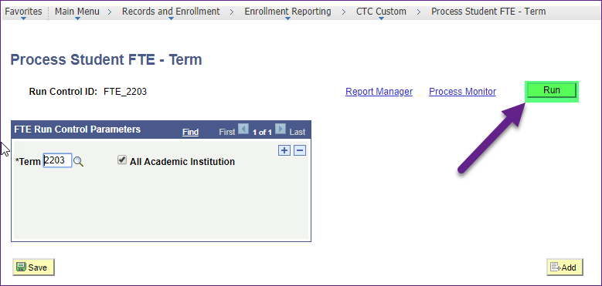

  - When you arrive at this page – depending on the time, just like in the example referenced above for JobSets: IF the Recurrence time has passed, as in the example below, update the “Run Date” to the next day – 04/26/2022. IF the Recurrence time has NOT passed, simply set the “Run Date” to current date – 04/25/2022.
  - Verify the Recurrence time auto-populated to existing Recurrence time – if so
  - Select OK
  - Double check your Recurrence time at the Process Monitor

