Updating the Need Duration and Cost of Attendance to Match Actual Enrollment

When you submit the Unit Record Report (URR) to WSAC, they require that the need duration, the cost of attendance and enrollment match. When the students are awarded, the need duration is usually correct and matches the cost of attendance and enrollment but if they withdraw for a quarter or do not attend for one of the quarters you awarded them, the need duration is no longer correct. In some cases, the COA is also not correct. This pop-update process was designed to aid colleges in cleaning up the need duration in batch.

Note: Need Duration is called Budget Duration in PeopleSoft.

To alter the budget duration value in batch requires two population updates prior to running batch INAS.

Overview of Process
Run the two pop-updates for each budget duration:
Population Update #1 selects students so that they are picked up for INAS re-calculation
Population Update #2 pushes the defined budget duration value into the Federal Application Data page for the selected students
Run Batch INAS Calculation
Submit a ticket to FA ERP to run a mass budget update for 2021 for your institution so that your COA will match the updated budget durations

IMPORTANT The two population updates must be run for each budget duration value. In other words, you would run Pop Update #1 and Pop Update #2 for your 2-month budget students then move on to running the Pop Update #1 and Pop Update #2 for your 3-month budget students and so forth.

Population Update #1 – Select Students for INAS Re-Calculation
Navigation | Description
Navigator > Set Up SACR > System Administration > Utilities > Population Update > Population Update Process | Selects students so that they are picked up for INAS re-calculation.

- Enter a New or Existing Run Control ID

- Select the folllowing parameters

Record Name: INAS_CALC_RECS
Institution: (This should auto-populate to your institution)
Aid Year: 2021
Rule: F

Report Error Messages radio button is selected

Selection Tool: PS Query
Query Name: CTC_FA_UPDATE_NS_NEED_DURATION

Field Name: Protection Reason (Field Value defaults to P)

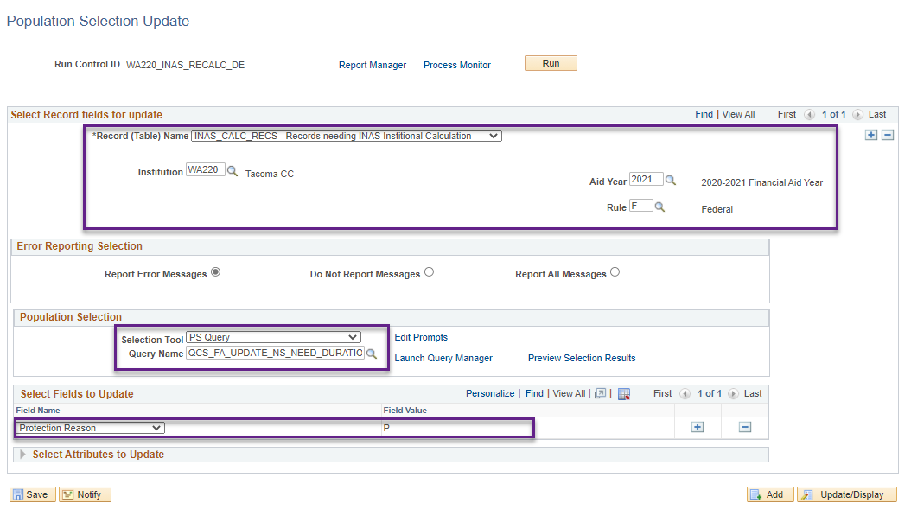

- Enter query edit prompts then click OK

Institution: WAxxx (i.e. WA220)
Summer Term: 2205 for headers / 2215 for trailers
Fall Term: 2207
Winter Term: 2211
Spring Term: 2213
2, 3, 5, 6, 8, 9 or 11: (Start with 2 to update your 2-month budget students, then after running both pop-updates move to 3-month budget students and so forth)
Aid Yr: 2021

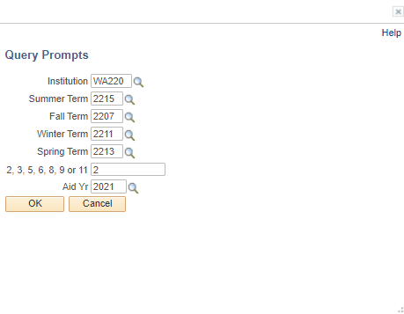

- Click on Preview Selection Results and review the list to make sure your parameters are picking up the correct population

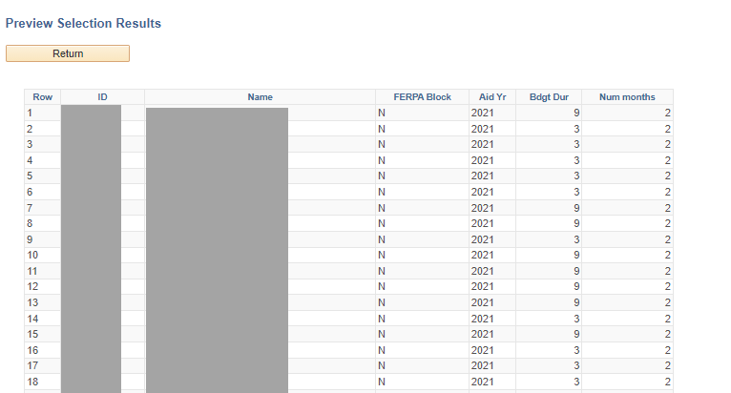

Note for Preview Selection Results: The Bdgt Dur field will display what the need duration is currently set to. Num of months field represents what the Budget Duration should change to by counting Active FA terms with an FA load greater than N and the W/D Info tab does not have a Withdrew or Cancelled status.

- Click Run then select SCC_POP_UPD then OK

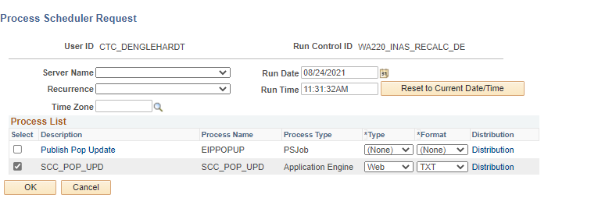

Population Update #2 - Update Budget Duration in Batch
Navigation | Description
Navigator > Set Up SACR > System Administration > Utilities > Population Update > Population Update Process | Pushes the defined budget duration value into the Federal Application Data page for the selected students.

- Enter a New or Existing Run Control ID

- Select the folllowing parameters

Record Name: INAS_FED_EXT
Institution: (This should auto-populate to your institution)
Don’t forget to update this value when you move onto the next budget duration. You wouldn’t want to accidentally pick up your 3-month budget students and populate 2 for their budget duration.
Aid Year: 2021

Report Error Messages radio button is selected

Selection Tool: PS Query
Query Name: CTC_FA_UPDATE_NS_NEED_DURATION

Field Name: Budget Duration- Acad Per Field Value: (This is the same number as your query edit prompts)
Field Name: INAS Calc Type Field Value: Federal Methodology
Field Name: INAS Data Source Field Value: Federal Data
Field Name: INAS Rule Set Field Value: CSS Rules/Values
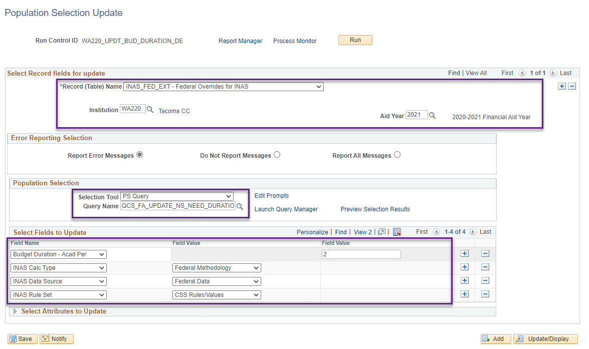
- Enter query edit prompts then click OK

Institution: WAxxx (i.e. WA220)
Summer Term: 2205 for headers / 2215 for trailers
Fall Term: 2207
Winter Term: 2211
Spring Term: 2213
2, 3, 5, 6, 8, 9 or 11: (Start with 2 to update your 2-month budget students, then after running both pop-updates move to 3-month budget students and so forth)
Aid Yr: 2021

- Click on Preview Selection Results and review the list to make sure your parameters are picking up the correct population

Note for Preview Selection Results: The Bdgt Dur field will display what the need duration is currently set to. Num of months field represents what the Budget Duration should change to by counting Active FA terms with an FA load greater than N and the W/D Info tab does not have a Withdrew or Cancelled status.

- Click Run then select SCC_POP_UPD then OK.

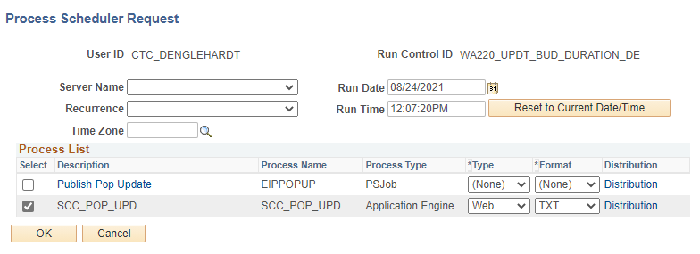

**Repeat Pop-Update #1 and Pop-Update #2 for all budget durations**

Batch INAS Calculation
Navigation | Description
Navigator > Financial Aid > File Management > INAS Batch Calculation | Batch calculate INAS on students.

- Enter a New or Existing Run Control ID

- Select the following parameters
Institution: (This should auto-populate to your institution)
Aid Year: 2021
Application Type: F
Clear Calc Requests: Y

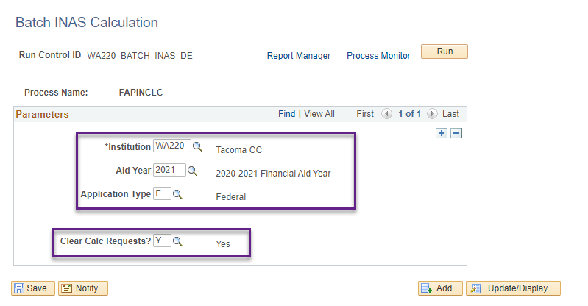
- Click Run then OK.
