FA ctcLink Customer Support

Washington State Board for Community and Technical Colleges
Unit Record Report Processing
2021

Contents
Unit Record Process Flow 2
Unit Record Report Overview 3
Unit Record Report Configuration 4
Ethnicity Config tab: 5
Awards Config tab: 10
Unit Record Report Process 10
Unit Record Report – Supplemental Reports 17
Appendix A: FA Item Type Worksheet for URR Config 22
Appendix B: Record File Layout and Data Source 26
Appendix C: Error Messages and Resolution 29

Unit Record Process Flow
Process | Process Name | Process Description | Review Log Required?
Reconcile all awards |  |  | N/A
Complete configuration | Unit Record Report Config | - Map PeopleSoft Ethnic Group values to URR Ethnicity Categories  - Map PeopleSoft FA Item Types to URR Award Categories (Use worksheet in Appendix A to assist with setup.) | N/A
Run State FA Reporting | Unit Record Report (CTC_URR_AE) | Generates CSV data file for URR and Reports A and B | Y
Review Report C |  | List of financial aid awards to be included in the URR extract file, but FA Item Types are missing from the Unit Record Report Config setup. | N/A
Review Report B |  | Student error details  Error summary | N/A
Review Report A |  | Student details included in the CSV data extract file  Summary of award totals | N/A
Rerun State FA Reporting, as needed once errors are resolved | Unit Record Report (CTC_URR_AE) | Generates CSV data file for URR and Reports A and B | Y
Submit URR CSV data extract file to WSAC | WSAC Secure Portal |  | N/A

Unit Record Report Overview
The Unit Record Report (URR) is a student-specific report of financial aid awarded to resident and nonresident students attending the Washington institutions that participate in the Washington College Grant program. The URR provides comprehensive information on federal, state, private, and institutional financial aid distributed to need-based financial aid recipients. The report also includes information about federal borrowing for non-need based loan recipients.
Unit Record Report Uses
Student-level data with term-by-term program-specific financial aid information is needed by the Council to conduct research; design state financial aid programs that complement other existing federal, state, and institutional programs; describe recipient populations; and administer and evaluate state financial aid programs as required by state law. The URR is the primary data source used by the Council to comply with these statutory requirements.
Data from the URR are used to:
- Provide financial aid data to the Education Research and Data Center (ERDC). These data, in combination with academic and workforce records, may be used by Council staff and other researchers to conduct longitudinal research on the educational and occupational achievements of financial aid recipients.
- Analyze the adequacy of financial aid resources available to financially needy Washington students.
- Describe funding trends and the characteristics of students receiving various types of financial assistance.
- Estimate funding needs and support budget requests for state-funded financial aid programs.
- Estimate the impact of new financial aid programs, changes in program policies, and altered funding levels.
- Contribute to student financial aid policy analysis and program evaluation.
- Respond to legislative requests for information about student financial aid programs available to Washington students. The URR significantly reduces the number of ad hoc data requests of institutions.

Unit Record Report Configuration
This configuration allows colleges to link the PeopleSoft Ethnic Group value associated with a student’s bio-demo record to the existing Unit Record Report Ethnic Category.
The Ethnic Group values are pulled from the student’s Ethnicity page in Campus Community.
Navigation: Nav Bar > Navigator > Set Up SACR > Product Related > Financial Aid > CTC Custom > CTC Interfaces > Unit Record Report > Unit Record Report Config > Ethnicity Config tab
Enter the Academic Institution
Select the Search button
If the table is already configured, you can verify, add, and update any of the Ethnic Group values mapped to the Ethnicity Category.
If the table is not configured, select the Add a New Value tab, enter Academic Institution, then select the Add button.
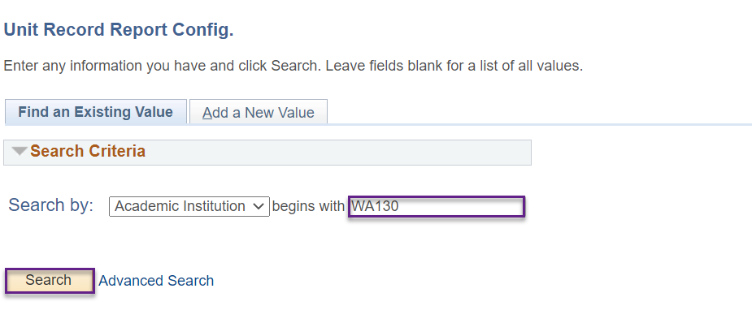
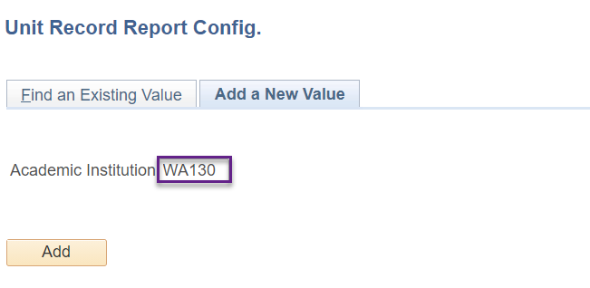

Ethnicity Config tab:
- Select the proper Summer Type value – ‘Header’ is for header colleges, ‘Trailer’ is for trailer colleges.
- Select the appropriate PeopleSoft Ethnic Group for the Unit Record Report Ethnicity Category.
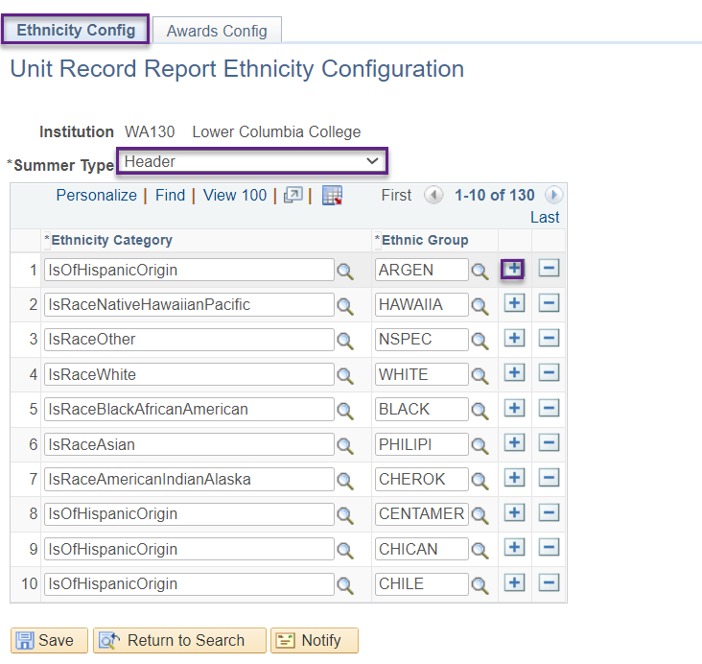
The following is the Ethnic Background to Ethnic Group Cross Walk as of 9/14/2021.
The Ethnic Group information is pulled directly from the records tables. Selecting the look up tool will enable users to see if any new Ethnic Groups have been added. This should be reviewed each year to verify Records staff have not added additional categories.
Ethnicity Category | Ethnic Group | Description
Black/African American | AFRAM | African American
American Indian/Alaska Native | ALASKN | Alaska Native
American Indian/Alaska Native | ALATHAB | Alaskan Athabaskans
American Indian/Alaska Native | ALEUT | Aleutian
American Indian/Alaska Native | AMIND | American Indian
American Indian/Alaska Native | APACHE | Apache
Hispanic/Latino | ARGEN | Argentinian
Asian | ASIAN | Asian
Asian | ASINDIAN | Asian Indian
American Indian/Alaska Native | BANNOCK | Bannock
Black/African American | BLACK | Black/African American
American Indian/Alaska Native | BLKFOOT | Blackfoot
Asian | CAMBOD | Cambodian
Hispanic/Latino | CENTAMER | Central American
American Indian/Alaska Native | CHEHALIS | Chehalis
American Indian/Alaska Native | CHEROK | Cherokee
American Indian/Alaska Native | CHEYEN | Cheyenne
Hispanic/Latino | CHICAN | Chicana/Chicano/Chicanx
American Indian/Alaska Native | CHICHSA | Chickasaw
Hispanic/Latino | CHILE | Chilean
Asian | CHINESE | Chinese
American Indian/Alaska Native | CHIPPEW | Chippewa
American Indian/Alaska Native | CHOCTAW | Choctaw
American Indian/Alaska Native | COEUR | Coeur d Alene Tribe
Hispanic/Latino | COLOMB | Colombian
American Indian/Alaska Native | COLVILLE | COLVILLE
American Indian/Alaska Native | COMANCH | Comanche
Hispanic/Latino | COSTAR | Costa Rican
American Indian/Alaska Native | COWLITZ | COWLITZ
American Indian/Alaska Native | CREE | Cree
American Indian/Alaska Native | CREEK | Creek
American Indian/Alaska Native | CROW | Crow
Hispanic/Latino | CUBAN | Cuban
American Indian/Alaska Native | DELAWA | Delaware
Hispanic/Latino | DOMIN | Dominican
Hispanic/Latino | ECUAT | Ecuadorian
Hispanic/Latino | ELSALVA | El Salvadorian
American Indian/Alaska Native | ESKIMO | Eskimo
Hispanic/Latino | GALAP | Galapagos Islander
American Indian/Alaska Native | GRANDRON | Confederated Tribes of the Grand Ronde
Hispanic/Latino | GUAJIR | Guajira/Guajiro/Guajirx
Native Hawaiian/Oth Pac Island | GUAMCHAM | Guamanian/Chamorro
Hispanic/Latino | GUATEM | Guatemalan
Native Hawaiian/Oth Pac Island | HAWAIIA | Hawaiian
Hispanic/Latino | HISPA | Hispanic
Asian | HMONG | Hmong
American Indian/Alaska Native | HOH | HOH
Hispanic/Latino | HONDUR | Honduran
American Indian/Alaska Native | HOPI | Hopi
American Indian/Alaska Native | IROQUI | Iroquois
American Indian/Alaska Native | JAMESTOW | JAMESTOWN
Asian | JAPANES | Japanese
American Indian/Alaska Native | KALISPEL | KALISPEL
American Indian/Alaska Native | KIOWA | Kiowa
American Indian/Alaska Native | KLAMATH | KLAMATH
American Indian/Alaska Native | KOOTENAI | KOOTENAI
Asian | KOREAN | Korean
Asian | LAOTIAN | Laotian
Hispanic/Latino | LARAZA | La Raza
Hispanic/Latino | LATINO | Latina/Latino/Latinx
American Indian/Alaska Native | LOWER | Lower Elwha Klallam Tribe
American Indian/Alaska Native | LUMBEE | Lumbee
American Indian/Alaska Native | LUMMI | LUMMI
American Indian/Alaska Native | MAKAH | MAKAH
Hispanic/Latino | MESITIZ | Mestiza/Mestizo/Mestizx
Hispanic/Latino | MEXAMER | Mexican-Amer, Mexican
Asian | MIENH | Mienh
Hispanic/Latino | MORENA | Morena
American Indian/Alaska Native | MUCKLESH | MUCKLESHOOT
American Indian/Alaska Native | NAVAJO | Navajo
American Indian/Alaska Native | NEZPERCE | Nez Perce Tribe
Hispanic/Latino | NICARAG | Nicaraguan
American Indian/Alaska Native | NISQUALL | NISQUALLY
American Indian/Alaska Native | NOOKSACK | NOOKSACK
Not Specified | NSPEC | Not Specified
Hispanic/Latino | NUEVOMEX | Nuevo Mexicano
American Indian/Alaska Native | OSAGE | Osage
Asian | OTHER | Other - Asian
Hispanic/Latino | OTHR | Other - Hispanic
Native Hawaiian/Oth Pac Island | PACIF | Other Pacific Islander
American Indian/Alaska Native | PAIUTE | Paiute
Hispanic/Latino | PANAMA | Panamanian
Hispanic/Latino | PARAGU | Paraguayan
Hispanic/Latino | PERU | Peruvian
Asian | PHILIPI | Filipino
American Indian/Alaska Native | PIMA | Pima
American Indian/Alaska Native | PORTGAMB | Port Gamble SKlallam Tribe
American Indian/Alaska Native | POTAWA | Potawatomi
American Indian/Alaska Native | PSSALISH | Puget Sound Salish
American Indian/Alaska Native | PUEBLO | Pueblo
Hispanic/Latino | PUERTOR | Puerto Rican
American Indian/Alaska Native | PUYALLUP | PUYALLUP
American Indian/Alaska Native | QUILEUTE | QUILEUTE
American Indian/Alaska Native | QUINAULT | QUINAULT
American Indian/Alaska Native | SALISHKO | Confederated Salish & Kootenai Tribes
American Indian/Alaska Native | SAMISH | SAMISH
Native Hawaiian/Oth Pac Island | SAMOAN | Samoan
American Indian/Alaska Native | SAUKSUIA | Sauk Suiattle Indian Tribe
American Indian/Alaska Native | SEMINO | Seminole
American Indian/Alaska Native | SHOALWAT | Shoalwater Bay Indian Tribe
American Indian/Alaska Native | SHOSHO | Shoshone
American Indian/Alaska Native | SHOSHONE | SHOSHONE
American Indian/Alaska Native | SILETZ | SILETZ
American Indian/Alaska Native | SIOUX | Sioux
American Indian/Alaska Native | SKOKOMIS | SKOKOMISH
American Indian/Alaska Native | SNOQUALM | SNOQUALMIE
Hispanic/Latino | SOAMER | South American
Hispanic/Latino | SPANAM | Spanish-American
Hispanic/Latino | SPANISH | Spanish
Hispanic/Latino | SPANMEX | Spanish-Mexican
American Indian/Alaska Native | SPOKANE | SPOKANE
American Indian/Alaska Native | SQUAXIN | SQUAXIN ISLAND
American Indian/Alaska Native | STILLAGU | STILLAGUAMISH
Hispanic/Latino | SUDAMER | Sudamericana/Sudamericano/Sudamericanx
American Indian/Alaska Native | SUQUAMIS | Suquamish Tribe
American Indian/Alaska Native | SWINOMIS | SWINOMISH
Hispanic/Latino | TEJANO | Tejano
Asian | THAI | Thai
American Indian/Alaska Native | TLINGIT | Tlingit
American Indian/Alaska Native | TOHONO | Tohono O'Odham
American Indian/Alaska Native | TULALIP | TULALIP
American Indian/Alaska Native | UMATILLA | UMATILLA
American Indian/Alaska Native | UPPERSKA | Upper Skagit Indian Tribe
Hispanic/Latino | URUGUAY | Uruguayan
Hispanic/Latino | VENEZUEL | Venezuelan
Asian | VIETNAME | Vietnamese
American Indian/Alaska Native | WARMSPRI | Confederated Tribes of Warm Springs
White | WHITE | White
American Indian/Alaska Native | YAKAMA | Confederated Tribes and Bands of the Yakama Nation
American Indian/Alaska Native | YAQUI | Yaqui

Awards Config tab:
- Select the appropriate existing FA Item Type for the Unit Record Report Award Category. Only FA Item Types that need to be reported to WSAC should be included in setup. As an example, you should not be configuring the Work Study Offer and WCG Waitlist on this page since they are not real funds awarded to the student. (Use the worksheet in Appendix A to categorize the FA Item Types to assist with setup.)
- Select the appropriate existing Award Status based on how you award the FA Item Type to students. The status associated with the FA Item Type is the field for which the dollar amount will be pulled from for the student and reported in the CSV data extract file. As an example, Direct Loan item types should have an award status of ‘Disbursed’, whereas the State Work Study Off Campus item type would have an award status of ‘Accepted’.
Please note – Users cannot enter values in Awards Config. fields that do not exist.
- Once all values are configured, select the Save button.

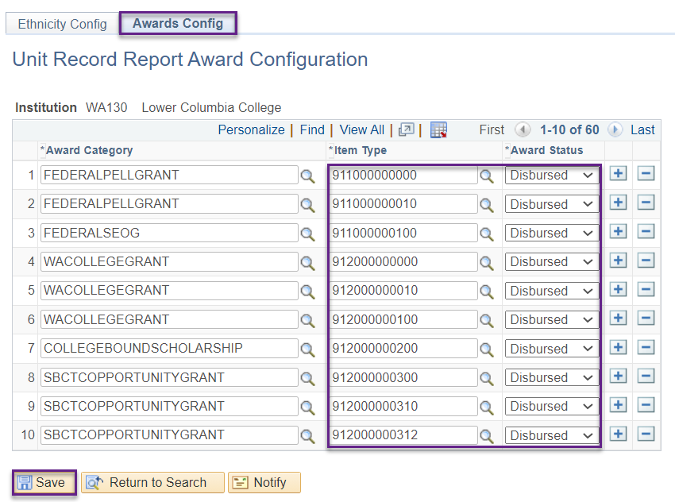

Unit Record Report Process
The PeopleSoft Unit Record Report allows colleges to generate a .CSV data extract file along with several reports to assist with data review and data cleanup. To run the Unit Record Report process, follow the instructions below.
Navigation: Nav Bar > Navigator > Financial Aid > CTC Custom > CTC Reports > State FA Reporting
Enter existing or new Run Control ID
Select the Add button
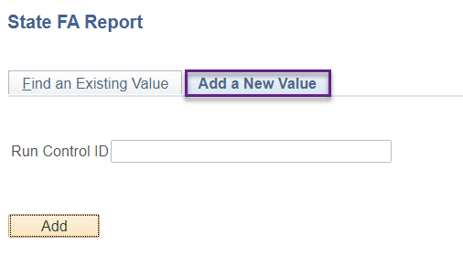
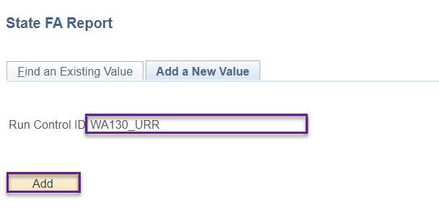

- Enter Institution
- Enter Aid Year
- Enter File Path: /CSTRANSFER/WAxxx/WCGyyyy/(where xxx represents your numeric college code, ex: 172, and yyyy represents the aid year, ex: 2021)
Report Type is not applicable for the Unit Record Report since the CSV file and supplemental reports are automatically generated in specific formats.
- Select the Run button
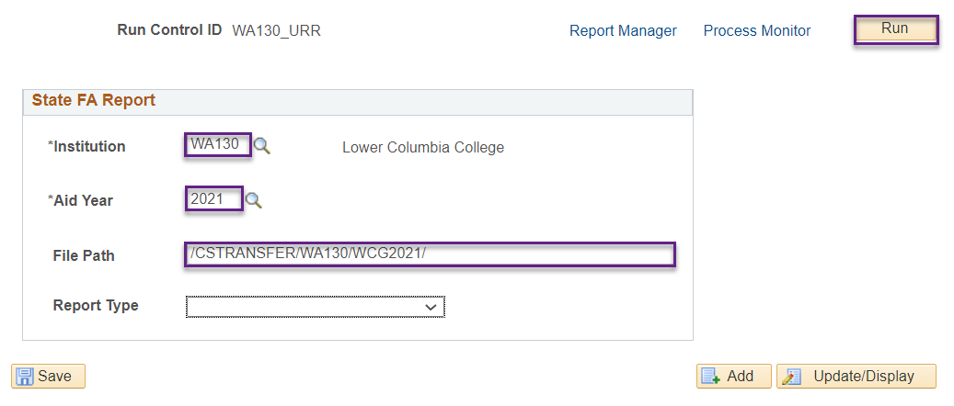

- At the Process Scheduler Request page, mark the checkbox for the Unit Record Report Process
- Select the OK button

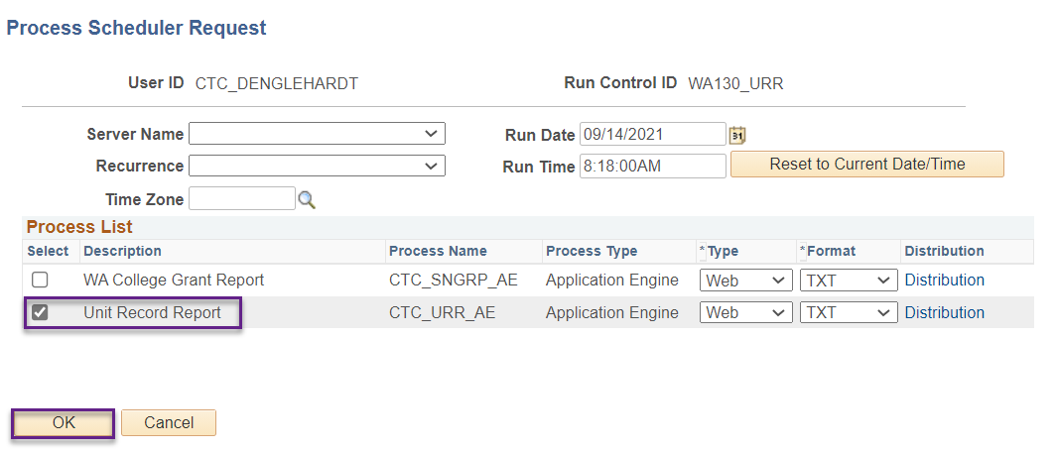

Back at the State FA Reporting run parameters page, verify that a Process Instance Number was assigned to your task.
Select the Process Monitor hyperlink
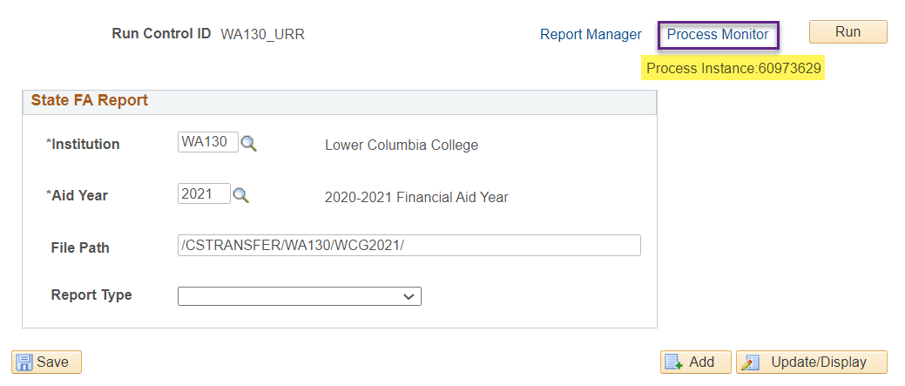
On the Process Monitor page, ensure that the Unit Record Report process (CTC_URR_AE) completes. The Run Status should say ‘Success’ and the Distribution Status say ‘Posted’.
Select the Details link to verify the process completed successfully and to access the CSV data file.
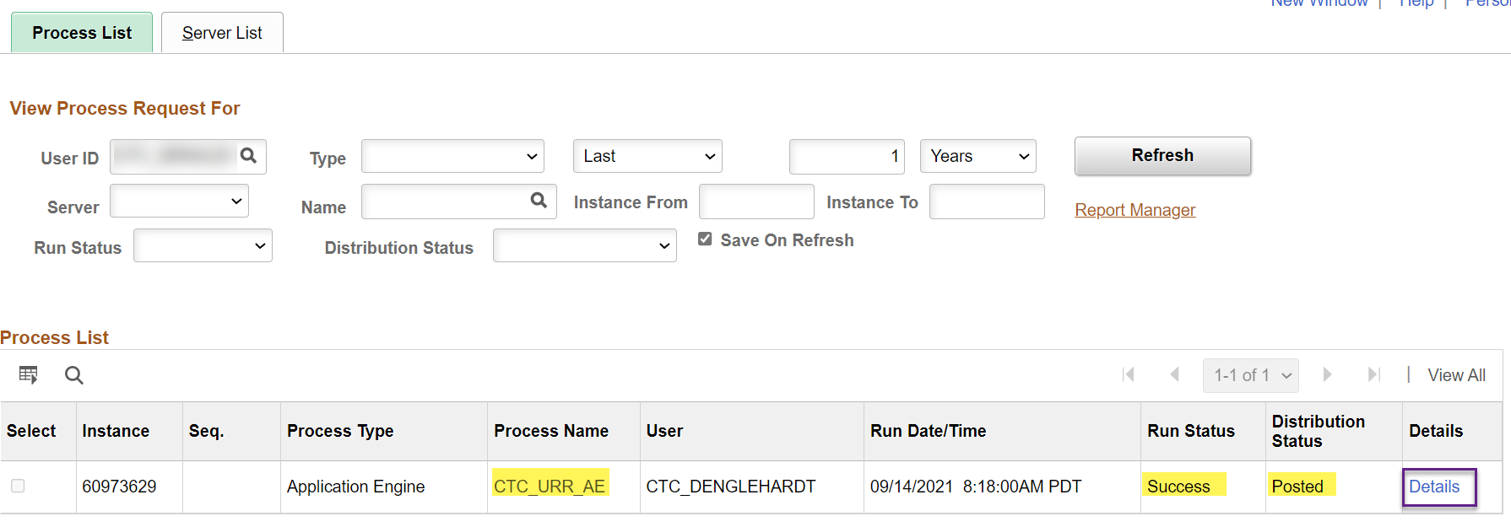
Select the Message Log link on the Process Detail page.

The following message should display to indicate the process completed successfully.
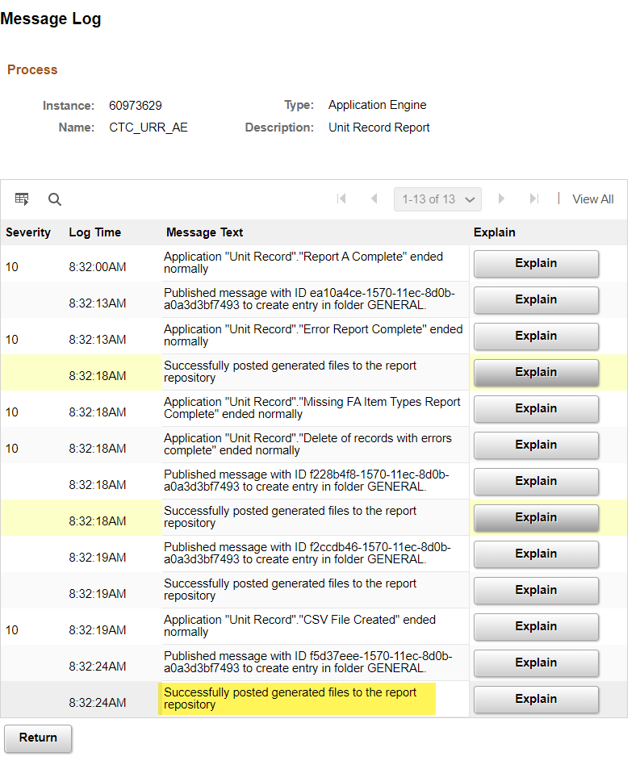

Select the View Log/Trace link to access the CSV data extract file.

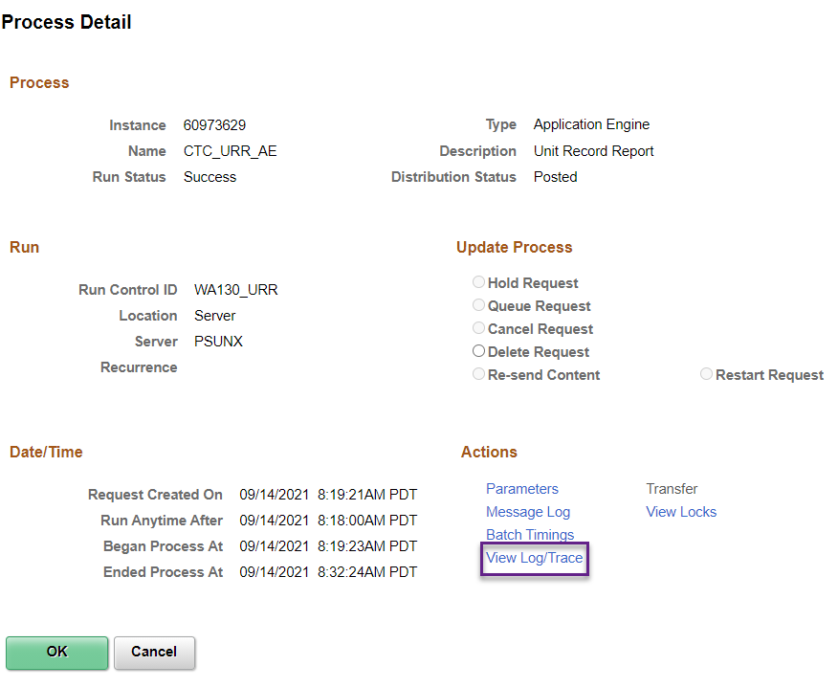

On the View Log/Trace page, select the Unit_Record_Report_xxxxxx.csv link (where xxxxx represents the Process Instance Number associated with the process that was just run).

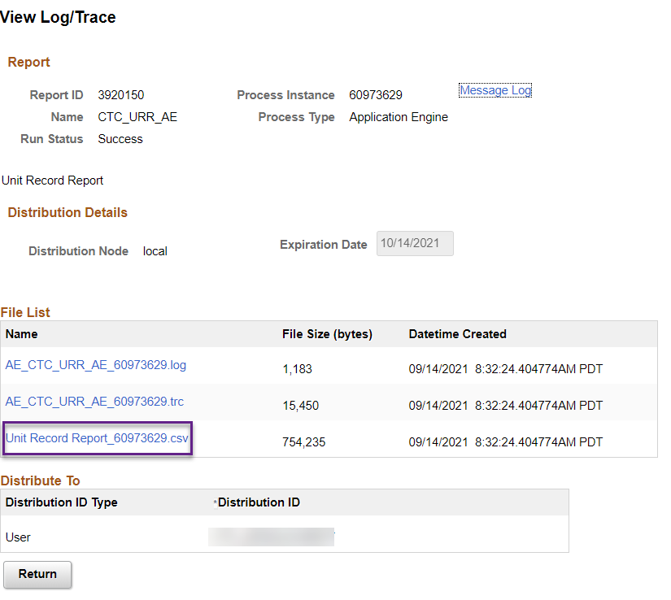

Depending on your browser, you may have a pop-up window providing you with the option to open or save the CSV file.
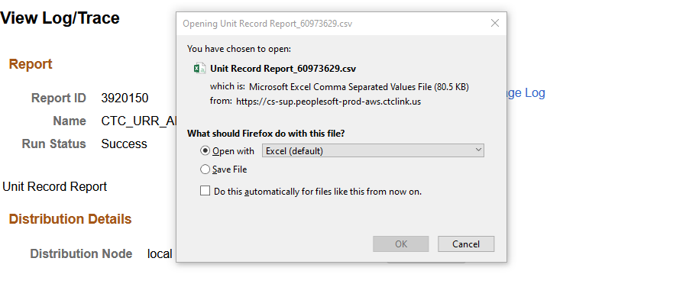

Unit Record Report – Supplemental Reports

It is recommended that the reports are reviewed and worked in the order listed below. This ensures that setup and errors are addressed prior to reviewing data to be included in the URR extract file.

Report C (CTCFAURR_C) – Missing Item Type Report
This report will identify any FA Item Type that has been awarded to a student with an amount greater than zero and qualifies to be reported in the Unit Record Report extract file, but the item type does not exist in the Unit Record Report Config setup page.
Report B (CTCFAURR_B) – Error Detail and Summary Report
This sample report is separated into 2 sections:
The first tab contains a list of students, sorted by Last Name, First Name, then EmplID, who have one or more errors. The error message number and description are included.
The second tab contains a list of all error messages encountered on the first tab with a total student count for each.
See Appendix B for suggestions on resolving each error condition.
Report A (CTCFAURR_A) – Student-detailed report.
This report provides a list of student details to be included in the extract file. In addition, the dollar amounts for each award received by the student is tallied and provided in the total columns.

To access the reports, select the Report Manager link on the State FA Reporting run control parameters page.
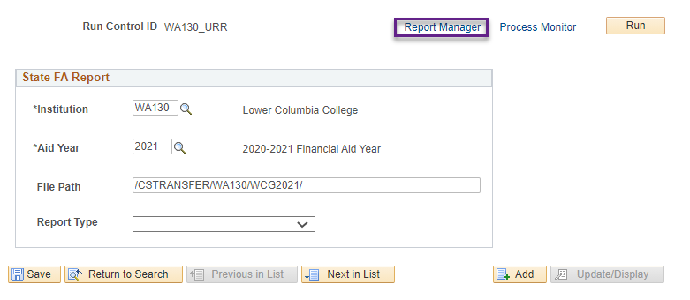

On the Reports page, it is recommended that Report C (CTCFAURR_C) is reviewed first to identify whether there are FA Item Types not configured in the URR setup for awards that should be reported to WSAC.
If there are FA Item Types that should be configured, please refer to the setup instructions under the Unit Record Report Configuration > Award Config tab section of this document.
Once the FA Item Types are correctly configured, you should rerun the Unit Record Report process prior to reviewing the CSV data extract file, Report A (CTCFAURR_A) or Report B (CTCFAURR_B).
When you are ready to review Report A and Report B, select the Report A (CTCFAURR_A) link and Report B (CTCFAURR_B) link.

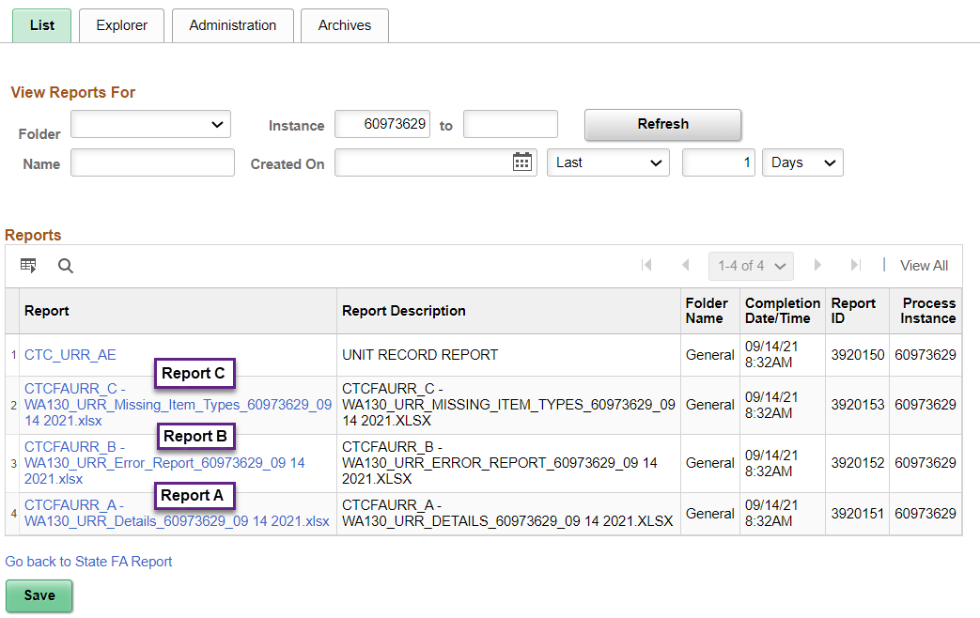

For Report C, from the File List page select the file link that ends in .xlsx (ex:WA130_URR_Missing_Item_Types_60973629_09 14 2021.xlsx).

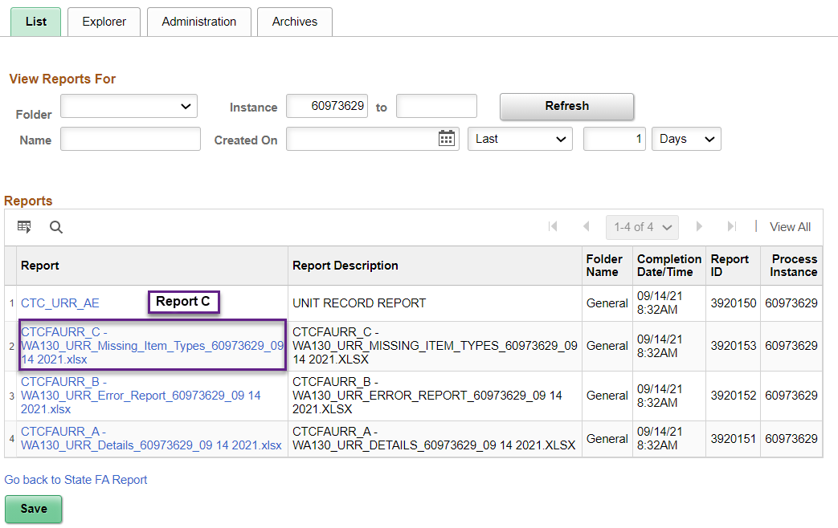

For Report B, select the file link that ends in .xlsx
(ex: WA130_URR_Error_Report_60973629_09 14 2021.xlsx).

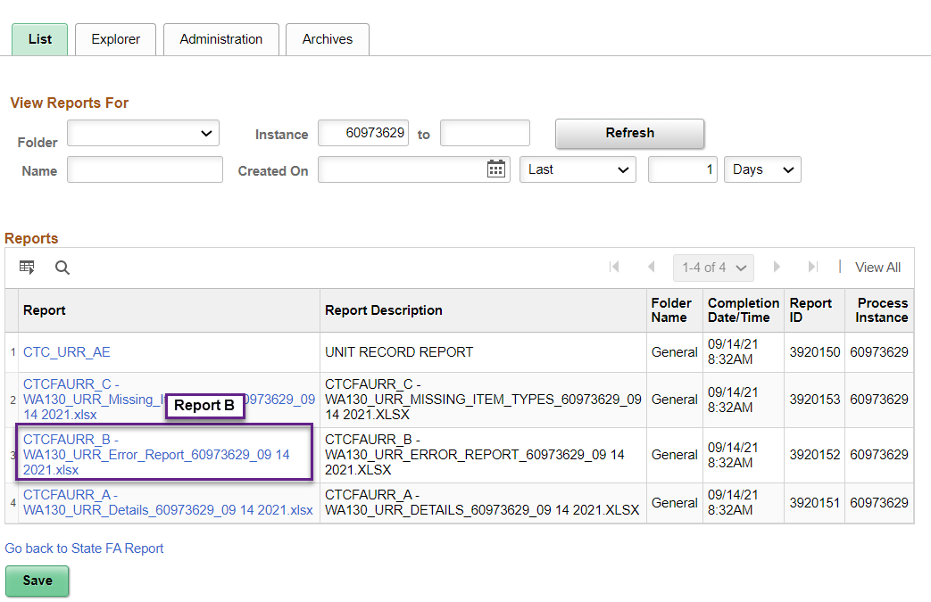

For Report A, select the file link that ends in .xlsx
(ex: WA130_URR_Details_60973629_09 14 2021.xlsx).

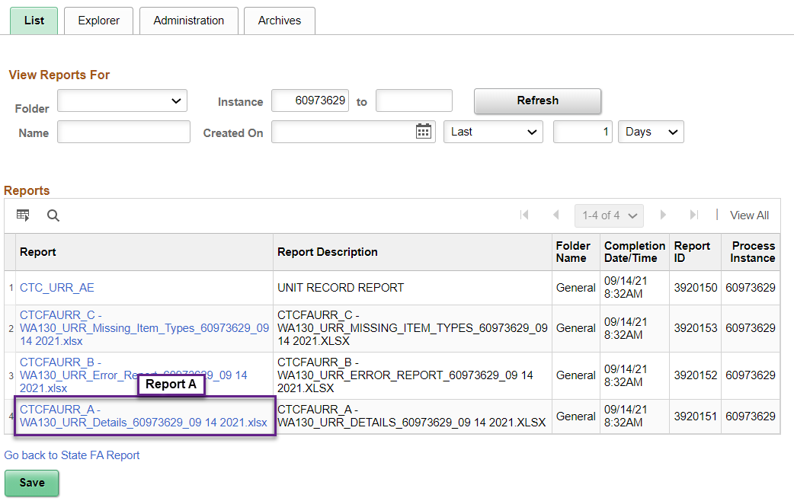

Appendix A: FA Item Type Worksheet for URR Config
In review of the FA Item Type Config page, if the Award Category is no longer valid, remove the row.
If the Award Category has been newly created, update award category field for applicable item-type(s).
Financial Aid Program | FA Item Type(s) | URR Awards Config | URR Category
Alternative Routes to Teaching Certification |  | ALTERNATIVEROUTES | Alternative Routes
College Bound Scholarship |  | COLLEGEBOUNDSCHOLARSHIP | College Bound Scholarship
Other conditional loans not reported elsewhere |  | CONDITIONALLOANS | Conditional Loans
Federal Direct/Stafford Subsidized Loans |  | FEDERALDIRECTSUBSIDIZEDLOANS | Federal Direct Subsidized Loans
Federal Direct/Stafford Unsubsidized Loans |  | FEDERALDIRECTUNSUBSIDIZEDLOANS | Federal Direct Unsubsidized Loans
Federal Parent PLUS Loan |  | FEDERALPARENTPLUSLOANS | Federal Parent PLUS Loans
Pell Grant |  | FEDERALPELLGRANT | Federal Pell Grant
Perkins Loan |  | FEDERALPERKINSLOAN | Federal Perkins Loan
SEOG |  | FEDERALSEOG | Federal SEOG
Federal Nursing Student Loan and health professions student loan funds |  | FEDERALNURSINGHEALTHLOANS | Federal Nursing Health Loans
Federal nursing and other health professional training scholarships and grants |  | FEDERALNURSINGSCHOLARSHIPS | Federal Nursing Scholarships
Federal TEACH Grant |  | FEDERALTEACHGRANT | Federal TEACH Grant
Federal Work Study |  | FEDERALWORKSTUDY | Federal Work Study
Work First Work Study  Non-Work Study Institutional and Off-Campus Employment  Institutional aid fund used as Work Study |  | INSTITUTIONALEMPLOYMENT | Institutional Employment
Institutional Loans |  | INSTITUTIONALLOANS | Institutional Loans
National Guard Grant |  | NATIONALGUARDGRANT | NationalGuardGrant
3.5% Waivers  Athletic Waivers (need-based) Graduate Tuition Waivers (need-based)  Institutional Aid Fund (need-based)  Institutional grants and scholarships (need-based) Need-Based Institutional Gift Aid Need-Based Tuition & Fee Waivers  Nonresident Enrollment Incentive Waiver (need-based)  Tuition & Fee Waivers (need-based)  Western Undergraduate Exchange Waiver (need-based) |  | NEEDBASEDINSTITUTIONALGIFTAID | Need-Based Institutional Gift Aid
Athletic Waivers (non-need based)  Graduation Tuition Waivers (non-need based)  Institutional Aid Fund (non-need based)  Institutional grants and scholarships (non-need based)  Non-Need Based Institutional Gift Aid  Nonresident Enrollment Incentive Waiver (non-need based)  Tuition & Fee Waiver (non-need based)  Western Undergraduate Exchange Waiver (non-need based) |  | NONNEEDBASEDINSTITUTIONGIFTAID | Non-Need Based Institutional Gift Aid
Off-Campus State Work Study |  | OFFCAMPUSSTATEWORKSTUDY | Off-Campus State Work Study
On-Campus State Work Study |  | ONCAMPUSSTATEWORKSTUDY | On-Campus State Work Study
AmeriCorp  Bureau of Indian Affairs (BIA) Scholarship, Federal scholarships for TRIO students, L & I Assistance,  ROTC Scholarships,  Services for the Blind Assistance, Vocational Rehab Assistance  (DVR), Workforce Investment Act Asst., Other Agency Assistance |  | OTHERAGENCYASSISTANCE | Other Agency Assistance
Alaska Student Loan Canadian Student Loan Micronesian Student Loan Other Loans not reported elsewhere |  | OTHERLOANS | Other Loans
Early Achievers Opportunity Grant  Washington Award for Vocational Excellence (WAVE) Washington Scholars American Indian Endowed Scholarships  GEAR-UP  All Other State-Funded Gift Asst.  Student Teaching Grant  Student Teaching Residency Grant |  | OTHERSTATEFUNDEDGIFTASSISTANCE | Other State Funded Gift Assistance
Company Scholarships Employer Funded Tuition Assistance  Governor’s Scholarship Leadership 1000 Scholarship National Merit Scholarships Organizational Scholarships Other state scholarships  (i.e.,Oregon)  Outside Scholarships Private Scholarships Robert C. Byrd Honors Scholarship  Service Club Scholarships Washington State Achievers Scholarship |  | OUTSIDESCHOLARSHIPS | Outside Scholarships
Paraeducator, Pipeline for Paraeducators |  | PARAEDUCATOR | Paraeducator
Passport to College Scholarship |  | PASSPORTTOCOLLEGESCHOLARSHIP | Passport to College Scholarship
Passport to College Incentive Grant |  | PASSPORTTOCOLLEGEINCENTIVEGRNT | Passport to College Incentive Grant
PREP Loan  Other Private Loans |  | PRIVATELOANS | Private Loans
List the award codes used for SBCTC Opportunity Grant |  | SBCTCOPPORTUNITYGRANT | SBCTC Opportunity Grant
Student Teaching Grant / Teacher Grant Programs |  | TEACHERGRANTPROGRAMS | Teacher Grant Programs
Award category no longer valid |  | TEACHERCONDITIONALSCHLRSHPPRGM | Teacher Conditional Scholarship Programs
Teacher Shortage Conditional Scholarship |  | TEACHERSHORTAGECONDITIONALSCHO | Teacher Shortage Conditional Scholarship
Veteran’s Benefits, Chapter 31 or 33 VA Benefits |  | VABENEFIT | VA Benefit
WA College Grant,  WCG Apprenticeship,  Do NOT include Gear-Up here |  | WACOLLEGEGRANT | WA College Grant
College Success Foundation Opportunity Scholarship (previously with CSF; now with Washington STEM/WSOS)  Opportunity Scholarship (from Washington STEM/WSOS)  Washington State Opportunity Scholarship (from Washington STEM/WSOS)  Washington State Opportunity Scholarship BA Scholarship  WSOS BA Scholarship |  | WSOSBASCHOLARSHIP | WSOS BA Scholarship
Washington State Opportunity Scholarship Career and Technical Scholarship  WSOS Career and Technical Scholarship |  | WSOSCAREERTECH | WSOS Career Tech Scholarship
Work-based Learning Tuition Assistance Funds  Worker Retraining  Workforce Training Program  Basic Food Employment & Training (BFET) |  | WORKFORCETRAININGFUNDS | WorkForce Training Funds

Appendix B: Record File Layout and Data Source

Field/Column Header Name | Valid Inputs | Remarks | Data Source
SSN | Numbers, with or without hyphens, no spaces | Required for all recipients. Nine-digit SSN. Include leading zeros, if necessary, to fill all nine digits. For students reported in the Final Interim Report: Report the same number that was reported in the Final Interim Report. For students not reported in the Final Interim Report: Report the same number used in your institutional reporting. | Bio-Demo if available, otherwise pull from FAFSA.
InstitutionStudentID | Any characters (up to 50) | Community and Technical Colleges (CTCs): Use the 9-character, college-assigned student identification number (SID) as the first 9 characters (include leading zeroes). You may add additional characters up to 50 characters. This field is required for public institutions but is overrideable. EMPLID | Bio-Demo
LastName | Any characters (up to 100) | Required for all recipients. If a student only has a first name, report that name as first name and last name. | Bio-Demo
FirstName | Any characters (up to 50) | Required for all recipients. | Bio-Demo
MiddleName | Any characters (up to 50) | Optional, but provide if available. | Bio-Demo
DateOfBirth | Most standard US database date-only outputs are supported e.g.:  - 12/1/1987  - Dec 10 1990  - 12 Aug 1994  - ‘April 1, 1992’  - ‘1 May, 1990’ | Required field if reporting FAFSA-based or WASFA aid types; otherwise optional and may be left blank. Standard US dates. Two digit years will be accepted, but four digit years are preferred. If commas are included in the dates, enclose the data in quotes. | Bio-Demo
Gender | '1' or 'Male'  '2' or 'Female'  ‘3’ or ‘Unknown’  ‘4’ or ‘X/Non-binary’ | Required for all recipients. | Bio-Demo
IsStateResident | ‘y’ or ‘true’  ‘n’ or ‘false’ | Required for all recipients. | Bio-Demo
YearInSchool | ‘1’ or ‘Freshman/1st Year’  ‘2’ or ‘Sophomore/2nd Year’  ‘3’ or ‘Junior/3rd Year’  4’ or ‘Senior/4th Year’  ‘5’ or ‘Unclassified/5th Year’  ‘6’ or ‘Graduate’  ‘7’ or ‘Professional’  ‘8’ or ‘Other’ | Required for all recipients. Report the status as of the beginning of the term of the recipient’s last financial aid disbursement for the year.  From legacy: Students who answer ‘Yes’ on FAFSA Question #28 should be reported with a value of ‘5’. | Student Record for values 1, 2, 3 or 4.
IsOfHispanicOrigin | ‘y’ or ‘true’  ‘n’ or ‘false’  blank if not reported | Report data if available. Leave blank only if information is not available. | Student Record
IsRaceAmericanIndianAlaskaNative | ‘y’ or ‘true’  ‘n’ or ‘false’  blank if not reported | Report data if available. Leave blank only if information is not available. Race may be reported as ‘y’ or ‘true’ in one or more race category. | Student Record
IsRaceAsian | ‘y’ or ‘true’  ‘n’ or ‘false’  blank if not reported | Report data if available. Leave blank only if information is not available. Race may be reported as ‘y’ or ‘true’ in one or more race category. | Student Record
IsRaceBlackAfricanAmerican | ‘y’ or ‘true’  ‘n’ or ‘false’  blank if not reported | Report data if available. Leave blank only if information is not available. Race may be reported as ‘y’ or ‘true’ in one or more race category. | Student Record
IsRaceNativeHawaiianPacificIslander | ‘y’ or ‘true’  ‘n’ or ‘false’  blank if not reported | Report data if available. Leave blank only if information is not available. Race may be reported as ‘y’ or ‘true’ in one or more race category. | Student Record
IsRaceWhite | ‘y’ or ‘true’  ‘n’ or ‘false’  blank if not reported | Report data if available. Leave blank only if information is not available. Race may be reported as ‘y’ or ‘true’ in one or more race category. | Student Record
IsRaceOther | ‘y’ or ‘true’  ‘n’ or ‘false’  blank if not reported | Report data if available. Leave blank only if information is not available. Race may be reported as ‘y’ or ‘true’ in one or more race category. | Student Record
ISIRWASFATransNumber | Integer  1 to 100  blank if no ISIR or WASFA | Required for all recipients with a FAFSA or WASFA on file. Report transaction number used to award aid. Leave blank if no FAFSA or WASFA data available | ISIR
RejectedISIRWASFA | ‘y’ or ‘true’  ‘n’ or ‘false’ | Required for all records. Use ‘y’ or ‘true’ if student did not file FAFSA or WASFA, or has only an invalid, rejected ISIR or WASFA. A blank will trigger an upload fail. | ISIR
MaritalStatus | ‘1’ or ‘Unmarried’  ‘2’ or ‘Married’  ‘3’ or ‘Separated’ | Required for all need-based aid recipients with a FAFSA or WASFA on file. May be left blank if FAFSA or WASFA data is not available. | ISIR
IsDependent | ‘y’ or ‘true’  ‘n’ or ‘false’ | Required for all need-based aid recipients with a FAFSA or WASFA on file. May be left blank if FAFSA or WASFA data is not available. | ISIR
FamilySize | Integer > 0  1 to 20 | Required for all need-based aid recipients with a FAFSA or WASFA on file. May be left blank if FAFSA or WASFA data is not available. Matched to CSAW data. | ISIR
NumberInCollege | Integer > 0  1 to 20 | Required for all need-based aid recipients with a FAFSA or WASFA on file. May be left blank if FAFSA or WASFA data is not available. Matched to CSAW data. | ISIR
FamilyIncome | Integer between  -300000 and 600000 | Required for all need-based aid recipients with a FAFSA or WASFA on file. Leave blank if FAFSA or WASFA data is not available. Matched to CSAW data. | ISIR
CostOfAttendance | Integer  0 to 250000 | Required for all need-based aid recipients with a FAFSA or WASFA on file. May be left blank if FAFSA or WASFA data is not available. Must use full assessed tuition amount in COA calculation for SNG and CBS recipients, and when possible, for recipients of other need-based aid. | FA
ExpectedFamilyContribution | Integer  0 to 250000 | Required for all need-based aid recipients with a FAFSA or WASFA on file. May be left blank if FAFSA or WASFA data is not available. Report FM only. | FA
NeedDuration | Integer  1 to 12 | Required for all need-based aid recipients with a FAFSA or WASFA on file. May be left blank if FAFSA or WASFA data is not available. | FA
NeedAmount | Integer  0 to250000 | Required for all need-based aid recipients with a FAFSA or WASFA on file. May be left blank if FAFSA or WASFA data is not available. | FA

Appendix C: Error Messages and Resolution
Error Number | Error Description | Error criteria | Record navigation to view or resolve data | Can record be included in .CSV extract file even if error condition occurs?
001 | Invalid or Missing SSN | Value being reported from the bio-demo record is blank or not equal to 9 digits in length | Campus Community > Personal Information > Add/Update a Person > National ID field | No, if null
002 | Invalid or Missing Resident Code | Student’s bio-demo residency value is missing or ‘Undetermined’  OR  The value is other than ‘In State’, ‘Out of State’ or ‘International’. | Campus Community > Personal Information > Identification > Residency Data > Residency Official 1 tab > Residency field | No
003 | Marital Status is Missing | Student’s marital status from the ISIR is missing. | Financial Aid > Federal Application Data > Correct 20xx – 20xx ISIR records > Marital Status field | No
004 | Dependency Status is Missing or Invalid | Student’s dependency status from the ISIR is neither ‘dependent’ nor ‘independent’. | Financial Aid > Federal Application Data > Correct 20xx – 20xx ISIR records > | No
005 | Not Enrolled in Any Terms | The student’s FA Load value on all terms in FA Term is ‘N’. | Financial Aid > Financial Aid Term > Maintain Student FA Term > Acad Level tab > Financial Aid Load field | No
006 | Invalid or Missing Year In School | The student’s year in school value is missing OR not equal to:  ‘1’ (freshman/1st year),  ‘2’ (sophomore/2nd year),  ‘3’ (junior/3rd year),  ‘4’ (senior/4th year), or  ‘5’ (unclassified/5th year).  Year in School is calculated by a combination of earned units (between the ranges indicated in the URR Manual), whether or not students are matriculated into a BAA/BAS program included on FA Term, and the NSLDS Loan Year on FA Term. | For NSLDS Loan Year: Financial Aid > Financial Aid Term > Maintain Student FA Term > Financial Aid Info tab > NSLDS Loan Year field  For Academic Program/Plan: Financial Aid > Financial Aid Term > Maintain Student FA Term > FA Term tab > Prim Prog or Acad Plan field  Earned units is being calculated by summing all earned units for courses numbered 100 or above | No
007 | Invalid or Missing Gender Code | Student’s bio-demo gender value being reported is blank OR other than ‘Female’, ‘Male’, ‘Unknown’ or ‘X/Non-Binary.’ | Campus Community > Personal Information > Add/Update a Person > Gender field | No
008 | DOB is Missing or Out of Range | The student’s bio-demo date of birth value is missing OR out of range.  Out of range value is less than 01/01/1944 or greater than 12/31/2004. | Campus Community > Personal Information > Add/Update a Person > Date of Birth field | Yes
009 | Family Size is Missing, Too Small or Too Large | The student’s Family size value from the ISIR is blank OR out of range.  For Dependent students, the value being reported is less than 02 or greater than 20.  For Independent students, the value being reported is less than 01 or greater than 20. | Financial Aid > Federal Application Data > Correct 20XX– 20XX ISIR records >  Dependent students: Parent Information tab > Number in Family field  Independent students: Student Information tab > Number in Family field | Yes
010 | Family Income is Missing, Negative Value or Too Large | The student’s Family income value from the SNG Eligibility Data page is blank OR is less than -300,000 OR greater than 600,000. | Financial Aid > CTC Custom > CTC Interfaces > State Need Grant > SNG Eligibility View > SNG Eligibility & Archive Data > SNG Eligible Data tab > SNG Income field | No
011 | Number in College is Missing, Too Small or Too Large | The student’s Number in College value from the ISIR is less than 1 or greater than 20 OR greater than the Family Size value being reported.  If number in college is blank, a default value of ‘1’ will be inserted allowing the record to be included in the CSV file. The student will not appear on the Error Report B. | Financial Aid > Federal Application Data > Correct 20XX – 20XX ISIR records >  Dependent students: Parent Information tab > Number in College field  Independent students: Student Information tab > Number in College field | Yes
012 | Cost of Attendance is Missing | The student’s Cost of Attendance value is blank OR zero. | Financial Aid > Awards > Award Processing > Assign Awards to a Student > Fed Year COA field  Also check if the student has a budget assigned to him/her.  Financial Aid > Budgets > Maintain Term Budgets | No
013 | Need Amount is Missing, Too Small or Too Large | The student’s Need Amount value is blank OR less than zero OR greater than $250,000. | Financial Aid > Awards > Award Processing > Assign Awards to a Student > Fed Need field | No
014 | State WS Recipient; Not State Resident | Student has a WA State Work Study award, with an amount greater than zero, but the residency value on the Residency Data page is not equal to “In State”. | Campus Community > Personal Information > Identification > Residency Data > Residency Official 1 tab > Residency field | No
015 | State Need Grant Recipient; Not State Resident | Student has a WA State Need Grant award, with an amount greater than zero, but the residency value on the Residency Data page is not equal to “In State”. | Campus Community > Personal Information > Identification > Residency Data > Residency Official 1 tab > Residency field | No
016 | College Bound Scholarship Recipient; Not State Resident | Student has a College Bound Scholarship award, with an amount greater than zero, but the residency value on the Residency Data page is not equal to “In State”. | Campus Community > Personal Information > Identification > Residency Data > Residency Official 1 tab > Residency field | No
017 | Opportunity Scholarship Recipient; Not State Resident | Student has an Opportunity Scholarship award, with an amount greater than zero, but the residency value on the Residency Data page is not equal to “In State”. | Campus Community > Personal Information > Identification > Residency Data > Residency Official 1 tab > Residency field | No
018 | Passport To College Recipient; Not State Resident | Student has a Passport to College award, with an amount greater than zero, but the residency value on the Residency Data page is not equal to “In State”. | Campus Community > Personal Information > Identification > Residency Data > Residency Official 1 tab > Residency field | No
019 | EFC is Missing, Negative Value or Too Large | EFC value being reported is missing OR  EFC value being reported is less than zero OR EFC value being reported greater than $250,000. | Financial Aid > Awards > Award Processing > Assign Awards to a Student > Prorated EFC field | No
020 | Invalid ISIR, No Need or no Budget Information | Student does not have a valid ISIR uploaded OR student budget information is missing OR the student’s initial Need (Cost of Attendance minus EFC) is zero. | ISIR not loaded or invalid: Financial Aid > File Management > ISIR Import > 20XX-20XX Suspense Management  Missing student budget: Financial Aid > Budgets > Maintain Term Budgets  No Need: Financial Aid > Awards > Award Processing > Assign Awards to a Student | Yes
021 | Pell Grant Exceeds Limit | The total award amount being reported is greater than the annual amount of $9,143. | Financial Aid > Awards > Award Processing > Assign Awards to a Student | Yes
022 | FSEOG Exceeds Limit | The total award amount being reported is greater than the annual amount of $6,000. | Financial Aid > Awards > Award Processing > Assign Awards to a Student | Yes
023 | TEACH Grant Exceeds Limit | The total award amount being reported is greater than the annual amount of $8,000. | Financial Aid > Awards > Award Processing > Assign Awards to a Student | Yes
024 | Federal Perkins Loan Exceeds Limit | The total award amount being reported is greater than the annual amount of $0. *Program expiration in 2017-18 | Financial Aid > Awards > Award Processing > Assign Awards to a Student | Yes
025 | Federal Direct Subsidized Loans Exceeds Limit | The total award amount being reported is greater than the annual amount of $5,500. | Financial Aid > Awards > Award Processing > Assign Awards to a Student | Yes
026 | Federal Direct Unsubsidized Loans Exceeds Limit | The total award amount being reported is greater than the annual amount of $12,500. | Financial Aid > Awards > Award Processing > Assign Awards to a Student | Yes
027 | State Need Grant Exceeds Term Limit(s) | The award amount being reported for one term exceeds $1,543  OR  The award amount being reported for two terms exceeds $3,086  OR  The award amount being reported for three terms exceeds $4,630  OR  The award amount being reported for four terms exceeds $6,172  The quarterly maximums are determined for non-BAA/BAS recipients which also includes the annual DCA amount. | Financial Aid > Awards > Award Processing > Assign Awards to a Student > Disbursement link for the State Need Grant item type | Yes
028 | College Bound Scholarship Exceeds Limit | The total award amount being reported is greater than the annual amount of $15,000. | Financial Aid > Awards > Award Processing > Assign Awards to a Student | Yes
029 | Passport to College Scholarship Exceeds Limit | The total award amount being reported is greater than the annual amount of $9,500. | Financial Aid > Awards > Award Processing > Assign Awards to a Student | Yes
030 | GET Ready for Math & Science Exceeds Limit | The total award amount being reported is greater than the annual amount of $0. *No new funds have been available | Financial Aid > Awards > Award Processing > Assign Awards to a Student | Yes
031 | SBCTC Opportunity Grant Exceeds Limit | The total award amount being reported is greater than the annual amount of $10,000. | Financial Aid > Awards > Award Processing > Assign Awards to a Student | Yes

Overview, Unit Record Report Manual: 2020-21 Academic Year
Unit Record Report Uses, Unit Record Report Manual: 2020-21 Academic Year
Award Category no longer valid, TeacherConditionalScholarshipPrograms
New Award Categories, NationalGuardGrant, AlternativeRoutes, Paraeducator, TeacherShortageConditionalScholarship, VABenefit

