ASSIGN, POP THEN WAIVE Process for V1

This process is designed to find the V1 checklists assigned by the ISIR that are still in Initiated status so that their Packaging Status Summary can be updated and V1 checklist can be waived with a standard comment.

Outline of steps in this guide
- Data Cleanup of Institutionally Selected V1 Students (One Time Only)
- Set Up the Run Control IDs for the Assign V1 Checklist Process
- Set Up the Run Control ID for the Pop-Update Process
- Set Up the Components for the Waive Process
- Run the ASSIGN, POP THEN WAIVE Process
  - Assign V1 Checklists
  - Pop-Update Packaging Status Summary Pages
  - Waive Checklists

Remove the Run Control IDs that assigns V1 checklists in Initiated status from the ISIR Jobset so that you can run it ad-hoc every morning before running the pop-update and waive process. If you leave it on your ISIR Jobset, students will get the To-Do communications at night only for you to pop-update and waive in the morning.

Timing of when to run the ASSIGN, POP THEN WAIVE Process
Colleges should run this 3-step process any morning your staff will be reviewing files.

Make sure to run the pop-update before the waive. If you run the waive first, then the students will not show up to pop-update.

***This process is not needed for every aid year moving forward so it will not be added to the ISIR Jobset for colleges***

Table of Contents
Data Cleanup of Institutionally Selected V1 students (ONE TIME ONLY) 3
Set Up Run Control IDs for the Assign V1 Checklist Process (if you don’t have them already) 6
Set Up Run Control ID for the Pop-Update Process 9
Set Up the Components for the Waive Process 11
Assign, Pop then Waive 16

Data Cleanup of Institutionally Selected V1 students (ONE TIME ONLY)

For this to be a one-time clean up, moving forward, when you institutionally select a student for verification, make sure to code the Packaging Status Summary page to INST Verification Status = Selected for Verification.

Find and clean up students who you’ve selected for verification and added the V1 checklist to but did not set the Packaging Status Summary page to INST Verification Status to Selected for Verification
- Go to Query Viewer and search for QCS_FA_WAIVE_V1_VERIF_NO_INST

Navigation: Reporting Tools > Query > Query Viewer

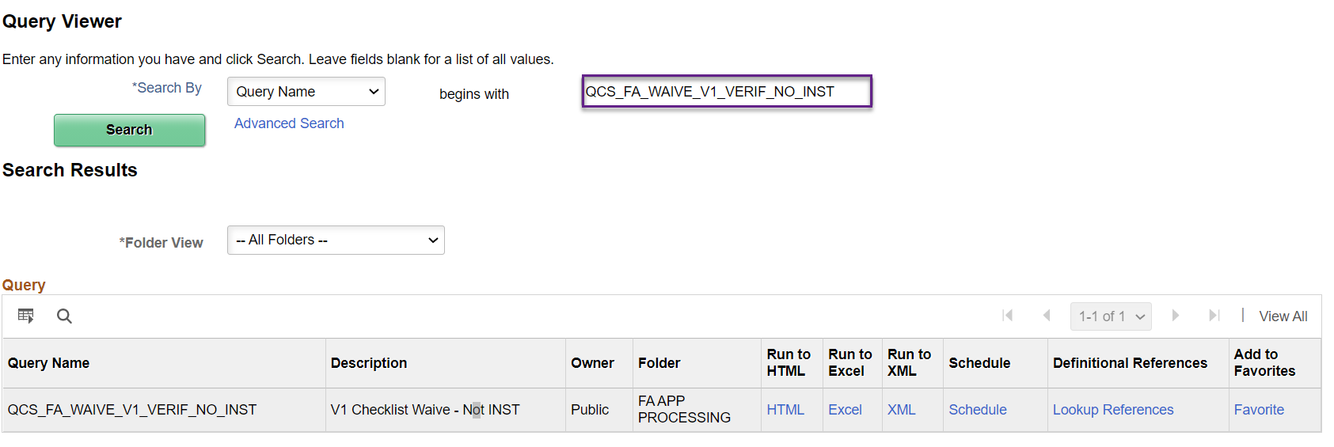

- Download a spreadsheet of the population that will be updated with this new process

Click on HTML, EXCEL or Schedule (if your college is a big school) and save the results
Query prompts
Aid Yr: 2022
Institution: WAxxx (i.e. WA130)
V1 Checklist 1: Exx029 (i.e. ELC029)
V1 Checklist 2: Colleges that have separated their V1 population into dependent versus independent will put their Exx185 here. Everyone else will put Exx029 again.

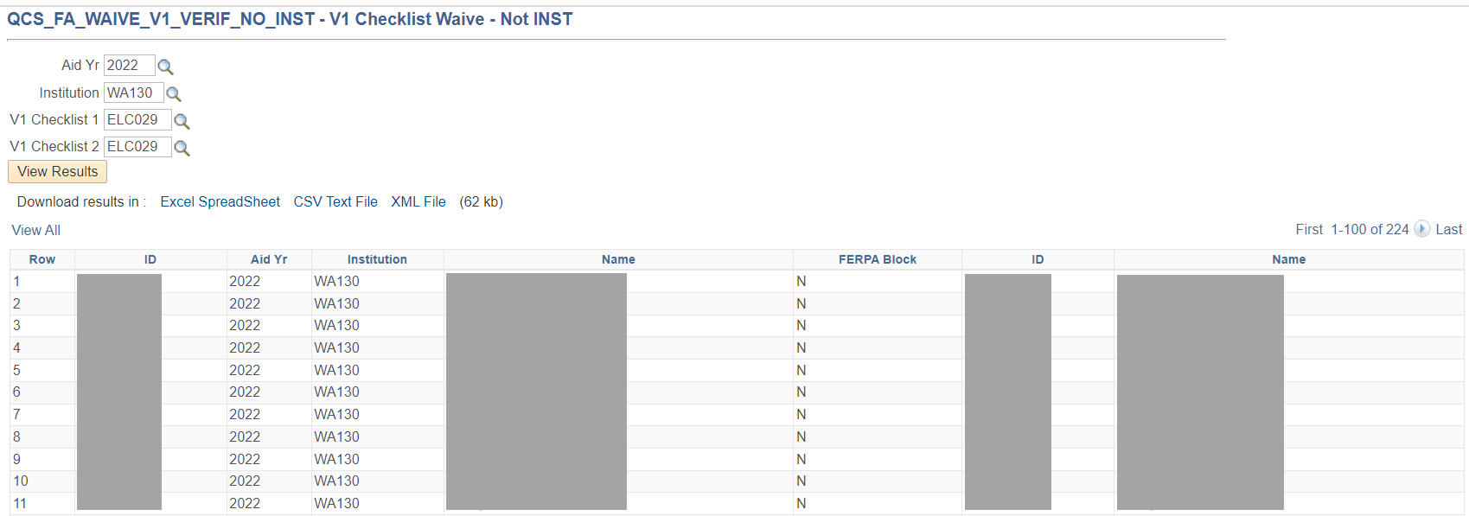

- Run the V1 queries (CTC_FA_SB_AD_V1_D and CTC_FA_SB_AD_V1_I) and download the results

Click on HTML, EXCEL or Schedule (if your college is a big school) and save the results
Query prompts
Aid Yr: 2022
Institution: WAxxx (i.e. WA130)
Checklist: Leave blank or enter 000000

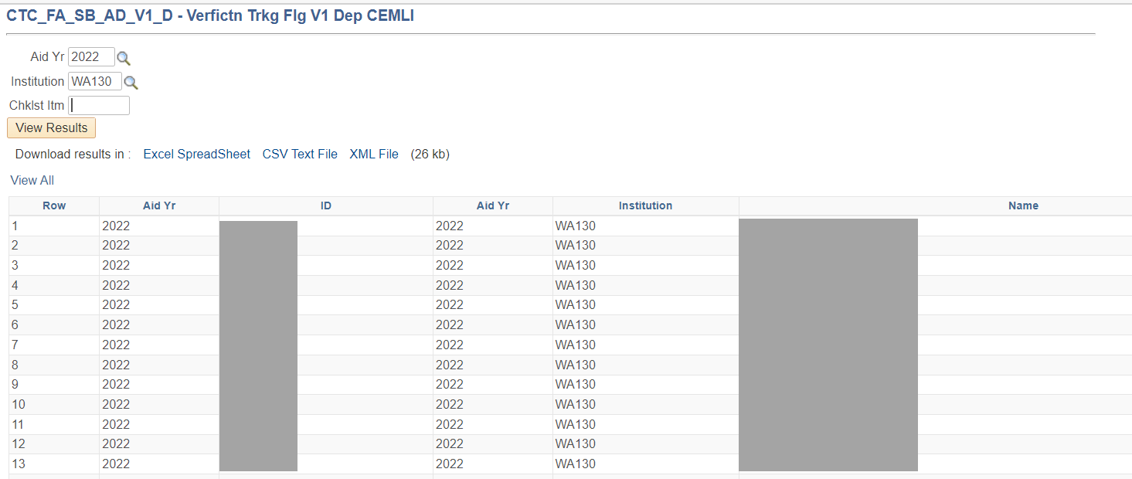

If you combine the results from both V1 queries, you will get the students who have V1 flag on their ISIR

- Compare the results from QCS_FA_WAIVE_V1_VERIF_NO_INST with the V1 list you created in the previous step

Anyone that you see is on the QCS_FA_WAIVE_V1_VERIF_NO_INST results but not on the V1 list is a student who was selected for V1 by your college and the Packaging Status Summary page needs to be updated so their V1 checklist does not get waived.

Below is an example of what the student’s Financial Aid Status screen may look like.

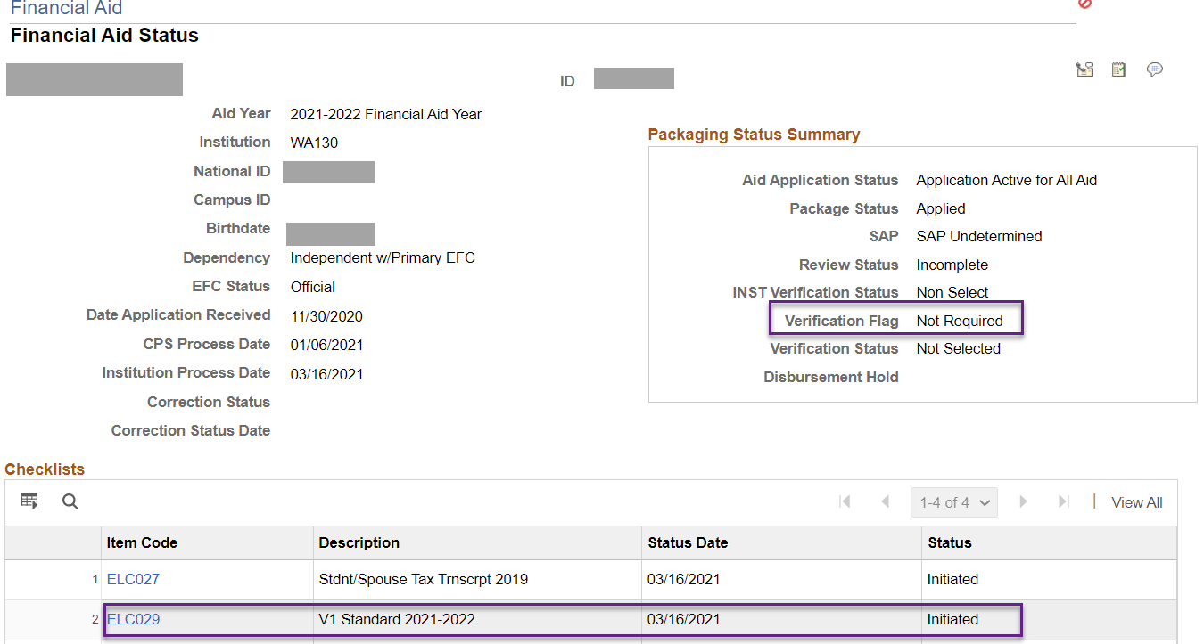

On the Packaging Status Summary page, flip the INST Verification Status to Selected for Verification then the student’s V1 checklist will not be waived when you run the waive process.

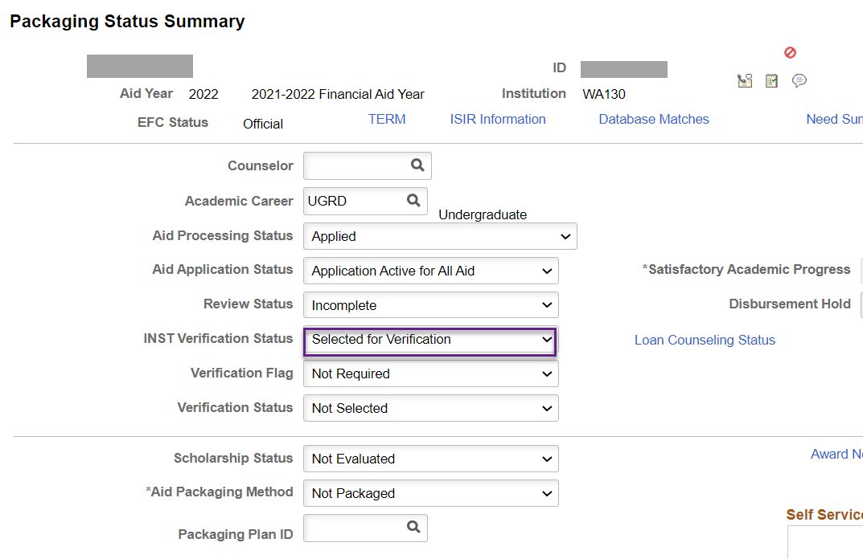

Set Up Run Control IDs for the Assign V1 Checklist Process (if you don’t have them already)

Navigation: Campus Community > 3C Engine > Run 3C Engine

Per usual, make sure to put your college and initials in the Run Control ID name so that your Run Control ID is unique in the system.

You will need two V1 assignment Run Control IDs: One for V1 dependents and one for V1 independents. This example is for the V1 dependent Run Control ID as indicated by the word “DEP” in the Run Control ID name.

Select Population Selection and enter the following prompts in the Event Selection section then click tab on your keyboard. The checklist and comment should populate.

Academic Institution: WAxxx
Administrative Function: FINA
Event ID: FISExx029I (i.e. FISELC029I)

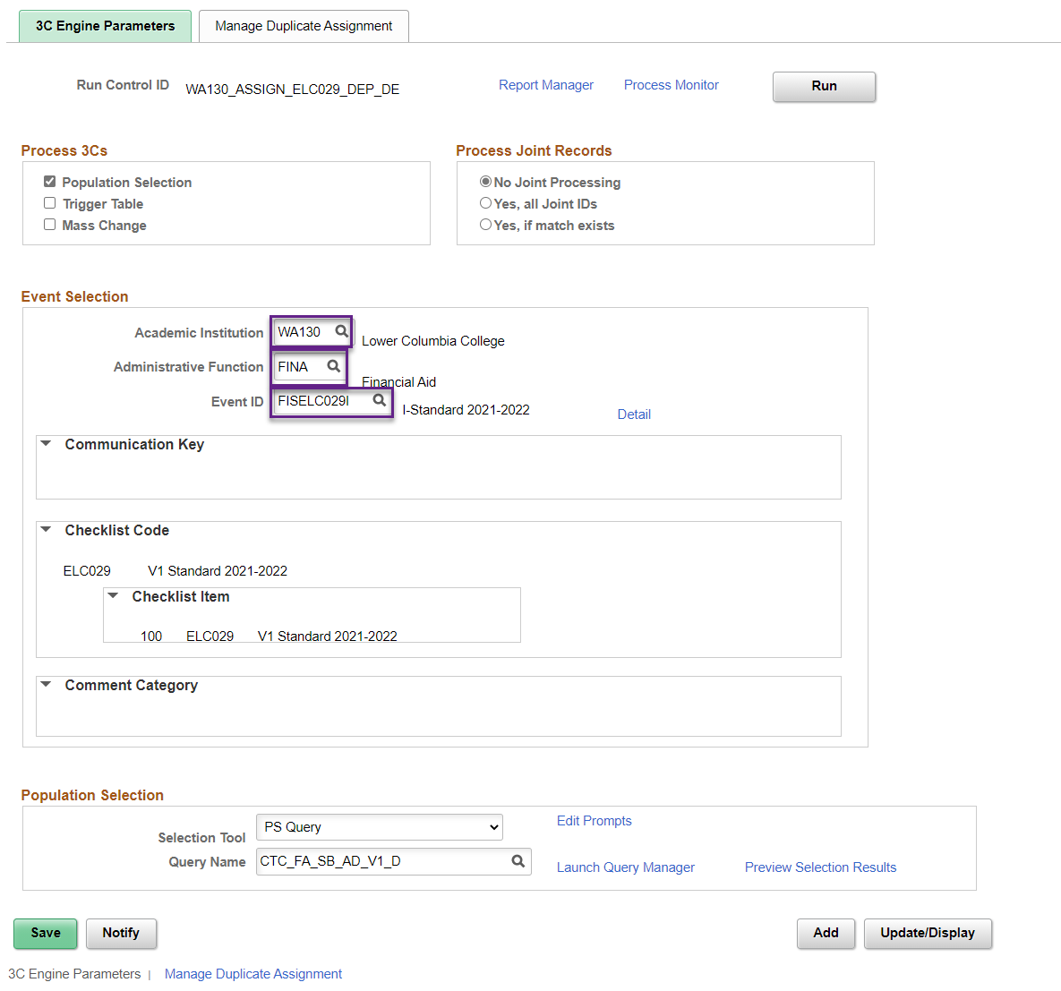
For Populations Selection, choose PS Query and CTC_FA_SB_AD_V1_D

Query prompts
Aid Yr: 2022
Institution: WAxxx (i.e. WA130)
Chklst Itm: Exx029 (i.e. ELC029)
**Some colleges have two V1 checklists so they may enter Exx185 depending on which checklist they use for V1 dependents**

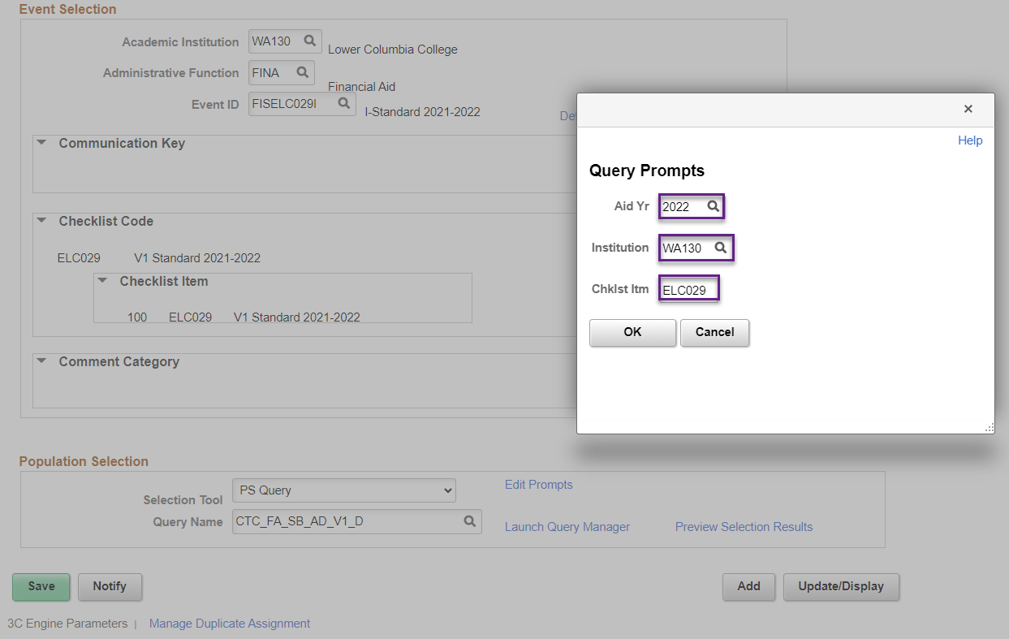

Click on Preview Selection Results to confirm the parameters you entered picked up the right students then click Return.

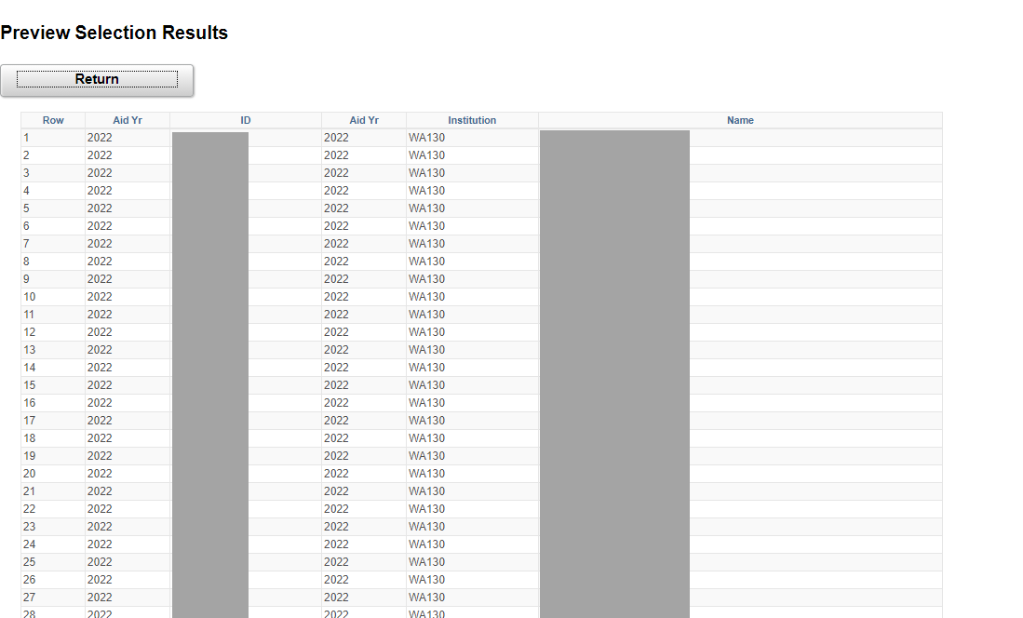

Go to Manage Duplicate Assignment tab, keep Check Duplicate Checklist checkbox checked and select ‘Match’ for Variable Data

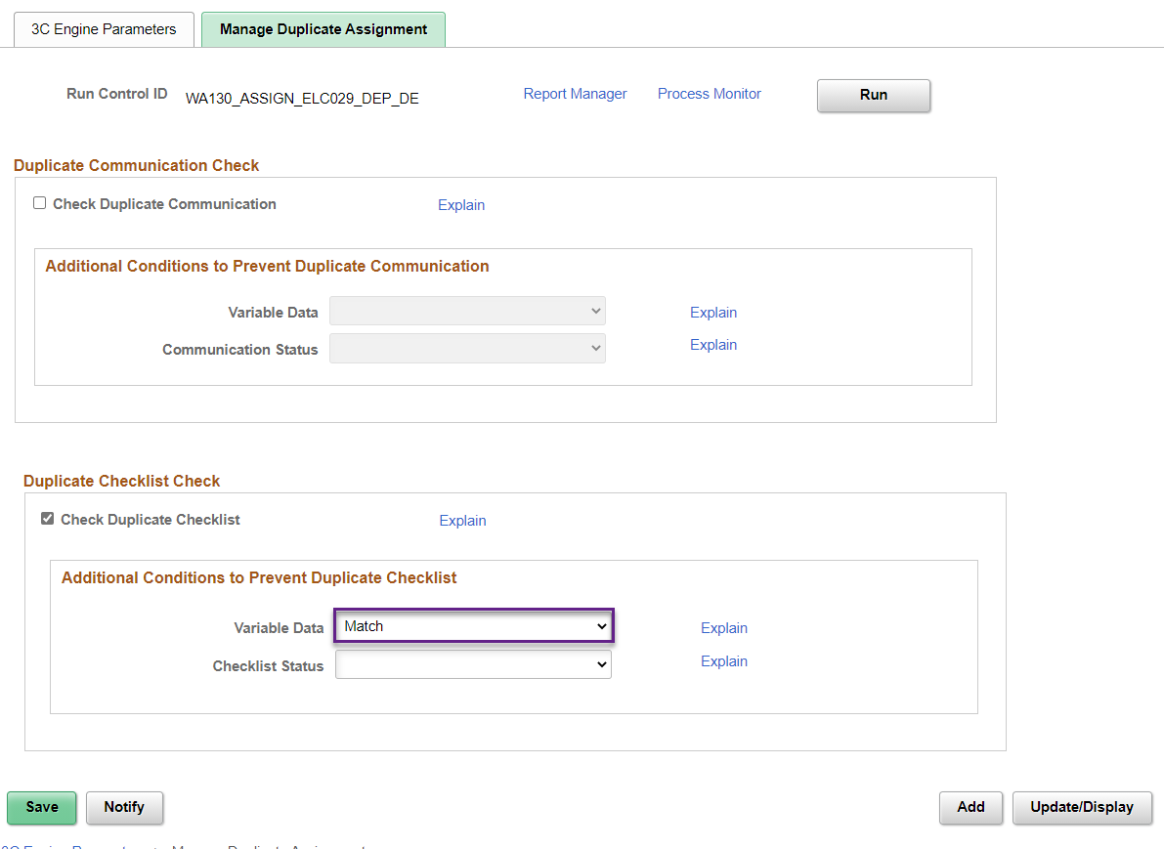

Click Save then exit.
**Repeat the same steps to create the V1 checklist assignment Run Control ID for V1 independent students. The query is CTC_FA_SB_AD_V1_I**

Set Up Run Control ID for the Pop-Update Process

Navigation: Set Up SACR > System Administration > Utilities > Population Update > Population Update Process

Per usual, make sure to put your college and initials in the Run Control ID name so that your Run Control ID is unique in the system.

Select the following parameters
Record (Table) Name: STDNT_AID_ATRBT – Packaging Status Summary
Institution: WAxxx (i.e. WA130)
Aid Year: 2022

Selection Tool: PS Query
Query Name: QCS_FA_WAIVE_V1_VERIF_NO_INST

Query prompts
Aid Yr: 2022
Institution: WAxxx (i.e. WA130)
V1 Checklist 1: Exx029 (i.e. ELC029)
V1 Checklist 2: Colleges that have separated their V1 population into dependent versus independent will put their Exx185 here. Everyone else will put Exx029 again.

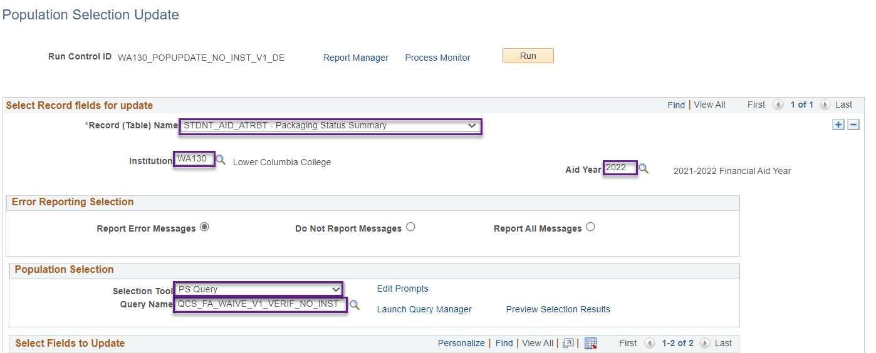

For the Select Fields to Update, you will need two rows so add a second row by clicking the plus button and carefully select the following.

Field Name: ED Verification Status Field Value: Not Required
Field Name: ED Verification Status Cd Field Value: Selected, Not Verified

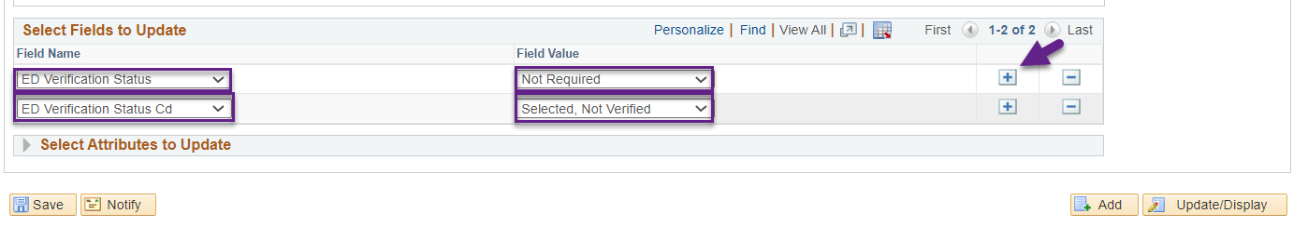

Click Save then exit.

Set Up the Components for the Waive Process

- Review and update the new Comment Category to Active

Navigation: Set Up SACR > Common Definitions > Comments > Comment Category Table

Comment Category name is DCL (DCL GEN 21-05 *DO NOT USE*)

To update the Comment Category, add a new effective dated row then make the changes. The description has **DO NOT USE** because this Comment Category is sitting in Inactive status in production and we wanted to make sure no one uses it without fully testing. You can update the Comment Category in production once you’ve fully tested the process in PCD.

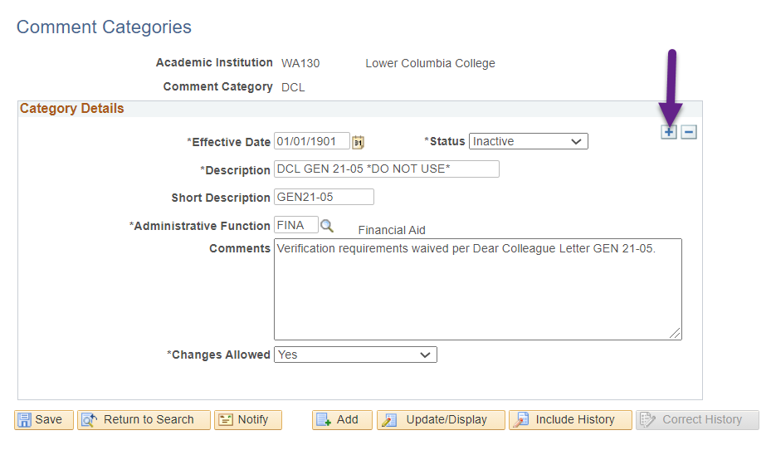
- Review and update the new Event Definition to Active and update checklist area if applicable (i.e. add the 2nd V1 checklist if you’re a college that has two)

Navigation: Campus Community > 3C Engine > Set Up 3C Engine > Event Definition

Event ID name is FISExxV1FW (**DO NOT USE**) with xx being your two-letter college code i.e. LC, CL, SP.

To update the Event ID, add a new effective dated row then make the changes. The description has **DO NOT USE** because this Event ID is sitting in Inactive status in production and we wanted to make sure no one uses it without fully testing. You can update the Event ID in production once you’ve fully tested the process in PCD.

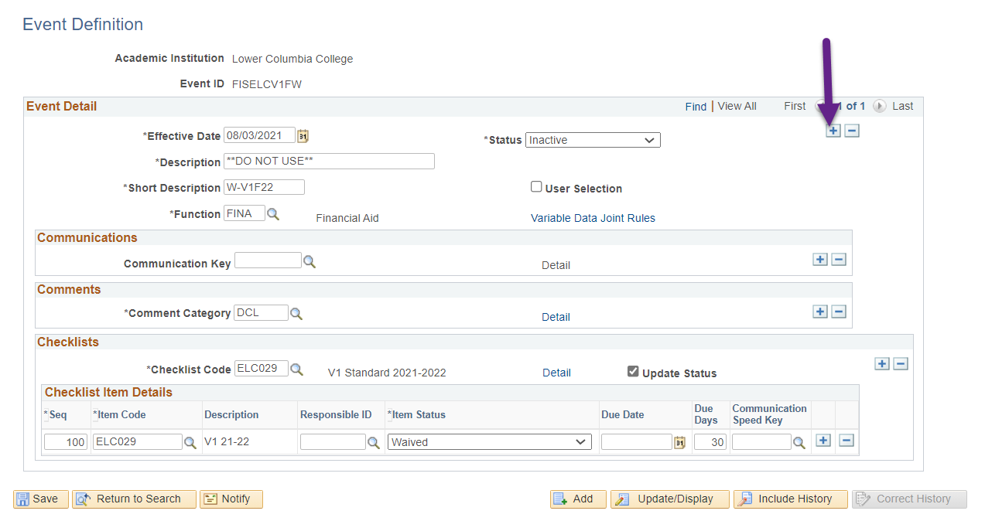

The following screenshot is an example of what your college’s Event ID may look like after you make updates
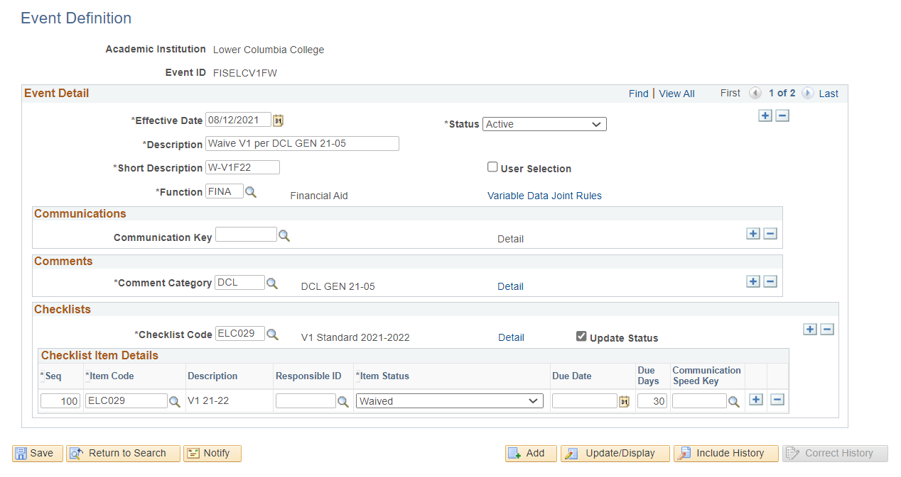

- Create a 3C Engine Run Control ID tied to FISxxCV1W Event ID but DO NOT CLICK RUN

Navigation: Campus Community > 3C Engine > Run 3C Engine

Per usual, make sure to put your college and initials in the Run Control ID name so that your Run Control ID is unique in the system.

Select Population Selection and enter the following prompts in the Event Selection section then click tab on your keyboard. The checklist and comment should populate.

Academic Institution: WAxxx
Administrative Function: FINA
Event ID: FISExxV1FW (i.e. FISELCV1FW)

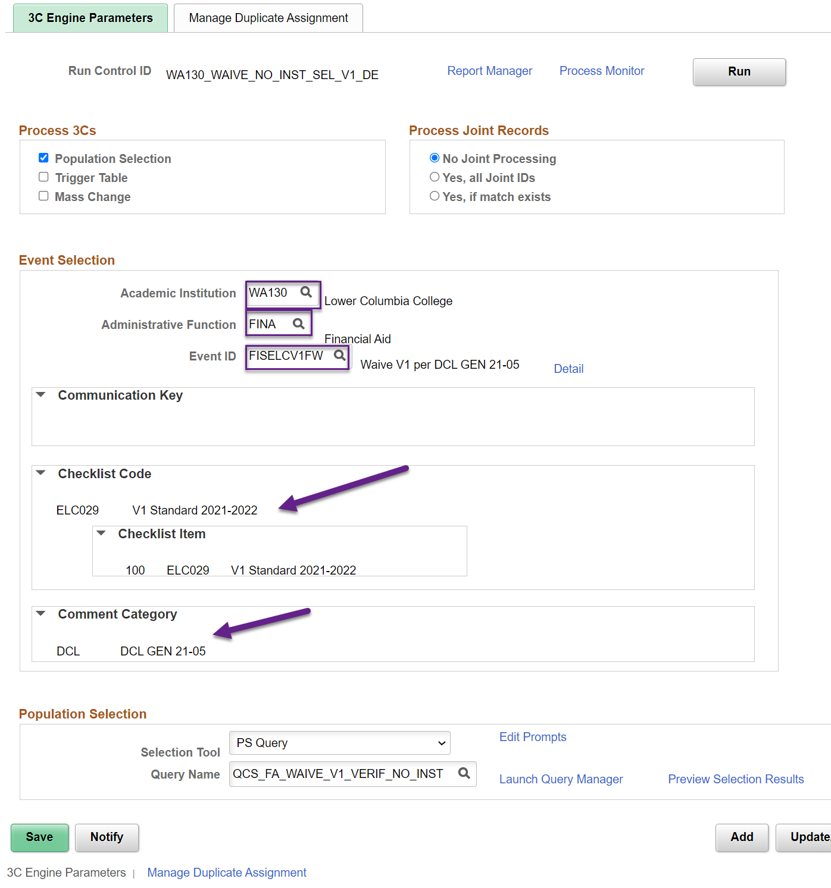

For Populations Selection, choose PS Query and QCS_FA_WAIVE_V1_VERIF_NO_INST

Query prompts
Aid Yr: 2022
Institution: WAxxx (i.e. WA130)
V1 Checklist 1: Exx029 (i.e. ELC029)
V1 Checklist 2: Colleges that have separated their V1 population into dependent versus independent will put their Exx185 here. Everyone else will put Exx029 again.

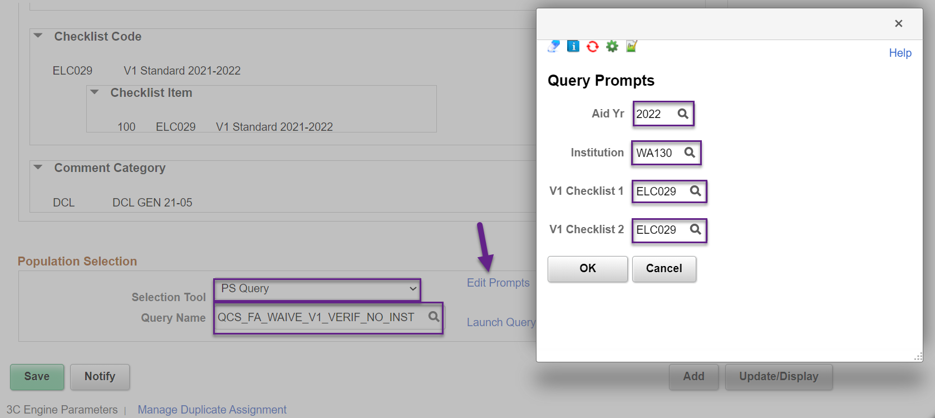

Click on Preview Selection Results to confirm the parameters you entered picked up the right students then click Return.

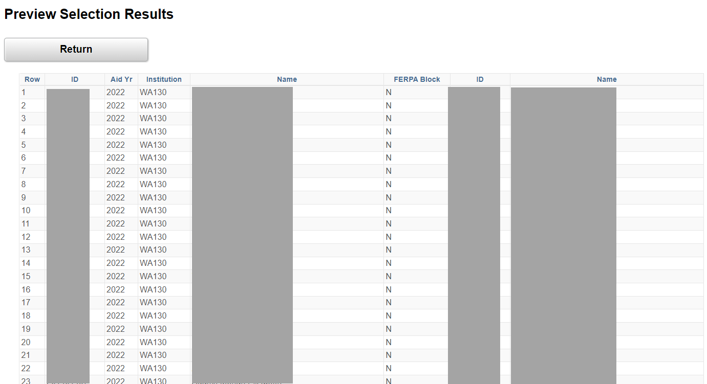

Note: This Event ID updates an existing checklist and does not assign a checklist, therefore, Manage Duplicate Assignment tab does not need to be configured.
Click Save then exit.

Assign, Pop then Waive

- Go to Run 3C Engine and run the two Run Control IDs you created to assign the V1 checklists to students that have the V1 flag on their ISIR
Example
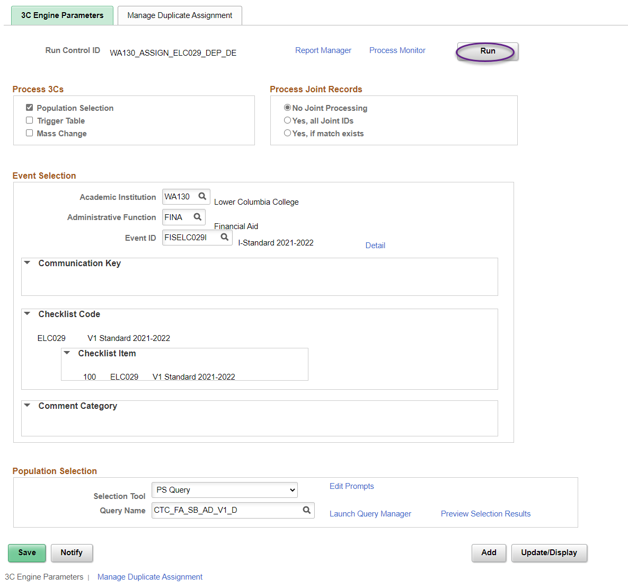

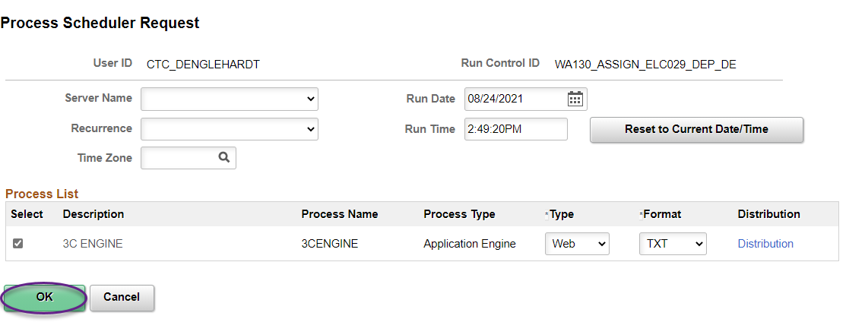

- Go to Population Update Process and run the Run Control ID you created to pop-update the Packaging Status Summary pages

Example 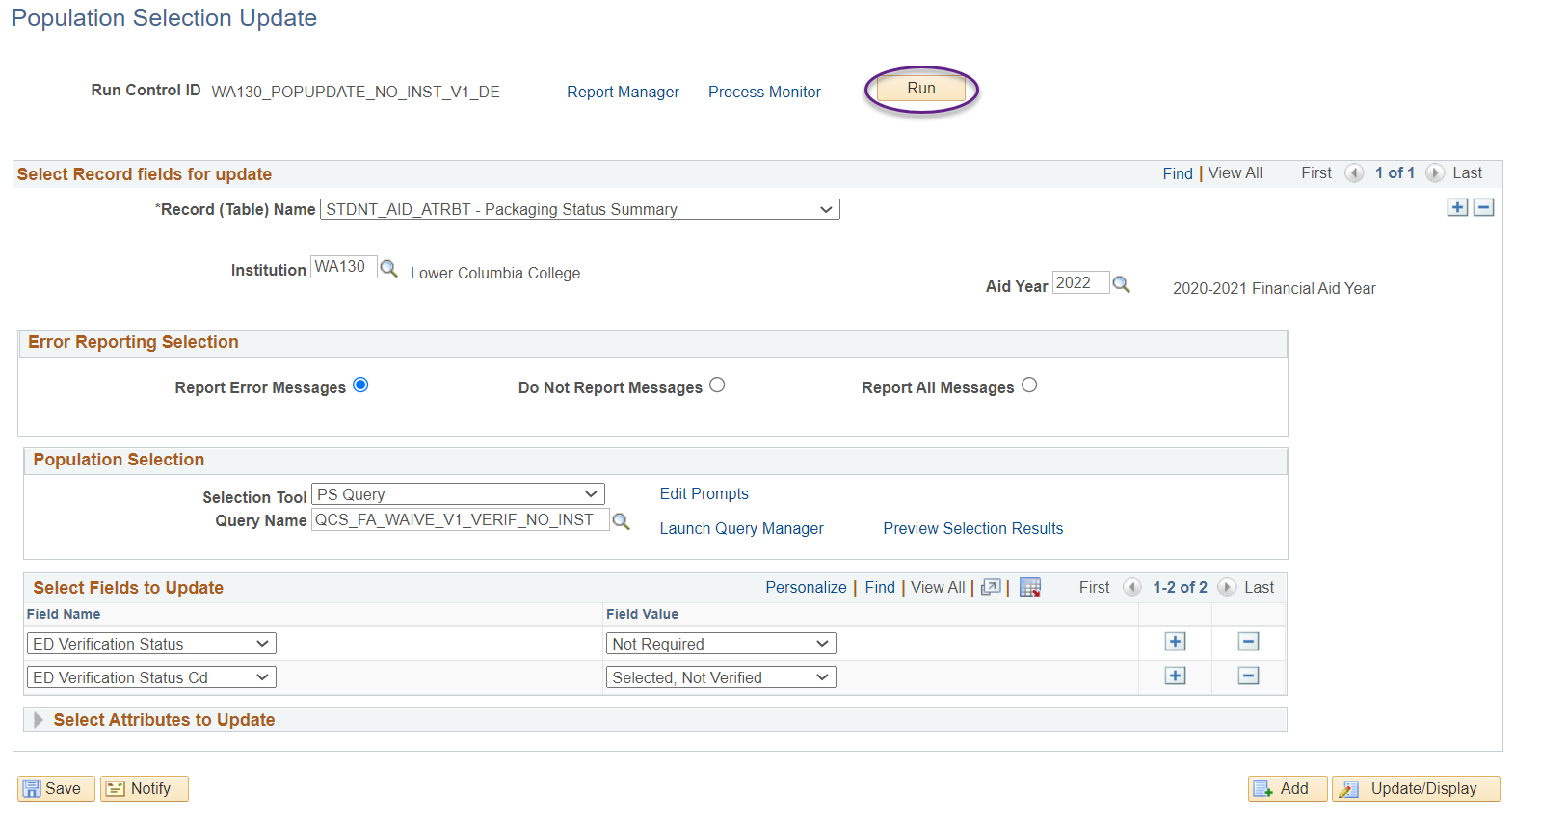

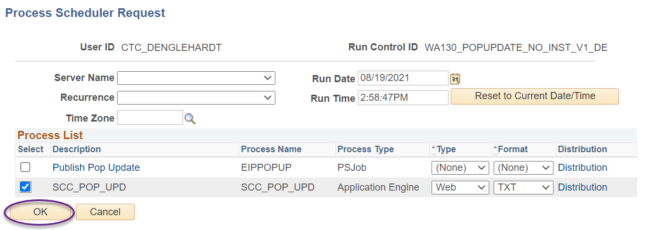

- Go to Run 3C Engine and run the Run Control ID you created to waive checklists and add the DCL comment
Example
