Pell COA Adjustment – Bug Fix Process
Bug Explanation:
This bug applies to students that have had more than one terms worth of budgets build and now have enrollment in less than the original amount of terms that budgets built.
Pell COA is not adjusting to account for the number of terms budgeted being less and prorating the Pell COA.
Query: QCS_FA_PELL_COA_BUG (in PRD 7/30/2021) – recommend scheduling this query
This report will return a list of students that have:
- a Pell COA < the max Pell COA that would allow Pell to be awarded
- a Pell eligible EFC
- at least one active FA term record for the year
- at least one inactive or N unit load FA term record for the year
Steps
Step 1:
Nav > Financial Aid > Financial Aid Term > Maintain Student FA Term
Determine which terms the student is “N” FA load or “Inactive” for the aid year.
Example:
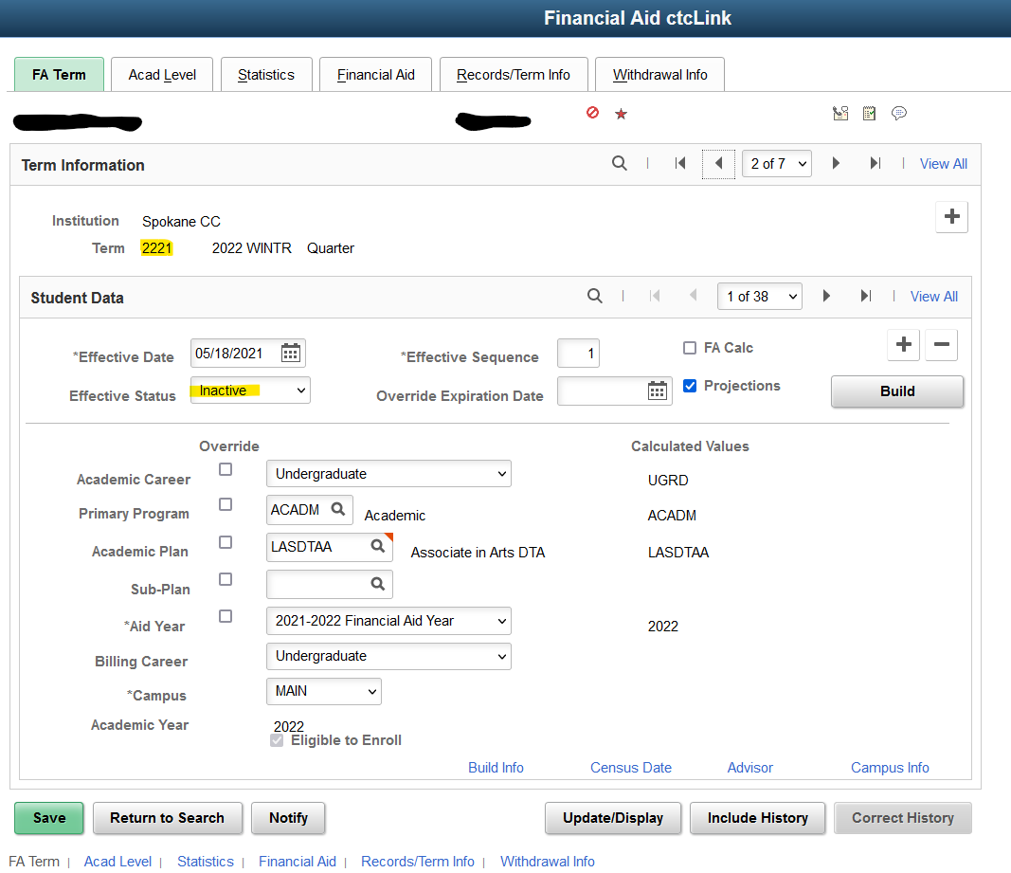
These terms will need to have the Budget “Weeks of Instruction” manually reduced to 0 in the next step.
Step 2:
Another good indicator that the “Weeks of Instruction” needs to be adjusted on a budget record is that the COA for that term is $0.00
Reduce “Weeks of Instruction” for all the terms that are “Inactive”, “N” FA load, or Federal Term COA = $0 to 0.0
Nav > Financial Aid > Budgets > Maintain Term Budgets
Before
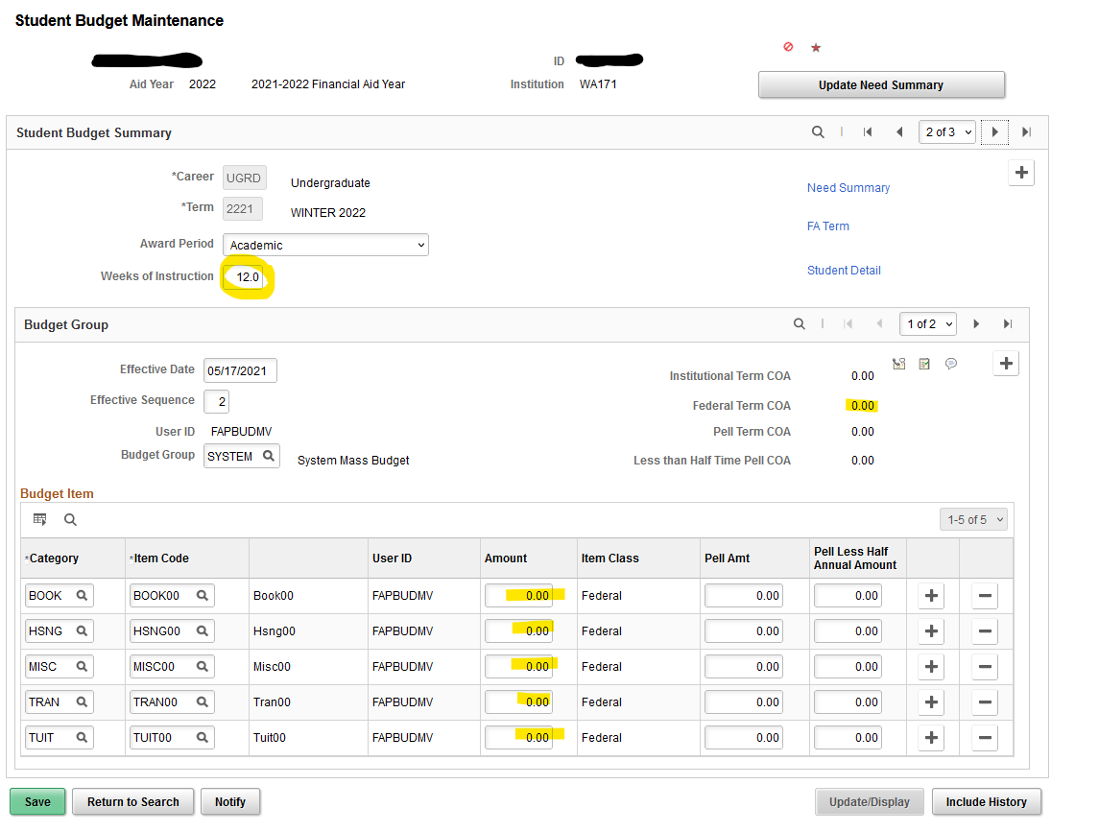
After
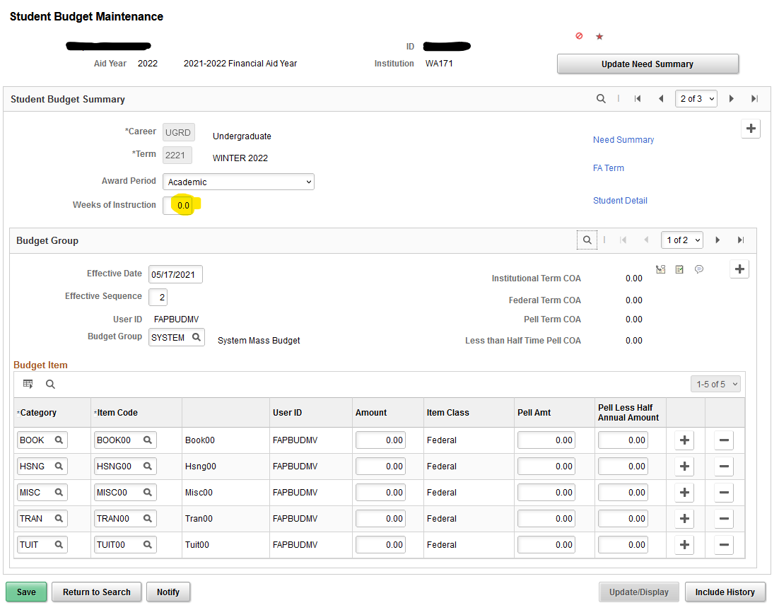
“Save” the Budget. Click OK on any warning messages about Weeks of Instruction.
Step 3:
Run the “Create Student Budget” process:
Nav > Financial Aid > Budgets > Create Student Budget
Build Budget for the terms the student is still “Active”. (the magnifying glass should only pull up active terms)
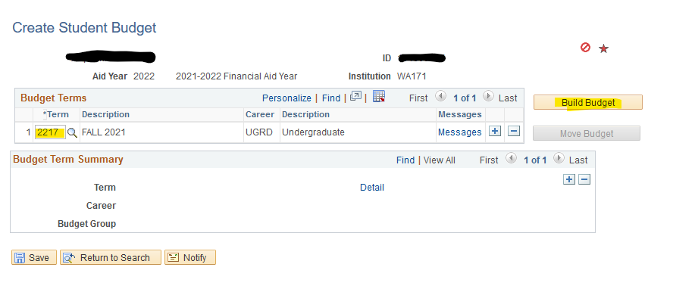
Move Budget
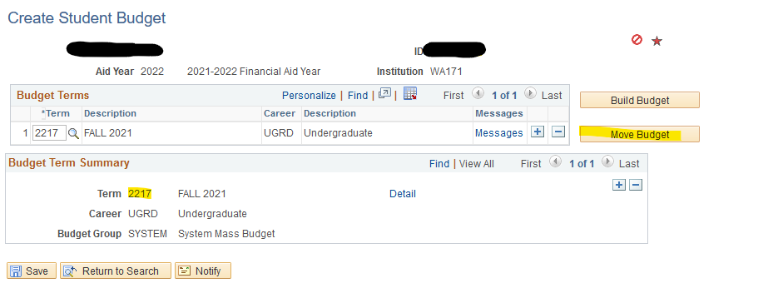

Step 4:
Review the student budget.
Nav > Financial Aid > Budgets > Maintain Term Budgets
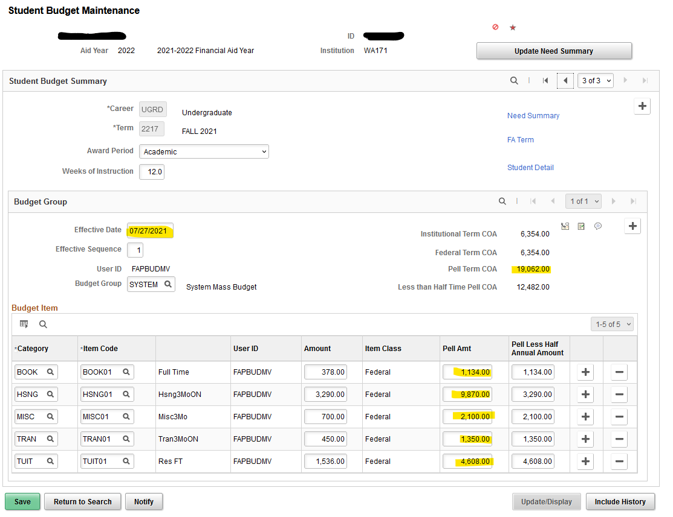
The students Pell COA for the active terms should = the Full Year / Full Time COA amount so that you can award Pell properly.
This budget will adjust again, if a student becomes “Active” in a FA term that is currently “Inactive”

Updating Pell Originations:
If the student was already awarded Pell and it was sent to COD with the lower Pell COA then you’ll want to resend the Pell Origination with the change to the Pell COA once it is fixed.
Financial Aid > Pell Payment > Manage Pell Payment
Check the flag for “Update Pell Origination”
Set “Pell Origination Status” = Change to Origination”
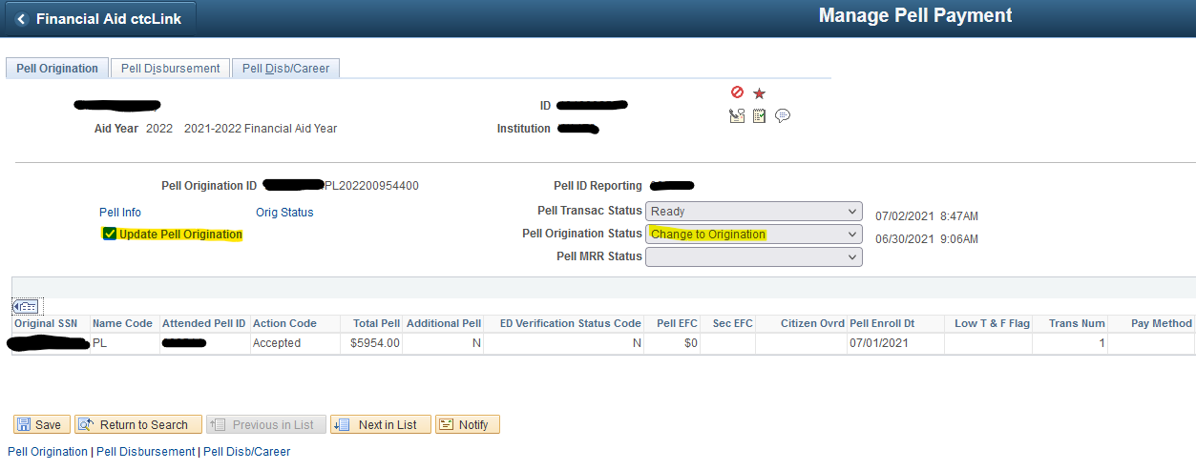
“Save”
These updates to Pell COA will be picked up in the next Pell Outbound file process.

