Steps to recalculate WCG records in batch. This process will recalculate all records that are not marked as “Lock Eligibility”. Those will need to be manually reviewed.
Step 1:
Financial Aid > CTC Custom > CTC Interfaces > WA College Grant > WCG Population/Update
It is recommended to create a new run control for “Recalculate”, so that your nightly job run control is not changed. If you use your nightly job run control, be sure to uncheck the “Recalculate” flag after running the process so that you are not recalculating records every time it is run during your nightly jobset.
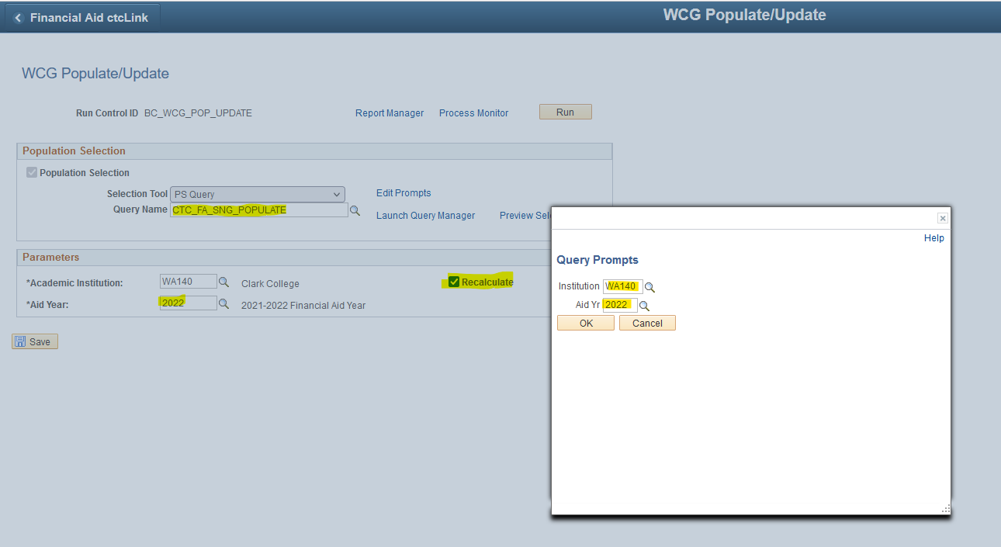
Query: CTC_FA_SNG_POPULATE
Make sure run control is setup with the accurate prompts and that the “Recalculate” flag is set.
Run population update process. Wait for this process to complete before continuing to “Step 2”
Step 2:
Financial Aid > CTC Custom > CTC Interfaces > WA College Grant > Calculate WCG Eligibility
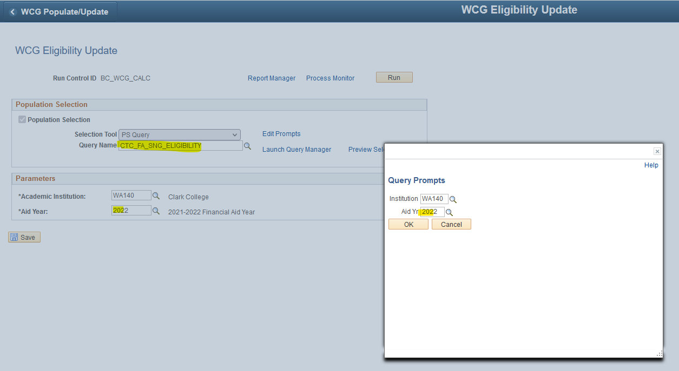
Query: CTC_FA_SNG_ELIGIBILITY
Make sure run control is setup with the accurate prompts.
Run calculation process.

Query Review:
Run query report: QCS_FA_WCG_5TH_YR_CLEANUP
This query will return 5th year UG students that:
- Have locked eligibility and may need manual review to recalculate
  - Locks will always be returned on the list
- Are now “eligible” after the recalculation, were previously awarded, and were not awarded WCG
  - These will drop off the list when awarded

