The CTCLDA
Fall 2018 Conference
Presented at Clover Park Technical College
November 30th, 2018

The CTCLDA is excited to present the last session on our series on Organizational Health.

Our Morning Session
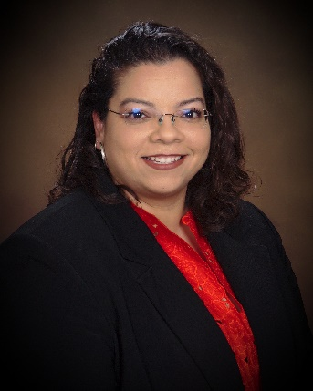
Our Keynote is Dr. Lucy Arellano, an Assistant Professor in Adult Education and Higher Education Leadership at Oregon State University. She will be exploring the socio-economic and political forces impacting the well-being of students, staff, faculty, leadership, and the communities they serve.

Participants will discuss how they can create a welcoming climate inside and out of their professional roles. Dr. Arellano will provide tools to assess commitment to diversity and gauge how welcoming a campus is to non-majority students. The main question is, “How do you create the institutions that students need?”

Our Afternoon Session
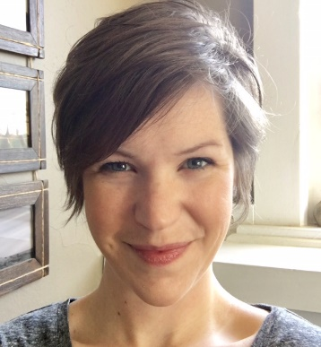
In the afternoon we will be joined by Jess Thompson, a Program Administrator in Accessible Technology Initiatives at the SBCTC. Many of us are familiar with the ways in which physical spaces are made accessible to people with disabilities. Jess will explore similar principles are used to design web spaces and digital content.

The presentation will introduce the state and federal policies that ensure accessibility, as well as how we can make better design decisions that not only support accessibility but will save time and resources in the long term. Emphasis will be placed on what accessibility - in practice and in advocacy - looks like for various roles and departments on campus.

The cost of this one-day conference is $225 to explore great theories, practices, and network with people from across the Washington CTC system.

Please join us November 30th by registering today!
https://www.regonline.com/ctcldafall2018conference
Sponsored by

