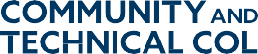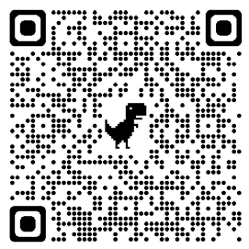

Calling all Washington Community and Technical College Students!
If you’re interested in learning about and being part of Washington state government, apply to be a 2023 Legislative Intern with the Washington State Board for Community and Technical Colleges. Two internships open with a remote work option available.
Some of the interns’ activities during the winter quarter internship are:
- Researching and testifying on legislation affecting community and technical colleges.
- Attending legislative hearings and floor debates.
- Tracking bills and work with State Board and college staff on those bills.
- Providing student perspective to legislators, legislative staff, and the community and technical college system.
Earn money and college credit while helping make college better for all students!
Apply by Oct. 28. Questions? Email Joe Holliday, director of student services, at jholliday@sbctc.edu.

