Accessing the Student Transcript Folder in the Microsoft Teams Deans and Directors Channel

1. Open the Microsoft Teams application or web page and [enter the SBCTC Microsoft Teams space](https://sbctcedu.sharepoint.com/:w:/r/sites/CorrectionsEducationIT/Shared%20Documents/General/How%20To%20Documents/MS%20Teams/AccessingSBCTCMicrosoftTeams.docx?d=w93247094818348a392d18a86acff4ef1&csf=1&web=1&e=OsujQS).
2. Click on the Deans and Directors channel.  
   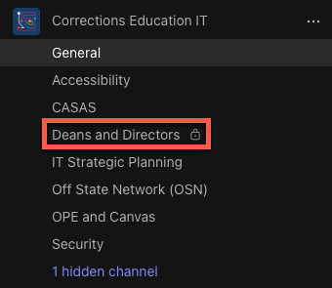
3. At the top of the channel, click the Files link.  
   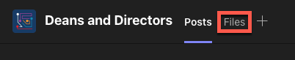
4. Click on the Student Transcripts folder to open.  
   