Accessing the SBCTC Space in Microsoft Teams

1. Open the Microsoft Teams application or web page.
2. Click on your profile icon in the upper right corner.  
   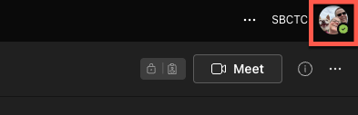
3. Click on the SBCTC site name.  
   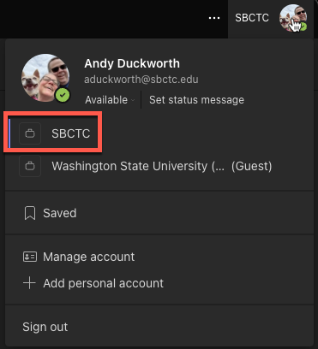
4. You should now be in the SBCTC space in Microsoft Teams.