# **Executive Summary**

## **SBCTC - ConexEd Web Assessment**

In April 2025, Deque Subject Matter Experts performed an accessibility assessment of SBCTC - ConexEd Web Assessment website based on the [Web Content Accessibility Guidelines (“WCAG”) 2.1 A & AA](https://www.w3.org/TR/WCAG21/). Performing an assessment is a key step in understanding your current state of accessibility. The results in this report will provide you with actionable next steps to improve the accessibility of your website. Addressing the recommended fixes will result in a better experience for all users, including people with disabilities. This is a high-level view of the results. You can also review the [full test results in the axe Auditor Dashboard](https://axeauditor.dequecloud.com/test-run/7b8a0f36-1530-11f0-a366-7b41298868ee).

## **Key Findings**

* In total, 517 issues were identified across 31 pages and 7 components assessed.
* 19.3% or 100 issues were found using automated testing, which means developers, can fix the issues and validate their work using the [axe DevTools browser extension.](https://www.deque.com/axe/devtools/)
* Four success criteria were related to 57.4% of all issues:
  + Name, Role, Value - 30.9%
  + Contrast (Minimum) - 11.2%
  + Non-text Contrast - 9.2%
  + Headings and Labels - 6.0%
* 52% of the 50 success criteria were passed.

## **How did we arrive at these results?**

This assessment was performed in a combination of SBCTC - ConexEd Web Assessment Staging environment using the following:

* Windows/Chrome
* NVDA screen reader
* Automated testing using axe-core rules
* Manual testing and keyboard-only navigation testing

## **What is the user impact?**

The assessment uses WCAG success criteria to determine user impact based on [four principles](https://www.w3.org/WAI/WCAG21/Understanding/intro#understanding-the-four-principles-of-accessibility) for ensuring accessibility for people living with disabilities:

* Can all your users, with the abilities and senses that they possess, **perceive** the information your application presents to them?
* Can your users, with their specific input device or assistive technology, **operate** all the controls within your application’s user interface?
* Can your users **understand** the information and the user interface controls?
* Is your content **robust** enough that it can be interpreted reliably by a wide variety of user agents, including assistive technologies?

## **Issues by user impact**

| **Impact** | **Impact Description** | **# Of Issues** |
| --- | --- | --- |
| **Blocker** | Prevents some users with disabilities from using your content - period. | 0 |
| **Critical** | Prevents some users with disabilities from accessing certain parts of your content, potentially rendering it unusable. | 142 |
| **Serious** | Presents serious barriers for some users with disabilities and will partially prevent them from using portions of your content. | 357 |
| **Moderate** | Presents some barriers for users with disabilities that will reduce their overall experience with your content. | 16 |
| **Minor** | Causes some nuisance or can be annoying, but not presenting barriers for users with disabilities. | 2 |

## **Critical issues and observations**

Here is an overview of all 142 critical issues identified during the assessment.

* **Text alternatives are missing (**[**WCAG 1.1.1**](https://www.w3.org/WAI/WCAG21/Understanding/non-text-content)**):** All non-text content should have alternative text, whether an actionable element such as a button or link, or a content element such as an informative or decorative image. People who are blind cannot see images on a page. In order to give people who cannot see an image access to the information conveyed by the image, it must have a text alternative. The text alternative must describe the information or function represented by the image. Screen readers can then use the alternative text to convey that information to the screen reader user. Although present through a variety of methods in HTML and CSS, the profile picture image was lacking alternative text. For actionable or functional images - such as links or buttons - the alternative text must describe the destination, purpose, or function of the image - not necessarily the image itself. For example, the alternative text for an image that is a link or a button will describe the link destination or the button function, not the shape or other visual characteristics of the image.

**Screenshot:**

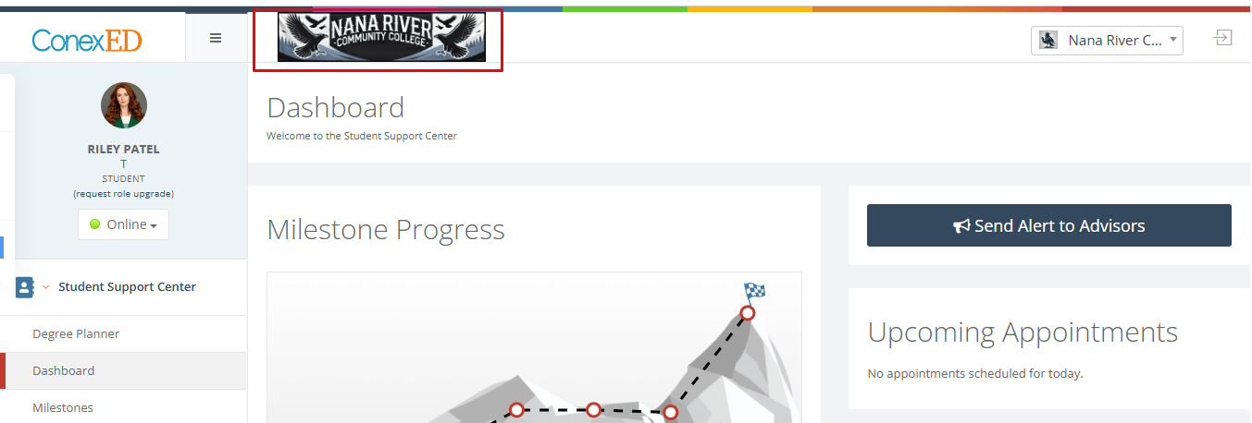

This issue is noted on the following test units and can be viewed through a custom filter for [Text alternatives are missing](https://axeauditor.dequecloud.com/test-run/7b8a0f36-1530-11f0-a366-7b41298868ee/issues?sortField=ordinal&sortDir=asc&filter%5Bseverity%5D=4&filter%5Btype%5D=issue&filter%5Bidentifier%5D=1.1.1.b&filter%5Bidentifier%5D=1.1.1.c) issues:

* + Student - Header
  + Faculty - Header
  + Student - Degree Planner
* **Data tables are missing table markup and/or used inappropriately (**[**WCAG 1.3.1**](https://www.w3.org/WAI/WCAG21/Understanding/info-and-relationships)**):** People who are blind cannot see the organizational structure of a table with data arranged in rows and columns with corresponding header cells. In order for screen reader users to understand the logical relationships of data arranged in a table, tables need HTML markup that indicates header cells and data cells and defines their relationship. When tables are marked correctly, screen reader users are able to navigate data tables from cell to cell, in a multi-directional way (up, down, right, left), much like navigating a spreadsheet. As they move from cell to cell, screen readers will read the associated header labels. But when this markup is inappropriately used for visual purpose, then it may cause confusion for screen reader users as the content relationship will wrongly be announced to screen reader users. In such cases, it is imperative to remove the table or grid markup that is present for the content.

**Screenshot:**

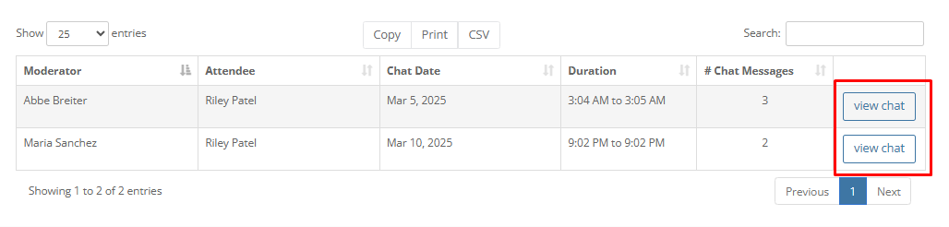

This issue is noted on the following test units and can be viewed through a custom filter for [Data tables are missing table markup and/or used inappropriately](https://axeauditor.dequecloud.com/test-run/7b8a0f36-1530-11f0-a366-7b41298868ee/issues?sortField=ordinal&sortDir=asc&filter%5Bseverity%5D=4&filter%5Btype%5D=issue&filter%5Bidentifier%5D=1.3.1.b) issues:

* + Student - Archives - Chat History
  + Student - Meetings Document Library
  + Student - Active Cases and Alerts
  + Faculty - Settings and Documents - Document Library
* **Content presented is not logical or unavailable to the screen reader users (**[**WCAG 1.3.2**](https://www.w3.org/WAI/WCAG21/Understanding/meaningful-sequence)**):** Meaningful sequence is all about making sure that, regardless of the way in which users consume content, that the order of this content will remain logical. Screen readers present web content linearly to visually impaired users, based on the order of the source code of the page. Sighted users may very well consume content differently, based on the page layout, or their own preferences. While this requirement acknowledges that there can be more than one meaningful sequence for the same page, it is strongly recommended that the meaning of the content in the visual order of the page be the same as when the content is presented by screen readers. But even when the visual order of the content differs from the source code order, as long as the reading order for screen readers is still logical and meaningful, differences in reading order are acceptable.

**Screenshot:**

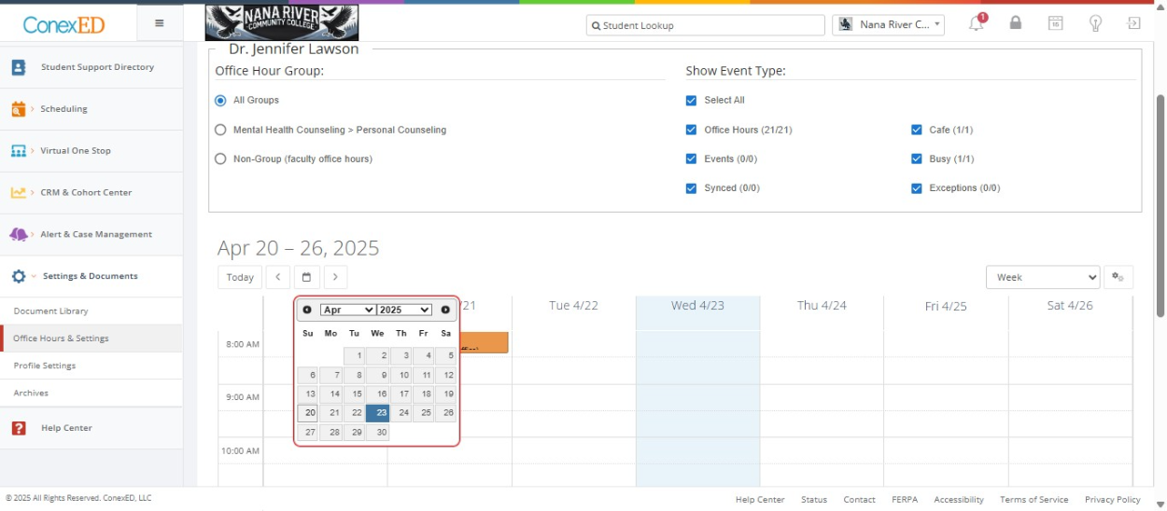

This issue is noted on the following test units and can be viewed through a custom filter for [Content presented is not logical or unavailable to the screen reader users](https://axeauditor.dequecloud.com/test-run/7b8a0f36-1530-11f0-a366-7b41298868ee/issues?sortField=ordinal&sortDir=asc&filter%5Bseverity%5D=4&filter%5Btype%5D=issue&filter%5Bidentifier%5D=1.3.2.a) issues:

* + Faculty - Scheduling - My Calendar - Office Hours - Calendar Widget
  + Faculty - Scheduling - My Calendar - Scheduler settings
  + Calendar Widget
* **Action cannot be performed by keyboard alone (**[**WCAG 2.1.1**](https://www.w3.org/WAI/WCAG21/Understanding/keyboard)**):** People who are blind and who cannot use devices such as mice that require eye-hand coordination and people with low vision who may have trouble finding or tracking a pointer indicator on a screen benefit most from this requirement. Also, some people with hand tremors may find using a mouse very difficult and therefore will usually use a keyboard instead. All these people, and more, will benefit from user interfaces that are built so they are entirely operable using only a keyboard. When functionality is available through a keyboard, people who are blind or use alternative keyboards and devices that emulate keyboards (sip-and-puff devices, speech-to-text software) can use and interact with web content. Even people who have low vision benefit from keyboard functionality during times where using a mouse can be difficult. Usually, functionality that is available through a mouse can be made available through a keyboard. There are some exceptions to the rule, though. For instance, input that relies on a user's movement (free hand drawing, water color painting) will require extremely difficult keystrokes to execute the path inputs. However, functionality like resizing and drawing geometric shapes can be done through a keyboard because they do not rely on the input of a user's path.

**Screenshot:**

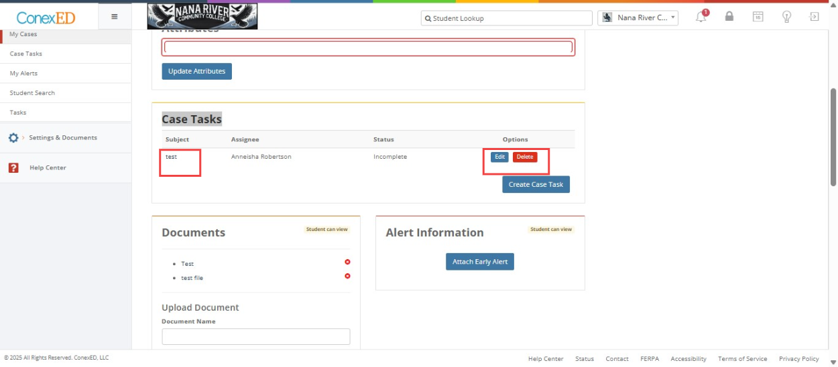

This issue is noted on the following test units and can be viewed through a custom filter for [Action cannot be performed by keyboard alone](https://axeauditor.dequecloud.com/test-run/7b8a0f36-1530-11f0-a366-7b41298868ee/issues?sortField=ordinal&sortDir=asc&filter%5Bseverity%5D=4&filter%5Btype%5D=issue&filter%5Bidentifier%5D=2.1.1.a) issues:

* + Faculty - Alert and Case management - My Cases - Case Details
  + Faculty - CRM and Cohort Center - Milestone Progress Alerts
  + Faculty - Scheduling - My Calendar - Scheduler settings
  + Faculty - Scheduling - My Calendar - Office Hours - Calendar Widget
  + Student - Landing
  + Faculty - Navigation Menu
  + Faculty Login
  + Faculty - Alert and Case management - My Cases
  + Faculty - Whiteboard
  + Calendar Widget
  + Faculty - Scheduling - My Calendar - Office Hours - edit series
  + Student - Profile settings - Customize Card
  + Student - Meetings Document Library
  + Faculty - Scheduling - My Calendar - Schedule and View - Schedule Office Meeting
  + Student - Degree Planner
  + Faculty - Reports - Report index
  + Student - View Meetings - Office Meetings
  + Faculty - Scheduling - My Calendar - Office Hours
  + Faculty - Settings and Documents - Document Library
* **Focus indicators are missing (**[**WCAG 2.4.7**](https://www.w3.org/WAI/WCAG21/Understanding/focus-visible)**):** All focusable elements must have a visual focus indicator when in focus. This allows keyboard users to determine their location within the content. When a visible keyboard focus indicator is not provided, sighted keyboard users will have no idea which link or control has focus making it extremely difficult, if not impossible, to interact with the content. Browsers provide default focus indicators for natively focusable elements, but these may be very difficult to see depending on the color of the control and the page background. In addition, custom elements often have no visible focus indicator at all. Ideal focus indicators are designed to provide good contrast with links and controls and their backgrounds. Focus indicators with good contrast make it much easier to track focus as a keyboard user navigates through the page.

**Screenshot:**

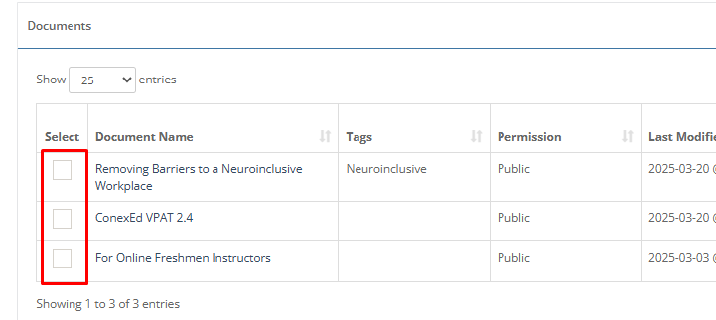

This issue is noted on the following test units and can be viewed through a custom filter for [Focus indicators are missing](https://axeauditor.dequecloud.com/test-run/7b8a0f36-1530-11f0-a366-7b41298868ee/issues?sortField=ordinal&sortDir=asc&filter%5Bseverity%5D=4&filter%5Btype%5D=issue&filter%5Bidentifier%5D=2.4.7.a) issues:

* + Faculty - Settings and Documents - Document Library
  + Faculty Login
  + Student - Degree Planner - Add course widget
  + Faculty - Whiteboard
  + Student - Meetings Document Library
  + Student - Profile settings - Account Settings
  + Faculty - Scheduling - My Calendar - Office Hours - edit series
  + Student - Profile settings - Customize Card
  + Faculty - Scheduling - My Calendar - Schedule and View - Schedule Office Meeting
* **Missing or incorrect name/role/value of custom controls (**[**WCAG 4.1.2**](https://www.w3.org/WAI/WCAG21/Understanding/name-role-value)**):** States and properties are attributes used to convey essential information about an element to screen readers and other assistive technologies. Some roles require certain state and property information - such as the checked/unchecked state of a checkbox. This code needs to be valid in order for a screen reader to convey the information to a user. Some buttons are missing an accessible name. Every user interface control must have a role along with any applicable states and properties so that screen reader users know how to interact with the control. Native HTML elements - such as <button>, <a>, <input>, <select> - already have a role, and their necessary states and properties - such as the checked/unchecked state of a checkbox - are automatically conveyed so nothing more needs to be done. If you create a custom version of a native HTML element or a custom control or widget that does not have a native HTML equivalent, you must add the relevant role(s) and any applicable states and properties using ARIA as well as expected keyboard interactions.

**Screenshot:**

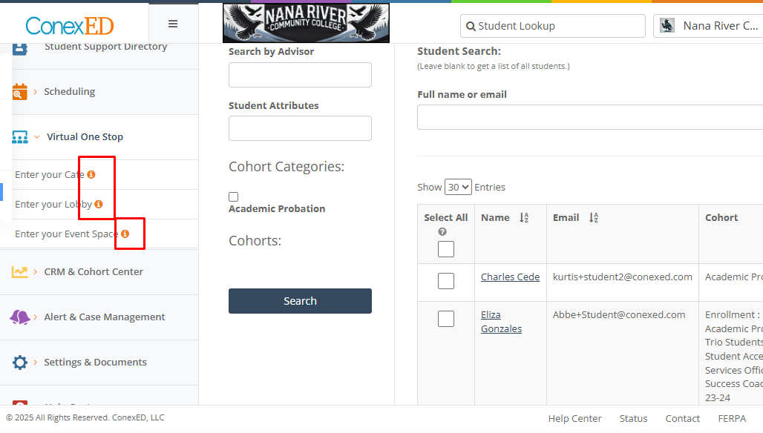

This issue is noted on the following test units and can be viewed through a custom filter for [Missing or incorrect name/role/value of custom controls](https://axeauditor.dequecloud.com/test-run/7b8a0f36-1530-11f0-a366-7b41298868ee/issues?sortField=ordinal&sortDir=asc&filter%5Bseverity%5D=4&filter%5Btype%5D=issue&filter%5Bidentifier%5D=4.1.2.a&filter%5Bidentifier%5D=4.1.2.b) issues:

* + Faculty - Navigation Menu
  + Faculty - Whiteboard
  + Student - Degree Planner - Add course widget
  + Faculty - Alert and Case management - My Cases - Case Details
  + Faculty - CRM and Cohort Center - Milestone Progress Alerts
  + Student - Meetings Document Library
  + Faculty - Scheduling - My Calendar - Office Hours - edit series
  + Student - Header
  + Student - Send Offline message
  + Student - Degree Planner
  + Student - Profile settings - Customize Card
  + Faculty - Header
  + Faculty - Scheduling - My Calendar - Schedule and View - Schedule Office Meeting
  + Faculty - Scheduling - My Calendar - Scheduler settings
  + Faculty - Scheduling - My Calendar - Office Hours
  + Student - View Meetings - Office Meetings
  + Faculty - Scheduling - My Calendar - Calendar Synch settings
  + Faculty - Alert and Case management - My Cases

## **Top 5 Pages/Components with issues by severity**

| **Page/Component** | **Blocker** | **Critical** | **Serious** | **Moderate** | **Minor** | **Total Issues** |
| --- | --- | --- | --- | --- | --- | --- |
| **Faculty - Whiteboard** | 0 | 39 | 28 | 2 | 0 | 69 |
| **Faculty - CRM and Cohort Center - Milestone Progress Alerts** | 0 | 9 | 23 | 0 | 0 | 32 |
| **Student - Degree Planner** | 0 | 19 | 12 | 0 | 0 | 31 |
| **Faculty - Scheduling - My Calendar - Office Hours** | 0 | 13 | 15 | 1 | 0 | 29 |
| **Faculty - Alert and Case management - My Cases - Case Details** | 0 | 4 | 23 | 1 | 0 | 28 |

## **Recommended Remediation Strategy**

Carefully review the detailed assessment report within axe Auditor as it contains the full results of our assessment with screenshots, code snippets and specific recommendations for fixes.

Developers and QA testers should [download Deque’s axe DevTools browser extension](https://www.deque.com/axe-devtools-audit-validation-help/)  to conduct quick, accurate and automated testing and validation of their own. Axe DevTools can catch up to 57% of accessibility issues automatically according to the results from our deep analysis for the Automated Accessibility [Coverage Report](https://www.deque.com/automated-accessibility-testing-coverage/). Start a free trial of axe DevTools Pro and catch up to 80% or more issues using Intelligent Guided Tests (IGT).

For remediation of these issues, we suggest considering the following when prioritizing:

* Correct the (blocker/critical) issues as soon as possible
* Address any project-wide issues early
* Make changes with the greatest ROI such as in the style sheet (color contrast) or in common components such as the header or footer
* Fix accessibility issues on pages that have the highest traffic
* Developers should download and use Deque’s free axe DevTools extension to conduct quick, automated testing of their own
* Connect with your trusted Deque expert to further discuss your remediation strategy and next steps

## **Beyond The Immediate Remediation**

* Use these findings as an input into efforts to create and maintain a [sustainable accessibility program](https://www.deque.com/services/accessibility-strategy-compliance/) that integrates accessibility testing into development processes. Catching an accessibility defect during development costs around 30 times less than doing so in production and is a great example of [the business case for accessibility.](https://www.deque.com/blog/the-business-case-for-accessibility/)
* Consider developing an accessibility policy, if you don’t have one, to support accessibility program activities. Direction, alignment, governance, and executive sponsorship are key to designing, executing, and sustaining a successful accessibility program.
* Think about if, when, and how to monitor, support, and communicate your accessibility progress internally and externally. This could include periodic accessibility scans that could be made available for reporting, public-facing certification and accessibility statements, and [customer service](https://www.deque.com/blog/customer-service-for-people-with-disabilities/) teams that are trained to understand and address accessibility inquiries.

## **Feedback**

Thank you for partnering with us for your accessibility initiatives. To help us improve and better serve you and others, we’d greatly appreciate it if you could take a minute to share your feedback by completing this short [survey](https://www.surveymonkey.com/r/YFWJ2MV).