ACT Beta Testing

Users

Instructions:
Please select at least two users to login and test with. Leave your name next to the users that you login and test as.
URL is https://mywcc.whatcom.edu/act
Usernames to select from:
- admin1 - Omar Bonilla (Cascadia)
- admin2
- Paidsubscriber1 -Jess
- paidsubscriber2
- public1
- public2
- reviewer1
- reviewer2
- trustedtester1
- trustedtester2
- vendor1
- vendor2

All passwords are set to 4cce$$ibilitY

The vendors are set to Microsoft, so they should see the Microsoft products only.

Feedback:
- Will change logo and remove the “ACT” background text
Jess: I did a video of my walk through when I went in as a paid subscriber: https://screencast-o-matic.com/watch/cF1jFbFVrR
- I find the submit and products pages too similar. The populated list on the submit page does not let me add myself/school as a user of the product, it just takes me to the results (that’s not aiding in submitting).
  - Submit product page is for submitting new products, not for adding institutions. That can be done in the product information page for a specific product
- Clicking on “compliance requirements” in the products page didn’t take me anywhere.
  - Document has not been created yet
- Under Products page (should this be titled something else? Product Evaluation?) I don’t understand why I’d select a college from a list when trying to see the list of colleges where a product is in use.
  - Will rename “Products” to “Product Search” and rename submit to “Submit new product”
  - In Search, will reword “Please specify the technology you are adding” and “Is this the product you’re looking for”
  - In search, put tooltip on “Archive status”
  - Changed so any user except vendor can add their institution
  - Change "Comments" to "Overall product comments" and move to just above Product Files
- I have a lot of strong opinions about how the testing info is defined and I feel very strongly this needs to be taken out or modified before piloting. We’re setting an expectation that I do not think is going to be compatible with the methodology defined by the trusted tester training we’re working on. Releasing it now with that format/language is going to give ideas (which will be seen as suggestions) for how to test and I guarantee some schools will start following that approach.
  - Ward will address
  - Less Compliant/More Compliant
  - Public gets simple view, exec summary, overview, institution list, meets access require, the most recent VPAT listed.
Product files can only be uploaded by reviewers or above
- When a user cannot type in a box shouldn’t there be some indicator/message explaining why they can’t? It seems like that would be an accessibility thing…
  - Disabled text boxes are ADA compliant. If they are unable to modify, it is greyed out. If able, shown as white.
- I was able to mark a product not compliant when it was already marked not assessed. -- it doesn’t stick, but it sure gives the impression that I’m able to make claims. Maybe those shouldn’t be buttons for people who just have permissions to view-only
  - Found issues with Reviewer role being able to change certain things.
  - Will change to just the selected button if no ability to edit
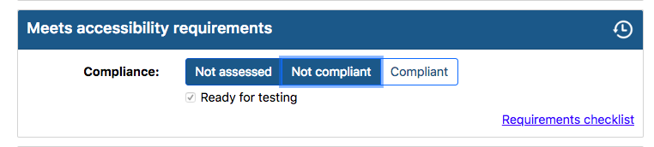
- What are WCAG files? I’ve never heard of this.
  - Will rename to “WCAG supporting documentation”
  - Will rename “Product Files” to “Misc Product Files”
- 508 compliance should be removed. It’s redundant and 508 does not apply to us, only to Federal gov’t (despite what testing vendors claim -- only trust .gov sites on this as vendors are using it to drum up business).
This paragraph was pulled directly from the CIO Policy 188 statement https://www.ocio.wa.gov/sites/default/files/public/policies/188_Accessibility_Interim_TSB_Sub_201705_3.pdf:
Compliance with this policy does not relieve each agency from its responsibility to otherwise comply with state and federal law, including but not limited to Section 508 of the Rehabilitation Act and the Americans with Disability Act.
VPAT section, 508 complinace changed to VPAT accuracy, buttons changed to Not assessed, Not accurate, Accurate.
- I'm also uncomfortable with screen reader testing section. I think it should be cut.
  - Ward will address this
    - Show only for reviewer, trusted tester, admin
- Overall, for now, I think we need to greatly limit the entire page about product results. Maybe even remove it until we actually have something in place for getting things tested. There are going to be a lot of people that see that and get angry that nothing's been tested - and rather than pay attention to why and what we're working on, they're going to freak out and complain.
  - Ward will address this

Omar:
- General
  - I would include confirmation dialogs for any changes to be written to the tracker.
    - Putting confirmation dialogs for every change would be very repetitive and slow things down a lot. On changes that are difficult to undo, a confirmation dialog is displayed.
- Dashboard
- Instructions
- Submit
- Products
  - Product Search
    - After activating Advanced Search, the Basic Search heading remains with an additional Advanced Search section underneath. This is confusing to users.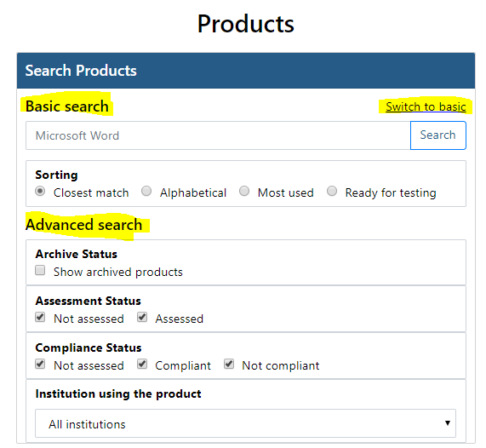
    - This has been changed
  - Individual Product Page
    - Overview section: There is a checkbox that indicates whether or not a product is a website. If something isn’t a website, it would be helpful to have something else to indicate what exactly a product is. Is it software, hardware, and so forth, and I’m not sure how granular we want to be in terms of categorizing the products.
      - We agree with the request. We will add it to a future version
    - ADA Verification
      - Will change “ADA Verificaiton” to “WCAG compliance”
      - WCAG Issues and Comments: A single text field for issues and comments might not be effective, as a single product may have myriad of issues with different timelines for resolution. If the idea is to track issues and resolutions over time, I think it would be best to have issues stored individually.
We will look into this. Change tracking currently logs all issues that have ever been entered
      - Screen Reader Compliance: I don’t know if there should be a separate compliance section for screen readers outside of WCAG itself. Known issues with screen readers may be noted in the Issues section of WCAG.
        - Due to our testing of applications with screen readers, we have found that each screen reader and the specific version is inconsistent and we need to be able to track particular issues with each reader and version specific to the application being tested. It’s not as simple as “it works or doesn’t work”
        - Will reword “Screen reader compliance” to something more appropriate
    - Institutions Using The Product: It would be more intuitive to display the institutions in a table or list, rather than a drop-down menu.
      - Will change to a listbox
    - Vendor with permissions to access product: Similarly to Institutions, vendors should be presented in a list or table, with a separate drop-down menu to add permissions for a new vendor.
      - Only one can be selected at a time, and only those with permissions to change it can see the section.
- Admin
  - Vendors: Admins should be able to see the view permissions for each vendor and subsequently add/remove permissions from within the Manage Vendors page. Otherwise, you would have to jump to a product page, find the vendor in the drop-down menu, then add or remove the vendor.
    - Good idea, will put in a future version
How many comments are shown, can we show a few and sort by recent/past/ your institution only
Future request, being able to track a users activity, upload products, review products, trusted tester work.
See info on a viewer, name, phone, email available to paid subscriber, reviewer, trusted tester, admin
- The number of comments shown is configurable, right now it’s set to 3. The rest can be viewed on the Comment History page.

