WACTC Technology Accessibility Strategy Proposal

Affordable Accessibility

Executive Summary
The WCTC system was created to provide educational access to everyone, we have fallen short of that ideal for the disabled. In DATE SBCTC recommitted our system to living its values by adopting a technology accessibility policy. It is our collective responsibility to make all of our technology accessible. If we fail to do so, we will fail our disabled community. The task is a challenging one that will require a strong commitment and significant investments to succeed.
At its February 2018 meeting WACTC-Tech directed CATO (Committee on Accessible Technology Oversight) to develop a proposal to lha gla. CATO subsequently presented at and consulted with all WACTC commissions; it found broad support for a “system” approach to technology accessibility testing. There was also significant, but not universal interest in other accessibility services being available through “the system”.
There are enormous efficiencies of scale associated with technology accessibility testing. The complexities of making information accessible means great value in the “system” developing core competence in technology accessibility. However, because institutional needs vary, complex to leverage. one size does not fit all. We need to be discerning in our approach to developing “system” capacity. Research into other schools nationally made it equally clear that the problems we are encountering a shared by educational and public institutions nationally and that an opportunity for WCTC/SBCTC to become first a state and then a national leader in tech access.
There is a continuum of technology accessibility services offerings with services building upon one another. The graphic below shows the potential evolution of services. To left, in green, are services already being offered by SBCTC’s eLearning department. The size of the circles indicate their limited nature, the larger the circle, the greater the commitment of resources associated with the service. The services on the left are highly scalable and of universal interest and value. The further to the right one goes, the more the varying capabilities and needs of different institutions complicate the development of an accessibility support program. The white lines represent uncertainty about cost and efficacy, the wider apart the lines, the greater the uncertainty.
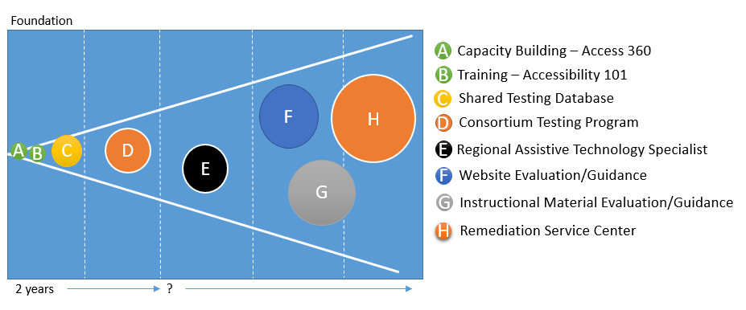
SBCTC is successfully accelerating institutional progress towards understanding how develop and implement technology accessibility plans through its Access 360 program and SBCTC’s Accessibility 101 course is providing college faculty and staff with a great training foundation on accessibility issues and creating accessible documents. However, penetration of those initiatives into the system remains limited and much work remains.
As noted earlier, there are enormous efficiencies of scale associated with technology accessibility testing. Colleges use a wide variety of software, approximately 80% of it is common to 80% of the colleges. The inefficiency of doing the testing independently immediately becomes obvious by a simple arithmetic exercise. If there are 1,000 software packages that need to be tested, approximately 800 of those will be used by 25 of the college. If the colleges do their software testing independently they will conduct 20,000 tests vs. only 800; testing software as a “system” can thus reduce testing costs by 95%. More importantly it will make it far more likely that we test software and thereby only acquire and use software that is accessible.
Testing Steps:
- Database
- Database + Trusted Testers
- National Testing Service
The other stuff and how to evolve into it via a risk management approach.
We recommend that:
- WCTC immediately fund an accessible technology certification program designed to scale to the national level.
- WCTC/SBCTC establish a prototyping process with validation gates to process to explore the benefits and manage the risks associated with providing services higher up the stack.
We recommend pursuing a parallel funding track for technology accessibility:
- Legislative Ask
- Skim plus buyback.

Technology Accessibility Center (TAC) AFA-accessiblity for all UA –universal accessibility

Mission
To help members accelerate their evolution to becoming fully accessible by:
- Facilitating the selection of technology to support the success of the disabled.
- Providing responsive, reliable and cost-effective accessibility services.
- Nurturing a community of practice in technology accessibility.

Problem Statement Opportunity
WACTC-Tech Charge
- Develop a proposal to leverage the resources of WACTC to address accessibility testing and remediation requirements in a cost-effective, equitable and responsive manner.
- Consult with appropriate commissions and councils on the development of the proposal.
- Deliver the resulting proposal to WACTC for its consideration no later than May 2018.

College Consultation
W

Other research – state of the field
Vision

Testing Service Priorities
Everyone gets a vote, top X are prioritized for the system and so on down the list. Require some type of minimum vote in order to justify 3rd party testing.

Business Model

Recommendation
Start at X, establish gates, climb up the evolutionary ladder and modify at each gate

